Hoàng Trọng Toàn
1250080202
12_ĐH_CNTT4

PHIẾU BÀI TẬP 1
Tạo bảng
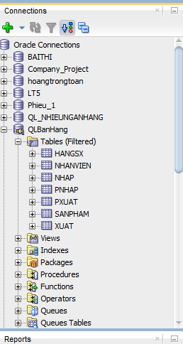

a. Thủ tục sp_NhapHangSX
CREATE OR REPLACE PROCEDURE sp_NhapHangSX (
p_MaHangSX IN VARCHAR2,
p_TenHang IN VARCHAR2,
p_DiaChi IN VARCHAR2,
p_SoDT IN VARCHAR2,
p_Email IN VARCHAR2
) AS
v_dem NUMBER := 0;
BEGIN
SELECT COUNT(*) INTO v_dem FROM HangSX WHERE TenHang = p_TenHang;

IF v_dem > 0 THEN
DBMS_OUTPUT.PUT_LINE('TenHang da ton tai!');
ELSE
INSERT INTO HangSX VALUES (p_MaHangSX, p_TenHang, p_DiaChi, p_SoDT, p_Email);
COMMIT;
DBMS_OUTPUT.PUT_LINE('Them HangSX thanh cong!');
END IF;
END sp_NhapHangSX;
/
TEST
SET SERVEROUTPUT ON;
TH1: Thêm mới thành công
BEGIN
sp_NhapHangSX('HSX01', 'Samsung', 'Han Quoc', '0123456789', 'samsung@gmail.com');
END;
/
TH2: TenHang đã tồn tại
BEGIN
sp_NhapHangSX('HSX02', 'Samsung', 'Han Quoc', '0987654321', 'samsung2@gmail.com');
END;
/
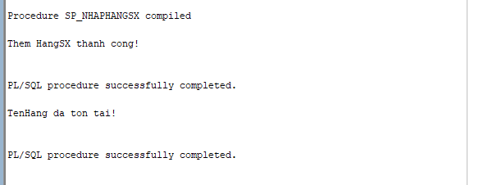

b. Thủ tục sp_NhapSP
CREATE OR REPLACE PROCEDURE sp_NhapSP (
p_MaSP IN VARCHAR2,
p_MaHangSX IN VARCHAR2,
p_TenSP IN VARCHAR2,
p_SoLuong IN NUMBER,
p_MauSac IN VARCHAR2,
p_GiaBan IN NUMBER,
p_DonViTinh IN VARCHAR2,
p_MoTa IN VARCHAR2
) AS
v_dem_hang NUMBER := 0;
v_dem_sp NUMBER := 0;
BEGIN
SELECT COUNT(*) INTO v_dem_hang FROM HangSX WHERE MaHangSX = p_MaHangSX;

IF v_dem_hang = 0 THEN
DBMS_OUTPUT.PUT_LINE('TenHang khong co trong bang HangSX!');
ELSE
SELECT COUNT(*) INTO v_dem_sp FROM SanPham WHERE MaSP = p_MaSP;

IF v_dem_sp > 0 THEN
UPDATE SanPham SET
MaHangSX = p_MaHangSX,
TenSP = p_TenSP,
SoLuong = p_SoLuong,
MauSac = p_MauSac,
GiaBan = p_GiaBan,
DonViTinh = p_DonViTinh,
MoTa = p_MoTa
WHERE MaSP = p_MaSP;
COMMIT;
DBMS_OUTPUT.PUT_LINE('Cap nhat san pham thanh cong!');
ELSE
INSERT INTO SanPham VALUES (p_MaSP, p_MaHangSX, p_TenSP, p_SoLuong, p_MauSac, p_GiaBan, p_DonViTinh, p_MoTa);
COMMIT;
DBMS_OUTPUT.PUT_LINE('Them san pham thanh cong!');
END IF;
END IF;
END sp_NhapSP;
/
TEST
SET SERVEROUTPUT ON;
BEGIN
sp_NhapSP('SP01', 'HSX01', 'Samsung A54', 100, 'Den', 8000000, 'Cai', 'Dien thoai Samsung');
END;
/
BEGIN
sp_NhapSP('SP01', 'HSX01', 'Samsung A54 Pro', 150, 'Trang', 9000000, 'Cai', 'Dien thoai Samsung moi');
END;
/
BEGIN
sp_NhapSP('SP02', 'HSX99', 'iPhone 14', 50, 'Trang', 25000000, 'Cai', 'Dien thoai Apple');
END;
/
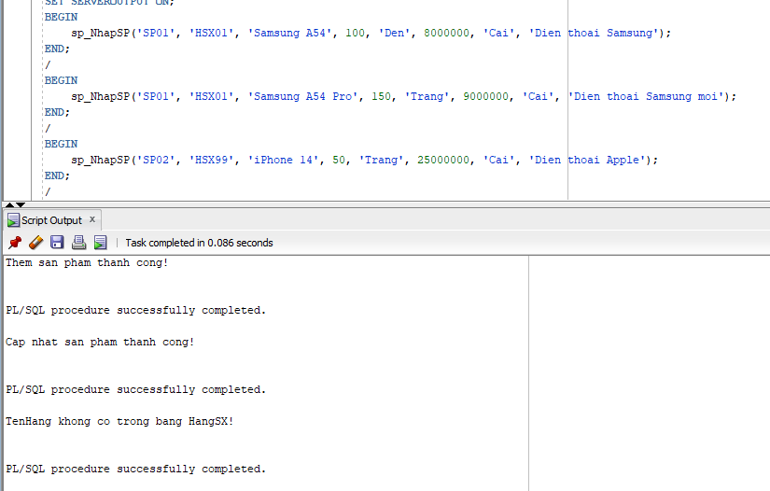

c. Thủ tục sp_XoaHangSX
CREATE OR REPLACE PROCEDURE sp_XoaHangSX (
p_TenHang IN VARCHAR2
) AS
v_dem NUMBER := 0;
BEGIN
SELECT COUNT(*) INTO v_dem FROM HangSX WHERE TenHang = p_TenHang;

IF v_dem = 0 THEN
DBMS_OUTPUT.PUT_LINE('TenHang chua co trong bang HangSX!');
ELSE
DELETE FROM SanPham WHERE MaHangSX = (
SELECT MaHangSX FROM HangSX WHERE TenHang = p_TenHang
);

DELETE FROM HangSX WHERE TenHang = p_TenHang;
COMMIT;
DBMS_OUTPUT.PUT_LINE('Xoa HangSX thanh cong!');
END IF;
END sp_XoaHangSX;
/
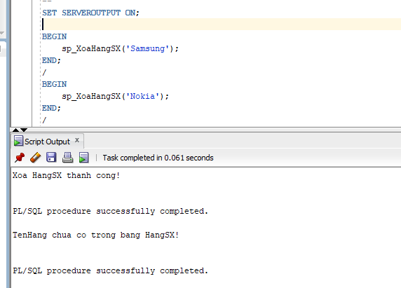

d. Thủ tục nhập dữ liệu NhanVien (có biến FLAG)
CREATE OR REPLACE PROCEDURE sp_NhapNhanVien (
p_MaNV IN VARCHAR2,
p_TenNV IN VARCHAR2,
p_GioiTinh IN VARCHAR2,
p_DiaChi IN VARCHAR2,
p_SoDT IN VARCHAR2,
p_Email IN VARCHAR2,
p_TenPhong IN VARCHAR2,
p_Flag IN NUMBER
) AS
BEGIN
IF p_Flag = 0 THEN
UPDATE NhanVien SET
TenNV = p_TenNV,
GioiTinh = p_GioiTinh,
DiaChi = p_DiaChi,
SoDT = p_SoDT,
Email = p_Email,
TenPhong = p_TenPhong
WHERE MaNV = p_MaNV;
COMMIT;
DBMS_OUTPUT.PUT_LINE('Cap nhat nhan vien thanh cong!');
ELSE
INSERT INTO NhanVien VALUES (p_MaNV, p_TenNV, p_GioiTinh, p_DiaChi, p_SoDT, p_Email, p_TenPhong);
COMMIT;
DBMS_OUTPUT.PUT_LINE('Them moi nhan vien thanh cong!');
END IF;
END sp_NhapNhanVien;
/
TEST
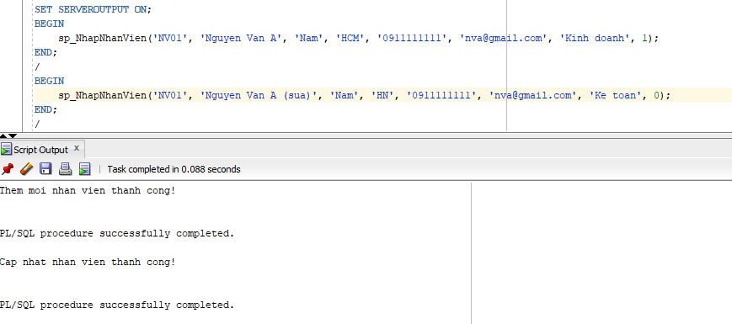

e. Thủ tục nhập dữ liệu bảng Nhap
CREATE OR REPLACE PROCEDURE sp_NhapHangNhap (
p_SoHDN IN VARCHAR2,
p_MaSP IN VARCHAR2,
p_MaNV IN VARCHAR2,
p_NgayNhap IN DATE,
p_SoLuongN IN NUMBER,
p_DonGiaN IN NUMBER
) AS
v_dem_sp NUMBER := 0;
v_dem_nv NUMBER := 0;
v_dem_hdn NUMBER := 0;
BEGIN
SELECT COUNT(*) INTO v_dem_sp FROM SanPham WHERE MaSP = p_MaSP;

IF v_dem_sp = 0 THEN
DBMS_OUTPUT.PUT_LINE('MaSP khong co trong bang SanPham!');
RETURN;
END IF;

SELECT COUNT(*) INTO v_dem_nv FROM NhanVien WHERE MaNV = p_MaNV;

IF v_dem_nv = 0 THEN
DBMS_OUTPUT.PUT_LINE('MaNV khong co trong bang NhanVien!');
RETURN;
END IF;

SELECT COUNT(*) INTO v_dem_hdn FROM PNhap WHERE SoHDN = p_SoHDN;

IF v_dem_hdn > 0 THEN
UPDATE Nhap SET
SoLuongN = p_SoLuongN,
DonGiaN = p_DonGiaN
WHERE SoHDN = p_SoHDN AND MaSP = p_MaSP;
COMMIT;
DBMS_OUTPUT.PUT_LINE('Cap nhat Nhap thanh cong!');
ELSE
INSERT INTO PNhap VALUES (p_SoHDN, p_NgayNhap, p_MaNV);
INSERT INTO Nhap VALUES (p_SoHDN, p_MaSP, p_SoLuongN, p_DonGiaN);
COMMIT;
DBMS_OUTPUT.PUT_LINE('Them moi Nhap thanh cong!');
END IF;
END sp_NhapHangNhap;
/
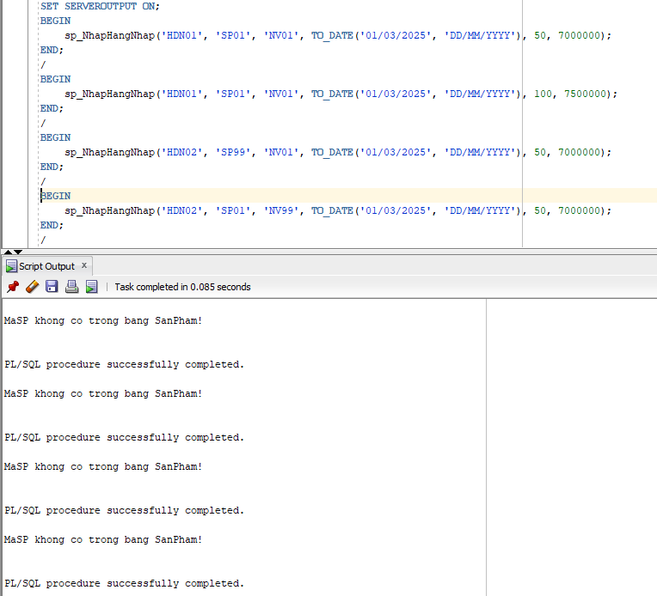

f. Thủ tục nhập dữ liệu bảng Xuat

CREATE OR REPLACE PROCEDURE sp_NhapHangXuat (
p_SoHDX IN VARCHAR2,
p_MaSP IN VARCHAR2,
p_MaNV IN VARCHAR2,
p_NgayXuat IN DATE,
p_SoLuongX IN NUMBER
) AS
v_dem_sp NUMBER := 0;
v_dem_nv NUMBER := 0;
v_dem_hdx NUMBER := 0;
v_soluong NUMBER := 0;
BEGIN
SELECT COUNT(*) INTO v_dem_sp FROM SanPham WHERE MaSP = p_MaSP;

IF v_dem_sp = 0 THEN
DBMS_OUTPUT.PUT_LINE('MaSP khong co trong bang SanPham!');
RETURN;
END IF;

SELECT COUNT(*) INTO v_dem_nv FROM NhanVien WHERE MaNV = p_MaNV;

IF v_dem_nv = 0 THEN
DBMS_OUTPUT.PUT_LINE('MaNV khong co trong bang NhanVien!');
RETURN;
END IF;

SELECT SoLuong INTO v_soluong FROM SanPham WHERE MaSP = p_MaSP;

IF p_SoLuongX > v_soluong THEN
DBMS_OUTPUT.PUT_LINE('SoLuongX vuot qua so luong ton kho!');
RETURN;
END IF;

SELECT COUNT(*) INTO v_dem_hdx FROM PXuat WHERE SoHDX = p_SoHDX;

IF v_dem_hdx > 0 THEN
UPDATE Xuat SET
SoLuongX = p_SoLuongX
WHERE SoHDX = p_SoHDX AND MaSP = p_MaSP;
COMMIT;
DBMS_OUTPUT.PUT_LINE('Cap nhat Xuat thanh cong!');
ELSE
INSERT INTO PXuat VALUES (p_SoHDX, p_NgayXuat, p_MaNV);
INSERT INTO Xuat VALUES (p_SoHDX, p_MaSP, p_SoLuongX);
COMMIT;
DBMS_OUTPUT.PUT_LINE('Them moi Xuat thanh cong!');
END IF;
END sp_NhapHangXuat;
/
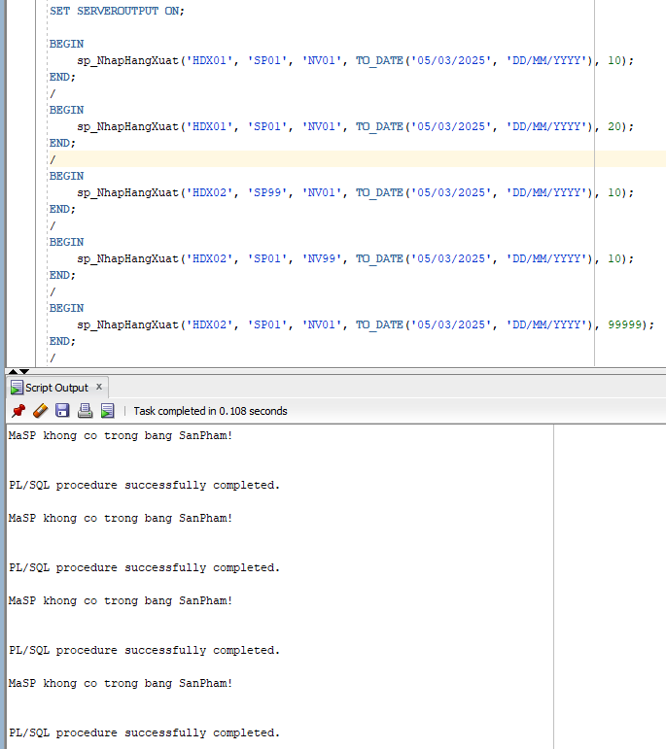

g. Thủ tục xóa NhanVien
CREATE OR REPLACE PROCEDURE sp_XoaNhanVien (
p_MaNV IN VARCHAR2
) AS
v_dem NUMBER := 0;
BEGIN
SELECT COUNT(*) INTO v_dem FROM NhanVien WHERE MaNV = p_MaNV;

IF v_dem = 0 THEN
DBMS_OUTPUT.PUT_LINE('MaNV chua co trong bang NhanVien!');
ELSE
DELETE FROM Nhap WHERE SoHDN IN (
SELECT SoHDN FROM PNhap WHERE MaNV = p_MaNV
);
DELETE FROM PNhap WHERE MaNV = p_MaNV;

DELETE FROM Xuat WHERE SoHDX IN (
SELECT SoHDX FROM PXuat WHERE MaNV = p_MaNV
);
DELETE FROM PXuat WHERE MaNV = p_MaNV;

DELETE FROM NhanVien WHERE MaNV = p_MaNV;
COMMIT;
DBMS_OUTPUT.PUT_LINE('Xoa NhanVien thanh cong!');
END IF;
END sp_XoaNhanVien;
/
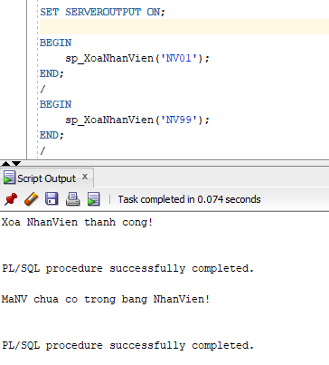

h. Thủ tục xóa SanPham
CREATE OR REPLACE PROCEDURE sp_XoaSanPham (
p_MaSP IN VARCHAR2
) AS
v_dem NUMBER := 0;
BEGIN
SELECT COUNT(*) INTO v_dem FROM SanPham WHERE MaSP = p_MaSP;

IF v_dem = 0 THEN
DBMS_OUTPUT.PUT_LINE('MaSP chua co trong bang SanPham!');
ELSE
DELETE FROM Nhap WHERE MaSP = p_MaSP;
DELETE FROM Xuat WHERE MaSP = p_MaSP;

DELETE FROM SanPham WHERE MaSP = p_MaSP;
COMMIT;
DBMS_OUTPUT.PUT_LINE('Xoa SanPham thanh cong!');
END IF;
END sp_XoaSanPham;
/
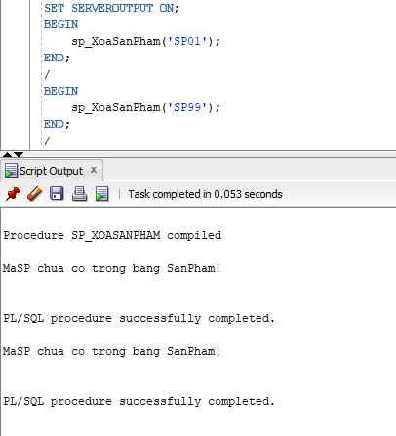

PHIẾU BÀI TẬP 2
a. Thủ tục sp_ThemNhanVien (có OUT)
CREATE OR REPLACE PROCEDURE sp_ThemNhanVien (
p_MaNV IN VARCHAR2,
p_TenNV IN VARCHAR2,
p_GioiTinh IN VARCHAR2,
p_DiaChi IN VARCHAR2,
p_SoDT IN VARCHAR2,
p_Email IN VARCHAR2,
p_TenPhong IN VARCHAR2,
p_Flag IN NUMBER,
p_KQ OUT NUMBER
) AS
v_dem NUMBER := 0;
BEGIN
IF p_GioiTinh <> 'Nam' AND p_GioiTinh <> 'Nu' THEN
p_KQ := 1;
RETURN;
END IF;

IF p_Flag = 0 THEN
INSERT INTO NhanVien VALUES (p_MaNV, p_TenNV, p_GioiTinh, p_DiaChi, p_SoDT, p_Email, p_TenPhong);
COMMIT;
p_KQ := 0;
ELSE
UPDATE NhanVien SET
TenNV = p_TenNV,
GioiTinh = p_GioiTinh,
DiaChi = p_DiaChi,
SoDT = p_SoDT,
Email = p_Email,
TenPhong = p_TenPhong
WHERE MaNV = p_MaNV;
COMMIT;
p_KQ := 0;
END IF;
END sp_ThemNhanVien;
/
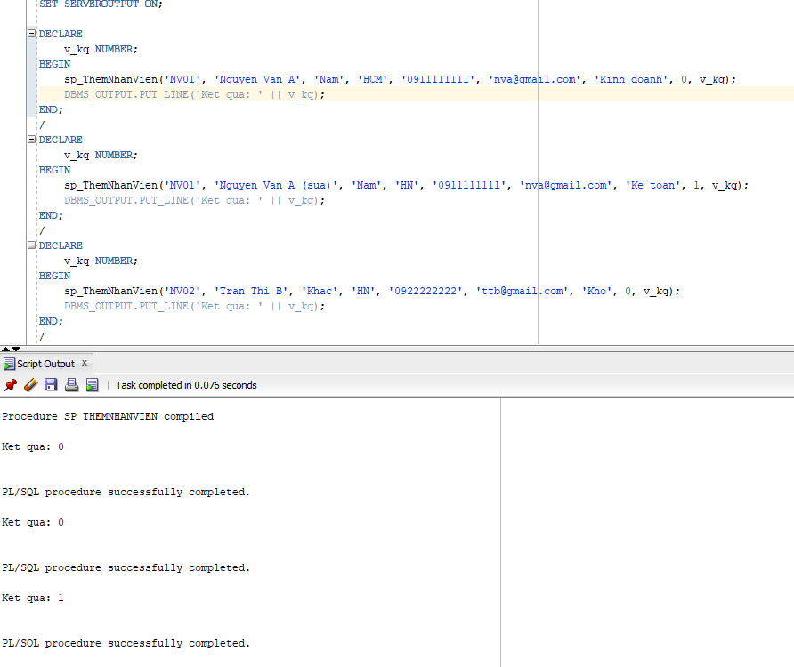
b. Thủ tục sp_ThemMoiSP (có OUT)

CREATE OR REPLACE PROCEDURE sp_ThemMoiSP (
p_MaSP IN VARCHAR2,
p_MaHangSX IN VARCHAR2,
p_TenSP IN VARCHAR2,
p_SoLuong IN NUMBER,
p_MauSac IN VARCHAR2,
p_GiaBan IN NUMBER,
p_DonViTinh IN VARCHAR2,
p_MoTa IN VARCHAR2,
p_Flag IN NUMBER,
p_KQ OUT NUMBER
) AS
v_dem_hang NUMBER := 0;
v_dem_sp NUMBER := 0;
BEGIN
SELECT COUNT(*) INTO v_dem_hang FROM HangSX WHERE MaHangSX = p_MaHangSX;

IF v_dem_hang = 0 THEN
p_KQ := 1;
RETURN;
END IF;

IF p_SoLuong < 0 THEN
p_KQ := 2;
RETURN;
END IF;

IF p_Flag = 0 THEN
INSERT INTO SanPham VALUES (p_MaSP, p_MaHangSX, p_TenSP, p_SoLuong, p_MauSac, p_GiaBan, p_DonViTinh, p_MoTa);
COMMIT;
p_KQ := 0;
ELSE
UPDATE SanPham SET
MaHangSX = p_MaHangSX,
TenSP = p_TenSP,
SoLuong = p_SoLuong,
MauSac = p_MauSac,
GiaBan = p_GiaBan,
DonViTinh = p_DonViTinh,
MoTa = p_MoTa
WHERE MaSP = p_MaSP;
COMMIT;
p_KQ := 0;
END IF;
END sp_ThemMoiSP;
/
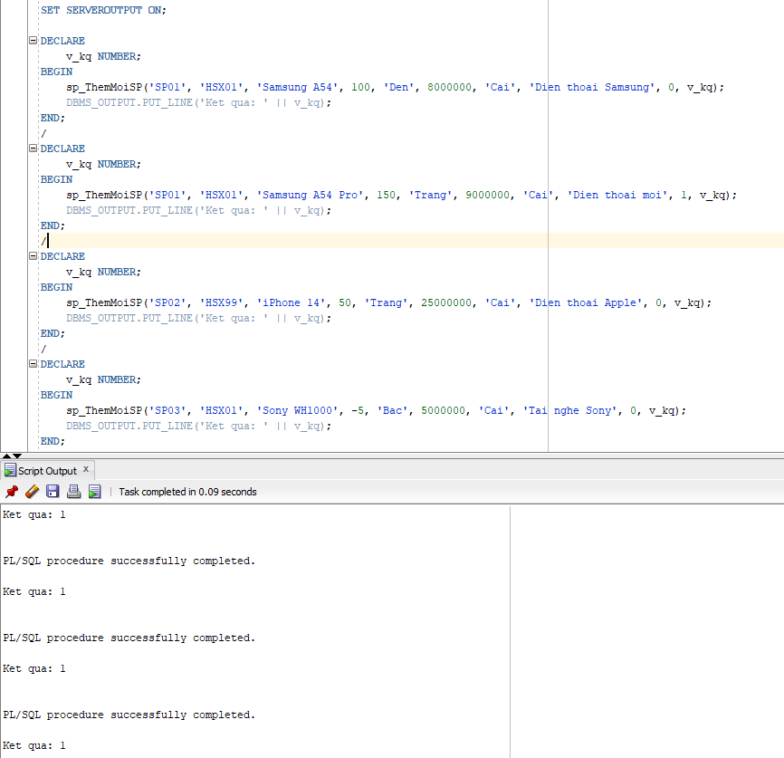

c. Thủ tục xóa NhanVien (có OUT)
CREATE OR REPLACE PROCEDURE sp_XoaNhanVien_OUT (
p_MaNV IN VARCHAR2,
p_KQ OUT NUMBER
) AS
v_dem NUMBER := 0;
BEGIN
SELECT COUNT(*) INTO v_dem FROM NhanVien WHERE MaNV = p_MaNV;

IF v_dem = 0 THEN
p_KQ := 1;
ELSE
DELETE FROM Nhap WHERE SoHDN IN (
SELECT SoHDN FROM PNhap WHERE MaNV = p_MaNV
);
DELETE FROM PNhap WHERE MaNV = p_MaNV;

DELETE FROM Xuat WHERE SoHDX IN (
SELECT SoHDX FROM PXuat WHERE MaNV = p_MaNV
);
DELETE FROM PXuat WHERE MaNV = p_MaNV;

DELETE FROM NhanVien WHERE MaNV = p_MaNV;
COMMIT;
p_KQ := 0;
END IF;
END sp_XoaNhanVien_OUT;
/
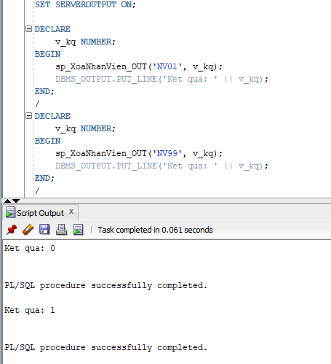

d. Thủ tục xóa SanPham (có OUT)
CREATE OR REPLACE PROCEDURE sp_XoaSanPham_OUT (
p_MaSP IN VARCHAR2,
p_KQ OUT NUMBER
) AS
v_dem NUMBER := 0;
BEGIN
SELECT COUNT(*) INTO v_dem FROM SanPham WHERE MaSP = p_MaSP;

IF v_dem = 0 THEN
p_KQ := 1;
ELSE
DELETE FROM Nhap WHERE MaSP = p_MaSP;
DELETE FROM Xuat WHERE MaSP = p_MaSP;
DELETE FROM SanPham WHERE MaSP = p_MaSP;
COMMIT;
p_KQ := 0;
END IF;
END sp_XoaSanPham_OUT;
/
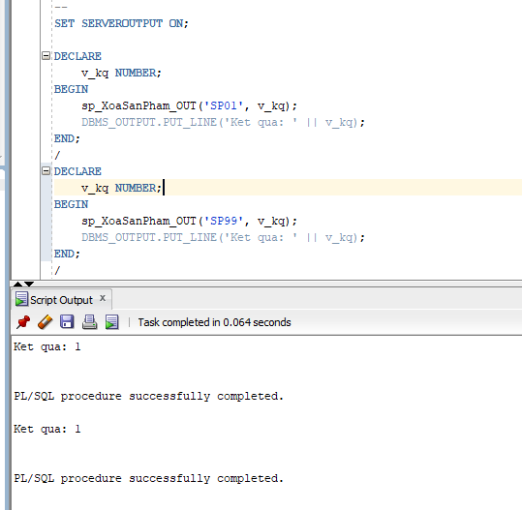
e. Thủ tục sp_NhapHangSX (có OUT)
CREATE OR REPLACE PROCEDURE sp_NhapHangSX_OUT (
p_MaHangSX IN VARCHAR2,
p_TenHang IN VARCHAR2,
p_DiaChi IN VARCHAR2,
p_SoDT IN VARCHAR2,
p_Email IN VARCHAR2,
p_KQ OUT NUMBER
) AS
v_dem NUMBER := 0;
BEGIN
SELECT COUNT(*) INTO v_dem FROM HangSX WHERE TenHang = p_TenHang;

IF v_dem > 0 THEN
p_KQ := 1;
ELSE
INSERT INTO HangSX VALUES (p_MaHangSX, p_TenHang, p_DiaChi, p_SoDT, p_Email);
COMMIT;
p_KQ := 0;
END IF;
END sp_NhapHangSX_OUT;
/
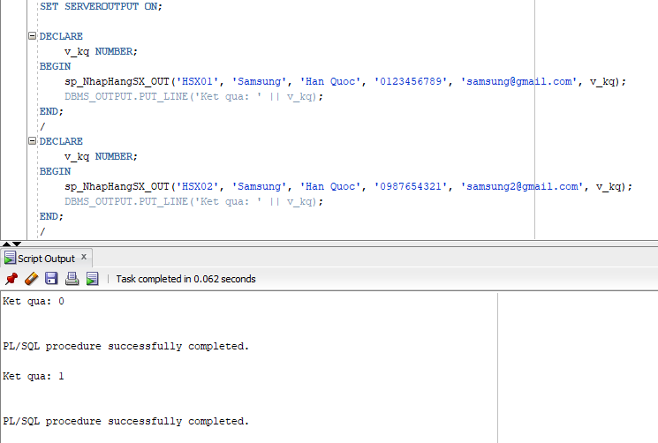

f. Thủ tục nhập bảng Nhap (có OUT)
CREATE OR REPLACE PROCEDURE sp_NhapHangNhap_OUT (
p_SoHDN IN VARCHAR2,
p_MaSP IN VARCHAR2,
p_MaNV IN VARCHAR2,
p_NgayNhap IN DATE,
p_SoLuongN IN NUMBER,
p_DonGiaN IN NUMBER,
p_KQ OUT NUMBER
) AS
v_dem_sp NUMBER := 0;
v_dem_nv NUMBER := 0;
v_dem_hdn NUMBER := 0;
BEGIN
SELECT COUNT(*) INTO v_dem_sp FROM SanPham WHERE MaSP = p_MaSP;

IF v_dem_sp = 0 THEN
p_KQ := 1;
RETURN;
END IF;

SELECT COUNT(*) INTO v_dem_nv FROM NhanVien WHERE MaNV = p_MaNV;

IF v_dem_nv = 0 THEN
p_KQ := 2;
RETURN;
END IF;

SELECT COUNT(*) INTO v_dem_hdn FROM PNhap WHERE SoHDN = p_SoHDN;

IF v_dem_hdn > 0 THEN
UPDATE Nhap SET
SoLuongN = p_SoLuongN,
DonGiaN = p_DonGiaN
WHERE SoHDN = p_SoHDN AND MaSP = p_MaSP;
COMMIT;
p_KQ := 0;
ELSE
INSERT INTO PNhap VALUES (p_SoHDN, p_NgayNhap, p_MaNV);
INSERT INTO Nhap VALUES (p_SoHDN, p_MaSP, p_SoLuongN, p_DonGiaN);
COMMIT;
p_KQ := 0;
END IF;
END sp_NhapHangNhap_OUT;
/
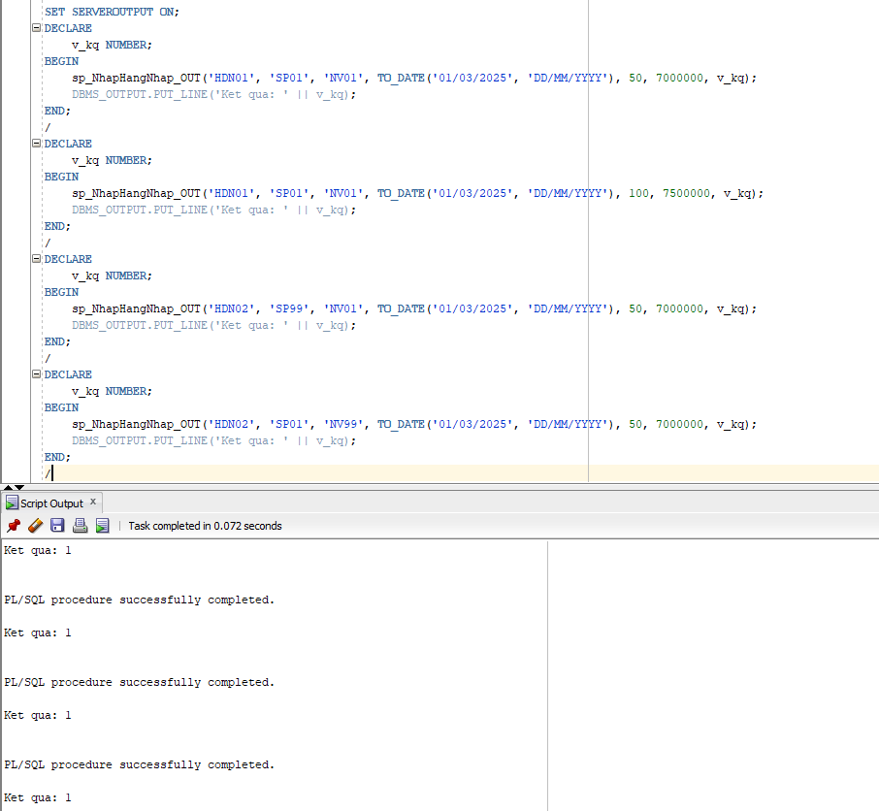
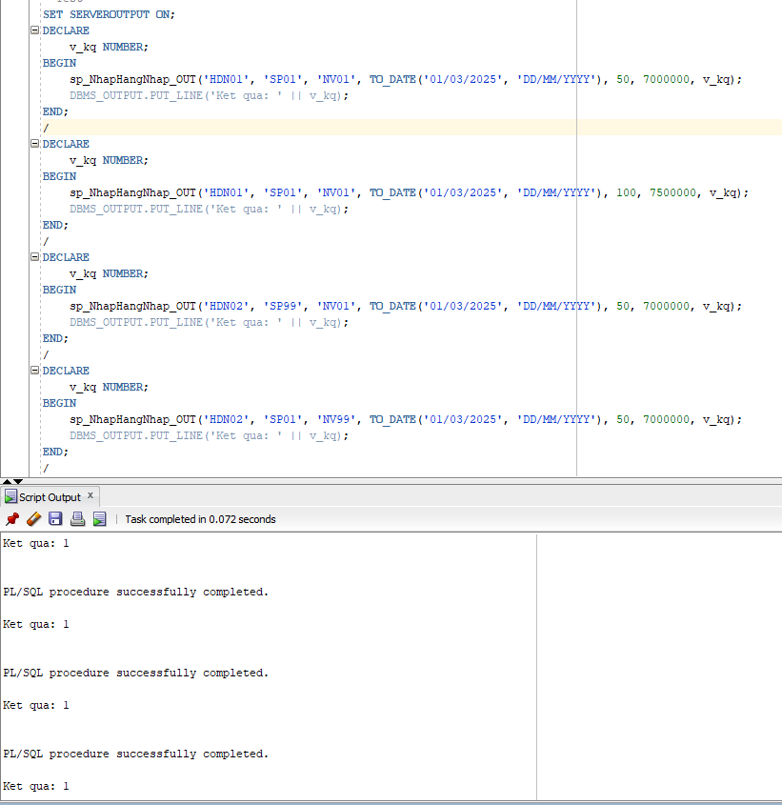

g. Thủ tục nhập bảng Xuat (có OUT)
CREATE OR REPLACE PROCEDURE sp_NhapHangXuat_OUT (
p_SoHDX IN VARCHAR2,
p_MaSP IN VARCHAR2,
p_MaNV IN VARCHAR2,
p_NgayXuat IN DATE,
p_SoLuongX IN NUMBER,
p_KQ OUT NUMBER
) AS
v_dem_sp NUMBER := 0;
v_dem_nv NUMBER := 0;
v_dem_hdx NUMBER := 0;
v_soluong NUMBER := 0;
BEGIN
SELECT COUNT(*) INTO v_dem_sp FROM SanPham WHERE MaSP = p_MaSP;

IF v_dem_sp = 0 THEN
p_KQ := 1;
RETURN;
END IF;
SELECT COUNT(*) INTO v_dem_nv FROM NhanVien WHERE MaNV = p_MaNV;

IF v_dem_nv = 0 THEN
p_KQ := 2;
RETURN;
END IF;
SELECT SoLuong INTO v_soluong FROM SanPham WHERE MaSP = p_MaSP;

IF p_SoLuongX > v_soluong THEN
p_KQ := 3;
RETURN;
END IF;
SELECT COUNT(*) INTO v_dem_hdx FROM PXuat WHERE SoHDX = p_SoHDX;

IF v_dem_hdx > 0 THEN
UPDATE Xuat SET
SoLuongX = p_SoLuongX
WHERE SoHDX = p_SoHDX AND MaSP = p_MaSP;
COMMIT;
p_KQ := 0;
ELSE
INSERT INTO PXuat VALUES (p_SoHDX, p_NgayXuat, p_MaNV);
INSERT INTO Xuat VALUES (p_SoHDX, p_MaSP, p_SoLuongX);
COMMIT;
p_KQ := 0;
END IF;
END sp_NhapHangXuat_OUT;
/
