

**FPT ACADEMY INTERNATIONAL**

**FPT – APTECH COMPUTER EDUCATION**

**USER GUIDE FOR VERTEX SYSTEM WEBSITE**

**I. System Requirement**

|  |  |  |
| --- | --- | --- |
| **No** | **Software** | **Description** |
| **1** | **Operating system** | **Windows 7 or higher** |
| **2** | **Hardware** | **Intel Pentium 4 processor or higher**  **512 Megabytes of RAM or higher** |
| **3** | **Software** | **Visual Studio Code, Dreamweaver** |
| **4** | **Web browser** | **Internet Explorer 11 , Chrome, Firefox, Safari** |

**Vertex website introduction**

1. **Home**

* Give overview information about virus, it’s influence…
* In each section of the page, you can click on the link of each section to get detail information.

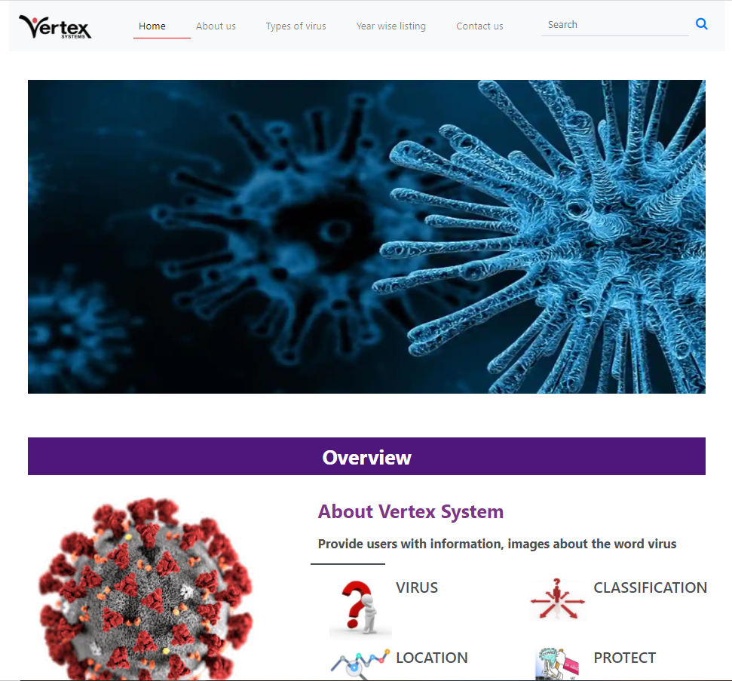

1. **About us**

- This page displays some more information about Vertex system and our team members.

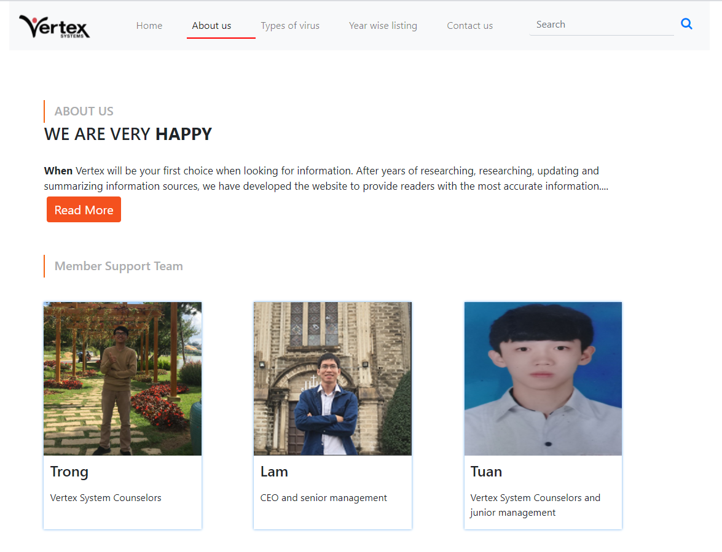

1. **Types of virus**

* Display types of virus and its classification base on structure or characteristics.

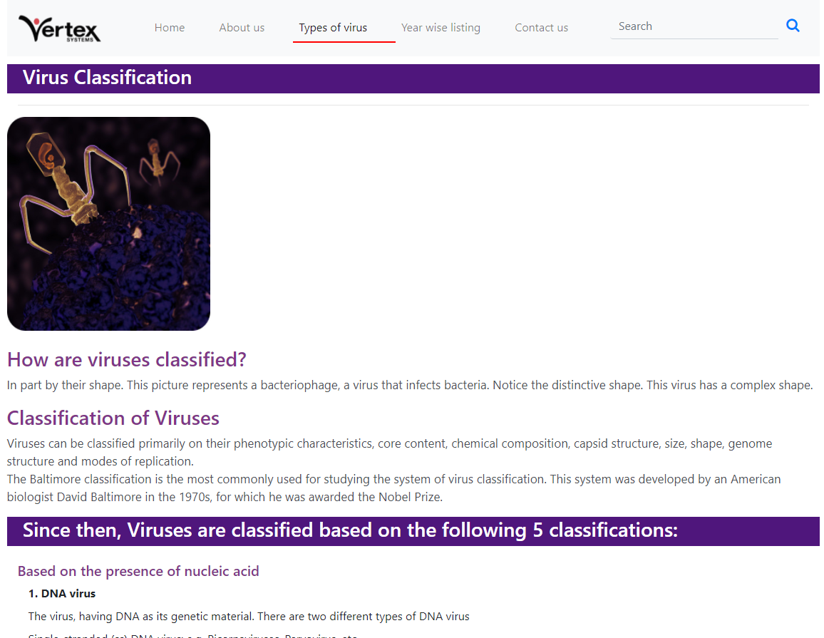

1. **Year wise listing**

* This page display the year which virus appears. Just select the year on the right of webpage, all viruses appear in that year will be displayed. To get more detail information, click “Read More”.

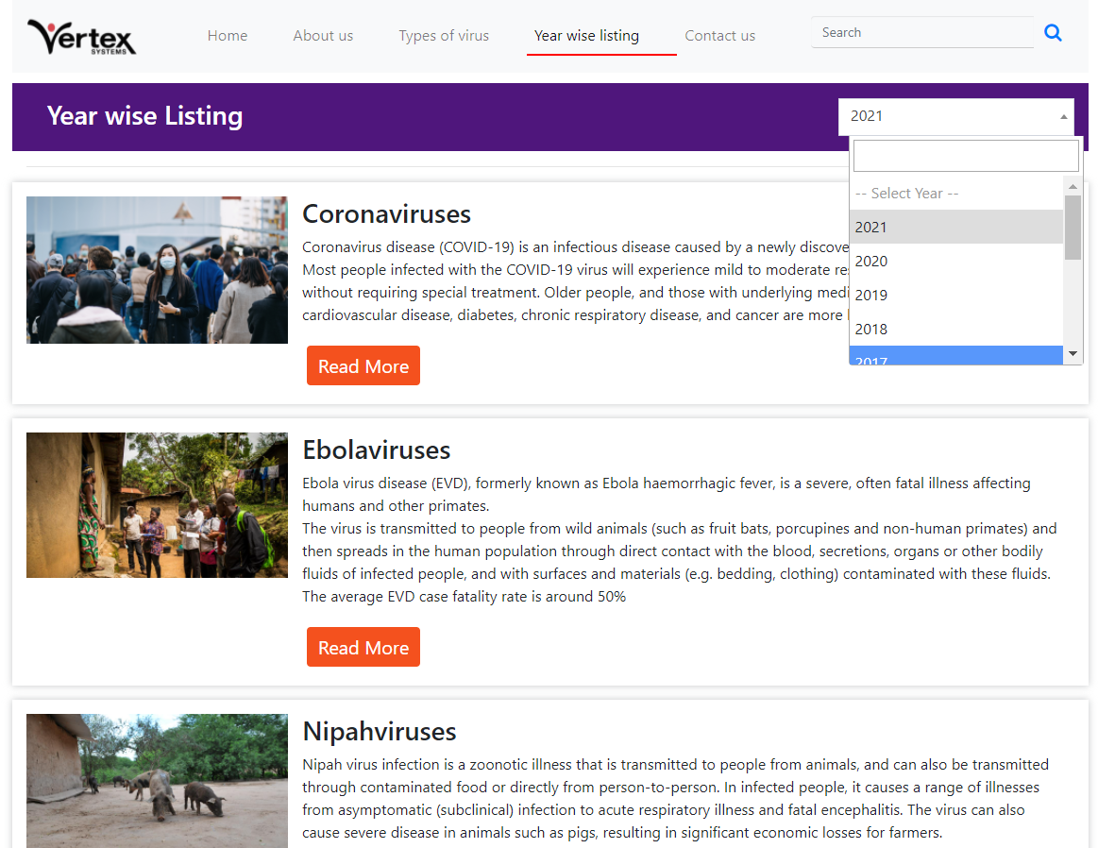

* This page displays the detail of virus information which is arranged in 4 tabs: “Overview”, “Location of Origin”, “Prevention”, “Symptoms”.

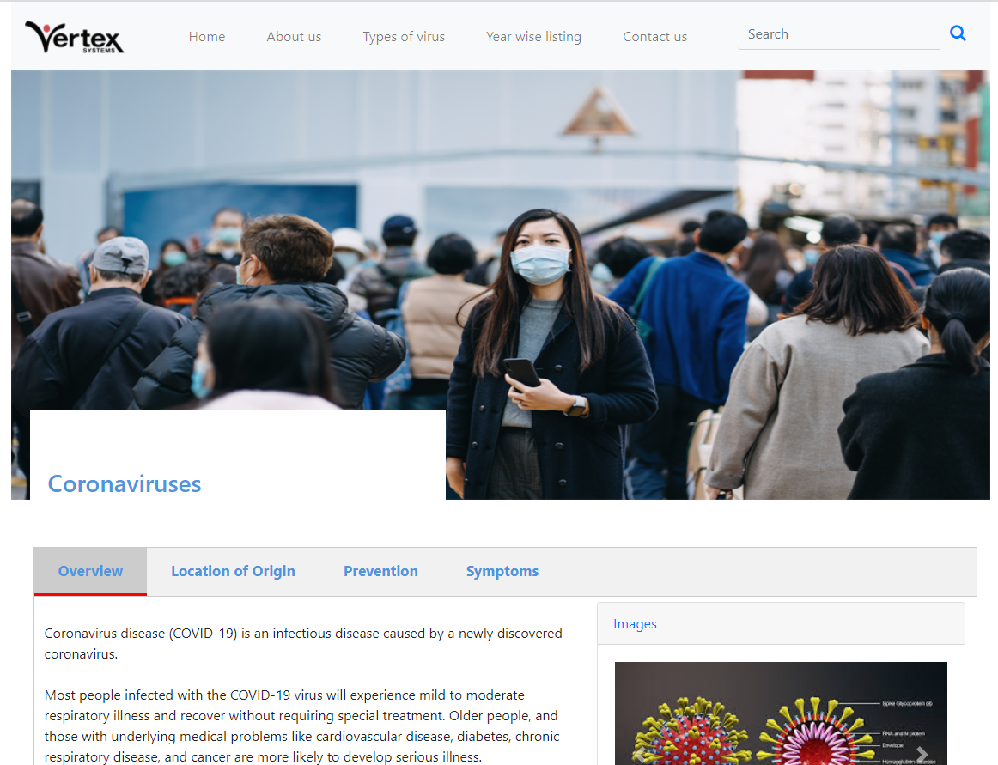

1. **Contact us**

* This page displays contact information: location, telephone number, email and a quick contact form for customer.

