project:
EMI_good03

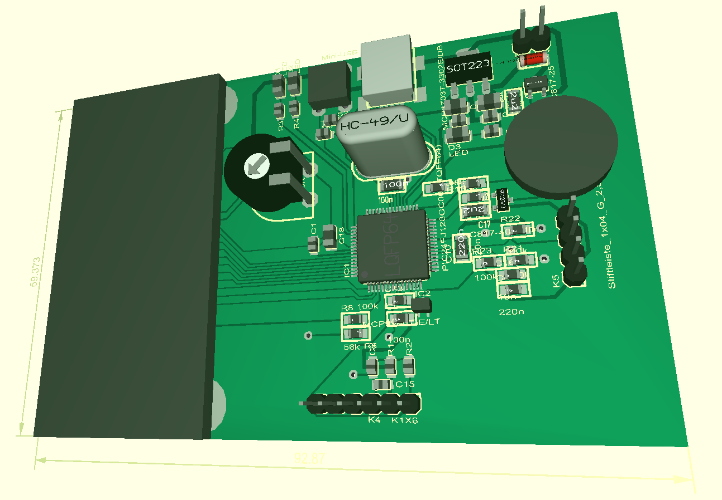

description:
This project demos in a practical way how to do a proper layout. It shows what to do and what shouldn’t be done in a few examples with the possibility of simple verification.

Christoph Baumgartner

(c)

