**JOMO KENYATTA UNIVERSITY OF AGRICULTURE AND TECHNOLOGY**

**INTRODUCTION TO PROJECT MANAGEMENT**

**HCT 0203**

**LECTURER: MISS NAOMI ROTICH**

**EMAIL:** [**rotich.naomi@jkuat.ac.ke**](mailto:rotich.naomi@jkuat.ac.ke)

**TOPICS.**

1. **DEFINITION OF KEY TERMS**
2. **PROJECT MNGT, PROJECT LIFECYCLE**
3. **PROJECT MNGT TOOLS**
4. **PROJECT:MANAGER, TEAMS**
5. **RISK MANAGEMENT**

**DEFINTION OF KEY TERMS**

**PROJECT**- is a means of moving from a problem to a solution via a series of planned activities. It is a unique venture with a specified start and end.

**A project** - is an interrelated set of activities that has a definite starting and ending point and results in the accomplishment of a unique, often major outcome.

**A project** - is a sequence of unique, complex and connected activities having one goal or purpose that must be completed by a specific time, within budget and according to specification.

**A project** -is a complex, no routine, one-time effort limited by time, budget, resources, and performance specifications designed to meet customer needs.

**A project** - is a temporary endeavour undertaken to create a unique product, service or result.

**A project** - is a sequence of activities that has a definite start and finish, an identifiable goal and an integrated system of complex but interdependent relationships

**Project management** -The application of knowledge, skills, tools, techniques, people, and systems focused on meeting or exceeding stakeholder needs. It is the process of planning, scheduling, and controlling of project activities to meet project objectives.

**A problem** - is a gap (achieving your objective) between where you are and where you want to be, with an obstacle that prevents easy movement to close the gap.

**Program** – is a long term project that will respond and resolve social issues basically the root causes. This involves series of projects to be implemented until problem is resolved. Continuing activity. It is group of related project managed in a coordinated way to obtain benefits and controls not available for managing them individually. It is a collection of interdependence projects managed in a coordinated manner that together will provide the desired outcome.

**Project plan**- is a formal approved document used to guide both the project implementation and project control.

**Project control** – is the process of comparing the actual performance with the planned performance and taking appropriate corrective action that will yield the desired outcome in the project when significant difference exist.

**An activity or task**- is the smallest unit of work effort within the project and consumes both time and resources which are under the control of the project manager.

**Project manager** – is the individual who has the overall responsibility for managing the project and guiding the project team towards the achievement of the desired objectives.

**Project teams**- these are the project human resource who have interdependence collections of roles and responsibilities queered towards a common goal. A project team is a team which is involved in the implementation of the project.

**A risk** is uncertain event which may occur in the future. It may prevent or delay the achievement of an organization or units objectives or goals.

**Risk management**- is process to identify all relevant risks, rank those risks, address the risks in order of priority, monitor and report on their management.

**Monitoring** - systematic collection on analysis of information as a project progress aimed at improving efficiency and effectiveness of a project or organization. It helps to determine whether the resources available are sufficient and been used well.

**Evaluation** - is the comparison of the actual project impact against the agreed strategic plan. It looks at what one set to do and what has been accomplished.

**Stakeholder**- is any individual, group or organization, community, with an interest in the outcome of a programme/ project. Any group within or outside a project that has a stake in the project’s activities and/or outcomes.

**Scope**: The magnitude of the work to be performed.

**Features / characteristics of a Project**

1. Uniqueness - every project has unique elements (no two projects are the same)
2. Complexity and Interdependencies - projects often have subtasks that require careful coordination and control in terms of timing, precedence, cost, and performance
3. Life Cycle - all projects have a life cycle (beginning, build in size, peak, and decline and must be terminated.
4. It must have an approved budget.
5. It has limited resources
6. Every project has an element of risk

**PROJECT MANAGEMENT**

Project management – is the use of techniques and skills (hard and soft) in planning and controlling tasks and resources needed for the project, from both inside and outside of organisation, to achieve results.

Project management is the process of planning, organizing, motivating and controlling resources, procedures and protocols so as to achieve the project goals.

Project management comprises the following; set of skills, suite of tools and series of project.

The purpose of project management is to achieve successful project completion with the resources available. A successful project is one which: has been finished on time, is within its cost budget and performs to a technical/performance standard which satisfies the end user.

For there to be effective project management the following should be present;

1. Effective communication throughout the project lifecycle
2. Proper stakeholders management
3. Risk management mechanism
4. Well defined project scope
5. Project schedule / proper time management mechanism
6. Project human resource management

**PROJECT LIFE CYCLE**

The life cycle is the only thing that uniquely distinguishes projects from non-projects. This is important in the sense that every project has a beginning and end and passes through phases of development these phases are referred to as the life cycle phases. Every project have least four stages.

**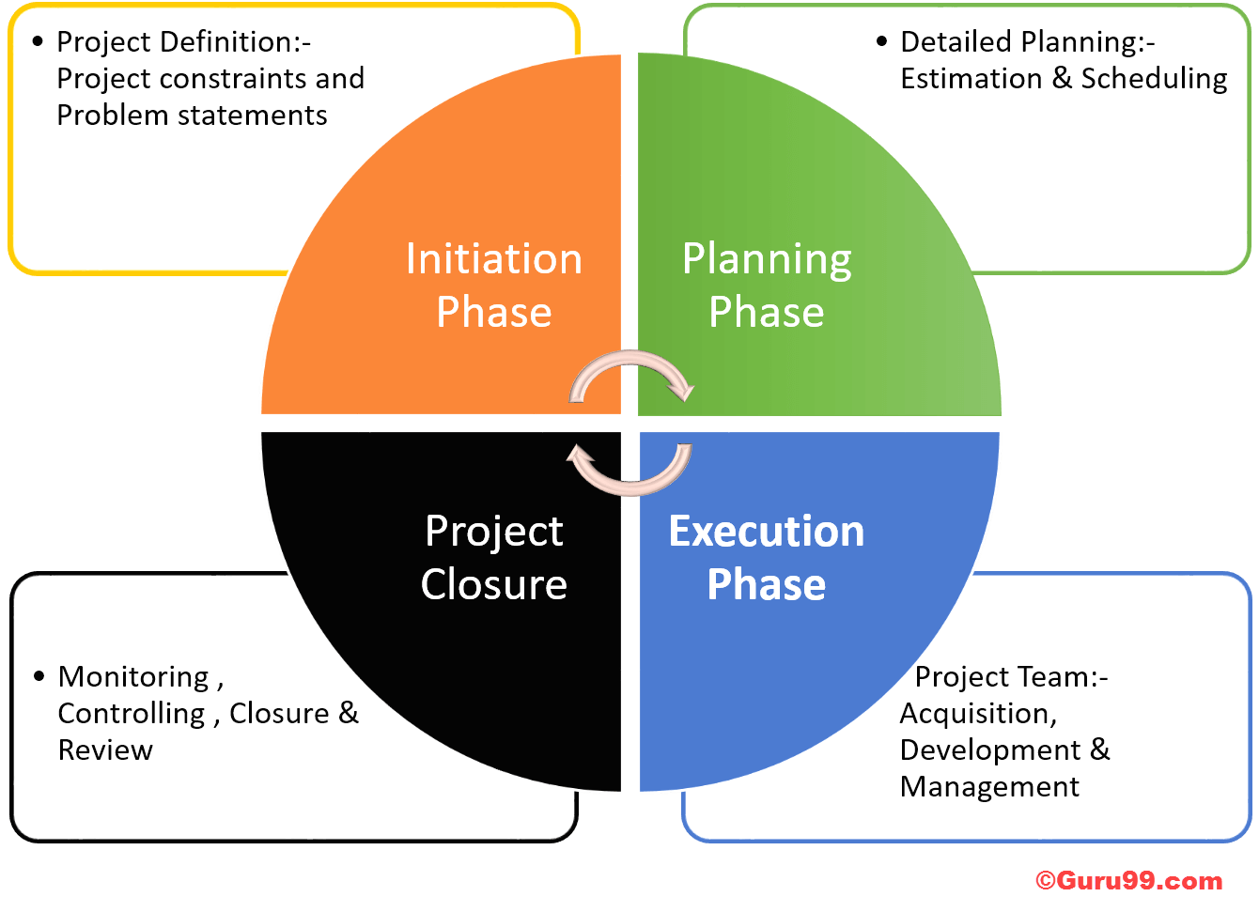1. INTIATION PHASE** It is the first stage of a project and includes the following, generating ideas, profitability of the project, definition of the scope of operation and doing a feasibility study. Some of the activities involved in this stage include;

1. Developing a business case
2. Undertaking the feasibility study
3. Establishing a project charter
4. Creating a project team
5. Setting up a project office
6. Doing a phase review

**Developing a business case**- it justifies the start-up of the project. It include the description of the business problem or opportunity. It will also describe the cost and benefit of each alternative solution and recommend solution of the approval. It is frequently referred to during the project to determine whether the project is on track. The success of the project is measured by its ability to meet the objectives defined in the business case.

**Undertaking the feasibility study** - it is an exercise undertaken which involves documenting each of the potential solution to a particular business problem or opportunity. It identify the like hood of one or more solutions in meeting the business requirement.

**Establishing a project charter/ terms of reference/ project definition report** - it set out the project vision, objectives, scope and implementation therefore giving the teams clear boundaries within which the project must be delivered. It outlines the purpose of the project, the way the project will be structured and how successfully the project will be implemented. It describe the project stakeholders and serve as a road map for the project manager.

**Creating a project team** – the project is a team which is involved in the implementation of the project. It may be made of;

Core members – who will be present for the duration of the project and have a broad range of skills which will be applicable throughout the project life cycle.

Non-core members – who may be brought in when specific skills are needed for a short period of time to carry out a particular task.

Setting up a project office - every project should have a project office. It becomes a project where the various operation of the project are carried out. It contains a list of items to help you determine what is needed in the project.it identify the right location for the project team as well where consultations can be done. Project office should be located where it can easily accessible

Project requirement review - it is like an assessment of the project at a particular point in time. The first time in a project life cycle that a project review is undertaken is after initiation stage during this time a decision is made as to whether or not the team has meet the objectives and is approved to proceed to the next phase referred as the project planning phase.

**2. PROJECT PLANNING STAGE**

**Project planning -**Project planning is concerned with developing a strategy that would deliver the project goals. It is an important part of the ‘deciding’ aspect of the project team’s job to think about the project’s future relationship to its present in such a way that organizational resources can be allocated in a manner which best suits the project’s purpose .The critical dimensions of Time, Cost and Quality can never be attained if a Project Plan is not in place. Project planning means an endeavour in which human, material and financial resources are organized in a better way to undertake a unique scope of a given specification within the constraints of time, cost and quality so as to achieve some intended goals/objectives.

**Purpose of project planning**

A. Project Planning provides a blue print that aids in project implementation and is a key determinant of whether the project will succeed or not. (If a plan is wrong, you will certainly not succeed at implementation)

B. The plan provides a road map which the project team follows in order to achieve the critical project objectives.

C. Project planning avoids unnecessary wastage and ensures that the project team thinks ahead.

D. The plan is used as a key monitoring and evaluation tool for the project. Project control generally becomes very difficult when planning is not properly done

**OBJECTIVES OF PROJECT PLANNING** The planning phase of a project aims to meet the following objectives:

1. Determining the project cost budget
2. Listing all activities or tasks involved or necessary to be done in order to complete the whole project. This requires analytical thinking for it to be comprehensive with the required details.
3. Estimating the activity durations of all the activities listed
4. Constructing network diagram giving all the logical interrelationships among the activities.

**BARRIERS TO PROJECT PLANNING**

1. Lack of time, or not making time to plan
2. Not knowing how to plan
3. Difficulty in getting the right people together
4. Finding it difficult to plan because the future is so uncertain
5. Wanting to do things immediately because the need is urgent, rather than think about them.

Planning stage include the planning of all elements and parameters of the project to be ready for the implementation. Successfully planning is one of the most critical function of the organization. **Planning involves the following;**

1. Developing a project plan- it gives all the details of what is the project is all about by identify the activities and tasks needed to be carried out to complete a project. It defines the project scope and the milestone. It also identifies the work breakdown structure, set and agree on the delivery dates, monitor and controls the allocation of resources.

2. Developing resource plan - every project require resources to be implemented. Resources are limited and hence planning for those resources becomes critical. A resource plan summarizes the level of resources needed to complete the project this is because it set out phases and tasks needed to deliver a project.

3. Developing a financial plan- it identifies the project finance needed to meet the specific objectives. It define all the various types of expenses that a project will incur that is in-terms of labour , equipment’s, materials and administrative cost along with an estimation of each expense. It summarizes the total expenses to be incurred across the project and this total expenses becomes the project budget.

4. Developing a quality plan- every project delivers some products at the end of its completion those products are expected to adhere to certain quality standards. The standard may be set by industries, organizations as well as specific client’s requirement. Hence to achieve the quality standards the quality assurance function should run from the start to the end of the project.

5. Developing a risk plan- one unique feature of any project is the risk aspect in this regard therefore every project manager need to consider the risks and put mechanism in place to mitigate it. A risk plan helps one to foresee risk, identify actions to prevent them from occurring and reduce their impacts.

6. Developing a communication plan - it describes how the project implementation will be carried out and how things will be done. It is important since it helps in creating a schedule to communicate the project progress to the project stakeholders. It also describes how one need to communicate the right messages to the right people and at the right time and also who will communicate the information.

7. Developing a procurement plan- Every project needs materials in terms of physical and non-physical materials which may be necessary these materials will need to be procured and hence a procurement plan become critical. It defines the product and services one need to obtain from external suppliers, the process of selecting suppliers and the timeframe for the delivery of the items.

8. Developing a project acceptance plan- acceptance plans define how we are going to check the project results if their meet all the requirements and specification as defined in the initiation stage. It guide one to create plans and it is used in the project implementation and closure phase to decide if the project goals are reached or not.

9. Project review plan- during this time a decision is made as to whether or not the team has meet the objectives and is approved to proceed to the next phase referred as the project implementation stage.

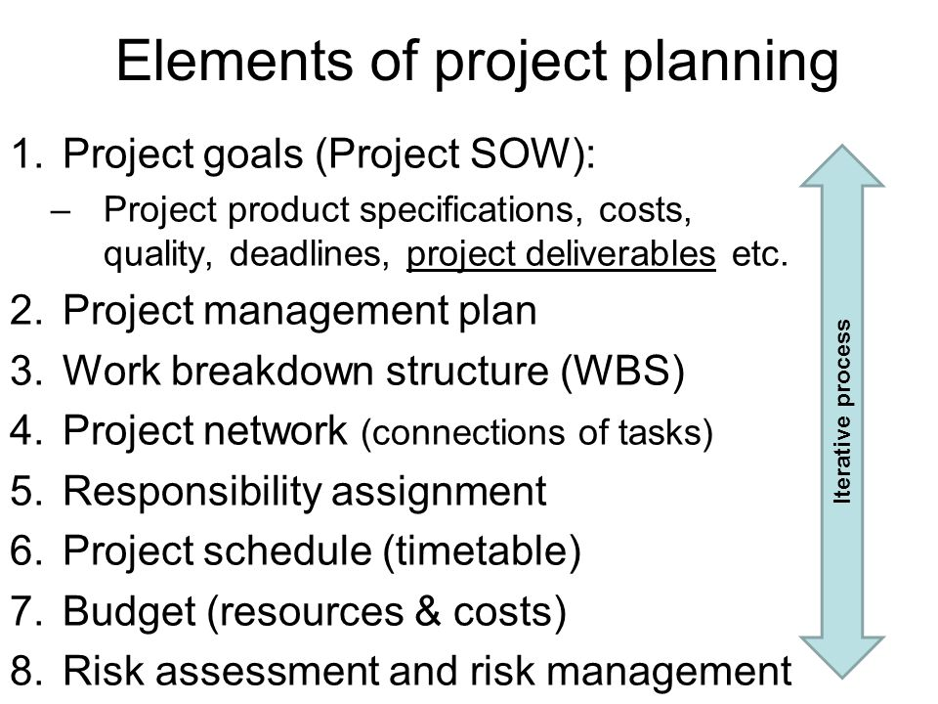

**ELEMENTS OF PROJECT PLANNING**

**Statement of work (scope of work) -**This describes the actual work that is going to be performed on the project which when combined with the specifications, usually forms the basis for a contractual agreement on the project. As a derivative of the Work Breakdown Structure (WBS), the statement of work (sometimes called scope of work) describes what is going to be accomplished, a description of the tasks and the deliverable end product that will be produced. Statement of work includes inputs required from other tasks involving the project and a key element of the customer's request for a proposal.

**Project specification -**Specifications are the descriptions of the technical content of the project. These specifications typically describe the product of the project and the requirements that the product must meet.

**Cost estimate -**This forms the baseline budget from which all actual expenditures will be measured. The cost estimate follows the WBS during development and implementation. During implementation, the cost estimate forms the baseline for project expenditure and provides a means of comparing actual cost to the estimate. The projects may require weekly or monthly cost reports to reflect the actual expenditure as compared to the baseline estimate.

**Financial plan -**Assuming that project budget, work package budget, and the budgets for all the appropriate cost accounts have been developed, financial planning involves the development of the action plan for obtaining and managing the organizational funds to support the project through the use of work authorization process. The work authorization process is an orderly way to delegate authority to expend resources for the project.

**Functional plan**

Each functional manager should prepare a functional operations plan that establishes the nature and timing of functional resources necessary to support the project plan. The plan would be an information system for monitoring actual project costs and comparing them with budgeted cost.

**3. PROJECT IMPLEMENTATION/ PROJECT EXECUTION STAGE**

It involves rolling out the project activities. It calls for tighter monitoring to ensure that the activities are implemented as planned. It is during this stage when the required items are procured and risk management mechanisms are put in place to mitigate risks. In this stage communication is very critical.

**4. PROJECT CLOSURE STAGE**

It the final stage of the project. It involves handing over the project documents, terminating the supplier’s contract, releasing project resources and communicating the project goals to all the stakeholders. A final evaluation is done to determine the extent to which the project was successfully to know lessons learnt from the project and list any recommendation for future similar project all this information should be contained in the final project closure report when handing over the project to the beneficiaries.

**PROJECT MANAGEMENT TOOLS**

**A. Work breakdown structure (WBS)/ Cost breakdown structure**

* 1. WBS is a tool that project managers use to breakdown work into manageable pieces.
  2. It involves dividing complex projects to simpler and manageable tasks.
  3. It provides a detailed list of tasks to be performed for a project thereby helping to deliver better scheduling and resource planning for a project.
  4. WBS is also referred to as cost breakdown structure since it involves listing items and classify it to expenditure for project in order to get a more detail estimate of cost and expenditure.

**BENEFITS OF WBS**

1. It can be used to allocate and delegate responsibilities to help accomplish different tasks or activities. Eg control through greater accountability.

2. It can help in improve resource planning and efficiency of how resources are consumed. Eg accurate focus for project staffs to save cost.

3. It can be used as bases for financial reporting. Eg the actual budget vs. budget cost allowance and also focus more accurately the project cost.

4. It can be used for risk management. Eg to identify risks and used as an ongoing process for monitoring risks or project

**LIMITATIONS**

1. It can’t be applied in very complex projects.

2. It tend to be limited in the sense it look at what can be predicted.

**NOTE;** The efficiency of a WBS can determine the success of a project; this is because it provide the foundation of all project management work including planning, cost estimation, resource allocation and scheduling creating WBS therefore is a critical step in the process of project management.

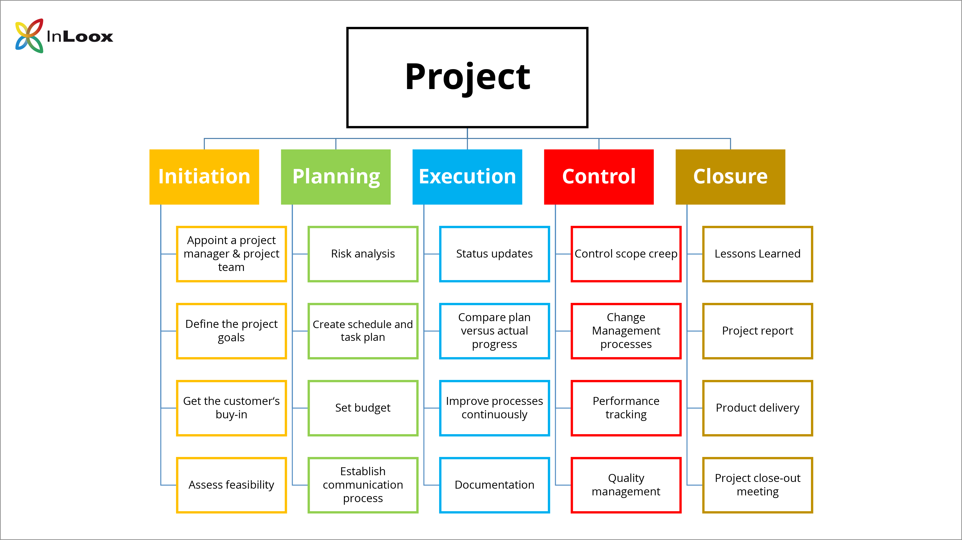

**B. GANNT CHART**

* 1. It was developed by Henry Gannt.
  2. It is a horizontal bar chart for project scheduling each activity is duplicated as a block over time.
  3. Actual performance is recorded in the real time and compared to planned deadlines necessary for completion.

**IMPORTANCE OF GANNT CHART**

1. It can be used to plan time scale for project

2. It can be used to estimate resources required

3. It is good for small project when the number of tasks are small and not complex

**LIMATATIONS**

1. It does not show the interdependence parallel activity.

2. It do not show the need to complete one task before another.

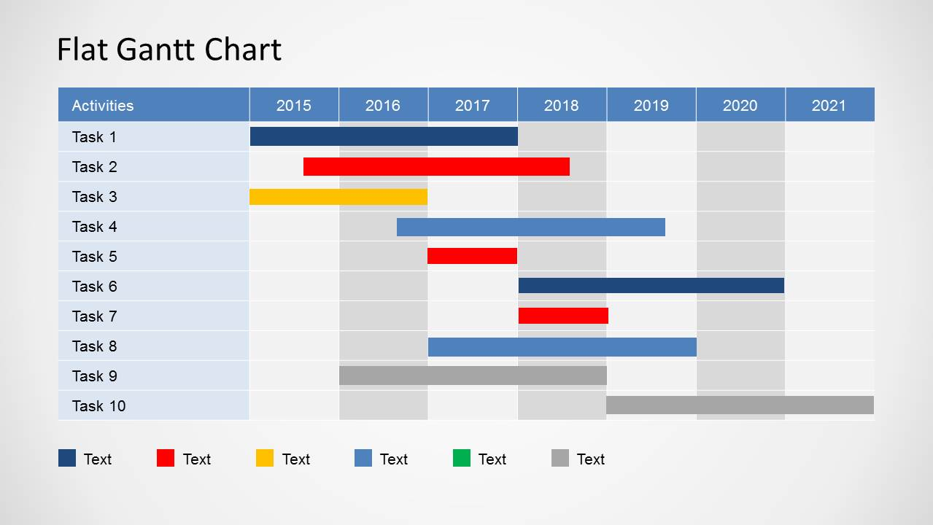

**C. CRITICAL PATH ANALYSIS** Gannt chart are not very useful in complex projects and in this case network and critical path analysis are used because they can indicate interdependence of activities through a logical sequence and time of each activity.

The critical path method (CPM), or critical path analysis (CPA), is an [algorithm](https://en.wikipedia.org/wiki/Algorithm) for [scheduling](https://en.wikipedia.org/wiki/Schedule_(project_management)) a set of project activities.[[1]](https://en.wikipedia.org/wiki/Critical_path_method#cite_note-1) It is commonly used in conjunction with the [program evaluation and review technique](https://en.wikipedia.org/wiki/Program_evaluation_and_review_technique) (PERT). A [critical path](https://www.wrike.com/blog/critical-path-is-easy-as-123/) is determined by identifying the longest stretch of dependent activities and measuring the time[[2]](https://en.wikipedia.org/wiki/Critical_path_method" \l "cite_note-2) required to complete them from start to finish.

They are therefore a more effective time management tool for large and complex projects. They are useful in the following ways;

1. They are good visual communication and planning tool for effective time management. They display clearly the interdependence relationship that exist between different activities or tasks to be completed.
2. They arrange tasks /activities into an optimal sequence of allowing projects to be completed at the shortest time possible.
3. They can highlight those activities which are considered as critical activities.
4. It enable more effectively resource planning as resources can be diverted from non- critical activities.

It is a powerful tool for accessing;

1. What task/ activities must be carried out?

2. Where parallel activity can be carried out.

3. In accessing the shortest time in which you can complete the project.

4. It can be used to determine the resources needed to execute a project.

5. It can be used in sequencing of activities.

**NOTE;** An effective critical path analysis can make the difference between success and failure of a complex project.

**PROCESS OF CRITICAL PATH ANALYSIS**

1. Breakdown the project into a logical sequence of activities to be completed.
2. Estimate the time duration for each project.
3. Arrange the activities in the most efficiency sequence of activities and estimate the elapse time of the project.

**Advantages of critical path analysis**

1. It identifies the interrelationship between different tasks or activities.

2. It is a good communication and planning tool for management.

**Disadvantages**

1. The complexity of the diagram will increase as more activities are included.

2. Key uncertainties often exist when estimating the duration for activities therefore can be a poor predicted of the project elapsed time.

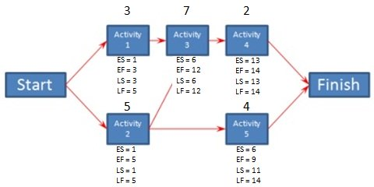

**D. RESOURCE HISTOGRAM**

It is a column / bar chart that show the number of resources assigned to a project over time. It is an effective tool for resource planning and coordinating project staff. It shows the number of resources of a given activity.

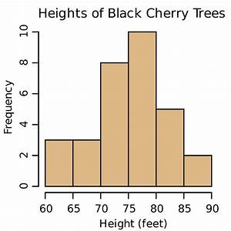

**E. MILESTONE**

1. It is an event that receives special attention. It is often put at the end of a stage to mark a completion of a work package or phase.
2. Once a milestone have been identified and defined an actual project work begins.
3. As work is executed milestones will either be met in whole or part or will be modified to suit changing project needs and circumstances
4. Project milestones are characterized by one or more of the following;
5. High significant tasks/events/ decisions
6. A significant point or phase in a project life cycle
7. A specified percentage of a complete of a project
8. Accomplish of one or more deliverables
9. Specified use of resources / budget
10. Any significant circumstance unique to a given project

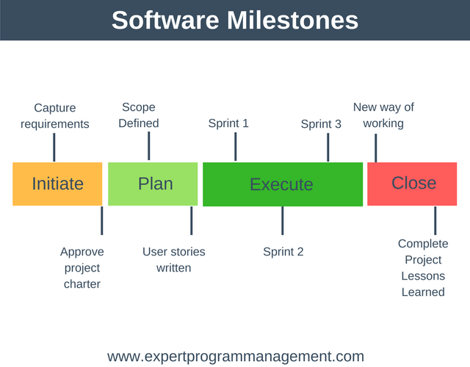

**F. Project/ program evaluation review technique (PERT)/ Critical path method** PERT is a project management tool used to schedule, organize and co-ordinate tasks within a project. It is a method to analysis that tasks involved in completing each task and to identify the minimum time to complete a total project

**STEPS IN DEVELOPING PERT**

1. Identifying specific activities and milestones- activities are tasks required to complete a project while milestones are events making the beginning and end of one or more activity

2. Determine the proper sequence of activities – how the activities follow each other. This may be combined with activity identification since the activity sequencing is evidence.

3. Construct a network diagram – this is done using the activity sequence information. Each activity represent a node an arrow represent the relation between activities.

4. Estimate the time required for each activity - Weeks are a commonly used unit for activity completion but any consistent of time can be used including months, days or even years. A distinguishing feature of PERT is its ability to deal with uncertainty in activity completion time. For each activity the model usually include 3 estimates.

Optimistic time – the shortest time in which an activity can be completed. 3 standard deviation from the mean is used so that there is 1% chance of a activity been completed.

Most likely time- the completion time having the highest probability. Note this time is different from the estimated time.

Pessimistic – the longest time that an activity can be completed. 3 standard deviation from the mean commonly used.

**EXPECTED TIME = (OPTIMISTIC+ FOUR × MOST LIKELY TIME+PESSIMISTIC) ÷6**

Expected time may be displaced in the network to calculate the variance of each activity completion time. If 3 standard deviation times were selected from the optimistic and 3 standard deviation from pessimistic time there are 6 standard deviation.

5. Determine the critical path –it is determined by adding the times for the activities in each sequence and determining the longest path in the project. The critical path determines the total calendar time required for the project. If activities outside the critical path speed up one slow down within limits (the total project time does not change the amount of time a non- critical path can be delayed without affecting the completion of a project is called a slack time.

If the critical path is not immediate obvious then it may be helpful to determine the following;

1. ES- Earliest start time
2. EF – Earliest finish time
3. LS – Latest start time
4. LF – Latest finish time

**BENEFITS OF PERT**

1. It provides the expected project time completion

2. It provide information on the probability of completion before specified date

3. It provide information of critical activities that directly impact the completion time

4. It can provide the information of activities that have a slack time and that can led resources to critical path activities.

5. It can provide information on the start and end date of the project.

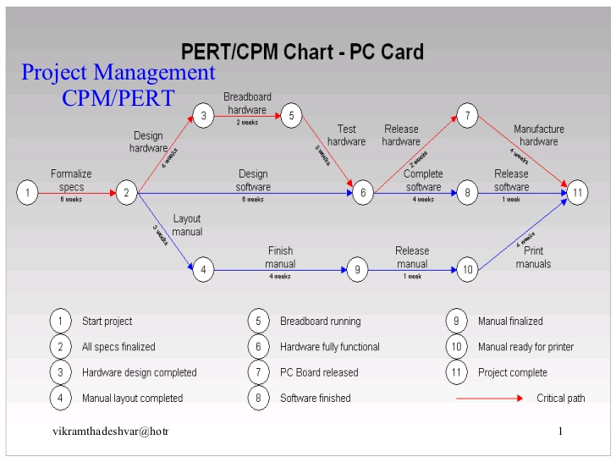

**WHY PROJECTS FAIL**

1. Poor risk planning or risk management
2. Inadequate resources
3. Poor stakeholders analysis
4. Poor project leadership
5. Interferences from sponsors or external forces.
6. Poor cost estimation
7. Lack of management commitment

**Project managers -** In order to coordinate the efforts of many people in different parts of the organization (and often outside it as well), all projects need a project manager. A project manager is a catalyst who lift the entire project and puts it into motion.

**Roles of the manager are:**

1. Developing the vision- has a sharp focus on the vision and draw others to it, ensure project relevance, set objectives and remain inspirational.

2. Integrator-coordinates activities, provide overall project management services, provide complete task definitions, defines the end and provide basic of performance criteria.

3. Knowledge-provides advisory technical information, is competent in the know-how especially when operational role is expected, a situation common in small scale projects.

4. Resource provider- is supposed to procure all the resources for the project i.e. Human resource, facilities, finances etc.

5. Concerned with controlling uncertainty by forecasting, planning and resolving problems.

**Characteristics of effective project manager**

Background and experience consistent with the needs of the project

Leadership and strategic expertise in order to maintain an understanding of the overall project and its environment while on the same time working on the details of the project

Technical expertise in the area of project in order to make sound technical decisions

Interpersonal competence and the people’s skills to take up such roles like project champion, communicator, facilitator etc.

Proven managerial ability in terms of track record of getting things done

**PROJECT TEAMS**

Project teams- these are the project human resource who have interdependence collections of roles and responsibilities queered towards a common goal. A project team is a team which is involved in the implementation of the project.

A Project Team- is an organized group of people who are involved in performing shared/individual tasks of the project as well as achieving shared/individual goals and objectives for the purpose of accomplishing the project and producing its results. The team consists of the full-time and part-time human resources supposed to collaboratively work on producing the deliverables and moving the project towards successful completion.

**CHARACTERISTICS OF HIGH PERFORMING TEAMS**

1. Team shares a sense of common purpose and each member is willing to work towards achieving project objectives.

2. Team identifies individual talents and expertise and uses them depending on project’s needs at any one time.

3. Roles are balanced and shared to facilities both the accomplishment of tasks and feelings of group cohesion and morale.

4. Team exerts energy towards problem solving rather than allowing it to be drained by interpersonal issues or competitive struggles.

5. Differences of opinion are encouraged and freely expressed.

6. Encourage risk taking and creativity; mistakes can be opportunities for learning.

7. Members set high personal standards of performance and encourage each other to realize the objectives of the project.

8. Members identify with the team and consider it an important source of both professional and personal growth.

**Teams are Most Effective When**

* 1. There are 10 or fewer members on the team
  2. Members volunteer to serve on the team
  3. Members serve on the project from beginning to end
  4. Members are assigned to the project full time
  5. Organization culture fosters cooperation and trust
  6. Members report solely to the project manager
  7. All relevant functional areas are represented on team
  8. The project involves a compelling objective
  9. Members are located within conversational distance of each other

**STAGES IN PROJECT TEAM DEVELOPMENT**

Irrespective of the reasons as to why people form or join groups, these groups typically go through a period of evolution or development. Most groups develop through the following stages:

a. **Forming**. In this stage, individual members become acquainted with each other. They become aware of individual behaviour and observe the emerging dynamics of the group. It is the period of orientation when members explore acceptable and unacceptable behaviours and some group code of conduct is formed.

b. **Storming.** Here conflicts arise among members when they disagree or tend to exert dominance. Disagreements may arise over priorities, goals or methods. Coalitions or sub groups may emerge within the group.

c. **Norming.** Once the disagreements and conflicts are addressed and resolved, the team comes together in the norming stage. The group unity emerges as members establish common goals, norms and sense of cohesion. Motivation and productivity begin to emerge as the sense of unity becomes stronger.

d**. Performing**. Here the team begins to function and moves towards accomplishing its goal. The team members function cordially with each other and direct their effort towards the common goal.

e. **Adjourning.** This is the stage applicable to temporary tasks groups and ad hoc committees. When their work is accomplished, the group wraps up its activities and the focus from performance to closure.

**Recruiting Project Members**

When recruiting project members the project manager can get them from within by asking for volunteers to reduce conflict.

When the project is high priority and critical to the future of the organization select whoever is necessary.

When recruiting project members, consider the following;

1. Problem solving ability,
2. Availability
3. Technological expertise
4. ✓Credibility
5. ✓Political connections
6. ✓Ambition, initiative and energy

**Qualities of a Valuable Project Team Member**

**Companies should strive to have project team members embody each of the following six characteristics:**

1. Excellent Communicator: Project team members work with individuals in all levels of the organization, coming from a variety of different backgrounds. As a result, these project management professionals must have the ability to effectively communicate with a number of different audiences, relying on information in a manner they can relate to. Poor communication can make or break the success of a project, so this is essential.

2. Knowledge of Project Management Principles: While team members don’t have to be experts on every tactic, tool, and term, having a basic knowledge of project management fundamentals provides them with a solid foundation to work with.

3. Highly Organized: Mass chaos and project success don’t mix. A project team member must be extremely organized, so they know exactly what is going on with each step of the project at all times. These professionals must know how to leverage available tools and techniques to stay organized, even when under significant stress.

4. Strong Ability to Read People: The best project team members are also solid leaders who know how to motivate people. They’re able to create a vision for both stakeholders and their teams to look to for inspiration. When crunch time begins they know exactly what it takes to motivate people to get the job done.

5. Accurate Estimating Skills: The project manager relies on team members to provide estimates for their individual tasks. It’s important for estimates to be accurate because they have the potential to throw the entire project timeline off. One delayed task can result in a domino effect, ultimately causing everyone to miss key deadlines.

6. Self-Assured: It’s important for a project team member to be able to politely-but-firmly stand their ground when faced with opposition from others in the organization. These professionals need to clearly convey their needs and stand up for the best interests of the project when faced with roadblocks.

**TOOLS/ TECHNIQUES OF MANAGING PROJECT TEAMS**

**1. Conflict management** - only few projects are completed without any conflict. It is important for project managers to understand strategies of handing conflicts proactively.

**2. Performance appraisal**- this is by evaluating the workers performance against the set measures and this will vary depending on the length of the project.

**3. Interpersonal skills**- it is important to focus on the leadership, communication and decision making skills of the project manager.

**4. Observation** – it is the practice of the managers popularly known as management by walking around to physically see and hear the team members while at work since informal conversation can provide essential information about how the project is going.

**5. Issue log**- this is by keeping an issue log to document, monitor and track issues that need to be resolved for the project team to work effectively. It may also involve monitoring solutions that need to be resolved that need more investigation and hence seeking to address them

**TEAM BUILDING**

In project management it is important to ensure team building.

**The 7 C's of Team Building are**

1. CONCEIVING. Conceive the interrelationship model that will become operative for the realization of the project objective.

2. CONCURRING. Make the members concur or agree on this.

3. COMMITMENT. Once they agree it is easy to get them committed.

4. COMMUNICATION. Communicate the requirements of the inter-relationship model.

5. COORDINATE. Total coordination is necessary so that team balance is not upset.

6. COUNSELING. Defaulting members should be counselled so that they can exercise more self-control and make an all-out effort to meet their commitments.

7. CONTROL. Must be exercised to bring the work in line with requirements.

**FACILITATING GROUP DECISION MAKING**

1. **Problem Identification**

Project managers should not state the problem in choices. Managers should identify the underlying problem to which these alternatives and others are potential solutions. One way of defining problems is to consider the gap between where a project is and where it should be.

1. **Generating Alternatives**

If the problem requires creativity then brainstorming is recommended. Here a team generates a list of possible solutions.

1. **Reaching a decision**

The next step is to evaluate and assess the merits of alternative solutions. Project managers can draw upon the priorities for the project and have the group assess each alternative in terms of its impact on cost, schedule and performance as well as reducing the problem gap. Project managers need to engage in consensus testing to determine what points the group agrees on.

**BARRIERS TO PROJECT TEAM PERFORMANCE**

1. Communication problems.

2. Conflict among team members or between team and support organizations.

3. Different outlooks, objectives, and priorities perceived by team members.

4. Poor trust, respect and credibility of team leader

5. Insufficient resources.

6. Insufficient rewards

7. Lack of project challenges.

8. Lack of team definition, role, conflict and confusion.

9. Lack of team member commitment.

10. Poor qualifications of project team leaders.

11. Poor project team/personnel selection.

12. Shifting goals and priorities

13. Power struggles.

14. Unstable project environment

**RISK MANAGEMENT**

Risk management - is the identification, assessment, and prioritization of risks followed by coordinated and economical application of resources to minimize, monitor, and control the probability and/or impact of unfortunate events or to maximize the realization of opportunities.

Risk management is a process of thinking systematically about all possible risks, problems or disasters before they happen and setting up procedures that will avoid the risk, or minimize its impact, or cope with its impact. It is basically setting up a process where you can identify the risk and set up a strategy to control or deal with it.

The purpose of risk management is to identify potential problems before they occur so that risk-handling activities may be planned and invoked as needed across the life of the product or project to mitigate adverse impacts on achieving objectives.

**RISK MANAGEMENT PROCESS**

The risk management process can be broken down into two interrelated phases, risk assessment and risk control. Risk assessment involves risk identification, risk analysis, and risk prioritization. Risk control involves risk planning, risk mitigation, and risk monitoring.

Risk assessment- involve identifying potential risk factors in a firm's operations, such as technical and non-technical aspects of the business, financial policies, and other policies that may impact the well-being of the firm.

Risk control - is the method by which firms evaluate potential losses and take action to reduce or eliminate such threats.

**STEPS IN RISK MANAGEMENT PROCESS**

**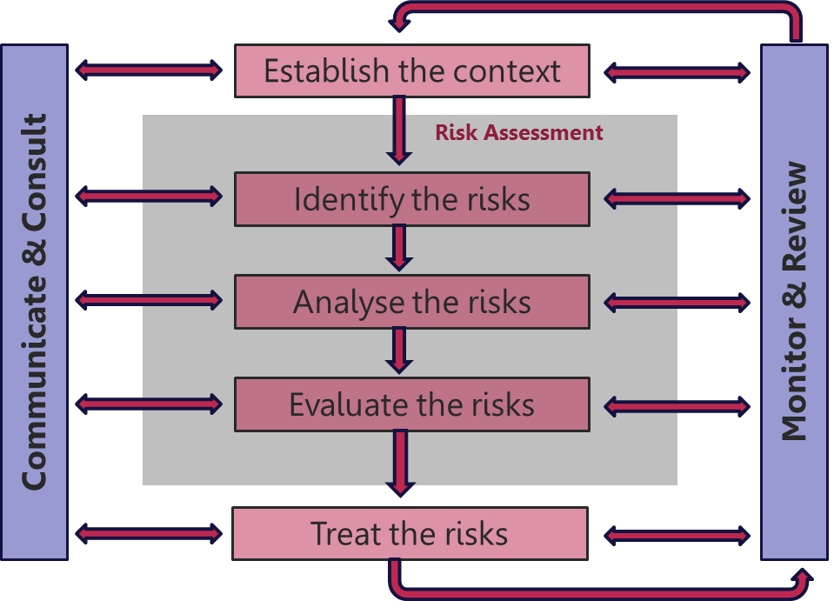**

**RISK IDENTIFICATION**

Risks are about events that, when triggered, cause problems or benefits. Hence, risk identification can start with the source of our problems and those of our competitors (benefit), or with the problem itself. Risk sources may be internal or external to the system that is the target of risk management (use mitigation instead of management since by its own definition

risk deals with factors of decision-making that cannot be managed). When either source or problem is known, the events that a source may trigger or the events that can lead to a problem can be investigated. For example: stakeholders withdrawing during a project may endanger funding of the project; confidential information may be stolen by employees even within a closed network; lightning striking an aircraft during take-off may make all people on board immediate casualties. It is helpful to understand the different types of risk so that a team can explore the possibilities of each of them.

**Techniques of risk identification**

1. Meeting- The group brainstorms; each participant spontaneously contributes as many risks as they can possibly think of.

2. Checklists/Taxonomy- The risk elicitors are aided in their risk identification by the use of checklists and/or taxonomies (in other words, a defined, orderly classification of potential risks) that focuses on some subset of known and predictable risks. Checklists and taxonomies based upon past projects are especially beneficial. These artifacts should be used to interview project participants, such as the client, the developers, and the manager.

3. Comparison with past events- The risk elicitors examine the risk management artefacts of previous projects. They consider whether these same risks are present in the new project.

4. Decomposition- Large, unwieldy, unmanageable risks that are identified are further broken down into small risks that are more likely to be managed. Additionally, by decomposing the development process into small pieces, you may be able to identify other potential problems.

**RISK ANALYSIS**

Risk analysis is the process of defining and analysing the dangers to individuals, businesses and government agencies posed by potential natural and human-caused adverse events. Risk analysis involves combining the possible consequences, or impact, of an event.

Through risk analysis, we transform the risks that were identified into decision-making information. In turn, each risk is considered and a judgment made about the probability and the seriousness of the risk. For each risk, the team must do the following:

Assess the probability of a loss occurring- Some risks are very likely to occur. Others are very unlikely. Establish and utilize a scale that reflects the perceived likelihood of a risk.

Assess the impact of the loss if the loss were to occur- Delineate the consequences of the risk, and estimate the impact of the risk on the project and the product.

**RISK PRIORITIZATION**

After the risks have been organized, the team prioritizes the risks by ranking them. It is too costly and perhaps even unnecessary to take action on every identified risk. Some of them have a very low impact or a very low probability of occurring – or both. Through the prioritization process, the team determines which risks it will take action on. The team sorts the list so that the high probability, high impact risks percolate to the top of the table and the low-probability, low impact risks drop to the bottom.

**RISK PLANNING**

Risk management plans should be developed for each of the prioritized risks so that proactive action can take place. The following are some examples of the kinds of risk planning actions that can take place:

• Information buying- Perceived risk can be reduced by obtaining more information through investigation. For example, in a project in which the use of a new technology has created risk, the team can invest some money to learn about the technology. Contingency plans.

• Contingency plan- is a plan that describes what to do if certain risks materialize. By planning ahead with such a plan, you are prepared and have a strategy in place do deal with the issue.

**RISK MITIGATION**

Related to risk planning, through risk mitigation, the team develops strategies to reduce the possibility or the loss impact of a risk. Risk mitigation produces a situation in which the risk items are eliminated or otherwise resolved. Some examples of risk mitigation strategies follow:

Risk avoidance- When a lose strategy is likely, the team can opt to eliminate the risk. An example of a risk avoidance strategy is the team opting not to develop a product or a particularly risky feature.

Risk protection- The organization can buy insurance to cover any financial loss should the risk become a reality. Alternately, a team can employ fault-tolerance strategies, such as parallel processors, to provide reliability insurance.

**RISK MONTORING**

After risks are identified, analysed, and prioritized, and actions are established, it is essential that the team regularly monitor the progress of the product and the resolution of the risk items, taking corrective action when necessary. Risks need to be revisited at regular intervals for the team to revaluate each risk to determine when new circumstances caused its probability and/or impact to change. At each interval, some risks may be added to the list and others taken away. Risks need to be reprioritized to see which are moved “above the line” and need to have action plans and which move “below the line” and no longer need action plans. A key to successful risk management is that proactive actions are owned by individuals and are monitored.

**RISK MANAGEMENT STRUCTURE**

**STRATEGIES FOR RISK MANAGEMENT**

1. Avoidance- Many times it is not possible to completely avoid risk but the possibility should not be overlooked. For example, at the height heavy rains, Car Fleet may not release vehicles for travel until the weather begins to clear, thus avoiding the risk of auto accidents during severe weather.

2. Retention- It may be determined that it is more practical to retain a risk even though other methods of handling the risk are available. For example, the University retains the risk of loss to fences, signs, parking meters, gates and light poles because of the difficulty of enumerating and evaluating all of these types of structures. When losses occur, the cost of repairs is absorbed by the campus maintenance budget, except for those situations when we collect from a third party.

3. Loss Prevention- When risk cannot be avoided; the effect of loss can often be minimized in terms of frequency and severity. For example, our office encourages the use of security devices on all computers, to reduce the risk of theft.

4. Transfer- In some cases risk can be transferred to others, usually by contract. When outside organizations use University facilities for public events, we require that they provide evidence of insurance and name the University as an additional insured under their policy, thereby transferring the risk from the University to the user. The purchase of insurance is also referred to as a risk transfer since the policy actually shifts the financial risk of loss, contractually, from the insured entity to the insurance company.

5. Share- Allocate risk ownership of an opportunity to another party who is best able to maximize its probability of occurrence and increase the potential benefits if it does occur. Transferring threats and sharing opportunities are similar in that a third party is used. Those to whom threats are transferred take on the liability and those to whom opportunities are allocated should be allowed to share in the potential.

6. Enhance- This response aims to modify the “size” of the positive risk. The opportunity is enhanced by increasing its probability and/or impact, thereby maximizing benefits realized for the project. If the probability can be increased to 100 percent, this is effectively an exploit.

7. Acceptance- This strategy is adopted when it is not possible or practical to respond to the risk by the other strategies or a response is not warranted by the importance of the risk. When the project manager and the project team decide to accept a risk, they are agreeing to address the risk if and when it occurs. A contingency plan, work around plan and/or contingency reserve may be developed for that eventuality.

8. Mitigate: Risk mitigation reduces the probability and/or impact of an adverse risk event to an acceptable threshold. Taking early action to reduce the probability and/or impact of a risk is often more effective than trying to repair the damage after the risk has occurred. Risk mitigation may require resources or time and thus presents a trade-off between doing nothing versus the cost of mitigation.