BOY SCOUT TROOP 834

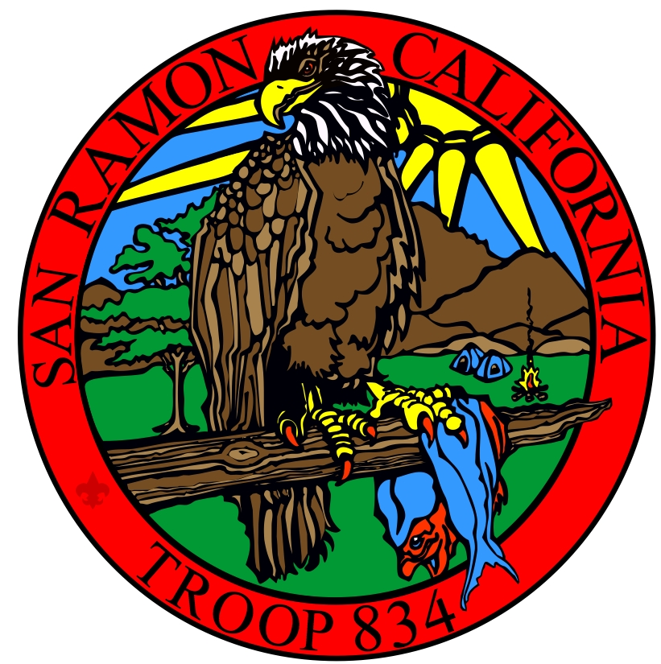

"THE SHACK” SAN RAMON

YOU & YOUR FAMILY ARE INVITED TO COME SEE WHAT OUR TROOP IS ALL ABOUT!

At this point in your Scouting career, you are preparing to bridge into Boy Scouts. We want this to be a fun, exciting and informative time for you. The Scouts of Troop 834 invite you to join us at several events designed to show you what makes Boy Scouting fun and our troop so special.

**“Scavenger Hunt” Tuesday, November 9th, 2021 7:00-8:30 PM**

Get to know our scouts and have fun in our unique meeting space.

**“Cubscout Hike”, Saturday December 11th, 1:00pm – 3:00pm**

details to follow

**“CAMPFIRE” Tuesday, January 11, 2022 7:00-8:30 PM**

Is there a better way to bond than over a campfire?

**“PARENT NIGHT” Tuesday, January 11, 2022 7:00-8:30 PM**

Parents have questions and we have answers. The Cubs will work with the Boy Scouts while leadership helps the adults learn what's next.

**TROOP MEETINGS - we invite you to check out our regular troop meetings**

7:00-8:30 PM, Tuesdays -- Please email and let us know when you'd like to come! Some meetings/events are NOT held at the Shack so please do contact us before coming out.

**WHERE WE MEET**:

The Scout Shack 28 Holly Court Far WEST end of Bollinger Canyon Road, San Ramon

Take Bollinger Canyon Rd. west of Crow Canyon Rd. towards Las Trampas Park & Stables. After the 25 MPH sign, turn right on Holly Ct. (3.3 miles from Crow Canyon)

**WHAT TO BRING:** Positive attitude and your class A uniform.

## **ADULT PARTICIPATION:** An adult must be present for each Cub Scout attending these events. We will have volunteers on hand to answer your questions.

Please contact our recruiting team at [newscout@bsatroop834.org](mailto:newscout@bsatroop834.org) to confirm your participation or to obtain any additional information you may need.

We look forward to seeing you at the Shack!

Troop 834 Outing Permission Slip…Fall/Winter 2021-22

**“Check out Scouting with Troop 834” Events**

__ 11/9 Scavenger Hunt __ 12/11 Hiking __ 1/11 Campfire

Print Youth or Adult Participant’s Name ____________________________________

**INFORMED CONSENT, RELEASE AGREEMENT, AND AUTHORIZATION**

I understand that participation in Scouting activities involves the risk of personal injury, including death, due to the physical, mental, and emotional challenges in the activities offered. Information about those activities may be obtained from the venue, activity coordinators, or local council. I also understand that participation in these activities is entirely voluntary and requires participants to follow instructions and abide by all applicable rules and the standards of conduct.  
  
In case of an emergency involving my child, I understand that efforts will be made to contact me. In the event I cannot be reached, permission is hereby given to the medical provider to secure proper treatment, including hospitalization, anesthesia, surgery, or injections of medication for my child. Medical providers are authorized to disclose protected health information to the adult in charge and/ or any physician or health care provider involved in providing medical care to the participant. Protected Health Information/Confidential Health Information (PHI/CHI) under the Standards for Privacy of Individually Identifiable Health Information, 45 C.F.R. §§160.103, 164.501, etc. seq., as amended from time to time, includes examination findings, test results, and treatment provided for purposes of medical evaluation of the participant, follow-up and communication with the participant’s parents or guardian, and/or determination of the participant’s ability to continue in the program activities.  
  
**With appreciation of the dangers and risks associated with programs and activities including preparations for and transportation to and from the activity, on my own behalf and/or on behalf of my child, I hereby fully and completely release and waive any and all claims for personal injury, death, or loss that may arise against the Boy Scouts of America, the local council, the activity coordinators, and all employees, volunteers, related parties, or other organizations associated with any program or activity.  
  
NOTE: The Boy Scouts of America and local councils cannot continually monitor compliance of program participants or any limitations imposed upon them by parents or medical providers. List any restrictions imposed on a child participant in connection with programs or activities below and counsel your child to comply with those restrictions.**

List participant restrictions, if any: ____________________________________________________

Participant’s Signature__________________________________ Date: ____________________

______________________ _____________________ _____________ __________________

Print Parent/Guardian Name Signature (if not above) Date Primary (Home/Cell)

Or Participating Adult Name and Emergency Phones