**Semi-local $V(s)$**

**SRG (LEFT) and Magnus with SRG $η(s)$ (RIGHT) at $λ=2.8 {fm}^{-1}$ for $Λ=$ 3 (TOP), 4 (BOTTOM)**

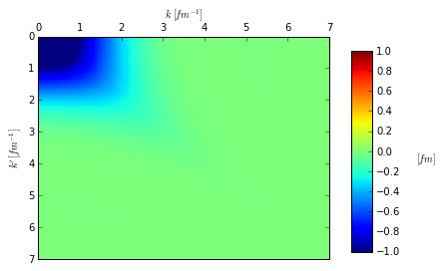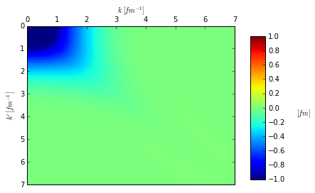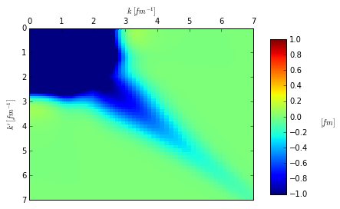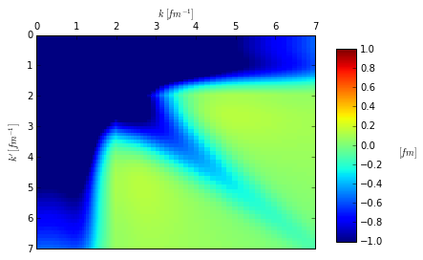

equation (68) or Theorem 9 in <https://arxiv.org/pdf/0810.5488.pdf>. T is rescaled to $λ$ value. T represents the maximum value that the Magnus expansion is valid up to (i.e., it is safe to evolve from s=0 to s=T).