**Magnus evolving matrix norms norms for non-local (LEFT) and semi-local (RIGHT) potential**

$\left\|Ω(s)\right\|$**(TOP), $\left\|H(s)\right\|$ and $\left\|H_{od}(s)\right\|$ (MIDDLE), $\left\|\frac{B_{k}}{k!}{ad}_{Ω}^{k}\right\|$ (BOTTOM)**





$$ds={10}^{-5}$$

*NOTICE THE X-AXIS: Non-local can evolve out past s > 0.06 whereas semi-local blows up before 0.06.

**Magnus evolving matrix norms norms for non-local (LEFT) and semi-local (RIGHT) potential**

$\left\|Ω(s)\right\|$**(TOP), $\left\|H(s)\right\|$ and $\left\|H_{od}(s)\right\|$ (MIDDLE), $\left\|\frac{B_{k}}{k!}{ad}_{Ω}^{k}\right\|$ (BOTTOM)**



$$ds={10}^{-6}$$

**Evolve semi-local potential out to $λ=2.8 {fm}^{-1}$ for SRG (TOP) and Magnus with SRG $η$ (BOTTOM)**

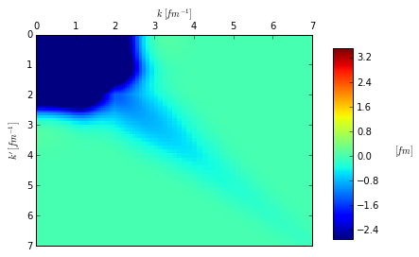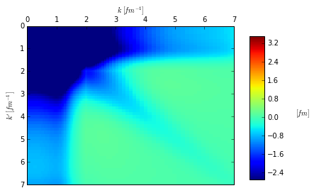

**Evolve semi-local potential out to $λ=2.0 {fm}^{-1}$ for SRG (TOP) and Magnus with SRG $η$ (BOTTOM)**

