# Exporter Plugin

[tk-listing-exporter]

This plugin is to be installed on the site that is to be the source of the listings that are to be exported to client sites.

Once it is activated check the wp-admin “Settings” menu, there should be a new option “Listing Export” click that to add new client sites that can export listing data remotely.

## Listing Export Settings

From here click the “Create Export Client” in the top right to create a new export client.

**Name:** This is just an identifier for you to know who the client is, it can be anything.

**Secret Key:** This is a string that must be less than 32 characters in length, avoid using known passwords a random string is fine, this is what is given to the client to enter into the importer plugin.

**Listing Author:** Use this setting to choose what listing the client can import. The options are all listings or only listings from a specific author/agent.

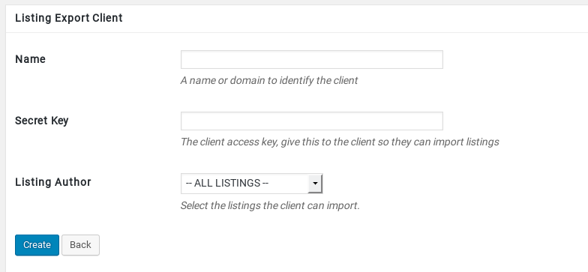

Save the client, then email the owner of the client site the Secret key to insert into their import plugin and they will be importing the listings nightly.

You will also need to provide the client with a “Provider URL” this is the full URL of your Wordpress site (EG: <http://www.roatanlife.com/>)

NOTE: Include the folder path if your Wordpress site if it is installed in a sub directory.

# Importer Plugin

[tk-listing-importer]

This plugin is to be installed on any client sites that you want to give the ability to import the listings.

*NOTE: This plugin will delete ALL posts with the “listings” type every time it is run. There is no update ability available. However the media files are not removed, it will only download new or modified media files as required. The first import may take some time to download all required media files.*

## Listing Import Settings

Navigate to the wp-admin “Settings” menu and you should see the “Listing Import” option.

This will take you to your import settings:

**Provider URL:** This is the URL of the providers Wordpress install (EG: <http://www.roatanlife.com/>)

**Secret Key:** This is the key provided to you by the exporter host.

**Import Author:** Choose which user all the imported listings will be linked to.

