Trost, DJ

Bellevue University, CSD310 Database Development and Use

Assignment 1.2

28 May 2023

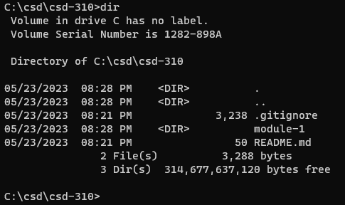

https://github.com/trosdj/csd-310