07/05/23

Module 9.1

Group Name: Data Commanders

Members:

Emanuel Pagan

Wendy Rzechula

Sheila Smallwood

DJ Trost

Case Study Selected: Bacchus Winery

Query Screenshots:

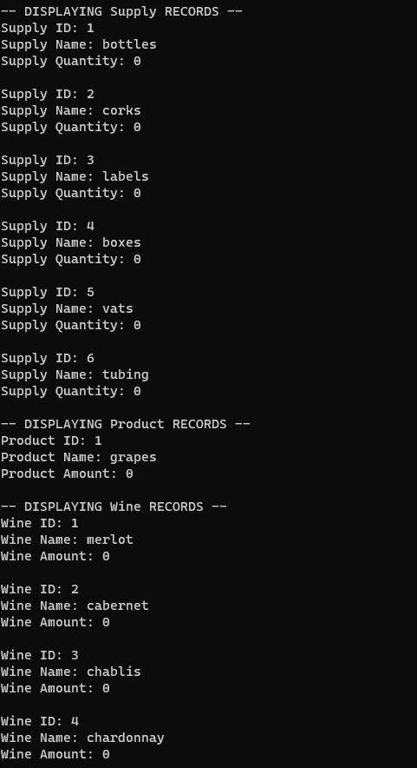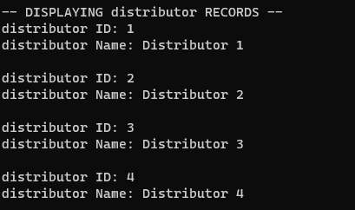

Revised ERD:

