Trost, DJ

Bellevue University, CSD310 Database Development and Use

Assignment 6.2

25 June 2023

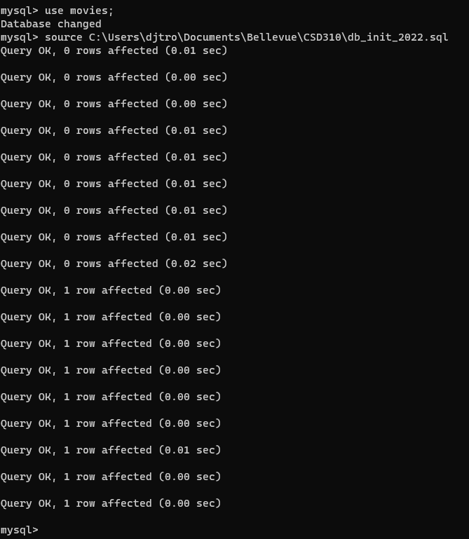

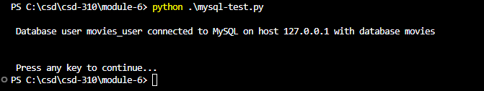

GitHub Repo:

https://github.com/trosdj/csd-310/tree/main/module-6