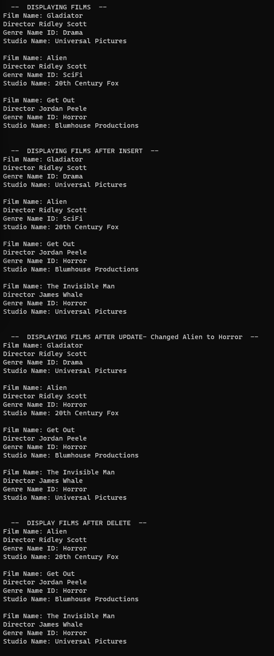Trost, DJ

Bellevue University, CSD310 Database Development and Use

Assignment 8.2

7 July 2023