Report

Homework 3 Facial Detection

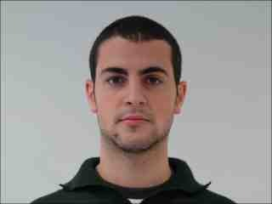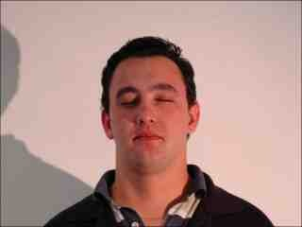

**First Take:**

So, this homework took me a considerable amount of trial and error to finally get my output image looking good. Turned out that I had a small error in my code from the beginning that was throwing my images off and it took me hours to realize it was a symbol error. Really frustrating but it happens.

**Tools:**

I ended up using a couple sources for my code. I used the code from <https://www.mathworks.com/matlabcentral/answers/73864-histogram-thresholding-to-get-the-threshold-point> To create an automatic threshold and then I used code from <https://www.mathworks.com/matlabcentral/answers/386250-how-can-i-remove-the-background-this-image-i-do-thresholding-but-i-can-t-remove-the-background-i> after I got my threshold value to create a binary image and to blacken out the background. I then added the original image to my binary image to create a facial recognized image with a black background.

**Output Images:**

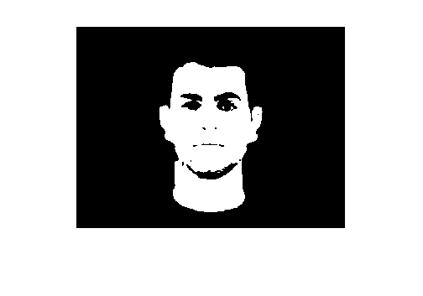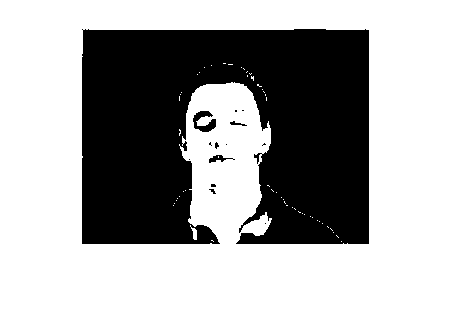

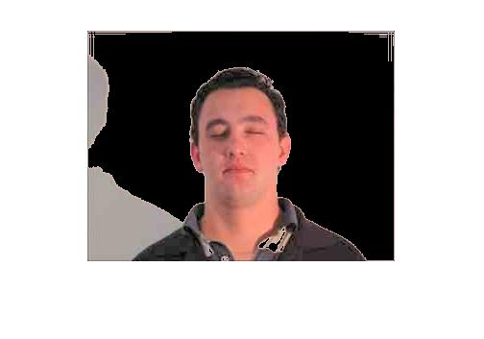

**Complications:**

I could not figure out how to add the original skin to the binary image. I am planning to talk to you in class to get some advice and some insight on how to get this done. I spent a few hours on this and could not get it right. The code I found online wasn’t helping me so I will speak to you soon about this issue.

//UPDATED

So, I figured out how to keep the skin by just finding the threshold from the L component and then using a for loop to zero out the background. My big issue with this project was finding the threshold by looping through the pixels.

**Conclusion:**

I spent too long on this project but at the same time it helped me learn a lot about facial recognition. I still have a long way to go but I am excited about my future with this subject.