|  |  |  |
| --- | --- | --- |
| **What did you do that made a meaningful contribution to the teamwork in producing the final solution** | **Evidence of that work (artefact)** | **How did it fit in the team work/project work?** |
| Helped design the database | Listed some possible tables and fields that would be needed for the site | A well-made database is a very important part of a booking system, so we needed to do it right. |
| Added gender fields to the courses table and subsequently to the courses pages | See appendix 1 for evidence | This was needed for further features to work |
| Hide sign up button when the user is logged in on the home page | See appendix 2 for evidence | Improved the user experience, there is no point in seeing a signup button when they already have an account |
| Check what gender the user is and then only show them courses that they can enroll in (male/female and mixed always shows) | See appendix 3 for evidence | By hiding the courses, the user is not meant to be able to enroll in, it streamlines the experience and gets rid of the need for checks. |
| Check what gender is specified within the course and then hide the progress bar for the gender that is not allowed to be in that course | See appendix 4 for evidence | This is a purely aesthetic thing and didn’t really add any functionality, it just makes things make more sense. |
| Designed user stories, acceptance criteria, assigning story points | User stories.pptx | Allowed us as a development team to craft our website into something that we would want to work on |

APPENDIX

1

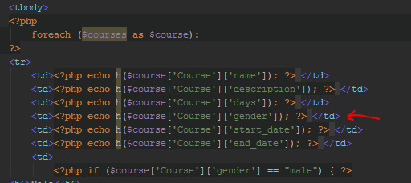

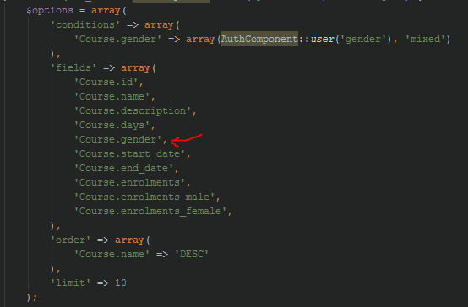

2

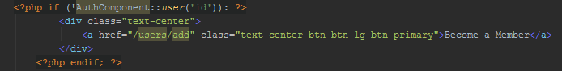

3

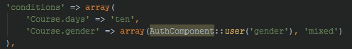

4

