Australia’s National
Science Agency
3-PG: Equations, data requirements and calculation of parameters

David I. Forrester
February 2026

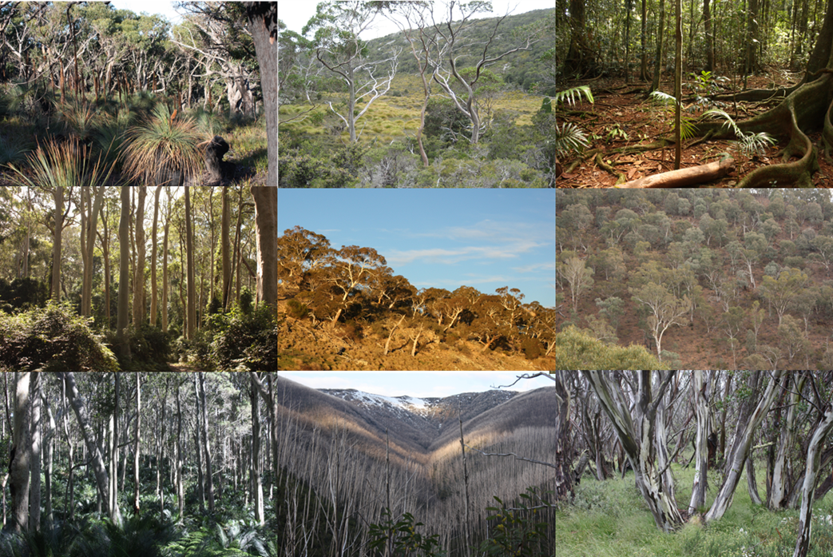
CSIRO, Environment Business Unit
Citation
Forrester DI (2026) 3-PG: Equations, data requirements and calculation of parameters. CSIRO. Canberra. pp. 55.
Copyright
© Commonwealth Scientific and Industrial Research Organisation 2026. To the extent permitted by law, all rights are reserved and no part of this publication covered by copyright may be reproduced or copied in any form or by any means except with the written permission of CSIRO.
Important disclaimer
CSIRO advises that the information contained in this publication comprises general statements based on scientific research. The reader is advised and needs to be aware that such information may be incomplete or unable to be used in any specific situation. No reliance or actions must therefore be made on that information without seeking prior expert professional, scientific and technical advice. To the extent permitted by law, CSIRO (including its employees and consultants) excludes all liability to any person for any consequences, including but not limited to all losses, damages, costs, expenses and any other compensation, arising directly or indirectly from using this publication (in part or in whole) and any information or material contained in it.
CSIRO is committed to providing web accessible content wherever possible. If you are having difficulties with accessing this document, please contact csiro.au/contact.

Executive summary

The 3-PG model was developed in the late 1990’s by Landsberg and Waring (1997) and has since been used in a wide range of forest types and as a routine management tool (Landsberg and Sands, 2011c, Gupta and Sharma, 2019). 3-PG is stand level (cohort) model with a monthly timestep and is composed of five interconnected sub-models: light interception, biomass production, water balance, biomass allocation, and mortality. It was originally developed for even-aged, evergreen, monospecific forests (Landsberg and Waring, 1997), and was later adapted into a cohort-based model by extending its applicability to deciduous species, mixed-species forests (Forrester and Tang, 2016), and uneven-aged forests (Forrester and Tang, 2016). Recent modifications focused on background mortality and defoliation calculations. 3-PG is available in the form of the r3PG package (Trotsiuk et al., 2020b), which is run using R (R Core Team, 2025). This document (i) lists the main changes that have been made to 3-PG over the past few years, (ii) provides some example simulations of different treatments and stand structures, (iii) describes the equations used for 3-PG, and (iv) describes how 3-PG parameters can be calculated using observations.

Table of Contents
Executive summary 4
1 Introduction 7
2 Major modifications, starting with 3-PG_{PJS 2.7}, to produce r3PG 9
2.1 Modifications to 3-PG_{PJS 2.7} to develop 3-PG_{mix} 9
2.2 Updates to 3-PG_{mix} since the publication of Forrester and Tang (2016) 10
2.3 Potential updates 11
3 Examples 13
4 Important considerations 14
5 Equations of 3-PG 20
5.1 Gross and net primary production 20
5.2 Growth modifiers 21
5.3 Light absorption 26
5.4 Biomass pools and partitioning 33
5.5 Cohort proportions and canopy cover 36
5.6 Mortality 37
5.7 Evapotranspiration and soil water balance 44
5.8 δ¹³C of wood 49
5.9 Litterfall and deciduous species 49
5.10 Diameter distributions 51
5.11 Stand-level variables 53
5.12 Thinning and defoliation calculations 57
6 Calibration and validation 62
7 Data requirements and calculations 65
7.1 Partitioning of NPP between stems and foliage 65
7.2 Fraction of NPP allocated to roots 66
7.3 Litterfall & root turnover 66
7.4 NPP & conductance modifiers 67
7.5 Stem mortality & self-thinning 70
7.6 Specific leaf area 72
7.7 Light absorption 72
7.8 Interception of rainfall 73
7.9 Quantum efficiency and NPP/GPP 74
7.10 Canopy conductance 75
7.11 δ¹³C of wood 76
7.12 Branch and bark fractions 77
7.13 Basic density of wood 77
7.14 Crown shape 78
7.15 Allometry parameters - height, volume, crown diameter, live-crown length 78
7.16 Allometry parameters – Size distributions 78
7.17 Relationship between net radiation and solar radiation 79
7.18 Calculations thinning fractions 79
7.19 Fertility rating 79
7.20 Soil textures 80
7.21 Available soil water 81
Acknowledgements 92
References 92

Introduction
3-PG – Physiological Principles in Predicting Growth – is a process-based forest growth model with a monthly time step. It is a stand level model, and recent versions (i.e. 3-PG_{mix}) allow the stand to be divided into multiple cohorts (species or ages). It was developed by Landsberg and Waring (1997) and has since been used in a wide range of forest types and as a routine management tool (Landsberg and Sands, 2011c, Gupta and Sharma, 2019). A detailed background of the physiological relationships considered by 3-PG is available in Landsberg and Sands (2011c). This document describes the equations in the version of 3-PG used for the use r3PG package (Trotsiuk et al., 2020b) that is run using R (R Core Team, 2025).

3-PG was designed to “bridge the gap between conventional empirical, mensuration based growth and yield models, and process-based, carbon-balance models” (Sands and Landsberg, 2002). It is therefore relatively simple for a process-based model to facilitate its use, the interpretation of its outputs, calibration and validation. It is based on many simple stand-level relationships and parameters that can generally be calculated directly using commonly available data. 3-PG is consistent with the production ecology equation where growth is described as a function of the supply of resources, the proportion of resources captured by trees, and the efficiency with which trees use resources to fix carbon dioxide (Binkley et al., 2004). This consistency provides a transparent and ecologically grounded link between resource availability and stand productivity, enhancing the interpretability and explanatory power of the model, and allowing its behaviour to be evaluated and contextualised using the large body of studies that apply the production ecology equation to understand how site conditions, silviculture, species interactions, stand density, and stand structure influence growth (Binkley et al., 2004, Richards et al., 2010, Binkley, 2012, Forrester, 2013, Forrester, 2014a, Forrester, 2019). Although it is designed to be relatively simple, it has enough physiological and stand structural detail to represent the main factors that influence growth, such as climate, soils, stand density, and interactions between species or age classes. As a result it has been used for a broad range of questions, by a broad range of users, for a broad range of vegetation types (Gupta and Sharma, 2019).

The version of 3-PG used for r3PG and described in this document was originally based on the Excel version of 3-PG_{PJS} 2.7 (Sands, 2010) that was designed for evergreen, uniform, even-aged stands. It was modified as 3-PG_{mix} to extend its use to multi-cohort stands (mixed-species, multi-aged) and deciduous species (Forrester and Tang, 2016). More recent updates enable simulation of defoliation events (e.g., fire, pruning) and responses involving modified rates of photosynthesis and carbon partitioning, such as epicormic shoots and coppice (Forrester, in prep-a, Forrester and Trotsiuk, in prep). r3PG will give the same results as 3-PG_{PJS} 2.7 when the original options are selected and even-aged evergreen monocultures are simulated.

This document (i) lists the main changes that have been made to 3-PG over the past few years, (ii) provides some example simulations of different treatments and stand structures, (iii) describes the equations used for 3-PG, and (iv) describes how 3-PG parameters can be calculated using observations. Additional documentation by Peter Sands is available on the 3-PG website (http://3pg.forestry.ubc.ca/documentation/).

The r3PG package contains “Help Pages” that describe how to run r3PG, and this is not repeated here. To see the Help Pages when using R studio, load r3PG, select Packages in the Help pane (bottom right pane of Rstudio), then select r3PG.
- A list of the input parameters, their default values and units can be found by running i_parameters in the Source pane (top left). Diameter distribution parameters are shown by running i_sizeDist.
- A library of many previous parameter sets can be found by running i_parameters_lit in the Source pane (top left)
- A list of the output variables and units can be found by running i_output
- Output variable names can also be obtained by running sort(unique(out_3PG$variable)) in the Source pane, where out_3PG is the output from using the r3PG::run_3PG() function.
- Several example simulation runs are documented in the package vignette, providing step-by-step guidance on how to set up and run the model (Trotsiuk et al., 2020b). These examples can be accessed in R by installing the r3PG package and running vignette("r3PG"). This will open the vignette, which contains runnable code and explanations for reproducing the example simulations.

Major modifications, starting with 3-PG_{PJS 2.7}, to produce r3PG

Modifications to 3-PG_{PJS 2.7} to develop 3-PG_{mix}
- Multi-cohort (mixed species or mixed age) stands can be simulated.
- A new light sub-model was added for mixed-species stands, uneven-aged stands and to improve predictions in stands with open canopies. This sub-model includes allometric relationships for height, crown radius and live-crown length. But it should not be used for latitudes > 56° (Forrester, 2014b, Forrester et al., 2014).
- The new light sub-model is based on a light extinction coefficient for homogeneous canopies rather than a typical light extinction coefficient. This is necessary because typical light extinction coefficients vary with canopy structure (age, stand density, site quality etc) (Cannell et al., 1987, Sampson and Smith, 1993, Binkley et al., 2013, le Maire et al., 2019).
- Water balance calculations now separate transpiration from soil evaporation.
- Climatic variables can now change along vertical gradients within the canopy when calculating transpiration and environmental modifiers, and hence influence GPP and canopy conductance.
- The PhysMod environmental modifier can now be calculated as either the minimum of soil water and VPD or the product of these variables. The PhysMod modifier influences GPP, canopy conductance and partitioning to roots.
- Diameter and stem mass distributions have been added to correct for Jensen’s inequality if allometric parameters are based on individual tree relationships.
- These diameter distributions can also be used to calculate crop tree development and mean dominant height.
- Additional volume information can be calculated, including extracted volumes (by thinning). The mean annual volume increment (MAI) is now predicted from cumulative volume instead of standing volume, which did not include extracted volume or volume lost due to mortality (see section 5.11).
- The δ¹³C of wood can be predicted to aid calibration when no GPP and transpiration data are available (Wei et al., 2014a, Wei et al., 2014b).
- Deciduous species can be simulated.

Updates to 3-PG_{mix} since the publication of Forrester and Tang (2016)
- Allometric equations for crown diameter and live-crown length can include parameters to quantify the effect of relative height (Forrester et al., 2017a). The relative height is the height of a tree divided by the mean height of all trees within the stand. This quantifies the vertical structure of the stand, such as the dominance status of the species within the mixture.
- Height and live-crown length equations can also have a non-linear Michajlow form (Equations 75b & 77b) (Forrester et al., 2021a) reflecting the asymptotic shape of relationships between height and crown length, that cannot be described using exponential forms. Asymptotic forms are important when simulating stands with large tree sizes.
- The diameter- and ws-distributions were originally described using functions such as: loc_{B} = loc_{B0} + loc_{BB}B + loc_{Bh}h + loc_{Bt}Age + loc_{BC}C (see Equations A54 to A59 in Forrester and Tang, 2016). These have now been revised so that all of the variables are ln-transformed, e.g. ln(loc_{B}) = loc_{B0} + loc_{BB}ln(B) + loc_{Bh}ln(h) + loc_{Bt}ln(Age) + loc_{BC}ln(C) (Forrester et al., 2017a) (Equations 61 - 76)
- The intensity of thinning events can be quantified using the percentage of biomass retained as an alternative to the number of stems retained (Forrester and Trotsiuk, in prep) (Equations 87 & 88)
- Height and crown diameter equations can now have a non-linear Näslund form (Equations 79c,d, 81c,d), which appears to be more flexible than the non-linear Michajlow form and the exponential form. Live-crown length calculated using height and live-crown ratio, instead of equations that directly calculate live-crown length. This prevents potential issues when height and live-crown length equations are not compatible (e.g. height < live-crown length). An exponential form of live crown ratio equations have been added (Forrester and Trotsiuk, in prep).
- Tree dimensions such as height, crown width and crown length, which are calculated using allometric equations that can include stand variables are now calculated in two different ways. The first time they are calculated per cohort, the State allometric equations are used (Table 3). For subsequent time steps, only the increment is calculated (Table 3). This is because sudden changes in stand variables would cause sudden changes in the tree dimension if calculated from the allometric equation, which is unrealistic. Instead, trees gradually adjust their allometry to the new conditions, as calculated using the increment equations (Table 3).
- Bias corrections are no longer applied because there is a potential that when size distributions become very wide (large coefficient of variation in tree size) the bias correction will be overestimated. That is, 3-PG uses allometric equations based on individual trees, but it uses these for mean tree calculations (not individual tree calculations). This can cause bias due to Jensen’s inequality. It is assumed that this bias is often minor, and that when the model is calibrated, that bias will be absorbed by the parameters being calibrated.
- 12 soil texture classes are now available based on Table 7.1 in Landsberg and Sands (2011b), rather than the previous four soil texture classes (Forrester and Trotsiuk, in prep) (Table 27)
- Defoliation events were added. This could potentially be used to simulate pruning, coppicing, defoliation by pests, and fire (e.g., responding using epicormic shoots and coppice). Defoliation events are associated with short term changes in the partitioning of NPP between stems, foliage and roots, as well as upregulation of photosynthesis (Forrester and Trotsiuk, in prep) (Equations 88-104)
- For deciduous species, it is assumed that all the new growing season W_{F} can be produced in the first month of the growing season using stored carbohydrates from previous growing seasons. This contrasts with the original 3-PG_{mix} calculation where it was also assumed that no further growth at the start of the growing season occurs until the tree has assimilated a NPP equal to the W_{F}, while losses (litterfall and roots) continue to occur as this W_{F} is being rebuilt, however this is no longer the case.
- Background mortality equations that account for long-term changes in soil or climate conditions, and that work for multi-cohort stands (Forrester, in prep-a) (Equations 46 & 51). These are site-specific parameters, not species-specific parameters as described where the equations are shown.

Potential updates
- Improve how tree allometry is influenced by stand density.
  - All variables calculated as functions of stem diameter, can be influenced by stand density, but currently stem mass (ws, Equation 83) or partitioning to stem mass is not influenced by stand density.
  - As described in Forrester (self-thinning), tree level allometry interacts with the self-thinning lines to control the potential maximum basal area, volume, biomass, leaf area index, or resource use (light absorption, transpiration). However, the tree allometric equations used in 3-PG are generally fitted to data averaged across stands with a range of stand densities, which is important to ensure that they are representative of many stand structures. In reality, the exponents of these tree level equations vary with stand density. Therefore, it may be beneficial to improve the way tree level allometry and stem mass partitioning are influenced by stand density (or the competition index, C).

Examples

Several examples runs can be examined using the R code and input Excel files in the appendix. These include:
- Defoliation in the form of manual pruning (only removes foliage): 1_Simulation_example_defoliation.R
- Defoliation event leading to coppice (removes all foliage and stem mass): 1_Simulation_example_defoliation.R
- Defoliation event leading to epicormic growth (kills some trees): 1_Simulation_example_defoliation.R
- Thinning event: 2_Simulation_example_thinning.R
- Multi-cohort stand (uneven-aged): 3_Simulation_example_multi-aged_vs_even-aged.R
- Even-aged monoculture with multiple rotations: 3_Simulation_example_multi-aged_vs_even-aged.R
- Multi-aged mixed-species stand with thinning: 4_Simulation_example_multi-aged-mixture.R
- Possibly add a traditional coppice with standards system

Several additional example simulation runs are documented in the r3PG package vignette (Trotsiuk et al., 2020b), which provides step-by-step guidance on how to set up and run the model. These examples can be accessed in R by installing the r3PG package and running vignette("r3PG"). This will open the vignette, which contains runnable code and explanations for reproducing the example simulations.

Important considerations
No tree size limits have been hard-coded such that the allometric relationships will define how tree sizes develop. This is to maintain transparency and enable users to define these limits.
- This means that if mean tree diameter is allowed to get very large (e.g. 200 cm), then it is important that the parameters provided to describe allometric relationships (Equations 79-85) are appropriate for this diameter range. This often means it will be inappropriate to use the exponential form (height_model = 1; crown_width_model = 1) of height and crown equations, except in relatively young stands where the exponential form can perform better than the other forms.
- Similarly the maximum diameter used when developing the density-dependent thinning relationships (section 5.6) should also be considered. It may be necessary to remove (i.e. thin to zero trees ha⁻¹) when a cohort reaches diameters considered to be at a maximum for the given species and density-dependent thinning relationships (e.g., Forrester, in prep-a). Note that the maximum diameter is the mean stand diameter, not the maximum diameter that individual trees can reach, which is often significantly larger than the stand mean.
- The tree diameter also influences biomass partitioning between stem and foliage mass (Equation 35), so it is important to consider whether the data used to calculate or calibrate these parameters is consistent with the mean stand diameter of the stands being simulated. If, for example, partitioning to foliage declines too much as stand diameter increases, the leaf area index will decline and so will the light absorption and growth.

Numbers of cohorts per stand
- It is recommended to use the lowest number of cohorts possible. This is because for any model there will be some bias in predictions, at least for some ages, site conditions, and stand structures. For single-cohort stands (even-aged monocultures), this bias may not be an major issue. However, for multi-cohort stands any bias associated with one cohort will influence the total stand density and resource availability (e.g., light and water availability). It will therefore influence how that cohort interacts will all other cohorts, and vice versa. This bias will propagate temporally through the simulation for all cohorts. Therefore, it is preferable to minimise the number of cohorts simulated. For example, in section 3 there is an example simulation “4_Simulation_example_multi-aged-mixture.R” based on mixed-species uneven-aged selection forests in Switzerland (Forrester et al., 2021b, Forrester et al., 2022). For these studies, 2 or 3 cohorts were used per dominant species, resulting in either 6 or 8 cohorts per stand, and provided accurate predictions of stand biomass and tree dimensions.
- While tree size inequality can influence stand growth, this appears to occur via the influence of the size distributions and the partitioning of growth between sizes, which can be quantified as the shape of the relationship between tree diameter and tree growth (Forrester, 2019). In contrast, whether there are many different tree sizes or only a couple of size classes, appears to have very little influence on stand growth (Forrester, 2019), which facilitates the use of minimal numbers of cohorts for a given species. In contrast, species interactions are well known to influence stand growth, so including cohorts for each dominant species is recommended. Several studies have directly quantified the ability of 3-PG to predict the effect of species interactions on growth (Forrester et al., 2017a, Bouwman et al., 2021).
- The light calculations used within 3-PG (light_model = 2) were developed for up to 8 cohorts per canopy layer (section 5.3) (Forrester, 2014b, Forrester et al., 2014). Therefore, it is recommended to limit the number of cohorts per layer to eight; a layer contains cohorts whose crowns vertically overlap with each other but do not overlap vertically with cohorts in lower or higher layers. However, as mentioned above, the total number of cohorts for all layers should be minimised.

Background mortality
- The background-mortality parameters (section 5.6) for mort_model = 2 or 3 are forced to be vegetation-type specific, rather than species-specific. They are therefore ‘site’ parameters. While these parameters are likely to vary between species within a single stand, the use of different self-thinning parameters within a single stand will result in the individual species with parameters representing the lowest self-thinning line to self-thin out of the stand before the other species begin to self-thin. Therefore, all species within a single stand should have the same background mortality parameters for mort_model = 2 or 3.
- Similarly, for multi-cohort stands, even those only containing one species, the smaller cohorts will self-thin out before the larger cohorts if their mortality is calculated independently of the other cohorts. Therefore, the mean stand diameter and total tree density (as opposed to individual cohort values) are used to calculate the total number of trees to remove, which is then split between cohorts based on their contribution to stand basal area (equations 47-50).
- The two points above potentially distort the effect of tree size or species identity on background mortality in stands with multiple cohorts.

Multiple disturbance events within a single time step
- Background mortality is not calculated if there was a thinning or defoliation event within the same month.
- There should not be more than one disturbance event per month. If by accident there was a thinning event and a defoliation event in the same month, the thinning calculations would be done before the defoliation calculations.

Table 1 Processes required to simulate responses to reductions in stand density or defoliation, and how (or if) they are implemented in 3-PG. Adapted from Forrester and Trotsiuk (in prep).
Process | Implemented in 3-PG
Higher rates of photosynthesis (GPP and NPP) due to higher light availability, and potentially higher nutrient and water availability | Reduction of stand density leads to higher light absorption and higher ASW (when stand transpiration after thinning is reduced by more than soil evaporation is increased)
Higher resource use efficiency (tree or stand biomass growth per unit resource used) | Resource use efficiency increases as growth limitations decline (3-PG growth modifiers increase; section 5.2), or light absorption per unit LAI increases (section 5.3).
Post-thinning climate | Climate (and available soil water) influences 3-PG growth modifiers (section 5.2).
Higher rates of photosynthesis following defoliation due to reduced shoot to root ratio and higher soil resource uptake than current foliage mass typically demands (quantified using P_{npp} input). | The P_{npp} input determines the temporary shift in NPP partitioning to foliage (section 5.12.2).
Growth resulting from the use of stored non-structural carbohydrates after defoliation (quantified using P_{carbs} input). | The P_{carbs} input determines how much foliage (and coppice stem) growth can be produced without new photosynthesis (section 5.12.2).
Allometry: increased crown width or length, for a given stem diameter, as stand density declines. | Allometric crown width and length equations can include stand density variables, which leads to incremental changes in response to changes in stand density (Table 3).
Allometry: reduced crown length, for a given stem diameter, due to pruning, thereby removing the least efficient (most shaded) lower crown foliage. | Not implemented.
Effect of size distribution on stand growth; for a given stand density, stand growth depends on the size distribution, especially in uneven-aged stands (Forrester, 2019). | Different size cohorts within a single stand can be simulated to account for different size distribution shapes. Background mortality influences different sizes differently due to its non-linear shape (on natural scale), and different cohorts can be influenced differently by thinning and defoliation (e.g., fire) events.
Interactions between size classes (and species) | The use of different size cohorts within a single stand leads to interactions that influence light absorption and transpiration (via influences on available soil water and vertical canopy gradients of radiation, VPD and temperature). For species interactions implemented in 3-PG, see Table 2.
Age-related decline: in even-aged stands, growth initially increases and peaks at similar time to the peak in LAI, then declines as the stand ages (Ryan et al 1997). | Growth declines after an early peak in current annual biomass increment because SLA declines with age, litterfall rate (proportion of foliage mass lost per month) increases with age, and partitioning of NPP to foliage declines with age. As a result, LAI declines after an early peak, and hence light absorption, and NPP declines. With regards to thinning, a given basal area will have a lower LAI, light absorption and hence growth as the stand ages. In very old stands, the age modifier (Equation 10) will reduce LUE and hence growth.

Table 2 Major processes or species interactions that can influence the growth of mixtures compared with monocultures, and how they are implemented within 3-PG. Modified from Forrester et al. (2017a)
Pattern or process | Implemented in 3-PG
Nutrient-related
Symbiotic nitrogen fixation | Not implemented directly. Processes influencing nutrient availability can be simulated indirectly by changing the fertility rating (Equation 7) or by linking 3-PG_{mix} with a nutrient model (e.g, Xenakis et al., 2008).
Nutrient cycling
Chemical, spatial or temporal stratification
Nutrient mineralization
Canopy nitrogen retention
Light-related
Space occupation – canopy stratification | Light absorption calculations of each cohort account for the horizontal and vertical structure of the canopy (section 5.3).
Space occupation – complementary crown shapes and architectures | Crown shapes may be cones, ellipsoids, half-ellipsoids or boxes (input parameter CrownShape). Crown dimensions depend on species-specific height and crown diameter allometry (Table 3).
Space occupation – intra-specific variability in crown architecture and size, or influence of inter-specific competition on intra-specific variability | Crown dimensions depend on species-specific height, live-crown length and crown diameter allometry (Table 3).
Physiological differences | All physiological parameters are species-specific, and each species light-use efficiency can be reduced relative to the species potential (α_{Cx}) in response to mixing effects on within canopy vapour pressure deficit, soil moisture and soil fertility.
Phenology and inter-specific effects on these | Simulated by changing the parameters determining bud break and leaf fall (leaf_{P} and leaf_{L})
Water-related
Hydraulic redistribution | Not implemented, such that vertical differences in available soil water are not considered. Could potentially be examined by changing the available soil water.
Shared mycorrhizal networks | Not implemented
Canopy interception | Species differ in terms of the maximum proportion of precipitation intercepted by their foliage (I_{Rx})
Transpiration and water-use efficiency | Calculated using species-specific parameters (section 5.7)
Litter layer as a sponge or barrier | Not directly implemented. Might be examined by changing the available soil water or climatic conditions
Isohydric vs. Anisohydric | Via the parameter defining stomatal responses to vapour pressure deficit (k_{D})
Inter-and intra-specific differences in phenology | Simulated by changing the values of parameters determining leaf fall and bud break (leaf_{P} and leaf_{L})
Modified within-stand environmental conditions | Light calculations influence vertical gradients in radiation, and vapour pressure deficit (section 5.3).
Biotic
Insect herbivory and leaf pathogens | Implemented using the defoliation calculations (section 5.12.2).
Other
Carbon partitioning | Mixing effects on partitioning to roots relative to aboveground growth depend on soil fertility, vapour pressure deficit within the canopy and soil moisture (Equation 33), while partitioning between stems and foliage is related to mixing effects on tree size (larger trees partition a lower proportion of NPP to foliage) (Equations 37 & 37). Defoliation also influences biomass partitioning (section 5.12.2).

Equations of 3-PG
This section lists the equations used for the version of 3-PG in the r3PG R package. These are mostly described in Forrester and Tang (2016) and have been updated with some minor changes described in section 2. A list of symbols is provided in Table 28 at the end of this document.

Gross and net primary production

A major underlying principle of 3-PG is the linear relationship between production and the absorption of photosynthetically active radiation (ϕ_{pa}). Often production refers to above-ground biomass and the slope of this relationship is the light-use efficiency (ε). In 3-PG, calculations start with production as gross primary production (GPP or P_{G}) and the slope of the relationship between P_{G} and ϕ_{pa} is the canopy quantum efficiency α_{C}.

$P_{G}=α_{C}ϕ_{pa}$ (1)

The α_{C} is calculated from the species-specific maximum potential α_{C} (α_{Cx}) and several dimensionless growth modifiers that take values between 0 for extremely limiting conditions and 1 (or > 1 for soil nutrition or atmospheric CO₂) for optimal conditions (Landsberg and Waring, 1997, Sands and Landsberg, 2002, Almeida et al., 2009). The modifiers account for the effects of temperature (f_{T}), frost (f_{F}), atmospheric vapour pressure deficit (VPD) (f_{D}), available soil water (f_{θ}), soil nutrition (f_{N}), atmospheric CO₂ (f_{Cα}), and stand age (f_{AGE}), such that

$α_{C}=α_{Cx}φf_{T}f_{F}f_{N}f_{Ca}$ (2)

The φ is a physiological modifier (PhysMod) that can be calculated using either the most limiting of soil water and VPD (Equation 3a; the original form used in 3-PG; phys_model = 1 in r3PG), or allows both soil water and VPD to have an effect based on Jarvis (1976) and also used in Wei et al. (2014b) and Feikema et al. (2010) (Equation 3b; phys_model = 2 in r3PG). PhysMod is used when predicting gross primary production (Equation 4), canopy conductance (Equation 59-60) and partitioning to roots (Equation 26).
$φ=f_{AGE}min\left\{f_{D}, f_{θ}\right\}$ (3a)$φ=f_{AGE}f_{D}f_{θ}$ (3b)

Then from Equations 1-3

$P_{G}=f_{T}f_{F}f_{N}f_{Ca}{{φα}_{Cx}ϕ}_{pa}$ (4)

The default ratio (Y) to convert P_{G} to net primary production (NPP) is 0.47.

Growth modifiers

The temperature modifier is given by

$f_{T}\left(T_{a}\right)=\left(\frac{T_{a}-T_{min}}{T_{opt}-T_{min}}\right){\left(\frac{T_{max}-T_{a}}{T_{max}-T_{opt}}\right)}^{\left(T_{max}-T_{opt}\right)/\left(T_{opt}-T_{min}\right)}$ (5)

where $f_{T}≥0$ and $f_{T}=0$ if $T_{a}>T_{max}$ or $T_{a}<T_{min}$ (Sands and Landsberg, 2002) (Figure 1). T_{a} is the mean monthly temperature and T_{min}, T_{opt}, and T_{max} are the minimum, optimal and maximum temperatures for growth.

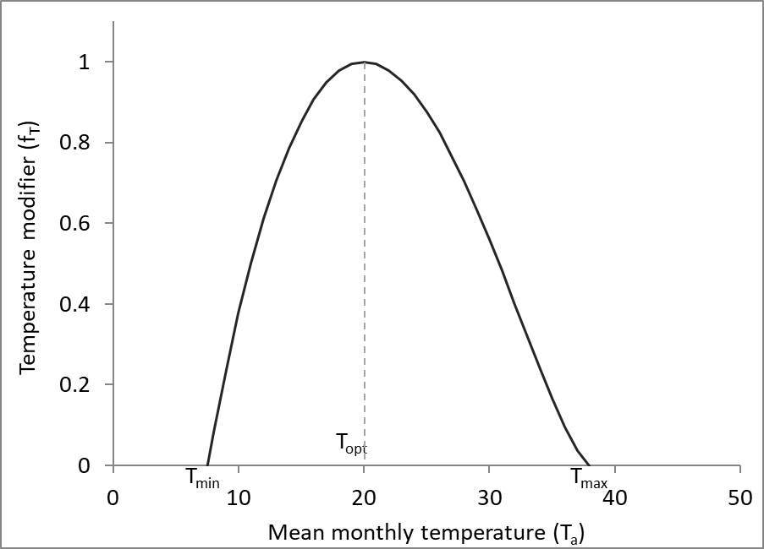
Figure 1 Temperature modifier (Equation 5).

A temperature modifier (f_{gT}) of the same form as f_{T} can be applied when calculating canopy conductance (g_{c}, Equations 59 and 60) (Feikema et al., 2010). This is calculated using the daytime mean temperature rather than T_{a}. The daytime mean temperature is estimated as the mean of T_{max} and T_{a} (not T_{a}) (Feikema et al., 2010). The canopy conductance modifier f_{gT} is only calculated when phys_model = 2 in r3PG.

The frost modifier is

$f_{F}\left(d_{f}\right)=1-k_{F}\left(\frac{d_{f}}{days in month} \right)$ (6)

where d_{f} is the number of frost days per month and k_{F} is the number of days production lost for each frost day (Landsberg and Waring, 1997). A frost day is defined as a day when the minimum daily temperature falls below the species frost tolerance threshold (T_{min}), which is species-specific. When the frost tolerance threshold is not known, some studies have used a rough estimate value of 2 ºC because the air temperature is often measured at about 1.5 to 2 m above the ground, and when that is 2 ºC, the foliage may be about 0 ºC (Hammer and Rosenthal, 1978).

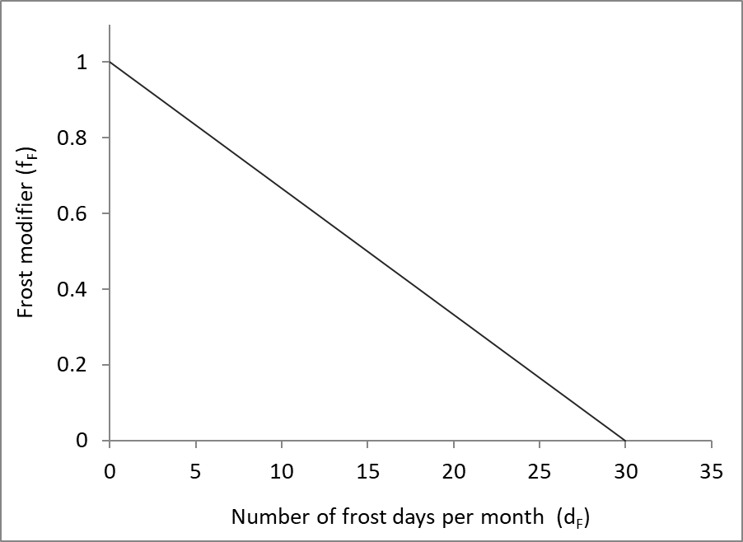
Figure 1 Frost modifier (Equation 6).

The nutrition modifier is given by

$f_{N}\left(FR\right)=1-\left(1-f_{N0}\right){\left(1-FR\right)}^{n_{f_{N}}}$ (7)

where FR is the fertility rating, f_{N0} is the value of f_{N} when FR = 0, and n_{fN} is a power (Landsberg et al., 2003, Almeida et al., 2004). FR can be between 0 (very limited nutrition) and 1, or even > 1 (non-limiting nutrition). The FR is species specific so different species within a given mixture could have different FR at the same site. Facilitative inter-specific interactions in mixed-species stands that influence nutrition (e.g. symbiotic N₂ fixation, nutrient cycling) could potentially be examined by changing the FR of any given species that experiences a change (increase or decrease) in nutrition as a stand develops (currently not coded into r3PG). This FR effect would not account for changes in nutrient availability that result from competitive exclusion where nutrient uptake for one species might increase simply because the other is a poorer competitor. That case is already considered because species that grow larger reduce the light absorption, growth and water use of smaller species, and use more nutrients.

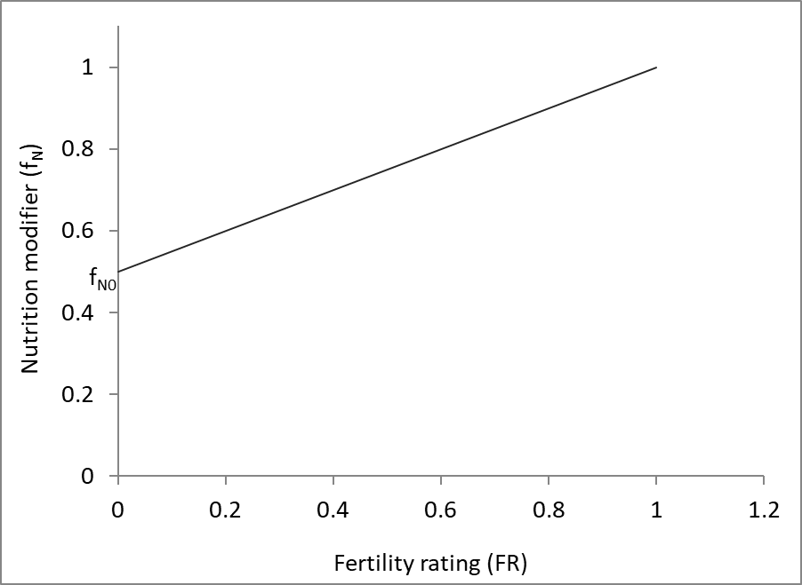
Figure 1 Soil nutrition modifier (Equation 7).

Vapour pressure deficit can reduce growth by directly influencing stomatal and canopy conductance; increasing VPD reduces conductance for many species. The vapour pressure deficit modifier is defined as

$f_{D}\left(D\right)=e^{{-k}_{D}D}$ (8)

where D is mean daytime VPD and k_{D} defines the stomatal response to VPD (Landsberg and Waring, 1997).

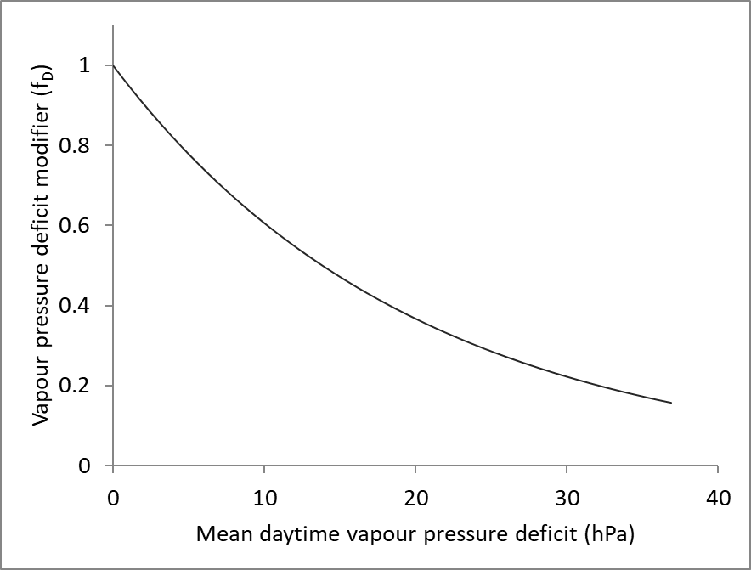
Figure 1 Vapour pressure deficit modifier (Equation 8).

The soil water modifier is defined as

$f_{θ}\left(θ_{S}\right)=\frac{1}{1+{\left[\left(1-θ_{S}/θ_{Sx}\right)/c_{θ}\right]}^{n_{θ}}}$ (9)

where θ_{S} is the available soil water, θ_{Sx} is the maximum available soil water, and n_{θ} and c_{θ} reflect differences in the relationship between transpiration rate and soil water content for different soil textures (Landsberg and Waring, 1997) (Table 27).

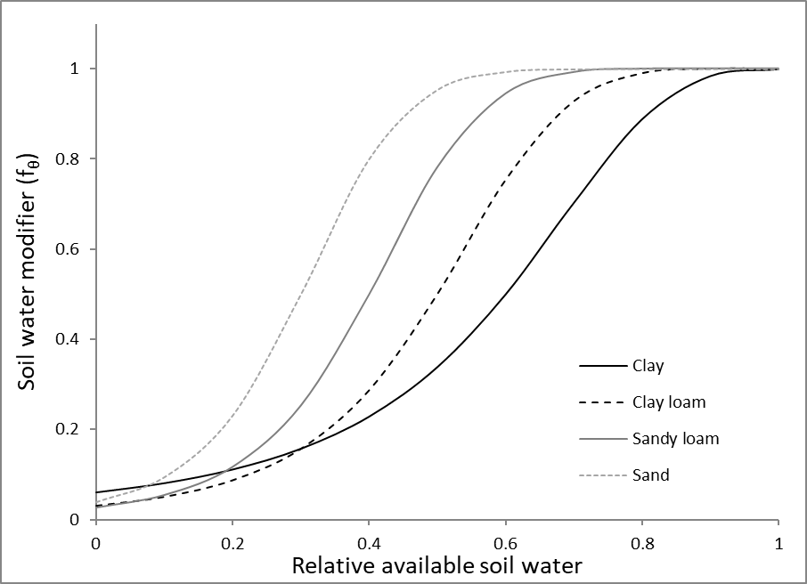
Figure 5 Soil water modifier (Equation 9).

Declines in current annual increment of forests after a peak close to the time of maximum L have been observed for many species (Ryan et al., 1997). In 3-PG, this decline is given by an empirical age modifier as

$f_{AGE}\left(t\right)=\frac{1}{1+{\left[\left(t/t_{x}\right)/r_{age}\right]}^{n_{age}}}$ (10)

where t_{x} is the maximum stand age, r_{age} is the relative age to give the f_{AGE} = 0.5 and n_{age} is the power (Landsberg and Waring, 1997). This modifier only has an influence in relatively old stands and may even be ‘switched off’ by setting t_{x} to be very large, especially when the modelled stands are not close to their maximum potential height.
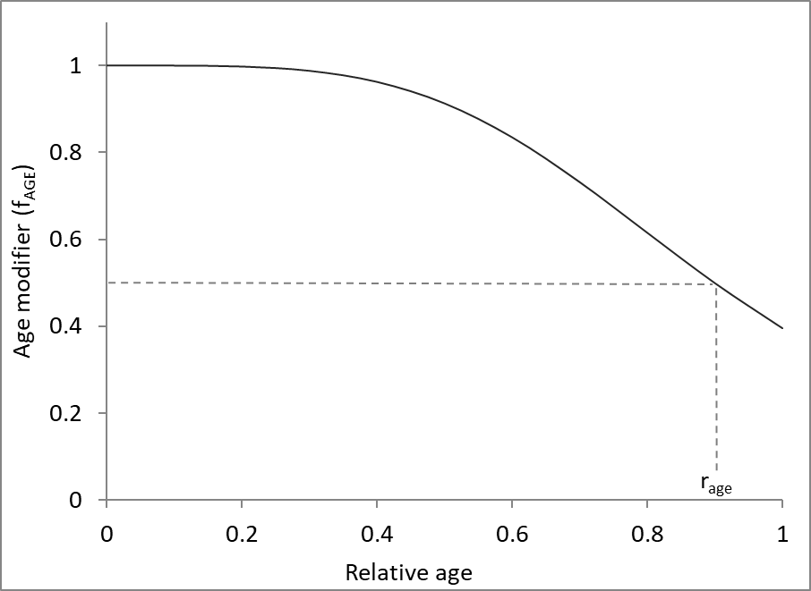
Figure 5 Age modifier (Equation 10).

The CO₂ modifier is defined differently depending on whether it is applied when calculating canopy conductance g_{c} (f_{Cg}) or P_{G} (f_{Cα}) (Almeida et al., 2009, Landsberg and Sands, 2011c).

$f_{Cα}\left({CO}_{2}\right)=f_{Cαx}×\frac{{CO}_{2}}{350×\left(f_{Cαx}-1\right)+{CO}_{2}}$ (11)
$f_{Cg}\left({CO}_{2}\right)=\frac{f_{Cg0}}{1+\left(f_{Cg0}-1\right)×{{CO}_{2}}/{350}}$ (12)

Where
$f_{Cαx}=\frac{f_{Cα700}}{2-f_{Cα700}}$ (13)

$f_{Cg0}=\frac{f_{Cg700}}{2×f_{Cg700}-1}$ (14)

The CO₂ is the atmospheric CO₂ (ppm). The f_{Cα700} and f_{Cg700} parameters define the species-specific responses of NPP and canopy conductance, respectively, to changes in atmospheric CO₂.

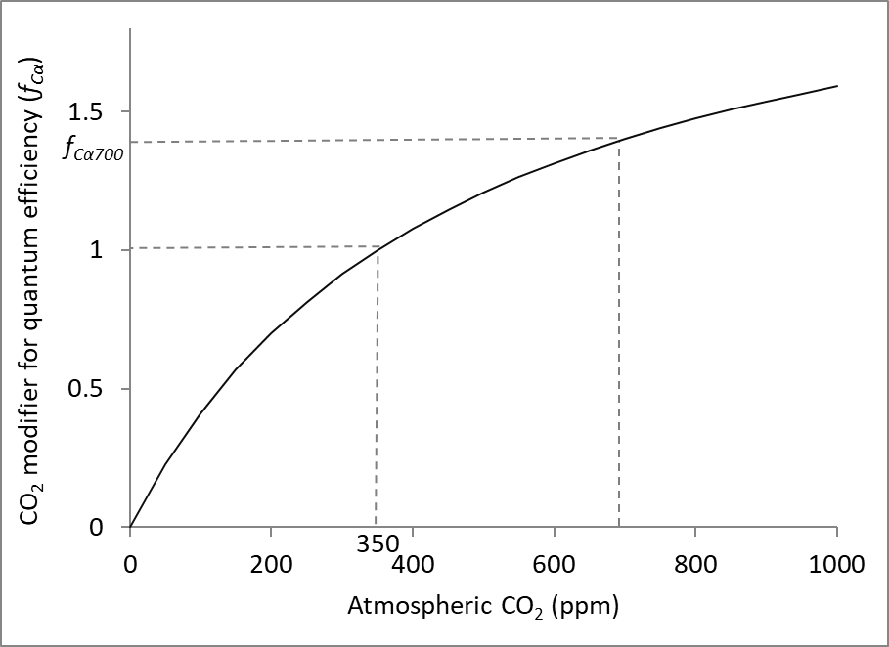
Figure 5 CO₂ modifier applied to quantum efficiency (α_{C}) when calculating GPP (Equation 11)

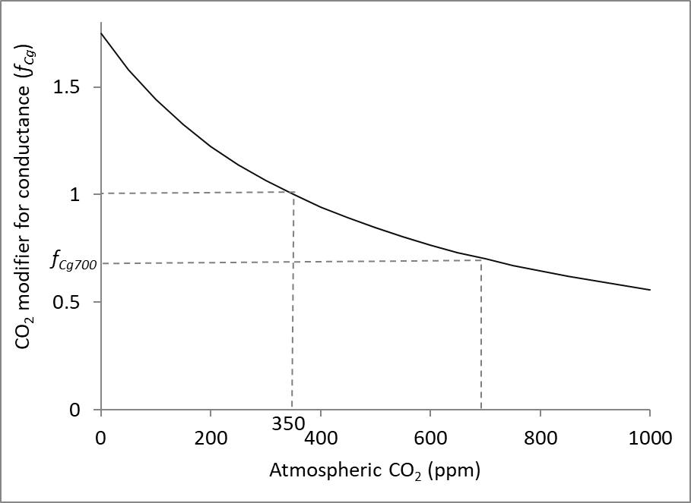
Figure 8 CO₂ modifier applied to canopy conductance (Equation 12)

The physiological modifier (PhysMod) φ is described in the previous section (Equation 3a,b).

Light absorption

There are two options to calculate ϕ_{pa}, both of which are based on the Lambert-Beer Law, such that the fraction of photosynthetically active radiation (ϕ_{p}) that is absorbed by the canopy, f (i.e. ϕ_{pai}/ϕ_{p}) is given by

$f=1-e^{-kL}$ (15)

where k is a light extinction coefficient and L is the leaf area index (m² m⁻²).

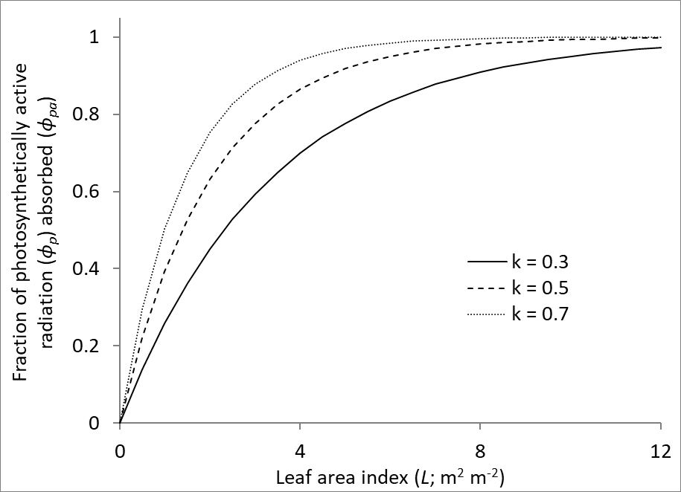
Figure 8 Fraction of light absorbed as a function of k and L (Equation 15)

The first approach to predict ϕ_{pa} (light_model = 1 in r3PG) is following the method used in 3-PG_{PJS}2.7 that was modified by Sands (2004) where ϕ_{pa} is determined from total incoming solar radiation and L as

$ϕ_{pa}=\left(1-e^{-kL/ζ}\right)2.3ζ\overline{Q}Δt$ (16)

where ζ is the proportion of ground area covered by the canopy and $\overline{Q}$ (MJ m⁻²d⁻¹) is the mean daily solar radiation above the canopy over the time period Δt (Sands, 2004). The factor of 2.3 converts total radiation into ϕ_{p} (2.3 mol MJ⁻¹). The ζ is calculated as a function of age, such that it is 1 after the canopy closes and prior to canopy closure it is the ratio of age/age of canopy closure (Equation 39-41). The ζ is therefore not influenced by thinning.

$L=0.1σW_{F}$ (17)

where σ is specific leaf area (SLA; m² kg⁻¹) and the 0.1 converts Mg ha⁻¹ to kg m⁻² (Landsberg and Waring, 1997). SLA declines with age such that

$σ\left(t\right)=σ_{1}+\left(σ_{0}-σ_{1}\right)e^{-\left(ln2\right){\left(t/t_{σ}\right)}^{2}}$ (18)

where σ₀ and σ₁ are the values of σ in young and older stands, respectively, and t_{σ} is the age at which σ = ½(σ₀ + σ₁) (Sands and Landsberg, 2002). The shape of this curve is the same as for density independent mortality (Equation 54), aerodynamic resistance within the canopy (Equation 63), basic wood density (Equation 86) and the fraction of w_{s} that is branch and bark (Equation 87).

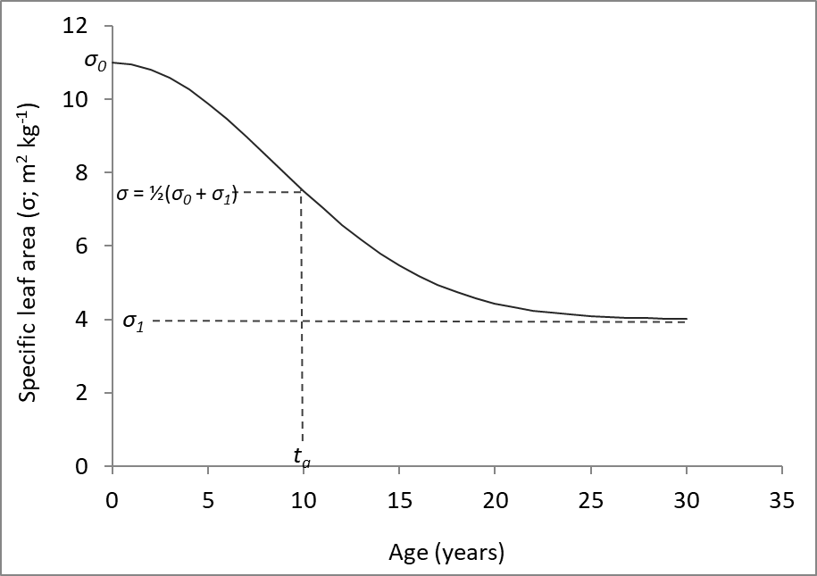
Figure 10 Specific leaf area as a function of age (Equation 18)

The use of Equation 16 to calculate ϕ_{pa} is appropriate for monospecific stands with horizontally and vertically uniform canopies. However, even in those stands the extinction coefficient (k) can vary, for a given species, with age, season and site quality (Cannell et al., 1987, Sampson and Smith, 1993, Binkley et al., 2013, le Maire et al., 2019), so care must be taken using this approach because it can result in biased predictions of ϕ_{pa} (see Figure 5b in Forrester et al., 2014). Part of the bias due to horizontal canopy heterogeneity (e.g. open canopies) can be accounted for by the ζ term in Equation 16, but this is only used before the canopy closes and therefore not after thinning, although Gonzalez-Benecke et al. (2014) calculated it using allometric relationships between tree diameter and crown projection area. Furthermore, when canopies are not closed there are two mechanisms that need to be accounted for. One is the reduction in ground area covered by the canopy (i.e. ζ), and another is the fact that individual tree ϕ_{pa} (for a given crown size) will be higher in an open canopy than in a closed canopy stand because there is less shading by neighbouring trees. The ζ term in Equation 16 may not adequately account for this (Forrester et al., 2014). This is important in stands that do not have closed canopies, such as young forests, thinned forests or naturally disturbed forests. Furthermore, Equation 16 will not work for mixed-species forests, except for the special case where each species forms a distinct canopy layer (with no vertical overlap between layers) and preferably when each canopy layer is closed, which is usually not the case for the lower layers.

Therefore, ϕ_{pa} can also be predicted using a second approach (light_model = 2 in r3PG) that can account for vertically and horizontally heterogeneous canopies e.g. thinned stands, mixed-species stands or uneven-aged stands where there is vertical overlap between the crowns of different cohorts (species or age classes), and/or horizontal variability in leaf area due to the mixing of cohorts, and gaps in the canopy resulting from disturbances (Forrester, 2014b, Forrester et al., 2014). For this approach ϕ_{pa} for the i^{th} cohort in the j^{th} (vertical) canopy layer (${∅_{pa}}_{ij}$) is predicted using Equation 19 (Forrester et al., 2014).

${∅_{pa}}_{ij}=λ_{v_{i}}λ_{h_{j}}\left[1-e^{\left(-\sum_{i=1}^{n}{k_{H,i}L_{i}}\right)}\right]2.3\overline{Q}Δt$ (19)

The k_{H} is defined as an extinction coefficient for a homogeneous canopy (Duursma and Mäkelä, 2007). This is required because typical long-term (monthly, annual) extinction coefficients, k (Equations 15 & 16) vary for a given species when the crown architecture and canopy structures change (Cannell et al., 1987, Sampson and Smith, 1993, Binkley et al., 2013, le Maire et al., 2019). A homogeneous canopy is defined as one composed of trees of the same height, with the same live-crown length, having box-shaped crowns that fit together perfectly (no space between crowns), and of the same leaf-area density (LAD, leaf area per crown volume, m² m⁻³), leaf angle distribution, leaf reflectance and leaf transmittance. k_{H} is therefore independent of trees per ha.
λ_{v}
The $λ_{v_{i}}$ is an empirical parameter that partitions the ϕ_{pa} to each of the i cohorts within a given layer (j) based on the vertical structure (relative species heights) of the layer as well as the k_{H} and L of each species (Equation 20).

$λ_{v_{i}}=0.0123+0.2366\frac{k_{H,i}L_{i}}{\sum_{i=1}^{n}{k_{H,i}L_{i}}}+0.0291\frac{h_{m,i}}{h_{m}}+0.6084\frac{k_{H,i}L_{i}}{\sum_{i=1}^{n}{k_{H,i}L_{i}}}\frac{h_{m,i}}{h_{m}}$ (20)

The h_{m,i} is the mid-crown height of cohort i and h_{m} is the mid-crown height of the layer in which cohort i belongs (Forrester et al., 2014). The mid-crown-height is the height of a point halfway between tree height and the height to crown base (h_{b}), where the h_{b} is the height where the lowest live branch joins the stem. Thus, the mid-crown height of a given cohort is calculated as (height – h_{b})/2 + h_{b}; the mid-crown height of a given layer is calculated using the height of the tallest cohort in that layer, and the minimum h_{b} of all cohort in that layer. Equation 20 has been tested for a wide range of crown architectures, species, species combinations, stand densities and vertical stand structures (Forrester, 2014b, Forrester et al., 2014).

The horizontal heterogeneity $λ_{h_{j}}$ is a function of mean midday solar zenith angle, k_{H}, the ratio of mean tree leaf area (L_{A}) to mean tree crown surface area (S_{A}) and v_{frac}, which is the sum of the crown volume (m³) of all crowns within a given layer within one hectare divided by the total volume of that layer (m³) (Equations 21 & 22; Forrester et al., 2014). Crown surface area is calculated assuming crown shapes for which there are four options (cone = 1, ellipsoid = 2, half-elipsoid = 3, rectangular = 4). The total volume of a layer is (height of the tallest cohort – minimum H_{b}) × 100 m × 100 m. The v_{frac} quantifies canopy openness and therefore the potential inter-tree shading, which increases as the mean midday zenith angle increases due to season and latitude. The zenith angle used to calculate $λ_{h_{j}}$ is an adjusted value, z_{adj}. This is needed because mean midday solar zenith angle is a sine-shaped function of Julian day, but at latitudes of < 23º, the sine shape is distorted when solar zenith angles decline to 0 and increase again, instead of continuing to decline below zero, which would maintain the sine shape (see Appendix B in Forrester et al., 2014). The z_{adj} allows that part of the curve to be negative (× -1). The $λ_{h_{j}}$ is then calculated using two empirical equations (21 and 22) because z_{adj} does not influence $λ_{h_{j}}$ until it is greater than 30º. These are general equations that can be applied to any species and stand structure.

$λ_{{h_{j},z}_{adj}≤30}=0.8260+\left(1.1698-0.9221 k_{H}\frac{L_{A}}{S_{A}}\right)×{0.1}^{v_{frac}}-0.6703×{0.1}^{v_{frac}}$ (21)

$λ_{h_{j},z_{adj}>30}=0.8260+0.0011×{1.0807}^{z_{adj}}+\left(1.1698-0.9221 k_{H}\frac{L_{A}}{S_{A}}\right)×{0.1}^{v_{frac}}-0.6703×{0.1}^{v_{frac}}$ (22)

These calculations (Equations 19-22; light_model = 2 in r3PG) assume a horizontally homogeneous canopy. This may be a horizontally homogeneous mixture of cohorts, but it represents stands without canopy gaps, or where gaps have recently closed. In such stands the youngest cohorts are likely to be larger than seedlings (e.g. > 2 m tall), having already established within gaps that have now partly or fully closed. Seedlings are more likely to successfully establish in canopy gaps, where there is enough photosynthetically active radiation (PAR). To simulate the establishment of seedling cohorts in a multi-cohort stand, it is necessary to add calculations that redistribute some of the remaining PAR (not absorbed when using Equations 19-22) to shorter cohorts within a stand to more accurately represent the PAR likely to be received by seedlings that successfully regenerate in canopy gaps. This redistribution is done by applying a multiplier to the cohort APAR that was calculated using Equations 19-22, and requires one species-specific parameter, γ, to amplify the light benefit to shorter cohorts.

The APAR multiplier declines towards 1 as the relative height of the cohort increases because taller cohorts are less likely to be in canopy gaps. The APAR multiplier also declines as the fraction of above-canopy PAR absorbed by the whole stand canopy (f) declines because this adjustment is less important in low density stands where high proportions of above-canopy PAR may reach the ground even in the absence of disturbances.

The relative height of a cohort (rh_{Li}; Equation 23) is the height of the cohort relative to the weighted average (by L, leaf area index, m² m⁻²) height (${\overline{h}}_{L}$; Equation 2) of all cohorts in the stand (Equation 24). The weighted average is used to provide a more stable height than the height of the tallest cohort or the unweighted mean height.

${rh}_{Li}=\frac{h_{i}}{{\overline{h}}_{L}}$, (23)

where h_{i} is the height of the ith cohort.

${\overline{h}}_{L}=\frac{\sum_{j}{\left(h_{j}×L_{j}\right)}}{\sum_{j}{L_{j}}}$, (24)

The APAR multiplier (m_{APAR}) is calculated for each cohort using Equation 25. m_{APAR} is highest for the shortest cohorts in dense (high f) stands and will decline towards 1 for the taller cohorts (as rh_{Li} increases to 1) and in very open stands (low f).

$m_{APAR,i}=\left\{\begin{matrix}1+f×\left(e^{γ_{i}\left({1-rh}_{Li}\right)}-1\right), & {rh}_{Li}<1 \\ 1, & {rh}_{Li}≥1\end{matrix}\right.$, (25)

where f is the proportion of above-canopy PAR absorbed by the whole canopy (sum of ${∅_{pa}}_{ij}$ from Equation 19), γ determines the strength of the light redistribution for shorter cohorts: γ = 0 results in no adjustment (m_{APAR} = 1), while higher γ increase the curvature of the m_{APAR} - rh relationship, amplifying the light benefit to shorter cohorts.

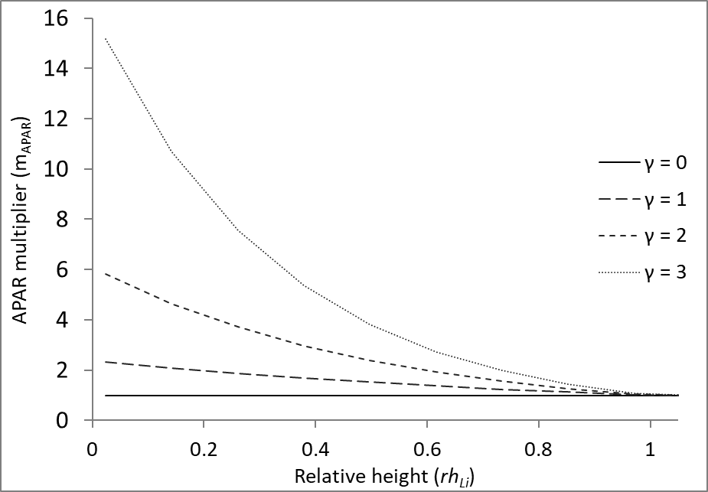
Figure 10 APAR multiplier as a function of relative height (Equation 25, with f = 0.8)

Critically, the final APAR of a cohort cannot be greater than the APAR it could potentially absorb if it received the above canopy photosynthetically active radiation ($∅_{p,above}$), which depends on its leaf area index (L_{i}), light extinction coefficient (k_{H}), and the PAR it receives. This is ensured using Equation 26.

$m_{APAR,i}=min\left(m_{APAR,i},\frac{∅_{p,above}×\left(1-e^{-k_{Hi}L_{i}}\right)}{{∅_{pa}}_{ij} }\right)$, (26)

where ${∅_{pa}}_{i}$ is the APAR of cohort i calculated using Equation 19, which assume a horizontally homogeneous canopy. The m_{APAR,i} is used to adjust ${∅_{pa}}_{ij}$ to quantify the potentially higher APAR the cohort may obtain if it was regenerating in a canopy gap (${∅_{pa}}_{i,final}$) (Equation 27).

${∅_{pa}}_{i,final}=m_{APAR,i}×{∅_{pa}}_{i}$, (27)

The total stand APAR cannot be greater than above-canopy PAR (i.e. f ≤ 1). This is ensured using equations 28 and 29.

$∅_{pa,stand}=\sum{{∅_{pa}}_{ij,final}}$, (28)

where $∅_{pa,stand}$ is the total stand APAR. If $∅_{pa,stand}$ ≤ $∅_{p,above}$, then no further adjustments are required. If $∅_{pa,stand}$ > PAR_{above}, the ${∅_{pa}}_{ij,final}$ is reduced using Equation (29).

${∅_{pa}}_{ij,final}={∅_{pa}}_{ij,final}×\frac{∅_{p,above}}{∅_{pa,stand}}$ (29)

It is important to note that the APAR multiplier function (Equation 25, Figure 10) has not yet been validated using observations of light absorption by seedling cohorts in stands with various gap sizes and mean dominant heights, or by using well validated detailed tree-level light models which could also be used when observations are unavailable. Examples of tree-level light models might include Maestra (Grace et al., 1987, Wang and Jarvis, 1990, Duursma and Medlyn, 2012), tRAYci (Brunner, 1998), SamsaraLight (Ligot et al., 2016), and SORTIE (Canham et al., 1999).

Biomass pools and partitioning

The NPP is divided into foliage (W_{F}), root (W_{R}) and stem biomass (W_{S}) based on McMurtrie and Wolf (1983)

$ΔW_{F}=η_{F}P_{n}-γ_{F}W_{F}Δt-m_{F}\left(W_{F}/N\right)ΔN$ (30)
$ΔW_{R}=η_{R}P_{n}-γ_{R}W_{R}Δt-m_{R}\left(W_{R}/N\right)ΔN$ (31)
$ΔW_{S}=η_{S}P_{n}-m_{S}\left(W_{S}/N\right)ΔN$ (32)

where ΔW_{i} is the change in the i^{th} pool over a time interval of Δt months, η_{i} is the fraction of NPP partitioned to the i^{th} pool, γ_{F} (months⁻¹) is the litterfall rate, γ_{R} (months⁻¹) is the root turnover rate, N is trees ha⁻¹ and m_{i} is the fraction of the biomass per tree (W_{i}/N) in the i^{th} pool that is lost when a tree dies (see also Equation 106).

The root biomass partitioning ratio is a function of the minimum and maximum root partitioning ratios (η_{Rn} and η_{Rx}) given by

$η_{R}=\frac{η_{Rx }η_{Rn}}{η_{Rn}+\left({η_{Rx}-η}_{Rn}\right)mφ}$ (33)

where m is a linear function of FR such that

$m=m_{0}+\left(1-m_{0}\right)FR$ (34)

where m₀ is the value of m on sites of poor fertility (i.e. FR=0) (Sands and Landsberg, 2002). Therefore, partitioning of NPP between above- and below-ground biomass is influenced by nutrition, soil moisture, VPD and age.

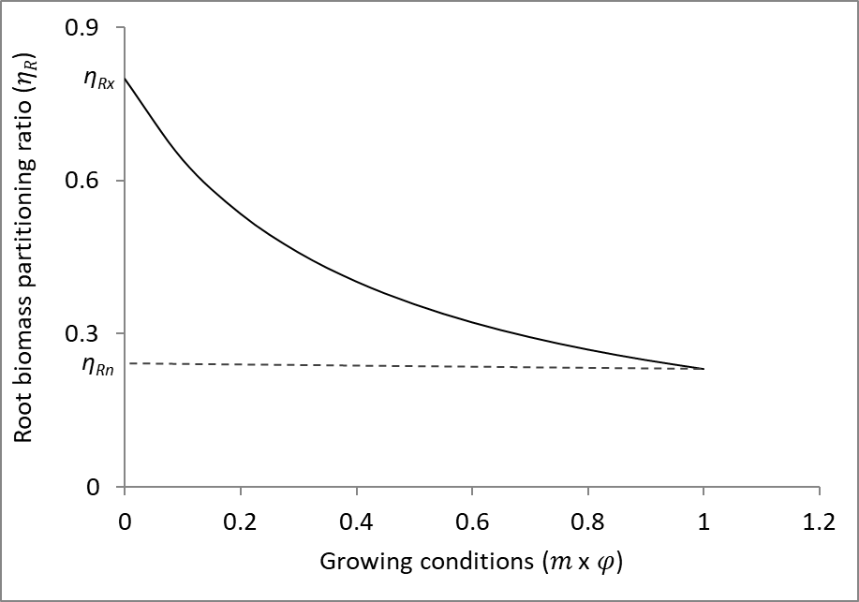
Figure 12 Root biomass partitioning ratio as a function of growing conditions (Equation 33)

The rest of the NPP is partitioned between the stems and foliage such that η_{R} + η_{S} + η_{F} = 1. Landsberg and Waring (1997) showed that the ratio η_{F}/η_{S} (denoted as p_{FS}) is an allometric function of stem diameter at breast height (B) (Equation 35).

While breast height (1.3 m) is a traditional height for measuring stem diameter, B can also be measured at other heights, such as 0.1 m for multi-stemmed shrubby species (e.g. reference Forrester rangelands paper). Therefore, diameter can be measured at any height, however, it is critical that the same height is used for all allometric parameters (Equations 35, 43, 46, 51, 71-84) and for all cohorts considered for a given simulation. The height of the diameter measurements is indicated using the H_{d} parameter.

$p_{FS}\left(B\right)=a_{P}B^{n_{p}}$ (35)

where a_{p} and n_{p}, are constants. While these constants can be derived from allometric leaf mass and stem mass equations (Landsberg and Waring, 1997), Sands and Landsberg (2002) note that after the canopy closes W_{F} is in a quasi-steady-state equilibrium and its relationship with B can deteriorate (note that W_{F} not only includes all current but also all past foliage mass, including litterfall). Therefore, to simplify parameterisation, p_{FS} is parameterised in terms of its values at B=2 cm (p_{FS2}) and B=20 cm (p_{FS20}) instead of in terms of a_{p} and n_{p}, which can instead be calculated from p₂ and p₂₀ such that

$n_{p}=\frac{ln\left({p_{FS20}}/{p_{FS2}}\right)}{ln10}$, $a_{p}=\frac{p_{FS2}}{2^{n_{p}}}$. (36)

$η_{S}=\frac{\left(1-η_{R}\right)}{1+pFS}$ (37)

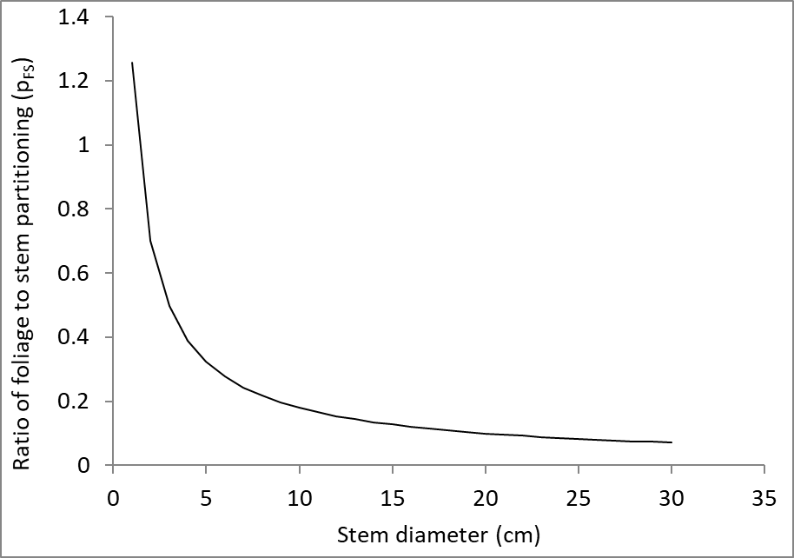
Figure 13 Ratio of foliage to stem partitioning (η_{F}/η_{S}) as a function of stem diameter (B) (Equation 35) with p_{FS2} = 0.7 and p_{FS20} = 0.1.

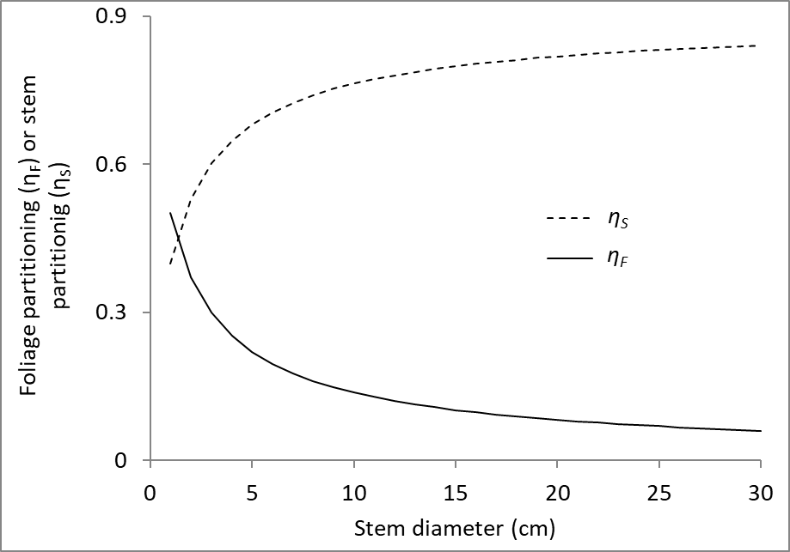
Figure 14 Foliage partitioning (η_{F} = 1- η_{R} - η_{S}) and stem partitioning (η_{S}) (Equation 37) as a function of stem diameter (B) with p_{FS2} = 0.7, p_{FS20} = 0.1, and η_{R} = 0.1.

Cohort proportions and canopy cover

The proportion of a multi-cohort stand that is composed of a given cohort is required when calculating canopy conductance, rainfall interception and density-dependent mortality. The cohort proportion of the i^{th} cohort in a mixture containing n cohorts can be calculated using Equation 38. The cohort proportion (sp) is calculated in terms of different variables (e.g. L, basal area, N) depending on what the sp will be used to calculate.

${sp}_{Xi}=\frac{X_{i}}{\sum_{i=1}^{n}{X_{i}}}$ (38)

where X is the variable that defines the cohort contributions (e.g. L, basal area, N).

The canopy cover, ζ, is required if Equation 16 is used to predict ϕ_{pa} (as opposed to Equation 19 which does not require ζ) or if wood δ¹³C is predicted using Equation 66. When the light model of Equation 16 is used, the ζ is calculated using a parameter that defines the age when that cohort closes its canopy (t_{C}) (Sands, 2004). If the age is already more than t_{C} then

$ζ=1$ (39)

If the stand age is still less than t_{C} then

$ζ={age}/{t_{C}}$ (40)

However, ζ then only varies with age, increasing until the canopy closes, but also needs to vary in response to any other factors that influence canopy cover, such as thinning, and in multi-cohort stands also needs to be expressed only in terms of a given cohort (not the total stand). Therefore, ζ is calculated as the sum of the crown projection area of all the trees of that cohort up to a maximum of 1 using Equation 41.

$ζ=min\left(1,\frac{N{(K+0.25)}^{2}}{10000}\right)$ (41)

where K is the crown diameter (m) and N is the number of trees ha⁻¹. Crown projection area is not calculated in the traditional way where it would be π(K/2)². Instead, it is estimated as a square with sides K + 0.25 m in length. The extra 0.25 m takes into account that crowns often don’t touch exactly leaving some space between them due to abrasion from the movement of adjacent crowns. The calculation is based on a square not a circle because there is often some open space between crowns (which tend to be more circular than square), even in stands with closed canopies, and this space also needs to be accounted for when calculating canopy cover in multi-cohort stands.

Mortality

The maximum stand biomass (or basal area or volume or LAI etc), for a given mean diameter, is determined by background mortality calculations. There are three options to calculate background mortality, and both are based on the self-thinning line (Reineke, 1933, Yoda et al., 1963) (Equation 42). When fitted to data on the outer edge of a scatter plot of mean tree size versus tree density, the resulting self-thinning line is assumed to represent a theoretical barrier where mean tree size can only increase if the tree density declines along the self-thinning line.

$ln\left(N\right)=n_{int}-n_{m} ×ln⁡(B)$ (log-log, linearised form) (42a)
$N=e^{n_{int}}B^{n_{m}}$ (power-law, original scale) (42b)

where N is the tree density (trees ha⁻¹), B is the quadratic mean stem diameter, and n_{int} and n_{m} are parameters.

Density-dependent mortality when mort_model = 1

The first approach (mort_model = 1 in r3PG) is following the method used in 3-PG_{PJS}2.7 (Landsberg and Waring, 1997, Sands and Landsberg, 2002), which is used to determine the maximum individual tree stem mass (w_{Sx}, kg per tree) from the current number of trees per ha (N) using Equation 43.

$w_{Sx}=w_{Sx1000}{\left(\frac{1000}{N}\right)}^{n_{m}}$ (43)

where w_{Sx1000} is the value of w_{Sx} when N = 1000 trees per ha and n_{m} is the exponent of the self-thinning line (Equation 42). When the mean individual tree stem mass w_{s} (W_{S}/N) is greater than w_{Sx}, N will be reduced and hence w_{Sx} will increase. This is done following an iterative procedure until w_{s} < w_{Sx}. For each tree that dies a fraction m_{i} of the mean biomass w_{i} of the i^{th} biomass pool (stem, foliage and root) is removed (Sands, 2004). The fractions m_{i} are generally less than 1 and are used in Equations 30-32 to update the values of W_{F}, W_{R}, and W_{S}. The use of m_{i} < 1, implies that the trees removed are smaller than the mean tree (for the given cohort).

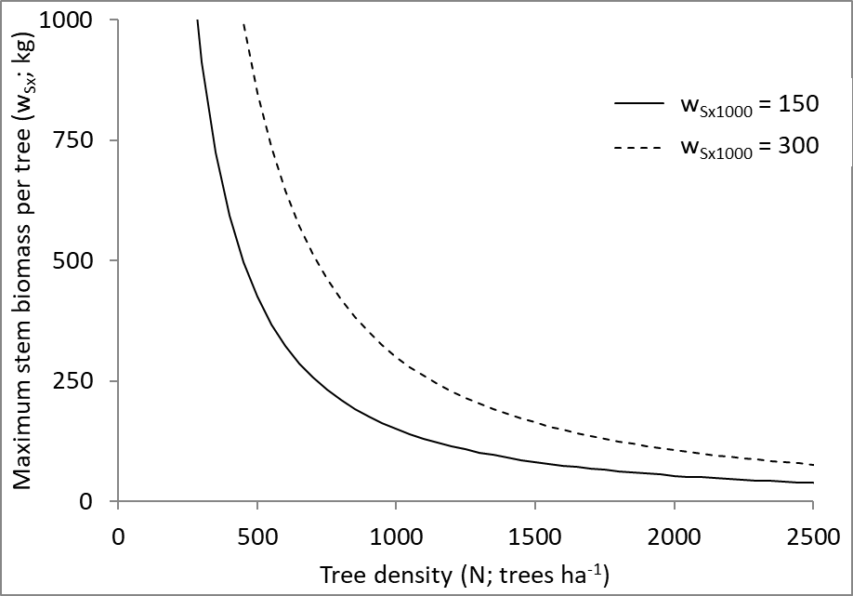
Figure 14 Maximum individual tree stem mass (w_{Sx}) as a function of tree density (Equation 43), with n_{m} = 1.5.

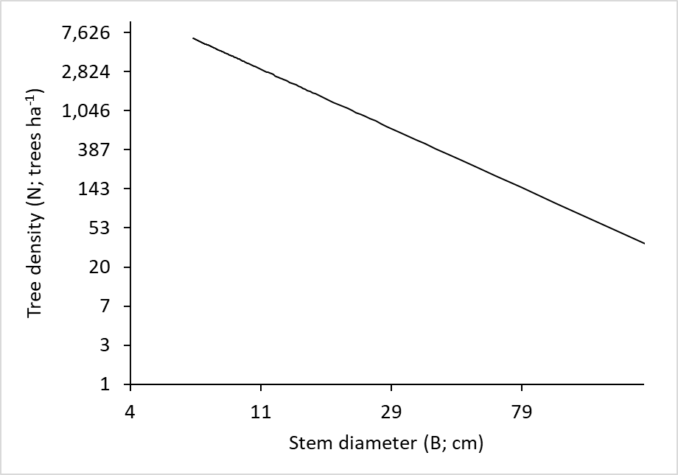
Figure 14 Relationship between stem diameter (B) and tree density (N) that results from Equation 42, or when combining Equations 43 and 83.

In multi-cohort stands, the N used in Equation 34 for the i^{th} cohort (N_{mix,i}) needs to be adjusted using the N of that cohort (N_{i}) and the sp. The N_{mix,i} is an estimate of what the N of the given cohort would be in a monoculture that has the same total stand basal area as the multi-cohort stand. For density-dependent mortality sp is calculated in terms of basal area using Equation 38 and N_{mix,i} is calculated as

$N_{mix,i}=\frac{N_{i}}{{sp}_{basal area,i}}$ (44)

Using equation 45, the n_{int} parameter of equation 42 can be calculated from the w_{Sx1000} and n_{m} parameters of Equation 43, and the a_{s} parameter of the relationship between stem diameter and stem biomass (Equation 83).

$n_{int}=ln\left(1000{\left(\frac{w_{Sx1000}}{a_{S}}\right)}^{1/{n_{m}}}\right)$ (45)

Density-dependent mortality when mort_model = 2

The self-thinning line for a given species or forest type can change from site to site, or even at the same site when there are long-term changes in site conditions (Zeide, 1987, Hynynen, 1993, Bi, 2001, Bi, 2004, Weiskittel et al., 2009, Zhang et al., 2013, Marqués et al., 2023, Trouvé et al., 2025). That is, the biomass (or leaf area) a site can support changes when there are long-term changes in resource availability and climatic conditions. The second approach (mort_model = 2 in r3PG) allows for this variability and is described using Equation 46. This is based on Equation 42, but with the option of allowing the self-thinning line (in particular the intercept n_{m}) to vary with long-term average values of the nutrition (f_{Nlt}; Equation 7), temperature (f_{Tlt}; Equation 5), and physiological modifiers (φ’_{lt}; Equation 3, but without the effect of the age modifier) described in section 5.6.4 below. These modifiers integrate temperature, rainfall, vapour pressure deficit, soil moisture and soil fertility. In multi-cohort stands, the long-term modifier values used in equation 46 are weighted averages (by proportional contribution to stand basal area) of the long-term average modifier values for all cohorts. Long-term is defined using the input ‘lt_mod_mths’ (months) provided for each site.

This approach also differs from the first approach (mort_model = 1 in r3PG) in that the n_{int} parameter is used instead of the w_{Sx1000} parameter. This is often useful because n_{int} is easier to measure than w_{Sx1000}, and is easier to interpret in relation to published self-thinning studies that often provide n_{int} rather than w_{Sx1000}.

$ln\left(N\right)=n_{int}-n_{m}\ln\left(B\right)+n_{fN}\ln\left(f_{Nlt}\right)+n_{fT}\ln\left(f_{Tlt}\right)+n_{fT}\ln\left({φ’}_{lt}\right)$ (46a)
$N=e^{n_{int}}×B^{{-n}_{m}}×{f_{Nlt}}^{n_{fN}}{×f_{Tlt}}^{n_{fT}}×{{φ’}_{lt}}^{n_{fφ^{'}}}$ (46b)
where n_{fN}, n_{fT} and n_{fφ’} are parameters.

The parameters of equation 46 are vegetation-specific parameters, such that all cohorts within a single stand should have the same parameter values, even if they are different species. Therefore, these are inputted as site parameters. Different positions along a self-thinning line often represent different stand densities (basal area, biomass etc), and therefore several calculation steps are used within 3-PG to partition changes in N between different cohorts (Forrester, in prep-a). The first is to calculate total stand ΔN (i.e. from Equations 46 or 51) using the total N and total stand B (not cohort B). The second step is to distribute the total stand ΔN among cohorts based on their relative competitive status, represented by a logistic function of relative height (Equation 47).

$w_{i}={BA}_{i}×\frac{1}{1+e^{\left(6×\left({rh}_{Li} -1\right)\right)}}$, (47)

where w_{i} is the weighting for cohort i based on its relative height (rh_{L}; weighted by leaf area index, Equation 23), and BA_{i} is the basal area of cohort i. The weighted average is used to provide a more stable height than the height of the tallest cohort or the unweighted mean height.

This weighting produces higher mortality for smaller cohorts, consistent with observed size-dependent mortality patterns (Forrester, in prep-a). The basal area lost for the whole stand in a given time step (BA_{lost}), and hence the change in tree density for a given cohort in that time step (∆N_{i}) was calculated using Equations 48 to 50.

${BA}_{lost}=∆N×\frac{{{\overline{d}}_{q}}^{2}π}{40000}$, (48)

${BA}_{lost,i}={BA}_{lost}×\frac{w_{i}}{\sum_{j}{w_{j}}}$, (49)

${∆N}_{i}=\frac{{BA}_{lost,i}}{\frac{{{\overline{d}}_{q,i}}^{2}π}{40000}}$, (50)

where BA is the basal area of all cohorts combined, ${\overline{d}}_{q,i}$ is the ${\overline{d}}_{q}$ of the i^{th} cohort (${\overline{d}}_{q}$ is for the whole stand), and ∆N_{i} is the change in tree density for that cohort.

Density-dependent mortality when mort_model = 3

The third approach to calculate background mortality (mort_model = 3 in r3PG) is more complex and this complexity can sometimes make the calculation within 3-PG unstable. The instability can be determined by running a simulation multiple times to check if the outputted mortality val are consistent. This approach should only be used when the model stability has been checked for each simulation.

Similar to the second approach, it allows the self-thinning line to vary with long-term average values of the nutrition, temperature, physiological modifiers. In addition, it allows background mortality to occur before the self-thinning line, rather than assuming mortality only occurs at the line, and is therefore more representative of observed patterns (Vanclay and Sands, 2009). For the third approach (mort_model = 3 in r3PG), the decline in tree density (N) as mean stem diameter (B) increases from one time step (t₁) to the next time step (t₂) is calculated using Equation 51 (Forrester, in prep-a).

$N_{t2}={\left(N_{t1}^{{1-β}_{2}}+e^{β_{0}}×\frac{1-β_{2}}{β_{1}+1}×\left(B_{t1}^{β_{1}+1}×{f_{Nlt}}_{t1}^{β_{3}}×{f_{Tlt}}_{t1}^{β_{4}}×{φ_{lt}^{'}}_{t1}^{β_{5}}-B_{t2}^{β_{1}+1}×{f_{Nlt}}_{t2}^{β_{3}}×{f_{Tlt}}_{t2}^{β_{4}}×{f_{φlt}}_{t2}^{β_{5}}\right)\right)}^{\frac{1}{1-β_{2}}}$ (51)

where f_{Nlt} and f_{Tlt} are long-term average values of the nutrition and temperature modifiers (Equation 7 and 5), and φ’_{lt} is the long-term average value of the physiological modifier (Equation 3) without the effect of the age modifier. The parameters β₀, … β₅ are vegetation-specific parameters, such that all cohorts within a single stand should have the same parameter values, even if they are different species. Therefore these parameters are inputted as site parameters. Increasing the β₁ (making it more negative) will shift the lines upwards, while increasing β₂ will make the lines steeper so that they cross the x axis at a lower stem diameter.

For multi-cohort stands, the same approach used for mort_model = 2 is used to split the total change in N total to the change in N for each cohort (Equations 47 to 50).

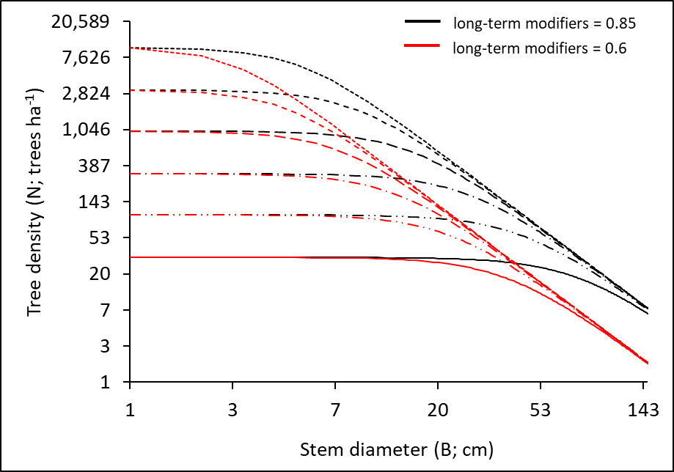
Figure 17 Relationship between stem diameter (B) and tree density (N) that results from Equation 51, such that 6 initial tree densities are used, and eventually these converge along a common self-thinning lines (i.e. represented by Equation 42 or 46) for each value of the long-term modifiers.

Long-term modifiers used for density-dependent mortality
The long-term average modifiers f_{Nlt}, f_{Tlt} and φ’_{lt} are calculated as rolling averages for the number of months considered to be long term (lt_mod_mths), which is a site input. These long-term averages are calculated for a stand as the weighted average (by proportion of stand basal area) of the long-term average modifier for each cohort.

The long-term averages are calculated each month using Equation 52.

${\overline{x}}_{new}={\overline{x}}_{old}+\frac{x_{new}-x_{oldest}}{lt_mod_mths}$, (52)

where ${\overline{x}}_{new}$ is the new value of the long-term average modifier of a cohort, ${\overline{x}}_{old}$ is the value for the previous month, x_{new} is the current months modifier value, and x_{oldest} is the modifier value from lt_mod_mths months + 1 month ago, which needs to be dropped from the calculation of the average.

To calculate these long-term values, an array is created at the start of a simulation for each modifier with lt_mod_mths of modifier values. Each month, the first value is dropped, and a new value is added based on the modifier value of the current month. The initial array for the f_{N} modifier contains lt_mod_mths values equal to the f_{N} for the current cohort. The initial array for the f_{T} modifier contains lt_mod_mths values equal to the average f_{T} for the first lt_mod_mths of the current simulation for the current cohort. The φ modifier is a function of the f_{θ} and f_{D} modifiers, both of which depend on stand structure, which is not known beyond the current month of the simulation. Therefore, the initial values for the φ modifier need to be approximated such that the f_{D} modifier is calculated using the average above-canopy VPD (instead of the VPD based on the cohorts’ canopy height) for the first lt_mod_mths months of the simulation, while the f_{θ} modifier is calculated assuming the ASW is equal to the maximum ASW for the site, instead of the actual ASW.

Biomass lost due to mortality

The biomass lost due to mortality (for both mort_model = 1 & 2) is calculated using the mean single-tree foliage/stem/root biomass of trees that died relative to that of the mean tree live tree (m_{F}, m_{S}, m_{R}; also in Equations 30, 31, 23). Similar fractions are used for thinning (see section 5.12.1 or Equations 90 & 92). Fractions < 1 indicate that smaller trees generally die due to mortality, which is by far the most common result of result of background mortality. Fractions > 1 indicate that larger trees generally die due to mortality. Fractions of 1 indicate that all sizes died due to mortality.

$W_{S,lost}=W_{S,pre}×\frac{{dN}_{cohort}}{N_{pre}}×m_{S}$, (53)

where N_{pre} is the cohort N before the mortality, and W_{S,lost} is the stem biomass lost due to mortality. Foliage and root biomass loss are calculated in the same way as stem (using the m_{F}, and m_{R}).

Density-independent mortality

Mortality can also be density-independent and the density-independent mortality rate (γ_{N}, %) declines with age according to Equation 54 (Sands, 2004).

$γ_{N}\left(t\right)=γ_{N1}+\left(γ_{N0}-γ_{N1}\right)e^{-\left(ln2\right){\left(t/t_{γN}\right)}^{n_{γN}}}$ (54)

where γ_{N0} and γ_{N1} are the values of γ_{N} in very young and mature stands, respectively, and t_{γN} is the age at which γ_{N} = ½(γ_{N0} + γ_{N1}). The shape of this curve is the same as for SLA (see Figure 10, Equation 18), aerodynamic resistance within the canopy (Equation 63), basic wood density (Equation 86), and the fraction of w_{s} that is branch and bark (Equation 87).

Evapotranspiration and soil water balance

The soil water balance model in 3-PG operates on a monthly time step and is a balance between evapotranspiration E_{T}, rainfall R_{P} and irrigation R_{Ir}, all in mm month⁻¹

$Δθ_{S}=\left(1-I_{RT}\right)R_{P}+R_{Ir}-E_{T},$ (55)

where Δθ_{S} is the change in soil water and I_{RT} is the fraction of rainfall intercepted and subsequently evaporated from the canopy (Sands and Landsberg, 2002). This I_{RT} is the total for all cohorts and canopy layers. If the Δθ_{S} results in a θ_{S} value more than the water holding capacity (θ_{Sx}), the excess water is drained off the site and assumed to have been run-off or deep drainage.

Rainfall interception

The calculation of I_{R} proportion is based on the correlation between I_{R} and L (Hatton et al., 1992, Vertessy et al., 1996) such that interception I_{R} by the i^{th} cohort increases with the L of that cohort up to a maximum interception I_{Rx}.

$I_{R}=I_{Rx}min\left\{1,L_{mix}/L_{Ix}\right\}×{sp}_{L}$ (56)

where L_{Ix} is the L at which interception is a maximum (in a monoculture) for cohort i. In single-cohort stands L = L_{mix}. In multi-cohort stands the L_{mix} of the i^{th} cohort is used to adjust the L of the i^{th} cohort according to the proportion of total stand L that the given cohort contributes (sp_{Li}, Equation 38) using Equation 57. The L_{mix} is an estimate of what the L of the given cohort would be in a monoculture that has the same total stand L as the multi-cohort stand.

$L_{mix}=\frac{L_{i}}{{sp}_{Li}}$ (57)

In multi-cohort stands the total stand I_{R} is calculated as the sum of the I_{R} of all cohort assuming an additive effect of mixing cohorts (André et al., 2008). No consideration is given to which cohorts overtop others, unlike light absorption, where vertical structure must be considered. It is important to note that this interception calculation is a considerable simplification, because interception is more accurately modelled at time scales of single rainfall events (Landsberg and Waring, 1997, Almeida et al., 2007, Feikema et al., 2010).

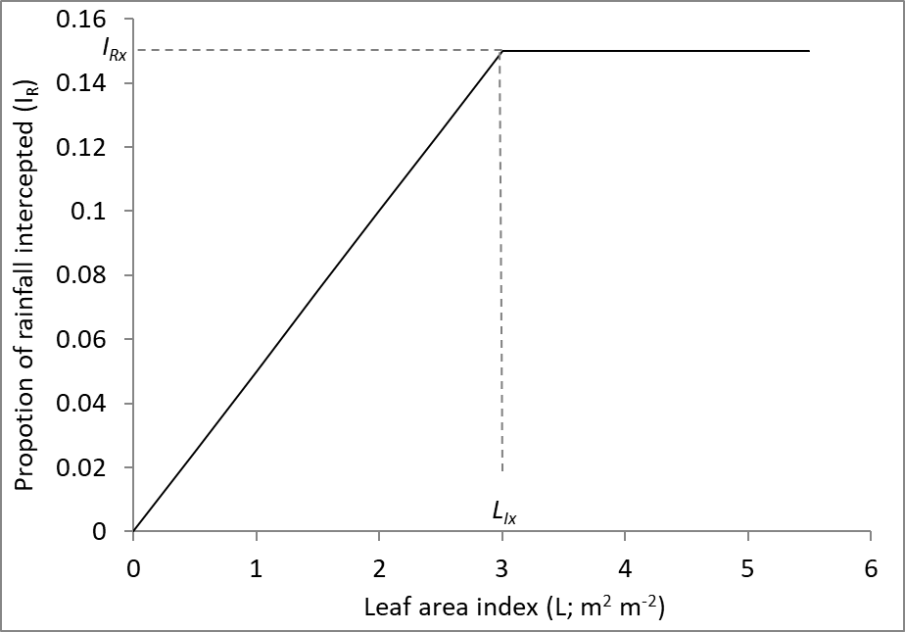
Figure 17 Proportion of rainfall intercepted by the canopy as a function of leaf area index (Equation 56).

Canopy conductance

There are two options for predicting canopy conductance (g_{c}) following the same distinction used when calculating canopy quantum efficiency. Both options assume that g_{c} increases with L up to a maximum g_{cmax} (Equation 58) and also change g_{c} in response to age, atmospheric CO₂, VPD and soil water (θ_{S}) (Equation 59-60). The first option (phys_model = 1 in r3PG) is the original approach used by 3-PG where the physiological modifier ϕ is calculated in the form of Equation 3a using the minimum of f_{θ} and f_{D} such that only the most limiting of VPD and soil water influence g_{c} (Equation 59) (Landsberg and Waring, 1997). Equations 59 and 60 also includes the CO₂ modifier (Equation 12). The L = L_{mix} for monocultures, and in multi-cohort stands the L_{mix} takes the cohort proportions into account (as previously shown in Equations 56 & 57).

$g_{c,opt}=\left\{\begin{matrix}g_{cmin}+\left(g_{cmax}-g_{cmin}\right)\frac{L_{mix}}{L_{g_{cmax}}} & 0<L<L_{g_{cmax}} \\ g_{cmax} & L_{g_{cmax}}<L\end{matrix}\right.$ (58)

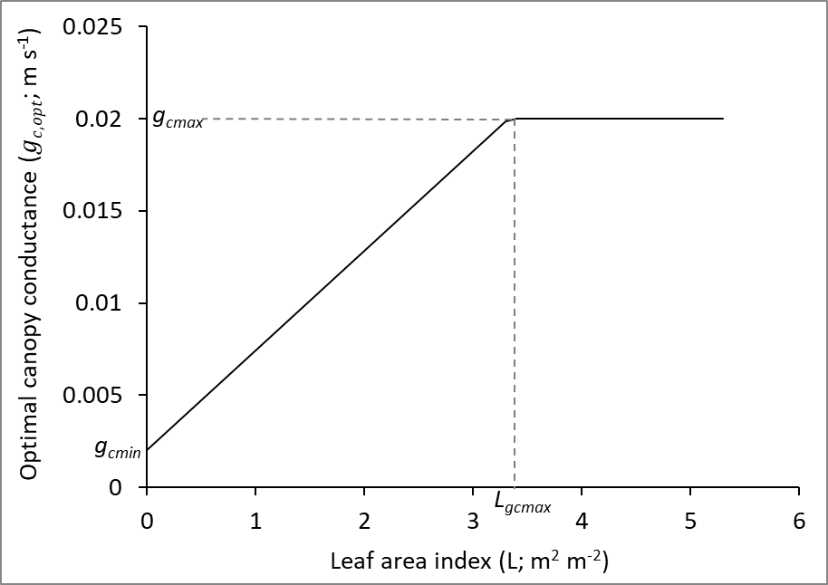
Figure 17 Optimal canopy conductance (before applying any modifiers) as a function of leaf area index (Equation 58).

$g_{c}=g_{c,opt}φ f_{Cg}L_{prop}$ (59)

where L_{gcmax} is the L at which g_{c} is a maximum, and L_{prop} is the proportion of stand L contributed by the cohort. The second option (phys_model = 2 in r3PG) uses ϕ calculated with Equation 3b (f_{θ} × f_{D}) so that both the soil water availability and VPD modifiers will influence g_{c} (Equation 59) (Feikema et al., 2010). In addition, the temperature modifier for g_{c} (f_{gT}) is applied.

$g_{c}=g_{c,opt}f_{θ}f_{D}f_{AGE}f_{gT}f_{Cg}L_{prop}$ (60)

Transpiration

Transpiration is predicted using the Penman-Monteith equation (Equation 61). This equation combines the two environmental drivers of evaporation, which are the supply of net radiant energy (ϕ_{n}) and of dry air (D_{q}), with the two essential controls, which are g_{B}, a measure of the mixing power of the atmosphere, and g_{c} the main physiological control exerted by the trees (Landsberg and Gower, 1997).

$λE=\frac{s∅_{n}+λρ_{a}g_{B}D_{q}}{s+1+g_{B}/g_{c}}$ (61)

λ is the latent heat of vaporisation of water (2.46 × 10⁶ J kg⁻¹). The total net radiation ϕ_{n} (W m⁻²) is calculated from solar radiation ϕ_{s} (MJ m⁻² day⁻¹) (Equation 62).
$∅_{n}=Q_{a}+Q_{b}\frac{∅_{s}×{10}^{6}}{\text{day length}}$ (62)
where $Q_{a}$(W m⁻²) is the intercept and $Q_{b}$(dimensionless) is the slope of the net vs. solar radiation relationship. The factor ${10}^{6}$converts megajoules to joules, and day length is the duration of daylight in seconds. Consequently, the term $\left(\frac{{∅_{s}×10}^{6}}{daylength}\right)$ represents the average solar radiation flux density during daylight (W m⁻²). This linear formulation allows the model to convert daily accumulated solar radiation into an instantaneous flux for use in canopy photosynthesis calculations.

s is the slope of saturated vapour pressure versus temperature curve at a temperature of 20°C (2.2). ρ_{a} is air density (1.2 kg m⁻³), g_{B} is the aerodynamic conductance (Equation 63) above the canopy (Landsberg and Gower, 1997 p. 76, Sands and Landsberg, 2002), D_{q} is the specific saturation deficit (6.22 × 10⁻⁴ × VPD).

Variables such as g_{B} and VPD are likely to vary at different depths within the canopy (Landsberg and Sands, 2011c p. 32) and each cohort i may receive a different net radiation ϕ_{ni} depending on its position within the canopy as well as the stand density. Therefore, g_{B}, VPD and ϕ_{n} used by Equation 61 can either be the same for all cohorts within the stand and equal to values above the canopy (transp_model = 1 in r3PG), or they can be predicted for the given cohort based on its position within the canopy and the vertical distribution of L (transp_model = 2 in r3PG). The ϕ_{ni} for an individual cohort is calculated using the same extinction coefficient as PAR such that ϕ_{ni} = ϕ_{n} × ϕ_{pai}/ϕ_{p} (Wallace, 1997), where ϕ_{pai} is from Equation 19 and considers the horizontal and vertical heterogeneity of the canopy. If this within-canopy climatic variation is used the same within-canopy VPD value is used to calculate the f_{D} modifier (Equation 8) and will therefore also influence the calculation of P_{G} and g_{c}. If the cohort is the tallest cohort in the forest then the g_{B} and VPD will not be changed, and therefore for a monoculture both options will give exactly the same predictions. Also, when this second option (transp_model = 2 in r3PG) is used the soil evaporation is calculated, whereas this is not calculated when within-canopy climate is not considered (transp_model = 1 in r3PG).

The aerodynamic resistance (r_{a} = 1/g_{B}, s m⁻¹) at a height of h metres is calculated as

$r_{a}\left(h\right)=\frac{1}{g_{B}}+\left(r_{a}^{soil}-\frac{1}{g_{B}}\right)e^{-\left(ln2\right){\left(h/h_{0.5}\right)}^{2}}$ (63)

where $r_{a}^{soil}$ is the aerodynamic resistance above the soil estimated as 5 × total L, which is sum of the L of all species in the forest. h_{0.5} is half the height of the tallest species within the forest. The shape of this curve is the same as for SLA (see Figure 10, Equation 18), density independent mortality (Equation 51), basic wood density (Equation 86), and the fraction of w_{s} that is branch and bark (Equation 87).

Soil conductance g_{soil} is calculated following (Soares and Almeida, 2001)
$g_{soil}=g_{soilx}\frac{θ}{θ_{max}}$ (64)
where g_{soilx} is the maximum g_{soil} and θ_{max} is the maximum soil θ. The g_{soilx} can be input, otherwise the default is 0.0025 m s⁻¹.

The VPD within the canopy (D_{c}) is calculated using Equation 65.

$D_{c}=D×e^{\frac{L_{above}×-ln⁡2}{L_{50}}}$ (65)

where L₅₀ is the (monoculture) L that leads to a 50% reduction in D (default = 5) for the given cohort, and L_{above} is the L of all layers above the layer in which the given cohort is in. If the cohort is positioned in the lower part of the layer and therefore $\frac{h_{m,i}}{h_{m}}$ < 1 (see Equation 20) then the L_{above} for that cohort also includes (1-$\frac{h_{m,i}}{h_{m}}$) × L of the given layer. This means that in multi-cohort stands, as soon as another cohort is taller than a given cohort its D_{c} will drop and so will its transpiration. The D_{c} above the soil is also calculated using Equation 65 and assuming L₅₀ = 5.

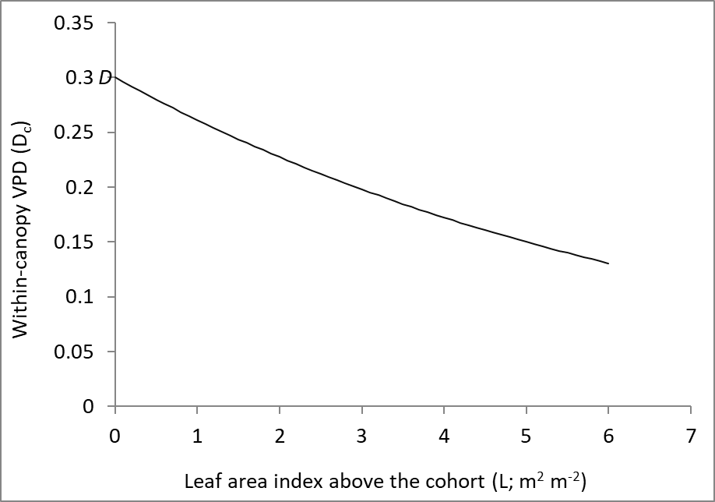
Figure 17 Change in within-canopy vapour pressure deficit (D_{C}; VPD experienced by a single cohort, or above the soil) as leaf area index increases above the current cohort (or soil) (Equation 65).

There is a feedback from transpiration calculations to growth calculations such that transpiration from vegetation + soil evaporation + canopy interception cannot be greater than the available soil water (θ_{S}). If it is that sum is greater than θ_{S}, the θ_{S} is divided by the sum (transpiration from vegetation + soil evaporation + canopy interception) and the resulting value (between 0 and 1) is used to reduce GPP and NPP.

δ¹³C of wood

The δ¹³C of wood is predicted using the approach of Wei et al. (2014a, 2014b). Predictions of δ¹³C have no influence on any of the predictions of other variables within 3-PG but they can be useful in when calibrating the model, especially where there are no empirical P_{G} and transpiration data available (Wei et al., 2014a). An example used by Wei et al. is when the model incorrectly predicts P_{G}. In this case, “tuning” the allocation parameters can still enable 3-PG to accurately predict stem mass, volume, basal area and L, however it would be doing so for the wrong physiological reasons.

The δ¹³C of new photosynthate in C₃ plants (δ¹³C_{p}) can be estimated using Equation 66 (Farquhar et al., 1982, Wei et al., 2014a, Wei et al., 2014b).

$δ^{13}C_{p}=δ^{13}C_{a}-a-(b-a)(1-\frac{A}{c_{a}g}$) (66)

The δ¹³C_{a} is the isotopic composition of air, a is the fractionation against ¹³C in diffusion through air (4.4‰), b is the enzymatic fractionation by Rubisco (27‰), c_{a} is the molar fraction of CO₂ in the air, A is net assimilation rate (mol C m⁻² s⁻¹) and g is conductance to the diffusion of CO₂ (mol C m⁻² s⁻¹). g is converted from g_{c} (m s⁻¹) assuming a ratio of diffusivities of CO₂ to water vapour in air (R_{GcGw}) of 0.66, and A is converted from GPP. The canopy cover (ζ, Equations 39-41) is used to convert g_{c} to g, because the former is calculated on the assumption of uniform leaf distribution across the land area, while g only needs the ground area covered by the leaves. It is assumed that the difference between mean annual δ¹³C_{p} and δ¹³C of tree rings (δ¹³C_{s}) is constant (ɛ_{sp}) for all months and years and therefore δ¹³C_{s} is calculated using Equation 67.

$δ^{13}C_{s}=δ^{13}C_{p}+ε_{sp}$ (67)

Litterfall and deciduous species

Monthly litterfall (Mg ha⁻¹ month⁻¹) is calculated as γ_{F}W_{F}, where the litterfall rate, γ_{F} (month⁻¹), is the fraction of W_{F} that falls as litter per month, and increases from γ_{F0} in young stands to γ_{F1} in older stands. For example, Landsberg et al. (2002) calculate γ_{F} for a stand where average leaf lifespan is 3 years, so the loss is about 33% per year, which would be equivalent to 0.33/12=0.0275 = γ_{F}. The age-dependency of γ_{F} is given by

$γ_{F}\left(t\right)=\frac{γ_{F1}γ_{F0}}{γ_{F0}+\left(γ_{F1}-γ_{F0}\right)e^{-\left(t/t_{γF}\right)ln\left(1+γ_{F1}/γ_{F0}\right)}}$ (68)

where t_{γF} is the age at which the litterfall rate is ½(γ_{F0} + γ_{F1}) (Sands and Landsberg, 2002). Litterfall will be influenced by all factors that influence W_{F} (and hence P_{G} and partitioning) as well as thinning, defoliation or other disturbances, but it is assumed that none of those factors influence the γ_{F}. For deciduous species the γ_{F} only includes the litterfall (if there is any) that occurs during the growing season and does not include the large litterfall event that occurs at the end of the growing season.

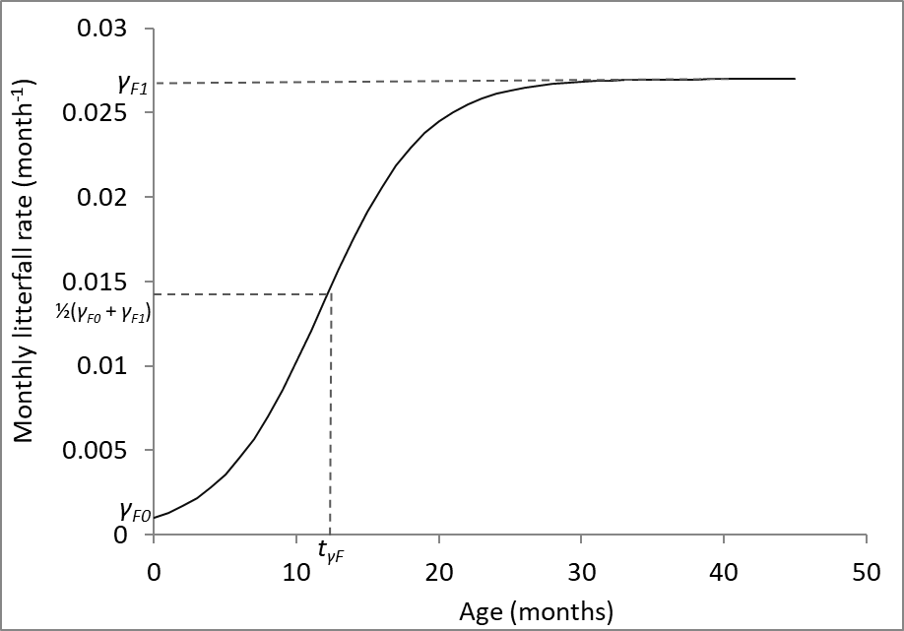
Figure 17 Litterfall rate as a function of age (Equation 68).

There are two options for controlling the timing of the large litterfall event that occurs for deciduous species. This also defines when they become inactive in terms of light absorption, assimilation, transpiration, canopy rainfall interception and hence their competitive effect on other species. The first option is to provide a T_{min} below (or T_{max} above) which the f_{T} (Equation 5) will result in zero P_{G}. This approach was used for Betula platyphylla forests (Potithep and Yasuoka, 2011). However, this approach only stops the trees from functioning during the cold (or hot) periods; it does not cause the loss of any leaves (L in 3-PG is unchanged) and hence no assimilates are required to rebuild the canopy in spring because the W_{F} has not been lost and simply becomes active again. Another potential problem is that the timing of leaf fall or bud break may also be influenced by variables other than temperature, so temperature alone may not be enough to determine the dormant season. Similarly, the dormant season can also be during the dry season or even during the wet season for some species (Roupsard et al., 1999). To deal with this, the second option for defining the growing season is that the month (an integer between 1 and 12) when the trees produce their leaves at the start of the season (leaf_{P}) and the month when they lose their leaves (leaf_{L}) must be provided. It is then assumed that all existing W_{F} is lost during the month of leaf fall and that the W_{F} that existed in the month prior to leaf fall will be produced during the first month of the next growing season. It is also assumed that all the new growing season W_{F} could have been produced using stored carbohydrates from previous growing seasons.

The increase or decrease in L at the beginning and end of a growing season does not occur instantly from one month to the next and is more gradual (Norby et al., 2003, Oishi et al., 2008) and 4 parameters (not 2) may be necessary to define the start and end times of leaf growth and the start and end times of leaf shedding.

Diameter distributions

The B distributions are described using 3-parameter Weibull probability distribution functions
$N_{class}=\left(\left(\frac{sh}{sc}\right)×{\left(\frac{sizeclass-loc}{sc}\right)}^{\left(sh-1\right)}×e^{{-\left(\frac{sizeclass-loc}{sc}\right)}^{sh}}\right)×N$ (69)
where N_{class} is the number of trees per ha within a given B class. The sizeclass is the diameter size class from the smallest size class (sizeclass = 1) to the largest size class in (strictly) 1-cm intervals. The location, scale and shape parameters must all be greater than zero. If sh = 3.6 the distribution is approximately normal, while if sh < 3.6 the distribution is positively skewed (to the right) and if sh > 3.6 the distribution is negatively skewed (to the left). Several previous studies have successfully used Weibull parameters to describe B distributions in 3-PG (Landsberg et al., 2005, Wang et al., 2011, Forrester et al., 2021b).

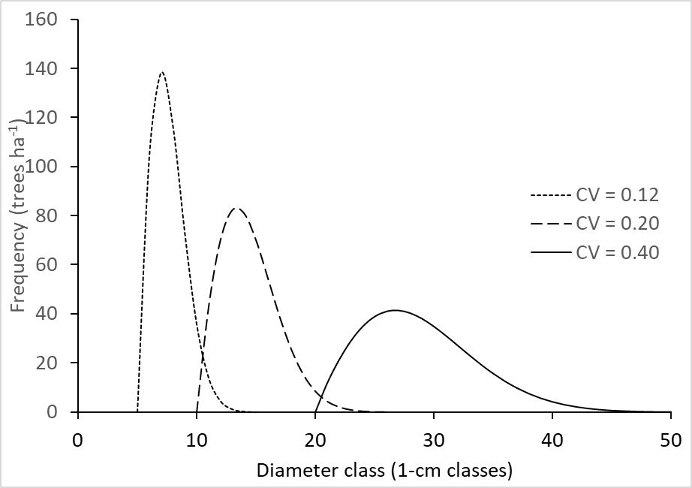
Figure 23 Diameter distributions (Equation 69) with different CV proportions.

Equation 70 is used to convert the sizeclass into the units of the distribution variable (B or w_{s}).

$Actual class=classwidth\left(1+sizeclass+location\right)$ (70)

where actual class is the mid-point of the given size class in the cm (B) or kg (w_{s}), classwidth is the width of each size class, which is strictly 1-cm for B and 10-kg intervals for w_{s}.

The location, scale and shape parameters of the Weibull distribution parameters vary according to empirical equations 71 to 76.

$ln\left({loc}_{B}\right)={loc}_{B0}+{loc}_{BB}×ln\left(B\right)+{loc}_{Brh}×ln\left(rh\right)+{loc}_{Bt}×ln\left(Age\right)+{loc}_{BC}×ln\left(C\right)$ (71)

$ln\left({sc}_{B}\right)={sc}_{B0}+{sc}_{BB}×ln\left(B\right)+{sc}_{Brh}×ln\left(rh\right)+{sc}_{Bt}×ln\left(Age\right)+{sc}_{BC}×ln\left(C\right)$ (72)

$ln\left({sh}_{B}\right)={sh}_{B0}+{sh}_{BB}×ln\left(B\right)+{sh}_{Brh}×ln\left(rh\right)+{sh}_{Bt}×ln\left(Age\right)+{sh}_{BC}×ln\left(C\right)$ (73)

$ln\left({loc}_{w}\right)={loc}_{w0}+{loc}_{wB}×ln\left(B\right)+{loc}_{wrh}×ln\left(rh\right)+{loc}_{wt}×ln\left(Age\right)+{loc}_{wC}×ln\left(C\right)$ (74)

$ln\left({sc}_{w}\right)={sc}_{w0}+{sc}_{wB}×ln\left(B\right)+{sc}_{wrh}×ln\left(rh\right)+{sc}_{wt}×ln\left(Age\right)+{sc}_{wC}×ln\left(C\right)$ (75)

$ln\left({sh}_{w}\right)={sh}_{w0}+{sh}_{wB}×ln\left(B\right)+{sh}_{wrh}×ln\left(rh\right)+{sh}_{wt}×ln\left(Age\right)+{sh}_{wC}×ln\left(C\right)$ (76)

where loc_{Bx}, sc_{Bx} and sh_{Bx} are fitted parameters for the B distributions, loc_{wx}, sc_{wx} and sh_{wx} are fitted parameters for the w_{s} distributions and C is a competition index calculated using Equation 77. The C is the sum of the products of the stand basal area (BA, m² ha⁻¹) and the wood basic density (ρ, t m⁻³) of each of n species.

$C=\sum_{i=1}^{n}{{BA}_{i}×}ρ_{i}$ (77)

It is assumed that ρ provides an estimate of the competitive ability of each species per unit of its basal area (e.g., Forrester et al., 2017b).

Stand-level variables

Allometric equations are used to predict mean tree height (h, m), live-crown ratio (LCR, m), crown diameter (K, m), basal area (ba, m²) and tree volume (Table 3). Diameter (B) is predicted from stem biomass (w_{s}, kg). The height, crown width and crown ratio equations include B as input, and sometimes additional variables, such as competition (Equation 77). When those additional variables change suddenly, such as when competition is reduced by thinning, the use of those equations (state equations in Table 3) could lead to sudden changes in the predicted variable, which is unrealistic. To avoid this, an incremental allometric approach is used based on Paudel et al. (2026), whereby tree geometry gradually changes in response to changes in environment through B growth, rather than instantaneously. Therefore, height, crown width and live-crown length are updated as functions of changes in B, rather than being recalculated directly from B at every timestep. The implementation described here adapts this concept to the mean-tree structure of 3-PG without introducing individual-tree state variables.

Changes in mean B in 3-PG arise from two distinct mechanisms:
- Compositional changes, such as thinning or mortality, which alter the population of trees contributing to the stand mean. Compositional changes can redefine the mean tree size and therefore lead to instantaneous changes in mean height or crown dimensions. For example, thinning from above or below, and mortality due to self-thinning or defoliation events (e.g., fire), can preferentially remove larger or smaller trees, as determined in 3-PG by the m_{St} parameter in Equations 53, 90 and 92.
- Growth-driven changes, in which individual trees increase in size through biomass accumulation. In contrast to composition changes, growth-driven changes represent physiological responses of trees to their environment and therefore result in incremental changes in tree geometry.

The first time a cohort appears in the simulation, the state equations (Table 3) are used rather than the increment equations. When there are changes in B due to growth, the increment equations (Table 3) are used to incrementally change the height or crown dimensions. These increments gradually reflect and stand structural changes, such as reductions in stand density, on tree dimensions. This assumes that there is enough time between events for the height and crown allometry to incrementally converge on what would be predicted using the State equations with current values of any additional variables (e.g. competition, relative height, leaf area index). While this is often the case, frequent large events may not allow enough time for this convergence of allometry in which case there can still be sudden jumps in height or crown dimensions. However, it is considered that the complexity that would need to be added to 3-PG to overcome this issue would be greater than the benefit. While the compositional changes mentioned above can also influence B, it is assumed that these lead to only minor changes in B. Therefore, no adjustment in height or crown dimensions is done following compositional changes.

To derive the incremental forms of each state equation, which would be y(B,C) (Table 3) when the explanatory variables are B and competition (C), the derivative is used such that

$Δy=\frac{∂y}{∂B} ΔB$ (78)
where $ΔB$is the growth-driven change in B over the timestep. The derivative $∂y/∂B$ is evaluated using the current competition index $C$, allowing growth responses to adjust dynamically to changes in stand structure. The specific state equations and corresponding increment equations used for height, crown width and live crown ratio are summarised in Table 3. No additional parameters are required beyond those already used in the state formulations.

There are 3 versions of the height and crown width equations. The versions “.a” (height_model = 1 in r3PG) are exponential equations. The versions “.b” are non-linear Michajlow equations (height_model = 2 in r3PG), and versions “.c” or “.d” are non-linear Näslund equations (height_model = 3 in r3PG). The non-linear equations have asymptotes and can therefore be more appropriate than the exponential “.a” versions (height_model = 1 in r3PG), which can overpredict values for large B. Live-crown ratio is often poorly correlated with B, L, rh or C, and when this occurs, the a_{HL} parameter can be used as the live crown ratio (by inputting zero for the other crown ratio parameters n_{HL1}, n_{HL2}, n_{HL3}, n_{HL4}). Live-crown length is calculated as height × live crown ratio.

Table 3 Equations used to calculate height, live-crown ratio and crown width. All a_{x} or $n_{x}$ parameters are constants. H_{d} is the height at which the B was measured (cm). The rh is the relative height of the cohort (height of the cohort divided by the mean height of all trees in the stand). All equations must have an “a_{x}” parameter (except versions “.b” which must also have an “n_{x1}” parameter. The inclusion of the other parameters is optional and will depend on whether they are deemed necessary for the given species.
Variable | Form (height_model) | State equation | Increment equation | Equation
Height | Exponential | $$h=a_{H}B^{n_{H1}}C^{n_{H2}}$$ | $$a_{H}n_{H1}B^{n_{H1}-1}C^{n_{H2}}∆B$$ | 79a
Height | Michajlow | $$h=H_{d}+a_{H}e^{{-n_{H1}}/B}+n_{H2}CB$$ | $$\left[a_{H}e^{{-n_{H1}}/B}\frac{n_{H1}}{B^{2}}+n_{H2}CB\right]∆B$$ | 79b
Height | Näslund (no C) | $$h=H_{d}+\frac{B^{a_{H}}}{n_{H1}+n_{H2}×B^{a_{H}}}$$ | $$\frac{a_{H}{n_{H1}B}^{a_{H}-1}}{{\left(n_{H1}+n_{H2}×B^{a_{H}}\right)}^{2}}∆B$$ | 79c
Height | Näslund (with C) | $$h=H_{d}+\frac{B^{a_{H}}}{e^{\left(n_{H1}+n_{H3}C\right)}+e^{\left(n_{H2}+n_{H4}C\right)}×B^{a_{H}}}$$ | $$\frac{a_{H}{e^{\left(n_{H1}+n_{H3}C\right)}B}^{a_{H}-1}}{{\left(e^{\left(n_{H1}+n_{H3}C\right)}+e^{\left(n_{H2}+n_{H4}C\right)}×B^{a_{H}}\right)}^{2}}∆B$$ | 79d
Live-crown ratio | Exponential | $$LCR=a_{HL}B^{n_{HL1}}{L^{n_{HL2}}{rh}^{n_{HL3}}C}^{n_{HL4}}$$ | $$a_{HL}n_{HL1}B^{n_{HL1}-1}{L^{n_{HL2}}{rh}^{n_{HL3}}C}^{n_{HL4}}∆B$$ | 80a
Crown width | Exponential | $$K=a_{K}B^{n_{K1}}h^{n_{K2}}{rh}^{n_{K3}}C^{n_{K4}}$$ | $$a_{K}n_{K1}B^{n_{K1}-1}C^{n_{K2}}∆B$$ | 81a
Crown width | Michajlow | $$K=a_{K}e^{{-n_{K1}}/B}+n_{K2}CB$$ | $$\left[a_{K}e^{{-n_{K1}}/B}\frac{n_{K1}}{B^{2}}+n_{K2}CB\right]∆B$$ | 81b
Crown width | Näslund (no C) | $$K=\frac{B^{a_{K}}}{n_{K1}+n_{K2}×B^{a_{K}}}$$ | $$\frac{a_{K}{n_{K1}B}^{a_{K}-1}}{{\left(n_{K1}+n_{K2}×B^{a_{K}}\right)}^{2}}∆B$$ | 81c
Crown width | Näslund (with C) | $$K=\frac{B^{a_{K}}}{n_{K1}+n_{K2}×B^{a_{K}}}$$ | $$\frac{a_{K}{e^{\left(n_{K1}+n_{K3}C\right)}B}^{a_{K}-1}}{{\left(e^{\left(n_{K1}+n_{K3}C\right)}+e^{\left(n_{K2}+n_{K4}C\right)}×B^{a_{K}}\right)}^{2}}∆B$$ | 81d

$ba={{πB}^{2}}/{40000}$ (82)
$w_{S}=a_{S}B^{n_{S}}$ (83)

Note that w_{s} (Equation 83) is all above-ground biomass that is not foliage (stem + bark + branch). Stand basal area (BA, m² ha⁻¹) is calculated as ba × N.

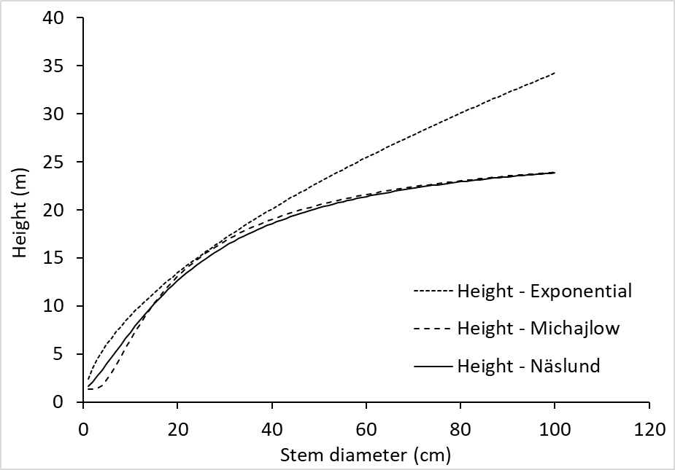
Figure 24 Height as a function of stem diameter in an exponential form (Equation 79a, height_model = 1 in r3PG), Michajlow form (Equation 79b, height_model = 2 in r3PG), and Näslund form (Equation 79c, height_model = 3 in r3PG)

There are two options for calculating stand volume (V_{S}, m³ ha⁻¹) and when both are provided Equation 84 will be used rather than Equation 85.

$V_{S}=a_{V}B^{n_{VB}}h^{n_{VH}}{\left(B^{2}h\right)}^{n_{VBH}}×N$ (84)
$V_{S}=\left(1-p_{BB}\right)W_{S}/ρ$ (85)

where p_{BB} is the fraction of w_{s} that is branch and bark and, which needs to account for temporal changes in p_{BB} and w_{s} (Sands and Landsberg, 2002). Volume can be output as the currently existing (standing) volume, cumulative extracted volume (all volume thinned so far during the rotation), extracted volume for the latest thinning event, total cumulative volume (standing + extracted + mortality) and mean annual volume increment (total cumulative volume / age).

The basic density of wood ρ increases with age such that

$ρ\left(t\right)=ρ_{1}+\left(ρ_{0}-ρ_{1}\right)e^{-\left(ln2\right)\left(t/t_{ρ}\right)}$ (86)

where ρ₀ and ρ₁ are the minimum (young trees) and maximum (older trees) values of ρ, respectively, and t_{ρ} is the age at which ρ = ½( ρ₀ + ρ₁) (Sands, 2004).

The p_{BB} declines with age such that

$p_{BB}\left(t\right)=p_{BB1}+\left(p_{BB0}-p_{BB1}\right)e^{-\left(ln2\right)\left(t/t_{BB}\right)}$ (87)

where p_{BB0} and p_{BB1} are the values of p_{BB} for very young and for mature stands, respectively, and t_{BB} is the age at which p_{BB} = ½(p_{BB0} + p_{BB1}) (Sands, 2004). The shape of these curves (Equations 86 and 87) are the same as for SLA (see Figure 10, Equation 18), density independent mortality (Equation 54), and aerodynamic resistance within the canopy (Equation 63).

Thinning and defoliation calculations

Thinning
Thinning intensity is quantified as either the retained N of the cohort (by providing stems_n in “thinning” input), or the retained proportion biomass, AGB_{P.ret}, which must be between 0 and 1 (by providing biom_prop_retained in “thinning” input) (Forrester and Trotsiuk, in prep). Only one of these inputs (N or AGB_{P.ret}, not both) should be provided for each thinning event. Regardless of which option is chosen, there are also three inputs that describe the mean single-tree foliage/stem/root biomass of removed trees relative to that of the mean tree prior to thinning (m_{Ft}, m_{St}, m_{Rt}), which are equivalent to the fractions used for trees lost due to mortality (m_{F}, m_{S}, m_{R} in Equation 30, 31, 32, & 53). Fractions < 1 indicate a thinning from below, such that removed trees were less dominant. Fractions > 1 indicate a thinning from above, such that removed trees were more dominant. Fractions of 1 indicate a uniform thin, such as when trees from any dominance class were removed, possibly randomly. The fractions adjust for the fact that relationships between tree diameter and tree biomass are not linear and therefore the proportion of trees retained is not going to equal the proportion of biomass (or volume) retained. The fractions are used to calculate thinning intensity in terms biomass retained even when only retained N is provided as input, or vice versa.

When retained N is provided as input, the proportion of trees removed (N_{P.rem}) is calculated as

$N_{P,rem}=\frac{N_{pre}-N_{post}}{N_{pre}}$ (88)

$N_{post}=N_{pre}×\left(1-N_{P,rem}\right)$ (89)

$W_{S,post}=W_{S,pre}×\left(1-N_{P,rem}×m_{St}\right)$, (90)

where N_{pre} and N_{post} are the cohort N before and after thinning, respectively, and W_{S,pre} and W_{S,post} are the stem biomass before and after thinning, respectively. Foliage and root thinning intensities are calculated in the same way as stem. When thinning is defined by specifying N_{post}, the compartment-specific biomass removal fractions (e.g., m_{St}) are applied to distribute stem loss among stems, roots, and foliage. If the product of N_{post} and one of these fractions is greater than 1 (e.g. N_{post} × m_{St} ≥ 1), it would lead to biomass losses that exceed the available biomass. Therefore, these products are constrained to be no more than 1.

When AGB_{P,ret} is provided as input,

$W_{S,post}=W_{S,pre}×{AGB}_{P,ret}$ (91)

$N_{post}=N_{pre}×\left(1-\frac{{1-AGB}_{P,ret}}{m_{St}}\right)$ (92)

The post thinning foliage and root mass are calculated in the same way as stem (Equation 91). The m_{Ft} and m_{Rt} are not used when thinning intensity is quantified as AGB_{P,ret}. When the sum of AGB_{P,ret} and m_{St} is 1 or less, all N will be removed even though some biomass remains (AGB_{P,ret} > 0). This occurs because this simple method scales stem retention directly from the biomass fraction without additional allometric constraints. In such extreme cases, all stems are removed, and the model restricts the stem number to zero to prevent negative values.

Note that for thinning events, it is assumed that all removed trees die. If thinned trees are expected to survive and coppice, then the stand needs to be simulated as multiple cohorts, and the cohort to be coppiced needs to have its foliage and stem biomass removed using a defoliation event (not a thinning event) (see Table 1).

Defoliation

Defoliation events in 3-PG are used to modify growth responses in two ways (Forrester and Trotsiuk, in prep). The first is to accelerate growth responses such as when trees use stored non-structural carbohydrates or benefit from higher rates of photosynthesis resulting from modified shoot to root ratios (Wildy and Pate, 2002, Pinkard, 2003, Smith et al., 2018a). In 3-PG, this can occur for a maximum period of one year after the defoliation event, consistent with observed responses (Forrester and Trotsiuk, in prep). The second process quantifies a change in biomass partitioning for the whole period of recovery, such that there is an increase in partitioning to foliage at the expense of partitioning to stems or roots (Wildy and Pate, 2002).

A maximum time to recover (months) input is used such that the change in biomass partitioning will stop when either the adjusted pre-defoliation foliage mass (W_{F,pre,adj}) or maximum time to recover is reached. Here ‘adjusted’ refers to the use of pre-defoliation foliage biomass of surviving trees rather than that of all trees. The W_{F,pre,adj} serves as a proxy for whole-tree non-structural carbohydrate availability, analogous to deciduous species that routinely rebuild their entire canopy each spring largely from NSC accumulated during the previous growing season, and reflecting findings that whole-tree NSC pools and resprouting vigour scale with overall tree size (Furze et al., 2019, Matula et al., 2019). The maximum time to recover must be at least 2 months given that defoliation and recovery cannot all happen within a single time step.

Note that for defoliation event inputs, the proportion of foliage mass retained is a proportion per tree, whereas the proportion of stem or root mass retained is a proportion of the stand (Table 4).

Table 4 Major Ranges of input values for the proportions of retained foliage, stem or root mass to simulate different responses. Loss of roots indicates tree mortality. The numbers in parentheses are used as 3-PG inputs to indicate the type of defoliation event.
Type of response | Proportion of retained foliage mass (per tree) | Proportion of retained stem mass (per stand) | Proportion of retained root mass (per stand)
Pruning (1) | <1 | 1 | 1
Coppice (2)^ | 0 | 0 | >0
Epicormic (3) | <1 | >0* | >0*
Stand-replacing (4) | 0 | 0 | 0
*For epicormic responses, the proportion of retained stem mass must equal that of roots.
^A coppice event will reset the cohort age to zero.

Defoliation partitioning calculations

When defoliation leads to a change in partitioning for pruning or epicormic responses, new partitioning ratios (η_{F2}, η_{S2}, η_{R2}) are obtained using the standard ratios (η_{F}, η_{S}, η_{R}) and the input P_{npp} defining the proportion of new photosynthesis that will be partitioned to foliage biomass.

$η_{F2}=\max\left(η_{F},P_{npp}\right)$ (93)

${∆η}_{F}=\left|η_{F2}-η_{F}\right|$ (94)

Given that η_{F2} + η_{S2} + η_{R2} = 1, the proportional change in stem and root partitioning ($Pη_{SR}$) required will be:

${Pη}_{SR}=\frac{\left(η_{R}+η_{S}\right)-{∆η}_{F}}{η_{R}+η_{S}}$ (95)

Therefore, the new stem and root partitioning ratios (η_{S2}, η_{R2}) will be

$η_{R2}={η_{R}×Pη}_{SR}$ (96)
$η_{S2}={η_{S}×Pη}_{SR}$ (97)

When defoliation leads to a change in partitioning for coppice responses, new partitioning ratios (η_{F2}, η_{S2}, η_{R2}) are obtained using the standard ratios (e.g., Equations 6 and 7) and the input P_{npp} defining the proportion of new photosynthesis that will be partitioned to foliage + stem biomass.

$η_{FS}=η_{F2}+η_{S2}=\max\left(η_{F}+η_{S},P_{npp}\right)$ (98)

Given that the fraction of partitioning to foliage relative to stem is given by η_{F}/η_{S},

$η_{F2}=\frac{η_{F}}{η_{F}+η_{S}}×η_{FS}$ (99)
$η_{S2}=\left(1-\frac{η_{F}}{η_{F}+η_{S}}\right)×η_{FS}$ (100)
$η_{R2}={1-η}_{F2}-η_{S2}$ (101)

Defoliation - stored carbohydrate calculations

The input variable P_{carbs} defines the proportion of 1st-year NPP derived from non-structural carbohydrates, such that the photosynthetic NPP is adjusted using Equation 102.

${NPP}_{t+1}=\frac{{NPP}_{t}}{{1-P}_{carbs}}$ (102)

where P_{carbs} < 1.

Following defoliation events that remove all foliage mass (e.g., coppicing), leaf area will be temporarily zero, resulting in zero photosynthetic NPP. To allow early resprouting driven by stored non-structural carbohydrates, a small non-structural-carbohydrate-derived NPP flux is imposed during the first month of recovery, but only for defoliation events where all foliage was removed. This NPP flux is scaled to the W_{F,pre,adj}, and is calculated using Equation 103.

$NPP=P_{carbs}\frac{W_{F,pre,adj}}{12}$ (103)

Calibration and validation

There is a wealth of information about model parameterisation, sensitivity analyses, calibration and validation. A more detailed description specific to 3-PG can be found in Sands (2004), Sands and Landsberg (2002) and in the 3PG-parameterisation.ppt by Peter Sands which is available from: https://3pg.forestry.ubc.ca/documentation/. The main objective of this section is to provide enough information to get people started, rather than providing a thorough review.

Parameterisation is the process of assigning values to model parameters that accurately represent the parameter and that will produce accurate predictions of all pools and fluxes. As many parameters as possible should be calculated directly from empirical data (e.g. from own experiments or from publications). The data and calculations required to directly calculate parameters are described in section “7. Data requirements and calculations”.

Note that all allometric parameters should be calculated and not calibrated (i.e. equations 71 to 76 and 75 to 80) because calibration is likely to lead to unrealistic relationships described by those equations. The equations of each allometric equation are dependent on each other and should not be influenced by the values of any other parameters.

The remaining parameters, for which direct calculation is not possible, can be calibrated by adjusting their values to optimise the fit of model predictions to observed data. Calibration can be done using software that uses observations of variables that are output by the model to constrain the parameter values (e.g., Thomas et al., 2017, Trotsiuk et al., 2020a, Forrester et al., 2021a, Forrester, in prep-b). There are > 70 published parameter sets for 3-PG, many of which can be seen by running i_parameters_lit after installing r3PG. Some of these were based on very good data sets that included many different variables, such as growth, biomass partitioning, water balance, gas exchange etc. However, others were based on very few observations and so their reliability is unknown. Therefore, published parameter values should be used cautiously, and careful consideration should be given to the quality of the data used to obtain the parameters.

Like all models, there are parameters and input variables to which 3-PG is very sensitive, and others to which it is far less sensitive. Information about the sensitivity to different parameters and inputs is useful when deciding where to put the most effort. Many sensitivity analyses of parameters or input variables are available for 3-PG (Law et al., 2000, Almeida et al., 2004, Esprey et al., 2004, Xenakis et al., 2008, Zhao et al., 2009, Pérez-Cruzado et al., 2011, Potithep and Yasuoka, 2011, Forrester and Tang, 2016, Navarro-Cerrillo et al., 2016, Meyer et al., 2017, Boukhris et al., 2023). The sensitivity of 3-PG outputs to a given parameter or input variable can vary between species and sites.

It is critical to note that a good match of predicted and observed biomass or basal area growth data does not show that any of the processes are being predicted correctly, such as transpiration, light absorption, biomass partitioning, mortality. That is, the model could be giving the “right” answers for the wrong reasons, leading to unreliable predictions on other sites or for other conditions. This problem can result if the calibrated parameter values are biased, or if the model does not accurately quantify all important processes. For example, the equation for a specific process many not have been tested before adding it to the model, or an important process may not be represented by the current equations or parameters within the model. While this may seem like stating the obvious, many models use sub-models that have not been validated using observations of the pools or fluxes they are used to predict. When one sub-models is biased, then if the model is still accurately predicting biomass or basal area growth, other sub-models must be biased to counter that bias, and hence the model is unreliable.

Compound parameters are also important to consider when deciding where to put the most effort to parameterise a model. These are nicely illustrated in the 3PG-parameterisation.ppt by Peter Sands (https://3pg.forestry.ubc.ca/documentation/) and in section 6 of Sands (2004). Compound parameters are formed where several parameters are multiplied together, and the resulting compound parameter is then used to calculate several new variables. For example, stem growth and foliage growth are both calculated using the compound parameter α_{C}Y(1-η_{R}) (Sands and Landsberg, 2002). This means that data about stem mass and foliage mass will not be enough to calculate the individual parameters η_{R}, α_{C} and Y (even the addition of root mass is not enough) (Sands and Landsberg, 2002). It also means that different values of these parameters can provide the same value of the compound parameter and hence the same prediction of growth, which does not make sense. This is very problematic because it is then easy to adjust such parameters to get a good fit to observations in a way that will provide the “right” answer for the “wrong” reasons (Sands, 2004, Landsberg and Sands, 2011a). Therefore, it is important to understand that these compound parameters exist in models and which data will be required to split these compound parameters to calculate the individual parameters.

Other examples of compound parameters are described in Sands (2004) under section “6.1 Available data and parameter estimation” and “6.3 Interacting parameter groups”. The section 7 also points out the different types of data that are required to split the parameters.

It is often not possible to directly calculate all parameters from observations because observations of all variables required are not often available, or may only be available for a sample of the species provenances within the region/s where the models are to be applied. Parameters that cannot be calculated directly from observations can be obtained via calibration. Calibration can be useful because even when accurately measured parameter values are obtained, given that models are simplifications of reality, their parameters can play slightly different roles in the model than their parameter name implies (van Oijen, 2017). Therefore the value of a parameter that produces the most realistic model behaviour may differ from the measured value (van Oijen, 2017). To address this uncertainty, model predictions can be improved when observations of outputs are used to constrain parameter values during model calibration (van Oijen et al., 2005, Hartig et al., 2012, van Oijen, 2017, Forrester et al., 2021a). While this means that the outputs will depend on the observed data in a similar way to statistical models (Minunno et al., 2019), it increases the reliability of the predictions for the region where the observed data was obtained. Several studies used inverse model-data assimilation methods such as Bayesian calibration (BC) to examine the uncertainty of parameters or model structures, and to provide probability distributions of parameter values (Hartig et al., 2012, van Oijen et al., 2013, Thomas et al., 2017, van Oijen, 2017, Minunno et al., 2019, Forrester et al., 2021a).

While calibration software makes parameter estimation easier, it is still be important to consider compound parameters and whether the data used for calibration includes a broad enough range of variables and conditions to so that the individual parameters that make up compound parameters can be estimated reliably. Sands (2004) describes the process as follows. “In geometrical terms, estimation is equivalent to searching for the lowest point in a complex, multi-dimensional landscape. This process rarely goes as smoothly as desired and can be quite slow, essentially because this landscape is complex. Sometimes this landscape has long contorted valleys with each step in the process jumping from side-to-side, or the landscape can be flat with the optimum poorly determined. Also, there is no guarantee that the solution is in fact the best – optimisation will only reach a local optimum, and can easily miss a saddle in the landscape leading to a deeper valley.”

Many studies have validated various 3-PG sub-models, and this has been done by independent groups and for a broad range of vegetation types (Gupta and Sharma, 2019). Therefore, the model structure of 3-PG appears to be robust, such that each process is adequately calculated and all processes that significantly influence growth must be represented, otherwise it would not perform as well as it does.

Data requirements and calculations

This section is structured by listing one or more parameters and then describing the data used to calculate them.

Partitioning of NPP between stems and foliage

Table 5 Allometric relationships & partitioning
Description | Name in r3PG code | Symbol | Units
Foliage:stem partitioning ratio @ B=2 cm | pFS2 | p_{FS2} | -
Foliage:stem partitioning ratio @ B=20 cm | pFS20 | p_{FS20} | -
Constant in the stem mass v. diam. relationship | aWS | a_{WS} | -
Power in the stem mass v. diam. relationship | nWS | n_{WS} | -

The a_{WS}, n_{WS} describe the relationship between mean B and mean ws (Equation 83), and be fit as shown in Example 1 of the R script file “3PGparameters_Examples.r”.

The foliage:stem partitioning ratios (p_{FS2}, p_{FS20}) are often calibrated, but they can be calculated from measurements as well (Landsberg and Waring, 1997, Sands and Landsberg, 2002, Almeida et al., 2004). This requires foliage biomass, stem biomass and litterfall data, ideally from time series within the same stand, rather than age series data, which may come from different sites with different soil and climatic conditions. Firstly, the relationships between mean B and mean tree stem and branch biomass (without foliage) w_{S} and foliage biomass w_{f} are determined.

$w_{S}=a_{S}B^{n_{S}}$ (Equation 83 from section 5)
$w_{F}=a_{F}B^{n_{F}}$ (104)

Critically, the w_{f} includes the accumulated litterfall because the w_{f} represents all biomass that has been partitioned to foliage, not just the current foliage mass at a given B. The coefficients (a_{S}, a_{F}) and exponents (n_{S} and n_{F}) can be fitted as shown in Example 1 of the R script file “3PGparameters_Examples.r”. It is then possible to determine the relationship between B and the ratio of foliage to stem mass partitioning p_{FS}:

$p_{FS}\left(B\right)=a_{P}B^{n_{p}}$ (Equation 35 from section 5)
where

$a_{p}=\frac{a_{F}n_{F}}{a_{S}n_{S}}$ and $n_{p}=n_{F}-n_{S}$ (Sands and Landsberg, 2002) (105)

The partitioning ratios at B = 2 cm (p_{FS2}) and B = 20 cm (p_{FS20}) can then be determined from Equation 35.

Fraction of NPP allocated to roots

Table 6 Allometric relationships & partitioning
Description | Name in r3PG code | Symbol | Units
Maximum fraction of NPP to roots | pRx | η_{Rx} | -
Minimum fraction of NPP to roots | pRn | η_{Rn} | -

These require measurements of NPP and root growth from stands where soil resources are not limiting and stands where soil resources are very limiting (e.g. Figures 5 & 6 in Landsberg and Waring, 1997). These data are often unavailable and η_{Rx}, η_{Rn} are therefore sometimes calibrated.

Litterfall & root turnover

Table 7 Maximum litterfall rate
Description | Name in r3PG code | Symbol | Units
Maximum litterfall rate | gammaF1 | γ_{F1} | 1/month
Litterfall rate at t = 0 | gammaF0 | γ_{F0} | 1/month
Age at which litterfall rate has median value | tgammaF | t_{γF} | months
Average monthly root turnover rate | gammaR | γ_{R} | 1/month
If deciduous, leaves are produced at end of this month | leafgrow | leaf_{P} | month
If deciduous, leaves all fall at start of this month | leaffall | leaf_{L} | month

For deciduous species, the litterfall rates (γ_{F0} and γ_{F1}) may be considered to be 0 because all of the foliage is lost at the end of the growing season anyway. For all other species, monthly litterfall is quantified as the product of the monthly litterfall rate (γ_{F}) and stand foliage mass (WF; Mg ha⁻¹). The γ_{F} is age dependent, increasing from a low value (γ_{F0}) at a young age to a maximum value (γ_{F1}) sometime after the canopy closes (for an even-aged stand). Litterfall rates can be calculated in two ways.

One approach is to measure litterfall and foliage mass at different ages (Sands and Landsberg, 2002). These ages should include the age where the stand has its peak LAI and current annual biomass increment to increase the likelihood of observing the maximum litterfall rate. If foliage biomass is not measured, foliage mass can also be approximated using LAI and specific leaf area measurements. The litterfall is typically measured monthly, and it varies during the year. The γ_{F} is calculated as:

γ_{F} = litterfall/WF, where both litterfall and WF are in Mg per ha per month.

The age t_{γF} when this litterfall rate is halfway between the minimum and maximum (γ_{F0} and γ_{F1}) can then be identified from the change in γ_{F} with age.

A second approach, is to calculate γ_{F1} using data about the lifespan of leaves or needles (Landsberg et al., 2005). For example, if the lifespan of leaves is 3 years, then the γ_{F} = 1/3 years/12 months = 0.0278.

The default γ_{F0} of 0.001 is often assumed.

The leafgrow and leaffall parameters are a very simple way to define the growing season length for deciduous species. These are usually determined based on local knowledge or from studies that use variables such as altitude to predict the timing of leaf development and leaf fall.

Root turnover and root biomass are difficult and time consuming to measure. If possible, it can be estimated in a comparable way to foliage litterfall. However, more often, the default value of 0.015 is used or it is calibrated.

NPP & conductance modifiers

Table 8 Temperature modifier (f_{T}) & Frost modifier (f_{F})
Description | Name in r3PG code | Symbol | Units
Minimum temperature for growth | Tmin | T_{min} | deg. C
Optimum temperature for growth | Topt | T_{opt} | deg. C
Maximum temperature for growth | Tmax | T_{max} | deg. C
Days production lost per frost day | kF | k_{F} | days

The temperature parameters are minimum, optimum and maximum temperatures for net photosynthetic production. An indication of what these parameters might be can be obtained from gas exchange studies that examined the effects of temperature on net assimilation (Sands and Landsberg, 2002) or from the mean minimum and maximum temperatures across the current species distribution.

Another approach is to firstly calculate the p_{PF2}, p_{FS20}, η_{Rn} and η_{Rx}, and then, for sites where temperature is known to limit productivity, adjust the α_{Cx} so that the predicted biomass matches the observed biomass at the given site. The relationship between the temperature of the site and the site-specific α_{Cx} will indicate the parameter values (Sands and Landsberg, 2002, Sands, 2004).

Note that the “T_{min}” parameter of 3-PG represents a mean monthly minimum temperature (i.e. monthly T_{min}) where there the species can no longer grow. However, this value will probably be lower than the actual daily T_{min} (daily T_{min}) that determines whether growth is possible for the given species, because even when the monthly-T_{min} is lower than the daily-T_{min}, there are likely to be several days during that month where the minimum temperature was higher than daily-T_{min}, and hence some growth will occur for that month (just not for all days of the month). Similarly for T_{max}.

The frost parameter is often assumed to be 1 or 0, as indicated in the lists of parameters shown in the worksheet 3PGmix_Parameters in 3PGmix.Data.xls). Other studies have developed more accurate estimates (Gonzalez-Benecke et al., 2016).

Table 9 VPD modifier (f_{D})
Description | Name in r3PG code | Symbol | Units
Defines stomatal response to VPD | CoeffCond | k_{D} | 1/mBar

This is explained below with the Conductance parameters.

Table 10 Atmospheric CO₂ modifier (f_{Ca})
Description | Name in r3PG code | Symbol | Units
Assimilation enhancement factor at 700 ppm | fCalpha700 | f_{Cα700} | -
Canopy conductance enhancement factor at 700 ppm | fCg700 | f_{Cg700} | -

There are two main ways these have been calculated. One is to calculate them using used outputs from detailed the process-based models, such as CABALA (Almeida et al., 2009), or the sets of other model outputs such as the Trendy data (Forrester et al in prep). The second approach is to calibrate the CO₂ modifier parameters using biomass data from permanent plots that cover many decades such that the atmospheric CO₂ concentrations changed significantly between the earliest and latest measurements (e.g., Forrester et al., 2021a). For any given year, there should be plots with multiple ages to enable the separation of the effects of age, changes in CO₂ and changes in other climatic inputs (Forrester et al., 2021a). If CO₂ do not need to be accounted for, both parameters can be set to 1.

Table 11 Fertility effects
Description | Name in r3PG code | Symbol | Units
Value of 'm' when FR = 0 | m0 | m₀ | -
Value of 'fNutr' when FR = 0 | fN0 | f_{N0} | -
Power of (1-FR) in 'fNutr' | fNn | n_{fN} | -

The m₀ parameter defines the effect of soil fertility on biomass partitioning to roots, and is almost always set to 0. Similarly, the n_{fN} is usually 1, which means that the nutrition modifier will be a linear function of the fertility rating (FR). It may be difficult to justify changing these from the default values without an accurate way to quantify the FR for a wide range of sites. The f_{N0} defines the lowest value the nutrition modifier can take. A value of 1 would mean that soil fertility has no influence on growth.

Table 12 Age modifier (f_{Age})
Description | Name in r3PG code | Symbol | Units
Maximum stand age used in age modifier | MaxAge | t_{x} | years
Power of relative age in function for fAge | nAge | n_{age} | -
Relative age to give fAge = 0.5 | rAge | r_{age} | -

The age modifier quantifies the decline in growth with increasing age. This process has received a lot of attention, but is not directly accounted for in 3-PG. The shape of this relationship is quantified by n_{age} and r_{age}, for which the default values of 4 and 0.95, respectively, are regularly used. The maximum age t_{x} appears to be interpreted differently in different studies. It usually represents the age the species can potentially obtain, but some studies represent it as the length of a rotation. For short rotations, there is unlikely to be any significant effect of this age-related decline on growth. However, the other age-related variables (e.g. SLA relationships, litterfall rates etc) can result in reductions in growth with stand age without the use of the age modifier. Therefore, the selection of an appropriate t_{x} may be best considered after examining whether the growth of older stands is still being overestimated.

Stem mortality & self-thinning

Table 13 Density independent mortality
Description | Name in r3PG code | Symbol | Units
Mortality rate for large t | gammaN1 | γ_{Nx} | %/year
Seedling mortality rate (t = 0) | gammaN0 | γ_{N0} | %/year
Age at which mortality rate has median value | tgammaN | t_{γN} | years
Shape of mortality response | ngammaN | n_{γN} | -

The density-independent mortality rate (γ_{N}) declines with age (Sands, 2004). This requires long-term growth and yield data where the causes of mortality are known. Alternatively, several studies have used other models to predict density-independent mortality and then used the output to obtain the 3-PG parameters (Gonzalez-Benecke et al., 2014, Gonzalez-Benecke et al., 2016).

Table 14 Stem mortality & self-thinning (mort_model = 1 or 2 in r3PG)
Description | Name in r3PG code | Symbol | Units
Max. stem mass per tree @ 1000 trees/hectare (mort_model = 1) | wSx1000 | w_{Sx1000} | kg/tree
Power in self-thinning rule (mort_model = 1) | thinPower | n_{m} | -
Power in self-thinning rule (mort_model = 2) | st_Power | n_{m}
Intercept for self-thinning rule (mort_model = 2) | st_Intercept | n_{int} | Ln(trees ha⁻¹)
Power in fertility modifier when (mort_model = 2) | st_fN | n_{fN}
Power in temperature modifier when (mort_model = 2) | st_fT | n_{fT}
Power in physmod modifier when (mort_model = 2) | st_fPhys | n_{fφ’}

The parameters that quantify density-dependent mortality require data from stands with high enough densities to have density-dependent mortality. The n_{m} parameter (used when mort_model = 1 or 2 in r3PG) can be calculated by fitting the data along the upper boundary (e.g. Figure 2 in Condés et al., 2017) to Equation 42a), as shown in Example X – also show the calculation of B when N = 1000.

The ws_{x1000} parameter (mort_model = 1) is calculated by using Equation 43 to calculate the B when N = 1000 trees per ha, which is $e^{\left(\frac{n_{int}-ln⁡(1000)}{n_{m}}\right)}$, and then using Equation 83 to calculate w_{s}.

For mort_model = 2 or 3, it is optional to include long-term values of three 3-PG modifiers as additional explanatory variables of density-dependent mortality. The period (months) considered long-term is defined using the site input called “lt_mod_mths”. To avoid circularity, these modifiers should be calculated using default physiological parameters and external inputs for LAI and water balance, rather than species-specific 3-PG simulations that calculate the modifiers. This ensures the modifiers represent potential, long-term site productivity rather than realised stress based on the stand structure that occurred during the simulation used to derive the modifiers. Consequently, a mismatch exists between these potential modifiers and the realised modifiers computed during model runs: realised modifiers reflect current stand structure and transient environmental conditions, whereas potential modifiers define the long-term self-thinning boundary. This separation allows self-thinning to act as an independent structural constraint on growth and mortality, rather than being confounded by dynamic canopy feedbacks. Example R file X shows how the modifiers can be calculated independent of 3-PG.

Table 15 Stem mortality & self-thinning (mort_model = 3 in r3PG)
Description | Name in r3PG code | Symbol | Units
Constant for self-thinning when mort_model = 3 | beta0 | ϐ₀ | -
Power for B when mort_model = 3 | betaB | ϐ₁ | -
Power in tree density when mort_model = 3 | betaN | ϐ₂ | -
Power in nutrition modifier when mort_model = 3 | betafN | ϐ₃ | -
Power in temperature modifier when mort_model = 3 | betafT | ϐ₄ | -
Power in physmod modifier when mort_model = 3 | betafPhys | ϐ₅ | -

The parameters used when mort_model = 3 require more specific data than those for mort_model = 1 or 2. The parameters can be calculated using data sets with repeated measures so that the change in N and the change in B can be calculated, and where there is a large range of long-term values of the temperature modifier, nutrition modifier and the physmod modifier. The data set also needs to contain plots close to the self-thinning line so that density-dependent mortality is occurring. An example of how to fit these parameters is in Example X of the R script file “3PGparameters_Examples.r”.

Table 16 Stem mortality & self-thinning (mort_model = 2 in r3PG)
Description | Name in r3PG code | Symbol | Units
Fraction mean single-tree foliage biomass lost per dead tree | mF | m_{F} | -
Fraction mean single-tree root biomass lost per dead tree | mR | m_{R} | -
Fraction mean single-tree stem biomass lost per dead tree | mS | m_{S} | -

These fractions can be calculated from similar data to that used to calculate n_{m} and ws_{x1000} and ϐ₀-ϐ₆. The plots must have been measured at least twice and there needs to be a record of which trees died and which trees were thinned. The fractions (m_{F}, m_{S}, m_{R}; Equations 30, 31, 32, 53) can be approximated as the proportion of foliage/stem/root biomass lost as dead trees compared with the proportion of trees that died (Landsberg et al., 2005). That is, for stem biomass

$\frac{ΔWS}{WS}=m_{s}×\frac{∆N}{N}$ (106)

where ΔWS is the WS of dead trees, and ΔN is the number of dead trees that died. This calculation is shown as Example 2 of the R script file “3PGparameters_Examples.r”. These fractions are assumed to apply for density-dependent and density-independent mortality.

Specific leaf area

Table 17 Specific leaf area
Description | Name in r3PG code | Symbol | Units
Specific leaf area at age 0 | SLA0 | σ₀ | m²/kg
Specific leaf area for mature leaves | SLA1 | σ₁ | m²/kg
Age at which specific leaf area = (SLA0+SLA1)/2 | tSLA | t_{σ} | years

The SLA parameters require measurements of SLA at different ages The SLA also needs to be representative of the whole tree and therefore sampled from several heights within the crown. The SLA parameters can then be calculated by fitting the data to Equation 18.

Light absorption

Table 18 Light absorption
Description | Name in r3PG code | Symbol | Units
Extinction coefficient for absorption of PAR by canopy | k | k or k_{H} | -
Age at canopy closure | fullCanAge | t_{c} | years

There are two types of k. The typical k is required for the original calculation of light absorption in closed canopy, even aged, monospecific stands (light_model = 1 in r3PG). This can be calculated from LAI and measurements of the photosynthetically active radiation (PAR) above (PAR_{a}) and below (PAR_{b}) the canopy as:

$k=\left(\frac{-ln\left(\frac{{PAR}_{b}}{{PAR}_{a}}\right)}{LAI}\right)$ (107)

The data needs to include multiple seasons and years to obtain a long-term average k.

A major problem with k is that it is based on an assumption that k is constant. However, even in even-aged monocultures, k varies systematically for a given species, with age, season and site quality (Cannell et al., 1987, Sampson and Smith, 1993, Binkley et al., 2013, le Maire et al., 2019). By ignoring this, other 3-PG parameters relating to partitioning and light-use efficiency may be distorted (if calibrated) to make up for any systematic changes in k. These changes result from changes in crown architectures and canopy structures.

The second type of extinction coefficient, k_{H}, is an alternative that can be used for all forest types, not only even-aged monocultures (light_model = 2 in r3PG). The k_{H} is an extinction coefficient in a theoretical uniform canopy, where there are no gaps between the crowns. This k_{H} can be calculated using detailed 3-D models such as Maestra (Forrester et al., 2014), in which case data about crown lengths, widths, foliage angles and tree positions are required. If this is not possible, the k_{H} can be calibrated.

The age at which the canopy has closed (t_{c}) is only required light_model = 1 and hence when using k (not k_{H}) for light absorption calculations. The t_{c} is often determined by visual inspection of when the canopy has closed.

Interception of rainfall

Table 19 Interception of rainfall
Description | Name in r3PG code | Symbol | Units
Maximum proportion of rainfall evaporated from canopy | MaxIntcptn | I_{Rx} | -
LAI for maximum rainfall interception | LAImaxIntcptn | L_{Ix} | -
LAI for 50% reduction of VPD in canopy | cVPD | L_{50D} | -

The I_{Rx} is calculated as the interception per unit of rainfall, where

Canopy Interception = rainfall - throughfall - stem flow

Rainfall is measured above the canopy or in a canopy gap, throughfall is the rainfall that falls through the canopy to the ground and stem flow is the water that runs along the stems to the ground (e.g. Roberts et al., 2015). These measurements need to be measured during different seasons because the I_{Rx} varies with the size of the rainfall events.

The parameters describing the LAI for maximum rainfall interception (L_{Ix}) and the LAI for 50% reduction of VPD in canopy (L_{50D}) are usually defined using default values because the model is not sensitive to these parameters. However, they are also measurable.

Quantum efficiency and NPP/GPP

Table 20 Quantum efficiency and NPP/GPP
Description | Name in r3PG code | Symbol | Units
Canopy quantum efficiency | alphaCx | α_{Cx} | molC/molPAR
Ratio NPP/GPP | Y | Y | -

The ratio NPP/GPP (Y) is very time consuming to measure because it requires information about all the carbon (C) inputs, C outputs and changes in the C stocks of the stand (e.g. Ryan et al., 2010). While the Y is known to vary with age, site conditions and management, a general average is about 0.47 (Collalti and Prentice, 2019).

The quantum efficiency is the GPP/light absorption under conditions where there are no limitations to growth. The canopy quantum efficiency requires most of the same data used to calculate the NPP/GPP ratio. Several studies have also estimated canopy quantum efficiency using eddy-covariance data (e.g. Gonzalez-Benecke et al., 2014).

Canopy conductance

Table 21 Canopy conductance
Description | Name in r3PG code | Symbol | Units
Minimum canopy conductance | MinCond | g_{Cmin} | m/s
Maximum canopy conductance | MaxCond | g_{Cmax} | m/s
LAI for maximum canopy conductance | LAIgcx | L_{gCmax} | -
Defines stomatal response to VPD | CoeffCond | k_{D} | 1/mBar
Canopy boundary layer conductance | BLcond | g_{B} | m/s

The parameter k_{D} defines the effect of the vapour pressure deficit modifier. This can be calculated from measurements of stomatal conductance (g_{s}) or canopy conductance (g_{c}) at different levels of vapour pressure deficit. The stomatal conductance needs to be representative of the canopy and therefore it is generally measured at several heights within the tree crowns (e.g. lower, middle, upper) and during different seasons (e.g. Almeida et al., 2004, González-García et al., 2016). After expressing the stomatal conductance relative to the maximum stomatal conductance (g_{sx}), and plotting it against VPD (in mBar), the k_{D} can be calculated by fitting Equation 108.

$\frac{g_{s}}{g_{sx}}=e^{-kD×VPD}$ (108)

Note that this is fit only to data points along the upper boundary of the relationship (e.g. Figure 2 in Gonzalez-Benecke et al., 2016).

The stomatal conductance can be used to estimate g_{cmax} as g_{sx} × LAI, but it is important that the g_{sx} data are representative of the whole canopy, and not only sampled from a specific part of the canopy.

The k_{D} can also be calculated from canopy conductance. Canopy conductance can be calculated from vapour pressure deficit and latent heat fluxes (e.g. from eddy-covariance data Gonzalez-Benecke et al., 2016) or transpiration (from sap flow data) using an inverted form of the Penman-Monteith equation (Monteith and Unsworth, 1990), such as

$g_{c}=\frac{γλE}{ρC_{p}VPD}$ (109)

where g_{c} is in m s⁻¹, E is the measured mean rate (kg m⁻² s⁻¹) of daily plot transpiration, VPD (kPa) is mean daily daytime vapour pressure deficit, λ is the latent heat of vapourisation (2450 kJ kg⁻¹), ρ is the density of air (1.2 kg m⁻³), γ is the psychrometric constant (66 Pa K⁻¹) and C_{p} is the specific heat of air at constant pressure (1010 J kg⁻¹ K⁻¹). These data can then be used to calculate the parameters k_{D} and g_{cmax} by fitting it to (Landsberg and Waring, 1997):

$ln\left(g_{c}\right)=ln\left(g_{cmax}\right)-k_{D}×VPD$ (110)

where VPD is in mbar, g_{c} is in m s⁻¹ and only the data along the upper boundary of the relationship are used to fit the relationship (e.g. Figure 2 in Gonzalez-Benecke et al., 2016).

The parameter for minimum canopy conductance (g_{cmin}) is generally set to 0, and the canopy boundary layer conductance (g_{B}) is generally set to the default of 0.2. The parameter L_{gCmax} is often set at the default of 3.33.

δ¹³C of wood

Table 22 δ¹³C of wood
Description | Name in r3PG code | Symbol | Units
The ratio of diffusivities of CO₂ and water vapour in air | RGcGw | - | -
d¹³C difference of modelled tissue and new photosynthate | D13CTissueDif | ɛ_{sp} | per mil
Fractionation against 13C in diffusion | aFracDiffu | a | per mil
Enzymatic fractionation by Rubisco | bFracRubi | b | per mil

These parameters are not required to run 3-PG. But when GPP or transpiration data are unavailable it can be useful to calculate the δ¹³C of wood (and compare it to measurements) to facilitate the calibration of parameters that generally require GPP or transpiration data (Wei et al., 2014a, Wei et al., 2014b). Wei et al note that when calculating the δ¹³C of wood it is necessary to use phys_model = 2 in r3PG so that canopy conductance and quantum efficiency are calculated using both soil moisture and VPD as opposed to the most limiting of soil moisture and VPD.

Branch and bark fractions

Table 23 Branch and bark fractions
Description | Name in r3PG code | Symbol | Units
Branch and bark fraction at age 0 | fracBB0 | p_{BB0} | -
Branch and bark fraction for mature stands | fracBB1 | p_{BB1} | -
Age at which fracBB = (fracBB0+fracBB1)/2 | tBB | t_{BB} | years

These parameters are only required if volume equation parameters are not provided (a_{V}, n_{VB}). These variables are used to remove the branch and bark mass from the w_{s}, where w_{s} is the mean tree stem mass + branch mass + bark mass (branch does not include any foliage). Volume is then calculated from the remaining stem mass and the basic density of wood. The branch and bark fraction parameters are calculated from biomass data where stem, branch and bark are separated, and measured at different ages. The branch and bark fraction = (branch + bark)/stem.

Basic density of wood

Table 24 Basic density of wood
Description | Name in r3PG code | Symbol | Units
Minimum basic density - for young trees | rhoMin | ρ₀ | Mg/m³ = g/cm³
Maximum basic density - for older trees | rhoMax | ρ₁ | Mg/m³ = g/cm³
Age at which rho = (rhoMin+rhoMax)/2 | tRho | t_{ρ} | years

The basic density parameters require measurements at different ages. These need to be representative of the whole stem, and therefore not based only on samples from e.g. 1.3 m. For example, the basic density of a tree can be calculated as the average of stem discs sampled from equal distances along the stem. The parameters can then be calculated by fitting the data to Equation 86.

Crown shape

Table 25 Crown shape
Description | Name in r3PG code | Symbol | Units
Crown shape (1=cone, 2=ellipsoid, 3=half-ellipsoid, 4=rectangular) | crownshape | - | -

This parameter describes the shape of the tree crowns when calculating light absorption using k_{H} (light_model = 2 in r3PG). 3-PG is not sensitive to this parameter, and the default of 3 is generally appropriate.

Allometry parameters - height, volume, crown diameter, live-crown length

These parameters are always obtained by fitting the allometric relationships directly, and never from calibrating the 3-PG model. The data should come from stands that have a similar or broader range in tree sizes, ages, site characteristics and stand densities to the stands that need to be simulated. This is because these relationships can vary with these characteristics (e.g. Forrester et al., 2017b). Examples of how to obtain the parameters from the raw data is shown in the R script file “3PGparameters_Examples.r”.

Allometry parameters – Size distributions

These parameters are obtained from data sets with many plots where the B of all individual trees was measured. The plots should vary in terms of mean B, age and possibly also the species proportions and relative height of the given species. This is because 3-PG is a cohort-level model, and each cohort/age class should have a bell-shaped distribution. When multiple cohorts or species are included in a simulation, then the resulting size distribution may not be bell-shaped (e.g. negative exponential shape, bi-modal), but each individual cohort will have a bell-shaped distribution. Examples of how to obtain the parameters from the raw data is shown in the R script file “3PGparameters_Examples.r”.

Relationship between net radiation and solar radiation

Table 26 Relationship between net radiation and solar radiation
Description | Name in r3PG code | Symbol | Units
Intercept of net v. solar radiation relationship | Qa | Q_{a} | W/m2
Slope of net v. solar radiation relationship | Qb | Q_{b} | -

This “species” parameter is actually a region-specific parameter. These parameters quantify the linear relationship between net radiation and solar radiation (Equation 62). They are often estimated at national (or regional) scale to ensure they represent large-scale atmospheric and surface radiation processes, rather than local site effects or short-term variability. This avoids confounding the radiation conversion with site-specific noise and improves parameter transferability across vegetation types and locations. Therefore, the linear radiation relationship can be fitted at the native spatial resolution of the forcing data to obtain grid-cell-specific Q_{a} and Q_{b} parameters, which can then be aggregated to derive regional or national mean values. When this is done for the Australian continent using ERA5-Land monthly radiation fields over the period 2001–2020 (using all months) (Muñoz Sabater, 2019, Muñoz-Sabater et al., 2021) the resulting Q_{a} = -1.069 and Q_{b} = 0.554 (standard errors are 0.0021 and 0.00026, respectively, R² = 0.69). While the slope Q_{b} is broadly similar to previously used 3-PG defaults, the intercept Q_{a} derived from ERA5-Land data is much closer to zero (–1 W m⁻² vs –80 W m⁻²). This reflects the average net radiation at low solar inputs across the continent and prevents unrealistic negative net radiation values in winter or arid regions, ensuring a physically consistent energy balance for continental-scale modelling.

Calculations thinning fractions

The thinning inputs “stem”, “root” and “foliage” are the m_{St}, m_{Rt} and m_{Ft} in Equations 90 and 92, which describe the fractions of mean single-tree foliage/stem/root biomass removed when thinning. These can be calculated from observed data, if necessary. This is done in a similar way to the m_{F}, m_{R} and m_{S} parameters (Equation 106), as shown in Example 3 of the R script file “3PGparameters_Examples.r”.

Fertility rating

In some studies, the FR has been calibrated or tuned by obtaining all the species parameters and then changing the FR until the predictions match the observed data. Other studies have developed equations to predict FR as a function of soil physical and chemical properties (Sampson et al., 2008, Almeida et al., 2010, Pérez-Cruzado et al., 2011, Vega-Nieva et al., 2013). FR has also been allowed to change during a rotation, such that it has been assumed that the FR could decline to about 20% of its original value by the end of the rotation (Almeida et al., 2010). FR has also been estimated by comparing growth responses of paired plots that either did or did not receive fertiliser (Stape et al., 2004). Other studies have estimated FR from site indices and age (Dye et al., 2004, Gonzalez-Benecke et al., 2014, Subedi et al., 2015). However, this potentially confounds the effects of soil fertility, and hence FR, with the potential available soil water and the climatic characteristics. Since site index is a function of all site characteristics, not just soil fertility, the FR has also be calculated by fitting a site index as a function of potential available soil water and climatic conditions, and then by assuming that the residual error of this function can quantify the FR (Forrester et al., 2017a) or by using the fertility parameters of the site index function to calculate the FR (Forrester, in prep-c). Table 1 of Taylor et al. (2023) lists several approaches that have been used to determine FR.

Soil textures

The soil water modifier depends on the soil textures. These are usually input as the 3-PG number in Table 27. The soil texture is the weighted mean by depth of the texture of each layer within the root zone. If these are not provided in the site inputs (or negative values are provided), the values of c_{θ} and n_{θ} in the species parameter inputs will be used.

Table 27 Soil textures based on Table 7.1 in Landsberg, J. and Sands, P. (2011). Hydrology and plant water relations. In: (Ed.), Physiological ecology of forest production: Principles, processes and models, pp. 185-219. Elsevier, Amsterdam.
Soil texture class | 3-PG number | Sand (%) | Clay (%) | Silt (%) | c_{θ}  (SWconst) | n_{θ} (SWpower)
User defined* | 0
Clay (C) | 1 | 30 | 50 | 20 | 0.4 | 3
Clay loam (CL) | 2 | 33 | 34 | 33 | 0.5 | 5
Loam (L) | 3 | 42 | 18 | 40 | 0.55 | 6
Loamy sand (LS) | 4 | 82 | 6 | 12 | 0.65 | 8
Sand (S) | 5 | 92 | 5 | 3 | 0.7 | 9
Sandy clay (SC) | 6 | 52 | 42 | 6 | 0.45 | 4
Sandy clay loam (SCL) | 7 | 60 | 28 | 12 | 0.525 | 5.5
Sandy loam (SL) | 8 | 65 | 10 | 25 | 0.6 | 7
Silt (T) | 9 | 7 | 6 | 87 | 0.625 | 7.5
Silty clay (TC) | 10 | 7 | 47 | 46 | 0.425 | 3.5
Silty clay loam (TCL) | 11 | 10 | 34 | 56 | 0.475 | 4.5
Silty loam (TL) | 12 | 20 | 20 | 60 | 0.575 | 6.5
*Uses c_{θ} and n_{θ} provided in the “parameters” input.

Available soil water

The available soil water (ASW) is the amount of water that plants can extract from the soil. It is the difference between the soil water content at field capacity and the soil water content at wilting point, which differs between soil types, i.e. due to soil texture.
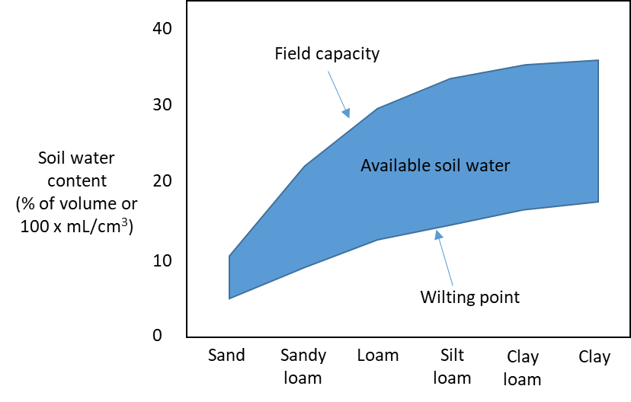
The field capacity indicates the point where the soil is holding as much water as it can after gravity has drained any free water. In contrast, the permanent wilting point is when the soil contains so little water that the tension with which it is held to the surfaces of soil particles is too high for the trees to extract (often about 1500kPa).
For 3-PG, the field capacity indicates the maximum ASW, while the permanent wilting point indicates the minimum ASW of 0 mm. Some sites may have a minimum ASW > 0 mm when trees have access to a deeper water source or when the soils are irrigated to prevent the minimum ASW from reaching 0 mm.
While field capacity and wilting point can be measured in the field. ASW can also be calculated as a function of various soil properties using pedo-transfer functions. However, it is also possible to calculate the maximum ASW from the soil texture and the water holding capacity of the given soil texture. The water holding capacity shown in the table below can be used for 3-PG purposes, and similar values can be found in forestry and agricultural guidelines.

Table 28 Examples of wilting points, field capacity and water holding capacity of several soil textures
Soil texture | Wilting point (% volume) | Field capacity (% volume) | Available water holding capacity
 |  |  | (% volume) | mm/m | mm/m*
Sand |  |  |  |  | 83
Loamy sand | 6 | 16 | 10 | 100 | 100
Sandy loam | 8 | 22 | 14 | 140 | 125
Fine sandy loam |  |  |  |  | 142
Loam | 12 | 30 | 18 | 180 | 175
Sandy clay loam | 13 | 29 | 16 | 160
Silt loam | 10 | 30 | 20 | 200 | 208
Clay loam | 16 | 36 | 20 | 200 | 200
Silty clay loam | 18 | 40 | 22 | 220
Sandy clay | 20 | 37 | 17 | 170
Silt clay | 25 | 46 | 21 | 210
Clay | 23 | 42 | 19 | 190 | 200
Source: (Alberta Agriculture Food and Rural Development, 2004, Bhattacharya, 2019) *Source: (Ministry of Agriculture British Columbia, 2015)

To estimate the ASW using the water holding capacity in the table above, it is necessary to know the texture and thickness (depth) of each soil horizon (sometimes there might only be one horizon). In addition, if there are lots of stones in the soil, the proportional volume of each horizon that is composed of gravel or stones (e.g. that will not pass through a 2-mm sieve) because this volume cannot hold any water and needs to be accounted for. Any soil horizons below the root zone where you cannot find tree roots can be ignored because this water is not available to the trees.
ASW of a given soil horizon = horizon depth (m) x water holding capacity (mm/m) x (1-proportion stones)
For example, the maximum ASW for a soil with 2 horizons:
- Horizon 1 is a 0.3 m thick Loam without any stones = 0.3 m x 180 mm/m = 55 mm
- Horizon 2 is a 0.8 m thick Sandy Clay with 10% stones = 0.8 m x 170 mm/m x (1-0.1) = 122.4 mm
Therefore, the maximum ASW = 55 + 122.4 = 177.4 mm.

Table 28 Symbols and abbreviations used within this document
Symbol / Abbreviation | Name in r3PG Fortran code | 3-PG species parameter | Description | Units
a | aFracDiffu | * | fractionation against ¹³C in diffusion through air (4.4‰) | per mil
AGB_{P,ret} |  |  | Proportion of aboveground biomass retained after thinning
a_{H} | aH | * | Parameter of height equation
a_{HL} | aHL | * | Parameter of crown ratio equation
a_{K} | aK | * | Parameter of crown diameter equation
a_{V} | aV | * | Constant in the stem volume relationship
a_{WS} | aWS | * | Constant in the stem mass v. diam. relationship
B | dbh |  | Quadratic mean stem diameter at breast height | cm
b | bFracRubi | * | enzymatic fractionation by Rubisco (27‰) | per mil
BA | basal_area or basal_area_total |  | Basal area | m² ha⁻¹
BA_{lost} |  |  | Basal area lost per month due to background mortality | m² ha⁻¹
BIAS_{rel} | DrelBias…. |  | relative bias that results from Jensen's inequality
B_{st} | dbh_total |  | Quadratic mean stem diameter of the whole stand | cm
C | competition_total |  | Competition index calculated from basal area and wood specific gravity | m² ha⁻¹ x Mg m⁻³
c_{a} |  |  | molar fraction of CO₂ in the air
calculate_d13c |  |  | setting. '0' = do not calculate; '1' = calculate
crown_width_model |  |  | setting, '1' = exponential form; '2' = Michajlow form; '3' = Näslund form
CrownShape | CrownShape |  | cone = 1, ellipsoid = 2, half-elipsoid = 3, rectangular = 4
CV | CV… |  | coefficient of variation of independent variable when calculating Jensen's inequality
c_{θ} | SWconst | * | Moisture ratio deficit for f_{θ} = 0.5 (can be provided as species parameter, but this will only be used if it wasn’t provided as a site parameter)
D | vpd_day, VPD_sp |  | Mean daytime VPD | mbar
D_{c} | VPD_sp |  | VPD within the canopy
d_{f} | frost_days |  | Number of frost days per month | days
dN | mort_thinn_total |  | Change in total stand N per month due to background mortality | trees per ha
dN_{cohort} | stems_loss_density |  | Change in N per month for a cohort due to background mortality | trees per ha
D_{q} |  |  | specific saturation deficit (6.22 ´ 10⁻⁴ ´ VPD)
E_{T} | evapo_transp |  | Evapotranspiration rate in current period | mm (= kg per m2)
ɛ_{sp} | D13CTissueDif | * | difference between mean annual δ¹³C of new photosynthate and δ¹³C of tree rings
f | sum( max(fi(:), 1d-12) ) |  | Fraction of photosynthetically active radiation (ϕ_{p}) that is absorbed by the canopy
f_{AGE} | f_age |  | Dimensionless growth modifier quantifying the effect of age
f_{Cg} | f_cg |  | Dimensionless canopy conductance modifier quantifying the effect of atmospheric CO₂
f_{Cg700} | fCg700 | * | Canopy conductance enhancement factor when CO₂ = 700 ppm
f_{Cα} | f_calpha |  | Dimensionless growth modifier quantifying the effect of atmospheric CO₂
f_{Cα700} | fCalpha700 | * | Assimilation enhancement factor when CO₂ = 700 ppm
f_{D} | f_vpd |  | Dimensionless growth modifier quantifying the effect of vapour pressure deficit
f_{F} | f_frost |  | Dimensionless growth modifier quantifying the effect of frost
f_{gT} | f_tmp_gc |  | Dimensionless canopy conductance modifier quantifying the effect of temperature
f_{N} | f_nutr |  | Dimensionless growth modifier quantifying the effect of soil nutrition
f_{N0} | fN0 | * | Value of f_{N} when FR = 0
f_{Nlt} | lt_fN_ave |  | Long-term dimensionless growth modifier quantifying the effect of soil nutrition, averaged across all cohorts (weighted by their contribution to stand basal area)
FR | fertility |  | Soil fertility rating
f_{T} | f_tmp |  | Dimensionless growth modifier quantifying the effect of temperature
f_{Tlt} | lt_fT_ave |  | Long-term dimensionless growth modifier quantifying the effect of temperature, averaged across all cohorts (weighted by their contribution to stand basal area)
f_{θ} | f_sw |  | Dimensionless growth modifier quantifying the effect of soil moisture
g_{B} | BLcond | * | aerodynamic conductance (boundary layer conductance) | m s⁻¹
g_{c} | conduct_canopy |  | Canopy conductance | m s⁻¹
g_{cmax} | MaxCond | * | Maximum canopy conductance | m s⁻¹
g_{cmin} | MinCond | * | Minimum canopy conductance | m s⁻¹
GPP | GPP |  | Gross primary productivity | tDM ha-1
g_{soil} | conduct_soil |  | Soil conductance | m s-1
g_{soilx} | MaxSoilCond |  | Maximum soil conductance | m s-1
h | height |  | Height of a cohort | m
h_{0.5} | Height_max / 2.d0 |  | half the height of the tallest species within the stand | m
h_{b} | Heightcrown |  | Height of the bottom of the live crown | m
H_{d} | Hd | * | Height of the diameter measurements for allometric equations | m
height_model |  |  | setting, '1' = exponential form; '2' = Michajlow form; '3' = Näslund form
h_{L} | height_wtav_LAI |  | Weighted average (by L) height of all cohorts in a stand
h_{m} | Heightmidcrown |  | Mid-crown height (mid point between tree height and the bottom of the live crown h_{b}) | m
I_{R} | prcp_interc_fract |  | Fraction of rainfall intercepted by the canopy for a single cohort
I_{R} | MaxIntcptn | * | Maximum proportion of rainfall evaporated from canopy
I_{RT} | prcp_interc_fract |  | Fraction of rainfall intercepted by canopy by all cohorts
K | crown_width |  | Crown diameter | m
k or k_{H} | k | * | Extinction coefficient for absorption of PAR by canopy (k_{H} is for a homogeneous canopy)
k_{D} | CoeffCond | * | Defines stomatal response to VPD | 1/mBar
k_{F} | kF | * | Days production lost per frost day | days
L | lai |  | Leaf area index | m² m⁻²
L₅₀ | cVPD | * | LAI for 50% reduction of VPD in canopy | m² m⁻²
L_{A} | lai(:) * 10000.d0 / stems_n(:) |  | Mean tree leaf area | m²/tree
L_{above} | lai_above |  | L of all layers above the layer in which the given cohort is in | m² m⁻²
LCR | aHL |  | Live crown ratio (live-crown length / height)
leaf_{L} | leaffall | * | If deciduous, leaves all fall at start of this month | month
leaf_{P} | leafgrow | * | If deciduous, leaves are produced at end of this month | month
L_{gcmax} | LAIgcx | * | LAI for maximum canopy conductance | m² m⁻²
light_model |  |  | setting, '1' = 3-PG_{pjs} (default); '2' = 3-Pgmix
L_{Ix} | LAImaxIntcptn | * | LAI for maximum rainfall interception | m² m⁻²
L_{mix} |  |  | Cohort L / sp_{L} | m² m⁻²
loc | ...WeibullLocation |  | location parameter of Weibull distribution
loc_{B0} | Dlocation0 | * | Constant in the relationship for Weibull location parameter of D distribution
loc_{BB} | DlocationB | * | Slope of DBH in relationship for Weibull location parameter of D distribution
loc_{BC} | DlocationC | * | Slope of competition in relationship for Weibull location parameter of D distribution
loc_{Brh} | Dlocationrh | * | Slope of relative height in relationship for Weibull location parameter of D distribution
loc_{Bt} | Dlocationt | * | Slope of age in relationship for Weibull location parameter of D distribution
L_{prop} | lai_per |  | Proportion of stand L contributed by the cohort
m₀ | m0 | * | Value of 'm' when FR = 0
m_{APAR} | m_apar |  | ϕ_{pa} multiplier to redistribute unabsorbed PAR ϕ_{p} to short cohorts
m_{F} | mF | * | Mean single-tree foliage biomass of trees that die due to background mortality relative to that of the mean tree
m_{Ft} | manag_remove_prop_compartment | * | Mean single-tree foliage biomass of removed trees relative to that of the mean tree prior to thinning
m_{R} | mR | * | Mean single-tree stem biomass of trees that die due to background mortality relative to that of the mean tree
m_{Rt} | manag_remove_prop_compartment | * | Mean single-tree root biomass of removed trees relative to that of the mean tree prior to thinning
m_{S} | mS | * | Mean single-tree root biomass of trees that die due to background mortality relative to that of the mean tree
m_{St} | manag_remove_prop_compartment | * | Mean single-tree stem biomass of removed trees relative to that of the mean tree prior to thinning
N | stems_n |  | Tree density | trees per ha
n_{age} | nAge | * | Power of relative age in function for f_{AGE}
N_{class} |  |  | number of trees per ha within a given B or w_{s} class
n_{fN} | fNn | * | Power of (1-FR) in f_{N}
n_{fN} | st_fN |  | Power in fertility modifier (mort_model = 2)
n_{fPhys} | st_fPhys |  | Power in physmod modifier (mort_model = 2)
n_{fT} | st_fT |  | Power in temperature modifier (mort_model = 2)
n_{H1} | nH1 | * | Parameter of height equation
n_{H2} | nH2 | * | Parameter of height equation
n_{H3} | nH3 | * | Parameter of height equation
n_{H4} | nH4 | * | Parameter of height equation
n_{HL1} | nHL1 | * | Parameter of crown ratio equation
n_{HL2} | nHL2 | * | Parameter of crown ratio equation
n_{HL3} | nHL3 | * | Parameter of crown ratio equation
n_{HL4} | nHL4 | * | Parameter of crown ratio equation
n_{int} | st_Intercept |  | Intercept for self-thinning rule (mort_model = 2) | ln(trees ha-1)
n_{K1} | nK1 | * | Parameter of crown diameter equation
n_{K2} | nK2 | * | Parameter of crown diameter equation
n_{K3} | nK3 | * | Parameter of crown diameter equation
n_{K4} | nK4 | * | Parameter of crown diameter equation
n_{m} | thinPower | * | Power in self-thinning rule (mort_model = 1)
n_{m} | st_Power |  | Power in self-thinning rule (mort_model = 2)
N_{mix} |  |  | N adjusted using sp to represent a single cohort in a multi-cohort stand | trees per ha
N_{P.rem} | manag_remove_prop |  | proportion of trees removed by thinning
N_{post} | stems_n |  | N after thinning | trees ha⁻¹
NPP | NPP |  | Net primary productivity | tDM ha-1
N_{pre} | stems_n |  | N before thinning | trees ha⁻¹
n_{VB} | nVB | * | Power of DBH in the stem volume relationship
n_{VBH} | nVBH | * | Power of DBH^2 x height in the stem volume relationship
n_{VH} | nVH | * | Power of height in the stem volume relationship
n_{WS} | nWS | * | Power in the stem mass v. diam. relationship
n_{θ} | SWpower | * | Power of moisture ratio deficit (can be provided as species parameter, but this will only be used if it wasn’t provided as a site parameter)
PAR | RADt |  | Photosynthetically active radiation | µmol photons m⁻² s⁻¹, or MJ m⁻² month⁻¹
p_{BB} | fracBB |  | Fraction of ws that is branch and bark
P_{carbs} | prop_carbs |  | proportion of adjusted pre-fire foliage mass W_{F,pre,adj} that can be used to produce new foliage (W_{F}) + stem (W_{S}) biomass in the first year after the fire
p_{FS} | pFS |  | Ratio of η_{F} and η_{S}
p_{FS2} | pFS2 | * | Ratio of η_{F} and η_{S} at a B of 2 cm
p_{FS20} | pFS20 | * | Ratio of η_{F} and η_{S} at a B of 20 cm
P_{G} | GPP |  | Gross primary productivity | tDM ha⁻¹
phys_model |  |  | setting, '1' = 3-PG_{pjs} (default), min of f_{d} and f_{θ}; '2' = 3-PG_{mix}, f_{d} x f_{θ}
P_{npp} | prop_npp |  | proportion of new photosynthesis that will be partitioned to foliage biomass
Pη_{SR} |  |  | proportional change in stem and root partitioning following defoliation
Q_{a} | Qa |  | Intercept of net v. solar radiation relationship | W m⁻²
Q_{b} | Qb |  | Slope of net v. solar radiation relationship
r_{a} | aero_resist |  | aerodynamic resistance | s m⁻¹
r_{age} | rAge | * | Relative age to give f_{AGE} = 0.5
r_{a}^{soil} |  |  | aerodynamic resistance above the soil | s m⁻¹
R_{GcGw} | RGcGw | * | The ratio of diffusivities of CO2 and water vapour in air
rh_{L} | height_rel_wt |  | Height of a cohort relative to the weighted average (by L) height of all cohorts.
R_{Ir} | irrig_supl |  | Supplemental irrigation | mm
R_{P} | prcp |  | Precipitation | mm
s | e20 |  | The slope of saturated vapour pressure versus temperature curve at a temperature of 20°C
S_{A} | CrownSA |  | Mean tree crown surface area | m²/tree
sc | ...WeibullShape |  | scale parameter of Weibull distribution
sc_{B0} | Dscale0 | * | Constant in the relationship for Weibull scale parameter of D distribution
sc_{BB} | DscaleB | * | Slope of DBH in relationship for Weibull scale parameter of D distribution
sc_{BC} | DscaleC | * | Slope of competition in relationship for Weibull scale parameter of D distribution
sc_{Brh} | Dscalerh | * | Slope of relative height in relationship for Weibull scale parameter of D distribution
sc_{Bt} | Dscalet | * | Slope of age in relationship for Weibull scale parameter of D distribution
sh | ...WeibullScale |  | shape parameter of Weibull distribution
sh_{B0} | Dshape0 | * | Constant in the relationship for Weibull shape parameter of D distribution
sh_{BB} | DshapeB | * | Slope of DBH in relationship for Weibull shape parameter of D distribution
sh_{BC} | DshapeC | * | Slope of competition in relationship for Weibull shape parameter of D distribution
sh_{Brh} | Dshaperh | * | Slope of relative height in relationship for Weibull shape parameter of D distribution
sh_{Bt} | Dshapet | * | Slope of age in relationship for Weibull shape parameter of D distribution
sizeclass |  |  | the diameter or w_{s} size class
SLA | SLA |  | Specific leaf area | m² kg⁻¹
sp |  |  | The proportion of a stand (in terms of L, basal area etc) that is a given cohort
SR | coppice_sr_ratio |  | Stem biomass to root biomass ratio immediately prior to a coppice defoliation event.
t | age |  | Age | years
T_{a} | tmp_ave |  | Mean monthly temperature | deg. C
t_{C} | fullCanAge | * | The age at which the canopy closes | years
T_{max} | Tmax | * | Maximum temperature for growth | deg. C
T_{min} | Tmin | * | Minimum temperature for growth | deg. C
T_{opt} | Topt | * | Optimum temperature for growth | deg. C
transp_model |  |  | setting, '1' = 3-PG_{pjs} (default); '2' = 3-Pgmix
t_{x} | MaxAge | * | Maximum stand age used in age modifier | years
t_{γF} | tgammaF | * | Age at which litterfall rate is ½(γ_{F0} + γ_{F1}) | months
t_{γN} | tgammaN |  | Age at which mortality rate has median value | years
t_{ρ} | tRho | * | Age at which rho = (rhoMin+rhoMax)/2 | years
t_{ρ} | tBB | * | Age at which ρ = ½( ρ₀ + ρ₁) | years
t_{σ} | tSLA | * | Age at which σ = (σ₀+σ₁)/2 | years
v_{frac} | canopy_vol_frac |  | Sum of the crown volume (m³) of all crowns within a given layer within one hectare, divided by the total volume of that layer (m³)
VPD | vpd_day, VPD_sp |  | Vapour pressure deficit | mbar
V_{S} | volume |  | Stand volume | m³ ha⁻¹
W_{F} | biom_foliage |  | Foliage biomass | tDM ha-1
W_{F,pre,adj} | biom_foliage_adj_pre_def |  | Foliage mass of the trees that survived the defoliation event (adjusted for trees that were killed) | tDM ha-1
w_{i} | weight |  | Weighting calculated using a relative height weighted by leaf area index, which is used to distribute background mortality between cohorts
W_{R} | biom_root |  | Root biomass | tDM ha-1
W_{R,loss} |  |  | Root biomass lost due to natural root pruning after recovering from a coppice defoliation event if the stem to root mass ratio is still lower than it was before defoliation | tDM ha-1
W_{S} | biom_stem |  | Stem biomass, including branches and bark | tDM ha-1
W_{S,post} | biom_stem |  | stem biomass after thinning | tDM ha-1
W_{S,pre} | biom_stem |  | stem biomass before thinning | tDM ha-1
w_{Sx} | biom_tree_max |  | Maximum stem mass per tree @ N (mort_model = 1) | kg/tree
w_{Sx1000} | wSx1000 | * | Maximum stem mass per tree @ N = 1000 trees/hectare (mort_model = 1) | kg/tree
Y | Y | * | Ratio NPP/GPP
z_{adj} |  |  | Zenith angle
α_{C} | alpha_c |  | Quantum canopy efficiency (after applying the growth modifiers) | mol C mol-1 PAR
α_{Cx} | alphaCx | * | Maximum quantum canopy efficiency (before applying the growth modifiers) | mol C mol-1 PAR
ϐ₀ | beta0 |  | constant for self-thinning (mort_model = 3)
ϐ₁ | betaB |  | Power for B (mort_model = 3)
ϐ₂ | betaN |  | Power in tree density (mort_model = 3)
ϐ₃ | betafN |  | Power in nutrition modifier (mort_model = 3)
ϐ₄ | betafT |  | Power in temperature modifier (mort_model = 3)
ϐ₅ | betafPhys |  | Power in physmod modifier (mort_model = 3)
γ | gammaAPAR | * | Parameter to amplify light benefit to shorter cohorts
γ_{F} | gammaF | * | Average monthly litterfall rate (Fraction of W_{F} that falls as litter per month) | 1/month
γ_{F0} | gammaF0 | * | Litterfall rate at t = 0 | 1/month
γ_{F1} | gammaF1 | * | Maximum litterfall rate | 1/month
γ_{N} | ngammaN |  | Shape of mortality response | -
γ_{N0} | gammaN0 |  | Seedling mortality rate (t = 0) | %/year
γ_{N1} | gammaN1 |  | Mortality rate for large t | %/year
γ_{R} | gammaR | * | Average monthly root turnover rate | 1/month
δ¹³C_{a} | d13Catm |  | δ¹³C_{a} of atmospheric CO₂ | per million
δ¹³C_{s} | D13CNewPS |  | δ¹³C of tree rings
ε | epsilon |  | Light use efficiency (GPP / ϕ_{pa}) | gDM MJ-1
ζ | canopy_cover |  | Fraction of ground area covered by canopy
η_{F} | npp_fract_foliage |  | Fraction of NPP partitioned to foliage biomass
η_{F2} | npp_fract_foliage |  | Fraction of NPP partitioned to foliage biomass following defoliation
η_{FS} |  |  | Fraction of NPP partitioned to foliage + stem biomass following defoliation
η_{R} | npp_fract_root |  | Fraction of NPP partitioned to root biomass
η_{R2} | npp_fract_root |  | Fraction of NPP partitioned to stem biomass following defoliation
η_{Rn} | pRn | * | Minimum fraction of NPP to roots
η_{Rx} | pRx | * | Maximum fraction of NPP to roots
η_{S} | npp_fract_stem |  | Fraction of NPP partitioned to stem biomass
η_{S2} | npp_fract_stem |  | Fraction of NPP partitioned to root biomass following defoliation
θ_{S} | ASW |  | Available soil water | mm
θ_{Sx} | asw_max |  | Maximum available soil water | mm
λ | lambda |  | latent heat of vaporisation of water (2.46 ´ 10⁶ J kg⁻¹) | 2.46 x 10⁶ J kg⁻¹
λ_{h} | lambda_h |  | Constant used to account for horizontal canopy heterogeneity
λ_{v} | lambda_v |  | Constant used to account for vertical canopy heterogeneity
ρ | wood_density |  | Wood basic density | Mg m⁻³ = g cm⁻³
ρ₀ | rhoMin | * | Minimum basic density - for young trees | Mg m⁻³ = g cm⁻³
ρ₀ | fracBB0 | * | Branch and bark fraction at age 0
ρ₁ | rhoMax | * | Maximum basic density - for older trees | Mg m⁻³ = g cm⁻³
ρ₁ | fracBB1 | * | Branch and bark fraction for mature stands
ρ_{a} | rhoAir |  | air density | 1.2 kg m⁻³
σ | SLA |  | Specific leaf area | m² kg⁻¹
σ₀ | SLA0 | * | Specific leaf area at age 0 | m² kg⁻¹
σ₁ | SLA1 | * | Specific leaf area for mature leaves | m² kg⁻¹
φ | f_phys |  | Dimensionless growth modifier quantifying the effect soil moisture, vapour pressure deficit and age
φ’_{lt} | lt_fPhys_ave |  | Long-term dimensionless growth modifier quantifying the effect soil moisture, vapour pressure deficit (not age), averaged across all cohorts (weighted by their contribution to stand basal area)
ϕ_{n} | netRad |  | total net radiation | W m⁻²
ϕ_{p} | RADt |  | Photosynthetically active radiation | µmol photons m⁻² s⁻¹, or MJ m⁻² month⁻¹
ϕ_{p,above} | RADt |  | Photosynthetically active radiation above the canopy | µmol photons m⁻² s⁻¹, or MJ m⁻² month⁻¹
ϕ_{p,stand} | sum( apar(:) ) |  | Sum of the ϕ_{pa,final} of all cohorts within a stand | µmol photons m⁻² s⁻¹, or MJ m⁻² month⁻¹
ϕ_{pa} | apar |  | Absorbed photosynthetically active radiation | MJ m-2 month-1
ϕ_{pa,final} | apar |  | ϕ_{pa} after aplying m_{APAR} | µmol photons m⁻² s⁻¹, or MJ m⁻² month⁻¹
 |  |  | Mean daily solar radiation above the canopy over the time period Δt | MJ m⁻²d⁻¹
 | def_recover_t |  | Maximum time to recover from defoliation. After this time growth is only from npp (not non-structural carbohydrates), and biomass partitioning returns to normal. | months
 | lt_mod_mths |  | Number of months considered to be long-term when calculating the long-term average modifier values for density-dependent mortality | months

Acknowledgements
Thanks to XX and XX for comments on an earlier draft of this report. This work was funded by Department of Climate Change, Energy, the Environment and Water (Canberra), CSIRO and the Terrestrial Ecosystem Research Network (TERN), an Australian Government NCRIS-enabled project (project number).

References
Alberta Agriculture Food and Rural Development. (2004). Procedures manual for the classification of land for irrigation in Alberta. pp. 90.
Almeida, A. C., Sands, P. J., Bruce, J., Siggins, A. W., Leriche, A., Battaglia, M. and Batista, T. R. (2009). Use of a spatial process-based model to quantify forest plantation productivity and water use efficiency under climate change scenarios. In R. S. Anderssen, R. D. Braddock and L. T. H. Newham (Eds.), Interfacing Modelling and Simulation with Mathematical and Computational Sciences. Modelling and Simulation Society of Australia and New Zealand and International Association for Mathematics and Computers in Simulation, Cairns, Australia, pp. 1816-1822.
Almeida, A. C., Siggins, A., Batista, T. R., Beadle, C., Fonseca, S. and Loos, R. (2010). Mapping the effect of spatial and temporal variation in climate and soils on Eucalyptus plantation production with 3-PG, a process-based growth model. Forest Ecology and Management, 259, 1730-1740.
Almeida, A. C., Soares, J. V., Landsberg, J. J. and Rezende, G. D. (2007). Growth and water balance of Eucalyptus grandis hybrid plantations in Brazil during a rotation for pulp production. Forest Ecology and Management, 251, 10-21.
Almeida, A. C. d., Landsberg, J. J. and Sands, P. J. (2004). Parameterisation of 3-PG model for fast-growing Eucalyptus grandis plantations. Forest Ecology and Management, 193, 179-195.
André, F., Jonard, M. and Ponette, Q. (2008). Precipitation water storage capacity in a temperate mixed oak-beech canopy. Hydrological Processes, 22, 4130-4141.
Bhattacharya, A. (2019). Water-use efficiency under changing climatic conditions. In: A. Bhattacharya (Ed.), Changing climate and resource use efficiency in plants, pp. 111-180.
Bi, H. (2001). The Self-Thinning Surface. Forest Science, 47, 361-370.
Bi, H. (2004). Stochastic Frontier analysis of a classic self-thinning experiment. Austral Ecology, 29, 408-417.
Binkley, D. (2012). Understanding the role resource use efficiency in determining the growth of trees and forests. In: T. Schlichter and L. Montes (Ed.), Forests in Development: A Vital Balance, pp. 13-26. Springer Netherlands,
Binkley, D., Campoe, O. C., Gspaltl, M. and Forrester, D. I. (2013). Light absorption and use efficiency in forests: Why patterns differ for trees and stands. Forest Ecology and Management, 288, 5-13.
Binkley, D., Stape, J. L. and Ryan, M. G. (2004). Thinking about efficiency of resource use in forests. Forest Ecology and Management, 193, 5-16.
Boukhris, I., Lahssini, S., Collalti, A., Moukrim, S., Santini, M., Chiti, T. and Valentini, R. (2023). Calibrating a process-based model to enhance robustness in carbon sequestration simulations: The case of Cedrus atlantica (Endl.) Manetti ex Carrière. Forests, 14, 401.
Bouwman, M., Forrester, D. I., Ouden, J. d., Nabuurs, G.-J. and Mohren, G. M. J. (2021). Species interactions under climate change in mixed stands of Scots pine and pedunculate oak. Forest Ecology and Management, 481, 118615.
Brunner, A. (1998). A light model for spatially explicit forest stand models. Forest Ecology and Management, 107, 19-46.
Canham, C., Coates, K. D., Bartemucci, P. and Quaglia, S. (1999). Measurement and modeling of spatially explicit variation in light transmission through interior cedar-hemlock forests of British Columbia. Canadian Journal of Forest Research, 29, 1775-1783.
Cannell, M. G. R., Milne, R., Shepphard, L. J. and Unsworth, M. A. (1987). Radiation interception and productivity of willow. Journal of Applied Ecology, 24, 261-278.
Collalti, A. and Prentice, I. C. (2019). Is NPP proportional to GPP? Waring’s hypothesis 20 years on. Tree Physiology, 39, 1473-148.
Condés, S., Vallet, P., Bielak, K., Bravo-Oviedo, A., Coll, L., Ducey, M. J., Pach, M., Pretzsch, H., Sterba, H., Vayreda, J. and Río, M. d. (2017). Climate influences on the maximum size-density relationship in Scots pine (Pinus sylvestris L.) and European beech (Fagus sylvatica L.) stands. Forest Ecology and Management, 385, 295-307.
Duursma, R. A. and Mäkelä, A. (2007). Summary models for light interception and light-use efficiency of non-homogeneous canopies. Tree Physiology, 27, 859-870.
Duursma, R. A. and Medlyn, B. E. (2012). MAESPA: a model to study interactions between water limitation, environmental drivers and vegetation function at tree and stand levels, with an example application to [CO₂] × drought interactions. Geoscientific Model Development, 5, 919-940.
Dye, P. J., Jacobs, S. and Drew, D. (2004). Verification of 3-PG growth and water-use predictions in twelve Eucalyptus plantation stands in Zululand, South Africa. Forest Ecology and Management, 193, 197-218.
Esprey, L. J., Sands, P. J. and Smith, C. W. (2004). Understanding 3-PG using a sensitivity analysis. Forest Ecology and Management, 193, 235-250.
Farquhar, G. D., Oleary, M. H. and Berry, J. A. (1982). On the relationship between carbon isotope discrimination and the inter-cellular carbon-dioxide concentration in leaves. Australian Journal of Plant Physiology, 9, 121-137.
Feikema, P. M., Morris, J. D., R.Beverly, C., Collopy, J. J., Baker, T. G. and Lane, P. N. J. (2010). Validation of plantation transpiration in south-eastern Australia estimated using the 3PG+ forest growth model. Forest Ecology And Management, 260, 663-678.
Forrester, D. I. (2013). Growth responses to thinning, pruning and fertiliser application in Eucalyptus plantations: A review of their production ecology and interactions. Forest Ecology and Management, 310, 336-347.
Forrester, D. I. (2014a). The spatial and temporal dynamics of species interactions in mixed-species forests: From pattern to process. Forest Ecology and Management, 312, 282-292.
Forrester, D. I. (2014b). A stand-level light interception model for horizontally and vertically heterogeneous canopies. Ecological Modelling, 276, 14-22.
Forrester, D. I. (2019). Linking forest growth with stand structure: Tree size inequality, tree growth or resource partitioning and the asymmetry of competition. Forest Ecology and Management, 447, 139-157.
Forrester, D. I. (in prep-a). Background mortality and carrying capacity of Australian vegetation for the 3-PG model.
Forrester, D. I. (in prep-b). Calibrating 3-PG and FullCAM for Australian native vegetation.
Forrester, D. I. (in prep-c). Tree and shrub biomass equations for Australian vegetation.
Forrester, D. I., Ammer, C., Annighöfer, P. J., Avdagic, A., Barbeito, I., Bielak, K., Brazaitis, G., Coll, L., Río, M. d., Drössler, L., Heym, M., Hurt, V., Löf, M., Matović, B., Meloni, F., Ouden, J. d., Pach, M., Pereira, M. G., Ponette, Q., Pretzsch, H., Skrzyszewski, J., Stojanović, D., Svoboda, M., Ruiz-Peinado, R., Vacchiano, G., Verheyen, K., Zlatanov, T. and Bravo-Oviedo, A. (2017a). Predicting the spatial and temporal dynamics of species interactions in Fagus sylvatica and Pinus sylvestris forests across Europe Forest Ecology and Management, 405, 112-133.
Forrester, D. I., Benneter, A., Bouriaud, O. and Bauhus, J. (2017b). Diversity and competition influence tree allometric relationships – developing functions for mixed-species forests. Journal of Ecology, 105, 761-774.
Forrester, D. I., Guisasola, R., Tang, X., Albrecht, A. T., Dong, T. L. and le Maire, G. (2014). Using a stand-level model to predict light absorption in stands with vertically and horizontally heterogeneous canopies. Forest Ecosystems, 1, 17.
Forrester, D. I., Hobi, M. L., Mathys, A. S., Stadelmann, G. and Trotsiuk, V. (2021a). Calibration of the process-based model 3-PG for major central European tree species. European Journal of Forest Research, 140, 847-868.
Forrester, D. I., Mathys, A. S., Stadelmann, G. and Trotsiuk, V. (2021b). Effects of climate on the growth of Swiss uneven-aged forests: combining > 100 years of observations with the 3-PG model. Forest Ecology and Management, 494, 119271.
Forrester, D. I., Schmid, H. and Nitzsche, J. (2022). Growth and structural changes in Swiss uneven-aged forests over 100 years, and comparisons between 15 uneven-aged forest types of Europe, North America and Australia. Forestry, 95, 166-186.
Forrester, D. I. and Tang, X. (2016). Analysing the spatial and temporal dynamics of species interactions in mixed-species forests and the effects of stand density using the 3-PG model. Ecological Modelling, 319, 233-254.
Forrester, D. I. and Trotsiuk, V. (in prep). Simulating forest growth responses to defoliation using the 3-PG model: events relating to pruning, fire and coppicing.
Furze, M. E., Huggett, B. A., Aubrecht, D. M., Stolz, C. D., Carbone, M. S. and Richardson, A. D. (2019). Whole-tree nonstructural carbohydrate storage and seasonal dynamics in five temperate species. New Phytologist, 221, 1466-1477.
Gonzalez-Benecke, C. A., Jokela, E. J., Cropper Jr, W. P., Bracho, R. and Leduc, D. J. (2014). Parameterization of the 3-PG model for Pinus elliottii stands using alternative methods to estimate fertility rating, biomass partitioning and canopy closure. Forest Ecology and Management, 327, 55-75.
Gonzalez-Benecke, C. A., Teskey, R. O., Martin, T. A., Jokela, E. J., Fox, T. R., Kane, M. B. and Noormets, A. (2016). Regional validation and improved parameterization of the 3-PG model for Pinus taeda stands. Forest Ecology and Management, 361, 237-256.
González-García, M., Almeida, A. C., Hevia, A., Majada, J. and Beadle, C. L. (2016). Application of a process-based model for predicting the productivity of Eucalyptus nitens bioenergy plantations in Spain. GCB Bioenergy, 8, 194-210.
Grace, J. C., Jarvis, P. G. and Norman, J. M. (1987). Modelling the interception of solar radiant energy in intensively managed stands. New Zealand Journal of Forest Science, 17, 193-209.
Gupta, R. and Sharma, L. K. (2019). The process-based forest growth model 3-PG for use in forest management: A review. Ecological Modelling, 397, 55-73.
Hammer, G. L. and Rosenthal, K. M. (1978). Frost and minimum temperature probabilities. Queensland Agricultural Journal, 104, 177-201.
Hartig, F., Dyke, J., Hickler, T., Higgins, S. I., O’Hara, R. B., Scheiter, S. and Huth, A. (2012). Connecting dynamic vegetation models to data – an inverse perspective. Journal of Biogeography, 39, 2240-2252.
Hatton, T. J., Walker, J., Dawes, W. R. and Dunin, F. X. (1992). Simulations of hydroecological responses to elevated CO₂ at the catchment scale. Australian Journal of Botany, 40, 679-696.
Hynynen, J. (1993). Self-thinning models for even-aged stands of Pinus sylvestris, Picea abies and Betula pendula. Scandinavian Journal of Forest Research, 8, 326-336.
Jarvis, P. G. (1976). The interpretation of the variations in leaf water potential and stomatal conductance round in canopies in the field. Philosophical Transactions of the Royal Society of London B, 273, 593-610.
Landsberg, J., Mäkelä, A., Sievänen, R. and Kukkola, M. (2005). Analysis of biomass accumulation and stem size distributions over long periods in managed stands of Pinus sylvestris in Finland using the 3-PG model. Tree Physiology, 25, 781-792.
Landsberg, J. and Sands, P. (2011a). The 3-PG Process-Based Model. In: (Ed.), Physiological ecology of forest production: Principles, processes and models, pp. 241-282. Elsevier, Amsterdam.
Landsberg, J. and Sands, P. (2011b). Hydrology and plant water relations. In: (Ed.), Physiological ecology of forest production: Principles, processes and models, pp. 185-219. Elsevier, Amsterdam.
Landsberg, J. and Sands, P. (2011c). Physiological ecology of forest production: Principles, processes and models. Elsevier, Amsterdam, pp. 352.
Landsberg, J. J. and Gower, S. T. (1997). Applications of physiological ecology to forest management. Academic Press, San Diego, pp. 354
Landsberg, J. J. and Waring, R. H. (1997). A generalised model of forest productivity using simplified concepts of radiation-use efficiency, carbon balance and partitioning. Forest Ecology and Management, 95, 209-228.
Landsberg, J. J., Waring, R. H. and Coops, N. C. (2002). Performance of the forest productivity model 3-PG applied to a wide range of forest types. Forest Ecology and Management, 1-16.
Landsberg, J. J., Waring, R. H. and Coops, N. C. (2003). Performance of the forest productivity model 3-PG applied to a wide range of forest types. Forest Ecology and Management, 172, 199-214.
Law, B. E., Waring, R. H., Anthoni, P. M. and Aber, J. D. (2000). Measurements of gross and net productivity and water vapor exchange of a Pinus ponderosa ecosystem, and an evaluation of two generalized models. Global Change Biology, 6, 155-168.
le Maire, G., Guillemot, J., Campoe, O. C., Stape, J.-L., Laclau, J.-P. and Nouvellon, Y. (2019). Light absorption, light use efficiency and productivity of 16 contrasted genotypes of several Eucalyptus species along a 6-year rotation in Brazil. Forest Ecology and Management, 449, 117443.
Ligot, G., Ameztegui, A., Courbaud, B., Coll, L. and Kneeshaw, D. (2016). Tree light capture and spatial variability of understory light increase with species mixing and tree size heterogeneity. Canadian Journal of Forest Research, 46, 968-977.
Marqués, L., Weng, E., Bugmann, H., Forrester, D. I., Rohner, B., Hobi, M. L., Trotsiuk, V. and Stocker, B. D. (2023). Tree growth enhancement drives a persistent biomass gain in unmanaged temperate forests. AGU Advances, 4, e2022AV000859.
Matula, R., Šrámek, M., Kvasnica, J., Uherková, B., Slepička, J., Matoušková, M., Kutchartt, E. and Svátek, M. (2019). Pre-disturbance tree size, sprouting vigour and competition drive the survival and growth of resprouting trees. Forest Ecology and Management, 446, 71-79.
McMurtrie, R. E. and Wolf, L. (1983). A model of competition between trees and grass for radiation, water and nutrients. Annals of Botany, 52, 449-458.
Meyer, G., Black, A., Jassal, R. S., Nesic, Z., Grant, N. J., Spittlehouse, D. L., Fredeen, A. L., Christen, A., Coops, N. C., Foord, V. N. and Bowler, R. (2017). Measurements and simulations using the 3-PG model of the water balance and water use efficiency of a lodgepole pine stand following mountain pine beetle attack. Forest Ecology and Management, 393, 89-104.
Ministry of Agriculture British Columbia. (2015). Soil water storage capacity and available soil moisture. Water conservation fact sheet 619.000-1. 4.
Minunno, F., Peltoniemi, M., Härkönen, S., Kalliokoski, T., Makinen, H. and Mäkelä, A. (2019). Bayesian calibration of a carbon balance model PREBAS using data from permanent growth experiments and national forest inventory. Forest Ecology and Management, 440, 208-257.
Monteith, J. L. and Unsworth, M. H. (1990). Principles of environmental physics. Edward Arnold, London, pp. 291.
Muñoz-Sabater, J., Dutra, E., Agustí-Panareda, A., Albergel, C., Arduini, G., Balsamo, G., Boussetta, S., Choulga, M., Harrigan, S., Hersbach, H., Martens, B., Miralles, D. G., Piles, M., Rodríguez-Fernández, N. J., Zsoter, E., Buontempo, C. and Thépaut, J.-N. (2021). ERA5-Land: a state-of-the-art global reanalysis dataset for land applications. Earth System Science Data, 13, 4349-4383.
Muñoz Sabater, J. (2019). ERA5-Land monthly averaged data from 1950 to present. Copernicus Climate Change Service (C3S) Climate Data Store (CDS).
https://doi.org/10.24381/cds.68d2bb30 (Accessed on 20-Feb-2026). pp.
Navarro-Cerrillo, R. M., Jesús Beira1, J. S., Xenakis, G., Sánchez-Salguero, R. and Hernández-Clemente, R. (2016). Growth decline assessment in Pinus sylvestris L. and Pinus nigra Arnold. forests by using 3-PG model. Forest Systems, 25, e068.
Norby, R. J., Sholtis, J. D., Gunderson, C. A. and Jawdy, S. S. (2003). Leaf dynamics of a deciduous forest canopy: no response to elevated CO₂. Oecologia, 136, 574-584.
Oishi, A. C., Oren, R. and Stoy, P. C. (2008). Estimating components of forest evapotranspiration: A footprint approach for scaling sap flux measurements. Agricultural and Forest Meteorology, 148, 1719-1732.
Paudel, P., Olin, S., Tjoelker, M., Pontarp, M., Metcalfe, D. and Smith, B. (2026). Impacts of tree allometry on structure, composition, functioning and competitive interactions in savanna ecosystems on the Northern Australian Tropical Transect. Journal of Biogeography, 53, e70131.
Pérez-Cruzado, C., Muñoz-Sáez, F., Basurco, F., Riesco, G. and Rodríguez-Soalleiro, R. (2011). Combining empirical models and the process-based model 3-PG to predict Eucalyptus nitens plantations growth in Spain. Forest Ecology and Management, 262, 1067-1077.
Pinkard, E. A. (2003). Physiological and growth responses related to pattern and severity of green pruning in young Eucalyptus globulus. Forest Ecology and Management, 182, 231-245.
Potithep, S. and Yasuoka, Y. (2011). Application of the 3-PG model for gross primary productivity estimation in deciduous broadleaf forests: A study area in Japan. Forests, 2, 590-609.
R Core Team. (2025). R: A language and environment for statistical computing. R Foundation for Statistical Computing, Vienna, Austria. URL http://www.R-project.org/. pp.
Reineke, L. H. (1933). Perfecting a stand-density index for even aged forests. Journal of Agricultural Research, 46, 627-638.
Richards, A. E., Forrester, D. I., Bauhus, J. and Scherer-Lorenzen, M. (2010). The influence of mixed tree plantations on the nutrition of individual species: a review. Tree Physiology, 30, 1192-1208.
Roberts, S., Barton-Johnson, R., McLarin, M. and Read, S. (2015). Predicting the water use of Eucalyptus nitens plantation sites in Tasmania from inventory data, and incorporation of water use into a forest estate model. Forest Ecology and Management, 343, 110-122.
Roupsard, O., Ferhi, A., Granier, A., Pallo, F., Depommier, D., Mallet, B., Joly, H. I. and Dreyer, E. (1999). Reverse phenology and dry-season water uptake by Faidherbia albida (Del.) A. Chev. in an agroforestry parkland of Sudanese west Africa. Functional Ecology, 13, 460-472.
Ryan, M. G., Binkley, D. and Fownes, J. H. (1997). Age-Related Decline in Forest Productivity: Pattern and Process. Advances in Ecological Research, 27, 213-262.
Ryan, M. G., Stape, J. L., Binkley, D., Fonseca, S., Loos, R. A., Takahashi, E. N., Silva, C. R., Silva, S. R., Hakamada, R. E., Ferreira, J. M., Lima, A. M. N., Gava, J. L., Leite, F. P., Andrade, H. B., Alves, J. M. and Silva, G. G. C. (2010). Factors controlling Eucalyptus productivity: How water availability and stand structure alter production and carbon allocation. Forest Ecology And Management, 259, 1695-1703.
Sampson, D. A. and Smith, F. W. (1993). Influence of canopy architecture on light penetration in lodgepole pine (Pinus contorta var. latifolia) forests. Agricultural and Forest Meteorology, 64, 63-79.
Sampson, D. A., Wynne, R. H. and Seiler, J. R. (2008). Edaphic and climatic effects on forest stand development, net primary production, and net ecosystem productivity simulated for Coastal Plain loblolly pine in Virginia. Journal of Geophysical Research, 113, 1-14.
Sands, P. (2004). Adaptation of 3-PG to novel species: guidelines for data collection and parameter assignment. Technical Report No.141. CRC for Sustainable Production Forestry, 35 p. pp.
Sands, P. J. (2010). 3PG_{PJS} user manual, 27 p. pp.
Sands, P. J. and Landsberg, J. J. (2002). Parameterisation of 3-PG for plantation grown Eucalyptus globulus. Forest Ecology and Management, 163, 273-292.
Smith, M. G., Arndt, S. K., Miller, R. E., Kasel, S. and Bennett, L. T. (2018a). Trees use more non-structural carbohydrate reserves during epicormic than basal resprouting. Tree Physiology, 38, 1779-1791.
Soares, J. V. and Almeida, A. C. (2001). Modeling the water balance and soil water fluxes in a fast-growing Eucalyptus plantation in Brazil. Journal of Hydrology, 253, 130-147.
Stape, J. L., Ryan, M. G. and Binkley, D. (2004). Testing the utility of the 3-PG model for growth of Eucalyptus grandis×urophylla with natural and manipulated supplies of water and nutrients. Forest Ecology and Management, 193, 219-234.
Subedi, S., Fox, T. R. and Wynne, R. H. (2015). Determination of fertility rating (FR) in the 3-PG model for Loblolly Pine plantations in the southeastern United States based on site index. Forests, 6, 3002-3027.
Taylor, P., Almeida, A. C., Kemmerer, E. and Abreu, R. O. d. S. (2023). Improving spatial predictions of Eucalypt plantation growth by combining interpretable machine learning with the 3-PG model. Frontiers in Forests and Global Change, 6, 1181049.
Thomas, R. Q., Brooks, E. B., Jersild, A. L., Ward, E. J., Wynne, R. H., Albaugh, T. J., Dinon-Aldridge, H., Burkhart, H. E., Domec, J.-C., Fox, T. R., Gonzalez-Benecke, C. A., Martin, T. A., Noormets, A., Sampson, D. A. and Teskey, R. O. (2017). Leveraging 35 years of Pinus taeda research in the southeastern US to constrain forest carbon cycle predictions: regional data assimilation using ecosystem experiments. Biogeosciences, 14, 3525-3547.
Trotsiuk, V., Hartig, F., Cailleret, M., Babst, F., Forrester, D. I., Baltensweiler, A., Buchmann, N., Bugmann, H., Gessler, A., Gharun, M., Minunno, F., Rigling, A., Rohner, B., Stillhard, J., Thuerig, E., Waldner, P., Ferretti, M., Eugster, W. and Schaub, M. (2020a). Assessing the response of forest productivity to climate extremes in Switzerland using model-data fusion. Global Change Biology, 26, 2463-2476.
Trotsiuk, V., Hartig, F. and Forrester, D. I. (2020b). r3PG – an R package for simulating forest growth using the 3-PG process-based model. Methods in Ecology and Evolution, 11, 1470-1475.
Trouvé, R., Baker, P. J., Ducey, M. J., Robinson, A. P. and Nitschke, C. R. (2025). Global warming reduces the carrying capacity of the tallest angiosperm species (Eucalyptus regnans). Nature Communications, 16, 7440.
van Oijen, M. (2017). Bayesian methods for quantifying and reducing uncertainty and error in forest models. Current Forestry Reports, 3, 269-280.
van Oijen, M., Reyer, C., Bohn, F. J., Cameron, D. R., Deckmyn, G., Flechsig, M., Härkönen, S., Hartig, F., Huth, A., Kiviste, A., Lasch, P., Mäkelä, A., Mette, T., Minunno, F. and Rammer, W. (2013). Bayesian calibration, comparison and averaging of six forest models, using data from Scots pine stands across Europe. Forest Ecology and Management, 289, 255-268.
van Oijen, M., Rougier, J. and Smith, R. (2005). Bayesian calibration of process-based forest models: bridging the gap between models and data. Tree Physiology, 25, 915-927.
Vanclay, J. K. and Sands, P. J. (2009). Calibrating the self-thinning frontier. Forest Ecology and Management, 259, 81-85.
Vega-Nieva, D. J., Tomé, M., Tomé, J., Fontes, L., Soares, P., Ortiz, L., Basurco, F. and Rodrígez-Soalleiro, R. (2013). Developing a general method for the estimation of the fertility rating parameter of the 3-PG model: application in Eucalyptus globulus plantations in northwestern Spain. Canadian Journal of Forestry, 43, 627-636.
Vertessy, R. A., Hatton, T. J., Benyon, R. G. and Dawes, W. R. (1996). Long-term growth and water balance predictions for a mountain ash (Eucalyptus regnans) forest catchment subject to clear-felling and regeneration. Tree Physiology, 16, 221-232.
Wallace, J. S. (1997). Evaporation and radiation interception by neighbouring plants. Q. J. R. Meteorol. Soc., 123, 1885-1905.
Wang, W., Peng, C., Zhang, S. Y., Zhou, X., Larocque, G. R., Kneeshaw, D. D. and Lei, X. (2011). Development of TRIPLEX-Management model for simulating the response of forest growth to pre-commercial thinning. Ecological Modelling, 222, 2249-2261.
Wang, Y. P. and Jarvis, P. G. (1990). Description and validation of an array model - MAESTRO. Agricultural and Forest Meteorology, 51, 257-280.
Wei, L., Marshall, J. D., Link, T. E., Kavanagh, K. L., Du, E., Pangle, R. E., Gag, P. J. and Ubierna, N. (2014a). Constraining 3-PG with a new δ¹³C submodel: a test using the δ¹³C of tree rings. Plant, Cell and Environment, 37, 82-100.
Wei, L., Marshall, J. D., Zhang, J., Zhou, H. and Powers, R. F. (2014b). 3-PG simulations of young ponderosa pine plantations under varied management intensity: Why do they grow so differently? Forest Ecology and Management, 313, 69-82.
Weiskittel, A., Gould, P. and Temesgen, H. (2009). Sources of variation in the self-thinning boundary line for three species with varying levels of shade tolerance. Forest Science, 55, 84-93.
Wildy, D. T. and Pate, J. S. (2002). Quantifying Above- and Below-ground Growth Responses of the Western Australian Oil Mallee, Eucalyptus kochii subsp. plenissima, to Contrasting Decapitation Regimes. Annals of Botany, 90, 285-197.
Xenakis, G., Ray, D. and Mencuccini, M. (2008). Sensitivity and uncertainty analysis from a coupled 3-PG and soil organic matter decomposition model. Ecological Modelling, 219, 1-16.
Yoda, K., Kira, T., Ogawa, H. and Hozami, K. (1963). Self thinning in overcrowded pure stands under cultivated and natural conditions. Journal of Biology Osaka City University, 14, 107-129.
Zeide, B. (1987). Analysis of the 3/2 power law of self-thinning. Forest Science, 33, 517-537.
Zhang, J., Oliver, W. W. and Powers, R. F. (2013). Reevaluating the self-thinning boundary line for ponderosa pine (Pinus ponderosa) forests. Canadian Journal of Forest Research, 43, 963-971.
Zhao, M., Xiang, W., Peng, C. and Tian, D. (2009). Simulating age-related changes in carbon storage and allocation in a Chinese fir plantation growing in southern China using the 3-PG model. Forest Ecology and Management, 257, 1520-1531.

As Australia’s national science agency and innovation catalyst, CSIRO is solving the greatest challenges through innovative science and technology.  CSIRO. Unlocking a better future for everyone.  Contact us  1300 363 400  +61 3 9545 2176  csiro.au/contact  csiro.au |  | For further information  Environment  David Forrester  david.forrester@csiro.au

