SOFTWARE REQUIREMENTS SPECIFICATION (SRS)
Smart Medical Specialist Directory System with Real-Time Availability Tracking
Dar es Salaam Region — Multi-Hospital, Location-Based Edition
Revision Notice
This document supersedes the single-hospital (MNH two-campus) design. The system has been
re-scoped to a multi-hospital, city-wide directory where each hospital is a registered actor
that manages its own specialists, and patients search by real GPS location.
Prepared for: Dar es Salaam Institute of Technology — Department of Computer Studies
Target Stack: Django REST Framework (backend) + React (frontend)
Date: July 2026

1. Introduction

1.1 Purpose
This SRS defines the functional and non-functional requirements for the revised Smart Medical Specialist Directory System. It reflects three structural changes to the original single-hospital proposal, requested for the Dar es Salaam-wide version of the project:
- Hospital as a first-class actor — each hospital registers its own account and manages (creates, edits, deactivates) its own specialists; specialists no longer self-register or self-update.
- Location-based nearby search — patients search using their live GPS position, and the system ranks/filters specialists by proximity rather than returning a flat list.
- Hospital-controlled availability — the hospital (via its admin/receptionist account) updates the duty status and schedule of its specialists, not the specialist individually.

1.2 Scope
The system is a web-based directory covering public and private hospitals, regional hospitals, and specialist clinics across Dar es Salaam. It allows patients to discover, filter, and locate available medical specialists near them, view which facility to visit, and (optionally) book an appointment. Hospitals independently manage their own specialist rosters and availability. A Super Admin oversees hospital verification, master data, and platform-wide analytics.

1.3 Definitions & Abbreviations
Term | Meaning
Hospital Admin | Account representing a hospital/clinic; manages that facility's specialists and availability.
Specialist | A doctor/consultant record owned by a hospital; not a login actor in this revision.
Patient | End user searching for and booking specialists.
Super Admin | Platform-level administrator who verifies hospitals and manages master/reference data.
Nearby Search | A geo-query that ranks hospitals/specialists by distance from the patient's current coordinates.
RBAC | Role-Based Access Control.
DRF | Django REST Framework.
PostGIS | Spatial extension for PostgreSQL used for geo-distance queries.

1.4 Actors (Revised)
Actor | Description
Patient | Searches specialists by specialization and proximity, views hospital location, books/tracks appointments.
Hospital Admin | Represents a hospital. Registers the hospital (pending verification), adds/edits/deactivates specialists, updates availability/schedules, views facility-level stats.
Super Admin | Verifies/suspends hospital accounts, manages specializations and region master data, views platform-wide reports.

2. Overall System Description

2.1 Product Perspective — What Changed and Why
The original proposal treated the specialist as the account holder who logs in and toggles their own status. In practice, front-line duty updates in Tanzanian hospitals are almost always handled by ward/reception staff, not by the specialist directly — so the hospital, not the specialist, is the natural account owner. This revision makes Hospital the primary organizational actor: it owns its specialists as managed records (no independent specialist login), and it is accountable for keeping availability data accurate. This also lets Super Admin verify a hospital once, rather than vetting every individual specialist.
The second change — nearby search — moves the system from 'browse a directory' to 'find what's closest to me.' Patients grant location access (or enter an address), and the backend runs a geo-distance query (PostGIS ST_Distance / Haversine fallback) against hospital coordinates, optionally filtered by specialization and current availability, and returns results sorted by distance with an estimated travel distance shown.

2.2 User Classes and Characteristics
User Class | Technical Skill | Primary Goal
Patient | Low–Medium; mobile-first | Find an available specialist near me, fast.
Hospital Admin | Medium; office/reception staff | Keep the facility's specialist roster and duty status current.
Super Admin | Medium–High; platform operator | Maintain data integrity and trust across all hospitals.

2.3 Operating Environment
- Backend: Django 5.x + Django REST Framework, Python 3.12
- Frontend: React 18+ (Vite), Tailwind CSS, React Query for API state
- Database: PostgreSQL 15+ with PostGIS extension (geo-distance queries)
- Async/Background: Celery + Redis (notifications, PDF exports, scheduled reminders)
- Auth: JWT (SimpleJWT) with refresh tokens; role claim embedded in token
- Geolocation: Browser Geolocation API (patient device) + Google Maps / OpenStreetMap-Nominatim for geocoding hospital addresses
- Deployment target: Cloud VM or PaaS reachable across Dar es Salaam network providers; HTTPS mandatory for geolocation permission

2.4 Design Constraints
- A specialist record must always belong to exactly one hospital (no shared/multi-hospital specialists in v1).
- Only a verified hospital's specialists appear in patient-facing search results.
- Distance calculations must complete within an acceptable response time for a typical result set; the query must be indexed spatially, not computed row-by-row in Python.
- All timestamps stored in Africa/Dar_es_Salaam local context, UTC in DB.

2.5 Assumptions and Dependencies
- Patients' browsers/devices support the Geolocation API or allow manual address entry as fallback.
- Hospitals have at least one staff member willing to act as the admin account holder.
- A Maps/Geocoding API key (Google Maps Platform or OSM Nominatim) is available and within free-tier or budgeted usage limits.

3. Functional Requirements

3.1 Module A — Hospital Registration & Management
ID | Requirement | Priority
FR-01 | The system shall allow a hospital to self-register with name, registration number, address, coordinates, contact details, and admin credentials. | High
FR-02 | A newly registered hospital account shall be in a 'Pending Verification' state and shall not appear in patient search until approved by a Super Admin. | High
FR-03 | The system shall allow a Super Admin to approve, reject, or suspend a hospital account. | High
FR-04 | The system shall allow a Hospital Admin to edit the hospital's own profile (address, coordinates, contact info, operating hours). | Medium

3.2 Module B — Specialist Management (Hospital-Controlled)
ID | Requirement | Priority
FR-05 | The system shall allow a Hospital Admin to add a specialist record under their own hospital (name, specialization, license number, photo). | High
FR-06 | The system shall allow a Hospital Admin to edit or soft-delete (deactivate) a specialist belonging to their hospital only. | High
FR-07 | The system shall prevent a Hospital Admin from viewing or editing specialists belonging to another hospital (row-level scoping). | High
FR-08 | Deactivated specialists shall be excluded from patient search results but retained in the database for record-keeping. | Medium

3.3 Module C — Availability Tracking (Hospital-Controlled)
ID | Requirement | Priority
FR-09 | The system shall allow a Hospital Admin to set/update a specialist's duty status (Available, Busy/In Surgery, Off Duty) for a given date. | High
FR-10 | The system shall enforce one availability record per (specialist, hospital, date) combination. | High
FR-11 | The system shall allow a Hospital Admin to set a recurring weekly schedule template for a specialist, auto-generating daily availability records. | Medium
FR-12 | The system shall timestamp and attribute every availability change to the acting Hospital Admin account for audit purposes. | Medium

3.4 Module D — Location-Based Patient Search
ID | Requirement | Priority
FR-13 | The system shall request the patient's current GPS coordinates (with consent) or accept a manually entered address/area. | High
FR-14 | The system shall return specialists/hospitals matching a specialization filter, ranked by distance from the patient's location. | High
FR-15 | Each search result shall display the hospital name, straight-line/road distance, current availability status of the specialist, and a map preview. | High
FR-16 | The system shall allow filtering by specialization, availability status, and maximum distance radius. | Medium
FR-17 | The system shall log search queries (specialization + approximate location) for analytics, without storing precise patient location beyond the session. | Low

3.5 Module E — Appointments
ID | Requirement | Priority
FR-18 | The system shall allow a logged-in patient to request/book an appointment with an available specialist at a specific hospital. | Medium
FR-19 | Each appointment shall be assigned an auto-generated reference in the format APT-YYYY-NNNNN. | Medium
FR-20 | The system shall notify the patient (SMS/email) on appointment confirmation, reminder, or cancellation. | Medium

3.6 Module F — Authentication & Access Control
ID | Requirement | Priority
FR-21 | The system shall provide secure registration/login for Patients and Hospital Admins, and a separately provisioned Super Admin account. | High
FR-22 | The system shall enforce role-based access control at the API level (custom DRF permission classes / RBAC mixins) for every protected endpoint. | High
FR-23 | The system shall issue short-lived JWT access tokens and longer-lived refresh tokens. | High

4. Non-Functional Requirements
Category | Requirement
Performance | Nearby-search queries should return within a couple of seconds for a metropolitan-scale hospital count, using a spatial index (PostGIS GiST index on coordinates).
Scalability | The data model shall support many hospitals, each with many specialists, without requiring schema changes (Hospital → Specialist is one-to-many).
Security | Passwords hashed (Django's default PBKDF2/Argon2); all traffic over HTTPS; role checks enforced server-side, never trusted from the client.
Usability | Patient-facing search must work well on low-end Android devices and slow mobile networks common in Dar es Salaam.
Availability | Target uptime suitable for a healthcare-adjacent directory (not a life-critical system); graceful degradation if the Maps API is unreachable (fallback to manual address search).
Auditability | All specialist and availability changes are attributed to the acting Hospital Admin and timestamped.
Localization | Interface content in English with room for Swahili translation; timezone Africa/Dar_es_Salaam throughout.
Data Privacy | Precise patient GPS coordinates are not persisted beyond the active search session unless the patient books an appointment.

5. Use Case Model
The diagram below replaces Slide 26's use case diagram. Specialist is no longer an actor — it is a managed resource under Hospital Admin. Two use cases are shown as <<include>> relationships: viewing a specialist's profile is part of searching nearby, and login is a precondition included by both booking and hospital registration flows.
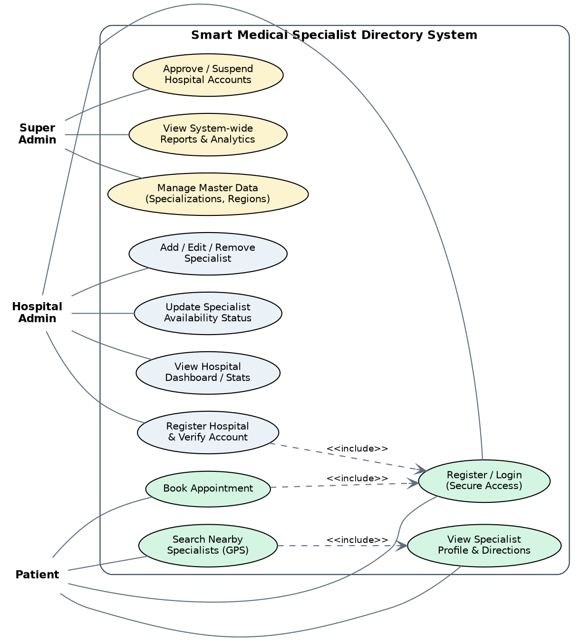
Figure A — Revised Use Case Diagram

5.1 Use Case Summary
Use Case | Primary Actor | Description
Register Hospital | Hospital Admin | Submit hospital profile + coordinates; enters Pending Verification state.
Approve/Suspend Hospital | Super Admin | Reviews pending hospitals; approves, rejects, or suspends existing ones.
Manage Specialist | Hospital Admin | Add, edit, or deactivate specialists under their own hospital.
Update Availability | Hospital Admin | Set daily/weekly duty status per specialist.
Search Nearby Specialists | Patient | Query by specialization + GPS/address; results ranked by distance.
View Specialist Profile | Patient | See specialist detail, hospital location, map, and directions.
Book Appointment | Patient | Request an appointment slot with an available specialist.
View Reports | Super Admin | Platform-wide analytics: hospitals, searches, specializations in demand.

6. Data Model (ERD)
This replaces Slides 26/29. The key structural change is the new Hospital entity holding latitude/longitude, with a one-to-many relationship to Specialist. Availability now carries both specialist and hospital foreign keys, and a NearbySearchLog table supports the location-based search analytics requirement (FR-17).
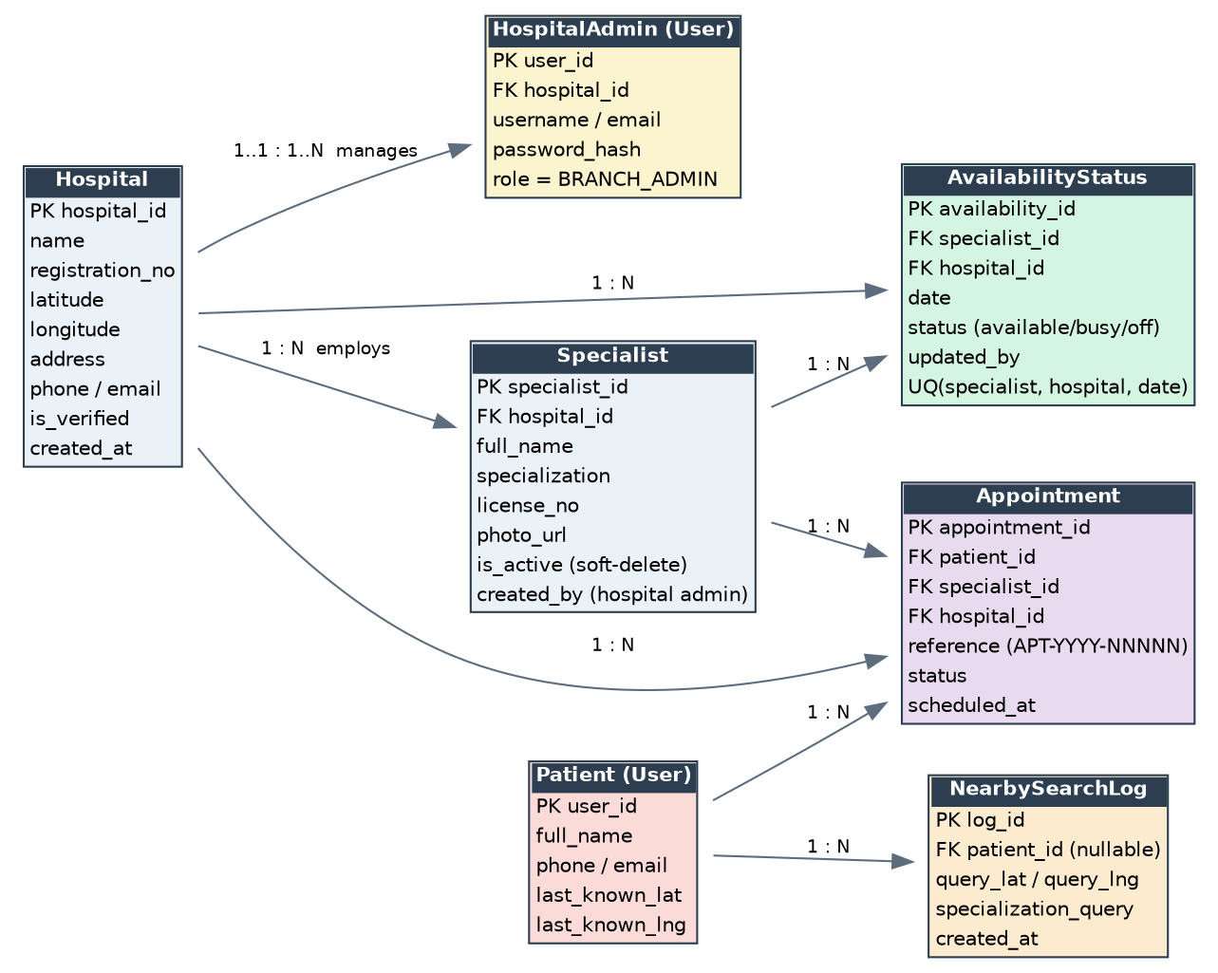
Figure B — Entity Relationship Diagram

6.1 Key Relationships
- Hospital (1) — (N) HospitalAdmin: a hospital may have more than one staff account managing it.
- Hospital (1) — (N) Specialist: every specialist belongs to exactly one hospital.
- Specialist (1) — (N) AvailabilityStatus, unique on (specialist, hospital, date).
- Patient (1) — (N) Appointment; Specialist (1) — (N) Appointment; Hospital (1) — (N) Appointment.
- Patient (1) — (N) NearbySearchLog for search analytics (FR-17), decoupled from precise stored location.

7. Data Flow Overview (replaces Slide 28)

7.1 Level 0 — Context
- Hospital Admin → System: hospital registration data, specialist CRUD, availability updates.
- System → Hospital Admin: verification status, dashboard stats.
- Patient → System: search criteria (specialization + coordinates/address), appointment requests.
- System → Patient: ranked nearby results, specialist/hospital detail, appointment confirmations.
- Super Admin → System: verification decisions, master data updates.
- System → Maps/Geolocation API: geocode hospital address → coordinates; System ↔ API: distance/route data for display.

7.2 Level 1 — Nearby Search Process (core new flow)
- 1. Patient device captures GPS coordinates (or patient enters an address, geocoded via Maps API).
- 2. Patient submits specialization filter + coordinates to the Search API.
- 3. Search Service queries the Specialist/Hospital store with a spatial distance function, filtered to verified hospitals and (optionally) currently available specialists.
- 4. Results are ranked by distance and returned with hospital location, map preview data, and availability status.
- 5. A NearbySearchLog entry is written asynchronously for analytics.

8. System Architecture (replaces Slides 27/30)
The backend follows a clean-architecture-style separation even within Django: HTTP concerns (DRF serializers/viewsets) stay thin, business rules live in a domain/service layer independent of the ORM, and persistence is accessed through repository-style adapters. This keeps the nearby-search algorithm, RBAC policy, and availability rules testable without spinning up the web layer, and makes it straightforward to swap the geo-provider or database later.
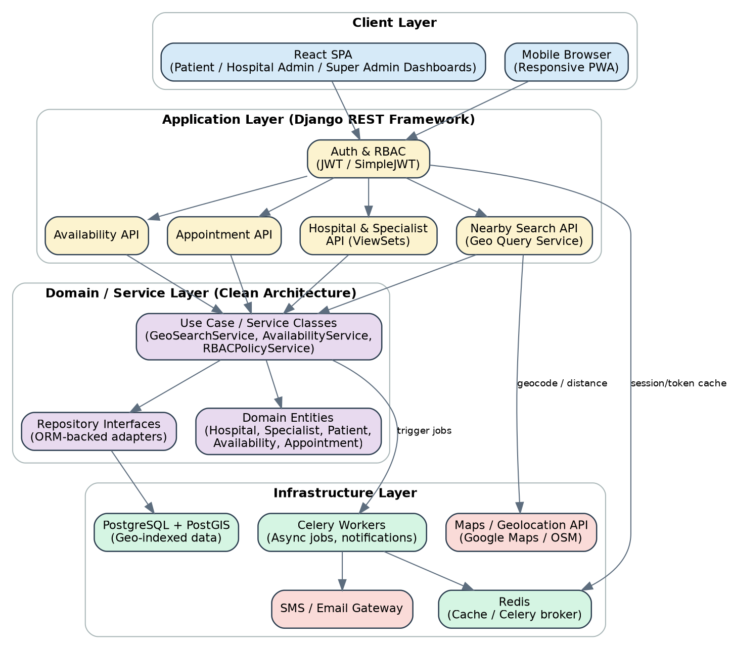
Figure C — System Architecture

8.1 Suggested Backend Package Layout
backend/
├── config/ # Django settings, urls, wsgi/asgi
├── apps/
│ ├── hospitals/
│ │ ├── domain/ # Hospital entity, value objects (Coordinates), validation rules
│ │ ├── services/ # RegisterHospitalService, VerifyHospitalService
│ │ ├── repositories/ # HospitalRepository (ORM adapter)
│ │ ├── api/ # serializers.py, views.py (viewsets), urls.py
│ │ └── models.py
│ ├── specialists/
│ │ ├── domain/ services/ repositories/ api/ models.py
│ ├── availability/
│ │ ├── domain/ services/ (AvailabilityService, ScheduleTemplateService)
│ │ └── api/ models.py
│ ├── search/
│ │ ├── services/ # GeoSearchService (PostGIS distance query)
│ │ └── api/
│ ├── appointments/
│ └── accounts/ # custom User model, RBAC mixins, JWT auth
└── common/
├── permissions.py # IsHospitalAdmin, IsOwnHospital, IsSuperAdmin
└── pagination.py

8.2 Why This Separation Matters Here
- RBAC rule 'a Hospital Admin can only touch their own hospital's specialists' lives once in a permission/service class, not repeated across every view.
- GeoSearchService encapsulates the distance query so it can be unit-tested with fixture coordinates, independent of DRF request/response cycles.
- Swapping Google Maps for OpenStreetMap later only touches the infrastructure adapter, not the domain services or API contracts.

9. Core API Endpoints (Django REST Framework)
Method & Path | Role | Purpose
POST /api/hospitals/register/ | Public | Register a new hospital (Pending status).
PATCH /api/hospitals/{id}/verify/ | Super Admin | Approve/reject/suspend a hospital.
GET/PATCH /api/hospitals/me/ | Hospital Admin | View/edit own hospital profile.
POST /api/specialists/ | Hospital Admin | Add a specialist under own hospital.
PATCH/DELETE /api/specialists/{id}/ | Hospital Admin (own hospital only) | Edit or soft-delete a specialist.
POST /api/availability/ | Hospital Admin | Set/update availability for a specialist + date.
GET /api/search/nearby/?lat=&lng=&specialization=&radius= | Patient (public) | Ranked nearby specialists/hospitals.
GET /api/specialists/{id}/ | Patient (public) | Specialist profile + hospital location.
POST /api/appointments/ | Patient | Book an appointment.
GET /api/reports/overview/ | Super Admin | Platform-wide analytics.

10. Mapping to Original Slide Deck
Summary of exactly which slides in the current presentation need rewriting to match this revised design:
Slide | Change Required
Slide 4 — Objectives | Add: hospital self-registration & specialist management; location-based nearby search objective.
Slide 5 — Significance | Replace 'specialists update their own duty status' with 'hospitals manage and update their specialists' status.'
Slide 9 — Proposed System | Rewrite the 4 bullets around Hospital Portal (registration + specialist management) and Patient nearby-search by location.
Slide 10 — Block Diagram (Fig. 2) | Add Hospital Admin as an actor; add a GPS/location flow on the patient side.
Slide 26 — Use Case Diagram | Replace with the revised diagram in Section 5 (Hospital Admin, Patient, Super Admin as actors; Specialist as a managed resource).
Slide 26/29 — ERD | Replace with Section 6's ERD: new Hospital entity with lat/lng, Hospital→Specialist one-to-many.
Slide 28 — DFD | Replace with Section 7: Hospital↔System and Patient(location)↔System↔Patient(results) flows.
Slide 27/30 — System Architecture | Replace with Section 8: add a Maps/Geolocation API component.

