Geographic Coordinates Tracker

Group 23B
Benoit Brummer

Fall 2015 – Spring 2016
Table of Contents
1.0 Executive Summary
2.0 Project Description
2.1 Project Motivation and Goals
2.2 Objectives
2.3 Requirements Specifications
3.0 Research related to Project Definition
3.1 Existing Similar Projects and Products
3.2 Relevant Technologies
3.3 Strategic Components
3.4 Possible Architectures and Related Diagrams
4.0 Related Standards
4.1 Search at www.nssn.org
4.2 Design Impact of Relevant Standards
5.0 Realistic Design Constraints
5.1 Economic and Time Constraints
5.2 Environmental, Social, and Political Constraints
5.3 Ethical, Health, and Safety Constraints
6.0 Project Hardware and Software Design Details
6.1 Initial Design Architectures and Related Diagrams
6.2 Power subsystem
6.3 MCU
6.4 GPS
6.5 Display
6.6 Input
6.7 Development environment
7.0 Project Prototype Construction and Coding
7.1 Parts Acquisition and BOM
7.2 PCB Vendor and Assembly
7.3 Final Coding Plan
8.0 Project Prototype Testing
8.1 Hardware Test Environment
8.2 Hardware Specific Testing
8.3 Software Test Environment
8.4 Software Specific Testing
9.0 Administrative Content
9.1 Milestone Discussion
9.2 Budget and Finance Discussion
Appendices
Appendix A – Copyright Permissions
Appendix B – Datasheets

1.0 Executive Summary

The Geographic Coordinates Tracker is a low-cost handheld GPS tracker whose main purpose is to display the current location.

2.0 Project Description

2.1 Project Motivation and Goals

This project aims to fill the market gap for a low-cost device that offfers location tracking and display. Currently the lowest cost solution, Garmin's eTrex 10 Hiking GPS, retails for $109.99. This is prohibitively expensive and most amateur adventurers must refrain from acquiring such a device. This leads to hikers using their phone at best, which is not as reliable in the wilderness, can break down easily, and whose battery life is highly dependent on the availability of a nearby micro-USB port. Getting lost in the woods in these conditions is highly unpleasant, sometimes frightening, and it may lead to death. The Geographic Coordinates Tracker is being developed to remedy this situation by providing an affordable tracking solution that can display the current GPS coordinates.

2.2 Objectives

The objective of this project is to produce an affordable device that provides users with their current GPS location. The initial arbitrary target price to assemble a prototype is $50, which is on par with what the author would be willing to spend on a similar preassembled unit.

The device should be able to track the current location and display it using a GPS and a screen and save the current landmark's location to flash memory to find it again in the future. The user should be able to input target coordinates that the device will remember, and the device should indicate the general direction using a magnetic field module (compass).

Ideally the battery should be able to power this device for as long as one decides to get lost in the woods. The initial target is to have this device reliably provide coordinates for at least one week.

The device should fit the “buy it for life” philosophy, it should be resilient but easy to repair. Standard parts are to be used and both documentation and software source code will be provided to anyone who requests it so that users are able to swap out parts.

Finally this device must be easy to manufacture on a larger scale. To achieve this goal, multiple initial prototypes will be built at the same time.

2.3 Requirements Specifications

The Geographic Coordinates Tracker must be able to determine the current geographic coordinates and display them in a user-friendly format. The device should allow users to input their own coordinates and point them to the right direction.

The user may save their current location as a landmark to be retrieved in the future, and they may easily set a saved landmark as the target location using the user-interface that allows for straightforward interaction with the device.

The device is to be powered by a long-lasting battery which can be recharged while inside the device, yet the battery can be replaced by another one of the same standard form factor once it reaches its end of life.

3.0 Research related to Project Definition

3.1 Existing Similar Projects and Products

This project was motivated by a lack of a relevant market offering. There are comparable technologies currently available, but they are prohibitively expensive to most “adventurers”.

3.1.1 Existing Products: Hiking GPS

Garmin eTrex GPS: $189.09 (2015-11-27, Amazon)
features: displays location, specs: monochrome display
watches, do not display location: TomTom Runner GPS Watch ($89.99), Garmin Vivoactive ($149.99), Garmin Forerunner 210 ($129), Garmin Forerunner 10 ($74.99)

Garmin GPSMAP

Garmin 72H $112.39 18h battery life
Garmin Quatix NMEA Marine GPS Sport Watch $223.41,

3.2 Relevant Technologies

Location Tracking: GPS, GLONASS, GALILEO, BeiDou-2, 3
Input: touch (capacitive, resistive), buttons
Output: LCD, segments, LED array, memory LCD
Batteries: NiMH, lithium-ion, lithium-ion polymer, lifepo4
Compass

3.3 Strategic Components

tracking device, input device, output device, battery, charging system, compass

3.4 Possible Architectures and Related Diagrams

?

4.0 Related Standards

4.1 Map Projection

There are several map projection standards in place around the world. We will be analyzing some of them and teremining which ones are to be implemented onto our device, and in what priority.

4.1.X Real World Samples

This section does not analyze any one particular map projection standard, but is used as a collection of real life examples. Collecting these real world samples is the first step that must be done in order to pinpoint real user requirements.

We first look at the “CANAVERAL NATIONAL SEASHORE MANATEE ZONES & ISLAND CAMPSITES” literature provided by the US National Park Service. This paper contains a map of the National Seashore, along with a list of coordinates for every campsite. It is extremely invaluable to anyone getting stranded in the waters without a motor equipped vessel. The coordinates read as follow:
Table X: Sample coordinates from US government issued National Seashore map
Number/Name | Label | Coordinates
Bissette Bay | BB | N 28 53' 39.7” W 80 50' 49.6”
All fourteen coordinates in the pamphlet use the same number of characters.

Another widespread example is the information provided by Google Maps. When using the web browser interface and clicking on “”What's here?” anywhere on the map, the coordinates are shown in the following format:
“Lake Claire
28.609324, -81.202928”
Furthermore, when requesting directions to a given point, Google Maps displays the coordinates in the same format used by the US National Park Service, that is: “28°36'32.4"N 81°12'11.6"W”.

Finally we explored Wikipedia and located a famous landmark, the Manneken Pis peeing boy statue in Brussels, Belgium. Both the English and the French version of Wikipedia use the same format, denoting the Manneken Pis' location as follow:
“Brussels
50°50′42″N 4°21′00″E”

4.1.X NMEA 0183

NMEA 0183 is the standard used by most GPS modules present in the market today. It is a set of communication standards used to interface with various marine electronic sensors, including GPS receivers. It is defined and controlled by the National Marine Electronics Association (NMEA), a US-based trade organization.

NMEA messages are transmitted over an 8-bit serial interface. The format can currently handle both GPS and GLONASS receivers, and support extended vendor-specific messages. We will be learning more about the interface through the specific GPS receiver's datasheet.

A sample NMEA 0183 output message followed by its analysis is shown below:
“$GPGGA,092751.000,5321.6802,N,00630.3371,W,1,8,1.03,61.7,M,55.3,M,,*75”
GP is the talker ID, a GPS unit is involved as opposed to a GLONASS (GL)
GGA provides the current coordinates
092751.000 is the current UTC time
5321.6802,N represents latitude 53 degrees 21.6802” North
00630.3371,W represents longitude 06 degrees 30.3371” West
1 is the “fix quality” (anything above 0 is valid), 8 is the number of satellites being tracked, 61.7M is the altitude (in meters), and *75 is the checksum data.

The coordinates we obtained from the GGA NMEA string follow the same format as the second set of Google Maps data, with the exception of a N/E/S/W letter instead of the plus or minus sign. This format is simply DDDMM.MMMMM, where D stands for degrees and M stands for minute. Converting between the two is as simple as converting time units to and from decimals.

4.1.1 Universal Transverse Mercator coordinate system (UTM)

The Universal Transverse Mercator coordinate system is used worldwide to describe a map projection. It was originally developed in the 1940's by the United States Army Corps of Engineers, and modified slightly since to cover inaccuracies. The UTM system divides the planet into sixty numbered longitude zones of six degrees each. Each of the sixty zones is divided into twenty lettered latitude bands of eight degrees. The UTM notation is sometimes misleading, because it uses the latitude band's letter but the letters N and S can also be used to denote North and South. Even though the UTM system is being globally used, a different notation is typically in place therefore this issue will not arise.

4.1.2 Universal Polar Stereographic coordinate system (UPS)

The Universal Polar Stereographic coordinate system was created to cover the Earth's polar regions and to work in conjunction with the Universal Transverse Mercator system. UPS does not extend to the UTM covered surface except for a small thirty minutes buffer area. The UPS format is similar to UTM, it would fit on the device's display using the same number of characters, but the device is not designed to sustain extreme polar weather. ([add operating temperature range]) This feature will be addressed in a future hardware revision of the device, the firmware should be able to at least display the proper coordinates given they are read from standard NMEA 0183 messages. In the mean time, the UPS coordinate system and the theory behind it not relevant to this project.

4.1.X World Geodetic System: WGS 84

The WGS 84 is the coordinate system used by all current positioning systems (the GPS, GLONASS, BeiDou, Galileo, IRNSS, and GNSS) as well as the US Department of Defense and the rest of the world. It is used to describe altitude data, the nominal sea level, and a geographic coordinate system. All of the “real world samples” taken earlier follow this format, which can be written either in degrees or decimal form. The WGS 84 standard is set to be replaced by the more accurate EGM2008 system.

4.1.3 Geographic Coordinate System Design Constraints

Using the sample “N 28 53' 39.7” W 80 50' 49.6””, we can constrict this format down to “N28 53'39.7” W80 50'49.6”” by removing two unnecessary spaces. This leaves sixteen alphanumeric characters and nine smaller characters (such as ', “, ., space). This notation will fit on a 84x48 screen using a 4x6 font (which only allows for up to 3x5 pixels because of font-spacing) for alphanumeric characters and a two pixels width for smaller characters (with one pixel-wide column to spare). The six pixels character height allow for eight lines to be displayed simultaneously. The pixel pitch of the Nokia 3310 84x48 LCD module is 1.15 millimeters, which makes for a 4.6mm x 6.9mm character. A 23” 1920x1080 monitor has a pixel pitch of 0.265mm, therefore a 4x6px font will be 4.34 times larger on the Nokia 3310 display than they appear on a standard PC. This should be visible enough for a user whose eyesight is still usable, and it will undoubtedly look unappealing.

When using a decimal sample instead, such as “28.609324, -81.202928”, we are displaying sixteen characters, two dots, one comma, and two signs. This format con be displayed more easily on a 84x48 display because it allows for four pixels width per character regardless of their content (alphanumeric or punctuation).

4.2 18650 Battery

The 18650 is a cylindrical lithium-ion rechargeable battery measuring 18.6mm in diameter by 65.2mm in height. It is not a recognized IEC or ANSI standard, but the 18650 remains one of the most commonly used rechargeable batteries all around. One notable use case is the Tesla Model S electric car which makes use of 7,104 lithium-ion 18650 battery cells. A 18650 battery typically provides 3.7V and a capacity that ranges between 1500 and 3400 mAh. The correct designation for a 18650 battery with built-in protection circuit is 19670.

The use of a 18650 allows for a more durable device. Users may easily find a replacement battery once the original one gives in.

4.3 Serial Peripheral Interface Bus (SPI)

The SPI interface was developed by Motorola and has become a de facto standard for synchronous serial communication. It is used to connect various types of peripherals using four wires. The four SPI pins are as follow:

Table X: SPI interface
Symbol | Name | Alternative symbols
SCLK | Serial Clock (master→slave) | SCK, CLK
MOSI | Master Output, Slave Input (master → slave) | SIMO, SDI (slave), DI, DIN, SI, MTST
MISO | Master Input, Slave Output (slave → master) | SOMI, SDO (slave), DO, DOUT, SO, MRSR
SS | Slave Select (master → slave, active low) | nCS, CS, CSB, CSN, EN, nSS, STE, SYNC

MISO can sometimes be omitted when the slave does not need to send messages to its host, and the slave select pin is unnecessary when there is only one device connected to the host. If there are more than one SPI device, they can share all the pins (given a compatible serial clock speed) except for Slave Select which must have its own pin on the microcontroller for each peripheral. The SS pin functions as an active low.

The SPI interface uses more pins than the I2C protocol, but anonymous sources on the internet have described I2C as being more complicated to implement, often requiring a tedious analysis of the large handshake sequence. SPI will be used over I2C when given this option, and both will be connected to the microcontroller if that is possible (at least while developing the initial prototype software).

4.X JTAG

4.X USB

5.0 Realistic Design Constraints

5.1 Economic and Time Constraints

time and budget are the heart of this project
last minute side project, no funding so keep the prototyping cost low. Low cost of the device is the main goal so not much of an issue as long as dev cost remains under control

5.2 Environmental, Social, and Political Constraints

Environmental: This GPS device is designed to (last, use standard parts, easily fixed, open-source)

(investigate: water proof)

political constraints: GPS devices are supposed to limit altitude and speed so that they are not used in missiles. It is unclear whether this was done on the gps module itself or it needs to be done on the scale of the finished device. I will not implement this limiting feature, instead rely on the low refresh rate to keep my device from massively murdering people while at the same time saving on battery life.

Add operating temperature

// upgrade firmware in future revisions
// indestructible screen

5.3 Ethical, Health, and Safety Constraints

battery explosion
may leave people stranded if device malfunctions, put warning to use a map and not rely solely on this device. Bring flare guns perhaps. On the other hand in the event that this device does work as intended by the designer, it may save lives. The designer is confident that this device will cause greater good by helping would be stranded people find their ways than chaos by malfunctioning. Rigorous testing will be done to ensure such positive outcome is achieved.

6.0 Project Hardware and Software Design Details

6.1 Hardware

6.1.1 Initial Design Architectures and Related Diagrams

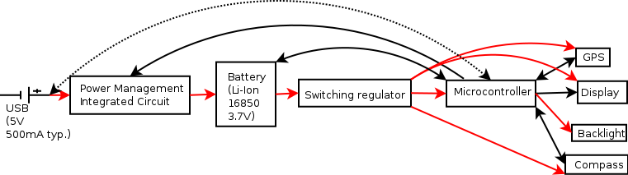
Figure X: Power and components diagram.
Red arrows indicate power transmission. Black arrows represent logic. The dotted arrow is a stretch goal.

6.1.4 GPS module

There are two ways to get GPS tracking onto an embedded system; using a GPS receiver or a GPS module. A GPS receiver contains only the bare minimum hardware required to establish a physical connection with GPS satellites, it is therefore the lowest cost solution. The Skyworks Solutions Inc. SE4150L-R GPS receiver can be purchased on Digi-Key for $2.99 per unit. All of the computation required to establish a connection and obtain useful data from a GPS receiver is done externally, typically using a relatively powerful microprocessor or a specialized FPGA. There is an open-source software-based GPS called OpenSourceGPS which aims at creating a software-based GPS solution that connects a GPS receiver to a computer's USB port, and has the computer do all of the processing in software, but the source code shows this solution falls outside the scope of this project, along with the use of an FPGA.

A viable alternative is to make use of a GPS module. GPS module contains all of the components necessary to obtain useful data, including a microprocessor and the software required to handle it all. GPS modules output standard NMEA 0183 data through the interface of choice, typically through UART, SPI, or I2C. GPS modules are significantly more expensive than GPS receivers. The modules that are being considered for this project range in price from $11.43 to $17.16, that is on average 4.87 times as expensive as the $2.99 SE4150L-R GPS receiver. Because the GPS module is the most expensive part of this project, it is being prioritized over other components which need to be selected accordingly.

Table X: Comparison of low-cost GPS modules
Manufacturer  Part Number | Inventek  ISM420R1-C33 | Jupiter  SE880 | Antenova  M10478-A2 | Antenova  M10478-A1
Price (USD) | 11.43* | 13.30* | 16.36 | 17.16*
Voltage (V) | 1.71 – 1.89 (typ.: 1.80) | 1.75 – 1.85 (typ.: 1.80) | 2.8 – 4.3 (typ.: 3.3) | 1.71 – 1.89 (typ.: 1.80)
Voltage (logic, V) | X | X | N/A | ≤ 3.3V in, 1.8V out
Current (peak, mA) | 45 | X | 31 | 47
Current (avg, mA) | 37 | X | 23 | 31
Power*** (pk, mW) | 81 | X | 102.3 | 84.6
Power*** (avg, mA) | 66.6 | X | 75.9 | 55.8
Interface | UART, SPI, I2C | UART, SPI, I2C | UART | UART, SPI, I2C
Requirements | Antenna, switching power regulator** | Antenna, 2 oscillators, switching power regulator** | None | Switching power regulator**
Package | No lead, 24-pads (underneath) | No lead, pads underneath | 28-pads with exposed sides | 28-pads with exposed sides
Chipset | CSR SiRFFstarIV | CSR SiRFFstarIV | Mediatek MT3337 | CSR SiRFstarIV 9333
Operating temperature range ( °C) | -35 – 80 | X | -30 – 85 | X
Misc |  |  | 1.10 mm between pins' centre
* This part requires additional components
** This is the only component that a different voltage requirement
*** P = I(V)

The Inventek ISM420R1-C33 and the Jupiter SE880 are the least expensive GPS modules, but they both require an external antenna which has the potential to jeopardize the initial prototype. They will be considered for future revisions. The next two least expensive options are Antenova's M10478-A1 and M10478-A2. These two modules have a built-in antenna as well as practically all of the components required to function. The M10478-A1 module is approximately $1 more expensive when taking its switching power regulator into account, and it is about twenty percent more power efficient. However this efficiency may be lost to its dedicated power regulator. Due to its low cost and simplicity, the Antenova M10478-A2 is the GPS module of choice for this project.

6.1.5 Display

The display technology plays an important role in this device's design. It is typically the second most expensive component, and modern displays require significantly more processing resources to function. The battery requirements may also be affected. Several display technologies were investigated along with their impact on the device's hardware and user interface.

Seven-segment displays (individual and arrays) and LED arrays were eliminated due to the higher cost and power consumption involved with displaying a large amount of information.

6.1.5.1 16-bit LCD display

The first potential output device is an LCD module. Varitronix's COG-C144MVGI-08 is the least expensive display available on Digi-Key, with a retail value of $7.05 per unit. Very little information is provided, but Varitronix was mindbogglingly quick at responding to our request. An email containing two complete datasheets for both the display module and the built-in driver was received three minutes after sending an initial message.

The Varitronix COG-C144MVGI-08 module features a 128x128 pixels 1.44” (36.57mm, diagonal) LCD display capable of displaying 16-bit color per pixel (2¹⁶ = 65536 colors). It operates on 2.7 – 2.9 V (typ: 2.8V) and consumes 0.85 mA for both the logic (driver) and the LCD display (ICC). This display operates with a “3-wire serial interface”, presumably SPI.

One of the major drawbacks with this type of display is that it may be damaged when displaying a static image for over thirty minutes. The low-cost GPS device will be displaying a mostly-static screen most of the time, therefore it would be a hassle to implement some type of screen saver and have the device automatically turn its display off after a relatively short amount of time. Another drawback is that standard LCD displays are typically not easily viewed outdoors, where this device is meant to be used.

The amount of RAM required on the microcontroller is directly proportional to the number of pixels and the number of bits per pixel shown on the display. We calculated the amount of RAM required to store one frame into the framebuffer below:
(16 bits / 8 bits per byte) x 128 pixels x 128 pixels = 32768 bytes
32 kilobytes is more volatile memory than what is found on the low-cost low-power microcontrollers that would otherwise be sufficiently powerful enough to drive this device. Another potential option is to use the COG-C144MVGI-08 as a monochrome display. If this can be done, it would not alleviate all of the issues present but the virtual memory requirement would decrease to a mere 2048 bytes. The monochrome mode does not appear to be specified in the datasheet, therefore the supplier will have to be contacted again if we are to move forward with this option.

6.1.5.2 Monochrome Memory LCD Display

Memory-LCD displays alleviate most of the issues found on the 16-bit LCD, and come with a 58.8 to 87.5 percent price increase. Memory LCD displays behave like the “E-Paper” found on popular Ebook devices. They are meant to display static images over a long period of time, while consuming minimal power between refreshes. They require no backlight and are ideal outdoors but invisible in the dark. We compared the two most affordable memory LCD displays.

Table X: Comparison of monochrome memory LCD displays
Manufacturer  Part number | Sharp Microelectronics LS012B7DD01 | Pervasive Displays E1144CS021
Cost (USD) | 13.22 | 12.00
Size (inches, diagonal) | 1.17 | 1.44
Resolution (pixels X x Y) | 184 x 38 | 128 x 96
RAM requirement* (bytes) | 874 | 1536
Voltage (V) | 2.7 – 3.3 (typ.: 3.0) | 2.3 – 3.6
Current (typ-max, no update, mA) | 0.002 – 0.015 | 4 – 8
Current (typ-max, updating, mA) | 0.063 – 0.150 | 30 – 90
Operating temperature range ( °C) | -10 to 70 | 0 – 50
Interface | SPI | X
* RAM requirement = Resolution / 8 bits per byte

The Pervasive Displays E1144CS021 was quickly taken out of consideration because its power consumption is not on par with the Sharp model, even though the price difference is minimal. The Pervasive model typically consumes two thousand times as much current while idling, yet the Sharp LS012B7DD01 costs 10.2% more.

The low RAM requirement of monochrome displays fits well within the capabilities of most inexpensive microcontrollers, and the generous resolution of the aforementioned displays allows for a comfortable user interface. The Sharp Microelectronics LS012B7DD01 is an attractive candidate. While its price is too excessive for the initial prototype, this display will be reconsidered in future revisions.

6.1.5.2 Monochrome Highly Inexpensive Display

The search for a truly low cost display took a turn to some unconventional suppliers, primarily eBay. Many sellers are selling what they call a Nokia 3310 / Nokia 5510 display. Whether these Chinese modules were pulled from authentic Nokia 3310 or not is irrelevant. These displays are the lowest cost solution available, they are very tolerant to a wide range of operating conditions, and there is a lot of available documentation as a result of their wide use over a long period of time.

While eBay sellers offer some basic specifications (eg: input voltage of 3.3 – 5 V, current consumption of 1 mA), we obtained a legitimate looking datasheet that was released by Goldentek Display System Co., Ltd for their GG0804A1FSN6G display in 2001. We will be using these specifications.

Table X: Specifications of a truly low-cost monochrome display
Model: Goldentek Display Systems Co. Ltd GG0804A1FSN6G | Price: $2.20 (shipped)
Dimension: 1.6” diagonal | Resolution: 84(W) x 48(H) pixels
Voltage: 2.7 – 3.3V | Interface: Serial data interface (assuming SPI). Additional backlight pin.
Current: 6.20 – 7.4 mA (typ. – max.) | Operating temperature: -20 – 70 °C

We will attempt to design a usable user-interface that fits on this display module. This will be our display of choice if we succeed.

6.1.X Compass

The least expensive compass available on Digi-Key is the STMicroelectronics LIS3MDLTR 3-axis magnetometer. It costs $1.70, operates on 1.9V - 3.6V while consuming between 40 uA (low-power mode) and 270 uA (“ultra-high resolution mode”). The LIS3MDLTR can communicate with the microcontroller through SPI or I2C. This unit requires
The major drawback of this unit is the unreliability associated with hand-assembly of a 12-VFLGA package.

The next most affordable option is the Bosch Sensortec BMC150, a 6-axis digital compass and accelerometer which comes in a slightly easier to work with 14-VFQFN exposed pads package. The Bosch model operates from 1.62V to 3.6V. Power modes are listed separately for the accelerometer, which is not needed, and the magnetometer. Using the magnetometer only, the BMC150 consumes on average 175 uA in its low power preset, and 0.5 mA in the regular preset. The Bosch BMC150 is equiped with an I2C and an SPI digital interfaces. It can be purchased on Digi-Key for $2.77 per unit, a 62.9%, $1.07 increase over the STMicro LIS3MDLTR solution.

Upon further research we came across the Freescale Semiconductor Xtrinsic MAG3110, a $1.30 digital magnetometer assembled into a 10-VFDFN package with exposed pads. The accelerometer is highlighted by its absence. The use of an accelerometer can allow the unit to keep track of orientation in order to provide a more accurate reading regardless of the position. Because this feature is not essential and the price difference is not critical, all features need to be compared, including the ease of installation, defined by the amount of space between the center of two adjascent pads.

Table X: Comparison of viable digital compasses
Part # | Bosch Sensortec BMC150 | Freescale Semiconductor Xtrinsic MAG3110 | Melexis Technologies NV MLX90393SLW-ABA-011-RE
Price ($/unit for 1, 10 units) | 2.77, 2.52 | 1.46, 1.30 | 2.14, 1.93
Package | 14-VFQFN Exposed Pad | 10-VDFN | 16-VFQN Exposed Pad
Distance between pads (mm) | 0.40 | 0.400 | 0.50
Voltage (V) | 1.62 – 3.6* (typ.: 2.4) | 1.95 – 3.6 (typ.: 2.4) | 2.2 – 3.6 (typ.: 3)
Current (mA) | 0.5*** | 0.0086 – 0.900 | 2.29*
Current (standby, uA) |  | 0.002
Interface | SPI, I2C | I2C | SPI, I2C
Features | 6-axis, built-in accelerometer | 3 axes | XYZ axes, temperature sensor.
Size |  | 2 x 2 mm | 3 x 3 mm
Operating temperature |  |  | -20 - 85
* Compass subsystem
** Conversion Current XY-axis. Duty cycle may be reduced to save power.
*** Regular preset

Even though the Freescale Semiconductor Xtrinsic MAG3110 offers the lowest cost, pin count, and power usage, the Melexis Technologies NV MLX90393SLW-ABA-011-RE was chosen because we were able to aquire a set of matching 3x3mm QFN16 to DIP adapters on eBay ($3.98 for a set of five, shipping included).

If this fails to be properly installed onto the PCB, a simple “Mini Aluminum Camping Compass” will be glued onto the initial prototype. A “Mini Aluminum Camping Compass” can be acquired on eBay for $0.99 (shipping included), it is extremely user-friendly for both the developer and the user, yet it operates with unprecedented reliability while requiring no power.

6.1.6 User Input

We considered having the user interact with this device using a touch screen interface or pressing physical buttons. Our device may include an accelerometer as part of the magnetometer integrated circuit (“compass”), and although the accelerometer may be used as an input in future software revisions, it will not affect our design because its lack of user-friendliness renders other input devices essential.

6.1.6.1 Touch Screen Overlay

A touch screen overlay may be laid on top of the LCD screen to provide tactile feedback. Two distinct technologies commonly provide this feature and they are both prohibitively expensive. Those are Resistive and capacitive sensing. Capacitive touchscreens are generally more precise and completely out of our price range, therefore we consider a resistive touchscreen.

Resistive touchscreens are made of two transparent layer facing each other on the screen. The layers touch each other and complete the circuit when pressure is applied to the screen (such as that exerted by a stylus or a finger). The signal is then sent as a voltage value, which the microcontroller can translate to coordinates using an Analog-to-Digital converter to read the signal. ADC ports are very common even in low-end microcontrollers, and they can be time-multiplexed to support multiple devices.

The Adafruit Industries LLC 333 is currently the least expensive touch screen overlay available on Digi-Key. It retails for $8.00 per unit ($7.20 when purchasing ten or more overlays). It is meant to fit on the 2.2” x 2.75” (3.2” diagonal) Nintendo DS screen.

The main advantages of a touch screen overlay are that users are allowed to intuitively press the item they wish to interact with, and no space is used up by physical buttons because the screen can handle almost all input requirements.

High cost is the main disadvantage of a touch screen overlay, and this has a much greater impact on low-cost devices such as this one. The Nintendo DS touch screen overlay is relatively inexpensive because it is heavily mass produced, but specialized units become much more expensive. Although the screen of our size does not necessarily need to be matched because a touch screen interface can function as input without a screen, having to scale our device up to the size of a Nintendo DS monitor voids the touchscreen's space saving advantage. Although cost alone deters us from using a touch screen overlay, there are many reasons not to opt for such an interface. Some reasons not to opt for a touch screen include their lack of accuracy (especially when operating on smaller displays without a stylus), their high sensitivity to varying environmental factors (rain can render a touch screen inoperable), or simply a user preference for the speed and predictability that comes with physical buttons.

6.1.6.2 Physical Buttons

Physical buttons provide the cheapest and simplest form of input. They are still commonly in use today in various devices, such as computer keyboards and remote controls.

The switches we will be using in this device are called “tactile switches”. They are available on Digi-Key starting at $0.06 each (with a price break of 10), although we will be using up our supply of generic switches before obtaining more.

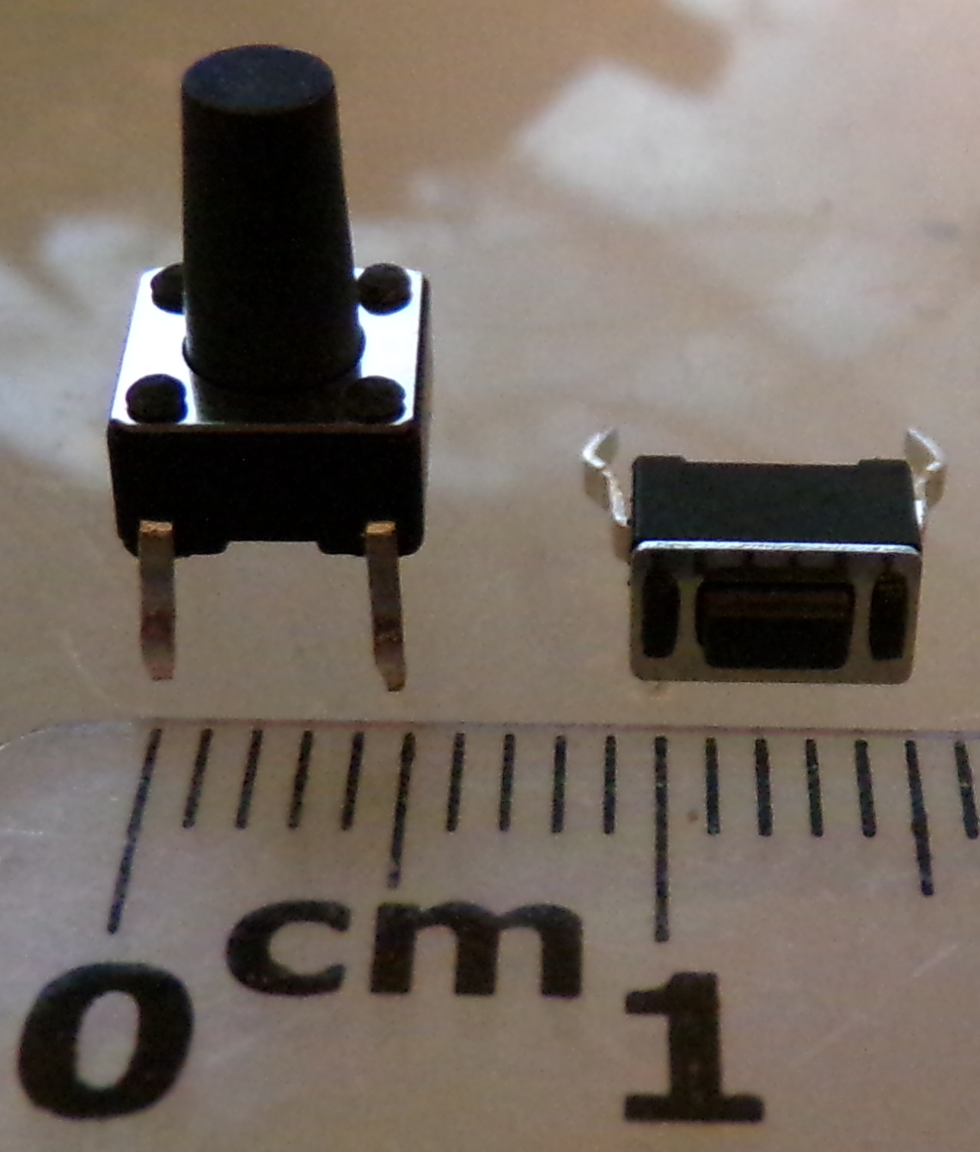
Figure X: Tactile switches (from current inventory)

These switches provide a “momentary on” while they are being pressed. They can be connected directly onto the PCB. We will be using these for all user inputs.

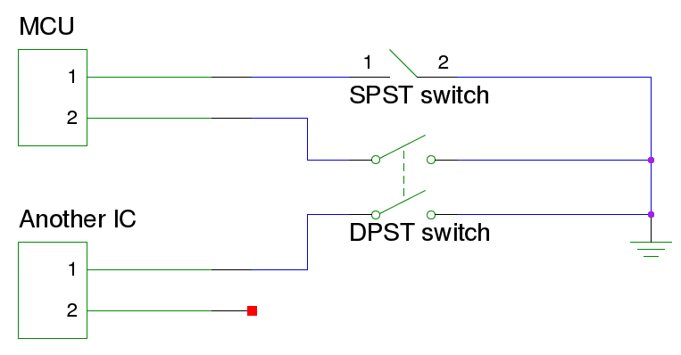
Figure X: input wiring

Figure X illustrates the simplicity of push buttons. Only one pin is required per button, the other side is connected to ground. The microcontroller uses the pullup resistor built onto each GPIO pin to detect whether the current is going through. SPST switches have only two pins. DPST switches have four pins and can be used to send the same input signal to two integrated circuits simultaneously.

We will also be using a DIP switch to control the enable pin on the Step-Down DC-DC converter by placing the switch between V_{IN} and EN. This will allow the user to switch off power to all circuits. DIP switches are difficult for users to use, but it should only be switched in case of emergency when the battery is about to get permanently damaged from complete depletion. The microcontroller will be programmed to put itself and all components to sleep before the voltage becomes critically low. The CTS Electrocomponents 210-2MS dual-switch is available on Digi-Key for $0.43 per unit with a 10 units price break.

We initially considered the Panasonic EVQQ3 Multi-direction Operation Switches (D-Pad) to be a must, but its $4.00 price tag convinced us otherwise.

6.1.3 Microcontroller

The choice between a microcontroller and a microprocessor is trivial with this device. Microprocessors require a multitude of external components and a complex supporting circuit, consume an abundant amount of power, and typically provide much more computing power. Microcontrollers on the other hand are highly integrated, containing almost everything a system requires to function (notably the RAM and Flash memory) in one single package. Microcontrollers usually have very little computing power because they are meant to complete a simple task. As a result they tend to consume less power.

6.1.3.1 MCU Requirements

Table X: Requirements analysis for microcontroller selection
Part | GPIO | UART | I2C | SPI | ADC | RAM (bytes) | Logic voltage (V)
GPS
Antenova M10478-A2 | 0 (3)* | Y |  |  |  |  | N/A
Antenova M10478-A1 |  | y | y | Y |  |  | ≤ 3.3V in, 1.8V out
Display
128x128x16-bits | 3 |  |  | Y |  | 32768**
Sharp Memory-LCD 184x38x1-bit | 1 |  |  | Y |  | 874
84x48x1-bit | 1 |  |  | Y |  | 504 | 2.7 – 3.3
Digital Magnetometer
Melexis MLX90393 | (1)*** |  | y | Y |  |  | 1.65 - V_{DD}
Bosch BMC150 |  |  | y | Y
Power Subsystem
MCP73811T-420I/OT | 1
Battery | 1 |  |  |  | 1
User input (buttons) | 10****
USB (opt) | Two dedicated USB pins
All of the above | Max: 15-17 (and 2/USB) | Y (2 pins) | y | Y (2 devices = 5 pins) | 1 | 504 – 32768 (+50%. Min.=756) | X
'Y' is a requirement unless 'y' appears on the same line, in which case either Y can be used.
* 3 optional pins are: HRST/System reset, FIXED INDICATOR, and HW_STANDBY, which can be replaced with UART command “PMTK161”
** 16384 bytes in 8-bit/256 colors, 2048 bytes in monochrome
*** Optional trigger (“TRG”) pin, used
**** Can be reduced down to one using shift registers

The

Criterias:
Price
Power consumption
Package (“SSOP (Shrink small outline package) is a shrinked down version of SOIC (Small Outline Integrated Circuit)”), DIP 1st

1. cheapest.
Silicon Labs EFM8BB10F2G-A-QFN20 $.42 20-UQFN
Silicon Labs EFM8BB10F8G-A-SOIC16 $.56 16-SOIC
Silicon Labs EFM8BB10F4G-A-QFN20 $.56 20-UQFN
Microchip Technology PIC12F1572-I/** $.60 8-SOIC,8-TSSOP 8-bit 3.5KB 256B

Not enough ram for display
calculate ram, compare those with enough ram

2. 16-bit color
We can calculate the number of colors our microcontroller can send to the display for any given number of bits n per pixel using the formula 2^{n}, which is derived from two colors per bit times the number of bits. With 16-bit color this device is capable of displaying 2¹⁶, or 65653 colors.

We calculated the amount of RAM memory required to store one 16-bit 128x128-pixels frame into the framebuffer as follow:
16 bits (128 pixels X) (128 pixels Y) = 262,144 bits = 32,768 bytes
(compare MCUs):
Microchip Technology PIC32MX270F256B series

PIC32MX270F256B-I/SS
(noUSB) Microchip Technology PIC32MX170F256B-I/SS $3.51 28-SSOP 64KB 2.3-3.6V 40MHz(8internal) 0.5mA/MHz
Microchip Technology PIC32MX170F256B-I/SP $3.74 28-SPDIP 64KB 2.3-3.6V 40MHz
(USB)

$3.80, 40MHz, USB OTG, 64 KB,256KB, 28-SSOP, 2.3v-3.6v, MIPS32 M4K, -40 to 85
“,PIC32MX270F256B-I/SO, $3.84, 28-SOIC (bigger
“, PIC32MX270F256B-I/SP, $4.03, 28-SPDIP
NXP Semiconductors LPC11U68JBD48E
$4.98, Cortex-M0 50MHz, 36KB,256KB, -40-105, 48-LQFP (no: RAM)

Atmel ATSAM4S2AA-AU
$5.64
Freescale MKV31F512VLH12 $5.58 M4 120MHz 96KB,512KB 1.71-3.6V 64-LQFP
PIC24FJ128GB206-I/PT $5.92 96,128KB 2.2-3.6V 64-TQFP

Arrow: flat-rate shipping $8.00
Look for STMicro to replicate dev environment of group 23 which uses F7
STMicroelectronics STM32F105R8T6 $4.03 1.65-3.6V 64-LQFP 72MHz,64KB,64KB (up to 256KB flash) I_{VDD,max} = 150mA, I_{IO, max} = +/- 25mA , max power dissipation: 444 mW = 135 mA
STMicroelectronics STM32L151RDT6 $4.53 2-3.6V 64-LQFP 32MHz, 48KB,384KB
, 230 μA/MHz Run mode = 7.36 mA at 32 MHz, -40-85 C
$5.33 per unit to have ten units shipped, $6.13 for 5, still cheaper than digikey's $8.38 STM32L152RET6

Mouser: economy shipping $4.99
STM32L151RDT6 $7.57/1 ($6.81 for 10-24) → $7.31 per unit to have ten units shipped

3. 24-bit color (sub of 16-bit)
With 24 bits per pixel, our device is capable of displaying 2²⁴, or 16,777,216 colors. The RAM memory requirement for this use case is calculated as follow:
3 bytes (128 pixels X) (128 pixels Y) = 49152 bytes
briefle compare
While the 50 kilobytes memory requirement is easily met at minimal to no additional cost by some of the micocontrollers we have already investigated, anything over 16-bits is unnecessary because the 128x128 LCD module that is taken into consideration can only display 65653 colors.

4. 1-bit color:
A monochrome display only needs one bit per pixel, which means a single byte can store enough information to save eight pixels into the frame buffer. The RAM memory requirement for the 184 x 34 memory LCD monochrome display is calculated as follow:
(184 (34)) / 8 = 782 bytes.
The RAM requirement for a 84 x 48 pixels “Nokia 3310” LCD panel is 504 bytes. We will chose a microcontroller that contains at least 1008 bytes of RAM, this should satisfy either of the two monochrome displays we considered.

Pins
1 gpio to disable charger
ADC port to check battery level
1 gpio port to enable/disable battery check
SPI display
1 gpio to light
SPI / I2C compass
gps: spi/i2c/uart

10pins?

min RAM: (84x48)/8 = 504B
200% = 1008B

buttons:
Menu/OK
arrows(4)
//light

hold

6but
16pins

NON-USB:

Silicon Labs EFM8BB31F16G-A-QSOP24
$0.87
24-QSOP
2.25KB,16KB
50MHz 8-bit CIP-51 8051
2.2-3.6V
on-chip Silicon Labs 2-Wire (C2) debug interface to allow flash programming and in-system debugging
-40 - 85
normal mode fs: 25MHz: 4.5mA, 1.53MHz: 0.615mA, idle 25MHz: 2.8mA, idle 1.53MHz: 0.455uA

Freescale Semiconductor MKE04Z8VWJ4
$0.92
Cortex M-0 32-bit 48MHz
20-SOIC
18 i/o
1K,8K
2.7-5.5V
-40-105
@3.3V
run mode 48MHz: 9.9 mA
25MHz: 6.9 mA
12MHz: 4.2 mA
1 MHz: 1.9 mA
wait mode: 7.1, 6.2, 3.5, 1.8

Microchip Technology PIC16LF1618-I/SS
$1.02
PIC
20-SSOP
1K,7KB (4K x 14)
1.8-3.6V
-40-85
<=16MHz: 1.8-3.6V
<= 32MHz: 2.5-3.6V
normal mode:
32MHz: 5mA @ 3V
16MHz: 1.85 mA @ 3V, 1.2 mA @ 1.8V
8MHz: 1.3 mA @ 3V, 0.800 mA @ 1.8V

uses far less power

USB:

Silicon Labs EFM8UB11F16G-C-QSOP24
$1.33
USB

Microchip Technology PIC32MX210F016B-I/SS
$2.24
MIPS32 M4K 40MHz
28-SSOP
19 I/O
2.3-3.6V
Table X: Comparison of 20+ I/O MCUs
Manufacturer | Part number | Price (USD) | Core | RAM, Flash (KB) | # of I/O | Package | Voltage (V) | Active Current @ 1 MHz (mAh) | USB
STMicroelectronics | STM32F030K6T6 | 1.328* | ARM Cortex M0 48MHz | 4, 32 | 26 | 32-LQFP (7x7) | 2.4-3.6 | 4.0*** – 4.9*** | N
STMicroelectronics | STM32L051C6T6 | 3.027* | ARM Cortex M0+ 32MHz | 8, 32 | 37 | 48-LQFP (7x7) | 1.65-3.6 |  | Y
STMicroelectronics | STM32L052K6T6 | 3.31** | ARM Cortex M0+ 32MHz | 8, 32 | 27 | LQFP-32 | 1.65-3.6 | 0.165 | Y
Silicon Labs | C8051T322-GQ | 1.55* | Intel 8051 48 MHz | 1.25, 16 | 25 | 32-LQFP (7x7) | 1.8-5.25 | 1.6 – 1.8 | Y
Silicon Labs | EFM8BB31F16G-A-QSOP24 | 0.87 | Intel 8051 50 MHz | 2.25, 16 | 21 | 24-QSOP | 2.2-3.6 |  | N
* @ quantity 10
** Arrow ($8.00 flat rate shipping)
*** @ 8 MHz

Zilog eZ8 and STMicroelectronics STM8 microcontrollers were not considered because Zilog does not provide Linux support.

STMicroelectronics STM32L052K6T6
$2.20 (arrow)
-40-85
LQFP-32 / UFQFPN32 7x7mm, 0.800mm pin-to-pin
Cortex M0+ 32MHz, 8KB,32KB, 27 I/O
1.65-3.6V
“88 uA/MHz run mode”
6.3 mA @ 32MHz, 2.6 mAh @ 16 MHz, 1.3 mA @ 8 MHz, 0.555 mA @ 4 MHz, 0.165 mAh @ 1 MHz
There are 18 pins left on the microcontroller after the UART, SPI (which requires an additional 2 pins), and USB (which is optional and takes up 2 pins) are activated.

STM32L053R8T6 dev board, $10.99 on digikey

3. USB
- compare mcus
- consider using a separate chip.: Cheapest USB to UART available is FTDI FT232RL-REEL, $4.50 IC USB FS SERIAL UART 32-QFN . Not cost effective
dev board ( NUCLEO-L152RE)

6.1.2 Power subsystem

Table X: Voltage requirements for all system components
Component | GPS | Display | Microcontroller | Compass
Voltage (V) | 2.8 – 4.3 (typ 3.3) | 2.7 – 3.3 | 2.2 – 3.6 | 1.95 – 3.6 (typ.: 2.4)
Common voltage (V) | 2.8 – 3.3

All system components can operate on the same 2.8 – 3.3 V voltage range. If such a battery is applicable to the project, then no DC/DC power conversion will be required. Otherwise, a single switching regulator will be able to provide power to all components.

The power subsystem is made of an external power source, a battery charging system, a battery, a regulator that steps battery power down to a level that will not damage the components, and the components that drain battery. The microcontroller will directly power the backlight, using Pulse Width Modulation to control the brightness. The battery will be connected to the microcontroller's Analog-to-Digital port (using an appropriate subcircuit) for voltage measurements, and a GPIO pin will be able to output to the power management IC in order to turn off the charger if the voltage becomes dangerously high. The switching regulator does have an “enable” digital pin that could be used when the battery level is critically low, but it is unusable when all of the components are connected to the same switching regulator as the microcontroller because the microcontroller would never be able to turn on and send the enable signal without a series of gates. Instead, the microcontroller will put the device to sleep and a physical switch will be put in place between the enable pin and V_{in}.

Figure X: Power diagram.
Red arrows indicate power transmission. Black arrows represent logic. The dotted arrow is a stretch goal.

6.1.x.x Battery

“ LFP has 25% less capacity than other lithium batteries, The major differences between LFP batteries and ordinary lithium batteries are that LFP batteries do not have safety concerns such as overheating and explosion, that they have 4 to 5 times longer cycle lifetimes than the lithium batteries 8 to 10 times higher discharge power and 30 to 50% less weight.”

STMicroelectronics EFL700A39 $35.80 700mAh 3.9V
3*Energizer NH12 AAA $2.75*3=8.25 700mAh 3.6V
3*Panasonic HHR-150AAC8 AA $3.6*3=10.8 1.5Ah 3.6V
3*Panasonic HHR-210AAC4B AA $4.23*3=12.69 2Ah 3.6V
Sparksfun Polymer Lithium Ion Battery - 1000mAh $9.95 3.7V lithium-ion polymer
SparksFun Polymer Lithium Ion Battery - 2000mAh $12.95 3.7V lithium-ion polymer
Eachine 3.7V 18650 2200mAh (Amazon) $9.95 (w/shipping) built-in protection, 75 reviews w/4.4

6.1.x.x Switching regulator

Zilog
IXD3235A30DMR-G 3MHz
IXD3236A30DMR-G 3MHz
IXD3236A30CMR-G 1.2MHz
IXD3236A30CMR-G 1.2MHz
$1.25@10 2-6V → 3V SOT-25 -40 – 85 C 600mA

Torex Semiconductor Ltd
XC9236A30CMR-G 1.2MHz
XC9235A30DMR-G 3MHz
$1.276 @ 10, 2-6 → 3V SOT-25 -40-85 600mA

“use switcher (linear regulator are not efficient, they use the same current so higher power”

Diodes Incorporated PAM2305AAB330 input:2.5-5.5V, output 3.3V (fixed) $0.58 1A TSOT-25
Texas Instruments LM3671MF-2.8/NOPB input: 2.7-5.5, output 2.8V, 600mA, SOT-23-5 $0.92
Diodes Incorporated AP3417CKTR-G1 input: 2.5-5.5V, output: 0.6V-4.95V $0.41 1A SOT-23-5

Diodes Incorporated provides a component guide for the AP3417C, which shows that V_{out}=1.8V can be obtained by using a 200 kOhm resistor R1, a 100 kΩ resistor R2, and a 2.2 uH inductor L.

6.1.X.X Charging system

use microUSB
Li-Ion,Li-Pol
Skyworks Solutions Inc. AAT3681AIJS-4.2-T1 $0.48 8-TFSOJ in:4-7.5V,out:4.1or4.2
Microchip Technology MCP73811T-420I/OT $0.51 SOT-23-5 in:3.75-6,out:4.2
Charge enable pin to the microcontroller, shut off when not within acceptable range

6.1.X.X Measuring Remaining Battery Capacity

6.1.X.X Battery Holder

AA:
MPD BC3AAL $1.44 Style:Holder(open) TerminationStyle:SolderLug
MPD BC3AAW $1.50 Style:Holder(open) TerminationStyle:WireLeads
BC3AAPC-ND $1.50 Style:Holder(open) TerminationStyle:PC Pin
Keystone Electronics 2487 $2.26 Style:Holder(covered)
18650:
Keystone Electronics 1044 $2.10 Holder(open) SolderLug

6.2 User Interface

The type of graphical user interface that needs to be developed and the input and output devices selection both depend on each other.

- expensive memory display gets fancy interface
- standard lcd needs to be turned off frequently, because it consumes power, and screen burn-in. Also needs X RAM
- fancy touch input makes for an intuitive user interface, but cheap buttons are sometimes preferred / price isn't always an improvement, especially by experienced users. Buttons are mechanical and can break (but they are cheap and easy to replace). Overlay will not work with gloves, dirty fingers, excessive humidity, or while the unit is safe inside a zip lock bag. While Buttons accept any condition the device will handle.

We first investigated the least expensive option, [Nokia 3310 screen]

- Graphical interface
display GPS status (sleep status, # of satellites)
display battery status
display hold status icon

84x48 resolution.

current location:

-(describe the buttons / ) Num, type, pos, function of buttons
buttons: hard on-off, up down right left middle, menu, hold/lock, offGPS,offLCD

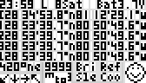
Figure X: First attempt designing a graphical user interface on the 84x48 LCD module.

menu:
- coordinates
- system
//- hide
- sleep delay
- light
- screen
- gps
- refresh rate
- gps
- compass
- directions
- brightness
- exit
press ok on current number 5 times to use current location

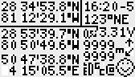
Figure X: Second attempt designing a graphical user interface for the 84x48 LCD module.

Replace 2 targets w/ list (allow user to save)
add compass

6.3 Development Environment

(mention stcubemx, lookup pic32)

6.4 Pinout

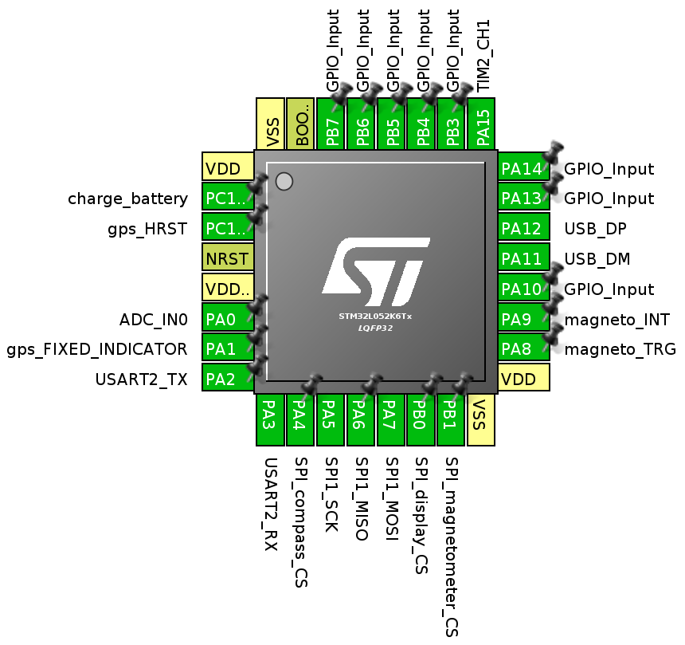
Figure X: STM32L052K6T6 pinout (generated using STM32CubeMX)

gps_HW_STANDBY and dc-dc_ENABLE are wired to physical pins only. This configuration allows for eight GPIO inputs without the use of any external component.

LCD, Pow, MCU,

6.5 Power Saving

if screen is off don't update framebuffer.
if screen is on refresh after all tasks are complete.

7.0 Project Prototype Construction and Coding

7.1 Parts Acquisition and BOM

In order to minimize development cost, this project will use the services of as few suppliers as possible, avoiding costly additional shipping costs. Digi-Key was designated as the primary supplier for this project's components. They provide a wide enough selection to cover most of the GCT's hardware needs, a user-friendly interface to find them all, and most importantly a well sorted database to quickly sort through specifications.

Another supplier, Arrow Electronics, was considered because they provide an extensive selection of STMicro STM32 microcontrollers at a competitive price. The Arrow website does not seem as user-friendly as Digi-Key. Sorting by price is not allowed for non-members, and membership requires a manual activation which takes one to two days.
[...]
. As a consequence, any order placed on Arrow must be made taking into consideration the additional $8.00 flat rate shipping. The same applies for all third-party suppliers. Mouser was considered as well, they offer flat-rate $4.99 shipping.

Bill of material: [TODO]

7.2 PCB Vendor and Assembly

lookitup

7.3 Final Coding Plan

hw diagram goes here

8.0 Project Prototype Testing

8.1 Hardware Test Environment

interface

8.2 Hardware Specific Testing

- check gps coordinates on dev board, power (safety)

8.3 Software Test Environment

- lookup

8.4 Software Specific Testing

GPS through debugger, using laptop outside
display, show coordinates, battery charge. Most work is done by then

9.0 Administrative Content

9.1 Milestone Discussion

This project was started on Friday November 27th, the beginning of Thanksgiving dinner. In order to be considered a potentially succesful senior design project contestant, this project will need to have an acceptable amount of quality documentation by Sunday November 29th. The components will then be purchased and a draft of the project documentation will be proposed on Tuesday December 1st or at Dr. Richie's earliest convenience. An outline of the paper describing all of the major components will be drawn out on Friday 2015-11-27. Saturday 2015-11-28 is to be spent doing further research in order to secure a definitive parts list, and a lot of writing is to be done. Sunday 2015-11-29 is mostly dedicated to determining the pinout diagrams and creating draft schematics in order to cautiously order all of the components by the end of the day.

Final documentation is due by the end of the Fall 2015 semester in lieu of the final exam, on Thursday December 10th. This paper must read as a complete guide to building the Geographic Coordinate Tracker by the documentation due date.

A working prototype of this project must be shown at the end of Spring 2016 semester.

Some features could be added onto the Geographic Coordinate Tracker if time constraints are overcome. These include the ability to use the device as a USB GPS unit from a computer, flash memory to store maps to be displayed on the screen (either as internal flash programmed by the aforementioned USB interface, or through an external microSD memory card reader. Finally the addition of a clock can be beneficial, and it should require minimal work outside of the potential addition of a 32.768 kHz crystal oscillator for the built-in Real Time Clock. Using a microcontroller based clock would save battery life over retrieving the time from the GPS module when the GPS can be left in standby mode.

if time is managed, add usb for pc/whatever, flashmem, possibly clock

9.2 Budget and Finance Discussion

The purpose of this project is to create a GPS tracking solution which can output current coordinates and make it less expensive than the current market offering . This places budgetary constrictions at the forefront of the development process. Additionally, the project is entirely self-funded, therefore development costs must remain minimal.

As of November 27th 2015, the least expensive solution is the Garmin eTrex Hiking GPS, which retails for $189.09. This project aims at creating a solution that can be manufactured for less than $50.

In order to achieve this goal, we consistently chose the least expensive components that can complete their required functions given the project's time constraint. We also attempt to source our parts from the same suppliers at the same time in order to save on shipping cost. Multiple parts will be ordered at once to compensate for probably failure. If enough working parts remain after the completion of a successful prototype, they will be used to assemble more prototypes.

Appendices
Appendix A – Copyright Permissions

Font:

Appendix B – Datasheets

