SenseWalk 2.0
By:
Benoit Brummer
Diego Merida
Ross Applegate
Chad Borgelin
Table of Contents

1.0 Executive Summary

2.0 Project Description
2.1 Project Motivation and Goals
2.2 Objectives
2.3 Project Requirements and Project Specifications
2.3.1 Software Specifications and Requirements
2.3.2 Hardware Specifications and Requirements

3.0 Research related to Project Definition
3.1 Existing Similar Projects and Ideas
3.2 Relevant Technologies
3.3 Feedbacks
3.4 Possible Architectures and Related Diagrams
3.4.1 Architectures: Advantages and Disadvantages
3.4.2 How to Arrange Parts
3.5 Strategic Components
3.6 System Communications
3.6.1 GPS Communication
3.6.2 Bluetooth Communication
3.6.3 Distance Sensor
3.7 Hardware
3.7.1 Microcontroller
3.7.2 Memory
3.7.3 Laser Sensor
3.7.5 Battery
3.7.6 Bluetooth
3.7.7 Bone Conduction Headphone
3.7.8 Microphone
3.7.9 GPS
3.7.10 Magnetometer and Accelerometer
3.7.11 Solar cell
3.7.12 Camera
3.7.13 SD Drive

4.0 Related Standards
4.1 Energy Standards
4.2 Design Impact of Relevant Standards

5.0 Related Design Constraints

6.0 Project Hardware and Software Design Details
6.1 Hardware: Structure and Design
6.1.1 Battery to microcontroller
6.1.2 Battery to GPS
6.1.3 Battery to Laser Detector
6.1.4 Battery to Bluetooth
6.1.5 Battery to memory
6.1.6 Battery to camera
6.1.7 Battery to SD card
6.1.8 Microcontroller to GPS
6.1.9 Microcontroller to Laser
6.1.10 Microcontroller to camera
6.1.11 Microcontroller to SD card
6.1.12 Microcontroller to Bluetooth Controller

6.2 Software: Structure and Design
6.2.1 Operating System
6.2.2 Laser Processing Coding Plan
6.2.3 Bluetooth Microcontroller Coding Plan
6.2.4 Voice Recognition Microcontroller Coding Plan
6.2.5 Memory Management Class
6.2.6 Battery Class
6.2.7 Computer Vision
6.2.8 Development environment

7.0 Project Prototype Construction and Coding
7.1 Parts Acquisition
7.2 PCB Vendor and Assembly

8.0 Project Prototype Testing
8.1 Hardware Test Environment
8.1.1 Microcontroller testing environment
8.1.2 User Input
8.2 Hardware Specific Testing
8.2.1 GPS Testing
8.2.2 Bluetooth Testing
8.2.3 Power subsystem testing
8.2.4 Headset Testing
8.2.5 Battery Testing
8.3 Software Specific Testing
8.3.1 GPS Testing
8.3.2 Bluetooth Testing
8.3.3 Voice Recognition Testing
8.3.4 Laser Testing
8.4 Software Test Environment
8.5 Miscellaneous Testing
8.5.1 Distance Test
8.5.2 Miscellaneous Troubleshooting

9.0 Administrative Content
9.1 Timeline
9.2 Milestone Discussion
9.3 Budget and Finance Discussion
9.4 Roles and Responsibilities
9.5 Research

Appendices
Appendix A - Copyright Permissions
Appendix B - Datasheets
Appendix C - Sources

1.0 Executive Summary

Detailed analysis of the research, design, coding, and testing procedures related to the navigation system for the visually impaired is thoroughly provided. The project description includes goals, motivators, and hardware and software system specifications. The foundation for the mission statement of this design is to aid the visually impaired with their travel on a daily basis. The cane is an alternative to seeing-eye dogs or personal assistants, as it doesn’t compromise independent mobility. It allows the individual to blend into society with little assistance or help from others. With a cane, they are able to be independent and not rely on others for their everyday needs. However, danger is still prevalent in the person’s inability to distinguish between safe paths and hazardous paths, thus presenting the opportunity for the cane to be perfected by modern-day technology. Many people in their day-to-day lives have a typical, established routine that may include routes going from home to work or going from one classroom to another.

For those that are visually impaired and use a cane, it would be deemed useful to have a device which stores some of their frequently used routes. The GPS in SenseWalk 2.0 will keep track of the user as they go about a certain route that they have selected and instructions transmitted will notify the user constantly of where they currently are and what direction they need to impart soon. Even when the option of using a stored route is not selected, the GPS can help the user in keeping them informed of their current whereabouts by announcing approaching streets and intersections. The GPS will need to use a software that offers access to maps and geographical points in order to configure routes and pinpoint the user's location in real-time.

2.0 Project Description

The inspiration for this navigation system came from SenseWalk. In our first Capstone meeting the group decided how improvements could be implemented and how to scale these ideas to shape this product into a more modernized infrastructure. A flowchart was developed to start our analytical procedures, design process, and manage our overall time management skills. Next up, the analysis of the specifications of the SenseWalk were used to develop the specifications as a comparison aid to the specifications which the group had previously established.

The different factors broken down in this project include: power and hardware, Bluetooth, GPS, MCU and laser. To ensure project tasks were on schedule weekly meetings were organized. The biggest factor researched and discussed in our meetings were the weight and size of this design.

Because this project design is a mobile application, SenseWalk 2.0 needs to be battery-powered. The device must be able to run on the battery pack for about 4 hours, allowing the user to recharge the console when the device is not at use by simply plugging it into any standard wall socket. The charge time is set to not take too long as it should be readily available for whenever the user needs it. Overall, this means that every component must use as little power as possible in order to be energy efficient.

The choice of possible batteries to employ included the consideration of the popular lithium ion battery option, nickel-metal hydride, or nickel-cadmium batteries. A low-power microcontroller, audio console, and GPS were objectives that had to be researched in order for the entire console to run on batteries alone for that established time frame.

Many people in their day-to-day lives have a typical, established routine that may include routes going from home to work or going from one classroom to another. For those that use a white cane, it was deemed useful to store some of their frequently used routes into the unit through the means of external memory such as with a SD memory card.

The GPS keeps track of the user as they go about a certain route that they have selected and instructions transmitted to the Bluetooth headset constantly notifies the user of where they currently are and what direction they need to take soon. Even for when the option of not using a stored route is chosen, the GPS can help the user in keeping them informed of their current whereabouts. The GPS uses a software program that offers access to maps in order to configure routes and pinpoint the user's location in real-time. Due to of the lack of relying on vision, other senses are heightened for visually impaired individuals.

One of these senses that is most advantageous to them is the sense of hearing. Bluetooth communication from the console to the user was the initial objective that the group hoped to achieve through the design. Wireless communication is deemed more efficient and less of a hassle for the user than having a wire run between the console and user.

There are two things that need to be communicated to the user. This consists of instructions directed by the GPS for a given route and the laser to notify the user that they are about to come across an obstruction in their current path soon. The microcontroller will process this information and help transmit it. This interface is necessary in order for the “SenseWalk” to be useful to a visually-impaired person.

2.1 Project Motivation and Goals

Technology advances exponentially so there must be a way to manufacture this project and design it to be more appealing to the visually impaired. There are new ways of detecting distance sonar, which can be a good benefit, but a laser can be systematically more accurate. Making the cane less intensive is essential to it being user friendly, since consumers will be using it in their hands frequently when mobile.

Another factor highly considered is cost of this project. It needs to be affordable for the visually impaired. High efficiency must be considered in this project design as well, the user may be gone for a multitude of hours in the day and may not be near a charger. Choosing parts is critical in making the layout of this design, an added feature will be the ability to regenerate energy by using the power of the sun to keep the device charged. A solar cell will allow the user to be able to be out in permittable weather.

The battery will also need to stay charged while the user is traversing in their day to day activities. The solar cell will help the user have an extended battery life. “Sense walk” offered one and a half hours of battery life, with the circuit improvements on efficiency along with the use of a solar cell. Also a different battery there is hope in gaining another hour of use with permitting weather. So the user should now be able to go farther if needed and with less charging involved.

2.2 Objectives

The main objective of the project is to help the visually impaired have a better quality of life, eye site is one thing that is taken advantage of until it is gone. There is nothing the same as being able to see what is in front of you. Other senses may become stronger but it is not the same so anything extra in being able to know what is in front of you is beneficial.

One of the most important objectives for this project is the weight of the overall system. Some knowledge of SenseWalk 2.0 was needed to know what parts were used and why. Once research and knowledge of SenseWalk 2.0 was done a new design could be made with new parts being used. One of the biggest things on the system was the battery which was not entirely necessary if better designing on power reduction is done. Looking at the GPS is was good but the microprocessor would not process the data fast enough so a faster microprocessor was chosen which in turn can give a better position on where you are at.

Another objective is knowing a visually impaired person has trouble seeing being able to charge that device could be a little frustrating and difficult. So the idea of a charge pad became a clear objective and necessity, the engineer in charge of the power took on this task.

2.3 Project Requirements and Project Specifications

Our design will have several features that will make SENSE WALK 2.0 very useful for the visually impaired. Global Positioning System (GPS) will be used to store up to four programmed routes. The idea behind is that since visually impaired people don’t go to many places, programming only the routes that the person visits frequently will suffice.

The routes will be given a specific name for example “route 1”, or “school” and the user will be able to request which route to go through verbal commands since the device will be able to receive and output audio because a microphone and a headset will be incorporated into the design to make it more efficient to the users. After the user request the command, it will be process by the microphone and the route will start, all the directions will come from the an audio output through the speakers, similarly to how a cell phone outputs audio when giving directions using google maps.

The device will also have Bluetooth capabilities which will allow users to send data from their computer or smartphone to the device in a more easy way. The data will be directions that the user will upload to the device to store as one of the four programmed routes, this feature can be extended for more than what is simply intended.

An example of another use that a Bluetooth device can provide to the users (in order to enhance their experience) may be the availability of a louder speaker than the one provided, if that is the case they can connect an external speaker through Bluetooth to help out with a louder audio output. A laser sensor will be implement in order to determine objects in the path of the user, in the event that the user is about to walk into an object, the laser will trigger a signal that will be processed and the user will be prevented from colliding into an object.

When it comes to the power source, the device will have a solar panel integrated on it, in order to help keep the device charged while it is in use, this will reduce the need for the user to be finding a power outlet, and this task could be very challenge for visually impaired people. The actual amount of power generated will depend solely on the amount of sunlight received. The device will also have a power mat to charge when the user is no using the device, this power mat use a “drop and charge method” which sends magnetic waves to charge the device and does not need direct connection to a DC power port.

2.3.1 Software Specifications

The project will be mostly programmed using the eclipse ide for c/c++ developers, one of the main reasons is that it's free and is very compatible with the system workbench which is also a free software released by STMicroelectronics and developed by Ac6 Tools. This open source software includes the ARM’s GNU GCC compiler and the GDB debugger.

The project will be also implemented with the help of the STM32Cube which a software is created by STMIcroelectronics as well in order to ease the developer's life by reducing the development effort, time and cost. The STM32Cube includes the STM32CubeMX which is a graphical software configuration tool that generates C initialization code. It activates all the pins with the function needed and component can be activated as well when needed, all using a graphical wizard. The project will be developed in a Linux and Windows platform since most of the software required is very friendly to windows operating systems and linux but no really to OS X.

2.3.2 Hardware Specification

After all the research and specifications were conducted a battery was chosen. The Polymer Lithium Ion Battery with 2000mAh was the best fit for SenseWalk2.0. It will provided a good amount of power to keep up with all of the components needs. After the battery a photonic cell was researched, the cell can provide .45W of power.

2.3.2.1 Battery

When picking a battery one needs to consider a lot of factors based upon the application of the device longevity, initial cost, maintenance cost, self-discharge, charge time and load. Inside of those factors are a lot of other factors in choosing a battery, choices to include are geometry type of battery and different applications for choosing each. A few factors in picking a battery include weight of the battery and length of run time, light weight and a long run time type of batteries will not last in the long term. There is also other types of batteries, heavy bulky types of batteries which will give you a long run time as well as overall life cycle of the battery.

There is also a third type of battery which can offer the best of both worlds where it is lightweight, has a long run time and a strong life cycle of the battery. But there are drawback to these kind of batteries were the cost will be too much for mass production. Prismatic Nickel metal hydride batteries are good for cell phones they are lightweight and have a good energy level. They have an energy density of about 60 Wh/kg and have a cycle count around 300. Which give them a moderate to low grade on energy at a reasonable price, but they don’t have a long life cycle compared to other types of batteries.

Now looking at a cylindrical Nickel metal hydride batteries they can have 80 Wh/kg or higher. By just changing the geometry of the battery it can affect the power you can get out of the battery. There is also high durability Nickel metal hydride batteries where longevity is important in certain applications. Longevity comes at a cost when you use a Nickel metal hydride battery you will only get around 70 Wh/kg.

There are 5 different types of batteries the first to be discussed is Nickel cadmium. Nickel Cadmium is the standard when talking batteries, it has a low energy level and high longevity it is the cheapest in batteries. It also contains toxics metals for the environment so proper disposal is important. Nickel Cadmium is inclined to fast charging, as opposed to slow charging, and pulse charge as opposed to DC charge. In the five different batteries the Nickel Cadmium performs the best under hard working conditions.

This type of battery does not like to be on charge for days and used sparingly. A full discharge is essential for long battery longevity. If a full discharge is not done large crystals will form on the cells inside the battery on the plates. These crystals can cause the battery to lose performance, lost their ability to charge to max capacity and lose their ability to hold a charge as long as it used to. The

Nickel Cadmium is the most common choice for rechargeable batteries. Some advantages of the Nickel Cadmium are it can support a high number of charges and discharge cycles they can usually provide over a thousand charge cycles. It can also charge at low temperatures and has a long shelf life. Nickel metal hydride as mentioned above have a higher energy level than Nickel Cadmium, but a reduced life cycle. They also do not harm the environment because they contain no toxic metals.

The next type of battery is the Lead acid they are usually bulky because size does not usually matter for its applications. Its most common place is found in the car and truck industry. They have high current and require periodic maintenance due high heat the water in them will evaporate and need to be replaced. They are usually heavy because of the metal inside of them being lead, they have 6 cells and are thin plates stacked on top of each other. The mixture is water and sulfuric acid about 38% and 62% water.

Another type of battery is the Li-ion, there is a military grade not available to the public which far exceeds the energy of commercial grade known to the public. These batteries are considered unsafe in the hands of the general public and they also carry a high price tag along with them. They are the newest type of battery on the market and any improvements that can be made are applied this this type of battery.

Sensewalk 9000 uses a 18650 lithium-ion battery. The 18650 battery comes in 3.6V or 3.7V and holds anywhere from 2000 mAh to 4000 mAh. It looks like a larger AA battery, is user-replaceable, and typically costs around $10.

3.0 Research related to Project Definition

3.1 Existing Similar Projects and Ideas

SenseWalk was the previous version for SenseWalk 2.0. A microcontroller was integrated with a sonar distance detection measuring device. SenseWalk alerted the individual as they approached an object through a voice automated message. The individual may choose to connect the device to headphones through a headphone jack located on the cane. This option allows users to hear messages emitted more clearly as they traversed a certain path. The user may also input a specific address (within walking distance) into the computing system component of the cane. The cane would then calculate and direct a route for the user to traverse.

There are also sonar sensing gloves, known as Tacit (though more technically “Hand-Mounted Haptic Feedback Sonar Obstacle Avoidance Assistance Device”). Self-contained gloves with sonar technology that measures the distance of how close or far away objects are and lets the wearer know using pressure. If an object is close by, the pressure from the glove will be stronger than objects that are farther away. It is a neoprene cuff that includes an Arduino Mini Pro 5v, ultrasonic sensors, hobby servo motors and a 9-volt battery. Tactic is mounted on the back of the hand and can sense objects from about 1 inch to 10 feet.

3.2 Relevant Technologies/Related Projects

SenseWalk 2.0 is based on a previous project back on 2013. And as it is known, technology advances very fast; therefore improving the device with the newest technologies will make it more useful for the visually impaired. When the decision was taken about improving the device the group knew that there are many different variations out there in the market and the group had to make ours device unique.

The goal it to make this device unique by implementing additional features that are seldom found in these kind of devices such as solar panel but what makes it very unique is that the group are combining many features that are in different devices into just one, which makes our device stand from all the other similar devices available in the market today.

Devices for visually impaired are very common, but most of them only target a couple of specific features such as obstacle detection, and GPS navigation, our goals it to make this device as useful as possible combining many technologies so our customers can get the most out of it.

A similar and very popular device in the market is Smart Cane; this device was developed by the Indian Institute of Technology Delhi’s Assistive Technologies Group (AssisTech), their implementation consists of a device attached to the top of the a cane, it uses sonar technology in order to detect obstacles up to the knee height that are conveyed through vibrations patterns. It is powered using rechargeable Li-ion battery, like the ones cellphones uses and can be used in both indoor and outdoor navigation mode.

Table 3.2.1 Smart Cane features
Key Features: | Specification
Adjustable detection range | User can switch between long (3m) and short (1.8m) range mode depending on the usage scenarios such as outdoor, indoor or crowded places.
Vibration | Four intuitive and distinctive vibration patterns.
Adjustable sensor orientation | Allows people of different heights and with different cane holding styles to direct the sensors appropriately
In-built rechargeable battery | easy charging like a cellphone
Fast Detection of approaching objects | Helpful in detection of reversing vehicles

Figure 3.2.1: Smart Cane (permission: open-source)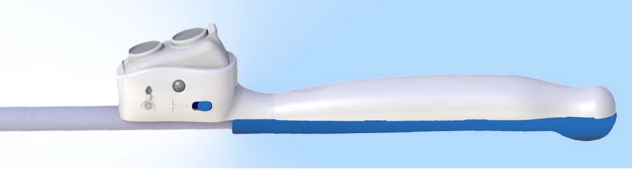
Another similar device is the one called “Ultra cane” developed by the company called Sound Foresight Technology Ltd, just as the Smart Cane this device gives mobility assistance by emitting ultrasonic waves.

Table 3.2.2: Ultra cane features
Key Feature | Specification
Range | Offers two ranges to choose from, short range mode, which detects obstacles with 2 meters and long mode which detects obstacles within 4 m.
Feedback | Provided through two vibrating buttons located on the handle.
Sensor | Ultrasonic waves are emitted through two transducers, one up and one down

Figure 3.2.2: Ultra Cane (permission: open-source)
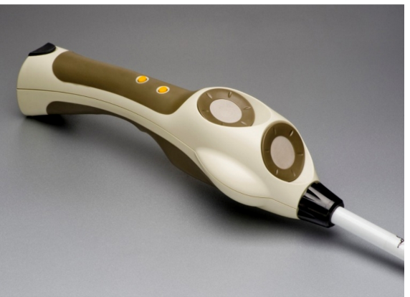

3.3 Feedbacks

The group reached out to the Blind subreddit community, a sub-forum within the Reddit social media platform, in order to get a better idea of what a useful device would accomplish. These feedbacks are located on a thread named “What device would make a blind person's life easier? We need your input to create a useful engineering senior design project. “.

The group originally planned to have the device vibrate the cane with varying intensity as a way to warn the user of objects they are walking into. The group then learned that visually impaired people rely on the faint vibrations they receive from their cane to analyze the environment, so the group decided to remove the vibration feedback in favor of both an internal speaker and a Bluetooth interface that will be paired with a bone conduction headset (which doesn’t block sound from coming in).

Another issue some potential users had was with adding weight to their already cumbersome cane. As much as the group work on keeping our device light, it will remain an issue for a cane-mounted device. Our device will be designed to be usable on a bicycle handlebar as well. This will make weight a non-issue, while providing the visually impaired people with some vital information about the world ahead of them.

The device also will ideally warn cyclists of oncoming obstacles, name each intersection, and if time permits describe the status of traffic lights. This has not been discussed on social media, but one of our group members was inspired through real life interaction with a cyclist suffering from damage to the optic nerve. This individual could potentially gain a longer lifespan through the use of our device.

3.4 Possible Architectures and Related Diagrams

3.4.1 Architectures: Advantages and Disadvantages

When it comes to the design of the device, the group wanted to implement a design that would be practical for long term use. The average person spends their out and about and for a blind person, they spend their day out and about, usually carrying a cane.

So the first design factor that the group considered was to make sure that the cane is lightweight. The heavier the cane, the more overbearing it is on the user after long periods of use. This was the issue with the previous design, SenseWalk. In about a half hour of usage, the device put too much stress on the user’s forearm and made it really difficult to hold.

For SenseWalk 2.0, the goal size for the device is about the size of a cell phone. With this size capacity, the device will be manageable for people of all age and size ranges, from adolescents to senior citizens.

The group originally planned to have the device vibrate the cane with varying intensities as a method to warn the user of objects that they are walking towards. The group then learned that visually impaired people rely on the faint vibrations, which they receive from their cane, to analyze the environment. The group made an executive decision to eliminate the vibration feedback in favor of maintaining the user’s safety. The group then moved towards replacing the vibration feature with audio and voice feedback through a microphone and speaker.

There are two design architectures which the group came up with for SenseWalk 2.0. The intention of the new architecture was to have both the speakers and microphone installed as their own individual component, as demonstrated in the figure below.

Figure 3.4.1.1 - Block Diagram: Initial Diagram
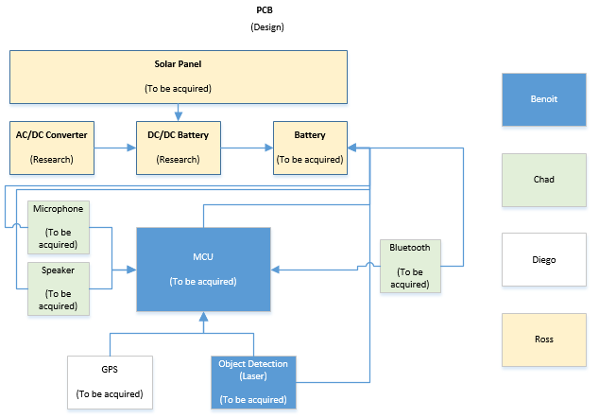

The group later determined that is best to remove those two components. There are two benefits in doing so. The first benefit of removing the microphone and speakers from being attached to the device, is that it results in an even lighter device. Again, the lighter the device, the less taxing it becomes on the user’s arm. The other benefit gained from removing those two components, is that it broadens the range and style of use for the user.

Each person is different. And each person has a different range or degree of hearing and speaking. If the group were to add a static speaker and microphone, the group would essentially run into issues for people who speak louder, softer, harsher, etc. than what the intended range of our microphone or people who have greater difficulty of hearing than our set speaker output range.

Allowing those components to be dynamic, users can cater the speaking and hearing aspect of the device to their specific need. Allowing the device to reach a wider market of users and improving its efficiency for each of them. Below is the updated diagram for SenseWalk 2.0.

Figure 3.4.1.2: Block Diagram - Final Diagram
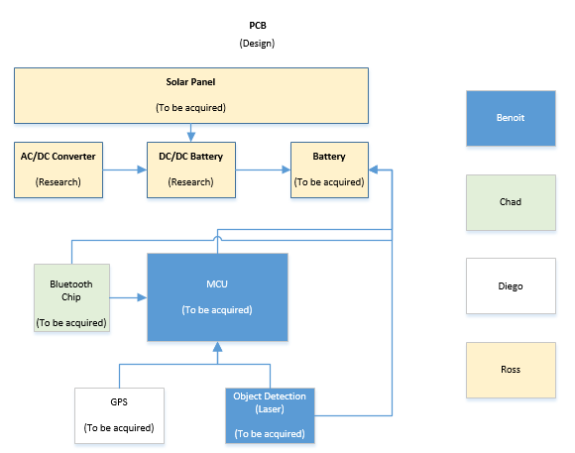

3.4.2 How to Arrange Parts

The “SenseWalk 2.0” is a portable electronic device which is powered by a rechargeable battery system. There are multiple power conversion stages which each have specific requirements. There are two main subdivisions for the “SenseWalk 2.0” power supply design, AC-DC and DC-DC regulators.

Since the “SenseWalk 2.0” operates on a rechargeable battery, there is need for an AC-DC battery charging system. The AC-DC battery charging system provides the means to recharge the “SenseWalk 2.0” battery supply when depleted. The “SenseWalk 2.0” requires two Different DC-DC regulators to power the various subsystems, such as the Laser detection system, GPS module, microcontroller unit, and the Bluetooth module. Below is a bulleted list of all the “SenseWalk 2.0” power supply design requirements.

Table 3.4.2.1: Power Supply Design Requirements
Power Supply
The AC-DC battery charger must have a minimum efficiency of 60%.
The AC-DC battery charger must produce a desired regulated output.
The AC-DC battery charger must have a universal operating range 90Vac - 280Vac.
The battery must be lightweight to provide a friendly user experience.
The Battery must power the “SenseWalk 2.0” for a minimum of 2-3 Hours.
All DC-DC converters must produce an accurate regulated output voltage.
All DC-DC converters must be able to operate in typical environment operating temperatures.
All DC-DC switching converters must have a minimum efficiency of 80%.

The GPS is the heart of the walk sense. It provides the main capability and usefulness to the visually impaired user. “SenseWalk” used a good GPS module to receive latitude and longitude coordinates. Ultimately this is why the group decided to use the same GPS as used before in the original design of “Sense walk”.

SenseWalk 2.0 requires the production of real-time directions and routing information to the user of the walking-stick. This is accomplished using an embedded GPS monitoring system that can learn the routes that the user wants and can reroute the user, if necessary, if they are led astray. The specifications for SenseWalk 2.0 are very stringent. The reasoning is to keep the design
lightweight, portable, and powerful while being able to run off of a battery.

The group used the same GPS module made by Locosys Technologies as previously used in “Sense walk”. In order for it to seamlessly integrate with the microcontroller design circuits were made.. All of this was processed mostly using Open Source software that is easily available on the Internet and requires no special permissions or licensing. Below is a bulleted list of “SenseWalk” GPS requirements:

Table 3.4.2.2: GPS Design Requirements
Requirements
GPS module must interface with microcontroller
GPS module must output location/position data in NMEA industry format
GPS module must have accuracy of at least 3 meters (if possible)
GPS module must have target acquisition of less than 1 minute from power on
GPS module must have hot start of less than 5 seconds
GPS module must be independent, have all processing done within the module, and cannot require outside computational power
Software must be able to select user waypoints and create a route
Software must be able to output waypoint data using OpenStreetMap data
Embedded software must be able to read CSV formatted file and load waypoint information from CSV formatted file
Embedded software must be to accurately route user in real-time to within 10 meters of declared waypoint
Embedded software must be able to send message to the user via Bluetooth-enabled headsets.
GPS module must be low power (Power Consumption TBD)

Every component will have a trace leading back to the battery the source of power. The leads will be short and components placed close together to save weight and space.

3.6 System Communications

3.6.1 GPS Communication

GPS stands for Global Positioning System and is one of the most useful technologies of our time. It is satellite-based navigation system that allows to locate any specific place and also can determine any user’s current location, velocity and time in land, sea or airborne at any time during the day, in all weather conditions anywhere in the world where there is an unobstructed line of sight of at least 4 GPS satellites.

GPS has become very popular that it is being implemented as a feature for many of the newest technological devices. Not surprisingly, the group has decided to implement GPS as one of our main features for our project SENSE WALK 2.0.

The project’s main goal is to assist visually impaired people in navigating throughout their day-to-day lives. This project will allow a user to store up to four of their most frequently visited places, for example their child’s schools, the supermarket, the bank, etc. In order to store the routes, the group first need to acquire the current location; therefore the group needs to add a GPS receiver to the device. The GPS receiver’s primary function will be to locate four or more satellites, figure out the distance to each, and use this information to acquire its own location. The GPS receiver does this by solving a simple mathematical principle called trilateration.

Another way to analyze and understand the operations of GPS systems is to look at the math that goes into calculating a position from the Pythagoras theorem. Consider the following formula:

Prs + T + Es = sqrt {(X - Xs)^2 + (Y - Ys)^2 + (Z - Zs)^2}

From the formula you have X, Y, Z, which are the positions whose values need to be found and T, is the time error at the receiver. The Xs, Ys, Zs are the satellite positions that are being calculated from the information sent from each satellite. The Es variable is a sum of all the errors considered by the GPS such as troposphere, clock errors from the satellites and any other error that the GPS may consider significantly important to include. It is not important at this point to fully analyze or understand how the GPS calculates the data, but having just a little understanding of the mathematical concepts behind this technology can help us build our project in a more efficient way.

When analyzing which GPS receiver that will be used, first it is important to decide what type of receiver that needs to be used. There are 3 types of receivers: multiplexing receiver, sequential receiver and parallel receiver but there are also some receivers that are mixed types, where some channels are dedicated to a single satellite and others are multiplexing or sequential.

The initial step, is to analyze the multiplexing receiver, this type of receiver establish contact with a satellite only for a short period of time just to sample its data, and then they go for the second satellite to sample data and get the information, and a third, fourth and so on. All this process takes just few seconds. Multiplexing receivers are the less expensive types of receivers because they don’t cost too much money to build, but the consequences of these savings result in less accurate positioning responses to changes in direction or speed. This receiver uses time division multiplexing; therefore the information must be pieced together and then averaged. Since they have to be switching constantly, they tend to have problems to keep in contact with satellites in areas where the sky is blocked by mountains, hills, trees or buildings.

The second type of GPS receiver that will be analyzed is the parallel receiver. Parallel receivers maintain a constant simultaneous lock on several satellites at once. This helps to eliminate the switching inaccuracies from the multiplexing receiver. Parallel channel receivers hold all the navigational information needed for the most reliable, up-to-date and accurate information.

The last type of receiver to analyze is the sequential. Sequential receivers also switches and obtains information from multiple satellites, it differentiates from the multiplexing receiver in that this one gets all its data from one satellite and then it moves to the next one in order to collect all the data needed to provide the location.

Among the 3 types of GPS receivers, the sequential type is almost obsolete today therefore you should only consider between multiplexing or parallel receivers. It is already known that parallel receivers are faster and provide a more reliable fix since they have a dedicated hardware to receive each satellite that it needs, but in the other hand multiplexing receivers work really good in any place where is a clear view of the sky but if more users live in a big metropolitan area where there are many buildings our best type would be to choose a parallel GPS receiver.

Another important aspect to be analyzed is what type of features does the GPS receiver provides. Among the most important are: size, update rate, power requirements, and number of channels, antennas and accuracy. Size is very important for our project since one of our goals is to build the device as small as possible.

One of the flaws from the version 1 of the project was the size; it was too bulky; therefore improving this aspect is very important in our current design. Our projects needs a standard update rate which is 1 Hz, we don’t need more than that since the user will be walking and they won’t go fast enough to have changed position significantly in the past second. We would only need a faster update rate if the user would be on an airplane or on a really fast vehicle, in that case we could use a 5 Hz or 10 Hz but for our project all we need is a 1 Hz.

Another really important aspect to take into consideration is the amount of power that our device will consume; on average most GPS receivers consume 30 mA at 3.3 V so we definitely need a GPS in that range, a GPS that will consume considerable more than the average would be discarded, in the other hand if we find a receiver with a lower power consumption will be great, we would only have to see if there is any drawback to it.

The numbers of channels for our GPS receiver is very important, there are 24 actives satellites in the space, so therefore the number of channels that the receiver runs will affect the time to first fix, the more satellites are in view, the faster it will find a fix. When it comes to the antenna for the receiver, many modules come with a chunk made of ceramic; each antenna is configured to pick up the GPS L1 frequency of 1.57542 GHz.

There are other types of antennas such as helical or chip, these types are more expensive and required significantly more amplifications and filtering. Also there is some receiver that already have the antenna incorporate, our goal is to find a GPS receiver with the antenna already incorporated to make our project easier.
The last feature we are going to analyze is the accuracy; in average a GPS receiver can find its position in less than 30 seconds down to +/- 10m. Many receivers can get down to +/-3 depending on the weather conditions and location. After all the research we have done about how a Global Positioning Systems works, what types and the features that we need to take into consideration in order to choose the right receiver for our project we need to start comparing. Since the GPS receiver is one of the main components in our device, we are willing to spend a decent amount of money, it doesn’t mean we are going to choose the more expensive one in the market, but money is not a limitation as long as the receiver meets all our needs. Next will compare some GPS receivers that we are taking into consideration for our project.

3.6.2 Bluetooth Communication

Bluetooth transmission will play an integral role in communicating directions from the device to the user. It is the gateway that will relate information given from the user’s command to the device, then the response from the device back to the user. It will be required of the controller to obtain instructions from the GPS and transmit the set of instructions on a given route into an audio signal for the user to receive and hear through their headset. Bluetooth works on a range of up to 400 feet (about 61 meters) with a Bluetooth 4.0 device.

Realistically, only a range of up to 10 meters with a Class 1 device is needed, since the proximity between the user and the device is very small (the cane will be in their hands at all times during use). Bluetooth uses a radio frequency that operates on the 2.4 GHz unlicensed (industrial, scientific, and medical) ISM band of radio frequencies.

This permits the console to communicate with many possible Bluetooth-enabled devices if necessary. Typically, a Bluetooth device can establish a connection with up to 8 devices all at the same time. This means that any Bluetooth-capable headset should be able to effortlessly interface with the cane.

The Bluetooth controller has software that holds and implements the Bluetooth protocol stack. All Bluetooth controllers have the three mandatory protocols already intact that are relative to finding other Bluetooth devices and setting up connections. This is called the Bluetooth protocol stack.

These protocols are the link management protocol (LMP), the logical link control and adaptation protocol (L2CAP), and the service discovery protocol (SDP). The protocol stack holds various profiles, in addition to the mandatory protocols, to use information relative to the purpose of protocol profiles to determine what devices to connect to. This happens only if they hold the same protocol profiles.

For this specific case, our Bluetooth controller of choice must also have an advanced audio distribution profile (A2DP) that designates that this chip has the given feature of transmitting audio information. The headset itself must also hold the same A2DP profile in order to properly receive and make sense of the audio-related transmission. The controller that is need for the project design must also hold a synchronous connection-oriented link (SCO) for establishing the transmission of voice data since the GPS instructions will be transmitted as voice instructions for the user to hear.

Furthermore, the controller must have a host/controller interface (HCI) protocol which allows it to communicate with the microcontroller through a universal asynchronous receiver/transmitter (UART) connection. In addition to this necessary feature, one of the best advantages to Bluetooth is that it consumes little power, making it a perfect attribute for the battery-powered console. Hitting one of the necessary and highly sought after goal for the device.

The chip will be a transmitter sending information to the headphones set. Because Bluetooth connection has a master/slave type relationship, the main console of the SenseWalk 2.0 which holds the Bluetooth chip, will be the master controlling unit. The headset and microphone that the user will be wearing will be the primary devices that will need connecting to and will be the slave unit. A computer may also be needed to send or upload new routes onto the device. Information from the microphone will need to be sent to SenseWalk 2.0’s console. Therefore, communication established will be multi-directional.

How the communication process works is the personal-area network (PAN) or piconet will be set up between the two units according to the link management protocol (LMP) on the controller that dictates the speed and size of data being sent. Interference between other neighboring Bluetooth devices should never be a concern due to the method of spread-spectrum frequency hopping that Bluetooth utilizes. Frequencies constantly change thus making interference from unconnected Bluetooth devices unlikely. If, by some rare occurrence, that interference does occur, software has been written into the Bluetooth controller stack protocol that handles and prevents such errors.

As of right now, the most current version of Bluetooth design specifications is Bluetooth v4.0. This version is backwards compatible with previous Bluetooth versions and many of the available controllers on today's market are version 4. Thus, it would be within our best interests to use a version 4.0 controller. This version consists of implementing the Bluetooth low energy (BLE) feature while being able to simultaneously communicate data at a high speed, the enhanced data rate (EDR) feature.

As the versions of Bluetooth progressed, they've adopted other modulation implementations to use. For this particular application, however, whatever modulation method the controller utilizes should not present itself to be an issue during design and testing. Typically, BLE utilizes Gaussian frequency-shift keying modulation while EDR implements differential phase-shift keying (DPSK). The controller that is needed for this design will have to offer a dual-mode, allowing the use of both of these protocols.

3.6.3 Distance Sensor

One of the main goals from the previous version of the device was to improve most of technologies implemented on it and the most important features for a visually impaired is the feature of obstacle detection, for this reason we will analyze several technologies and compare them in order to use buy the sensor that will meet and surpass all the requirement for SenseWalk 2.0. There are many types of sensor out there in the market and selecting the right sensor is very important but a very difficult task.

One of the main key sub-systems which SenseWalk2.0 implements, is an object proximity detection system. It is designed to be very helpful for the visually impaired user to have access to information relating to approaching or stationary objects within the users walking path. Because SenseWalk 2.0 users are unable to visually observe approaching objects, SenseWalk 2.0 detects this information and audibly relays it to the user through Bluetooth.

There are different options which could be implemented to detect an object’s proximity, such as Sonar, infrared, or laser methods. Each of these three methods has advantages and disadvantages which were investigated and discussed below in more detail during the research phase. Some of the important factors that were decided regarding the correct object proximity detection method were accuracy, size and weight, cost, and operating limitations.

Selecting the best sensor from a variety of products and manufacturers is hard especially for beginners, the sensor have to meet all requirements such as size, shape and range. Before talking about all the requirements let’s understand a little bit about how a sensor works. A sensor is a sophisticated device that measures a physical quantity like speed or pressure and converts it into a signal that can measured electronically, they are made based on several working principles and types of measurements. There may aspects to consider when it comes to selecting the right type of sensor, it is necessary to analyze a few of the aspects to consider:

Table 3.6.3.1: Distance sensor requirements
Accuracy | The accuracy of a sensor is very important in detecting tracking objects; always choose the sensor with accuracy values between desired measurement margins.
Resolution | Very important aspect to consider, high resolution can detect smallest changes in positions of the desired target.
Calibration | Calibrating the sensor is an essential step in to ensure efficiency.
Cost | Depends on the budget allocates to a project.

Ultrasonic Sensor

These types of sensor are designated to generate high frequency sound waves and receive the echo reflected by the target. These kind of sensors are used in many projects where the detection of colors, surface and texture is not important. The size and weight of the object detection system are very important. “SenseWalk 2.0” needed to be extremely lightweight and small so that it is not hassle for the user to carry the extra weight on their cane. The weight of the device was proven to be a design flaw of “Sense Walk”. It is vital to reduce the overall system power requirements to prolong battery life, and reduce the required battery size and weight discussed in other sections.

Table 3.6.3.2: Ultrasonic Sensor pros and cons
Advantages | Disadvantages
Sensor response is not dependent on the colors, transparency of objects, optical reflection properties or texture of object | Must view a high-density surface for good results. Low-density surface such as foam and cloth absorb the sound wave emitted by the sensor.
Output value is linear with the distance between the sensor and the target. | Could have erroneous responses for loud noises such as air hoses.
Accurate detection even of small objects. | Ultrasonic sensor has a minimum sensing distance
Ultrasonic work under critical conditions such as dirt and dust. | Sonar is vulnerable to noise
The design cost for a fully functioning sonar system was estimated to be relatively low. | Changes in the environment such as humidity, temperature and pressure can affect the response of the sensor.
Relatively low power requirements

Infrared Sensor

Infrared range finding works based on the use of triangulation. An IR light beam is set out to detect the presence of an object. The beam is usually at a pulse of 850nm ± 70nm. The beam is then reflected off an object and back to the sensor. The angle of the beam is then determined and the distance is calculated from the measured angle. This is shown in figure 3.2.2.a below. This is done by a special lens in the receiver. The light beam passes through this lens and into a linear CCD array. The triangulation would be done and the range would be outputted in an analog form. The analog signal is then able to be read by the microcontroller.

In order to get rid of interference, a modulated frequency is emitted from the transmitter. This solution makes the IR beam able to determine ranges in any type of light and off of any object despite the object's color. The advantage is that it has a wide angle and is capable of sensing objects anywhere in the range. If an object appears outside of the detection range, it cannot be detected. With a narrow range angle like sonar, the location of the object can be much more easily determined but the device has to be pointed directly at the object. Infrared triangulation for range finding is an effective solution to identify distances accurately. This in addition to the sonar, would be the best combination to identifying distances. Since the infrared sensor is not necessary, this could be a possible feature that may be added in future revisions of the final design.

These types of sensors measure the IR light that is transmitted in the environment to find objects by an IR LED. Infrared sensor are very efficient when it comes to object avoidance, distance measured and line following applications. They are very sensitive to IR light and sunlight, and this is one of the main reasons why IR sensor are used in places with low light for a better precision.

Table 3.6.3.3. Infrared Sensor advantages and disadvantages
Advantages | Disadvantages
Can detect infrared light over a large area. | Very sensitive to IR lights and sunlight
Can operate in real time. | Weakness to dark colors
IR sensor uses non-visible light for detection.

Cost effective, very cheap compared to other types

Sonar Sensor

These kinds of sensor are very expensive and most of the times are used in projects with big budgets, they are used primarily in navigation for object detection, even for really small objects. This type of sensor has a very high performance on the ground and in water.

Laser Sensor

These types of sensors are very useful for tracking and detecting a target at long distances, the distance is calculated by measuring the speed of light and the time since light is emitted and until it is returned to the receiver. The laser is beamed to an object, bounced off and captured by a receiver/detector. The purpose is to measure the distance between the device and the object. In order for the laser to achieve this, it applies the principle of the “time to flight”. The time of flight principle is called like that because it makes use of the duration over which the light pulse of the laser travels from the device to the object and back.

This principle also needs the speed of light which has a value of 300,000,000 m/s. Once the time of flight is measured, the distance can be computed using the two known values. The relative speeds between the object and the device can also be measured by means of the Doppler.

A really important aspect to take into consideration is that accuracy of the reading is highly dependent on the presence of impurities in the air, the temperature of the air and other obstruction.

Another method in order to determine distances is the” triangulation method”. The sensor projects laser spot onto the measurement object, the reflected light fall incident onto a receiving element at a certain angle depending on the distance. From the position of the light spot on the receiver element and the distance from the sender to the receiver element, the distance to the measurement object is calculated in the sensor.

Table 3.6.3.4: Laser Sensor
Advantages | Disadvantages
Very precise in measurement. | Depends on weather, visually path should be clear, dusty air, rain and cloudy day will affect the accuracy.
Ideal for near real time positioning of an object. | Very expensive

3.7 Hardware

The following sections summarize the researched components for SenseWalk 2.0. Each section will discuss the principal points of interest for the specific component, as well as the choices for each component. The two most important components of the project (is probably the MCU and Battery).Each component of the system needed an extensive amount of research done in order to find the most efficient and cost effective hardware for our device.

3.7.1 Microcontroller

The main defining factor of our project is most likely the microcontroller. It determines the amount of processing power available to get the work done, the number and types of ports available to connect external devices, and the type of software we will be developing. The development environment we will be using usually depends on what the chip’s manufacturer releases, and the manufacturing complexity is largely based on the processor’s pin number and type.

3.7.1.1 Microprocessors

Microprocessors are the processors most people are aware of, because they are present in most devices known to consumers as computers. These devices include desktop personal computers, laptops, tablets, smartphones, servers, and supercomputers.

Microprocessors are the brain that power the aforementioned technology. They take any input stored in virtual memory (by moving it through the memory hierarchy), and perform whatever kind of calculation is stored on the RAM. Microprocessors are simply defined as an arithmetic logic unit (which performs computation) and a control logic section (to route instructions), because their only job is to execute instructions. They are simple but typically much more powerful than their microcontroller counterparts.

We investigated the following microprocessors:

Broadcom BCM2835 (ARM1176JZF-S)
We first considered the Broadcom BCM2835. It is a 700 MHz processor featuring an ARM ARM1176JZF-S core.
The BCM2835 was our first choice because it powers the Raspberry Pi B+, which is currently the most widely used single-board computer. This makes it a very attractive choice for our design because of the large number of applications and documentation available for that specific processor.
Unfortunately the Raspberry Pi’s design is not open, and Broadcom does not sell the BCM2835 to individual hobbyists. As a result, it would be impossible to design a senior design project based on this processor.

Analog Devices Blackfin ADSP-BF606
We went through the uClinux Ports page (http://www.uclinux.org/ports/ ) to find a processor that would run uClinux. The Blackfin came up on top of our search because it is still widespread, relatively inexpensive, and there is a panoply of documentation available on its uClinux port (see http://blackfin.uclinux.org ) as well as an active community of developers.
The ADSP-BP606 was chosen as our Blackfin model because it is part of the Blackfin family (as opposed to the Blackfin+, which may have incompatibility issues with uClinux), yet it features a dual-core processor and is the least expensive model to do so. It is priced $14.99 (unit price for 1000 to 4999 units) which is reasonable for the cost of our project, and each core is clocked at 400 MHz, plenty more than what we may require (giving us a lot of room for future computer vision software upgrades).
Ultimately we steered away from the Analog Devices Blackfin ADSP-BF606 because its 349-ball BGA package would have been nearly impossible to work with considering our limited knowledge and equipment.

Texas Instruments Sitara AM3358
The TI Sitara AM3358’s foremost selling point is its presence in the BeagleBone Black, a relatively inexpensive development board whose development which ships with Debian Linux preinstalled and is funded by Digi-Key and Texas Instruments. It uses only TI components, but its whole design has been open-sourced from the start. This lead to a flourishing open-source developer community contributing to its ecosystem and sharing ideas.
This processor features a 1-GHz ARM Cortex-A8 32-bit core, an abundance of ports, and TI provides a dedicated distribution of both Linux and Android at no additional cost.
The AM3358BZCZ60 is the least expensive AM3358 model and it is priced at $8.14 per unit when purchasing at least a thousand processors, while the BeagleBone Black development board costs $45 a piece.
All Sitara AM3358 processors come packaged in the NFBGA 324 format, a BGA package that would have been too complicated for a project of the SenseWalk’s scale. For this reason we did not consider it any further.
Intel Edison
The Intel Edison is the last microprocessor we investigated. It is not a typical processor, but a development system as Intel calls it. This means everything we may need is built into a small device approximately the size of a Secure Digital card. As a result we would not need to purchase a conventional development board. Instead, a simple board that plugs into the 70-pin dense "Hirose DF40" connector and merely provides easier access to the pins would suffice.
The second version of the Intel Edison is packaged as a 35.5 x 25 x 3.9 mm board. It features both a 500 MHz dual-core Intel Atom which handles the high level operating system and a 100 MHz Intel Quark core for the low-level real-time processing, 1GB of RAM is built-in, as well as 4GB of eMMC flash. There is a Wi-Fi, Bluetooth 4, and USB controller, as well as SD, UARTs, and GPIOs ports.
The Edison makes use of the same x86 architecture, allowing for the entire Intel IA-32 software ecosystem to run effortlessly. This opens up a panoply of new use cases. Intel ships its Edison system with Yocto Linux, a Linux distribution supported by the Linux Foundation that targets embedded systems, but it is relatively easy to install any x86-compatible distribution onto the Intel Edison. Debian is an obvious possibility, and with it comes approximately forty three thousand precompiled packages (as of 2015-04-25).
This development system is significantly more expensive than a similarly powerful microprocessor, with a $49.95 price tag per unit (and no restriction on the minimum amount to purchase). However the “development boards”, or blocks, are much less expensive. A simple board that exposes the GPIO ports costs $14.95 on sparkfun.com, while a “base block” that exposes the USB port costs $32.95 and can be stacked on top of another. This potentially reduces the development cost at the expense of the final product’s, but with a project with the scope of the SenseWalk 2.0, the development cost far exceeds any possible future return on investment from the final product so long as it does not become a great commercial hit (in which case a revised design would be necessary).
Some of the drawbacks we had to take into consideration include the highly unusual 70-pin dense "Hirose DF40" connector that Intel chose for this system. This connector issue is derisory compared to the three hundred plus balls BGA connectors present on the CPUs we have taken into consideration this far. Another potential issue comes from the latency introduced when physical GPIO pins are switched. Flipping bits is not as quick as the switching produced on microcontroller-based systems, but the issue is barely significant because a fast port switching speed is of little to no importance to our device.
The benefits of using the Intel Edison far outweigh its downsides, therefore it is the group’s choice of microprocessor for SenseWalk 2.0.

3.7.1.2 Microcontrollers

Texas Instruments MSP430
The TI MSP430 is a low-cost, ultra-low power microcontroller built around a 16-bit custom (“MSP430”) architecture. Its top speed is 25 MHz, and it is used extensively at the University of Central Florida. UCF computer engineering students are first introduced to the MSP430 in EGN 3211 “Engineering Analysis and Computation” through an end of semester project and a few assignments that involve the MSP430F5529 Launchpad evaluation kit and the Energia IDE. It is used again through the whole semester in EEL 4742C “Embedded Systems”, this time using a more advanced Experimenter board as well as the TI Code Composer Studio software suite. The TI MSP430 platform is also available to all engineering students in the Idea lab. This extensive exposure makes the MSP430 architecture ideal for any UCF student-made project, and for this reason it made its way into the original SenseWalk project.
The MSP430 is very attractively priced, at $5.91 (on orders of at least a thousand units) for the MSP430F67491, which is the highest performing part featuring a 25 MHz clock, 32 KB of RAM, and 512 KB of nonvolatile memory. It consumes 2.9 to 346.8 micro amperes per megahertz, and comes in a relatively simple 100LQFP package. The MSP-EXP430F5529LP development board can be purchased for $12.99 per single unit from Texas Instruments. It features the same 25 MHz clock, but only 128 KB of Flash and 8 KB of RAM.
While the quasi entirety of the original SenseWalk project’s invaluable data has been lost when one of its members tragically smashed his computer with a hammer during a moment of sheer frustration, we were able to get a hold of the aforementioned individual and we briefly detained him for questioning and moral support. It was reported to us that the MSP430, even in its fastest twenty five MHz revision, could not keep up with the processing load that the SenseWalk software put on it. Given that we wish to add features to the original SenseWalk (e.g.: computer vision, which requires a considerably high degree of computing power on its own), we have no choice but to steer away from the MSP430 architecture at last.

Texas Instruments MSP432
After eliminating the MSP430, our next obvious target is the TI MSP432, Texas Instruments’ newest and most powerful take on the low power microcontroller market slice. When boarding the 32-bit microcontroller, Texas Instruments ditched its in-house MSP430 architecture altogether in favor of a proven ARM Cortex-M4F core. The MSP432 is almost twice as fast as its MSP430 predecessor, clocking in at 48 MHz (from 25 MHz), while the active power consumption decreased from 346.8 micro amperes per megahertz to 90 uA/MHz (allowing the microcontroller to run at full speed while using less power than its MSP430 counterpart). Price has not been announced for the MSP432P401R (which is still categorized as a preview), but the price of the development board remains unchanged, an MSP432P401R LaunchPad development kit would set us back $12.99.
While the MSP432 is a very attractive alternative, we feel that its 48 MHz clock might set us back. The ARM Cortex-M4F architecture is capable of much higher speeds. We will not know about the actual clock speed requirement until we implement some sort of robotic vision functionality, and the price difference between different microcontrollers is typically insignificant (in the range of five to fifteen dollars), therefore we will be looking for a faster alternative from different suppliers.

Imagination Technologies / MIPS
The MIPS architecture is an attractive alternative to ARM cores. MIPS is a reduced instruction set computer instruction set architecture (RISC ISA) developed by MIPS Technologies, Inc., which was acquired by Imagination Technologies in 2013. It is ARM’s closest competitor. UCF computer and electrical engineering students get accustomed to the MIPS assembly language as part of their EEE 3342C Digital Systems class, the first in a series of three classes that deal with computer architecture and assembly languages. Much like ARM, Imagination Technologies do not manufacture their own physical processors. Instead, they license their intellectual property to various semiconductor actors.
We looked into Microchip Technology Inc and their renowned PIC32 microcontroller series. The 32-bit PIC microcontroller can attain a speed of up to 200 MHz. A simple $25 development board, the PIC32MZ EF PIM, is available. It includes a PIC32MZ2048EFH100 microcontroller, featuring a 200 MHz clock, 2 MB of flash memory, 512 KB of RAM, and an easy to use 100 pins package. The PIC32MZ2048EFH100’s price tag is $8.26, it includes six UARTs, 6 SPIs, and 5 I2C ports.

ARM Cortex-M4 core
Following the Texas Instruments MSP 432 investigation, we skimmed the market looking for a more powerful ARM Cortex-M4 core. We considered microcontrollers that have a matching development board and meet our clock speed requirements.

Table 3.7.1.2.1: ARM Cortex-M4 based microcontroller’s specs comparison
Supplier | Part# | Frequency (MHz) | Flash (kB) | RAM (kB) | Price (MCU, $) | Price (dev board, $)
TI*** | MSP432P401R | 48 | 256 | 64 | TBA | 12.99
Atmel | SAM4SD32 | 120 | 2048 | 160 | 7.93** | 42.65
Atmel | SAMG55J19A | 120 | 512 | 176 | 4.16** | 31.71
STMicroelectronics | STM32F479II | 180 | 2048 | 384 | 10.411* | 61.2
* @ 10000 units
** @ 5000 units
*** The TI MSP 432 has been added to the table for comparison.

The STMicroelectronics STM32F479II comes ahead of its competition in all aspects except its price, but the difference is negligible (between $2.48 and $6.25).

Its closest affordable development board, the STM32479I-EVAL, is much more expensive than its rivals’. This is because it comes with a panoply of fancy features, such as a 800x480 pixel TFT color LCD, most (but not all) of which are of absolutely no use to our project but make the STM32F479II a keeper.
Some of the useful features built into the STM32479-EVAL include 512-Mbit of Flash memory, 256-Mbit of RAM, an SD card adapter, and a digital microphone.

ARM Cortex-M7 core

The Cortex-M7 is the newest most efficient member of the ARM Cortex-M microcontroller family. Its performance efficiency is fifty percent higher than that of the Cortex-M4 microcontroller (5 CoreMark/MHz vs 3.40 CoreMark/MHz, as measured by ARM). The Cortex-M7 core can currently reach a clock speed of up to 300 MHz, and this number is set to increase as smaller manufacturing technologies come along. This high performance is comparable to that of a microprocessor, yet the Cortex-M7 core maintains the simplicity of a microcontroller (and as such it still lacks a memory management unit).

At the time we initiated our research, there were only three ARM licensees shipping Cortex-M7 cores. They are Atmel, STMicroelectronics, and Freescale Semiconductor. Only one of Atmel’s three Cortex-M7 cores, the ATSAMV71Q21, has a matching development board. Freescale had not shipped a development board for its Kinetic KV5x yet at the time. This limited our search to only two options; the Atmel ATSAMV71Q21 and the STMicroelectronics STM32F746ZG. They are compared in the table below, along with the Freescale Kinetic KV5x which now has its own outrageously expensive development board.

Table 3.7.1.2.2: ARM Cortex-M7 based microcontrollers specs comparison
Manufacturer | Part Number | Frequency (MHz) | Flash (KB) | RAM (KB) | Price (MCU, USD) | Price (dev board, USD)
Atmel | ATSAMV71Q21 | 300 | 2048 | 384 |  | 136.25
STMicroelectronics | STM32F746ZGT6 | 216 | 1024 | 320 | 9.472* | 47.04
Freescale | Kinetic KV5x | 220 | 1024 |  |  | 159.00
* @ 10000 units. STMicroelectronics provided us with free samples.

Without further research, we notice that the STMicroelectronics STM32F746ZG is the only viable Cortex-M7 option. The other two are much too costly for each group member to have their own development board. Both the STMicroelectronics STM32F746ZG microcontroller and the 32F746GDISCOVERY development board are less expensive than their Cortex-M4 counterpart, while the M7 MCU increases performance and efficiency, and its development board contains all of the fancy features located on the STMicro “F4” Discovery development board.

Using such bleeding edge technology means that our project would be somewhat future-proof. Without modifying the hardware, a user would be able to update the firmware and introduce more demanding algorithms. This could be especially useful for the computer vision side, whose software will initially be developed as a simple proof of concept.

Some relevant features of the STMicroelectronics STM32F74ZG which were not mentioned in the table above include:

Table 3.7.1.2.3: Additional features present on the STmicroelectronics STM32F746ZG
Package: | LQFP 144 20x20x1.4
Connectivity: | 4 x I2C, 4 x UART, 6 x SPI (Dual mode Quad-SPI)

We will be using the STMicroelectronics STM32F746ZG (ARM Cortex-M7 core).

3.7.1.3 Microcontroller or microprocessor

A microcontroller and a microprocessor perform the same role in different ways. In this section we will pick one or the other, the contenders being the Intel Edison “microprocessor” (really a “development system”) based on an x86 Atom dual-core, and the STMicroelectronics STM32F746ZGT6 microcontroller (which is an ARM Cortex-M7 core).

Microprocessors typically perform one task, raw computation, and they perform it very fast. The main components found in a microprocessor are an arithmetic logic unit (ALU) and a control unit. Microcontrollers on the other hand contain everything a system needs to run, including RAM and flash memory.

MCUs are simple, low-cost, low power and used to get a specific task done. CPUs offer a lot more flexibility and several order of magnitudes more computing power which can be used to achieve many tasks together, at the cost of a much more complicated board design and a heavier power usage.

The Raspberry Pi is a current “CPU” development board, Linux can be installed on it and with it every open-source software (e.g.: a file server) and library (e.g.: OpenCV) that run on a computer. Most of the software that runs on a microcontroller must be written from scratch, but it is much easier to design a physical microcontroller-based board.

The Arduino is one current MCU development board, and it can be replicated with minimal effort using an off the shelf Atmel ATmega 328p microcontroller and few components. When computing power is not an issue, the reason a microcontroller cannot run an operating system and its underlying libraries is its lack of a memory management unit.

The SenseWalk 2.0 could have incorporated either a CPU or an MCU because it performs several tasks at once, which falls into the realm of a CPU, but these tasks are well defined and not extremely demanding. In the end a microcontroller, the ARM Cortex-M7 core, was chosen because the advantages granted by a microcontroller are essential to successful completion. These advantages are a higher battery life and a physical design that is not too demanding for our only one electrical engineer team member. Furthermore, the ARM Cortex-M7 core brings a level of performance comparable to that of a low power microprocessor.

The major drawback we will have to work around is the lack of an embedded computer vision library such as OpenCV. We will have to port OpenCV onto the Cortex-M7 platform, find an alternative computer vision library, or create our own. This is somewhat mitigated by the fact that computer vision is done in software and it is set as a stretch goal for the SenseWalk 2.0, therefore, our project can go on and additional computer vision capabilities will be implementable “when it is ready”, whether that is by the end of senior design 2 or at a later time.

In conclusion, the STMicroelectronics STM32F746ZG ARM Cortex-M7 core based microcontroller is our processor of choice for the SenseWalk 2.0, and the group will be developing this project on a STMicroelectronics 32F746GDISCOVERY development board.

3.7.2 Memory

We will attempt to replicate the hardware environment present on our 32F746GDISCOVERY development board in order to facilitate both the hardware and software development. By using the same RAM and flash memory chips and connecting them to the same pins used on our development board, we will ensure that transitioning our software from the development environment to our prototype is as effortless of a process as it can be. Moreover, the 32F746GDISCOVERY datasheet comes with a complete series of diagrams describing the microcontroller pinout as well as the required resistors, capacitors, and other miscellaneous components.

3.7.2.1 Random Access Memory

Our development board comes with a built-in Micron MT48LC4M32B2B5-6A 128-Mbit SDRAM integrated circuit connected to the “FMC” interface. 64 of the 128-Mbit are wasted in order to retain the 16 data pins the RAM would use for other purposes. We will attempt to make use of all of the SDRAM memory present on our final prototype if these pins are not required by other components.

The MT48LC4M32B2B5-6A comes in a 90-ball VFBGA package, therefore the first step will be to find an equivalent chip in a different package, because ball grid arrays are nearly impossible to work with on such a small scale and low budget. The ideal package will have pin connections coming out of the sides.

The other specs we need to match are a 32x width, 166 6fmMHz clock rate, PC133 data rate, 4 Mb depth, 6 nanoseconds cycle time, and a CL of 3. According to Micron’s website, the following integrated circuits fit these specifications: MT48LC4M32B2P-6A, MT48LC4M32B2P-6A IT,
MT48LC4M32B2P-6A AAT, MT48LC4M32B2P-6A XIT, MT48LC4M32B2P-6A AIT, and MT48LC4M32B2TG-6A. The MT48LC4M32B2TG-6A IT is the most similar chip available to us. We are able to purchase the MT48LC4M32B2P-6A IT on Difi-Key for $8.74 per unit, and it comes in an 86-pin TSOP II package like all of its non-BGA counterparts.

After investigating the pinout of our 144-pins MCU, we determined that it would be impossible to use the full 32-bit Data bus. We instead settled for a 64MB chip that follows the same specifications while using a 16-bit data bus. This allows us to use a simpler 54-pin TSOP-II package and reduce the cost of our SDRAM chip down to $1.88. The part we will be using is Alliance Memory, Inc.’s AS4C4M16SA-6TIN.

3.7.2.2 Flash memory

The STM32F746NGH6 discovery kit uses a Micron N25Q128A13EF840E 128Mb NOR flash memory chip connected to the Quad-SPI port. The N25Q128A13EF840E uses an 8-pin V-PDFN-8 package, which is a no-lead type of package that we are trying to avoid. We will be trying to match the following specifications: 128Mb density, multi I/O type, x1/x2/x4 width, 108 MHz speed, N25Q part family, embedded type. According to Micron’s website, the following parts match our requirements: N25Q128A13ESEA0F, N25Q128A13ESE40G, N25Q128A13ESE40E, and N25Q128A13ESE40F. All of the above use an 8-pins "SO8 Wide" package, which stands for Small Outline Integrated Circuit and is defined as a surface-mounted integrated circuit that is smaller than DIPs. We will be using the N25Q128A13ESE40E which is available on Digi-Key for $1.71 per unit. The N25Q128A13ESE40E requires a 2.7-3.6V power source, which is slightly less than the 3.7V coming out of the battery.

3.7.3 Laser Sensor

Seeing that the GPS is the heart of the project it only makes sense to call the laser the eyes of the project. After some research and comparing different types of sensors to use in our project we decided to go for the laser sensor SF10 which is very effective 0-25 meter rangefinder. It uses a time-of-flight system to make accurate distance measurements that are not affected by speed, wind, changes in pressure, noise, ambient light, terrain or air temperature, all this features were taken into consideration when making our decision to use this type of sensor.

Table 3.7.3.1 Features of the Laser Sensor SF10
Laser Sensor SF10
Outputs 32 readings per second for very quick data refresh
Multiple interfaces for use with different types of flight controllers or other embedded system
Ready to use with no calibration needed
Set optional configurations with the free LightWare Terminal Software
18" (46 cm) USB A to MicroB cable and 7-wire cable/plug included.
Very compact and lightweight -only 35 grams.
Fast Update Rate

The SF10-A Laser has 7 pins as shown in Figure 9, these pins will need to be properly integrated into the electronic system. The image does not describe the function on each pin; therefore the information is provided in Table 3.

Figure 3.7.3.1: SF10-A Pin Layout (with permission from lightware)
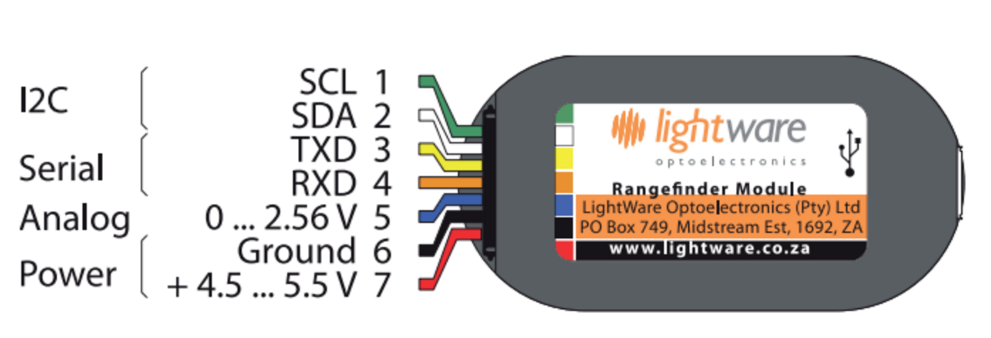

Table 3.7.3.2 Pin Layout Description
Pin # | Name | Description
1 | SCL | Clock line
2 | SDA | Data line
3 | TXD | Data Output
4 | RXD | Data Input
5 |  | Analog Input
6 | GND | Ground
7 | VCC | Power Input

The SF10 range finder gets power from either a regulated +5 volts DC supply on the main connector or via the USB port when it is connected to a computer. The SF10 has two of interfaces in the main connector which are digital and analog and either one or a combination of both can be connected to a host controller. The build-in micro USB port can be used to input settings and to test the performance. Because the SF10 can be directed connected to a computer, it makes it really useful for testing before it’s installed in any system as well for changing the settings for the final application.

Interfaces:

The analog interfaces on the main connector produces a linear voltage between 0 and 2.6 V and its proportional the measured altitude. The physical altitude in meters that is equal to the maximum linear voltage can be adjusted through the USB menu system. The serial interfaces on the main connector outputs the measured altitude in meters as a ASCII encoded number. The distances are transmitted whenever the SF10 received the ASCII character from the host controller. The baud rate for the serial interface can be easily changed through the USB menu system and the maximum delay to receive a character and returning the altitude is only 25ms. The inter-integrated circuit I2C interface on the main connector outputs a value that represents the altitude in centimeters, this interface operates in slave mode at 3.3 V, for some clarification the master/slave mode is a communication protocol in which one device or process known and as the master controls one or more devices known as slaves.

Once the master/slave relationship is established the direction of control is always from master to slave. The I2C address can be set through the USB system. The host controller acts as the master and sends the address to the SF10 in a byte value or 8 bits and the SF10 returns the altitude as a 16 bit integer. The serial port transmit a serial of ASCII encoded data from the SF10 to the host controller. The baud rate can range from 9600 to 115200. A useful formula where the output voltage can be converted back into distance is the following:

a=v/2.56*C

Where:
a = measure distance
v = voltage measured by the ADC of the host
c = 2.56 V distance setting

Table 3.7.3.3: SF10 Laser Specifications
Specifications | SF10A
Range | 0-25 meters
Resolution | 1 cm
Update rate | 32 per second
Accuracy | +- 0.05
Power Supply Voltage | 5.0 V +- .5 DC
Power Supply Current | 125 maximum
Outputs and Interfaces | Serial, i2c, analog with max latency of 25ms
Dimensions | 30 x 55 x 50 mm
Weight | 35 grams
Connections | Plug and socket, micro USB
Laser power | 4 W(peak),5 mW average
Optical aperture | 51 mm
Beam divergence | .4°
Operating Temperature | 0-40C
Approvals | FDA

3.7.4 Battery

We looked at these 3 types of batteries and ultimately choose the lithium ion battery. Because this project design is a mobile application, SenseWalk 2.0 console needs to be battery-powered. The console must be able to run on the battery pack for about 4 hours, allowing the user to recharge the console when SenseWalk 2.0 is not at use by simply plugging it into any standard wall socket. The charge time should not take too long as SenseWalk 2.0 should be readily available for whenever the user needs it.

Overall, this means that every component must use as little power as possible in order to be energy efficient. The choice of possible batteries to employ includes the popular lithium ion battery option, nickel-metal hydride, or nickel-cadmium batteries. A low-power microcontroller, Bluetooth controller, and GPS are objectives that need to be researched in order for the entire console to run on batteries alone for that established time frame. Furthermore, power regulation must be established through the power supply design that will help meet this objective. Many people in their day-to-day lives have a typical, established routine that may include routes going from home to work or going from one classroom to another.

For those that use a white cane, it would be deemed useful to store some of their frequently used routes into SenseWalk 2.0 console through the means of external memory such as with a SD memory card. The GPS will keep track of the user as they go about a certain route that they have selected and instructions transmitted via Bluetooth will notify the user constantly of where they currently are and what direction they need to take soon. Even for when the option of not using a stored route is chosen, the GPS can help the user in keeping them informed of their current whereabouts. The GPS will need to use a software that offers access to maps in order to configure routes and pinpoint the user's location in real-time.

SenseWalk 2.0 is a portable device that will need to be powered by a rechargeable battery. The common choices of battery technologies are NiCd, NiMH and Lithium Ion. The advantages and disadvantages of the various battery technologies will be discussed in the sections directly listed below.

Since the battery will only have a limited battery life, there will be a need to alert the visually impaired person as to how much battery is left on the device. The device will incorporate a button that can be pressed to audibly project how much battery life is left on a 0% to 100% scale in intervals of 10%.

With most rechargeable batteries the cycle of charging and discharged has a great impact on the battery. With Lithium Ion batteries this is not the case. Lithium Ion batteries can be charged and discharged with almost no effect on the life of the battery. However, in order to maintain this long life several precautions need to be taken. The first is that the Lithium Ion battery cannot be overcharged. This is because anything over the specifications of the battery will cause stress and damage to the Lithium Ion battery. For this reason a voltage limiting circuit needs to be used.

In the first stage, the battery charges and the voltage increases while the current stays the same. In the second stage, the voltage has peaked and stays constant while the current decreases till it is < 3% of the rated current. At this point, the current drops off while the voltage starts to decrease; this is the third stage. And in the fourth and final stage, a topping charge is applied to make sure the battery stays at a full charge.

During the first stage, the battery is charged at a rate of 0.5 to 1 Coulomb at efficiency of 97% to 99%. Some batteries might see a temperature increase of 5 degrees C, this is usually due to the internal resistance and the resistance of the protection circuits around the battery. When the current is increased, the amount of time in stage 1 will decrease while the time in stage 2 will increase. This is because the battery will reach the peak voltage faster but the saturation in stage 2 will take longer. A lithium ion battery, unlike a lead acid battery, does not need to be fully charged in order to function properly. Actually the opposite is true; in order to avoid stresses on the batteries, it is better to not fully charge the battery.

SenseWalk 2.0 had the option to use a quick charger that will charge 85% of the battery in about an hour. Instead, it uses a standard charger that will result in almost 100% of the batteries value but will take longer to charge. Because the device needs to make the battery last as long as possible, it was decided to use a standard charger instead of the quick charger. Because of this, it needs to incorporate a protection circuit to make sure the battery is not overstressed. Adding full saturation at the set voltage boosts the capacity by about 10 percent but adds stress due to high voltage.

Sensewalk 2.0 will be a light weight portable electronic device which will require electrical power for operation. Because the SenseWalk 2.0 will be portable, the system must be able to fully operate on a small lightweight rechargeable battery. There are many battery technology options available such as NiCd, NiMH, and Lithium Ion. Each battery technology will be researched and described below in other sections. This will allow for the optimum battery technology selection for the application.

Factors to be considered for battery selection are size and weight, price, charge duration, and charge lifetime. Sensewalk 2.0 will have many sub-systems, such as microcontroller, GPS, Bluetooth and Sonar each sub-system will require a specific constant supply voltage. Since it is not feasible to have a designated battery, with a specific voltage for each sub-system, DC-DC converters will be utilized. DC-DC converters will allow for multiple supply voltages to power the sub-systems. There are two types of DC-DC converts, linear and switch mode, it is important to understand DC-DC converters and the many topologies.

As mentioned above, the “The device will be powered by a rechargeable battery; therefore an AC-DC battery charger needs to be designed. Most all consumer portable electronics require an AC-DC battery chargers. As the battery is depleted, the user will need to recharge the battery. Because of the easy access to AC outlets, batteries are charged from AC voltage. But batteries cannot be directly charged from AC voltage, DC voltage is required. For this reason there is a need for an AC-DC converter. Often for user convenience and battery protection, battery charging systems utilize charge level detector. There are many manufactures who produce fuel gauge IC’s. The fuel gauge IC will be interface to the microcontroller.

When a charge is first placed on a battery, the voltage will increase very quickly at first and then will begin to level out as time increases. The charge will increase at a more constant rate as time progresses. While the current will start high and constant, as time progresses the current will then decrease as a function of time. Overcharging the lithium ion can result in a reduced life cycle. On the other hand, if the lithium ion battery is discharged too low, this can also damage the battery. SenseWalk 2.0 will have safe guard circuitry in place to prevent over charging or discharging.

There are two types of circuits that can be used to measure the capacity of the battery. One is the Closed Circuit Voltage (CCV) and the other is the Open Circuit Voltage (OCV). OCV is the potential difference in voltage of the two terminals on the battery when no load is connected to the battery. CCV is the potential difference in voltage when the battery is under a load. It is important to be able to measure the charge of the battery. CCV is one of the easiest methods but can be inaccurate. The individual cells can have different chemical compositions which can give off different results. In addition, temperature affects the reading. Higher temperature can raise the voltage reading and lower temperature can lower the voltage reading in the OCV method. Because of the volatility with the chemicals inside the battery, it is recommended to wait from 4 to 24 hours in order to get a proper reading. Because of the long wait time this would not work for the function of sensewalk a user may be on the go and does not have time to be sitting around waiting. An alternative method is called Coulomb Counting.

This is the method that most laptops and other portable devices implement to calculate the State of Charge of the battery. This method works by simply measuring the amps into the battery and the amps out. If ‘A’ number of amps are put into the battery over time ‘T’ then ‘A’ number of amps should be outputted over the same ‘T’ time. This method can be inaccurate towards the end of the charge.

3.7.5 Bluetooth

Once we realized that a vibration feature would cause an issue for the user and that each user would have a different severity of hearing and speaking issues associated with their lack of ability to see, we decided it would be best to allow each user to use a microphone and speaker device that is more carefully catered to their situation. These external components would connect to the device through a Bluetooth connection.

In choosing the Bluetooth device, there were several factors to consider. One of the factors, was the capability of the Bluetooth component to support voice and data transfer. In technological terms, we need a Bluetooth component that can handle sending and receiving data in a master-slave format. The device will rely on Bluetooth to transmit voice commands from the user, for example in cases where the user decides to request one of the preprogrammed routes stored in the device’s memory. The device would in turn, take the data received from the user’s command and respond to the user’s headset with an audio output of the directions of the requested route.

Initially, the Bluetooth component, HC-05 seemed like a very attractive component to help us establish the aforementioned feature. The Bluetooth HC-05 component has both master and slave capabilities and comes at an inexpensive cost of five dollars. But upon further research, an even more attractive device was discovered, TI’s CC2564. There are many things that makes TI’s CC2564 a better fit for our device. One of the advantage that TI’s CC2564 has is that it has a more modern Bluetooth firmware. TI’s CC2564 has Bluetooth V4.0 protocol standards, compared to the Bluetooth V2.0 protocol standards in the HC-05.

The advantages gained with this protocol standard are that Bluetooth 4.0 provides a higher transmission rate, uses very low power consumption, and has a broader range of Advance Audio Distribution Profile (A2DP) support, not to mention it has a smaller chip size than the HC-05, all while staying at a low cost. Yes, it is a little more expensive than the HC-05, however it is only about one dollar extra. At the same time, the advantages that the CC2564 provides makes the price difference seem insignificant.

3.7.6 Bone Conduction Headphones

As an engineer safety is our number one priority. We want our device to help benefit the visually impaired, but doing so in a way that doesn’t come at a negative cost. When it comes to traversing streets and dealing with cars, it is important to use both sight and hearing to stay out of harm's way. SenseWalk 2.0 aims to support the eyes and ears of our users.

For that reason, we must take into consideration the consequences of having audio output to the user. If the user’s route requires them to cross streets, hearing is needed to guide them away from oncoming dangers (i.e. moving vehicles). If directions are being blasted into the user’s ear as they are crossing a street in their neighborhood and there’s an oncoming speeding car that is far enough for the user to miss while they’re focusing on the directions being output into their headset from the device, but close enough for the car to have trouble stopping immediately and hit the user, we would be putting our user at a great risk.

One solution we came up with for volume control and noise cancellation is bone conduction headsets. It leaves the user’s ear free and removes any distraction from the environment. It also causes less damage to the user’s eardrums than traditional headphones may cause over long use at certain volumes.

Another potential danger that users may face, is weather conditions. Electrical devices and water may result in harmful situations. An exposed microphone or speaker to rain would put the user at a risk of being electrocuted. And for users living in tropical climates, like Florida for example, sometimes rainy conditions arise abruptly without warning leaving people with no time to react or protect themselves from becoming soaked. Not to mention, that a visually impaired person is at a bigger disadvantage by not being able to see rain clouds form or having a weather update given to them everywhere they go. The bone conduction headphone would again play a big role in helping us solve our dilemma. The bone conduction headphone we chose is waterproof. A waterproof headphone will not guarantee that our users won’t get wet, but it will allow our users to be able to continue to use the device without any negative consequences to their wellbeing.

When looking up bone conduction devices that would meet this requirement, we made our selection in a certain hierarchy of categories. Number one on the list of categories was price. We want the device to be manageable for the average citizen, since not all users will be working and having a steady flow of income, especially kids. Next up is, ensuring unblemished quality in hearing and speaking in a moderately noisy environment (i.e. busy streets) was the next factor. We need the user to be able to speak into the microphone and have the device pick it up clearly, as well as having the device output audio to the user and have the user pick it up clearly.

Following that, is checking for good battery life. For the range of battery life, we wanted something that would last between the four to seven hour range. We concluded that range based off of the amount of time that the average person spends walking and leisure activities, which is about 2 hours, preferably up to 3, with an hour of leeway for idle moments during usage when the user is not walking around.

The last category focused on making sure that the device would be and remain comfortable for long periods of use, since we anticipate that the visually impaired will be moving around quite a lot and could run into adjustment issues during usage; which would include having slippage control while the user is in different ranges of motion, having the headphone be adaptable to account for different head sizes and shapes, and having the headphone remain comfortable and painless after long hours of wear.

With that in mind here are the top three headphone choices that filtered out by the aforementioned categories, listing their advantages and disadvantages:
Table 3.7.7.1: Comparison Between Bone Conduction Headphone Options
Device | Advantages | Disadvantages
Aftershokz AS500 Bluez 2 | LeakSlayer technology significantly reduces natural sound leakage | Not fully waterproof - easily worn out by sweat
 | Dual microphones deliver clear communication even in noisy environments | Price: $80.00-$100 (varies by vendor)
 | Battery: Continuous play: 6 hours, Standby: 10 days
 | Decent water resistance
Walson Bone Conduction Bluetooth Headphone | Comfortability in long usage | Sound quality isn’t amazing in moderately noisy environments
 | Great Adjustability | Price: $60.00-$100.00 (varies by vendor)
 | Battery: Continuous play: 6 hours, Standby: 10 days
Marsboy Nice 2 | Battery: Continuous play: 6 hours, Standby: 10 days | Price: $69.00-$100.00 (varies by vendor)
 | Great adjustability and comfortability
 | Moderate water resistance (sweat proof)
 | Good sound quality

The optimal selection between these three devices is the Marsboy Nice 2 bone conduction headphone. Out of all the categories that was determined to make a good headphone for SenseWalk 2.0 users, it has fulfilled the most requirements. And with the price being right in the middle of the other two options, it can easily be considered a negligible factor in being chosen for the users.

One upcoming problem that arises is the question of whether or not bone conduction headsets, whose microphone aspect was specifically designed for mobile communication, can be used for a purpose other than that which it was intended. Their microphones were established to be used when answering phone calls. Depending on the programming of the microphone in the bone conduction headset, this may restrict the usage of the microphone for features catered to SenseWalk 2.0, such as selecting routes. For this potential roadblock, separate microphones will be reviewed and selected to accommodate this issue.

3.7.7 Microphone

As mentioned before, there is uncertainty about whether or not the microphone in bone conduction headsets can be utilized outside of intended purpose, a tool for mobile communication, and be used instead for our intended purpose, to communicate commands to the device with regards to the GPS and route selection.

As a backup, it was decided to use Micro-Electrical Mechanical System or MEMS microphones. In this section, different MEMS microphones will be cross examined and determined which one specifically will best suit the needs and requirements of the project. There are a few parameters that will serve as a guide in the selection process. Those parameters are sensitivity, sound pressure level (SPL), and signal-to-noise ratio (SNR)

MEMS are acoustic sensors. Acoustic sensors detect sound, or mechanical vibration, producing an electrical signal representing the sound or vibration detected. Sensitivity is a specification of the microphone's output to a given acoustic input (a 1kHz sine wave typically at 94 dB SPL). The sensitivity of an analog microphone is straightforward and easy to understand. Typically specified in logarithmic units of dBV (decibels with respect to 1 V), it tells how many volts the output signal will be for a given SPL. For an analog microphone, sensitivity, in linear units of mV/Pa, can be expressed logarithmically in decibels:

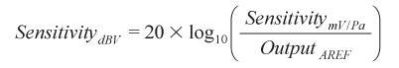

Where Output_{AREF} is the 1000 mV/Pa (1 V/Pa) reference output ratio. For digital microphones, sensitivity is measured as a percentage of the full-scale output that is generated by a 94 dB SPL input. For a digital microphone, the conversion equation is

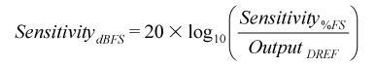
*where Output_{DREF} is the full-scale digital output level.

MEMS microphones offer plenty of advantages typical of MEMS devices, including tiny size, low power usage, and consistent performance over time and temperature. Now high performance MEMS mics are changing what is possible, and many acoustics experts would say self-noise is the first specification to consider. Any microphone produces some level of noise: through its electronics, its transducer element, and its housing. This inherent noise is known as self-noise. It’s a familiar sound to anyone using a cell phone. For example, self-noise contributes to the hiss you hear when your mobile phone is on and nobody is talking.

Sound Pressure Level, is defined as the level of the pressure deviation from the local ambient pressure caused by sound waves. It indicates the loudness of sound, in decibels.

Microphone self-noise is an ever present constraint. The idea is to have the mic present as much signal as possible to the rest of the signal chain. But part of the signal you capture from the audio source will fall below the microphone’s inherent self-noise, which is also called its noise floor. The noisier a microphone is, the less signal you have available. A lower noise microphone will give you room to isolate the sound you want from the noise that you don’t.

Then your processor DSP or codec has more signal to work with. As a result, the output from the signal chain sounds much better when you start with a quieter microphone. A high signal -to-noise ratio is a good indicator of a quiet microphone. The microphone's signal-to-noise ratio is a measurement of the quietest sounds that a given microphone can detect. A lower SNR specification tells you the microphone has more self-noise.

Reflecting back to the aforementioned criteria, the optimal selection for a MEMS microphone would be one that preferably has high Signal to Noise Ratio, has a sound pressure of at least 94 dB, has low power consumption, and has low cost. Here are some products which met that criteria:

STMicroelectronics MP34DT01TR-M

STMicroelectronics MP34Dx0x/45DT0x Audio Digital Microphones are ultra-compact, low-power, omnidirectional, digital MEMS microphone built with a capacitive sensing element and an IC interface with stereo operation capability. The sensing element, capable of detecting acoustic waves, is manufactured using a specialized silicon micromachining process dedicated to produce audio sensors.

The IC interface is manufactured using a CMOS process that allows designing a dedicated circuit able to provide a digital signal externally in PDM format. Typical applications include mobile terminals, laptop and notebook computers, portable media players, VoIP, speech recognition, A/V eLearning devices, gaming and virtual reality input devices, digital still and video cameras and anti-theft systems. The MP33AB01H is available in a package compliant with reflow soldering and is guaranteed to operate over an extended temperature range from -30 °C to +100 °C.

Table 3.7.7.1: Features met for selection
STMicroelectronics MP34DT01TR-M
Low cost
High bandwidth
Low power consumption
Omnidirectional sensitivity (-26dBFS)
High signal-to-noise ratio (66dB)
High sound pressure level (125dBSPL)
Package compliant with reflow soldering

STMicroelectronics MP34DT01-M

STMicroelectronics MP34Dx0x/45DT0x Audio Digital Microphones are ultra-compact, low-power, omnidirectional, digital MEMS microphone built with a capacitive sensing element and an IC interface with stereo operation capability. The sensing element, capable of detecting acoustic waves, is manufactured using a specialized silicon micromachining process dedicated to produce audio sensors.

The IC interface is manufactured using a CMOS process that allows designing a dedicated circuit able to provide a digital signal externally in PDM format. Typical applications include mobile terminals, laptop and notebook computers, portable media players, VoIP, speech recognition, A/V eLearning devices, gaming and virtual reality input devices, digital still and video cameras and anti-theft systems. The MP34DT01-M is available in a top-port, SMD-compliant, EMI-shielded package and is guaranteed to operate over an extended temperature range from -40 °C to +85 °C.

Table 3.7.7.2: Features met for microphone selection
STMicroelectronics MP34DT01-M
Low cost
Low power consumption
Omnidirectional sensitivity (-26dB)
High signal-to-noise ratio (61dB)
High sound pressure level (120dBSPL)

Knowles SPV0840LR5H-B

Knowles SP Series SiSonic™ MEMS Silicon Microphones are high-performance, low power, top port silicon, digital miniature microphones. These digital microphones use SiSonic™ MEMS technology and consist of an acoustic sensor, a low noise input buffer, and either a sigma-delta modulator or output amplifier. Suitable applications include cell phones, smart phones, laptop computers, sensors, digital still cameras, portable music recorders, and other portable electronic devices where wideband audio performance and RF immunity are needed. The SPH06x and SPH16x MEMS Silicon Microphones are the world's first digital microphones to support the ultrasonic bandwidth.

Table 3.7.7.3: Features met for selection
Knowles SPV0840LR5H-B
Low cost
Small size
Low power consumption
Omnidirectional sensitivity (-38dBFS)
High degree of manufacturing repeatability
Package compliant with reflow soldering

Knowles SPU0414HR5H-SB

SiSonic™ Microphone Series, built on Knowles CMOS/MEMS technology platform, is in the fourth generation of development. The series supports high-performance design in cell phones, digital cameras, and other portable devices. New MaxRF models eliminate GSM/TDMA burst noise and provide wide-band RF suppression. The 4th generation SiSonic Microphones from Knowles offer smaller sizes, lower profiles and mounting options, increased output, and new digital noise-eliminating audio options.

Table 3.7.7.4: Features met for microphone selection
Knowles SPU0414HR5H-SB
Low cost
Small size
Low power consumption
Omnidirectional sensitivity (-38dBFS)
Digital mics eliminate analog noise
High signal to noise ratio

Table 3.7.7.5: MEMS Microphones Comparison
 | STMicroelectronics MP34DT01TR-M | STMicroelectronics  MP33AB01HTR | Knowles SPV0840LR5H-B | Knowles SPU0414HR5H-SB
Voltage | 2.2 V | 1.8 V | 1.5 V - 3.6 V | 1.5 V - 3.6 V
Frequency Range | 100 Hz to 10 kHz | 100 Hz to 10 kHz | 100 Hz to 10 kHz | 100 Hz to 10 kHz
Operating Supply Current | 0.25 mA | 0.6 mA | 60 uA | 220 uA
Sensitivity | -38 dB | -26 dB | -38 dB | -22db
Maximum Operating Temperature | + 100 C | + 85 C | + 100 C | + 100 C
Minimum Operating Temperature | - 30 C | - 40 C | - 40 C | -40
Signal to Noise Ratio (SNR) | 66 dB | 63 dB | 62.5 dB | 59 dB
Impedance | N/A | N/A | 400 Ohms | 400 Ohms
Directional Properties | Omnidirectional | Omnidirectional | Omnidirectional | Omnidirectional
Signal | Analog | Digital | Analog | Analog
Price  (in USD) | $1.55 | $1.91 | $1.82 | $1.60

The product that will be selected for SenseWalk 2.0 will be the STMicroelectronics MP34DT01TR-M. It was carefully weighed in the main categories for high sensitivity, maximum and minimum operating temperatures, high sound to noise ratio, low power consumption, and low cost (it being the cheapest of all four devices) and came out with the most beneficial points.

3.7.8 GPS

The GPS module selection was essential. An appropriate module was chosen in order to ensure all “SenseWalk” requirements were met or exceeded. Proper selection between GPS cards guaranteed that accurate, reliable data is being received that can be read on the microcontroller. GPS connection with the satellites is known to weaken when inside buildings or as one gets closer to a building. This means that whatever routes the user chooses to load, they must be situated outdoors. As a user enters a building,GPS connection will be lost and will be reset once they return outdoors

SparkFun Venus GPS with SmA Connector
Figure 6 shows the SparkFun Venus GPS with SmA Connector. This is the latest version of the Venus GPS board and is the smallest, most powerful and versatile GPS receiver that the SparkFun company carries. It offers update rates up to 20 Hz. It includes a SmA connector to attach an external antenna. Solder jumpers are provided to easily configure the power consumption, boot memory and backup supply. The price is $49.95, which is a little bit higher than the average GPS receivers.

Table 3.7.8.1. SparkFun Venus GPS Analysis
Device | Advantages | Disadvantages
Venus GPS  SparkFun Venus GPS with SmA Connector | Up to 20 Hz update rate, 1Hz default. | Can transfer up to 15,200bps, which is a lot of data for the microcontroller to process in short amount of time, but can be modified.
 | Jamming detection and mitigation. | Requires voltage regulation if the system where is implemented runs at different voltage.
 | 14 channels. | Price $50.00
 | Average power consumption 3.3 V, 29 mA.
 | 2.5m accuracy

LS20031 GPS 5Hz Receiver

Another option is the Locosys LS20031 GPS receiver that integrates the MediaTek MT3329 66-channel GPS chip with an embedded ceramic antenna. This creates a complete GPS module that track up to 66 satellites at a time providing fast time-to-first, one-second navigation update and lower power consumption.

Table 3.7.8.2: LS20031 GPS Receiver Analysis
Device | Advantages | Disadvantages
LS20031 GPS 5Hz Receiver | 66 channels. | It requires voltage regulation if the module is implemented in a system that run on a different voltage.
 | Average power consumption 3.3 V @41mA. | It can transfer up to 57600 bps, which is a lot of data for the microprocessor to handle in a short period of time, but this can be modified.
 | Up to 10 Hz update rate, but it can be configured to lower. | Price: $59.99
 | Built-in micro battery to preserve system data for rapid satellite acquisition.
 | LED indicator for fix or no fix.

Table 3.7.8.3: LS20031 GPS Specifications
Chip | MediaTek MT3339
Frequency | L1 1575.42MHz
L1 1575.42MHz | Support 66 channels Tracking, 66 Acquisition
Update rate | 1Hz default, up to 10Hz
Acquisition Time | Hot start (Open Sky) :1s (typical)  Cold Start (Open Sky) :32s
Position Accuracy | Autonomous :3m  SBAS :2.5m (depends on accuracy of correction data)
Max. Altitude | 50,000 m
Max. Velocity | Max 515m/s
Protocol Support | NMEA 0183 ver 3.01

GPS Receiver - GP-735

There are many GPS receivers to consider in the market but this is the last one that we are going to take into consideration due to our time constraint. So far the ones we have reviewed meet all our needs for our project. The GPS Receiver GP-735 is an ultra-high performance, easy to use GPS smart antenna receiver. It is very tiny yet very powerful. Since we are trying to make our project as small as possible this one comes handy since it is really small. GP-735 supports the easy power saving control mechanism via a GPIO pin. To control the power of GP-735, connect the PWR_CTRL pin to a GPIO of microprocessor, In order to support this we will need an extra GPIO port in the microcontroller.

Table 3.7.8.4: GP-735 Specifications
GPS receiver type | 56 channels, L1 frequency
Horizontal Position Accuracy | 2.5m (Autonomous)  2.0m (WAAS) (CEP, 50%, 24hr static, -130dBm)
Accuracy of Time Pulse Signal | 30ns (RMS) or <60 ns (99%)
Sensitivity | Tracking: –162dBm Acquisition: -148dBm
Measurement Data Output | Update rate: 1 Hz (default), up to 10 Hz by enabling command NMEA output protocol: Ver. 2.3 (compatible to 3.0) UART baud rate: 9600 bps, (N-8-1) Datum: WGS-84 Default: GGA, GLL, GSA, GSV, RMC, VTG, TXT
Max. Altitude | 50,000 m
Max. Velocity | 1,852 km/hr
Dynamics | 4g
Power supply | 3.1 ~ 5.5 V (TTL); 4.75~5.25V (USB)
Dimension | 8 W x 35 L x 6.55 H mm
Operating temperature | -40°C ~ +85°C
Storage temperature | -40°C ~ +85°C

Table 3.7.8.5 LS20031 GPS Receiver - GP-735 Analysis
Device | Advantages | Disadvantages
GPS Receiver - GP-735 | Size dimensions 35 x 8 x6.5 mm | Needs a power regulator if the module is implemented in a system that run on a different voltage than the one required at 3.5-5.5 V
 | 66 channels
 | Power Consumption 37 mA
 | 1 Hz update rate can be increased if needed up to 10Hz
 | Price: $39.95

We also compared lower cost alternatives and summarized them in the table below. These are all GPS modules, we did not analyze GPS receivers because those require complex FPGAs which fall beyond the scope of this project.

Table 3.7.8.6: Comparison of lower-cost GPS modules
 | Antenova M10478-A2 | Jupiter SE880 | Inventek ISM420R1-C33
Price (USD, Digi-Key) | 16.36 | 13.30 | 11.43
Voltage | 2.8-4.2 (3.3 typ) | 1.75-1.85 (1.8 typ) | 1.71-1.89 (1.8 typ)
Ports | UART | UART, SPI, I2C | UART, SPI, I2C
Package | QFN with contacts on the sides, 28 pins | QFN, 34 pins | QFN, 24 pins
Chipset | Mediatek MT3337 | CSR SiRFstarIV | CSR SiRFstarIV
Requirements | N/A | Antenna, 32KHz oscillator (XTAL), 16.369MHz oscillator (TCXO) | Antenna

The Antenova M10478-A2 is an attractive alternative to the Locosys LS20031. The M10478-A2 is built with a chipset similar to that found on the LS20031, both of which are supplied by Mediatek, and as a result these two modules have the same power requirements. The Antenova module comes with a built-in antenna and requires no additional components. The ease of development brought on by these features largely make up for the slight added cost over the Jupiter SE880 and the Inventek ISM420R1-C33 solutions. The amount of pins may seem intimidating at first sight, but the vast majority (16) of the pins present on the Antenova package are meant to be connected to ground.

Furthermore, the ability to connect these QFN pins from the sides facilitates hardware development over the Locosys LS20031. Interfacing with this module is essentially the same as with any other UART GPS module; the UART TX and RX pins are used to transmit standard NMEA data, and the optional added pins offer more flexibility.

After the research for what GPS to use, we chose the Locosys LS20031 GPS. All its specification meet the requirement that are needed to successfully build the device and has proven in the past to be reliable. The GPS receiver has 5 pins as shown in Figure 10, these pins will need to be properly integrated into the electronic system.

The image does not describe the function on each pin; therefore the information is provided in Table 7. The unit will need to be soldered, but the process should be easy due to the small number of pins on the module. A really important aspect to take into consideration is that this GPS module requires an input voltage of 3.3 V; therefore we will need a voltage regulator in order to achieve the exact required voltage.

Figure 3.7.8.7: GPS LS20031 Receiver Pin Layout (open source)
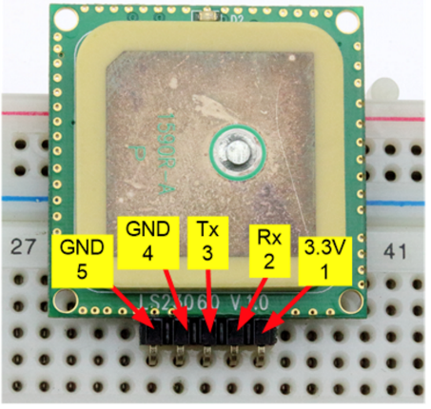

Table 3.7.8.8: GPS LS20031 Receiver Pin Description
Pin # | Name | Description
1 | Vcc | Power Input
2 | Rx | Data input
3 | Tx | Data Output
4 | GND | Ground
5 | GND | Ground

The type of information that a GPS receiver gives as an output is the NMEA (National Marine Electronic Association) messages. There are many type of information you can get from the NMEA, they are shown below in Table 8.
Table 3.7.8.9: GPS Information Type
NMEA | Description
GGA | Global Positioning System Fix data
GLL | Global positioning latitude and longitude
GSA | GNSS DOP and active satellites
GSV | GNSS satellites in view
RMC | Recommended minimum specific GNSS data
VTG | Course over ground and ground speed

For our device we don’t need all this information and we are going to use only the GGA and GLL NMEA record outputs. The next table below illustrates a full detail description of the output provided by GGA.

Table 3.7.8.10: Global Positioning System Fixed Data (GGA) output description
Name | Example | Units | Description
Message ID | $GPGGA |  | GGA protocol header
UTC Time | 53740 |  | hhmmss.sss
Latitude | 2503.6319 |  | ddmm.mmmm
N/S indicator | N |  | N = North or S = South
Longitude | 12136.0099 |  | ddmm.mmmm
E/W indicator | E |  | E = East or W = West
Position Fix Indicator | 1 |  | See Table Below
Satellites Used | 8 |  | Range 0 to 12
HDOP | 1.1 |  | Horizontal Dilution of Precision
MSL Altitude | 63.8 | meters
Units | M | meters
Geoid Separation | 15.2 | meters
Units | M | meters
Age of Diff. Corr. |  | second | Null fields when DGPS is not used
Diff. Ref. Station ID | 0
Checksum | *64

The next Figure 11 shows how the pins are going to be used. Pin 1 will be used to supply the 3.3 V that the module requires, pin 2 and 3 will be connected to the microcontroller in order to transfer the data and finally pin 4 and 5 will be grounded.

Figure 3.7.8.11 LS20031 GPS Receiver Schematic (Open source Permission)
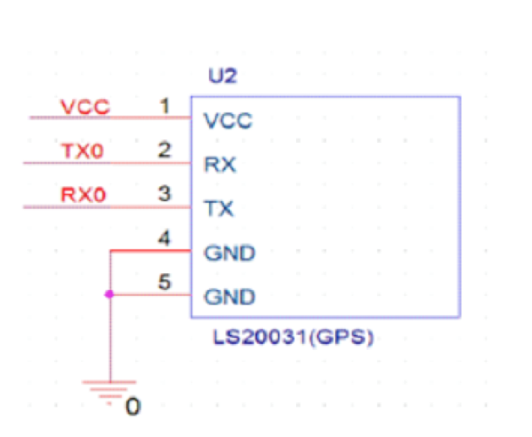

3.7.9 Magnetometer and Accelerometer

The use of GPS in SenseWalk 2.0 requires the need for a compass to help in the navigation of the user. Without a compass, the orientation and direction the user is facing would be unknown to the device and could potentially cause errors in real-time direction and decision making. In order to know what direction the user is facing we need to implement a compass module or a magnetometer into the project. The earth is like a giant magnet with a north and a south pole and it has a magnetic field all around it.

The strength of the magnetic field will vary with location and orientation. The way a compass module works is by detecting the earth’s natural magnetic field, the earth has an iron core that is part liquid and part solid crystal due to the gravitational pressure and the movements in the liquid outer core is what produces the Earth’s magnetic field. The module that will measure the magnetic field in three directions or axes, labeled as X, Y, Z. In order to choose the right one we will compare several modules and choose the one meets all the requirements for this project.

The first module that was taken into consideration was the LIS3MDLTR by STMICROELECTRONICS, this module is ultra-low-power and high-performance three-axis magnetic sensor. It has the capability of self-test that will allow the users to check the functioning of the sensor in the final prototype. This module can also be configured to generate interrupt signals for magnetic field detection. It is relatively inexpensive, it cost only $1.70 and operates on a 1.9- 3.6 V and as mentioned before this module is ultra-low power consuming only 40 uA in the low-power mode and 270 uA in the ultra-high resolution mode. This module can communicate with the microcontroller either by SPI or I2C.

The next option that was considered was the BMC150 by Bosch Sensortec, this module combines the three-axis magnetic field sensor and 12 bit three-axis accelerometer with the ability that the accelerometer can still be used independently from magnetometer operation. It has 14 pins LGA and can communicate with the microcontroller via a SPI or I2C. This module works on a low voltage operation of 1.62 -3.6 V and also is a ultra-low power consuming 190 uA at 10 Hz.

This module one is also really inexpensive as well, it cost only $2.77 per unit. Upon further research we found another good option which is the Xtrinsic MAG3110 by Freescale, this module is a digital 3-axis magnetometer that comes assemble into a 10-VFDFN package with exposed pads. This module do not comes with a accelerometer bundled together as the BMC150 did, but i can be used in conjunction with any 3-axis accelerometer, can communicate with microcontroller using only i2c serial interface.

This module works also under low voltage operation of 1.95-3.6 V and is low power under the single-shot measurement mode. The last module to be compared is the MLX90393 by Melexis, this triaxis magnetometer works under low power as well, only 2.2-3.6 V and can communicate via I2C interface, comes in QFN3x3 package, 16 pins. The next table compares the main features taken into consideration when choosing the module to be installed in the project.

The compass is connected to the board and the board must be taken to a company for it to be imprinted. However, the group also had the option of laying out and soldering the board. The decision had not been made to which avenue will be taken between the two options. It would be a relatively minor fee to get the board professionally laid out and often they will offer student discounts to those students that are working on design projects.

Table 3.7.9.1: Compass module comparison
Name: | Sensortec BMC150 by Bosch | Xtrinsic MAG3110  by Freescale | MLX9039SLW by Melexis
Price | $2.77 | $1.46 | $2.14
Package | 14-VFQFN | 10-VDFN | 16-VFQN
Distance between pads (mm) | .40 | .40 | .50
Voltage (V) | 1.62-3.6 | 1.95-3.6 | 2.2-3.6
Current (mA) | 67 | 99 | 88
Interface | SPI, I2C, 4 interrupts pins | I2C | SPI,I2C
Features | 6-axis  built-in accelerometer | 3-axes | 3-axes, temperature sensor
Size (mm) | 2.2x2.2x.95 | 2x2x.85 | 3x3x3

After considering all the options to what module to buy we chose the BMC150 by Bosch Sensortec, one of the main reasons is that it does accelerometer which combined with the magnetometer can allow the unit to give a more accurate data this due to the fact that a correct implemented compass systems must compensate for the effect of elevation and bank angle (tilt) as well as calibrate out hard-and soft iron effects as much as possible.

In order to understand why a combination of both magnetometer and accelerometer can give a very accurate data we need to explain what an accelerometer is and how it works. An accelerometer is a special sensor that detects accelerations and decelerations in any axis. Acceleration is the rate of change of the velocity. They are measure in meter per second squared (m/s2) or in G-forces (g). A single g force is equivalent to 9.8 (m/s2), but this vary slightly with elevation. They way an accelerometer is by sensing the static and dynamic forces of acceleration when talking about the static forces we refer to gravity and when talking about dynamic forces we refer to vibrations and movement.

This device measure acceleration on one, two or three axes, most accelerometers measure in 3-axis now days since the cost of development is really cheap. Accelerometer have some capacitive plates inside as the plates move in relation to each other, the capacitance between them changes and is from this changes in capacitance that acceleration can be determined.

The magnetometer we chose have a accelerometer already built-in but when choosing one there some features that essential in order to choose the correct one, as most of time the communication interface is really important, most of them will communicate over an analog or digital interface.

Analog interfaces show accelerations through a vary voltage levels, the values fluctuate between the ground and supply voltage in the other hand accelerometers with a digital interface can either communicate over SPI or I2C communication protocols , these kind have more functionality and be less susceptible to noise than the analog ones. Another aspect to take into consideration is the range, most accelerometers have a selectable range of forces that can vary from +-1g up to +-250g, the smaller the range, the more sensitive the reading will be.

BMC150 by Bosch Specifications

Table 3.7.9.2: BMC150 specifications
Interfaces | I2C, SPI(¾ wires) 4 interrupt pins
Current consumption | 540 uA @ 10Hz
Current consumption in  low power mode | 190 uA @ 10Hz
supply voltage | 1.62-3.6 V
Package (LGA type) | 2.2x2.2x.95 mm3
Geomagnetic Sensor
Measurement range | +- 1300 uT(x-,y-axis) +-2500 uT(z-axis)
resolution | .3 uT
Acceleration sensor
Stand-alone operation | supported
Resolution | 12 bit
Programmable g-range | +-2g,+-4g,+-8g,+-16g
sensitivity tolerance | +-4%

3.7.10 Solar cell

The solar cell will be used to generate energy by harvesting free energy when available from the sun. It is sometimes called a photonic cell, it turns light energy directly into electrical energy. The operation of a photovoltaic cell requires three basic things: the absorption of light, generating either electron-hole pairs or excitons, the separation of charge carriers of opposite types, the separate extraction of those carriers to an external circuit.

In order to keep the weight down, a small solar cell was used. It supplies 0.45W. It is rated for 4.5V open voltage and 100mA short circuit. Termination is a 5.5mm x 2.1mm barrel plug, center positive on a 2m cable. Mates directly with many of the development boards. Monocrystalline high efficiency cells at 15-15.2%. Unit has a clear epoxy coating with hard-board backing.

How a solar cell is constructed, is by multiple solar cells in an integrated group, all oriented in one plane, constitute a solar photovoltaic panel or solar photovoltaic module. Photovoltaic modules often have a sheet of glass on the sun-facing side, allowing light to pass while protecting the semiconductor wafers. Solar cells are usually connected in series in modules, creating an additive voltage.

The difficult part is going to be to different voltage inputs being connected. The device cannot have two separate voltages being introduced at the same time, because it would be too much power for the different components being used. There was some research done and circuit testing. A design had to be made where two voltage inputs would not be introduced into the components at the same time. Multisim was used to test and prove the circuit design would work for the project.

How the circuit design works is basically two separate switches where one will shut off one voltage while the other voltage is providing power to the device components. The switches are called Mosfets they switch back and forth hundreds of time a second. The battery is the other source that needs to be controlled by the circuit.

3.7.11 Camera

We would like to include a camera to perform computer vision as part of our navigation device, it will be used to analyze and translate visual points-of-interest. We would initially build the camera as part of our project, and then develop the software for it as time permits. Our first goal for this optional feature would be to have the device let its user know whether it is safe to cross the street by analyzing the traffic light.

Once the hardware is in place, it would be possible for a savvy user to modify the open firmware and add various computer vision detection algorithms. Such algorithms could detect and keep track of bathrooms, elevator signs, and various symbols and key elements inside of buildings, then direct the user to them when inquired and give out warnings when necessary.

There are three alternative ways to achieve computer vision. The easiest one would be to use a camera which has the required software, OpenCV, programmed onto a dedicated microcontroller. The second method involves a camera built onto a small circuit which contains its own small microcontroller and sends images to our device. The third and last option is to connect our microcontroller’s DCMI interface to a CMOS sensor. These solutions’ cost increases as their complexity decreases.

Table 3.7.11.1. Comparison of Potential CMOS Sensors
Model | Price (USD) | Resolution | Pros | Cons
OmniVision OV7690 | $3.85 | 640x480 | Least expensive. | 20-BGA package, low resolution.  Requires most hardware and software development.
OV9655 camera board | $11.99 | 1280x1024 | Pre-built, including lense. Higher resolution.  Requires less hardware development. | Requires most software development.
Adafruit TTL | $39.95 | 640x480 | Pre-built, including lenses and logic. TTL interface.  Requires less software development, least hardware development. | Ten times as expensive
Pixy CMUcam5 | $69.00 | 1280x800 | Pre-built, comes with some computer vision software.  Higher resolution.  Requires less hardware development, least software development. | Most expensive, bulkiest

We chose the OV9655 camera board. While it requires significantly more software development, its low cost justifies the added efforts.

Table 3.7.11.2 OV9655 Camera board miscellaneous specifications
Parameter | Value
Active (operating) current (_{IDDA}) | 20 mA
Standby current (I_{DDS-PWDN}) | 10 uA
Input clock frequency (f_{CLK}) | 10 - 48 MHz (typ: 24 MHz)

3.7.12 SD socket

We will be using the Molex 5033981892 MicroSD push/push socket. It is available on Digi-Key for $2.97 per unit, and merely provides a housing and electrical connections to and from the microcontroller. The Secure Digital specifications call for a 3.3V operating voltage.

The side of the Molex 5033981892 socket provides a “DETECT SWITCH” which can be used to determine whether an SD card has been inserted. The switch is closed when a card is inserted and open when the slot is empty.

4.0 Related Standards

4.1 Energy Standards

With the large increase in global population, energy demands are at an all-time high. The number of electronics per person has also largely increased. With the increase in power demand and a limited supply of power generation, efficient electronics have become a necessity. Governments and green environmental organizations have established energy efficiency standards.

ENERGY STAR has become the largest most recognized international standard for energy efficient consumer products. The standard originated in the United States in 1992 when it was created by the Environmental Protection Agency and the Department of Energy. Depending on the specific device, there are standard requirements for a consumer product to be labeled with the ENERGY STAR mark. A specific set of guidelines and requirements has been constructed in order for an AC-DC power supply to be labeled with the ENERGY STAR mark. A full chart of Energy-Efficiency requirements can be found at http://www.energystar.gov/.

4.2 Design Impact of Relevant Standards

Bluetooth uses the Industrial Scientific and Medical (ISM) band, which is free to use in most countries. The regulators expect lots of devices to be using the same spectrum, so they have set out rules for using ISM bandwidth to make sure that devices can share the bandwidth.

The rules state that you must spread the power of your transmissions across the ISM band somehow. Two main methods are used for spreading out the power: direct sequence spread spectrum (DSSS) and frequency-hopping spread spectrum.

Direct sequence spread spectrum smears a transmission across a wide range of frequencies at low power. Frequency-hopping spread spectrum uses a small bandwidth but changes (or hops) frequency after each packet. Bluetooth uses frequency-hopping spread spectrum. There are 79 channels of 1 MHz each; after each transmit or receive, devices hop to a new channel.

5.0 Related Design Constraints

In order to deal with the potential issue of being restricted from using the microphone in the bone conduction headset, separate microphones were researched and compared. There are many types of microphone that exist. In the selection of the type of microphone needed for the device, a couple of factors needed to be considered. Size, performance, and feasibility.

As mentioned before, one of the goals of SenseWalk 2.0 was to provide a more compact design. Finding components of smaller size were priority in that components selection. In choosing the microphone for SenseWalk 2.0, electret microphones (ECM), fiber optic microphones, and Micro-Electrical Mechanical System or MEMS microphones (MEMS) were perfect candidates. With both the electret microphone and the MEM microphone being smaller than a quarter (see figure below), and the fiber optic microphone being adjustable to any size these types were favorable to help maintain the goal of the project.

Figure 5.0.1: Electret Microphone, MEM Microphone Size Comparison (Permission: Adafruit)
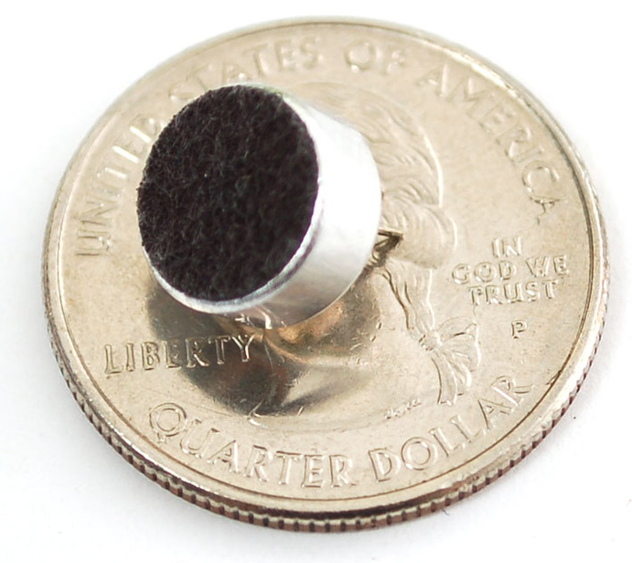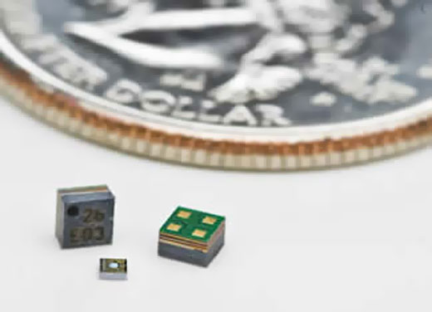

In addition to size, it is imperative that despite the small size that power or performance remains high. Since Fiber optics are were designed for ideal use in areas where conventional microphones are ineffective or dangerous it was decided not to choose it for SenseWalk 2.0, leaving ECM and MEMs left to be compared. MEMS microphones have a higher "performance density" than ECMs. What this means is that a MEMS microphone will have much better noise performance than an ECM in an equivalent package size (volume). MEMS microphones have lower vibration sensitivity than ECMs. The mass of a MEMS microphone's diaphragm is lower than that of an ECM, so it will have less response to vibrations in a system.….

With the time constraints for the building Sensewalk 2.0 imposed by the University’s school semester, feasibility plays a substantial role in selecting a particular device. MEMS microphones can be reflow soldered, while ECMs cannot. The charge on an ECMs diaphragm cannot withstand the high temperatures of a reflow soldering process, so they often must be hand-soldered to a board. MEMS microphones, however, can be assembled on the same reflow soldering process as most other integrated circuits on a PCB.

Upon finishing comparison of the three types of microphones in regards to their size, performance, and feasibility Microelectromechanical systems arose as the victor. With Fiber Optic microphones being disregarded because its design purpose does not align with the intention of its use in SenseWalk 2.0, and with MEMS providing a greater amount of benefits than an ECM in the aforementioned categories in the microphone selection process, MCMS will be the choice of the microphone unit used in SenseWalk 2.0.

Now that a specific microphone type has been selected, the question of format now comes into play. Microphones come in two audio signal variations, analog signal and digital signal. Neither of these signals can necessarily be deemed greater than the other. Instead, to determine which signal best suits the usage one has to identify the purpose and situations that the microphone will be used for and in. Take a look at the advantages and disadvantages of each signal.

Table 5.0.1: Analog and Digital Signal Analysis
 | Analog Signal | Digital Signal
Best Application |  | Often used in  applications where analog audio signals may be susceptible  to interference.  Also in applications where you only need audio capture, not playback (ie surveillance cameras)
Latency | Zero Latency | Has varying latency durations, based on the quality of the microphone
Dynamic and Frequency Response | Better audio as far as dynamic response and frequency response
RF Performance | Depends on the system. | Depends on the system. But, generally excels in the UHF TV Band range.  Allows almost twice as many compatible systems in the same RF footprint as an analog counterpart.
Noise Control | less noisy at end of range situations
Size | Smaller in size  2.5 mm × 3.35 mm × 0.88 mm or smaller | Larger in size (about 62% times)  3 mm × 4mm × 1 mm

6.0 Project Hardware and Software Design Details

The design phase is essentially the development and selection phase which is targeted to be completed by the end of the first semester. With all of the devices required selected and electrical designs drawn, larger parts can now be purchased so that the next stage of the process SenseWalk 2.0 can take place. The next phase of the project will deal with assimilation and implementation of the components.

Every electronic system requires the design of a power supply in order to power the device. Power supply design is a vast and complicated field that requires much knowledge for a successful design. The two main sub-divisions in power supply design are AC-DC and DC-DC. There are also designs that require DCAC, but this application is not as common as the first two listed. Power supply designers face many new challenges, such as size constraints, high efficiency, and high power factor requirements.

There were numerous numbers of circuit topologies that could be implemented in power supply design. The designer will choose the correct topology based on the specific application, design requirements, and available cost. There are two types of regulators: linear and switch mode regulators. Linear regulators were being used many years before switch mode regulators.

Both regulators provide the same function, but the designs and performance will differ between the two. In recent years, switch mode power supplies have become a very popular choice for designers. Switch mode power supplies are used in many applications, ranging from powering CPU’s and smart phones to drivers for LEDs. Every electronic device will require power management.

Sensewalk 2.0 required DC-DC linear and switching regulators and also an AC-DC switching converter. All DC-DC regulators convert the input voltage from the lithium ion battery to the required output voltage.

There is a long list of topology choices for switch mode power supplies (SMPS). Circuit topology refers to the arrangement of active and passive electrical components. There is not a “one size fits all” SMPS design; the correct topology selection depends on the specific application and requirements.

In consumer electronics, the most commonly used DC-DC topologies are the Buck and the Boost; while the most commonly used AC-DC topology is the Flyback (Figure). The Buck/Boost (Figure 6.1.2.1) was used because a lithium ion battery was used and when the voltage is below what is needed a boost circuit can step it back up.

It is necessary to understand the operations and limitations of the all the fundamental Switch Mode Topologies. With the circuit fundamentals understood, an engineer is able to choose the correct SMPS topology for the given application.

Without understanding the operations of the various SMPS topologies, a design will suffer in functionality and efficiency. When selecting the correct topology, many factors need to be considered. SMPS topology selection is based on required input voltage, output voltage, output power, number of outputs, isolation, non-isolation, max load current, design cost, design complexity, inverted polarity, and size constraints. Each variable needed to be considered in order to select the correct topology for the given application.

A poor selection in topology will result in a failed design. In the figure below is a general flowchart that is useful for selecting the correct SMPS topology for the given application. This is a general guideline that covers most applications and most topologies.

Figure 6.0.1: SMPS Topology Selection Flowchart 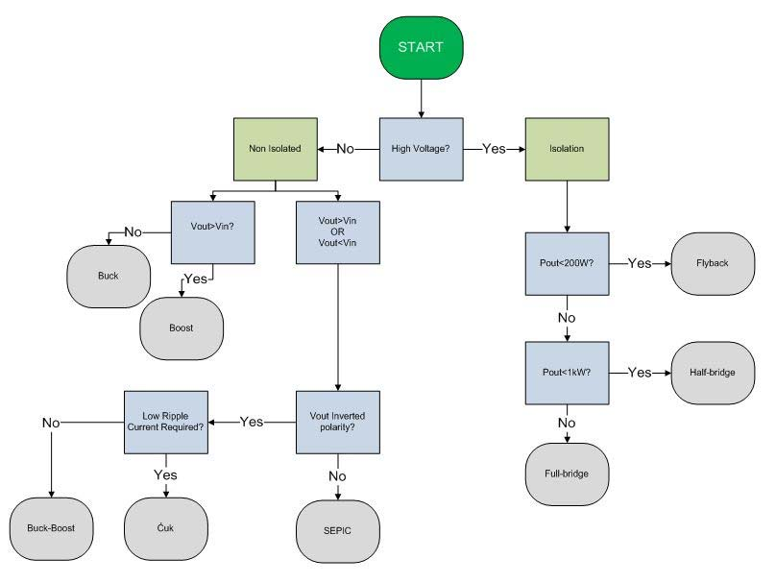
It was out of the scope of this paper to provide an in depth understanding of all of the SMPS topologies; it was useful to have a breadth of knowledge in order to understand the topology selection process.

Sensewalk 2.0 operates on a rechargeable type battery. This required an AC-DC converter to recharge the battery which will be bought; also this required a DC-DC converter to regulate the battery voltage to the required load voltage. The above flow chart was used to choose the correct topology for the DC-DC battery charger. The above flow chart was used to choose the correct topology for the DC-DC voltage regulators. There are multiple DC-DC voltage regulators in this application. Since the design required high efficiency, there was need to use a SMPS.

Typically a battery powered device will implement a Buck topology. Since the Buck was initially planned to be used, there was need to fully understand the operations of the topology. Without fully understanding the Buck, the performance and efficiency of the design might have suffered.

Another type of switching regulator not mentioned above is referred to as a Charge Pump. The above listed switching topologies are based on the use of an inductor; the Charge Pump is based on the use of a capacitor. (Figure ) below shows a basic schematic of a Charge Pump voltage booster. The charge pump topology is able to increase the input voltage and provide either an inverted or non-inverted output voltage. Charge pumps are easier, than inductor based topologies, to design. The disadvantage of charge pumps is that they offer a lower efficiency with a varying input voltage range and often are required to operate on a lower load than inductive based switching topologies.

Figure 6.0.2: Charge Pump Schematic
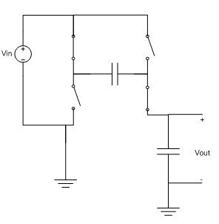
6.1 Hardware: Structure and Design

In order to complete a functioning and highly efficient Buck/Boost converter design, the fundamental circuit operations had to be fully understood. It was important to understand the Buck/Boost circuit operation and switching states, also control loop consideration are of high importance. (Figure 13) below shows a basic schematic representation of a Buck/Boost regulator.

There are two stages of operation to examine with the Buck/Boost regulator. The Buck/Boost is implemented by the use of an inductor, a FET, two diodes and a capacitor. The FET acts a switch, turning on and off. The gate of the FET is driven typically by a control IC. When the gate of the FET receives a voltage, the inductor is connected to the input voltage and the diode is turned off due to the polarity; this is referred to as the “on” state.

During the “on” state the inductor begins to store up energy. Since the properties of an inductor offer reluctance to change in current, when the inductor is turned from the “off” state, where current is equal to zero, to the “on” state, the output voltage is forced to drop. The inductor resists the change in current by decreasing the voltage.

As the current increases over time, the voltage drop across the inductor is reduced and the output voltage is increased. When the converter is switched to the “off” state, the input voltage is removed and the inductor begins to release its stored energy. This allows for a reduced output voltage that is regulated. Often to improve efficiency, the buck regulator topology is slightly modified to the Synchronous Buck Regulator. The Buck is converted to a Synchronous Buck by replacing the freewheeling diode with a second MOSFET.

There are three types of control circuits often used in the Buck regulator; they are called Type 1, 2, and 3. Control loops are needed to regulate the output voltage to a constant value by adjusting the MOSFET drive signal accordingly. Advanced control loop design is too large of a topic to cover in this write up, so provided below is a brief understanding of control implementation in the Buck regulator. It is important to note the effects of each component in (Figure 13). Without careful compensation design, the regulator could become unstable and have poor transient response performance. It is useful to understand the function of each element in the control loop.

Understanding each component’s effect will greatly help with tuning the system for dynamic responses. There is too much mathematical derivation to cover in depth for designing Type 1, 2, and 3 control systems. A basic understanding has been provided and it sufficed for tuning the regulator control loops implemented in the project. The basics of the Buck/Boost converter have been laid out above. This provided a solid understanding of the operation and control of a Buck Regulator. Once a general design has been produced, the engineer needs to go through a design optimization phase in order to meet all required specifications. This section provides a general optimization process for DC-DC converters.

The first step in optimizing a DC-DC design is to initially tune the control loop for stable transient response. This might also require the designer to consider thermal compensation if needed. This step only provides a temporary tuning of the control loop; the loop will need retuned as changes are made to the inductor and output capacitors to ensure an optimized design.

The second step is for the designer to optimize the input filter to meet the given design specifications. The designer should test the input ripple voltage for worst case conditions; worst case input ripple occurs at the maximum load current (Imax). If the measured input ripple is too high then the input capacitance needs to be increased to reduce the ripple value. If the measured input ripple is well below the design specifications then the input capacitance should be reduced to lower the Bill of Materials (BOM) cost.

The third step in the optimization phase is for the designer to experiment with the inductor and output capacitor selection. The design specifications will require a balance between efficiency, transient response, and output ripple performance. It is not possible to optimize all three variables, so the designer will need to balance the variables to meet specifications.

When the designer increases output capacitance the output ripple will decrease, but an increase in capacitance will increase BOM cost. Increasing the inductance value will improve output ripple, but decreases efficiency due to a higher associated DCR of the larger inductor. When optimizing the inductor and output capacitance, the designer should test at worst case conditions, minimum output voltage and maximum input voltage.

The fourth step is for the designer to experiment with switching frequency (Fsw) if available. Adjusting the Fsw will provide an optimal setting for efficiency versus ripple performance. Not every control IC provides the option to adjust the Fsw. As Fsw is increased, the switching losses start to dominate over conduction losses, therefore MOSFET selection becomes of great importance.

The fifth step in DC-DC design optimization is MOSFET selection. If a synchronous topology is being implemented, the designer will need to consider both the high side and low side MOSFETs. The most important factor in the high side FET is switching losses. Typically in the high side FET switching losses dominant over conduction losses.

The main factors to impact switching losses are the device rise and fall times and capacitances. Therefore to combat switching losses, the high side FET should have low rise and fall times, and low parasitic capacitances such as the gate capacitance. In the low side FET conduction losses dominate over switching losses.

The main contributions to conduction losses are due to the “on resistance” of the FET, called Rds(on). For this reason, the low side FET should have minimum Rds(on) to combat conduction losses. MOSFET selection is a vital part of DC-DC SMPS design. If the incorrect MOSFETs are selected, the efficiency will take a large hit.

The sixth step in the optimization phase is to consider Snubber circuits. A Snubber is typically used to combat switch node (SWN) ringing. Since the FETs are rapidly turning on and off, there are overshoots, undershoots, and ringing issues. The overshoot is very important because the voltage might rise above the maximum allowed voltage of the MOSFET, which could result in damage to the device. Ringing is also important because the noise can be coupled and carried to the output.

To reduce these unwanted problems, a Snubber circuit is implemented. A Snubber will decrease SWN ringing and overshoot, but also decrease efficiency. For this reason, the designer will need to optimize the Snubber circuit to meet SWN ringing specifications without causing a larger decrease in efficiency.

The seventh step in the design optimization phase is to test the thermal performance of the parts, chips, and the board. An infrared camera is often used to spot out hot spots. Knowing the hot spots will allow the designer a visual look at where the efficiency is being lost.

The eighth step is to tune the control loop for a final and optimal transient response. The designer should test for the required dynamic load step to ensure specifications are met. Also the designer should check for high load frequency sub-harmonics by doing a frequency sweep. Then the tuning loop needs to be tested for sensitivity. The compensation values should be varied by 10 - 20 percent to ensure a robust design.

The ninth and final step in the DC-DC optimization phase is for the designer to set specific protection logic. The desired settings for Over Voltage Protection (OVP), Over Current Protection (OCP), Under Voltage Lockout (UVLO), etc. need to be set. These above nine steps provide a solid process for DC-DC optimization. Extra steps can be added and steps can be skipped depending on the application and topology.

Figure 6.1.1: DC-DC battery charger

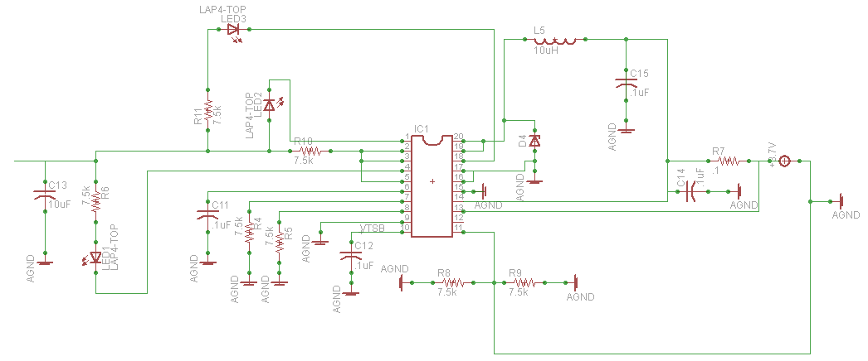

In order to let the user know how much battery life is left in the device, a circuit was needed to read the charge of the lithium ion battery. In order to accomplish this, the group researched Texas Instruments BQ3055. This integrated circuit provided a wide range of features to manage the power of lithium ion batteries. This device can measure the capacitance, voltage, current and temperature of the battery.

It also provided overvoltage and under voltage protection at a software level. In addition, there is hardware short circuit protection as well as over current discharge protection. DC-DC converters can be split into three sections based on circuit topology. The two DC-DC converters which are implemented are Buck/Boost switching regulator, and Boost switching regulator.

6.1.1 Battery to Microcontroller

It was determined that a Switching Buck/boost Regulator would be utilized to provide power to the microcontroller unit. The microcontroller (Part Number: STM32F746ZG) will require 3.3 Volts to operate. It was determined to use a Buck/Boost Regulator to improve the power conversion efficiency and thus extend battery operation time.

The MCU STMicro (STM32F746ZG) was chosen. The input voltage for the MCU is 3.3V. A 2000mA battery at 3.7V was chosen. Since the two are different, they cannot just simply connect without some type of circuit to compensate the 2 different voltages. For this we need a DC-DC converter.

A buck circuit is used for stepping the voltages down, which will work perfect in this case of the higher battery voltage. Below in Figure 13 illustrates what it will look like. The switch is sometimes referred to as the driver. This is where the circuit design comes into play. In order to come up with a circuit, the total current must be accounted for.

There will be two devices running on 3.3V: the MCU STMicro (STM32F746ZG) and the LS20031GPS 5Hz Receiver. The total current must be added together. The MCU’s current, according to Ohm's law, is 320mA. The GPS current is 41mA, adding the two together 320mA + 41mA = 165mA.

Once again, a switch mode power supply will be chosen over the linear power supply for this application, due to high efficiency needs. The positive side of the battery terminal will be connected to the buck circuit. From there, the circuit will convert to a lower voltage at the output of the buck circuit. The positive side of the MCU will connect and give it the lower voltage needed to function properly.

6.1.2 Battery to GPS

It was decided that a Switching Buck Regulator will be used to provide power to the GPS system. The GPS chip (Part Number: LS20031) will require only 3.3 V to operate and 41 mA max current draw. Because the required supply voltage (3.3 V) is well below the battery voltage, there was need for a converter to step the voltage level down.

Since the maximum required supply current was only 41 mA, it was decided to use a switching Buck Regulator. Even though the linear regulator offered simplicity and minimum component count. A Switching Buck Regulator would be preferred because it provides higher efficiency.

The GPS chosen was the LS20031 GPS 5Hz Receiver. The input voltage for the GPS is 3.3V. A 2000mA battery at 3.7V was chosen and since the two are different they cannot just simply connect without some type of circuit to compensate for the 2 different voltages. For this a DC-DC converter, a buck circuit, will be used for stepping the voltages down which will work perfect in this case of the higher battery voltage. Below in Figure 13 illustrates what it looks like. The switch is sometimes referred to as the driver. This is where the circuit design comes into play. The buck boost circuit is chosen over just the buck, because when the voltage falls below 3.3V the circuit will still need to function.

Figure 6.1.2.1: Buck Boost circuit 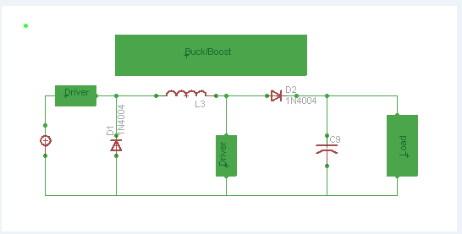
In order to come up with a circuit the total current must be accounted for. There will be two devices running on 3.3V the LS20031 GPS 5Hz Receiver and MCU STMicro - STM32F746ZG. The total current must be added. The GPS’ current, according to Ohm's law, is 41mA. The MCU’s current is 320mA, adding the two together 41mA + 320mA = 361mA.

Once again a switch mode power supply will be chosen over the linear power supply for this application due to high efficiency needs. The positive side of the battery terminal will be connected to the buck circuit. From there, the circuit will convert to a lower voltage. At the output of the buck circuit, the positive side of the GPS will connect to give it the lower voltage needed.

Figure 6.1.2.2: MCU to GPS voltage converter 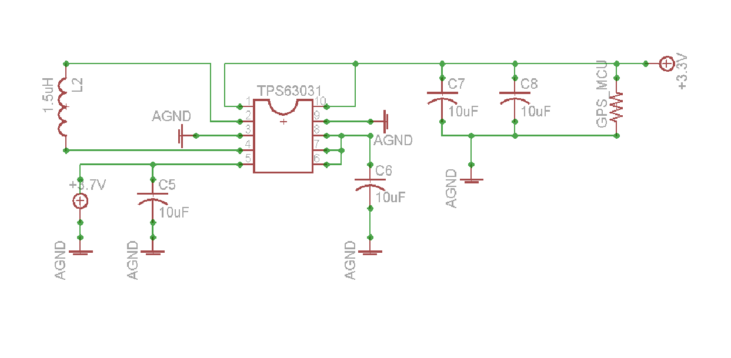
6.1.3 Battery to Laser Detector

It was decided that a Switching Boost Regulator would be used to provide power to the Laser system. The Laser system would require 5 Volts to drive the infrared sensor. Because the required supply voltage exceeds the battery voltage, it was decided to use a Boost Regulator.

The Laser chosen has an input voltage 5 Volts (V). A 2000 mA battery at 3.7 V was chosen. Since the two are different they cannot just simply connect without some type of circuit to compensate for the 2 different voltages. A DC-DC converter, a boost circuit, is used for stepping the voltage up, which will work perfect in this case for the lower battery voltage. Figure 14 depicts what it looks like. The switch is sometimes referred to as the driver.

This is where the circuit design comes into play. In order to come up with a circuit, the total current must be accounted for. There will be two devices running on 5V the Laser and Bluetooth so the total current must be added. The lasers current, according to Ohm's law, is 125mA. The Bluetooth current is 40mA, adding the two together 125mA + 40mA = 165mA.

A switch mode power supply will be chosen over the linear power supply for this application due to high efficiency needs. The positive side of the battery terminal will be connected to the boost circuit. From there the circuit will convert to a higher voltage. At the output of the boost circuit, the positive side of the Laser will connect to give it the higher voltage needed.

Some really important aspects to take into consideration is that it requires an input voltage of 5 V and a maximum current of 125 mA. In order to make the laser work, a switch mode power supply is needed to step the voltage up. The switch mode method will allow us to easily boost the circuit. A switch mode power supply was chosen over the linear power supply for this application, because the switch mode power supply has higher efficiency.
Its downsides are that it is more complex to design, costs more, and generates more electrical noise than a linear power supply. No one power supply is better than the other in and of itself. It all depends on the application being used. For this particular application, the switch back is better because high efficiency is needed. Refer to the formula P=I*V or P=I^2*R. The total current for this circuit is 125 mA + 40 mA =165 mA the circuit design is discussed later on.
Figure 6.1.3.1: Boost Circuit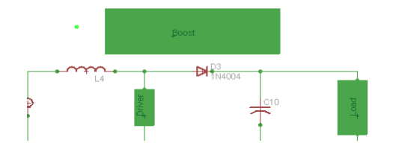
The switch in the middle is the driver. It turns on and off thousands of times per second. The TI TPS61028 was chosen to control the switch. Adjustable, 800mA Switch, 96% Efficient Boost Converter w/LDO down-Mode, in a QFN-10 package.
Figure 6.1.3.1: Battery to Bluetooth and Laser DC-DC Converter
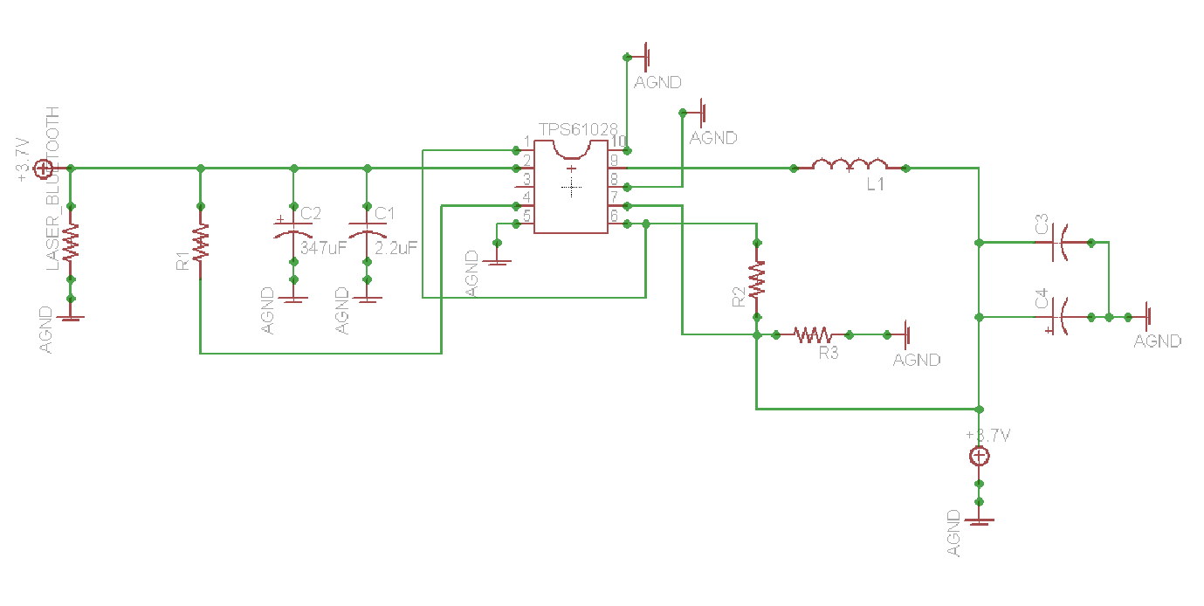

TPS6102x is based on a fixed frequency, pulse-width-modulation (PWM) controller using synchronous rectification to obtain maximum efficiency. Input voltage, output voltage, and voltage drop on the NMOS switch are monitored and forwarded to the regulator. So changes in the operating conditions of the converter directly affect the duty cycle. At low load currents, the converter enters Power Save Mode to ensure high efficiency over a wide load current range. The Power Save mode can be disabled, forcing the converter to operate at a fixed switching frequency.

6.1.4 Battery to Bluetooth

The Bluetooth chip from TI CC2564B chosen has an input voltage 5 Volts (V). A 2000mA battery at 3.7V was chosen. Since the two are different it cannot just simply connect without some type of circuit to compensate the 2 different voltages. For this is a DC-DC converter, a boost circuit, is used to step the voltage up, which will work perfectly in the case of a lower battery voltage. Figure 14 illustrates what this looks like.

The switch is sometimes referred to as the driver this is where the circuit design comes into play. In order to come up with a circuit the total current must be accounted for. There will be two devices running on 5V, the Laser and the Bluetooth devices, so the total current must be added. The Bluetooth current, according to Ohm's law, is 40mA. The Lasers current is 125mA, adding the two together 40mA + 125mA = 165mA.

Once again a switch mode power supply will be chosen over the linear power supply for this application, due to high efficiency needs. The positive side of the battery terminal will be connected to the boost circuit. From there, the circuit will do converting to a higher voltage at the output of the boost circuit the positive side of the Laser will connect to give it the higher voltage needed.

6.1.5 Battery to memory

The Micron MT48LC4M32B2B5-6A 128-Mbit SDRAM module tolerates an input voltage ranging from 3 V to 3.6 V. The Micron N25Q128A13EF840E 128Mb NOR flash memory chip functions between 2.7 V and 3.6 V. A 3.3V source will be provided to both the RAM and the flash memory modules.

6.1.6 Battery to camera

The camera is for finding and identifying objects in an image or video sequence. Humans recognize a multitude of objects in images with very little effort, despite the fact that the image of the objects may vary somewhat in different viewpoints. It also can vary in many different sizes and scales or even when they are translated or rotated. Objects can even be recognized when they are partially obstructed from view. This task is still a challenge for computer vision systems.

Many approaches to the task have been implemented over multiple decades. If the project goes smooth and time permits we wanted to add a camera to help with recognizing objects. Several different cameras were looked into certain factors had to be accounted for like the weight and size being two of the biggest factors due to the fact SenseWalk 2.0 is an improvement. Cost was another variable but most cameras were relatively cheap.

One camera that sparked the team's interest was the “Pixy” camera is a video camera that you can train to recognize objects through programing. Instead of outputting a large, difficult-to-process image it simply provides information like, purple dinosaur detected at x=54, y=103.

Pixy has a relatively low cost, for about $59. It is a video camera that provides higher level semantic output potentially to another microcontroller. Because the circuit does the processing it allows our microcontroller to not have to do the processing a large video file.

There is a downside to the way that Pixy actually does its object recognition. Because it uses a color hue detection algorithm to spot objects of a specified color. The color hue is a good approach because the mix of RGB in a color doesn't change much with changed in brightness. For example out in sunlight it won't be affected heavily. On the other hand, it does mean that if the objects you are trying to detect aren't of a very specific color it isn't going to work very well. “Pixy” can detect up to seven color signatures which you can establish by training and by training I mean programing and showing the color to the camera.

Another benefit to pixy is it is fast enough to track a hundred objects or more. meaning it would work great for the visually impaired if they are out walking around using SenseWalk 2.0 the more sensors you can use to add to SenseWalk 2.0 the more accurate it will be for allowing the visually impaired how to see and avoid objects. Nothing can replace one's sight yet, so if you lose your sight there are alternatives.

Also as the medical field advances along with technology eventually sight will be able to be restored. There are expensive procedures one can go through such as brain surgery where they connect a microcontroller to a small camera into the back of your eye and some of the patients are able to see in a black and white object environment. There is also a fly type vision where everything is pixelated like a house flys vision. Resolution is what effects the range the camera is able to detect up to. The clearer the resolution the farther away you can detect an object.

Mobileye was researched due to its ability to detect objects 30-40 meters away. Mobileye uses a different type of software where it tries to pick out familiar objects. An example would be at a crosswalk the icon that shows a white walk symbol to let the pedestrian to know to begin to walk or the orange hand showing the pedestrian to not walk. Which is a huge thing for the camera to be able to detect because a visually impaired individual will not be able to see it so a camera being able to detect that object is of vital importance!

One of the downfalls to mobileye was it runs the large video files on the Microprocessor. Since the large video file has to run on the microprocessor a fast microprocessor with lots of memory would be needed. Ultimately, more research will need to be conducted. For now the best option looks like “Pixy”. Once a camera is designated to the project a DC-DC circuit will be designed.

6.1.7 Battery to SD card

This section details any external memory sources that would be connected to the microSD Transflash. Many options were available in the forms of SD Cards, serial flash, microSD, and USB thumb drives. Only SD cards were taken into consideration. This is due to the overall cost and efficiency of using an SD card.

The prices of SD cards have significantly dropped over the years and they have become a viable option for mass data storage on mobile devices. SparkFun has a microSD Transflash Breakout for just under $10 the SD card reader will be used to store the pre saved routes. This extra memory will allow for the microprocessor to run at a fast speed due to the fact that memory is not being used on the microprocessor. SD card requires 3.3 Volts a DC-DC circuit will need to be made because the battery runs on 3.7 Volts.

The SD card will hold 5 pre saved routes. The pre saved routes will need to be walked by someone with sight once and a map will be drawn after the pins on the Global Positioning satellite are taken off from the internet and code will tell the microcontroller where these pins are once a user is off the path by a few feet a message will tell the user to correct their course.

An SD card will be used to deliver waypoint data and other information from the user’s home computer to the embedded microcontroller on the device. A decision to use SanDisk manufactured SD cards came from the company’s reputation and widespread use of its products. SanDisk offers a wide variety of cards for every need. Two sizes of SD cards are available today. There are micro SD cards and then there are standard SD cards. For the projects application, the group choose to go with the microSD card because of the availability of accessories to such as a USB adapter. Also for a smaller design seeing that was one of the main goals in Sensewalk 2.0.

6.1.8 Microcontroller to GPS

The LS20031 GPS module contains five pins and communicates with the microcontroller through a UART interface.

Figure 6.1.8.1: Abstract GPS module connection
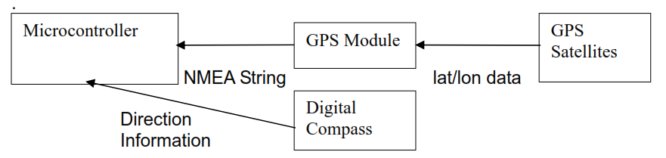

Table 6.1.8.1: LS20031 Pin description
Pin# | Name | Type | Description
1 | VCC | Power | Power input
2 | RX | Input | Data input (TTL level)
3 | TX | Output | Data output (TTL level)
4 | GND | Ground | Ground
5 | GND | Ground | Ground

The VCC input voltage has a minimum of 3 volts, a maximum of 4.3 volts, and a typical value of 3.3 volts. The logic voltage V_{IH} can range from 2.0 to 3.6 volts.

The GPS module can be connected to the STM32F7-DISCOVERY development board as follow:

Table 6.1.8.2 GPS module to STM32F7 development board pinout
Pin name (GPS) | Pin name (MCU, “Arduino connectors”) | MCU Pin | Function
VCC | +3V3 | - | 3.3V input/output
RX | D1 | PC6 | USART6_TX
TX | D0 | PC7 | USART6_RX
GND | GND | - | Ground
GND | GND | - | Ground

The following tables lists all of the microcontroller pins combinations that can potentially be used to connect the STM32F746ZG microcontroller to the GPS RX and TX UART pins.

Table 6.1.8.3 List of potential UART TX and RX pins on the STM32F746ZG MCU
Pin number | Pin name | Function | Pin number | Pin name | Function
101 | PA9 | USART1_TX | 102 | PA10 | USART1_RX
136 | PB6 |  | 137 | PB7
36 | PA2 | USART2_TX | 37 | PA3 | USART2_RX
119 | PD5 |  | 122 | PD6
69 | PB10 | USART3_TX | 70 | PB11 | USART3_RX
77 | PD8 |  | 78 | PD9
111 | PC10 |  | 112 | PC11
34 | PA0 | UART4_TX | 35 | PA1 | UART4_RX
111 | PC10 |  | 112 | PC11
113 | PC12 | UART5_TX | 116 | PD2 | UART5_RX
96 | PC6 | USART6_TX | 97 | PC7 | USART6_RX
129 | PG14 |  | 124 | PG9
19 | PF7 | UART7_Tx | 18 | PF6 | UART7_Rx
59 | PE8 |  | 58 | PE7
142 | PE1 | UART8_Tx | 141 | PE0 | UART8_Rx
Note that a device’s RX pin must be connected to the microcontroller’s TX pin and vice versa

The VCC and two GND pins are connected to the power subsystem.

6.1.9 Microcontroller to laser

The microcontroller communicates with the laser module through a UART interface. Table 6.1.8.2 and table 6.1.8.3 apply to the laser as well.

6.1.10 Microcontroller to camera

The OV9655 camera board contains the following labelled pins: PWDN, RET, D2, D3, D4, D5, D6, D7, D8, D9, XCLK, PCLK, HREF, VSYNC, SIOD, SIOC, GND, 3.3V.

The development board contains a preassembled DCMI port, therefore the “Arduino” pins will not be connected to the DCMI interface and it will be impossible to connect the camera board to the development board, unless the camera board’s internal connector is physically compatible with that present on the development board. A custom “development board” will be made using a STM32F746ZG microcontroller and a LQFP144 to DIP adapter, the camera is most likely to remain unused and undeveloped until then.

The camera requires a system clock input of 10 to 48 MHz (typically 24 MHz). This frequency is compatible with the STM32F746ZG microcontroller’s built-in 16 MHz internal HSI RC oscillator. It can be output directly from the Microcontroller Clock Output source; MCO1 set to output HSI (16 MHz), or through MCO2 divided by five (from SYSCLK or PLLCLK’s 216 MHz, or PLLI2SR’s 192 MHz). MCO1 is preferable. We may be able to use the I²C clock pin instead of a dedicated clock source.

Table 6.1.10.1 OV9655 camera board (DCMI interface) to STM32F746ZG microcontroller pinout
Pin name (camera board) | Function (camera) | Pin number (MCU) | Pin name (MCU) | Function (MCU)
PWDN | Power Down Mode Selection - active high, internal pull-down resistor (0: normal mode, 1: power down mode) | any | GPIO | Output bit
RET | Clears all registers and resets them to their default values (0: reset mode, 1: normal mode) | any | GPIO | Output bit
D2 | Output bit[2] - LSB for 8-bit YUV or RGB565/RGB555 | 98 | PC8 | DCMI_D2
 |  | 125 | PG10
 |  | 141 | PE0
D3 | Output bit[3] | 99 | PC9 | DCMI_D3
 |  | 126 | PG11
 |  | 142 | PE1
D4 | Output bit[4] | 3 | PE4 | DCMI_D4
 |  | 112 | PC11
D5 | Output bit[5] | 117 | PD3 | DCMI_D5
 |  | 136 | PB6
D6 | Output bit[6] | 4 | PE5 | DCMI_D6
 |  | 139 | PB8
D7 | Output bit[7] | 5 | PE6 | DCMI_D7
 |  | 140 | PB9
D8 | Output bit[8] | 111 | PC10 | DCMI_D8
D9 | Output bit[9] - MSB for 10-bit Raw RGB data and 8-bit YUV or  RGB565/RGB555 | 113 | PC12 | DCMI_D9
XCLK | System clock input | Share I²C_SDA with the SIOC pin. See table 6.1.12.2.** |  | I2C*_SDA**
 |  | 100 | PA8 | MCO1
 |  | 99 | PC9 | MCO2*
PCLK | Pixel clock output | 42 | PA6 | DCMI_PIXCLK
HREF | HREF output | 40 | PA4 | DCMI_HSYNC
VSYNC | Vertical sync output | 124 | PG9 | DCMI_VSYNC
 |  | 137 | PB7
SIOD | SCCB serial interface data I/O | See table 6.1.12.2: I²C_SDA
SIOC | SCCB serial interface clock input | See table 6.1.12.2: I²C_SDC
GND | Ground | Power subsystem
3.3V | Power supply | Power subsystem
* MCO2 is undesirable.
** This is the prefered approach

Table 6.1.10.2: I²C ports on the STM32F746ZG microcontroller
I²C_SDA |  |  | I²C_SDC
Pin number | Pin name | Function | Pin number | Pin name | Function
137 | PB7 | I2C1_SDA | 136 | PB6 | I2C1_SCL
140 | PB9 |  | 139 | PB8
10 | PF0 | I2C2_SDA | 11 | PF1 | I2C2_SCL
70 | PB11 |  | 69 | PB10
99 | PC9 | I2C3_SDA | 100 | PA8 | I2C3_SCL
55 | PF15 | I2C4_SDA | 54 | PF14 | I2C4_SCL
82 | PD13 |  | 81 | PD12

6.1.11 Microcontroller to SD card

It is unnecessary to connect a SD card slot to the STM32F7-DISCOVERY development board because it already contains one.

The Micro SD memory card slot we chose for this project is the Molex 503398-1892. The product drawing provides a list of pins with no description. We were able to determine the SD card slot pinout from the pin description table in the STM32F746ZG microcontroller datasheet.

Table 6.1.11.1 Molex 503398-1892 to STM32F746ZG pinout
Pin # (SD slot) | Pin name (SD slot) | Pin # (MCU) | Pin name (MCU) | Pin function (MCU)
1 | DAT2 | 111 | PC10 | SDMMC1_D2
2 | CD/DAT3 | 112 | PC11 | SDMMC1_D3
3 | CMD | 116 | PD2 | SDMMC1_CMD
4 | VDD | Power subsystem |  | Positive supply voltage
5 | CLK | 113 | PC12 | SDMMC1_CK
6 | VSS | Power subsystem |  | Negative supply, ground
7 | DAT0 | 98 | PC8 | SDMMC1_D0
8 | DAT1 | 99 | PC9 | SDMMC1_D1
10 | DETECT SWITCH | any* | any* | GPIO
* The STM32F7-Discovery development board has its MicroSDcard_detect pin connected to pin PC13. It is unclear whether this pin is used as a standard GPIO input or it is meant to take advantage of the “WKUP2” functionality present on pin PC13.

6.1.12 Microcontroller to Bluetooth Controller

The Bluetooth controller uses UART to communicate with the microcontroller. Table 6.1.8.3 is insufficient because the CC256xx microcontroller makes use of the request-to-send and clear-to-send pins as well. In addition, four pins are dedicated to PCM audio data transmission. They are AUD_FSYNC, AUD_CLK, AUD_IN, and AUD_OUT. Three clocks must be provided from the microcontroller, one of which is the standard 32.768 kHz RTC signal.

6.2 Software: Structure and Design

6.2.1 Operating System

6.2.1.1 Operating System (CPU) or RTOS/noOS (MCU)

The type of processor used in this device is determinant in our operating system choice. A microprocessor can be used to run a fully featured operating system similar to that found on personal computers (such as GNU/Linux distributions) and smartphones (such as Android). The Debian Linux distribution has been ported to many types of devices, and microcontroller makers have been making the necessary revisions to Debian Linux so that they can ship it with their evaluation development board (or make it available as an optional download).

Some examples of such Debian-ready development boards include the Texas Instruments BeagleBoard and the Intel Edison system-on-a-chip. Using a mainstream Linux distribution such as Debian Linux simplifies software development by allowing embedded software engineers to start off with a well understood (and well documented) base and focus on developing embedded software.

Microcontrollers lack the Memory Management Unit (MMU) required by all modern operating systems. This makes it impossible to run Debian Linux or Android on a microcontroller regardless of its computing power. The 300 MHz capable ARM Cortex-M7 core has more than enough processing power to run any modern operating system, yet it has yet such a feat has not been accomplished. This limits our options to either using a simple “Real Time Operating System” (RTOS), or write our own operating system routines (such as the scheduler) from scratch.

6.2.1.2 μClinux

μClinux is a fork of the Linux operating system that contradicts the above paragraph by running on microcontrollers deprived of a memory management unit. We initially considered using the Analog Devices Inc. Blackfin processor because of its uClinux support and extensive documentation, but we eventually decided that the Blackfin packed much more processing power than we could use, at the cost of excessive power consumption, much higher development board cost, and a large pin count that is practically impossible to integrate.

As of the Linux kernel 2.5.46, uClinux has been discontinued in favor of mainstream Linux kernel integration. This brought Linux support to the prominent ARM Cortex-M series based microcontrollers, but the documentation for Linux usage on these microcontrollers is very sparse especially compared to that of the ADI Blackfin. With no proper support, the use of a fully featured Linux kernel falls outside the scope of this project.

6.2.1.3 No OS

Another attractive option for microcontrollers is not to use an operating system that is writing all of the required low-level functions typically performed by an operating-system from scratch instead. These functions include memory allocation, a task scheduler, device drivers, and mutexes and semaphores implementation.

Because our device must schedule many different tasks to handle all of the functions provided by the extensive array of input and output devices, it would be impractical to write our own scheduler from scratch. Moreover, we are likely to be dealing with multiple layers of memory with the CMOS sensor requiring an external DRAM module.

6.2.1.4 FreeRTOS

Introduction to FreeRTOS

FreeRTOS is a real-time operating system for embedded system. It sparked our interest because it is distributed for free under a modified GPL open source license, and it is highly integrated with the STMicroelectronics STM32 proprietary development ecosystem that we are to use. The STCubeMX software suite allows embedded software developers to generate firmware code which includes a pre-configured copy of FreeRTOS.

FreeRTOS itself is minimalistic, its core is contained in only three files (named tasks.c, queue.c, and list.c), allowing developers to wrap their head around the entire operating system. More files are available to demo the RTOS and provide advanced functions. The STCubeMX implementation contains nine files: croutine.c, event_groups.c, heap_4.c, list.c, port.c, queue.c, tasks.c, timers.c, and User/freertos.c. FreeRTOS does not support advanced operating system features such as device drivers.

Some of the resources used to better understand FreeRTOS development on the STM32F7 series of microcontrollers include:
- “Developing Applications on STM32Cube with RTOS” (DM00105262.pdf, reffered to by STMicroelectronics as UM1722), a twenty-six pages user manual released by STMicroelectronics that provides a broad introduction to FreeRTOS, its components, and a few short applicable examples.
- “FreeRTOS/FreeRTOS_ThreadCreation/Src/main.c”, a file contained in the STM32CubeF7 package that illustrates thread creation.

FreeRTOS content

Some files that are relevant to our interests include:

FreeRTOSConfig.h, which contains the variable configTOTAL_HEAP_SIZE used to set the amount of RAM available, as well as most of the relevant configuration settings.

heap_*.c: FreeRTOS memory management.
heap_1.c creates a single large array the size of the memory available. It is fastest but does not allow for tasks or queues to be deleted.
heap_2.c allows for tasks and queues to be deleted, but it does not recombine adjacent blocks.
heap_3.c provide the standard malloc() and free() function, and result in a considerable larger operating system codebase.
heap_4.c is the default choice on the code STCubeMX generated for the STM32F7-DISCOVERY development board. Heap_4.c is the holy grail of Real Time Operating Systems memory management providers. It allows for the standard memory functions to be used, and it does recombine adjacent free blocks. We will be keeping this default choice and replace it in the future if its advanced features turn out to be unnecessary.

cmsis_os.c provides a programming interface that is common to most real time operating system. The CMSIS-RTOS API provides thread management, interprocess messaging, mutex and semaphore management.

stm32f7xx_it.c is not part of FreeRTOS, but it is relevant to our interests because that is where the interrupt handlers are stored.

Some relevant features include:

Low power mode

An idle task hook allows the microcontroller to be placed into a low-power mode. The low-power state is exited whenever a tick occurs, therefore FreeRTOS provides a tickless low-power mode which adjusts the tick count when the microcontroller awakens.

Simple Thread Use Case

This section illustrates a pair of green LEDs, each running on their own thread. C code is written using a ten-point font to be distinguishable from standard language.

Code segment 6.2.1.4.1: Threads are first defined underneath the #include statement using the osThreadId data type
osThreadId LED1ThreadHandle, LED2ThreadHandle;

Code segment 6.2.1.4.2: A function prototype is then defined for each thread, still outside of the main function
static void LED1Thread(void const *argument);
static void LED2Thread(void const *argument);

Code segment 6.2.1.4.3: Any required initialization takes place inside of the main function
MX_GPIO_Init(); // This was generated by STM32CubeMX to activate the GPIO pins as output

Threads are then formally defined using the osThreadDef() function, which should be part of the CMSIS-RTOS but does not appear to fit the standard definition. According to the ARM documentation for CMSIS-RTOS, the osThreadDef function is defined as follow: osThreadDef(name, priority, instances, stacksz) where name is an arbitrary name, priority is a value from enum osPriority, instances is a number representing the maximum number of instances of a given thread allowed to run at once, and stacksz is the size this thread requires in bytes. The book “Using the FreeRTOS Real Time Kernel - a Practical Guide - Standard Base Edition” written by Richard Barry and released in 2009 does not make any mention of the osThreadDef() function.

This unfathomable function is most likely STMicroelectronics’ own undocumented vendor-specific implementation, but it is similar enough to the one documented by ARM, the only exception being the inclusion of the function prototype’s name between the name and the priority. This is confirmed by pressing ctrl+shift+space in Eclipse to show the function definition with its required parameters: osThreadDef(name, thread, priority, instances, stacksz), as it is defined in the header file cmos_os.h, located in the folder /Middlewares/Third_Party/FreeRTOS/Source/CMSIS_RTOS/.

Code segment 6.2.1.4.4: Two threads are defined using the osThreadDef(...) function.
osThreadDef(LED1, LED1Thread, osPriorityLow, 0, configMINIMAL_STACK_SIZE);
osThreadDef(LED2, LED2Thread, osPriorityLow, 0, configMINIMAL_STACK_SIZE);

Table 6.2.1.4.5: osThreadDef() parameters
Parameter | Description | Possible values*
name | Arbitrary thread name | any string
thread | Function prototype name | String matching a function prototype name
priority | The thread’s priority | osPriorityIdle or -3  osPriorityLow or -2  osPriorityBelowNormal or -1 osPriorityNormal or 0 osPriorityAboveNormal or +1  osPriorityHigh or +2  osPriorityRealtime or +3  osPriorityError or 0x84
instances | Number of possible thread instances | Positive integer, 0
stacksz | Stack size in bytes | Positive integer. The example uses “configMINIMAL_STACK_SIZE”
*Values obtained from the Keil CMSIS-RTOS documentation, may be different from STMicroelectronics’ implementation

We then start the threads by defining the previously initialized “osThreadId” thread handles with the osThreadCreate() function, which creates a thread, adds it to the active threads list, and sets the thread's state to READY. The osThreadCreate method takes two parameters. The first parameter simply finds the thread using osThread(name) (as defined in table 6.2.1.1 above), the second argument is a pointer to the thread’s required starting value (or NULL if none is required).

Code segment 6.2.1.4.5: Two threads are created
LED1ThreadHandle = osThreadCreate(osThread(LED1), NULL);
LED2ThreadHandle = osThreadCreate(osThread(LED2), NULL);

The scheduler is then started and nothing else goes inside the main function (the infinite loop should remain empty).

Code segment 6.2.1.4.6: The scheduler is started
osKernelStart();

We then define the threads using the previously declared function prototypes.

Code segment 6.2.1.4.7: Source code of two threads running concurrently
static void LED1Thread(void const *argument) // dim LED1 using software PWM (10%)
{
for(;;)
{
HAL_GPIO_WritePin(GPIOI, GPIO_PIN_3, 0);
osDelay(10);
HAL_GPIO_WritePin(GPIOI, GPIO_PIN_3, 1);
osDelay(1);
}
}
static void LED2Thread(void const *argument) // dim LED2 using software PWM (50%)
{
for(;;)
{
HAL_GPIO_TogglePin(GPIOC, GPIO_PIN_7);
}
}

CMSIS-RTOS Functions

Table 6.2.1.4.6: Thread handling functions
Name | Description | Arguments
osThreadDef(*) | Creates a new thread. | *See Table 6.2.1.1. Arguments data type are not listed because osThreadDef() is a function-like macro
osThreadSuspend(osThreadId) | Suspend a thread indefinitely | Thread ID
osThreadResume(osThreadId) | Resume a suspended thread | Thread ID
osDelay(uint32_t) | Wait (other threads can run) | Length of time (ms)
osThreadYield(void) | Yield to other threads (once) | N/A

6.2.2 Laser Processing Coding Plan

The laser will programmed using the software it comes with. Then the laser will properly connected to the board to to check that everything is configured right and several simple tests will be done to see that all the information obtained by the laser is correct and precise.

6.2.3 Bluetooth Microcontroller Coding Plan

The Bluetooth component will be programmed via an ISP header connected to the appropriate pins on the chip. TI provides a Sensortag development kit for less than $100 that includes a small PCB with a CC2541, accelerometer and coin cell battery holder. A USB programming pod that mates with the ISP header is also included.

At this time TI's BLE stack is only compatible with IAR's 8051 Workbench. Assuming that this is the only method to program the chip, there will be a strict time constraint of 30 days (for the free trial offered) to try to and get the chip programmed and ready for use, because the cost to fully purchase IAR’s 8051 Workbench is about $3000. An amount that greatly exceeds the planned budget and a price that the group is unwilling to pay.

6.2.4 Voice Recognition Microcontroller Coding Plan

The voice commands will be stored in a voice command file. This command file will be the library of words that will be recognized by the device when the user speaks. The list of commands to be stored are:

Table 6.2.4.1: List of Voice Commands
Command 1 | “Start Route 1”
Command 2 | “Start Route 2”
Command 3 | “Start Route 3”
Command 4 | “Start Route 4”
Command 5 | “End Route”

The commands chosen are one syllable words, which were specifically chosen to reduce the chance of incomprehension due to accents or mispronunciation. It is less difficult to mispronounce one syllable words than multiple syllable words. When the device properly receives a command from the user, the device will output audio from the text to speech engine programmed into the bone conduction microphone.

In detail, first a speech library will first be created. The library will contain a speech recognition engine. Events will be created for each activity we want to occur (from the commands listed in the table above). Once the eventhandler confirms each command, the method for that specific activity will initiate and output audio based off of the selection that the user made. The audio output will be controlled by a speech synthesizer.

6.2.5 GPS Subsystem Coding Plan

We will get the coordinates for each of the places, at every certain distance a node will be set. When the user inputs a request via a voice command or possibly by pressing a button, the user to will be direct to next node via audio command. Every turn and street intersection will be a node where the user will have to carefully cross the road at their own risk. In order to get the coordinates for each place can either get them for a map software such as google maps or openstreetmap or by walking with gps while it tracks our path. At most 3 places will be recorded starting at the ucf campus and ending at the destination

6.2.6 Battery Class

The battery is being monitored using one of the ADC ports present on microcontroller. An additional pin is required to turn off the voltage divider, which would otherwise dissipate power through its resistors.

Another pin is connected to the battery charging system and allows the microcontroller to turn stop the charge if the voltage becomes dangerously high.

6.2.7 Computer Vision

With recent advancements in technology, the visually impaired have benefited tremendously from computer vision. Computer vision is a discipline that studies how to reconstruct, interpret and understand a 3D scene from a set of inputted 2D images, in terms of properties of the structures present in the scene.

The goal of this field is to model, replicate and exceed human vision using computer software and hardware at different levels.

The group took into consideration implementing a camera into the project. The camera will be able to recognize street signs that a normal pedestrian would encounter while walking in any street, although the biggest problem a visually impaired faces on a daily basis is crossing urban intersections, implementing the code to detect the crosswalk lines is out of the scope for this project, we will just reduce if possible to object and color recognition , while the decision of implementing this is completely depends on the project timing, It is very important to understand the hardware and software needed in order to achieve this.

While computer vision seems to be a hard task to complete, there are very useful libraries, OpenCV in particular, which is used to detect and recognize objects and can also be used to detect faces. OpenCV stands for Open Source Computer Vision, it was developed at the Intel Research Center. This library is written in C++. The library supports real-time capture, video file import, basic image treatment (brightness, contrast, threshold), object detection (face, body, etc) and blob detection. Blob detection are methods for detecting regions in a digital image.

The following lines of code shows how an object can be easily detected using OpenCV and python language.

Code segment 6.2.11.1: Object detection using OpenCV and Python
img_filt = cv2.medianBlur(cv2.imread('f.jpg',0), 5)
img_th=cv2.adaptiveThreshold(img_filt,255,cv2.ADAPTIVE_THRESH_GAUSSIAN_C,cv2.THRESH_BINARY,11,2)contours, hierarchy = cv2.findContours(img_th, cv2.RETR_LIST, cv2.CHAIN_APPROX_SIMPLE)

Where img-filt is the variable that contains the filter image, it is using the imread function, the 0 flag that is being passed would make the output image in grayscale, The resulting image is then passed to the medianblur filter (to make the image blur). The filtered image is then passed to adaptive threshold with a Gaussian adaptive method and a binary threshold method.

Finally, the threshold image is then used for extracting contours. This is the way we will try to recognize the street signs such as stop signs, bathroom signs and food signs etc., which for sure would be very useful for the user, as mentioned above this is not sure to be implemented in the project due to time constraint. Important aspect to mention is that a couple of members of the group have some experience in computer vision otherwise we wouldn’t even try attempt this feature for the project .

6.2.8 Development Environment

6.2.8.1 GNU ARM Plugin for Eclipse CDT

The GNU ARM Plugin for Eclipse CDT is the ideal development environment. While it does not have a user-friendly graphical user interface like proprietary solutions, it uses a bundle of widely used free and open-source tools such as GNU GCC. This brings several benefits.

The GNU ARM plugin is portable across different platforms, and it is unlikely to ever go obsolete. Learning to use these software is beneficial over the long term. Not only does it support most STMicroelectronics STM32 microcontrollers, it is also compatible with most ARM microcontrollers on the market today. These benefits bring an enormous user base, and as a result a tremendous ecosystem of documentation, tutorials, and fellow developers’ shoulders to cry on.

This plugin did not support the new ARM Cortex-M7 microcontroller (nor the STMicroelectronics STM32F7 series which is based on a Cortex-M7 core) when this section was originally written on 2015-10-20, but as of November 18th 2015, the GNU ARM Eclipse Project developers have brought on support for the Cortex-M7 and our microcontroller specifically.

Installing the GNU ARM Plugin for Eclipse CDT

The GNU ARM plugin requires several components..

Table 6.2.8.1.1: Components required by the GNU ARM plugin for Eclipse CDT
Component | Source | Function | License
Eclipse CDT | System package manager | IDE | Eclipse Public License v1.0
GCC (ARM cross compiler) | System package manager | Compiler | Simplified BSD Licence, GNU GPL v2, GNU GPL v3, GNU LGPL v2.1, GNU LGPL v3, MIT / X / Expat Licence
OpenOCD | OpenOCD GIT or GNU ARM Eclipse website | Debugger | GNU GPLv2
GNU ARM Eclipse plugin | Eclipse software manager | Development toolchain | Eclipse Public License v1.0
Zylin Embedded CDT plugin | Eclipse software manager | Flash and debug within Eclipse | Eclipse Public License v1.0

The GNUARMEclipse project includes a fork of QEMU that can be downloaded separately. QEMU is a hardware emulator that supports many different architectures. The QEMU fork plugin simplifies development and debugging by emulating a whole microcontroller or a development board, going so far as to display the status of the built-in LEDs. Sadly the STM32F7 platform is not supported as of December 2nd 2015.

Installing Eclipse CDT and the ARM GCC cross compiler can be done from the command line on most Linux distributions’ packaging system.

Code segment 6.2.8.1.1: Bash command to install the ARM GCC plugin dependencies on Arch Linux
# pacman -S arm-none-eabi-gcc openocd gdb arm-none-eabi-gdb

Code segment 6.2.8.1.2: Bash command to install the ARM GCC plugin dependencies on Ubuntu Linux
$ sudo apt-get install ia32-libs gcc-5-arm-linux-gnueabi gcc-5-arm-linux-gnueabi openocd eclipse-cdt

The GNU ARM Eclipse plugin and Zylin can be installed from the Eclipse software manager independently of the host platform. This is done in the Eclipse “Help” menu through the “Install New Software…”, using the following sources:

Code segment 6.2.8.1.3: url’s required by Eclipse to install the GNU ARM and Zylin Embedded CDT plugins
GNU ARM Eclipse plugin: http://gnuarmeclipse.sourceforge.net/updates
Zylin Embedded CDT plugin: http://opensource.zylin.com/zylincdt

Although OpenOCD is available in most distribution’s official repositories, version 0.9.0 released on May 18th 2015 (the latest version as of 2015-12-01) does not yet support the STM32F7 series development board and microcontrollers. The development version available on the OpenOCD GIT repository appears to bring support for the STMicroelectronics Cortex-M7 series, as shown on the file “/tcl/target/stm32f7x.cfg” edited on 2015-11-11. This file along with /tcl/board/stm32f7discovery.cfg need to be downloaded. They can be imported into the OpenOCD installation directory, and while this solution would most likely function, we will be using the fork (“distribution”) of OpenOCD packaged and published by the GNU ARM Eclipse plugin team instead to ensure compatibility. This OpenOCD fork can be downloaded on the gnuarmeclipse github page. It can be installed on a 64-bit Linux distribution using the following command lines:

Code segment 6.2.8.1.4: Bash commands to install the GNU ARM OpenOCD fork
# mkdir -p /opt/gnuarmeclipse
# cd /opt/gnuarmeclipse
# tar xvf /PATH/gnuarmeclipse-openocd-debian64-0.10.0-201510281129-dev.tgz

PATH is replaced by the location OpenOCD was downloaded into (such as /home/trougnouf) in the code segment above. Using this default location ensures that Eclipse can locate the OpenOCD file as needed.
Finally a set of rules must be loaded into UDEV for the USB debugging to function properly.

Code segment 6.2.8.1.5: Bash command to set up UDEV rules for OpenOCD development
# cp /opt/gnuarmeclipse/openocd/0.10.0-201510281129-dev/contrib/99-openocd.rules \ /etc/udev/rules.d/
# udevadm control --reload-rules

We will then add the /board/stm32f7discovery.cfg and /target/stm32f7x.cfg downloaded from the OpenOCD GIT master branch into the installation directory located in /opt/gnuarmeclipse/openocd/0.10.0-201510281129-dev/scripts/ , because they are still not part of gnuarmeclipse’s latest OpenOCD development branch. This can be done using the following commands from the Download folder:

Code segment 6.2.8.1.6: Bash command to add the OpenOCD git master branch needed files into the GNU ARM plugins’ directory
# cp stm32f7x.cfg /opt/gnuarmeclipse/openocd/0.10.0-201510281129-dev/scripts/target/stm32f7x.cfg
# cp stm32f7discovery.cfg /opt/gnuarmeclipse/openocd/0.10.0-201510281129-dev/scripts/board/stm32f7discovery.cfg

Unfortunately OpenOCD cannot identify the target as a STM32, a few more steps could be added to add device id 0x10016449 to the list of known STM32 devices, but simply installing the GIT development version of OpenOCD is a more effective solution while stable open-source software is being developed.

Despite our best effort, we were unable to use the GNU ARM plugin for Eclipse in its current state. We will be periodically checking for improvements and switching to this fully open-source development environment if that becomes an option in the future.

6.2.8.2 System Workbench for STM32 (SW4STM32) and STM32CubeMX

System Workbench for STM32 is a software suite released by STMicroelectronics, developed by Ac6 Tools, and mostly based on a bundle of free and open-source software such as ARM’s GNU GCC compiler, the Eclipse-CDT IDE, and the gdb debugger. It is compatible with all STM32 microcontrollers and developer boards, and is able to import code generated on STM32CubeMX. SW4STM32 is very similar to the GNU ARM plugin, but it is a vendor-specific solution that works out of the box for the most part (that is, when importing a project generated on STM32CubeMX).

STM32CubeMX allows embedded software developers to generate code in which all pins are activated with their desired functions and components are activated as needed. This is done with a human-friendly Hardware Abstraction Layer (HAL) which translates all activation routines (which would often be written in assembly language and require port numbers and addresses) into descriptive statements, making the use of the UART and other interfaces much more intuitive. The STM32CubeMX allows for some software to be pre-installed. These include the FreeRTOS operating system, the FAT file system, and a plethora of device drivers.

Both the source code generated by STM32CubeMX and the STMicroelectronics HAL libraries are licensed under the “MCD-ST Liberty SW License Agreement V2”, according to the source code present in the STM32CubeF7 “firmware” archive that was downloaded. While the source code is available, making it open-source software, it is not defined as free software according to the Free Software Foundation.

Although MCD-ST Liberty SW License Agreement V2 may have been omitted from the FSF list because it is relatively unknown, it does not possess the attributes that would define its derived work as “free software”. That is because STMicroelectronics does not allow source code derived from its licensed code to be used in processors supplied by other manufacturers.

While we are deeply saddened that our software cannot be published as a truly free software because of such restriction, the terms of the license are “not that bad”, allowing developers to publish source code so long as it contains a copyright notice. Some additional potentially disastrous restrictions include STMicroelectronics’ right to revoke the license at any given time, and the vague language being used. These restrictions are an acceptable tradeoff when we consider that the entire license has a three pages length.

Installing SW4STM32 and STM32CubeMX

Before being able to use the System Workbench for STM32 software suite, we must install a compatible USB driver. Windows users can install it on the STMicroelectronics website. Linux contains a compatible driver, but the appropriate UDEV rule must be set, this can be done by downloading the stlink_udev_rule.tar.bz2 tarball and extracting it into the /etc/udev/rules.d folder. The software prerequisites for SW4STM32 and STM32CubeMX are the Eclipse-CDT IDE, the Java JDK (preferable jre8-openjdk), and JavaFX (java-openjfx).

System Workbench for STM32 is hosted on the OpenSTM32 website, STMicroelectronics’ community portal for STM32 developers. One must create a user account in order to receive a link to the System Workbench Eclipse installer. The installation process takes place within the Eclipse IDE, in “Help” > “Install New Software…” > “Add” using the link found on the OpenSTM32 website as the location and anything as the name.

STM32CubeMX is hosted on the official STMicroelectronics website. It has official support for the Windows operating system only, but it is a portable Java software that can easily be made to run on Linux and Mac OSX. The downloaded file is packaged inside a .zip file that needs to be decompressed and yields a .exe executable file, which is itself a self-extracting archive that can be treated as another .zip archive. Care must be taken not to extract the executable archive outside of a dedicated folder because it acts as a tarbomb. Once everything has been extracted, it needs to be installed as root.

Code segment 6.2.8.2.1: Bash command to install STM32CubeMX
# java -cp . com.izforge.izpack.installer.bootstrap.Installer

This command creates another .exe self-extracting executable archive named STM32CubeMX.exe in /usr/local/STMicroelectronics/STM32Cube/STM32CubeMX/ (default location), it needs to be extracted as well using the unzip command.

Using STM32CubeMX

The resulting file from the final installation step can then be executed on any operating system.

Code segment 6.2.8.2.2: Bash command to launch STM32CubeMX
$ cd /usr/local/STMicroelectronics/STM32Cube/STM32CubeMX/ && java -cp . com.st.microxplorer.maingui.IOConfigurator

From there a new project can be created in “File > New Project”, the “MCU Selector” tab allows for a barebone microcontroller setup, while the “Board Selector” can be used to create the firmware for any STM32 development board and activate its built-in components. The “Initialize all IP with their default Mode” option activates all components, which is useful to determine a working configuration but wastes a lot of power by having everything turned on.

Individual pins can be selected directly on the pinout image or searched using the “Find” text box (in which case the matching pins will blink), a left clicking on any given pin opens up a submenu that allows users to have the pin initialized to a desired compatible function (ie: GPIO_Output, SPI*_MISO, …). Alternatively users may select a peripheral and its desired configuration in the menu located on the left of the screen. This features automatically activates the required pins or informs the user of any eventual conflict. The left-hand menu contains a MiddleWares section that contains various pre-configurable softwares (FreeRTOS, FatFS) and drivers (USB, ethernet).

C code can be generated for the SW4STM32 IDE (as well as EWARM, ARM’s MDK-ARM, and TrueSTUDIO) in Project > Generate Code.

Using SW4STM32

Eclipse can import STM32CubeMX projects by having the user select “File > Import… > Existing Projects into Workspace”. When browsing projects, the “SW4STM32” folder must be selected. If it does not exist, then the wrong IDE was likely selected in STM32CubeMX and code must be regenerated after selecting SW4STM32 in the project settings. The default options have been found to work, that is with all of the checkboxes in “Options” and “Working sets” unchecked.

The main.c file is located in the Application/User folder. It contains an infinite loop in which software can be written, and developers have the opportunity to perform any one-time configuration beforehand. STMicroelectronics provide extensive documentation for their Hardware Abstraction Layer on their official website, and the 270MB firmware archive downloaded by STM32CubeMX contains an extensive selection of examples for many potential functions (such as the simple GPIO_Toggle used to create an LED “Hello World”, and another example that illustrates UART usage).

A binary file can be generated by compiling the project. This is performed with a right-click on the project root folder followed by “Build project”, or simply clicking on “Project > Build all” (the later will build all projects currently opened in the Eclipse IDE). The resulting .bin firmware binary is located in the Debug folder and can be copied and pasted to the development board using any file browser.

Debugging is integrated with Eclipse’s native debugging interface. The Ac6 software interacts with the ST-LINK/V2 debugger/programmer and the GNU debugger (gdb) is used. “printf” statements are displayed in the console and breakpoints can be set graphically.

The System Workbench for STM32 Eclipse plugin allows developers to write a firmware from scratch without downloading the “firmware” package (Hardware Abstraction Layer and examples). This removes any uncertainty about the licensability and copyright status of the code, but the amount of work this entails falls outside the scope of this project.

7.0 Project Prototype Construction and Coding

Once software has been written, testing needs to be applied to guarantee that the software has fulfilled the software requirements and specifications. This process consists of outlining how an assessment should be set up for the specific software. The assessment will determine if the requirements have been satisfied.

Once the test has been implemented, the results of the assessment are to be examined to see if any debugging or any other alterations to the program need to be done. There are four levels of testing the software that need to be completed before testing the program in its entirety. They comprise of unit testing, integration testing, and system and acceptance testing.

7.1 Parts Acquisition

The lithium ion battery pack will provide power to all of the subsystems. There are four main sub-systems, the GPS unit, the Bluetooth audio unit, the microcontroller unit, and the Laser unit. Because each of these listed subunits required either a higher or lower supply voltage then the 3.8 Volts produced by the lithium ion battery, DC-DC converters were required. There are two DC-DC converters that were designed for SenseWalk 2.0.

The first is a 3.3 Volt Buck/Boost regulator for the GPS, microcontroller and compass. The second is a Boost regulator to provide 5 Volts to the Laser and bluetooth. The Boost converter would provide a constant 5Volts which is required for the Laser unit. The microcontroller is required to communicate with the GPS, bluetooth audio, and Laser units. The microcontroller would serve to control each sub-system. It would be responsible for turning on and off the Laser and interpreting Laser data.

Also the microcontroller was responsible for processing GPS data and transmitting relevant information to the Bluetooth audio sub-system to determine which audio instruction to play to the user. SenseWalk 2.0 operates from a single lithium ion battery pack. The various sub-systems each required specific supply voltages. Also SenseWalk 2.0 requires an AC-DC battery charger to recharge the lithium ion battery which will be bought.

Some other parts that need to be considered are the cane which will be bought along with the housing of all the circuitry. The actual housing will be one of the last things once SenseWalk 2.0 is brought to life. If everything goes to plan SenseWalk 2.0 will be half the size of SenseWalk.

7.2 PCB Vendor and Assembly

Before the circuits are made into PCB they will go through several steps of testing. First everything will be simulated on a Spice program like LTSpice or Multisim. The circuits will first be tested as individuals and then combined as a whole and tested. The simulation values will need to be the same as the values expected from the calculations.

The next step will be to breadboard the circuits. Like in the Spice simulations each circuit will be isolated and tested by itself then the circuits will be combined and tested as a whole. The breadboarded circuits will need to match the results of the simulation with a small amount of experimental error before we will proceed in have the PCB printed and finalized. For SenseWalk 2.0 to be created with a lighter weight and smaller design some big changes needed to happen to the original design of SenseWalk on the PCB boards. This PCB also had the have amplifying and filtering circuits that will be needed for the receiving transducer.

The PCB included the microcontroller, GPS unit, digital compass, Bluetooth audio module and the Boost and Buck/Boost regulator power management circuits. In order to get these boards printed, we think we are going to use 4PCB. The layout of the different IC and the connection between the nodes will be done on software before the board will be printed. This layout was on Eagle.

The first designs done in eagle were for testing purposes. Many hours will go into actually laying out the correct distances for each individual part along with reading data sheets to see what the minimum distance can be for spacing parts. Because SenseWalk 2.0 needs to be smaller and lighter than the previous version of Sensewalk. Because accidents do happen we will be ordering 3 printed circuit boards. Once the board is printed out by 4PCB and shipped back to the group.

The next step will be in mounting all of the parts onto the printed circuit board. SenseWalk 2.0 needed to be lighter than Sensewalk so some of the parts are smaller which entails surface mounting. Even though one of the group members is good at soldiering he does not have the capability of surface mounting the parts. Surface mount parts are every small dots of solder at the bottom of the chips hits where the word surface mount comes from. Surface mount chips have pre solder on them so all you need to do is put them in a oven to bake the solder melts and the part is attached to the board once the solder cools.

8.0 Project Prototype Testing

The operation of SenseWalk 2.0 console was designed to be simple and intuitive to use for the user. This is due to the user needing to hold the cane for long periods. In order to first use the console, the user must attach the SenseWalk 2.0 device to their white cane of choice by using the mounting unit that will need to be designed later on in the project For SenseWalk they used a mounting unit was taken from a GPS mounting unit used for GPS navigations used on cars that are affixed to dashboards.

Once the console has been properly attached to the cane, the console may be used. To turn on the console, the user will press a button from there it will give power on the face of the console box to the one position. This powers on the entire console. This means that the microcontroller is turned on, which allows it to run the program stored on its flash memory, the GPS module, compass, Laser, and Bluetooth audio are turned on as well and begin communication with the microcontroller. The user must insert the SD card with their specified routes already stored onboard the card. To create the routes, the user must have another individual use a computer to use the route making software and then save it to the SD card.

To use the Laser feature, the user must make sure that the device is turned on. When on, the Laser module begins shooting out a infrared beam to determine if there is an obstruction. The microcontroller will make the decision if whether is given distance sent by the module is worth notifying the user by speaking to the user. If no obstructions are found, the user will not be notified of anything. When on, the GPS will take a minute to make a connection.

When connection has been made, the route will be read from the SD card to determine the waypoints of a given route. The compass will determine the orientation of the user and the user is free to move along their path. The console will immediately start telling the user what direction to head in and will constantly keep them updated with the most current instruction to pursue.

A timer will need to be coded in so that it is not trying to tell the direction as well as let the user know what's in front of them at the same time. An override will happen if both commands are given and an object detected in front of the user will take priority.

8.1 Hardware Test Environment

A development board was necessary for implementing the microcontroller with all necessary circuitry for the hardware. Programs were uploaded through the development board to the microcontroller so that it can be ensured that the program has correctly met all design requirements. Any errors in the code can be monitored and fixed through this method. Many microcontroller manufacturers already offer development boards and kits designed for a specific family of their microcontrollers so applicability to a chosen microcontroller was not an issue.

A development board allowed for the possibility to become acquainted with programming and implementing the microcontroller. In addition to this, the board allowed the connection of peripherals that would communicate with the microcontroller such as connecting an audio module or external memory chips if needed.

8.1.1 Microcontroller testing environment

External debugger / programmer

The STMicroelectronics ST-LINK/V2 will be used to increase the chances of software compatibility and to reduce costs. The ST-LINK/V2 is STMicroelectronics’ vendor specific in-circuit debugger/programmer, it is compatible with the STM8 and the STM32 lines of microcontrollers.

Our STM32F7 Discovery development includes a built-in ST-LINK/V2 interface connected to the microcontroller’s SWD pins and accessible through the USB ports, as well as a four pins that provide a standard JTAG or SWD interface for standard ARM debuggers. These external “pins” (holes) are located on connectors “CM8” on the side of the development board, labelled as 3V3, CLK, GND, and DI0. Although the ST-LINK/V2 is a proprietary debugger/programmer, it is used on any platform using the free and open-source software “Open On-Chip Debugger”, or OpenOCD.

The official STMicroelecronics ST-LINK/V2 programmer/debugger is available on Digi-Key for $22.61 per unit. STMicroelectronics also provides the ST-LINK/V2-ISOL starting at $77.17 (directly from STMicroelectronics). The “ISOL” configuration comes with digital isolation, which we hope will not be necessary. The ST-LINK/V2 protocol is well understood and the official unit’s firmware has been extracted, therefore there are less expensive third party debugger/programmer modules available. One unofficial clone is made by Adafruit and retails for $12.50. We will be using the official ST-LINK/V2 in order to minimize potential issues.

Using the ST-LINK/V2 datasheet and the STM32CubeMX software, we were able to determine the pins required to replicate the development board built-in debugger configuration, a SWD and asynchronous trace debugging interface.

Table 8.1.1.1: ST-LINK/V2 to STM32F7 SWD Pinout
ST-LINK/V2 | VAPP | TMS_SWDIO | TCK_SWCLK | TDO_SWO | TRST, GND, TDI | NRST
Target (SWD) | V_{DD}* | SWDIO | SWCLK | TRACESWO | GND | NRST
Target name (HAL) | V_{DD} | SYS_JTMS-SWDIO | SYS_JTCK_SWCLK | SYS_JTD0-SW0 | V_{SS} | NRST
Target description | Power | Debug Serial Wire Debug (SWD) | Debug Serial Wire Debug (SWD) | Asynchronous Trace | Power (Ground) | Reset State
Target pin (STM32F7-DISCO) | [E7, E8, E9, E10, F4, F5, F11, G5, H5, H11, J5, J11, K5, K11, L7, L8, L9, L10] | [A15]-PA13 | [A15]-PA14 | [A10]-PB3 | [F6, F7, F8, F9, F10, G6, G10, G6, H6, H10, J6, J10, K6, K7, K8, K9, K10, L6, F2] | [J1]-NRST
Target pin (STM32F746ZG) |  | PA13 | PA14 | PB3
*V_{DD} ensures that the microcontroller and the debugger are communicating on the same voltage.

The JTAG-Debug port is active by default on the microcontroller, therefore we will be keeping the two additional pins required for JTAG available and accessible if they remain unused.

MCU to breadboard

We will be using a LQFP to DIP adapter in order to set up and test the microcontroller outside of its development board environment. The STM32F746ZGT6 microcontroller uses a LQFP144 20 x 20 mm packaging with a typical 0.500 millimeters PIN pitch. We found a set of five “QFP/EQFP/TQFP/LQFP144/128 SMT to DIP Adapter PCB Converter Expansion Board” on Ebay for $10.90 (shipping included). These have the matching 0.5mm PIN pitch therefore they should be compatible with our microcontroller, and they are being shipped from Hong Kong so we ordered them ahead of Senior Design II.

8.1.2 User Input

The Bluetooth voice recognition input will likely be one of the last steps of our project because it is one of the most complicated software components, and it required the audio input/output and Bluetooth hardware to be correctly set-up before work can begin.

Moreover, voice recognition may always be completely unreliable despite our best effort. Using voice recognition as the only input may leave the user stranded in an incongruous place, or worse, result in this project’s failure as the judging committee is unable to convince this device to perform any given task. We will be using a physical switching input on both our development boards and the final product in order to avoid this potential disaster.

The CTS Electrocomponents 210-6MS DIP switch provides six inputs and connects using twelve standard DIP pins that are breadboard compatible. It is available on Digi-Key for $0.664 per unit at 10-99 units.

The TE Connectivity Alcoswitch Switches 1825910-7 provides a single tactile switch for $0.06 per unit (at 10-24 units). This option is more user-friendly because DIP switches are not meant to be switched frequently (they provide a fancy alternative to the common jumper) while tactile switches are only the push of a button away from being activated. This creates a software and hardware hurdle as the button state is not saved (OFF-ON-OFF) and each switch must be installed separately, but the added flexibility, ease of use, and potential price advantage largely make up for these small hindrances.

8.2 Hardware Specific Testing

8.2.1 G

During the first phase of testing the GPS receiver, one of the first functions we are going to check is the Time To First Fix (TTFF) which is the time required for the GPS receiver to acquire satellite signal and navigation data in order to get a fix, which basically means that the GPS receiver has successfully found the satellites.

PS Testing

Another aspect we are going to check is the cold start test which is how long does the GPS receiver takes to lock on a satellite and start transmitting coordinates.

After these steps have been successfully checked will be start checking the GPS in different locations just to make sure we are receiving the coordinates at all the time. Some of the places we are going to start checking the GPS receiver would be outside of the Harris Engineering Building, another place will be checking the GPS would be in indoor places such as the Student Union Building.

After several places have been checked we are going to get the output we got in all these places and comparing them with values from the Google Maps just to double check that our GPS receiver is accurate.

8.2.2 Bluetooth Testing

In this field of testing the capability of the device to connect to the headphone and speaker will be measured. We want to ensure that the Bluetooth will successfully allow for audio output to the connected speaker and that it will be able to successfully receive audio input into the connected microphone. This field of testing will also measure the power consumption during the time that Bluetooth is enabled on the device.

It is important that the device maintain low power consumption when Bluetooth is activated to prolong the use of SenseWalk 2.0 during long trips. The goal is to have the device be able to maintain at least 3 hours of usage time while Bluetooth is enabled.

8.2.3 Power Subsystem Testing

A switch will be created to switch the microcontroller power source between the solar cell and the actual battery as appropriate. This can be done in an external circuit for testing purposes.

Figure 8.2.3.1: Diagram of an external power source switch 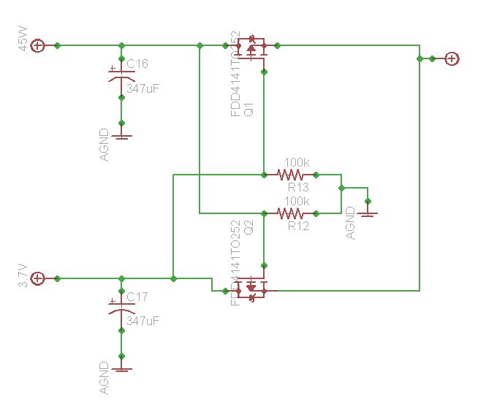

8.2.4 Headset Testing

In this field of testing the quality of sound will be observed and measured. Close observation must be made to see what conditions will the device maintain its highest capacity of clarity. Testing locations will include busy city streets, small neighborhoods, on campus at a university, within public facilities (such as the library and gym), and at a residential house.

Sound levels will then be observed, determined, and noted to maximize quality for each given location. That information will be important to relate to users who may find themselves encountering such circumstances.

For quieter locations, noise control will be observed. It is a moral responsibility that SenseWalk 2.0 does not bother or disturb others within the area. As a result, a reasonable volume level will be determined to be set to when users are in quieter public locations.

Voice reception from the user to the microphone will also be measured. It is crucial that SenseWalk 2.0 will be able to receive commands at any given location. If the user is lost in a busy city street, it would be disheartening that they would not be able to find the correct location to head towards, solely because the device was unable to filter out their commands.

At the same time, the device should be able to pick up every form of dialect and voice tone. Whether the person is soft spoken or speaks harsh, has a foreign accent or any other form of an American accent, the device should be able to easily pick up and make out what the user says and translate that information correctly to the device.

8.2.6 Battery Testing

We emulated the power subsystem using the Multisim software.

Test Case 1: Input Voltage V1 at 3.3V
Figure 8.2.6.1: Battery to Bluetooth and Laser DC-DC Converter
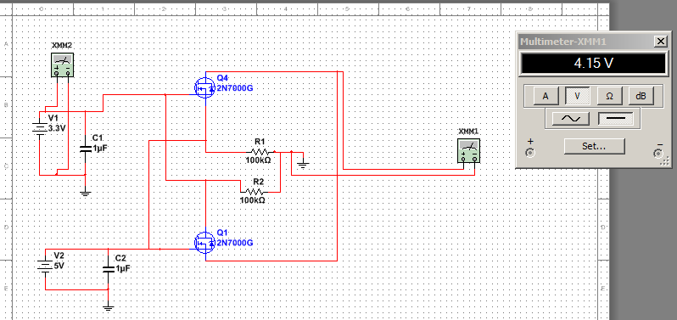
Test Case 2: Input Voltage V1 at 12V
Figure 8.2.6.2 Battery to Bluetooth and Laser DC-DC Converter
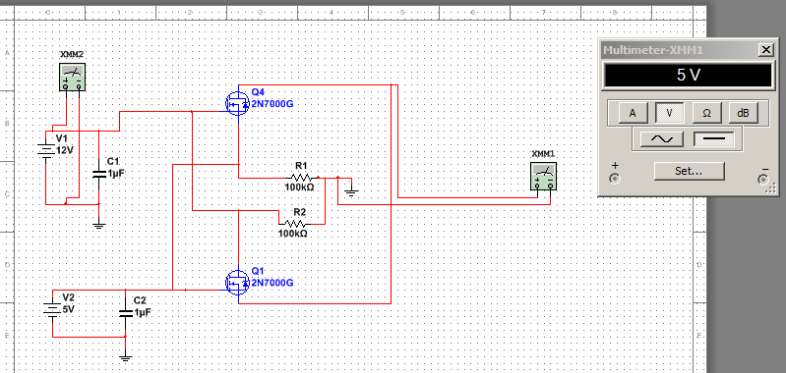
Test Case 3: Input Voltage V1 at 0V
Figure 8.2.6.3: Battery to Bluetooth and Laser DC-DC Converter
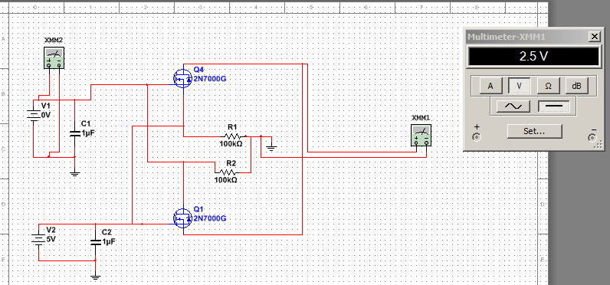
Test Case 1: Input Voltage V2 at 0V
Figure 8.2.6.4: Battery to Bluetooth and Laser DC-DC Converter
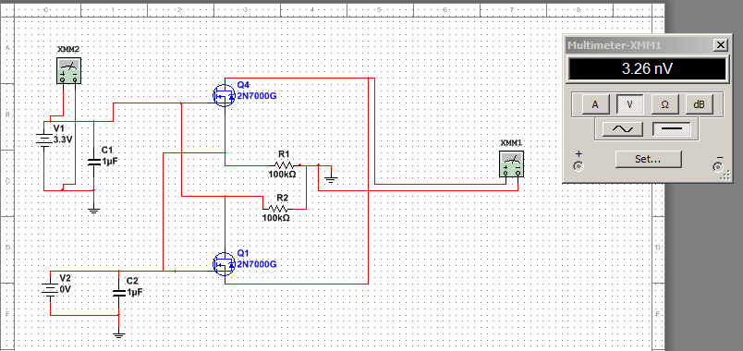
8.3 Software Specific Testing

8.3.1 GPS Testing

During this stage a software MiniGPS will use, it a great utility for configuring the GPS some of the task that this software allows are turning off and on the GPS, change frequency and baud rate. This will make the configuration a lot easier also a library called TinyGPS++ will be use in order to integrate data from the GPS into the project designed to provide most of the NMEA GPS functionality such as position, date, time, altitude, speed and course, without the large size that seems to accompany similar bodies of code. To keep resource consumption low, the library avoids any mandatory floating point dependency and ignores all but a few key GPS fields

8.3.2 Bluetooth Testing

In this field of testing, the ability of the device to pair with another will be determined. The device should be able to connect to any other Bluetooth enabled device and maintain that connection while the device remains active. The figure below illustrates how a Bluetooth connection between the chips in the device is established.

Figure 8.3.2.1 Bluetooth Device Pairing Illustration
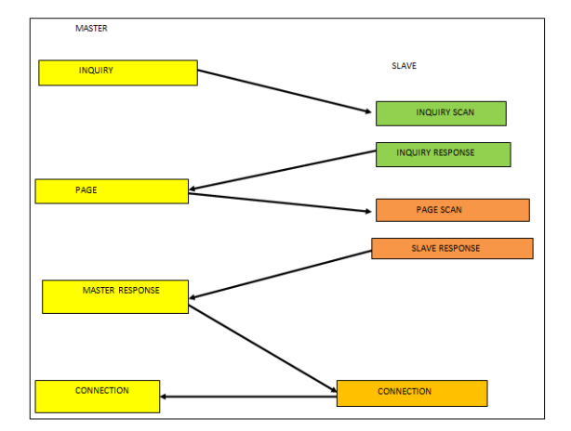

Additionally, the master-slave functionality will be examined. The microphone, as a master device, should be able to successfully receive voice commands from the user and transmit those commands into data for the MCU, which in this particular step will be a slave device.

That information must then be correctly received and interpreted by the MCU. The MCU, now in this case as a master device, should be able to successfully transmit and relay the information to the headphone. The headphone, as a slave device, should be able to successfully receive data and transmit audio to the user’s ears based on the type of data being relayed.

Figure 8.3.2.2: SenseWalk 2.Master-Slave Diagram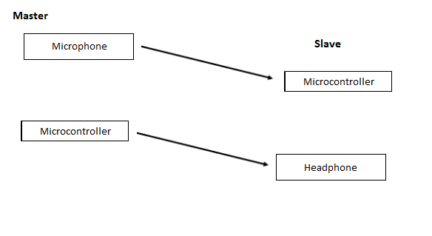

8.3.3 Voice Recognition Testing

In this field of testing code will be written to pick up words being spoken by the user and will be processed as commands to the device. For example, when the user says, “Start Route 1,” the microphone will translate that command to the device and the device will then commence giving directions through the user’s headphone.

In more detail, a phrase, the word “test” will be created and stored into the grammar (voice command) library. An event handler will then be created to initiate the testing. Once the speech is recognized the _recognizer_SpeechRecognized method will be invoked and will output the phrase, “The test was successful," through the speak method created.

8.3.4 Laser Testing

During this stage the laser sensor will be tested by writing a small initialization code in order to check that it’s properly configured to the microcontroller. Several reading will be taken to ensure the laser is working properly. The reading will be at several different distances, the SF10 outputs 32 readings per second. If all is correctly configured, the laser will be ready to be implement with the other devices to work together in an efficient way.

8.4 Software Test Environment

Software will be tested on the latest version of both Windows and Linux Operating Systems. The specific compiler and IDE utilized will be STM32CubeMX, the software recommended from STMIcroelectroincs to use on the dev board for the selected MCU for SenseWalk 2.0 and Eclipse Mars.1 (4.5.1). STM32CubeMX will be used to help identify which pins will be used on the board and will handle the initialization of the code and variables needed to make the board perform specific functions and tasks.

While, Eclipse Mars 1 will be used to manipulate the code and write each task specifically and then producing a bin file to deposit into the board once it is completed and built. The core programming for the device will be constructed here.

8.5 Miscellaneous Testing

One form of testing that will be measured will be the physical durability of users who utilize the device. The goal for a smaller size variant of a smart can was to minimize the amount of stress or strain on the user's forearm produce from long usage of the cane. The expected result is that the user can utilize the device for a long period of time (maybe 2-3 hours at a time) without becoming sore or having muscle fatigue from holding the cane upright.

8.5.1 Distance Test

In this field of testing the SF10 will be use to check its accuracy, several objects will be put in front of the laser to simulate obstacles at different distances. The measurements should be accurate since this laser uses a time-of-flight system meaning that it is not affected by the speed, wind, change in barometric pressure, noise, ambient, light, air or temperature, this test is very important since the laser may be defective or broken so it's better for the project to test it at an early stage where we could replace than a later time where it could be too late to replace it and affecting the entire project.

8.5.2 Miscellaneous Troubleshooting

Problems can arise with SD cards, quite often they can have an issue where they fail to initialize when being connected to and accessed for the first time. To overcome this issue, it is recommended for the user to turn off and on the power to the device. This should eventually lead to proper initialization. If this continues to fail, try removing the SD card from the console and putting it back in place.

The issue may be that the SD card was not properly inserted. If the SD card still continues to have issue initializing, the problem may be that the incorrect file type was loaded onto the card. To resolve this, remove the card and check which files are on it by loading the card to a computer. When problems arise the microcontroller cannot process because it is not receiving the data.

9.0 Administrative Content

The SenseWalk 2.0 is a Senior Design project that is being 90% funded from the companies Boeing and Leidos. The remaining 10% of the funds is self-funded by the members of our group. Some features that are being implemented are very expensive; therefore it is important to be very careful when dealing with each component, so that replacing any of the pieces will be avoided.

Table 9.0.1: Bill of Material
Parts | Description | Quantity | Cost
GPS Module | LS20031 (66 Channel) | 1 | $45.00
MCU | STMicro - STM32F746ZG | 1 | $9.47
MCU Dev Board | STMicro - STM32F746G-DISCO | 3 | $150.00
Solar Cell | Solar Cell Small - 0.45W | 1 | $16.00
Battery | Polymer Lithium Ion | 1 | $13.00
Bluetooth | TI CC2564B Bluetooth Chip | 1 | $6.00
Headphone/Microphone | Digital Care Bluetooth Wireless Headphone | 1 | $65.00
Laser | SF10-A Laser Ranger Finder | 1 | $350.00
Professional Soldering Cost | Miscellaneous Parts | 1 | $100.00
Miscellaneous Parts | Professional Soldering Cost | 1 | $100.00
Cane | Cane | 1 | $20.00
PCB Boards | PCB Boards | 3 | $90.00
Total |  |  | $964.47

9.1 Timeline

This section details the Timeline for SenseWalk 2.0. Organization is a necessary factor that is often times underutilized in many design projects. This often leads to a lack of progress and can be a huge hindrance toward making a project come into frustration.

This task consists of how to budget the project, meeting significant milestones, and outlining what tasks need to be completed within these milestones. Here the group introduces a budget, financing plan and the intensive scheduling for Senior Design 1 and Senior Design 2. Project milestones and timelines are proposed in order to keep a structured pace in development and design progress. In order to have a successful Senior Design Project, it is necessary to manage time very carefully, the following table (Table 12) shows how planning was made to organize the group schedule for Senior Design 1.

A really important fact is that the team only had a little bit more than 3 months in order to plan the whole project, this means that keeping in track is extremely important in order to success in this project otherwise a failure is inevitable. The group have really clear the fact that this is a group project and if only one member falls behind on their job, it will completely affect the others members which is what we are trying to avoid by this timeline.

Table 9.1.1: Timeline
Date | Task Description
September 1th | Research on which microcontroller would be best for the project.
September 15th | Research on GPS receiver, Bluetooth,  laser and speaker to implement in device
September 17th | Research of battery pack and solar panel based on requirements.
October 20th | Getting started on learning to use the microcontroller/ install all software needed.
October 29th | GPS and Bluetooth and speaker testing
November 5th | GPS and Bluetooth start programming into microcontroller.
November 19th | Laser testing
December 3th | Laser programming
December 11th | Turn in Final copy of Research Paper

9.2 Milestone Discussion

Milestones in group projects is what either makes or breaks a team. There is no way to avoid them, so in order to deal with them, a group must learn to adjust and overcome. Milestones have a negative connotation to them. However, there is a positive side when dealing with them.

Milestones help distribute the work towards the project a little more evenly for each individual in the group. To put an entire project in one person’s hand would be overwhelming for the individual. To break that same project down into smaller parts divided evenly among the group members allows that project to be completed at a more reasonable time and fashion.

Also, breaking down the work allows for development of each individual within that group. Everyone is learning and gaining experience. Which, in terms of the future of the students taking senior design, will boost the resume of the students, making them a little more marketable than they were prior to working on the project.

By strategically establishing the milestones of the project based off of a sound understanding of the task at hand, by carefully evaluating the strengths and weaknesses of each member of the group, and by constructing a thoroughly designed strategy, the group can confidently expect that the project will be completed on time. Here is a sample of our group’s milestones:

Table 9.2.1: Outline of Milestones for SenseWalk 2.0
Project Milestones
28 August - Define project and seek advisor’s approval
30 August - Create a block diagram and establish design parts
15 September - Write Initial Document on project
18 September - Make final selection on specific parts to be purchased
12 November - Complete over half of the Research Paper
01 December - Initiate coding phase
11 December - Turn in final copy of Research Paper
01 February - Begin Testing Phase
01 May - Finalize Presentation
01 May - Finalize Paper for submission

Our first milestone was to determine and define what our project is. In order to complete that objective a group meeting occurred where the group brainstormed on ideas of what would be both innovative and would make a positive contribution to society. At the same time, whatever idea that was selected would have to be practical and fit within the time frame allotted and within a reasonable spending range for typical college students.

A one to two hour discussion was held and the idea went from a vibrating bracelet, to a visually impaired smart glasses, to the SenseWalk 2.0, a smartcane device for the visually impaired. Once the idea was establish, the next step was to make sure that the idea got approved by the Senior Design advisor. If the idea got approved, the next milestone would be approached. If it did not get approve, another group meeting would be held and a new idea would be formulated.

The next milestone would then be to allocate responsibilities to each member of the group. The most efficient way to do this would be to first determine the strength and weaknesses of each member of the group. Each member would be assigned a task based off of the strength of their capability to complete each task. If their ability to complete a task was strong due to prior experience, they were given that task. If none of the members have had no prior experience to a specific task, it was given to the person who had the strongest feeling that they could complete it or who would have the least difficulty to learn about the intricacies of that specific task.

The following milestone would be to determine what parts were needed for the completion of our design. It was important to keep in mind that each component for a particular function in the device needed to be compatible with each other and do so efficiently. Size was a major factor within our design too, so on top of compatibility each component had to be of a reasonable size to meet our goal of keeping the design small, to avoid having a heavy device.

Another milestone, one which may be the most difficult, not due to the level of work, but due to the work load and getting everyone to be and remain efficient in completing, is the completing the research paper. Each member of the group is required to write at least 30 pages worth of experience and research of the project. 30 pages over the span of three to four months doesn’t seem like much because there is a large amount of time to work on it.

But, the common issue that arises, especially for your typical college student is that the work is usually pushed back until the last minute. In order to avoid falling into that situation, a milestone was created throughout the semester to have a certain number of pages written by a certain time frame.

The goal was to reduce the load of the work, so that the assignment could be completed more efficiently. Every time the group met, the pages written were reviewed and were carefully analyzed in terms of what was acceptable and what necessary to be inputted or removed. A new quota of number of pages were then determined at the conclusion of the meetings of what each person had to have had written by the time of the next meeting. The final due date of the assignment is on December 10, 2015. However, the goal is to have over half of the assignment completed and ready for submission the Tuesday before on November 12.

9.3 Budget and Finance Discussion

SenseWalk 2.0 was partially funded by the members of the group: Ross Applegate, Chad Borgelin, Benoit Drummer, and Diego Merida. It was also partially funded by Boeing. Purchases were made prior to receiving funding from Boeing, so our initial purchases were chosen very carefully. It was uncertain of whether or not this project would get funded and none of the members wanted and at that point in time did have sufficient funds to make any large purchases needed for the device.

The group agreed to buy smaller parts first while waiting to see if this project would receive funding. Once funding was confirmed, the group allowed to then make the bigger purchases needed for the device. The estimated cost for all the parts and supplies is about $1000. This number is rounded up for any additional marginal cost that may arise through the building process of the device.

Keep in mind that once all parts have been purchased and the assembly phase of the project has begun, there may be additional purchase made depending on if a device becomes damaged or become unusable. The group will make a careful effort to keep each device in a healthy shape as possible. However, situations may arise that may be outside of our control which may affect the wellbeing of a device.

The group members are mentally and financially prepared for any situation which may arise, as it is the group’s responsibility to ensure that the project is completed and functioning properly and safely. With a greater motivation coming from the fact that the group’s grade is dependent on the project’s success.

9.4 Roles and Responsibilities

Generally speaking, it is the responsibility of every member of the group to ensure that the project gets completed and completed on time. Specifically, each member chose or was given a subtask to complete for the overall project. It is essential that each member complete each given task, because many of the task are interrelated and the efficiency of the group’s progression throughout the semester depends on it.

This project is a collaborative effort, so even though each member has a specific set of tasks, they are not limited to only those tasks. Wherever one member can give aid to another member, it is encouraged that aid is given. For example, each member of the group is required to write 30 pages towards the project paper for Senior Design. In that paper sections are divided for each person. Group members have written in not only their own sections, but in sections of every other member in the group. The group philosophy (and reality of the project and course) is that if one member fails, the whole group fails.

Again, the overall responsibility of the group is to have SenseWalk 2.0 functioning correctly and ready for submission. Listed below are the specific subtask outlined for each member of the group:

Ross Applegate is responsible for the hardware aspect of the device. He is in charge of making sure that each hardware component does not exceed the amount of power of the battery and that each component uses power efficiently. He is responsible for designing a circuit that causes the device to switch between solar power to DC power. He is responsible for establishing a physical connection between each major component in the device to the battery. He is responsible for making sure that the battery supplies the correct amount of voltages that each component needs to have proper functionality.

Chad Borgelin is responsible for the Bluetooth and voice recognition aspect of the device. He is in charge of ensuring that SenseWalk 2.0 can connect to another Bluetooth device, specifically a Bluetooth headset, microphone, and laptop or computer. And is in charge of ensuring that the microphone can pick up and understand commands from the user and take those commands to perform a feature on the device (for example, making a route selection). On top of, ensuring that the device sends the proper response (an audio output) through the Bluetooth headphones to the user. Chad will be in charge of properly program the voice recognition module and give it proper commands so that the processor can understand the commands given by the user without any error.

Benoit Brummer is responsible for the low-level microcontroller development. This includes getting software programmed onto the development board, then into the microcontroller that is on our final prototype, as well as the typical “operating system” functions required by our project. These low level tasks range from developing a scheduling algorithm which ensures that all software written for this project can run concurrently without conflict, to helping the other team members with driver development to get the hardware they are responsible for up and running. Benoit will also work on the computer vision algorithms, getting as many functionalities out of the camera as possible given the limited time frame of this project. The computer vision software will be done by either porting OpenCV to our microcontroller, or developing computer vision algorithms from scratch.

Diego Merida is responsible for the laser and distance detection, as well as the GPS system. He will ensure that the GPS signal is clear and precise and will develop a means of processing directions for each of the stored routes on the device. He is also in charge of the laser detection. He is to compare devices for both the GPS and Laser and is to select the best option for the two components. Once the devices are selected he is responsible to make sure that the GPS is correctly configured, meaning that it has a working map, with pin points for each geographical point and directional or polar awareness from the compass. As for the laser, he is responsible for ensuring that it is on the most efficient setting for detecting objects and distances.

To encourage the group to uphold each member’s responsibility, an overall group value was established. Each member voted on what they thought were their top five core values. Everyone then looked at all twenty-five choices made by each member and gave each set of values a rating from one to five (one being the least valued and five being the greatest valued). The scores of all twenty-five values were then tallied.

The top five choices were selected as the group’s overall core values. Each member agreed to uphold these values to improve the dynamic of the work needed to be completed. The five core values chosen by the group are: communication, happiness, open-mindedness, growth, and risk taking (with the values list in order from greatest to least).

9.5 Research

Research is the most vital step toward the completion of a design. For any project idea, once the initial purpose of the project has been established, the engineer(s) must figure out which method would be most efficient in implementing the design. This occurred throughout the beginning of the project for establishing what the proximity detection, GPS, Bluetooth, and microcontroller subsystems must achieve.

For this specific project, it was easy to divide subsystems out of the main system which is represented as the whole SenseWalk 2.0 console operating with all of these sub-systems integrated together. There are many way to go about implementing the various sub-systems.

Therefore, it is up to the discretion of the engineer to find the method that proves most efficient and lives up to whatever constraints the project may hold. For this case, low-power and light-weight were constraints that had to be considered for all sub-systems research.

For example, the choice of microcontroller revolved around researching low-power microcontrollers that held the processing capabilities needed for operations. The choice of batteries was restricted to something that did not take up much weight and could be easily rechargeable with a long battery-life for the user.

For the proximity detection system, there are various ways that detecting the surroundings of a point can be done. Therefore, research into sonar, infrared and laser range were done to determine which solution would offer the most benefits to the project. Research was also done into existing Bluetooth and GPS modules that are currently on the market. It was also necessary to research how both modules could properly interface with the microcontroller chosen and transmit/receive their respective data for use.

Lastly, which software would be needed was a critical component for research as this project employs both electrical and computer engineering foundations. Software is used for the Bluetooth, GPS, and microcontroller subsystems. Determining which programs could be acquired and utilized for both Bluetooth and GPS had to be researched while understanding how to program the microcontroller to interface with its peripherals were objectives to be met.

Once research has been done for all sub-systems with an understanding of how to integrate all subsystems into a final, working system, final decisions are made on parts to acquire and order for the next stage. The integration phase occurs at the beginning of the second semester.

Once the specific parts have been selected, purchasing of the hardware, software, and modules can be done. With the parts acquired, the design can finally be built. This means that the power supply will be laid out on a printed circuit board along with all other necessary electrical hardware.

The microcontroller will be interfaced with the Laser, GPS and Bluetooth thus making the entire device which will then be attached to any standard white cane. During this time, all necessary software will be set up for their respective hardware components. Programming of the microcontroller and GPS will take place at this point as well. As each sub-system reaches completion of its construction for both hardware and software modules, they may then be integrated.

The end goal is to have a functional device that is ready for the next stage. Testing must be done at every sub-system level in addition to testing the overall system as a whole once every sub-system has been integrated. A detailed explanation of testing of the sub-systems with regards to both software and hardware components is discussed in all of section 7 of this paper.

Testing is scheduled to occur during the last quarter of the second semester. Testing the device to ensure that it has met all functional requirements of the design. This means that once the program has been written for the microcontroller, it will be uploaded to the microcontroller's flash memory for the microcontroller to access and implement.

The GPS map software will also be interfaced with the GPS module, allowing the module to access the software and configure routes as well as keeping track of the user's current position. As each level of integration occurs, it is important to ensure that all subsystems are compatible and interfacing correctly with their software and other peripherals.

As these subsystems are all developed, the final step is to integrate these subsystems into the complete system which is the whole console. This approach is called a bottom-up approach in which small portions of the subsystem make it up.

As a result, once they've been completed, another level is gone up until the entire system has been fully integrated and completed. The power supply (battery) basically powers every sub-system and the microcontroller serves as taking in inputs. Another step to undertake during the integration and implementation phase is for the group to select a panel of professors at the university that are willing to review the design. This panel will serve as advisers offering insight into the design, deeming it to be a good approach or not.

Once testing of a sub-system has been deemed successful, it can be considered that that sub-system has met its functional requirements. Individual test cases unique to the component that is being tested are set up for the component to undergo evaluation. Any issues that arise that fail to meet proper functioning will require an inspection of the sub-system to address the error. Once the error has been found and fixed, the test must be run again.

After the testing of every single component has been done, including the unit system in its entirety, the entire design implementation may be deemed successful, with the discretion of the panel included. The system must be able to perform by having all subsystems interface correctly with each other. This means that proper power was delivered correctly to all subsystems that need power to run. With a successful working system that has passed all testing, the project may now be prepared for demonstration during the project presentation.

Appendices

Appendix A - Copyright Permissions

Permission from lightware.com
Permission requested on 12/8/2015
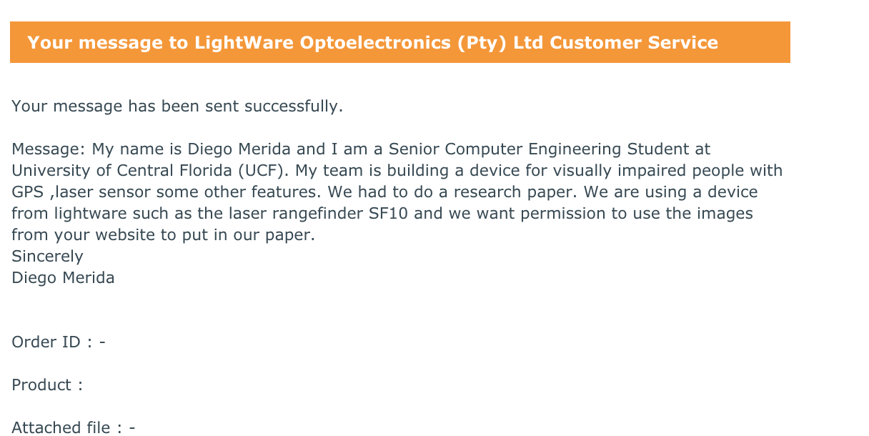
Permission Approved on 12/8/2015
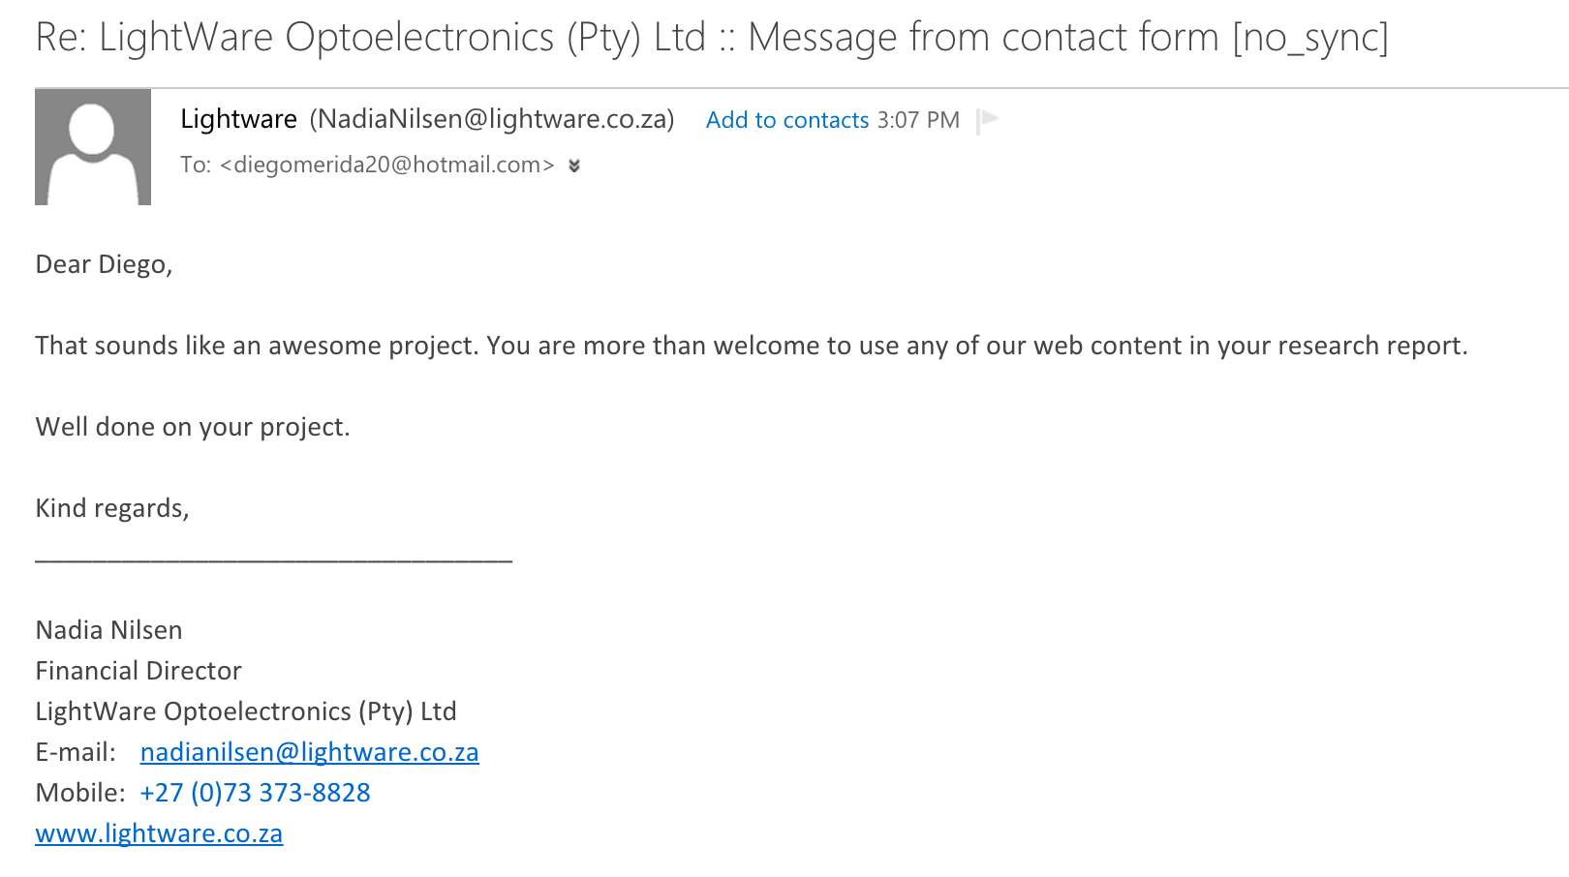

Permission from Sparkfun
Permission requested on 12/8/2015

Permission Approved on 12/8/2015
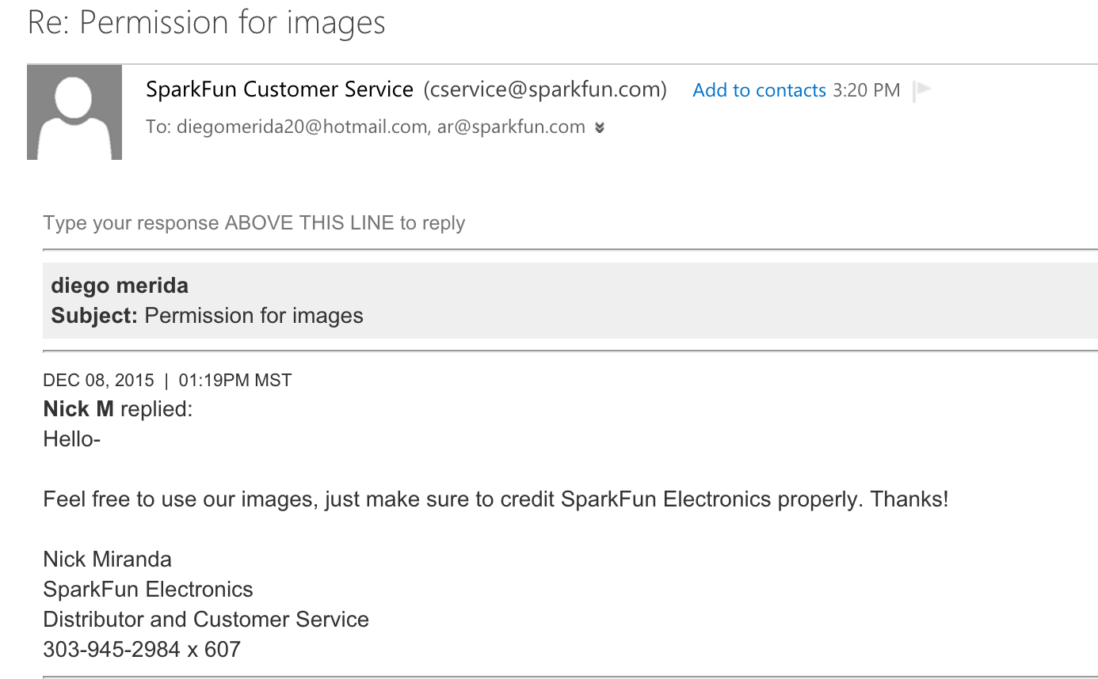
Permission Approved on 12/8/2015


Appendix B - Datasheets

The datasheets supplied by our vendors contain a vast amount of useful information. They are listed in the table below, and a digital link is provided under publication number when applicable.

Table App-B: List of datasheets used to design SenseWalk 2.0
Vendor | Part | Type | Title | Publication number
STMicroelectronics | STM32F746G-DISCO development board | User manual | Discovery kit for STM32F7 Series with STM32F746NG MCU | UM1907
 | STM32F746ZG microcontroller | Datasheet - production data | ARM-based Cortex-M7 32b MCU+FPU, 462DMIPS, up to 1MB Flash/320+16+4KB RAM, USB OTG HS/FS, ethernet, 18 TIMs, 3 ADCs, 25 com itf, cam & LCD | STM32F745xx STM32F746xx
 |  | Reference manual | STM32F75xxx and STM32F74xxx advanced ARM-based 32-bit MCUs | RM0385
 | ST-LINK/V2 debugger | User manual | ST-LINK/V2 in-circuit debigger/programmer for STM8 and STM32 | UM1075
 | STM32CubeMX software | User manual | STM32CubeMX for STM32 configuration and initialization C code generation | UM1718
 |  |  | Developing Applications on STM32Cube with RTOS | UM1722
 |  |  | Description of STM32F7xx HAL drivers | UM1905
Locosys | LS20031 GPS module | Datasheet | Datasheet of GPS smart antenna module, LS20030~3 | LS20030~3_datasheet_v1.3.pdf
Texas Instruments | CC256x Bluetooth controller | Datasheet | Bluetooth and Dual-Mode Controller | SWRS121D
OmniVision | OV9656 CMOS sensor | Advanced Information Preliminary Datasheet | OV9656 Color CMOS SXGA (1.3 MegaPixel) CameraChip Sensor with OmniPixel Technology | OV9655.pdf
Alliance Memory | AS4C4M16SA-6TIN RAM module | Datasheet | 64M - (4M x 16 bit) Synchronous DRAM (SDRAM) | AS4C4M16SA-C&I
Molex Incorporated | Micro SD Connector | Drawing | MICRO SD CONN. PUSH/PUSH & NORMAL SUPER-SMALL TYPE | EN-02JA(021)

Appendix C - Sources

"Differences between Analog and Digital Microphones." Apexis. N.p., n.d. Web. 09 Dec. 2015.
Lewis, Jerad. "Analog-to-Digital ESD Design Synthesis." Analog Circuits and Design ESD (2014): 89-100. Web. 08 Dec. 2015.
Mendez, Dave. "Analog Wireless Microphones vs. Digital Wireless." Shure. N.p., 21 Oct. 2014. Web. 08 Dec. 2015.
"MP33AB01HTR STMicroelectronics | Mouser." Mouser Electronics. N.p., n.d. Web. 08 Dec. 2015.
"Product Costs: Microphones." MEMS Cost Analysis From Laboratory to Industry (2014): 225-45. Jan. 2014. Web. 08 Dec. 2015.
ProgramFOX. "Speech Recognition, Speech to Text, Text to Speech, and Speech Synthesis in C#." - CodeProject. N.p., 8 Dec. 2015. Web. 9 Dec. 2015.
"SPU0414HR5H-SB Knowles | Mouser." Mouser Electronics. N.p., n.d. Web. 08 Dec. 2015.
"SPV0840LR5H-B Knowles | Mouser." Mouser Electronics. N.p., n.d. Web. 8 Dec. 2015.
"STMicroelectronics MEMs Audio Analog & Digital Sensor Microphones." MP3xABxx MEMS Audio Microphones. N.p., n.d. Web. 09 Dec. 2015.

