Title of My Very Interesting Senior Design Project (Title in 18-point Times font)
J. Clerk Maxwell, Michael Faraday, and André M. Ampère (List authors on this line using 12 point Times font – use a second line if necessary)

Dept. of Electrical Engineering and Computer Science, University of Central Florida, Orlando, Florida, 32816-2450 (12 point Times font)

Abstract — Use 9 point Times New Roman Bold font for the abstract. Set your line spacing to be 10 points rather than single space. Indent the first line by 0.125 inches and type the word "Abstract" in 9 point Times New Roman Bold Italic. This should be followed by two spaces, a long dash (option / shift / minus), two spaces, and then the first word of your abstract (as shown above). Please try to keep the length of your abstract to 100 words or less. Times font is an acceptable substitute for Times New Roman font. After the abstract, you should list a few key words from the IEEE approved “Index Terms” list that describe your paper. The index terms are used by automated IEEE search engines to quickly locate your paper. Typically, you should list about 5 to 7 key words, in alphabetical order, using 9 point Times New Roman Bold font. An example is shown next.

Index Terms — Ceramics, coaxial resonators, delay filters, delay-lines, power amplifiers.

I. Introduction
Please read through this entire template before you start using it to create your paper! This will save you and the RFIC considerable time, and improve your chances for acceptance. The following information is provided to help you prepare the Initial Submission as well as the Final Paper for submission to RFIC2005. (Many authors submit the same paper for the initial as well as the final submission. This is a common practice. See item #4 below.) A contributor should remember that:
1) Deadlines are absolute, don't even ask!
2) Papers may not exceed 8 pages, including all figures, tables, references, etc. Additionally, there is a size limit on the electronic version of all Summaries. In Adobe Portable Document Format (PDF), submissions may not exceed 1 Megabyte.
3) Acceptance rates have historically run at approx-imately 50%. There is not sufficient room within the Technical Program to accept all submissions.
4) Many submitters with previous experience realize that, if their submission is accepted, they will be required to submit a version of their Final Paper to be published in the Symposium Digest. As the Digest paper will be similar in length to the Summary, many contributors opt to prepare their Summary in the format required for the Digest. This template contains the instructions for the proper preparation of such a document.
5) Although not required, you are encouraged to employ this format. This document is being made available as a template for your convenience. If you elect not to use this template, please remember that you must still adhere to the general guidelines embodied in this document concerning, but not limited to, font size, margin size, page limits, file size, etc. (This template is equivalent to the IMS2003 template used last year, except that Index Terms have been added for 2004. You may use either template as a starting point, provided you include index terms in your paper.)

II. Overview of the Digest Format
We are requesting that you follow these guidelines as closely as possible so that the Digest has a professional look and resembles the MTT Transactions. All paragraphs of text, including the abstract, figure captions, and refer-ences, should be justified at the left and the right edges.
For the Title use 18-point Times (Roman) font. Its paragraph description should be set so that the line spacing is single with 6-point spacing before and 6-point spacing after (Format --> Paragraph --> Indents and Spacing). The font description for the Author List and Authors' Affiliation(s) should be 12-point Times. The paragraph descriptions should be set so that the line spacing is single with 6-point spacings before and after. Use an additional line spacing of 12 points before the beginning of the double column section, as shown above.

III. Detailed Text Formatting
Using 8.5 x 11-inch paper, the top and bottom margins are 1.125 inches, and the left and right margins are
0.85 inches. Except for Title, Authors and Affiliations, use a double column format. The column width is 3.275 inches and the column spacing is 0.25 inch.
Each major section begins with a Heading in 10 point Times font centered within the column and numbered using Roman numerals (except for Acknowledgement and References), followed by a period, a single space,
and the title using an initial capital letter for each word. The remaining letters are in small capitals. The paragraph description of the section heading line should be set for 18 points before, 6 points after, and the line spacing should be set to exactly 12 points.
For the body of your paper, use 10-point Times font and set your line spacing at "exactly 12 points" with 0 points before and after. Indent each paragraph by 0.125 inches.
Further details are provided in the remainder of this paper for specific situations.
A. Major Subsections
TABLE I
Summary of Typographical Settings
 | Font Specifics |  |  | Paragraph Description
Section | (Times Roman unless specified) |  |  | spacing (in points) |  |  | alignment | indent
 | style | size | special | line | before | after |  | (in inches)
Title | plain | 18 | none | single | 6 | 6 | centered | none
Author List | plain | 12 | none | single | 6 | 6 | centered | none
Affiliations | plain | 12 | none | single | 6 | 6 | centered | none
Abstract | bold | 9 | none | exactly 10 | 0 | 0 | justified | 0.125 1st line
Index Terms | bold | 9 | none | exactly 10 | 0 | 0 | justified | 0.125 1st line
Headings | plain | 10 | small caps | exactly 12 | 18 | 6 | centered | none
Subheadings | italic | 10 | none | exactly 12 | 6 | 6 | left | none
Body Paragraphs | plain | 10 | none | exactly 12 | 0 | 0 | justified | 0.125 1st line
Equations | Symbol font for special characters |  |  | single | 6 | 6 | centered | none
Figures | 6 to 9 point sans serif (Helvetica) |  |  | single | 0 | 0 | centered | none
Figure Captions | plain | 9 | none | 10 | 0 | 0 | justified | none, tab at 0.5
References | plain | 9 | none | 10 | 0 | 0 | justified | 0.25 hanging

As shown, denote subsections with left justified 10-point Times Italic. Order them with capitalized alphabetic characters (A, B,...). Follow the letter designation with a period, a single space, and then the subsection title capitalizing the first letter of each word. The paragraph description of the subsection heading is set to "exactly
12-point" line spacing with 6 points before and after.
B. Equations
Equations should be centered in the column and numbered sequentially. Place the equation number to the right of the equation within a parenthesis, with right justification within its column. An example would be
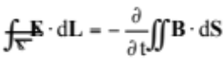 (1)
or
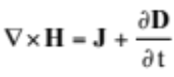. (2)

Note that a period is used to properly punctuate the previous sentence. It is placed at the end of the second equation. Make sure that any subscripts in your equations are legible and are not too small to read! When referring to an equation, use the number within parenthesis. For example, you would usually refer to the second equation as (2) rather than equation (2). If possible, use the Symbol font for all special characters, or better yet, use Equation Editor™ or MathType™. The paragraph description of the line containing the equation should be set for 6 points before and 6 points after. The paragraph spacing will need to be set to "single" rather than "exactly 12 point" so that the height will autoscale to fit the equation.

IV. Figures
Figures should utilize as much of the column width as possible in order to maximize legibility. Use a sans serif font, such as Helvetica or Arial. Helvetica and Arial are larger and much easier to read than Times. Using 6- to
9-point Helvetica usually results in a legible figure. Do not use any font smaller than 6-point! It must be legible. When referring to a figure, use the abbreviation Fig. followed by its number. Place figure captions directly below each figure. Use 9-point Times with the paragraph spacing set at "exactly 10 points". Set a tab at 0.5 inch. Type "Fig. #." (# is the numeral) then tab over to the
0.5 inch mark before beginning the text of the figure caption. Note that figure captions are always (left and right) justified, rather than centered, even if they are less than a single full line in length. See the captions for Fig. 1 and Fig. 2.
Within Microsoft Word there are several options for placing figures within your paper. Often the easiest is to insert them between existing paragraphs allowing the figures to remain in that relative position. The paragraph description where the figure is inserted must be set to "single" spacing rather than "exactly 12 points" in order to allow the line to autoscale in height to display the entire figure. Some disadvantages of this approach are that you don't have total flexibility in placing figures, and that the figures will move as text is inserted or deleted in any part of the document before the figure. If you elect to use this approach, it is recommended that you nearly complete the editing of your text before inserting any figures. Remember to allow room for them, however. Then begin inserting figures starting from the beginning of your document. Do not lump all figures at the end of the paper!
If you have difficulties with the titles on your figures, you can always elect to add in the titles as separate text boxes, rather than importing the titles with the graph. This is sometimes helpful in getting a lengthy vertically-oriented title to display correctly.
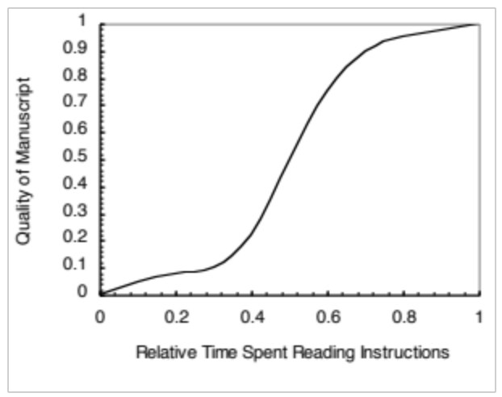
Example of 8 point Helvetica
Example of 6 point Helvetica

Fig. 1. Estimated relationship between the time an author spends reading these instructions and the quality of the author's digest article.

Notice that prior to the graph, a single 12-point line is used to separate the preceding text from the graph. The equivalent of a blank line should exist between the bottom of the graph (the x-axis caption) and the figure caption. (In this particular case, there was no need to add a blank line between the x-axis label and the figure caption, because there was already adequate spacing provided by the image border.) After the figure caption, there should be a single 12-point blank line before the text resumes.
More flexibility is obtained in inserting figures if you can place them exactly where you would like them to be on a page. This can be accomplished by inserting the figure, selecting the figure, and then choosing "Format Picture...". Various settings allow you to place the figure at an absolute position on a page; specify if the text is supposed to flow around the figure or if the figure should move with the text, etc. If you elect to let the text flow around the figure, then remember that you will have to insert a separate text box for the caption, otherwise the figure caption is likely to become separated from the figure.
When importing a graph from Excel into Word, it is often helpful to special-paste it in as a “Picture (Enhanced Meta-file)”. This saves file memory for Word documents. Be aware that the usual Copy --> Paste procedure will copy the entire Excel spreadsheet into your Word file. The Copy --> Paste Special --> Picture (Enhanced Metafile) command copies only the graph as a static picture.
If you decide to use color traces in your graphical data, be absolutely certain that there is no ambiguity about your graphical information when printed on a B&W printer.
Here is a common example of what can go wrong with the numbering and sizing of axis titles on a graph. In this case, the graph was initially pasted at a much larger size than the column width, and then reduced to fit:

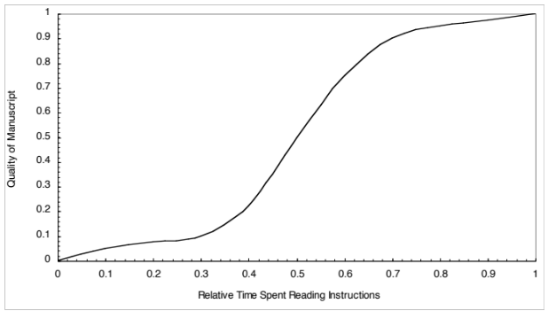
Fig. 2. Example of an improperly titled figure. The numerics and the labels on the axes are illegible. This will cause a submission to be rejected. Don’t let this happen to you!
Don’t let this happen to your graphs!

Table I on the second page was inserted using "Insert", "Text Box", creating the text contained in Table I, and then formatting the text box using all the settings available under "Format", "Text Box...". Table I also serves as an illustration of one of the rare instances when the double column format requirement can be violated. Certain figures and tables will require the full-page width to display. It is usually best to place these figures and tables at the top or bottom, rather than in the middle of a page. Tables should be entered within a single column if this can be done cleanly, without the entry becoming too crowded.

V. Citing Previous Work
When referencing a journal article [1], a conference digest article [2] or a book [3], place the reference numbers within square brackets. To simultaneously cite these references [1]-[3] use the format just demonstrated. The reference list is the last section and references are listed in the order cited. Use 9 point Times. The paragraph description is set for a line spacing of exactly 10 points with 0 point spacing before and after. A 0.25 inch hanging indention should be specified.
Generally speaking, references should be very detailed. For journal articles, list all authors by initials and last name, the title of the paper in quotations (capitalizing only the first letter of the first word, unless it would be capitalized in a sentence, e.g., a proper noun), the journal name in italics, the volume number, the issue number, the page numbers, and the date. Use the examples provided [1]–[3] as a guide.
VI. File Submission Formats
Beginning in 2004, the IEEE has mandated that all published papers comply with certain IEEE conference standards for electronic searchability. Please note that a detailed checklist is available on the submission site to help guide authors through the task of converting their Word documents into PDFs. Going forward, this will ensure compatibility with the new search requirements for the IEEE Xplore database.
Therefore for RFIC2005, we ask all authors to convert their Word documents to Portable Document Format (PDF), prior to submission for verification purposes. A simple and specific guideline is posted on the submission site. This will also avoid some of the pitfalls associated with having the author submit a paper using Word, and then having an automated system convert it to PDF without a through check. As always, with a conversion to PDF, authors should very carefully check a printed copy. Some conversion problems that have been known to occur are:
- A full 4-page Word document may “spill over” onto a fifth page, upon being converted.
- A text box that overlays a graph in Word might disappear when converted to PDF. This depends on how the graph was pasted into the Word document (the text box may become covered by the graphic in the PDF).
- Arrows in a drawing may become slightly discon-nected from their stems, and/or shifted in position.
- Check all special symbols and equations, especially right-hand brackets.
- Don’t expect the two bottom lines of a double column to line-up exactly with each other.
Authors should perform a careful check to catch minor nuisances and resolve any problems encountered.
To ensure compatibility with the new search requirements for the IEEE Xplore database and maintain the quality of the published work, we require you to submit your final manuscript electronically in two formats: 1) pdf file, and 2) the source file. The accepted source file formats are: MS Word, TeX DVI format, Adobe Framemaker interchange format or RTF format,and (La)TEX. All source files must be contained in a single file such as a single MS Word (.doc), rich text (.rtf) or Framemaker (.fm) file. For (La)TeX source files, create a single ZIP-file which contains the DVI-file and the corresponding EPS-files for the graphics. Name the ZIP-file "xxxx_dvi.zip", where the "xxxx" part of the name is whatever you wish.
VII. Conclusion
Although reading these instructions may have been an unpleasant experience, following them will improve the quality of your paper and the RFIC Digest. Table I summarizes much of the detail provided and illustrates one of the rare instances where the double column format can be violated. If you have comments, suggestions, or are willing to volunteer your time to improve these instructions, please contact one of the RFIC TPC Chairs.

Acknowledgement
The authors wish to acknowledge the assistance and support of the IMS Steering Committee.

References
[1] W. H. Cantrell, “Tuning analysis for the high-Q class-E power amplifier,” IEEE Trans. Microwave Theory & Tech., vol. 48, no. 12, pp. 2397-2402, December 2000.
[2] W. H. Cantrell, and W. A. Davis, “Amplitude modulator utilizing a high-Q class-E DC-DC converter,” 2003 IEEE MTT-S Int. Microwave Symp. Dig., vol. 3, pp. 1721-1724, June 2003.

