# Labwork 4. Servlet sessions, architecture.

**Prerequisites:**

* **Project should be configured with Java 8.**
* **Lab should be download as whole project. Project folder should be archived before upload to dl.**
* **Tomcat version 8.5~**
* **Tomcat EE version 7.1 or 8.0**
* **If project won’t run, automatically 0.**

Given and index.jsp:

<%@ **page** contentType="text/html;charset=UTF-8" language="java" %>  
<html>  
<head>  
 <title>Servlet Demo</title>  
</head>  
<body>  
  
<h1> Форма регистрации</h1>  
<form action="<%= request.getContextPath() %>/servlet1" method="post">  
 Имя: <input type="text" name="fname">  
 <br> <br>  
  
 Фамилия: <input type="text" name="lname">  
 <br> <br>  
  
 Группа: <input type="text" name="group">  
 <br> <br>  
  
 Почта: <input type="email" name="emailId">  
 <br>  
 <br>  
  
 <input type="submit" value="Отправить">  
</form>  
</body>  
</html>

* Create a first servlet which accept registration form and show it again to user.
* Create a second servlet which show all this information again. (Registration form should be submitted only for once, only for first servlet). In fact, you create first servlet, which accept submitted information from jsp page. Show registration information in first servlet. After this you should go to second servlet page by changing URL in browser, and you should see information from first servlet.

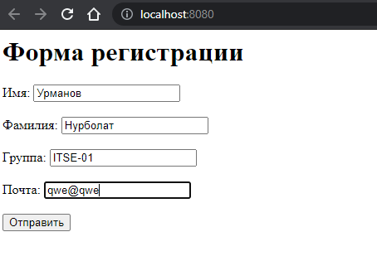

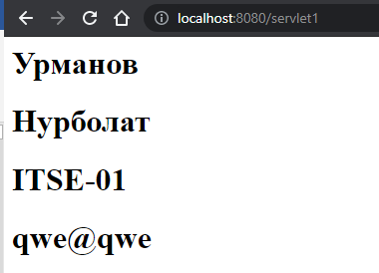

After this go to second servlet page by changing URL:

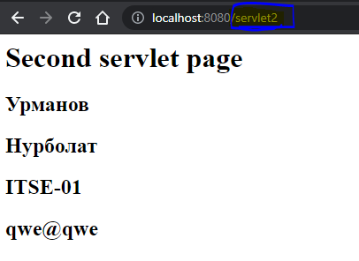

70-100% (DON’T USE LOGIC/CODE from internet)

* Use a Cookie.
* Write a full login and logout logic:
  + Register a user
  + Save all registered user info for a 15 minutes.
  + After registration, if user logout, user can login in 15 minutes, before registration info is valid.
  + If user login after 15 minute, system should redirect user to registration form
  + In session save encrypted information. In servlet, decrypt information. Encryption/Decryption algorithm is up to you.