Report

Sessions

Structure

Initially, the index page opens, in which the condition for the presence of cookies is first checked, if they are, then the user is already registered and he stays on this page and logs in, if not, then this is a new user and he is transferred to the registration page.

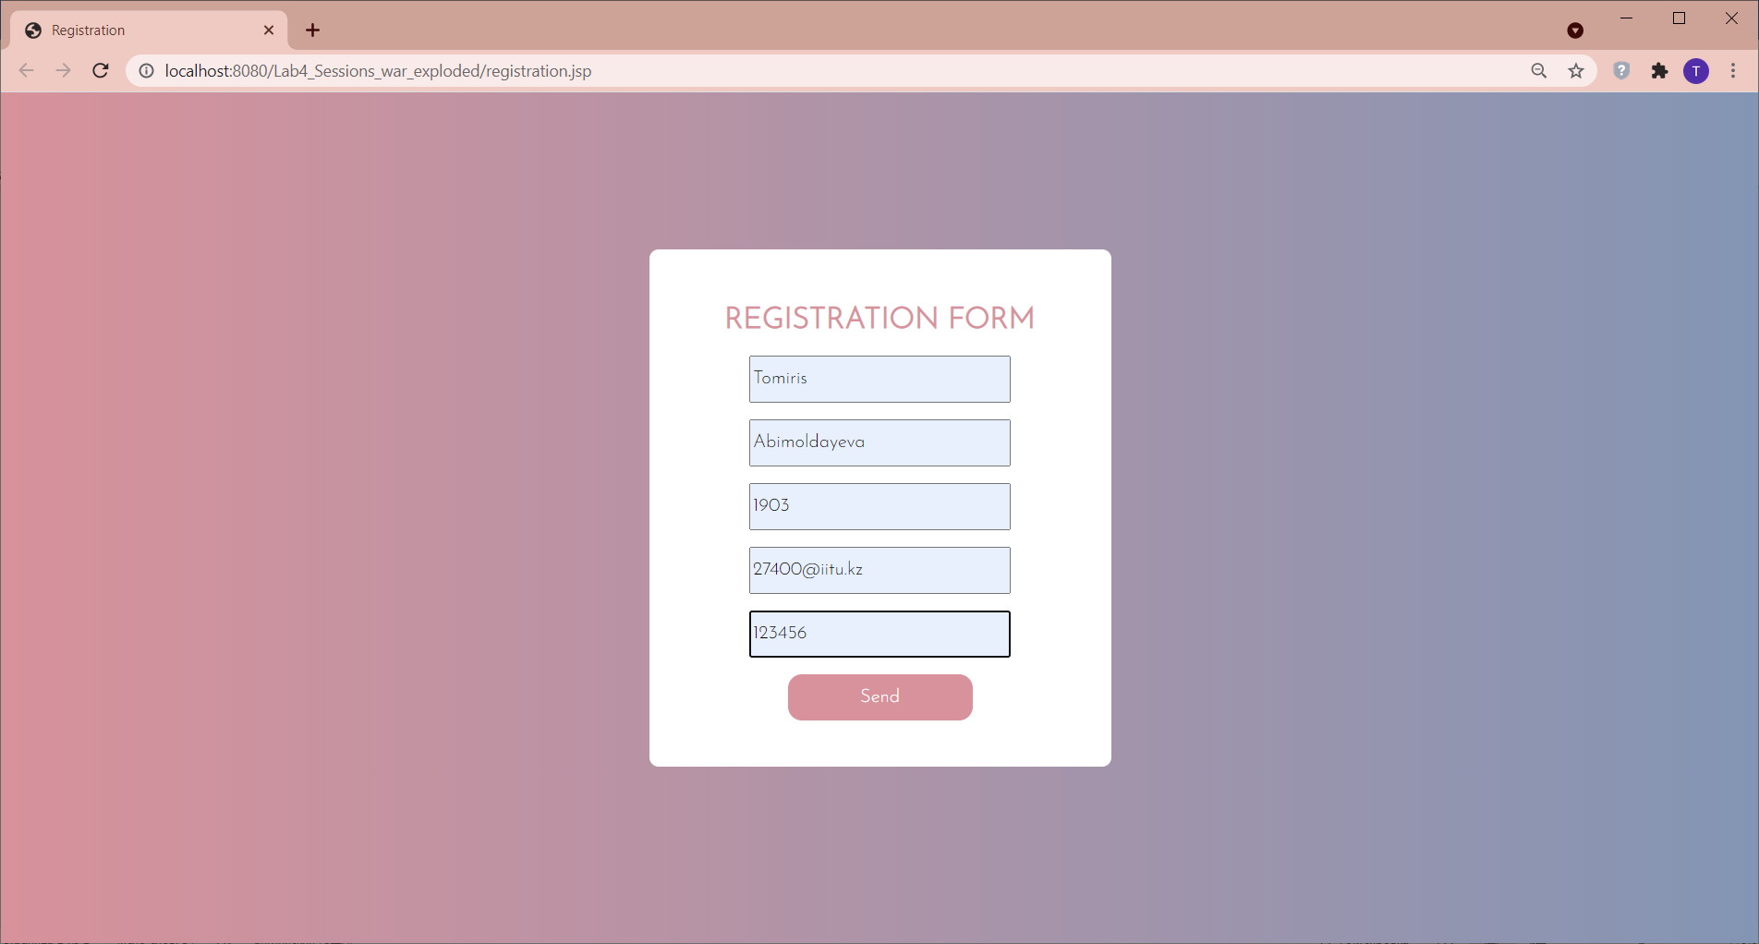

The submitted data is received in the registration servlet, where it is encrypted (by using TripleDes algorithm) in the method doPost() and a new object of the User class is created.

Then, in the method doGet(), we create a session and cookies. The cookie stores an encrypted username and password. And in the session, all user data. And then the user is transferred to the Profile page

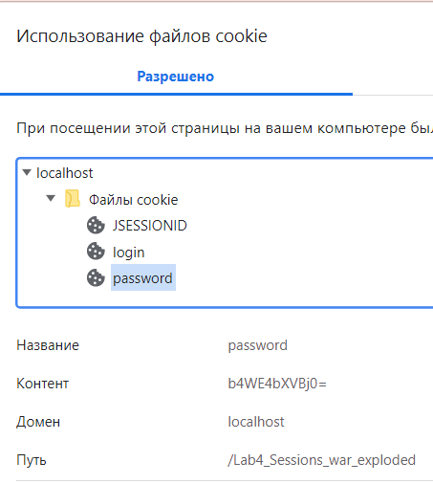

In this page, we decrypt data from the session and display

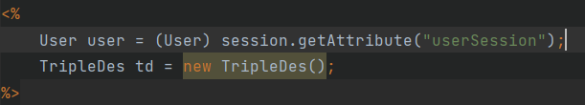

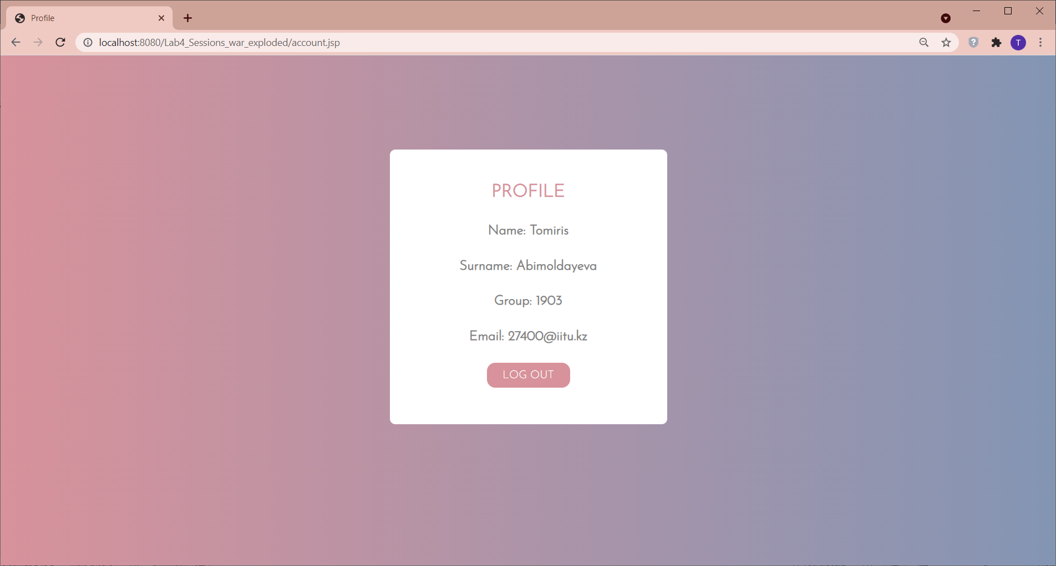

After clicking on the log out button, the Logout servlet redirects to the index page, where, if there is a cookie, it is allowed to log into the index page, where, if there are cookies, it is allowed to log in.

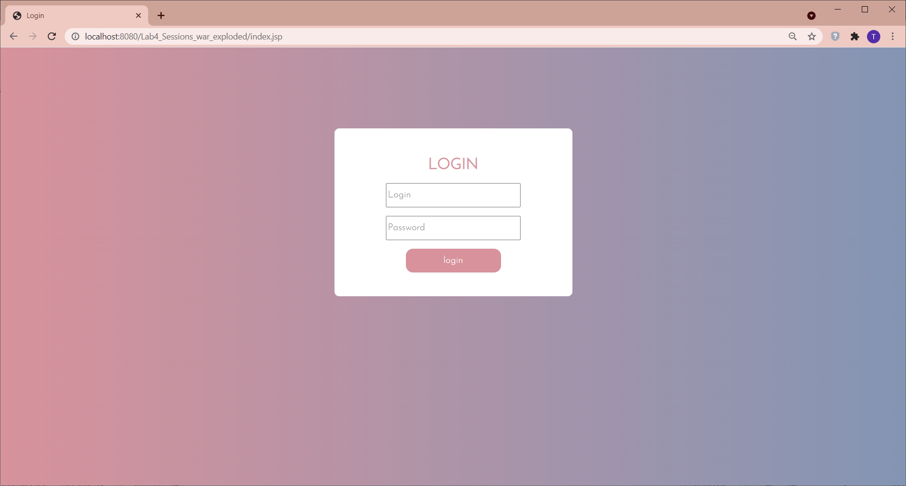

After entering the data, two conditions are checked.

If entered login and password are correct and there is the same cookie you will redirected to profile, otherwise to index.jsp page.