Assignment #5 k NN by Joshua Troup

1. How would the new customer be classified?

This customer will not accept the loan offer based on the score displayed below:

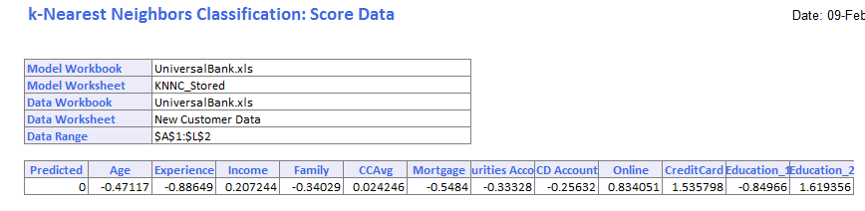

1. What is the best k chosen? What does it mean?

K=1 is the best with a training error of 0 and validation error of 4.64.

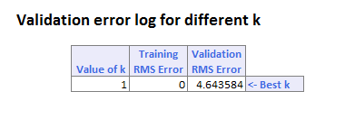

Predict the MEDV for a new data (use worksheet NewData) using the best k.

The predicted MEDV is 24.7 based on the score shown below.

