Chapter 2 Practice Tasks by Joshua Troup

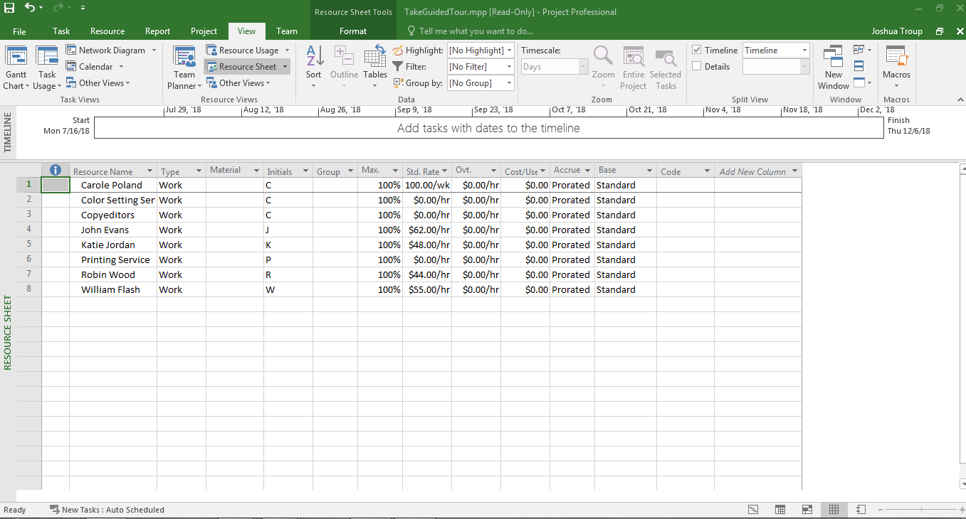

RESOURCE SHEET VIEW

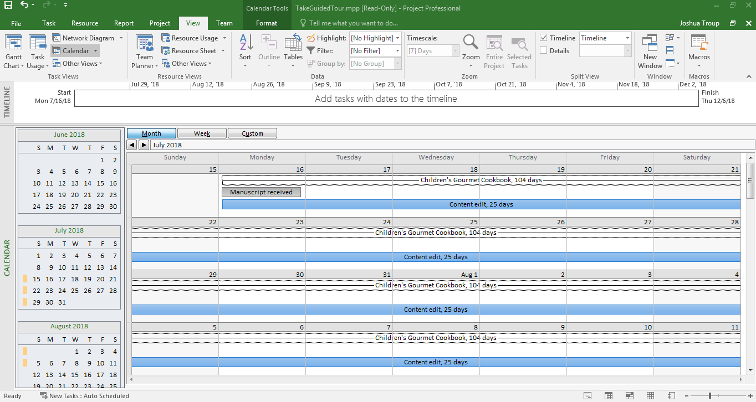

CALENDAR VIEW

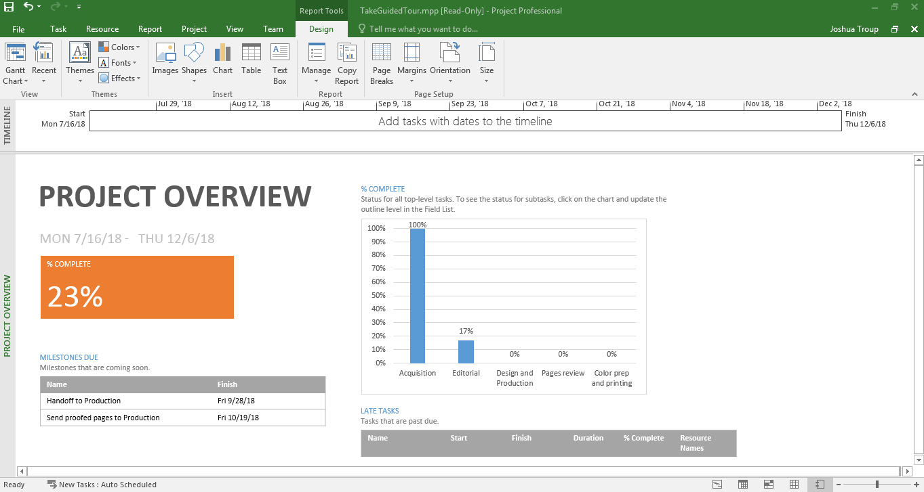

PROJECT OVERVIEW

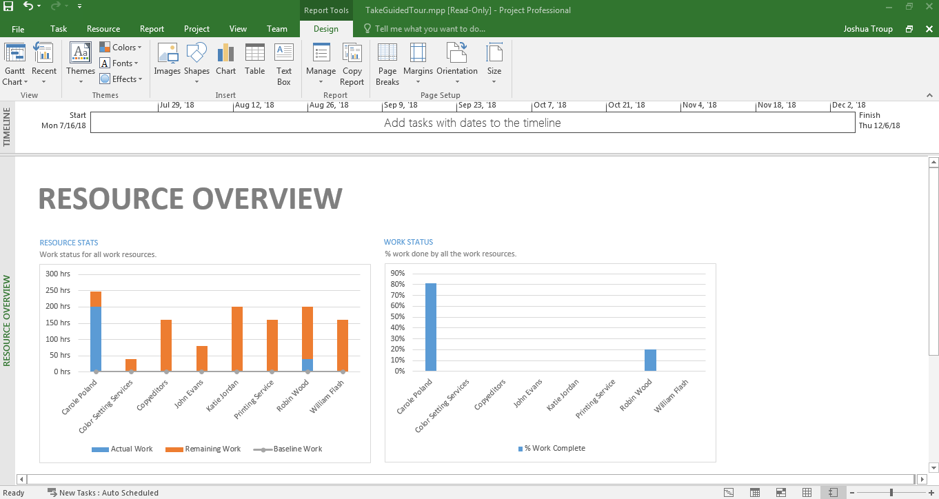

RESOURCE OVERVIEW