Chapter 4 Practice Tasks Screenshots by Joshua Troup



In the Timeline view, noting the plan’s current start and finish dates



Finding the plan’s finish date in the Project Information dialog box

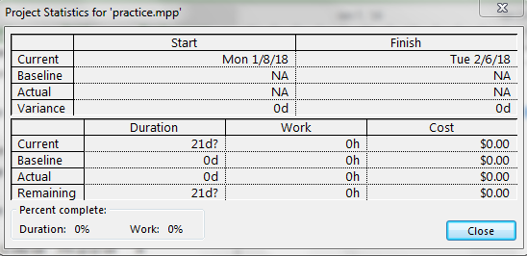

Looking at the duration information in more detail in the Project Statistics dialog box

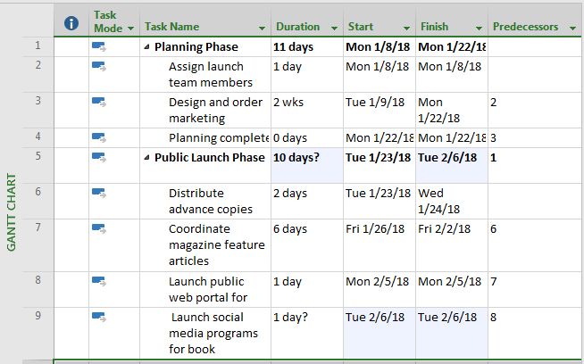

Displaying the project summary task in the Gantt Chart view

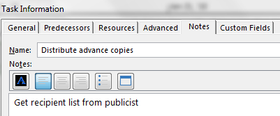

Pointing to the note icon for task 6. The note appears in a ScreenTip

NOTE: I was unable to display the ScreenTip with the snipping tool. My prt sc button does not take snapshots of the screen.