Ch.5 SimpleSetUpResources Screenshots by Joshua Troup

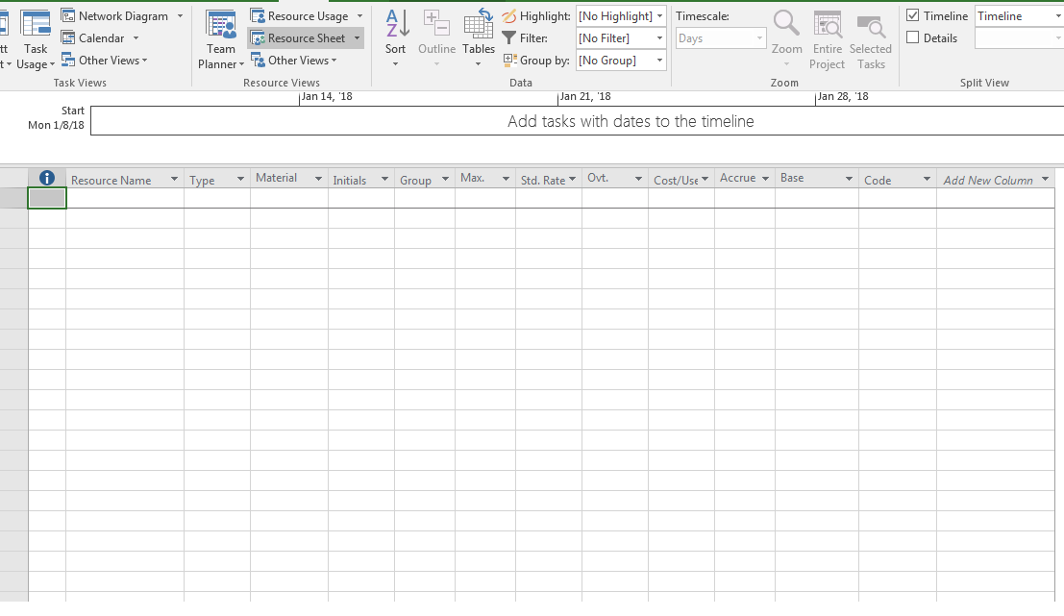

On the View tab, in the Resource Views group, clicking Resource Sheet