CH. 6 All Files Screenshots by Joshua Troup

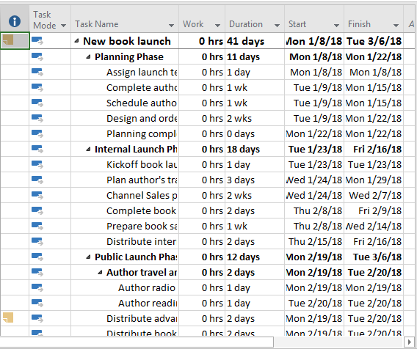

Using Task Usage view with Summary table visible to check the plan’s initial values – provide a screen shot

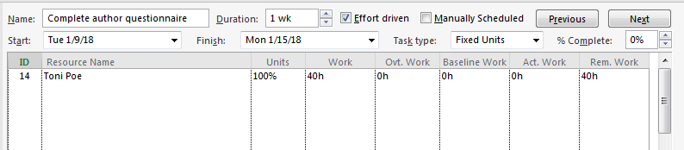

Displaying the Task Form view with Work details – provide a screen shot

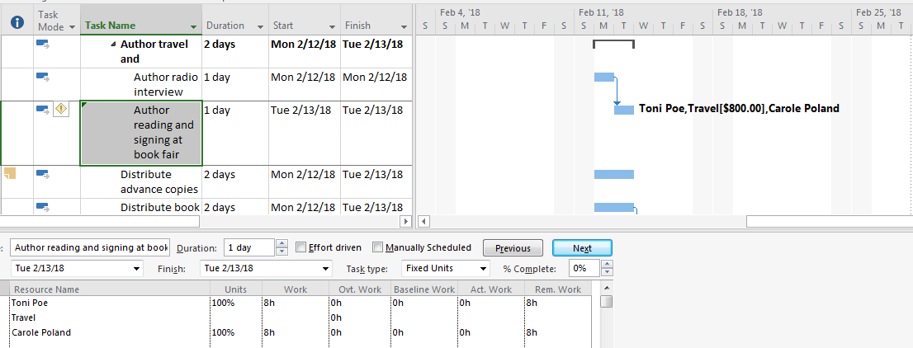

Closing Assign Resources dialog box – provide a screen shot

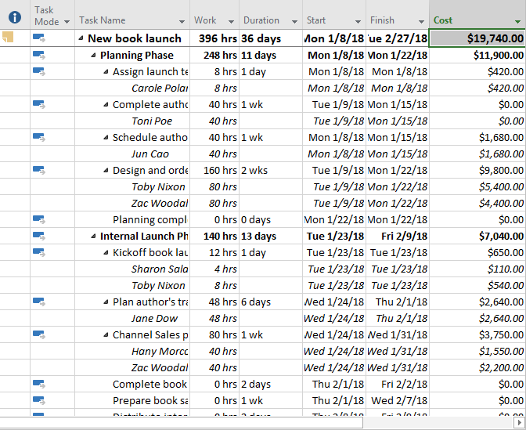

Displaying the Task Usage view with the Summary table – provide a screen shot

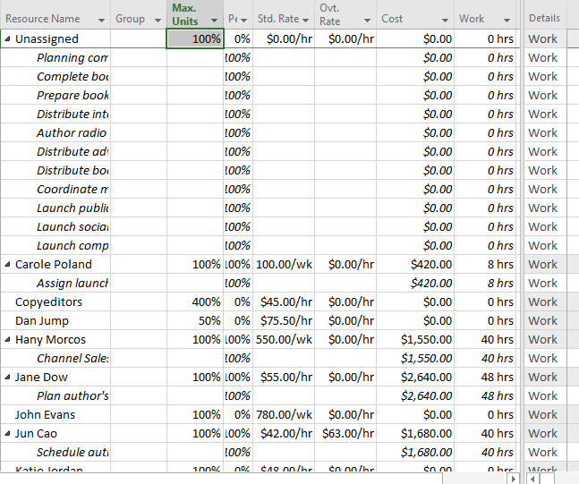

Displaying the Resource Usage view with the Summary table – provide a screen shot