Ch.7 Simple Format Screenshots by Joshua Troup

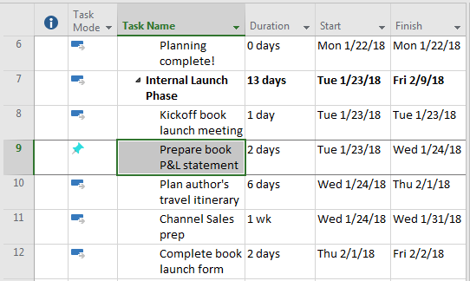

In the Gantt Chart, scrolling to the manually scheduled task 9 – provide a screen shot

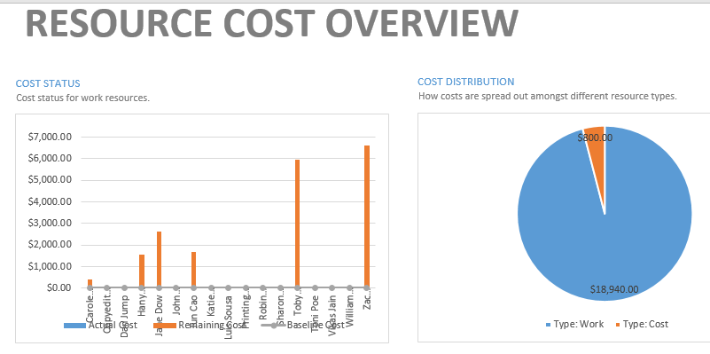

Displaying the Resource Cost Overview report – provide a screen shot

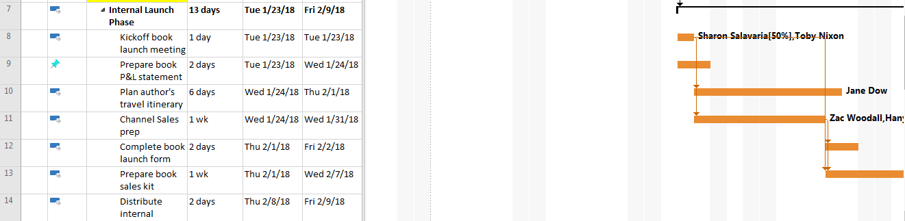

Displaying the Gantt Chart view so the Gantt bars of tasks 7 through 14 are visible – provide a screen shot

Copying a picture of tasks 7 through 14. Rendering the picture for the screen

Pasting the image into a new document or e-mail message

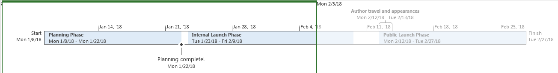

Copying a full-sized image of the detailed Timeline and pasting it into the same documents or e-mail message

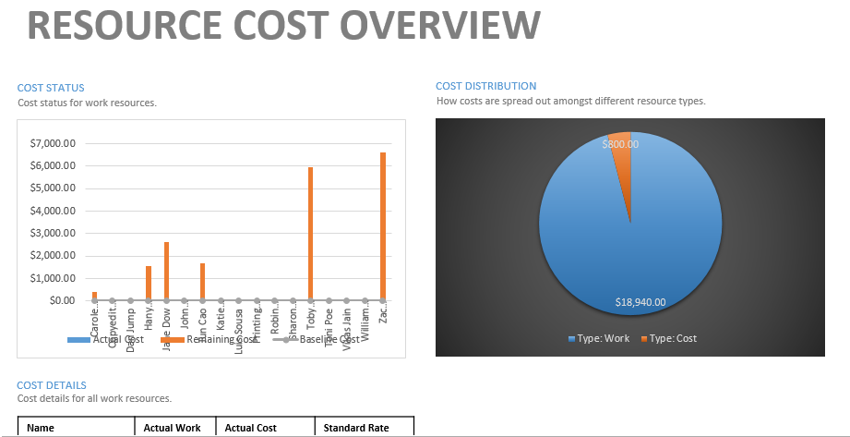

Copying the Resources Cost Overview report and pasting it into the same document of e-mail message

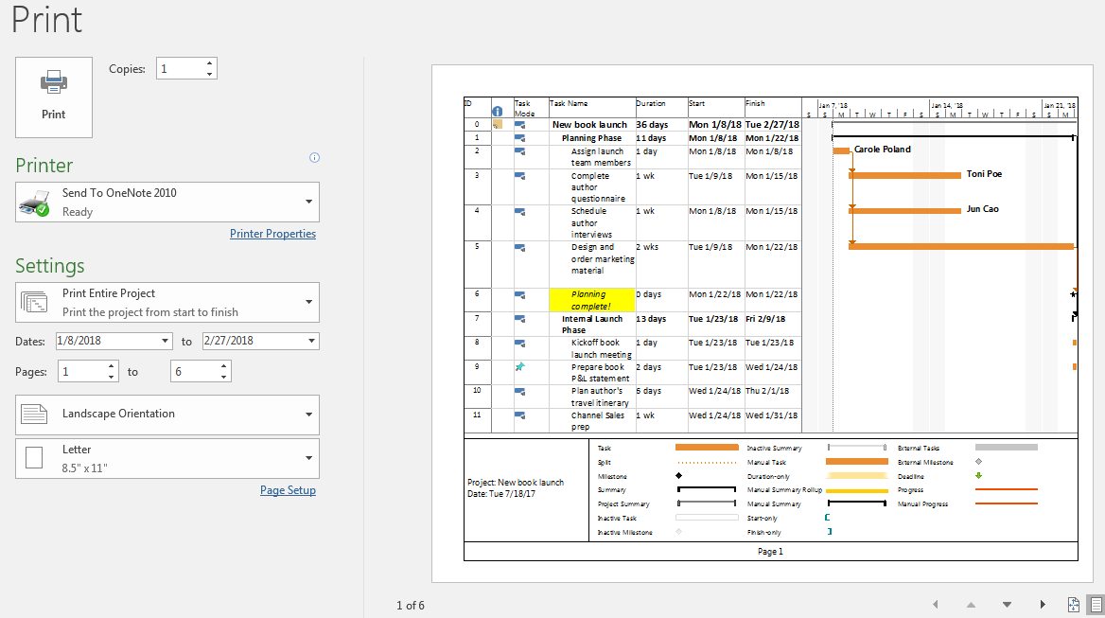

Displaying the print preview of the full Gantt Chart view, set to multiple pages – provide a screen shot

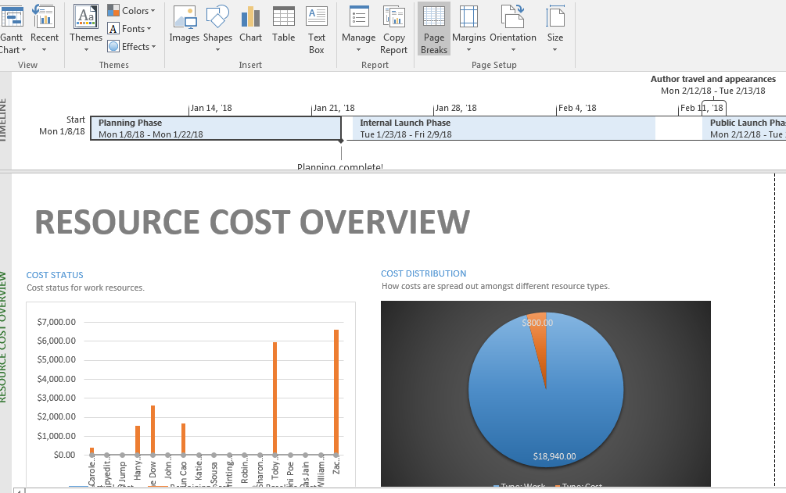

Displaying page breaks in the Resources Cost Overview report – provide a screen shot