Ch.8 Both Files Screenshots by Joshua Troup

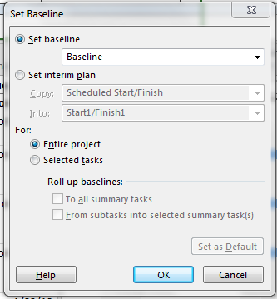

Saving a baseline for the entire plan using the default baseline values – provide a screen shot showing the baseline dialog box

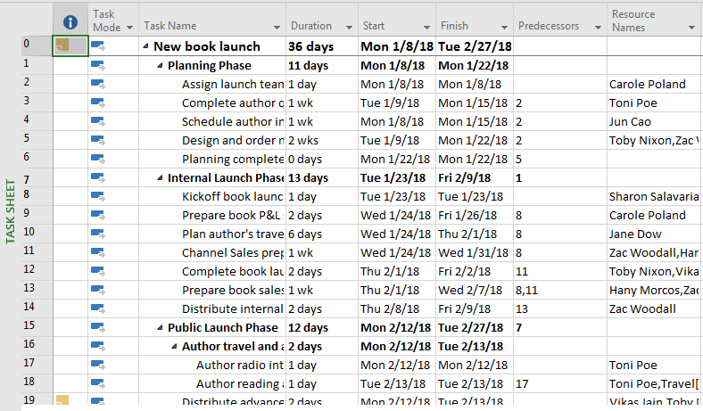

Switching to Task Sheet view – provide a screen shot

