Ch.9 Both Files Screenshots by Joshua Troup

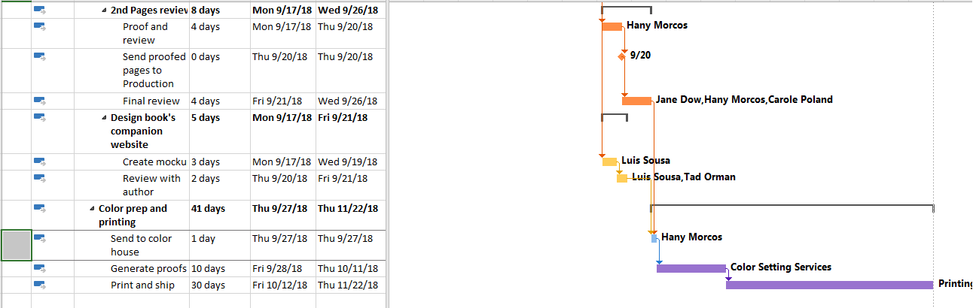

Applying the Task Path command to task 29, highlighting: (a) the predecessors, (b) the driving predecessors, then (c) the successors and, finally, (d) the driven successors – provide a screen shot



Pointing to the icon in the Indicators column to see the constraint details in a ScreenTip – provide a screen shot

NOTE: unable to display screentip while using snipping tool to capture screenshot



Pointing to the calendar icon in the Indicators column to see the task’s calendar details in a ScreenTip – provide a screen shot

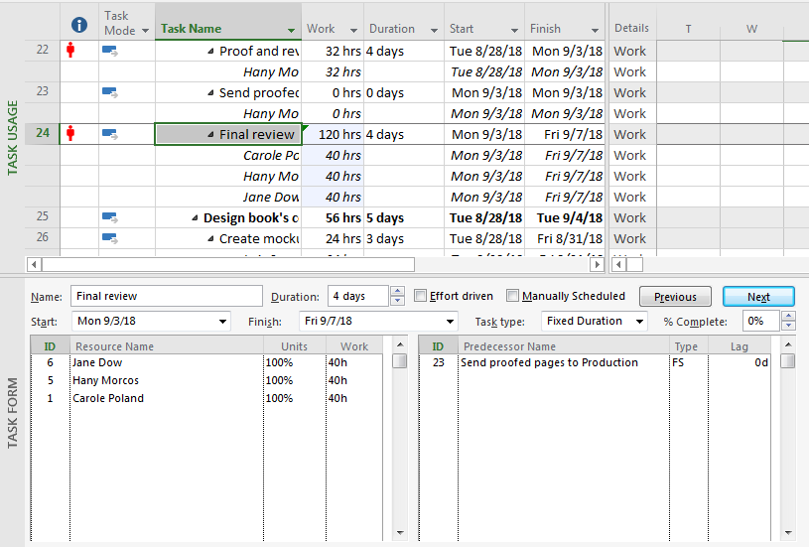

Displaying the Task Usage view with the Task Form and then clicking task 24 in the Task Usage view – provide a screen shot

Changing task 24 to Fixed Duration and then, in the Task Usage view, increasing work to 120 hours

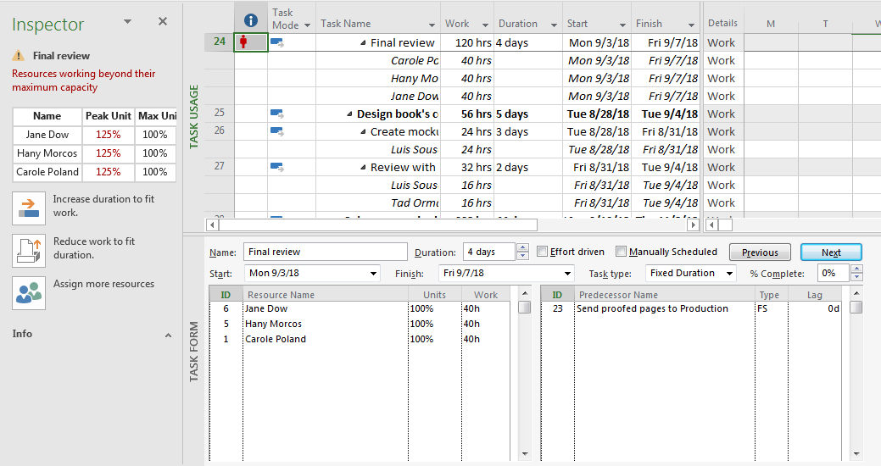

Ensuring that task 24 is still selected in the Task Usage view, and then displaying the Task Inspector to view additional information about this task – provide a screen shot

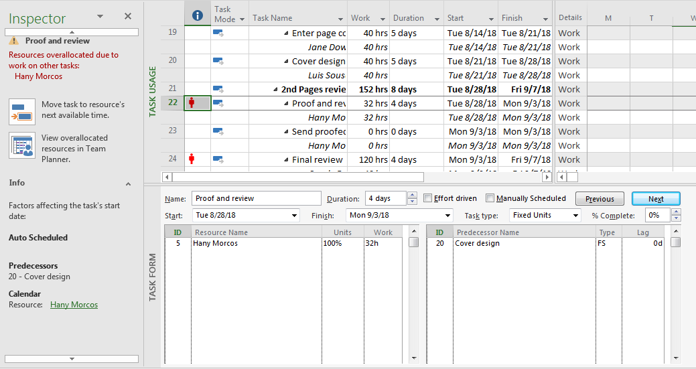

Clicking task 22 and reviewing details about this task – provide a screen shot

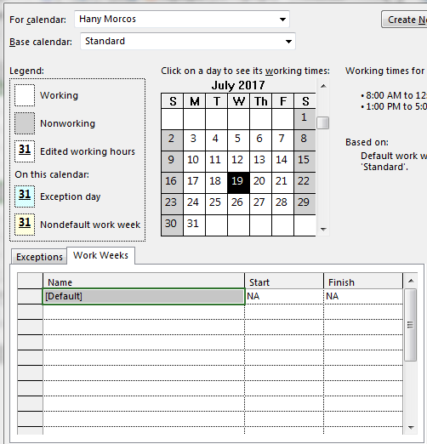

In the Task Inspector, clicking the resource name Hany Morcos to view her resource calendar – provide a screen shot