Ch.10 FineTuneTasks Screenshots by Joshua Troup

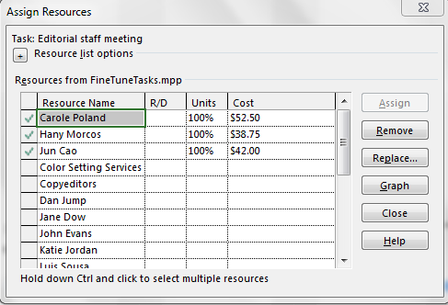

Collapsing the summary recurring task – provide a screen shot

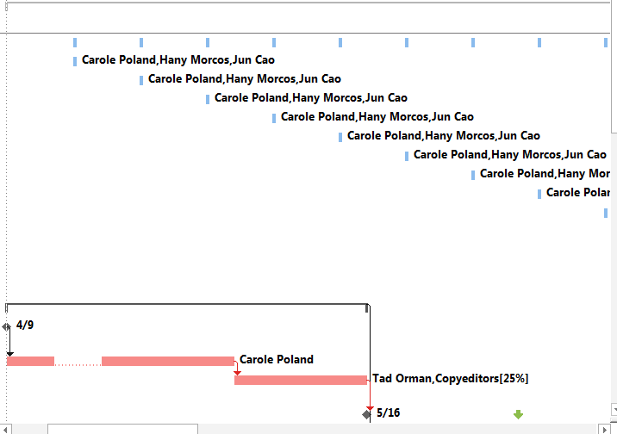

Displaying critical tasks in the plan – provide a screen shot



Check task 20’s updated schedule details in each Gannt bar’s ScreenTips – provide a screen shot