Ch.11 Both Files Screenshots by Joshua Troup

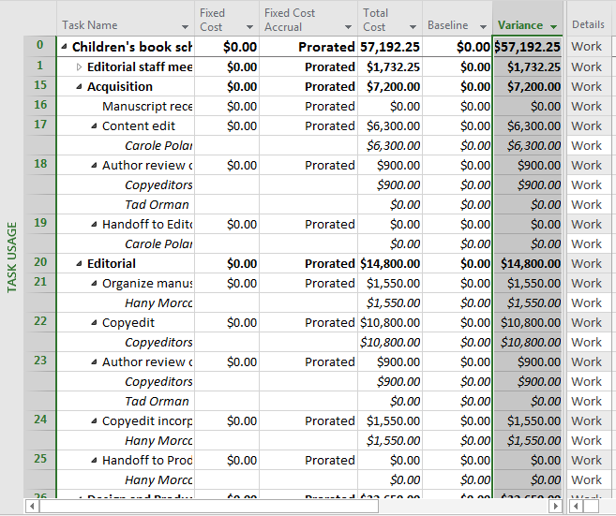

Displaying the Cost table in Task Usage view to easily see the change in the assignment cost in this table – provide a screen shot

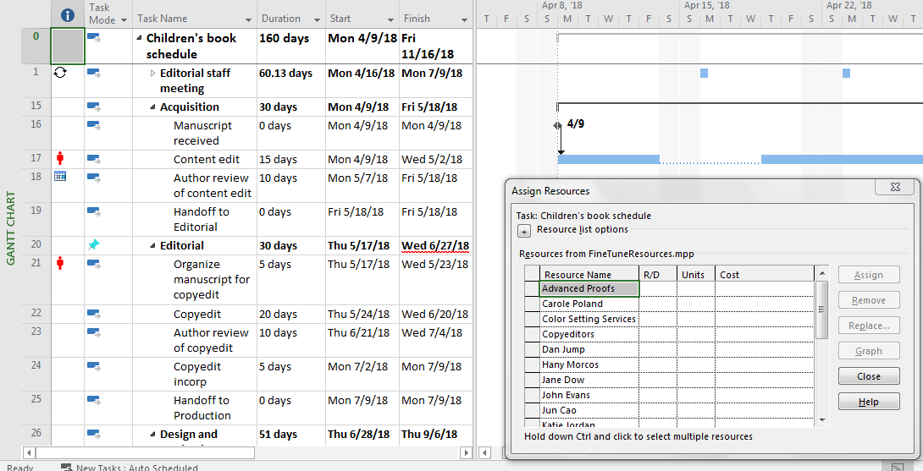

In the Gantt Chart view, opening the Assign Resources dialog box – provide a screen shot

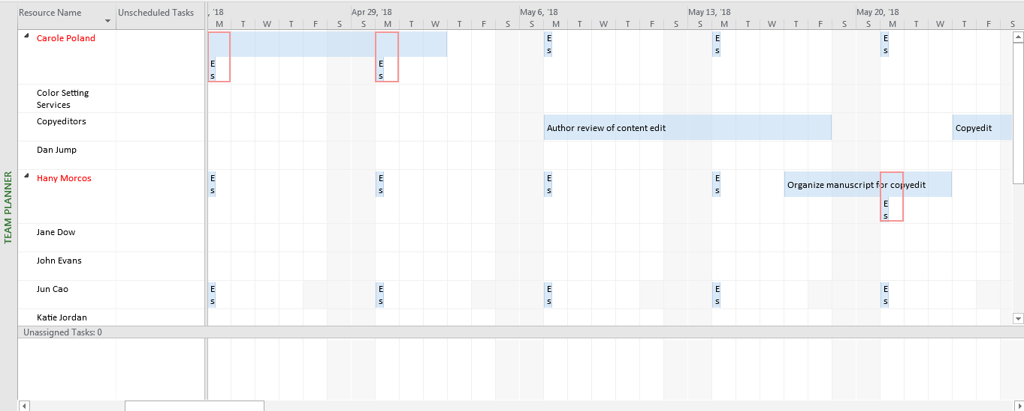

Displaying the Team Planner view – provide a screen shot