Ch.12 FineTunePlan Screenshots by Joshua Troup

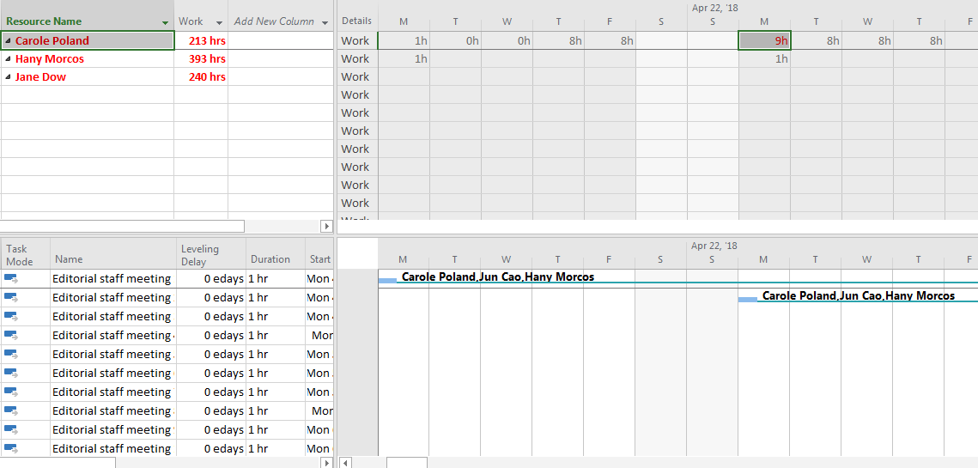

Using the Resource Usage view to examine Carole Poland’s overallocation on Monday, April 23, 2018 - provide a screen shot

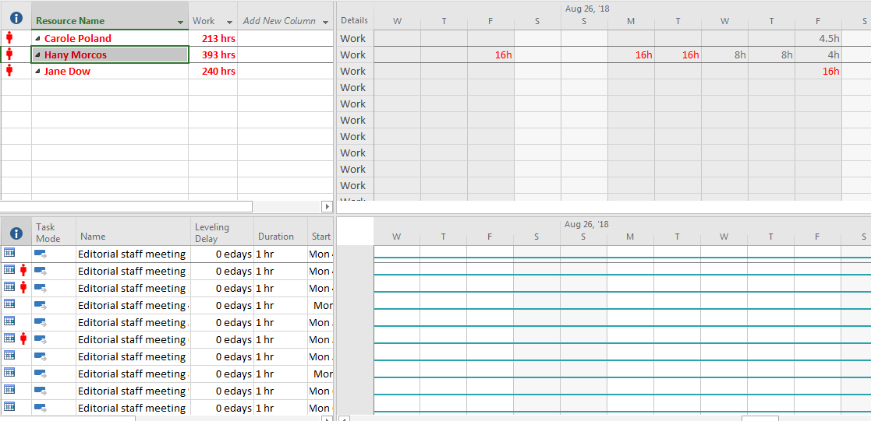

In the Resource Usage view, locating Hany Morcos’s overallocations in the last week of August – provide a screen shot

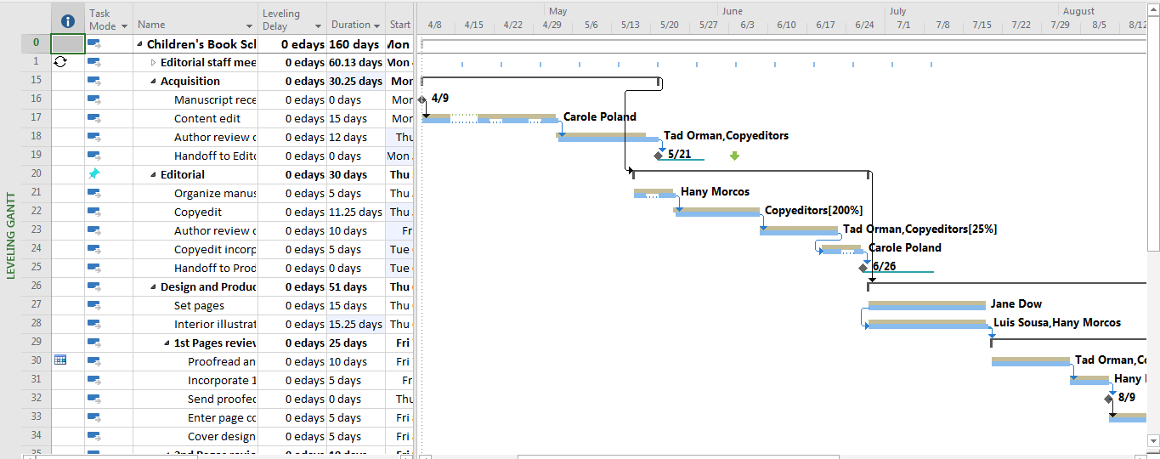

In the Leveling Gantt Chart view, examining the impact of leveling across the plan – provide a screen shot

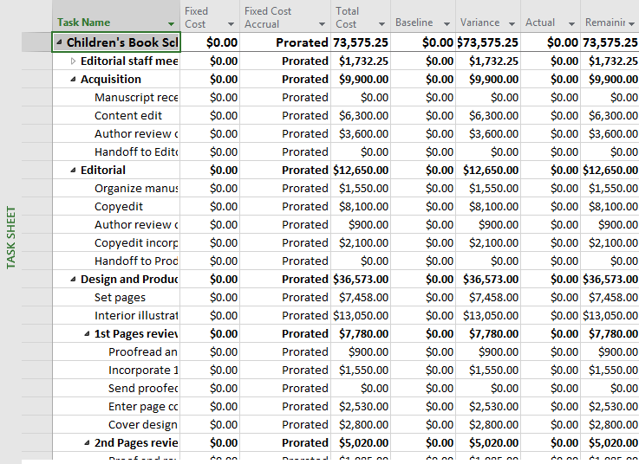

Switching to the Cost table in the Task Sheet view and examining the plan’s cost details there – provide a screen shot

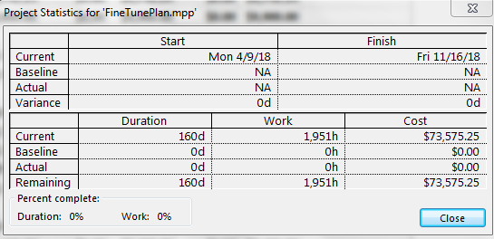

Checking the plan’s finish date and other summary values in the Project Statistics dialog box – provide a screen shot



Switching to Gantt Chart view and locating summary task 39 – provide a screen shot

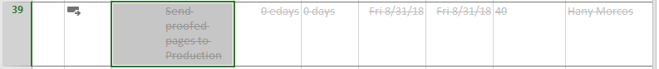

Inactivating task 39, which will also inactivate its subtasks