Ch.13 OrganizeDetails Screenshots by Joshua Troup

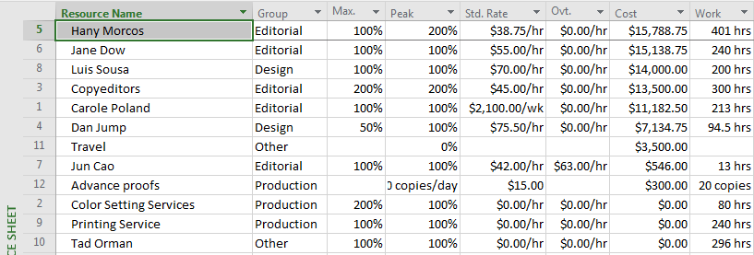

In the Resource Sheet view, with the Summary table displayed, sorting resources in the Cost column, from most to lease expensive

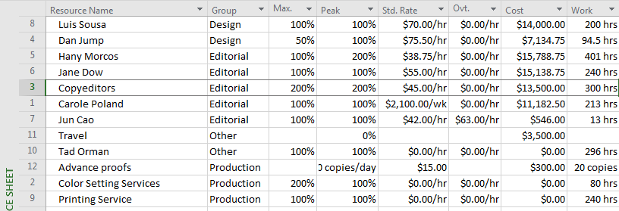

Using the Sort by command to sort resources by the Group field in descending order

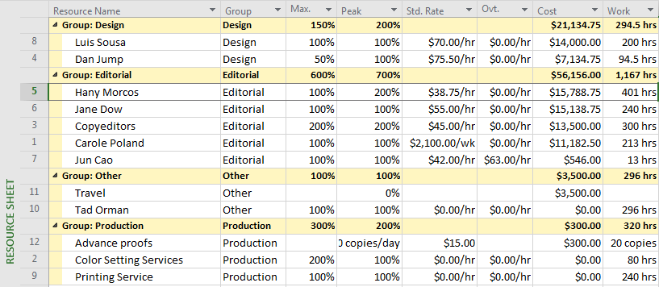

In the Resource Sheet view, with the Summary table displayed, grouping the resources by the built-in Resource Group group – provide a screen shot

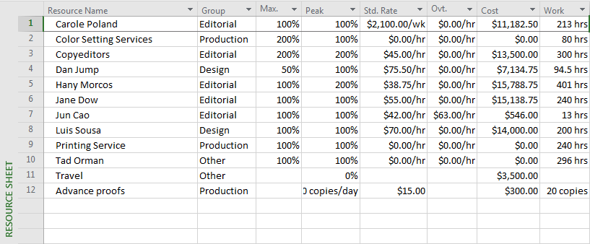

Clearing the grouping from the list and re-sorting resources by ID (2 points)

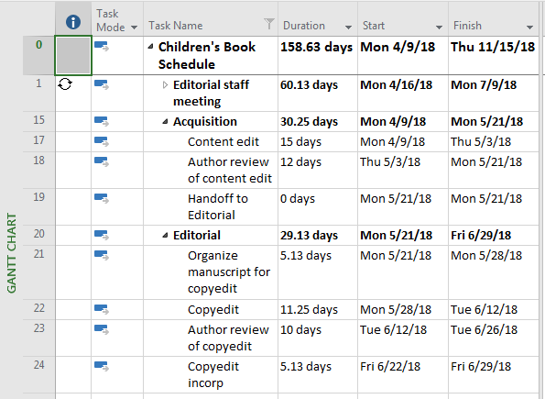

In the Gantt Chart view, applying a custom Autofilter on the Task Name column. The criterion for the Filter is Name contains edit (0 point) 2. Applying but not saving the custom AutoFilter – provide a screen shot (1 point)

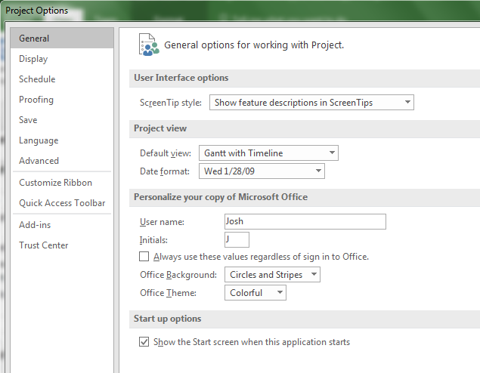

Clicking the File tab and then clicking Options to open the Project Options dialog box – provide a screen shot

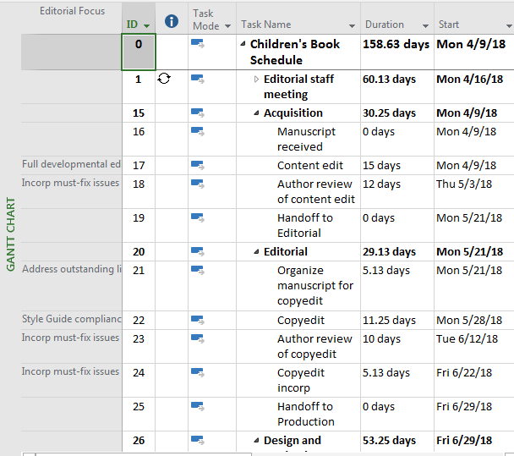

Displaying the new table in Gantt Chart view (1 point)

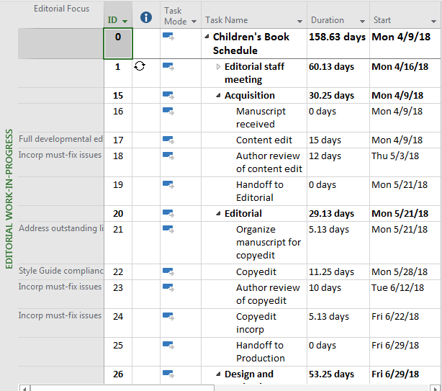

Displaying the new view – provide a screen shot

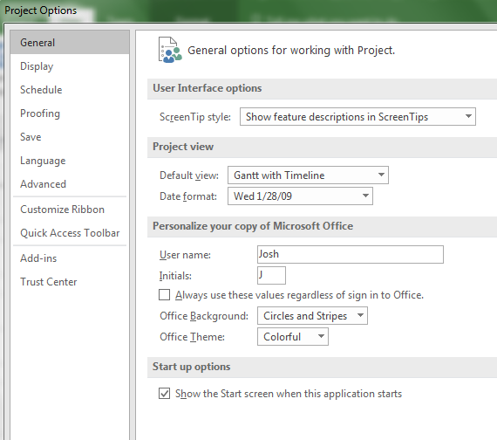

Clicking the File tab and then clicking Options to open the Project Options dialog box – provide a screen shot