Ch.14 All Files Screenshots by Joshua Troup

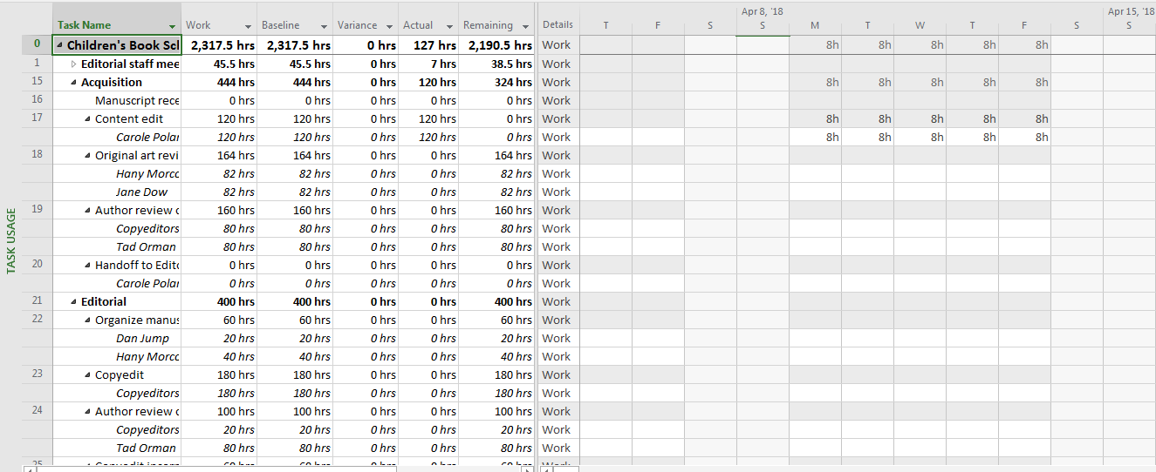

Displaying the Work table in the Task Usage view – provide a screen shot



Scrolling the timephased grid in the Task Usage view until scheduled work for task 22 is visible – provide a screen shot



Scrolling the Task Usage view to display the latest actual work recorded for task 31 – provide a screen shot