Ch.15 ReportStatus Screenshots by Joshua Troup

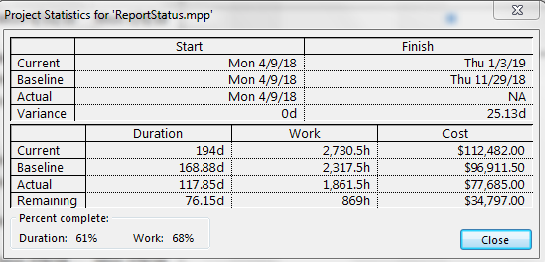

Locating the plan’s overall schedule variance of its finish date (just over 25 days) in the Project Statistics dialog box – provide a screen shot

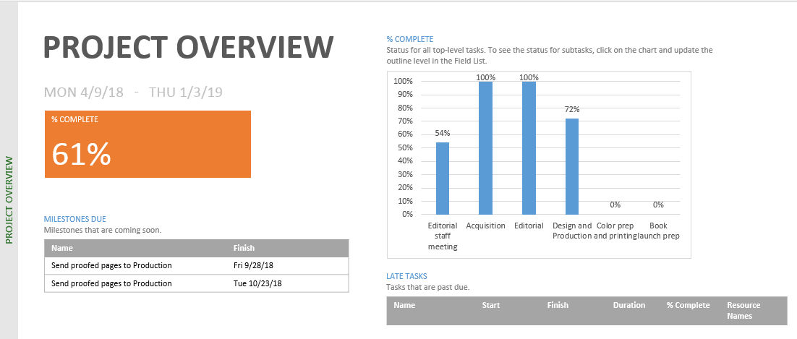

Displaying the Project Overview report and noting the percent complete values of top-level summary tasks – provide a screen shot

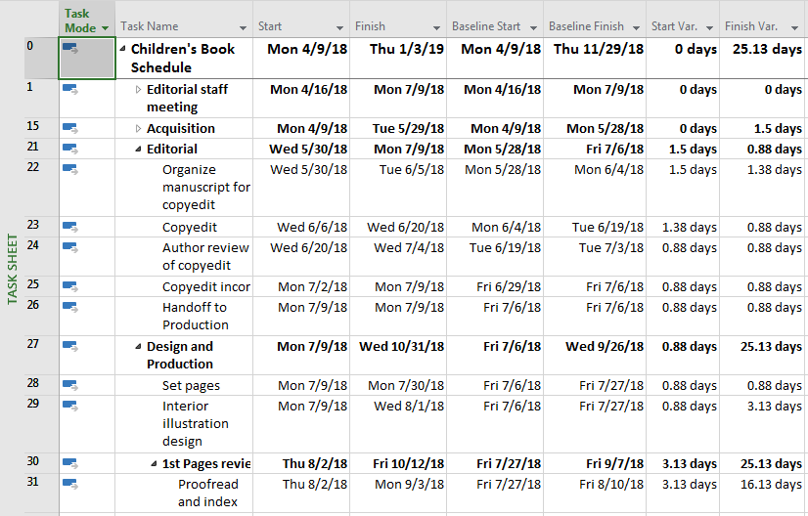

Displaying the Variance table in the Task Sheet view – provide a screen shot

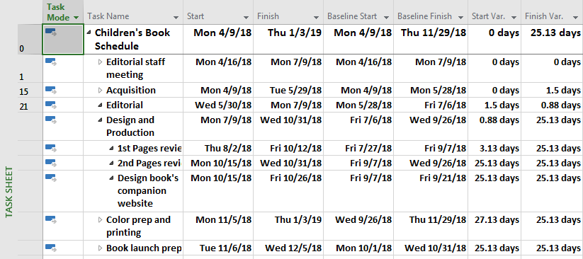

Filtering the table to display only summary tasks – provide a screen shot

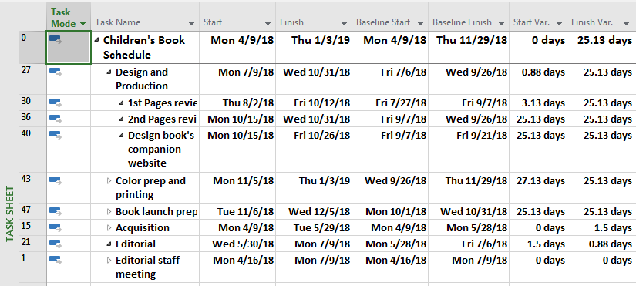

Identifying the summary tasks (or phases) of the plan that have incurred the highest finish variance – provide a screen shot

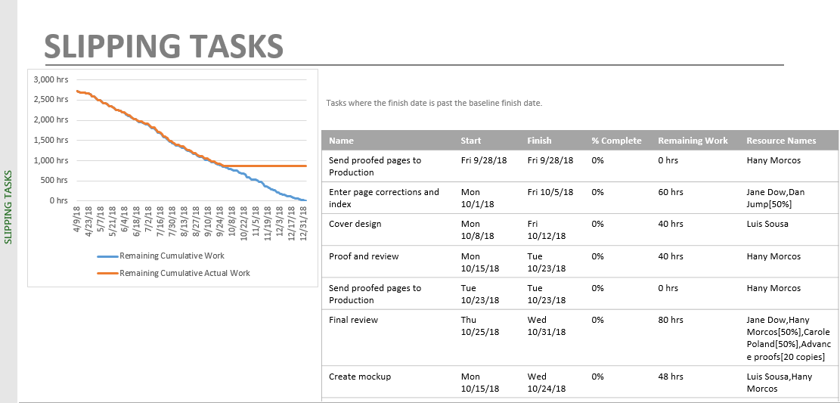

Displaying the Slipping Tasks report and identifying the tasks with the most remaining work that have slipped from the baseline – provide a screen shot

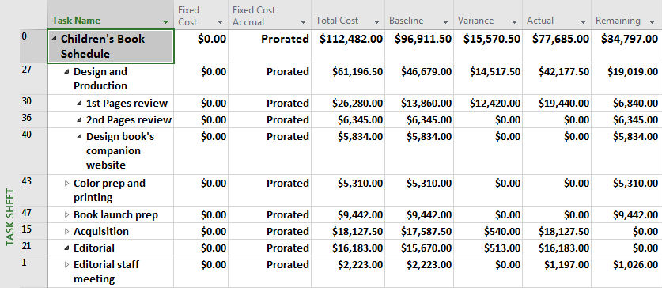

Displaying the Cost table in the Task Sheet view to find the total remaining costs per summary tasks – provide a screen shot

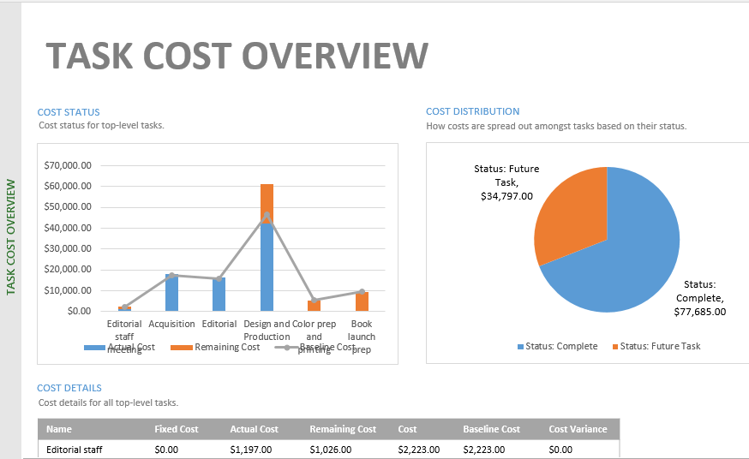

Displaying the Cost Overview report and then finding the expected cost of the plans incomplete future tasks – provide a screen shot

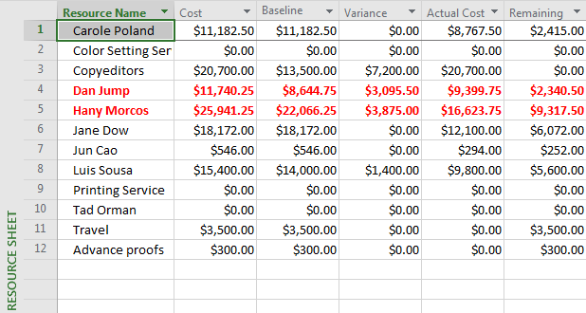

Displaying the Cost table in the Resource Sheet view– provide a screen shot

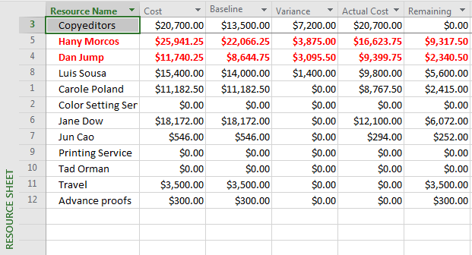

Sorting the resources from most to least cost variance– provide a screen shot