Ch.16 FormatInDepth Screenshots by Joshua Troup

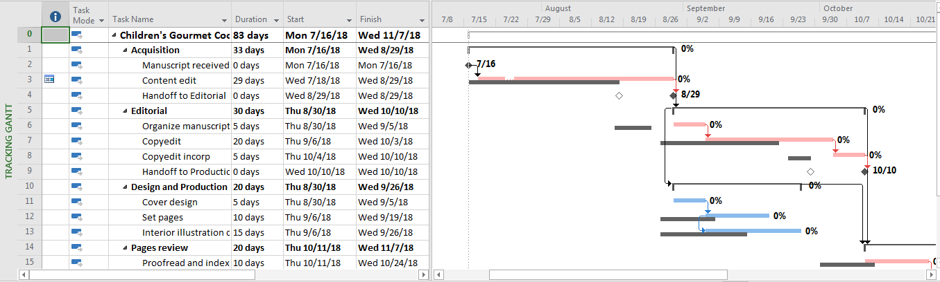

Displaying the Tracking Gantt view – provide a screen shot

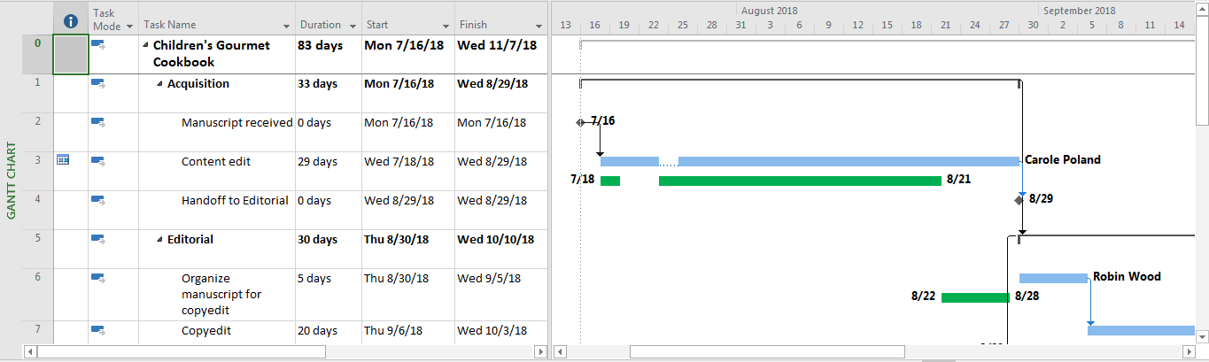

Clicking OK to display the new Interim bar style in the Tracking Gantt view – provide a screen shot

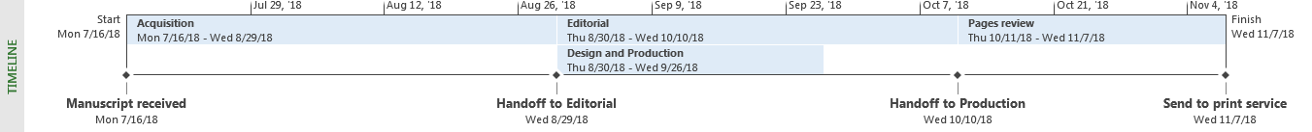

Reformatting the Timeline’s text for milestone dates so that they are bold – provide a screen shot

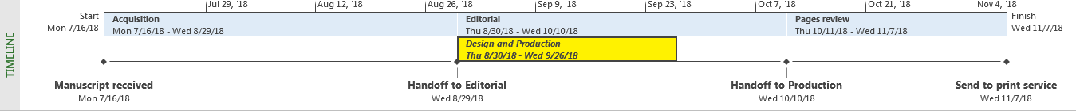

Reformatting the Design and Production task bar so that its text is italic and it has a yellow background – provide a screen shot

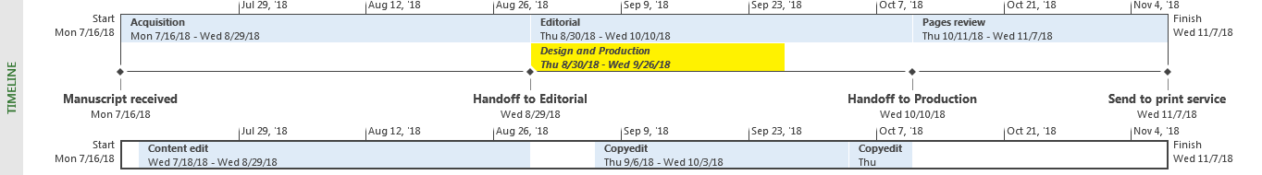

Adding an additional timeline bar by using the default project start and finish date range and then adding tasks 3, 7, and 8 to the new timeline bar – provide a screen shot

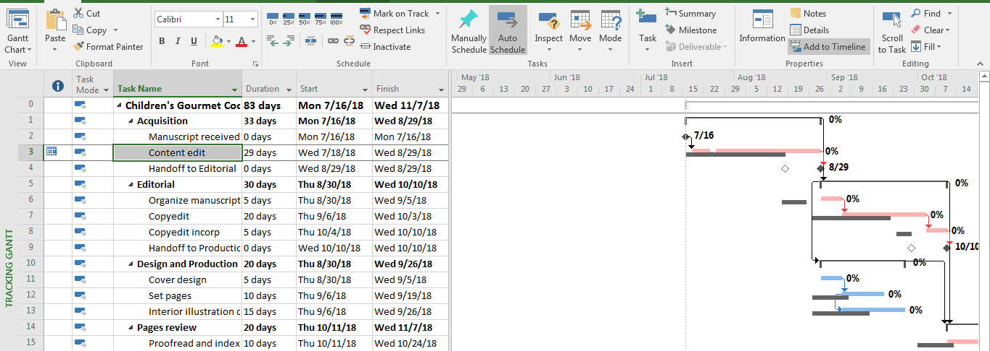

Hiding the Timeline view to give yourself more working space – provide a screen shot

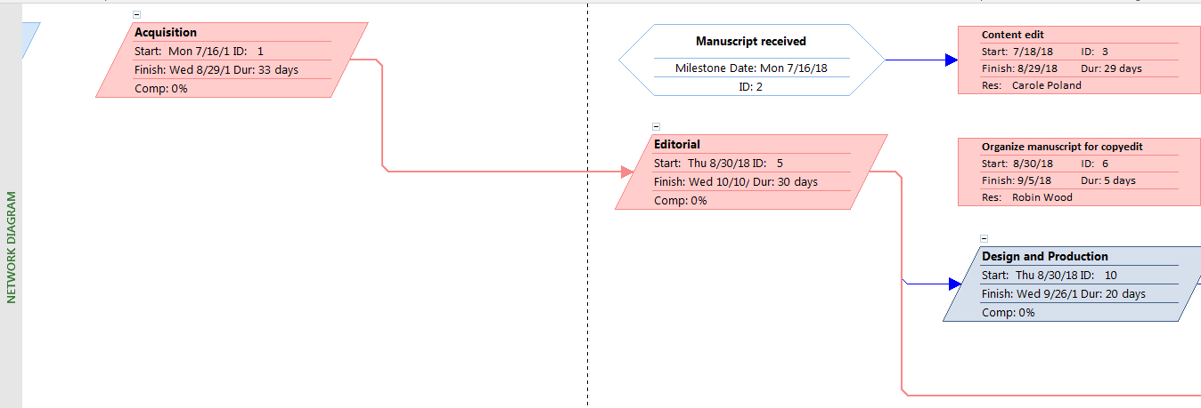

Switching to Network Diagram view – provide a screen shot

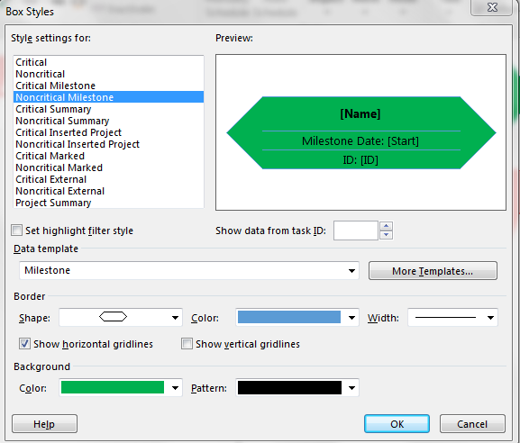

Change the box style for noncritical milestones to use a green background color – provide a screen shot

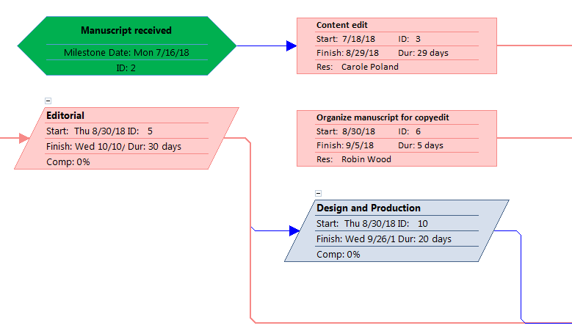

Applying the updated box style to the Network Diagram view – provide a screen shot

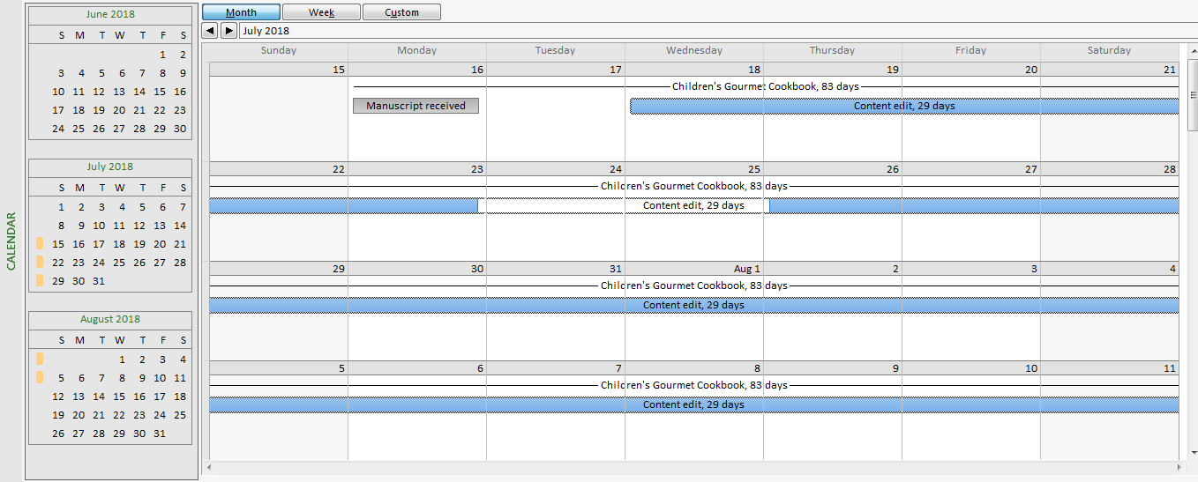

Displaying the Calendar view – provide a screen shot

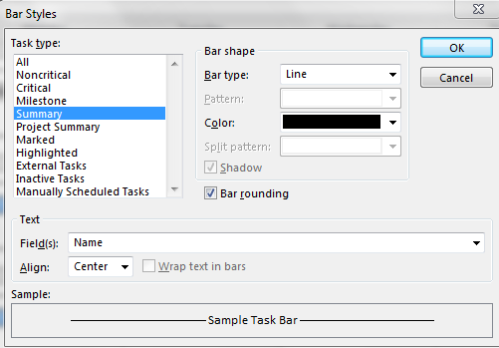

Formatting the Summary bar style to be a line bar – provide a screen shot

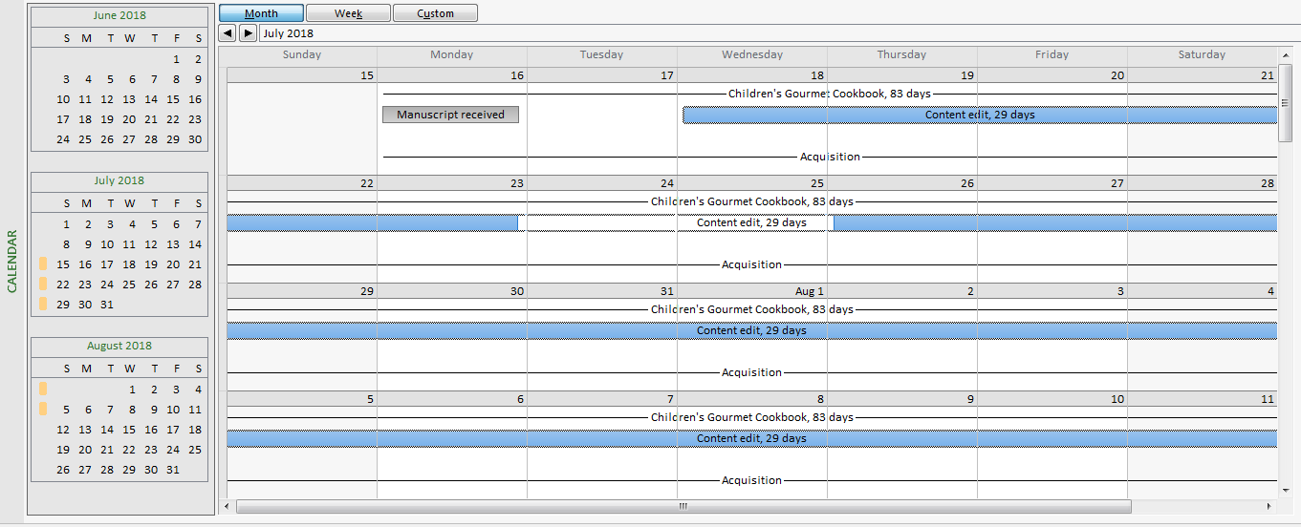

Applying the updated Summary bar style and updating the Calendar view layout – provide a screen shot

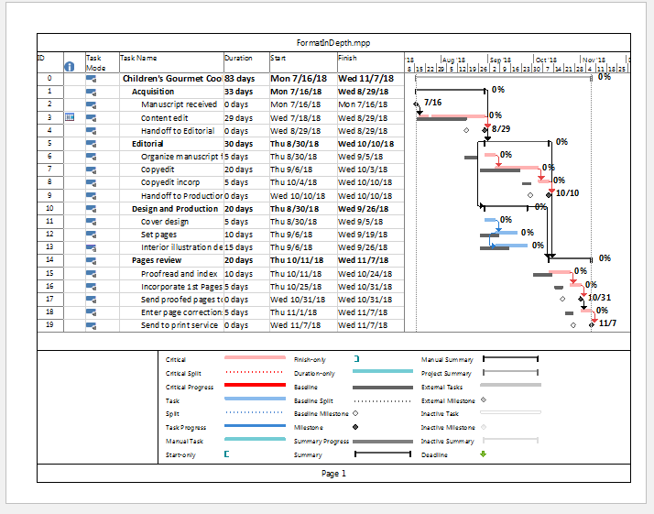

Displaying the print preview of the Gantt Chart view on the print page – provide a screen shot

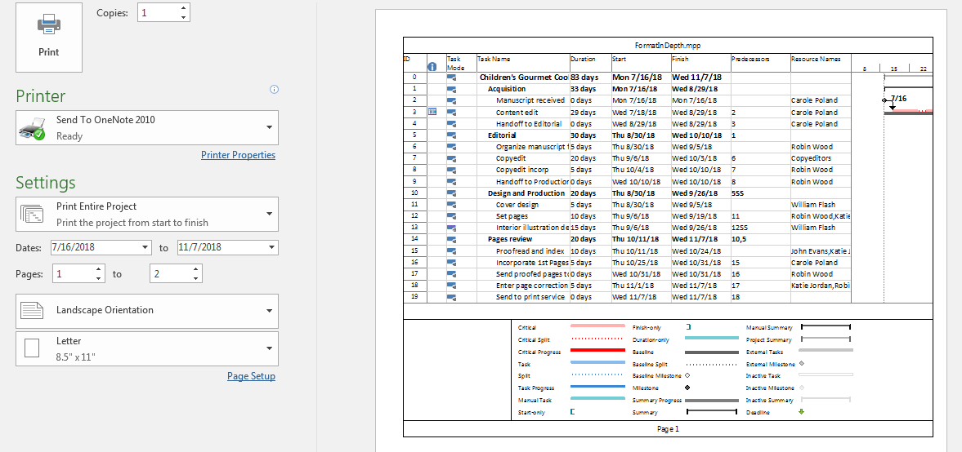

Changing the page setup to print all sheet columns – provide a screen shot