Ch.18 BothFiles Screenshots by Joshua Troup

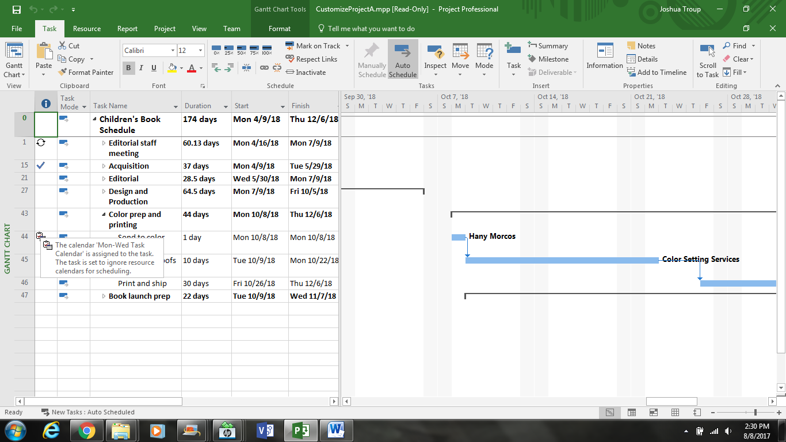

In CustomizeProjectA, pointing to the Calendar indicator to task 44 and noting the SreenTip: the task has the Mon-Wed Task Calendar applied. (provide a screenshot

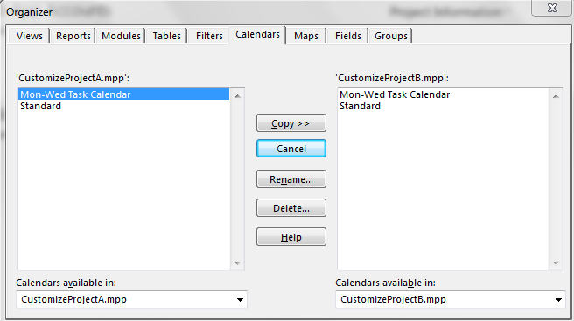

Using the Organizer to copy the Mon-Wed Task Calendar from CustomizeProjectA to CustomizeProjectB (provide a screenshot –

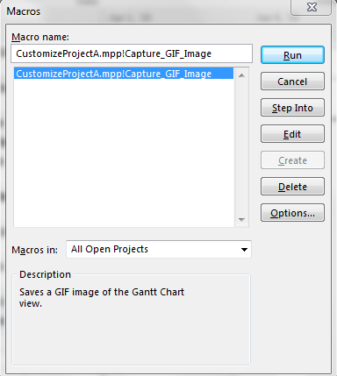

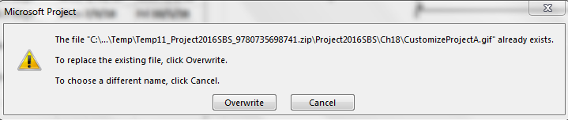

Running the macro from the Macros dialog box successfully. Overwriting the GIF image file when prompted (provide a screenshot

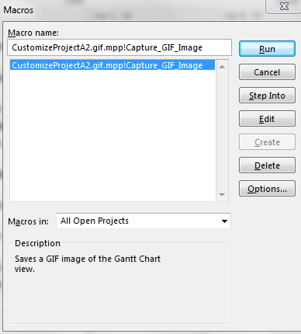

Running the macro successfully. This time, you should not see the prompt to overwrite the previously saved GIF image (provide a screenshot

NOTE: Added “2” after CustomizeProjectA to distinguish this is an updated macro with added line of code.

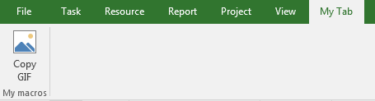

Clicking OK to close the Project Options dialog box and displaying your custom tab (provide a screenshot

On the My Tab tab, in the My Macros group, clicking Copy GIS to run the macro (provide a screenshot