Ch.19 Both Files Screenshots by Joshua Troup

|  |  |  |  |  |  |  |
| --- | --- | --- | --- | --- | --- | --- |
| Task Mode | Task Name | Duration | Start | Finish | Predecessors | Resource Names |
| **Auto Scheduled** | **Editorial** | **30 days** | **Tue 8/28/18** | **Mon 10/8/18** | **1** |  |
| Auto Scheduled | Organize manuscript for copyedit | 5 days | Tue 8/28/18 | Mon 9/3/18 |  | Robin Wood |
| Auto Scheduled | Copyedit | 20 days | Tue 9/4/18 | Mon 10/1/18 | 6 | Copyeditors |
| Auto Scheduled | Copyedit incorp | 5 days | Tue 10/2/18 | Mon 10/8/18 | 7 | Robin Wood |
| Auto Scheduled | Handoff to Production | 0 days | Mon 10/8/18 | Mon 10/8/18 | 8 | Robin Wood |
| **Auto Scheduled** | **Design and Production** | **20 days** | **Tue 8/28/18** | **Mon 9/24/18** | **5SS** |  |
| Auto Scheduled | Cover design | 5 days | Tue 8/28/18 | Mon 9/3/18 |  | William Flash |
| Auto Scheduled | Set pages | 10 days | Tue 9/4/18 | Mon 9/17/18 | 11 | Robin Wood,Katie Jordan |
| Auto Scheduled | Interior illustration design | 15 days | Tue 9/4/18 | Mon 9/24/18 | 12SS | William Flash |

Starting Word, creating a new document, and then pasting the copied tasks into the new document, using the default paste option (provide a screenshot

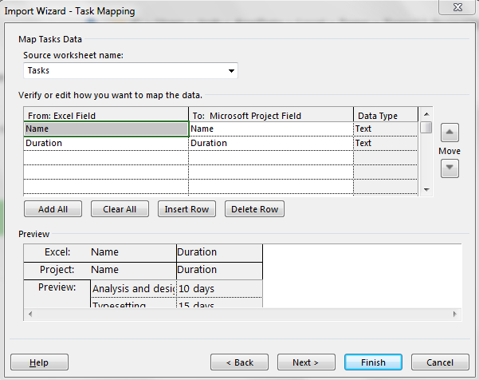

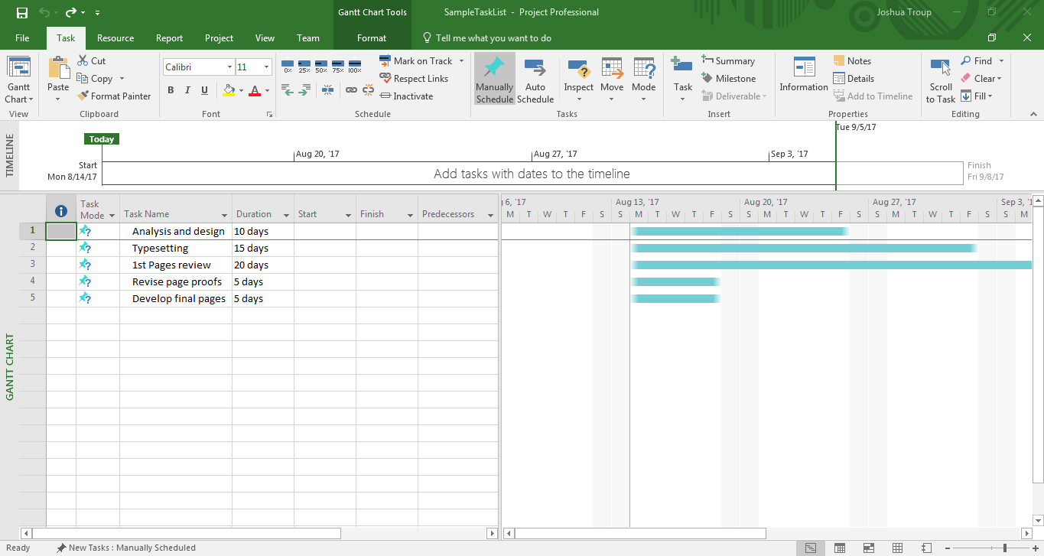

Finishing the Import Wizard reviewing the resulting task list (provide a screenshot