Ch.20 All Files Screenshots by Joshua Troup

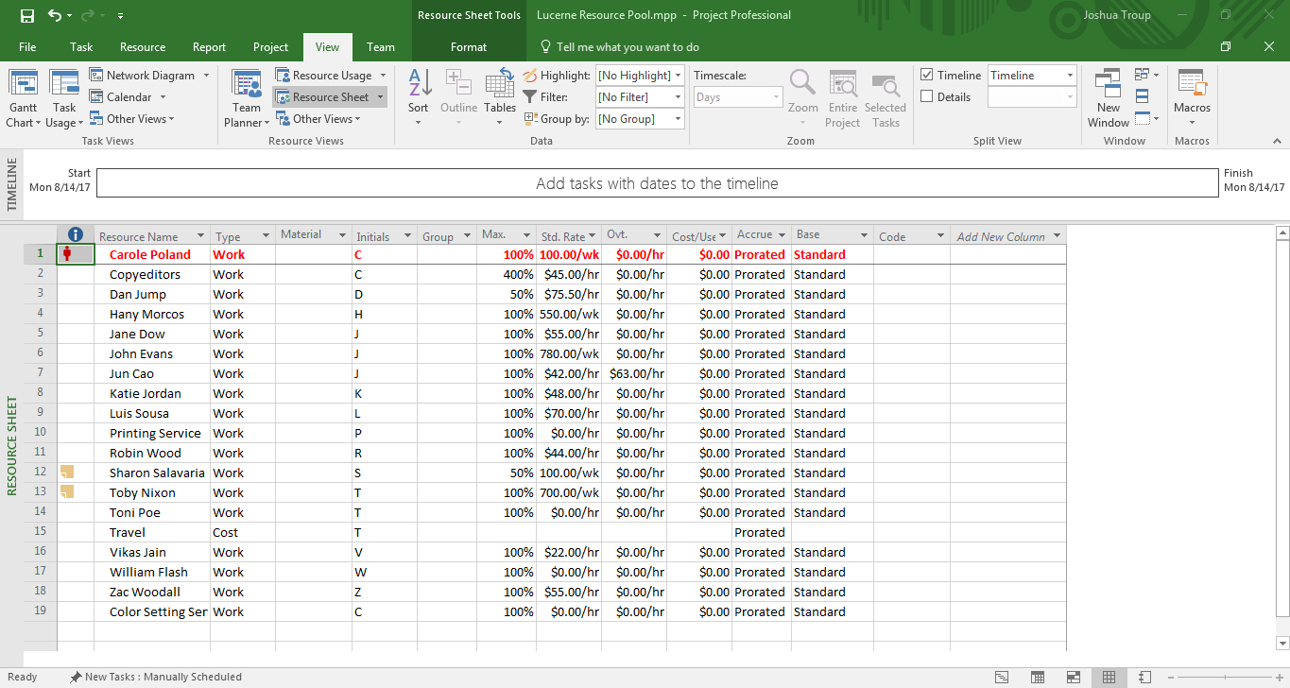

Displaying the Resource Sheet view in the resource pool (provide a screenshot

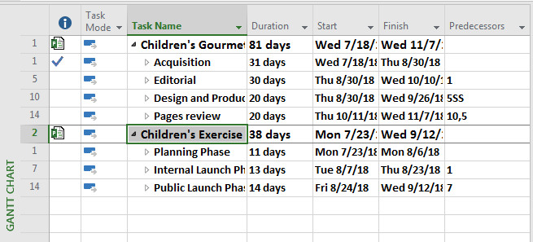

In Lucerne Consolidated Plan, expanding both inserted plans to see their details (provide a screenshot

Displaying the project summary task (provide a screenshot –