voles uniform-mesh solver optimizations — benchmarks
Branch fast-uniform-mesh (fork of trout314/voles, three commits: 782fb58 Toeplitz weight-tensor assembly for the function-mode solvers; 382ec8d blocked-FFT history sums for the sampled-data solvers; a56349d runtime-dimension d > 8 support). All 363 tests pass. Timings on an Apple-silicon laptop, July 2026, collocation order p = 3.
case | before | after | speedup
function mode, Abel kernel, M = 320 | 3.31 s | 0.98 s | 3.4× (now O(M): M = 2560 in 8.0 s vs ~210 s)
function mode, smooth kernel, M = 320 | 1.02 s | 0.013 s | ~80×
sampled VIE-1, N = 160,001 | 19.9 s | 0.26 s | 77×
sampled VIE-1, N = 640,001 | ~5 min | 1.32 s | ~240×
test suite (363 tests) | 35.5 s | ~19 s | ≈1.8× (free side effect)
sampled VIE-2, d = 10 system, N = 36,001 | 79.9 s | 2.6 s | 31× (near-linear scaling)

Accuracy of the optimized paths
- Function mode (commit 1): adaptive-quadrature entries are recomputed per row with exactly the same calls as the original code and are bit-identical; reused Gauss–Legendre entries agree to rounding level (≤ 8×10⁻¹⁵). Non-uniform (graded) meshes are bit-for-bit unchanged.
- Sampled mode (commit 2): the blocked/FFT summation reorders floating-point additions, so results differ from the sequential sum at rounding level: worst 9.9×10⁻¹³ relative over a 16-case battery spanning all solver families (typically 10⁻¹⁵–10⁻¹⁴).
- Runtime-dimension (d > 8) LAPACK paths: accelerated by the same engine in commit a56349d (runtime-dimension core, compile-time wrapper bitwise-identical). A/B at d = 10 across all solver families: worst 2.5×10⁻¹² relative.

Scaling at d = 10 (sampled VIE-2, p = 3)
Runtime-dimension LAPACK path, commit a56349d. “Before” timings from a build of the preceding commit (direct O(Q²) summation) on the same machine and inputs; ten coupled equations (10×10 matrix kernel).
N (samples) | direct (before) | blocked-FFT (after) | speedup
9,001 | 5.2 s | 0.46 s | 11×
18,001 | 19.8 s | 1.1 s | 18×
36,001 | 79.9 s | 2.6 s | 31×
Doubling N now roughly doubles the runtime (near-linear, O(Q log² Q)) instead of quadrupling it, so the speedup grows with N.

Verification: np.allclose across all A/B cases
Every problem spec in the test suite (20 specs spanning VIE-1, VIE-2, and VIDE, run through both the sampled-data and function-mode solvers at the suite's own size and at a larger size that exercises the FFT merge path) plus the two extra batteries (d ≤ 2 at Q = 700, and d = 10) — 100 cases in total — were solved on both the upstream-main build and the optimized branch. With numpy's default tolerances (rtol = 1e-5, atol = 1e-8), np.allclose(old, new) returns True for all 100 cases.
Because the default tolerances are loose relative to the differences actually present, a second, roughly 100,000× stricter check was also run: rtol = 1e-10 with the absolute floor scaled to each problem, atol = 1e-10 × max|old| for that case. All 98 finite cases pass this too; the largest deviation observed anywhere is 2×10⁻¹¹ of the problem's solution scale, so even the tightened tolerance is not the binding constraint.
The per-problem (“scale-aware”) absolute floor is needed for two reasons. First, the batteries' solution magnitudes span roughly 10⁰ to 10¹⁶, so a single fixed atol cannot mean the same thing for every case. Second, a purely elementwise relative comparison fails spuriously wherever a solution crosses zero: rounding noise in these solvers has an absolute size set by the magnitudes flowing through the computation (the history sums involve the whole solution), not by the local value at one output point, so at a grid point where |y| ≈ 2×10⁻⁴ a rounding-scale difference of 2×10⁻¹² looks like a 10⁻⁸ relative error while being 10⁻¹² of the solution scale. Scaling atol by max|old| restores the meaningful yardstick.
Two cases in the extra d ≤ 2 battery contain inf/NaN values and are excluded from the strict finite-case statistics (they pass the default check with equal_nan=True). These are continuous VIE-1 runs with collocation nodes {0.5, 1.0}, whose amplification factor sits exactly at the ρ = 1 boundary of Brunner's convergence criterion; over 700 mesh intervals the marginal mode grows until it overflows double precision. Both builds produce this blow-up identically — same overflow positions, same values, finite prefixes agreeing to ~10⁻¹⁶⁷ relative — i.e. it is pre-existing behaviour of a deliberately borderline discretization, not an effect of the optimizations; the test suite itself never runs that combination at that length.

Figures
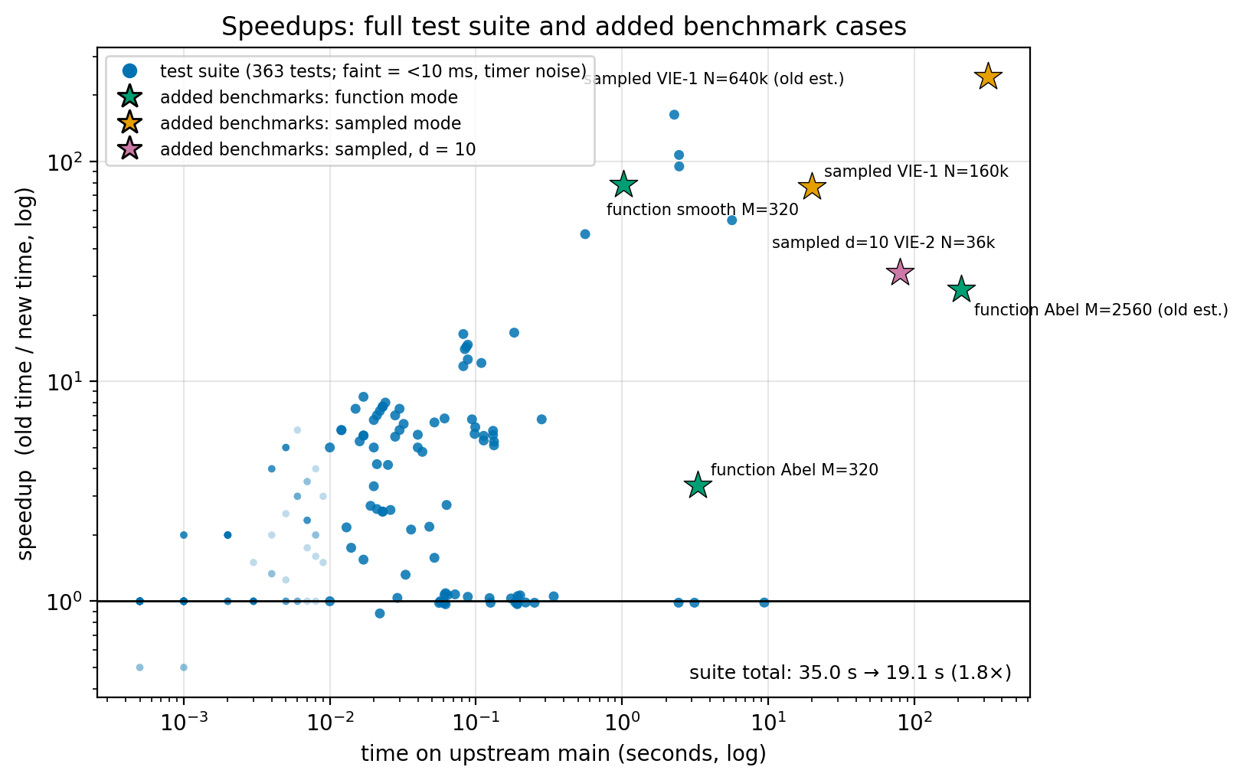
Figure 1. Per-test speedups for the full 363-test suite (circles) and the six added benchmark cases (stars), against each case's runtime on upstream main.
The trend is the story: the slower a case was under the old code, the larger its speedup, because long runs are exactly where the removed O(N²)/O(M²) terms dominated. Suite tests reach ~170×; the added large-N benchmarks (which no suite test approaches in size) reach 26–240×, with the two “old est.” stars using the old code's measured quadratic scaling to extrapolate runs that would have taken minutes. Faint circles are sub-10-ms tests whose ratios are timer noise, and the cluster at 1× comprises tests that never touch the optimized paths (input validation, warnings, numba-fallback settings). The suite as a whole runs 1.8× faster (35.0 s → 19.1 s).
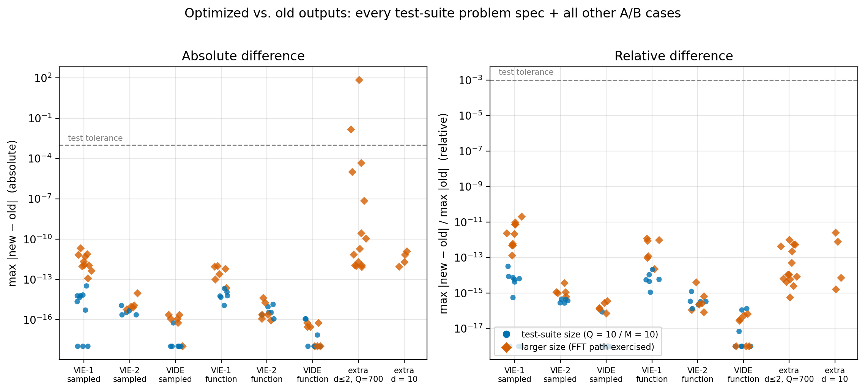
Figure 2. Maximum |new − old| for every test-suite problem spec through both solver modes at two sizes, plus the extra batteries; left panel absolute, right panel relative to each problem's solution scale.
Every case sits at least eight orders of magnitude below the suite's 10⁻³ tolerance (dashed line). Blue circles are the suite's own sizes, where merges stay below the FFT cutoff and differences are pure summation-reordering at the 10⁻¹⁶ level; orange diamonds are the larger sizes that exercise the FFT path and the one-row assembly, adding a few digits of rounding noise but never exceeding 2×10⁻¹¹ relative (a first-kind case, where conditioning mildly amplifies rounding). The apparent outliers in the absolute panel (up to ~70) belong to extra-battery problems whose solutions themselves reach ~10¹⁵–10¹⁶; the relative panel shows they are ~10⁻¹⁴ of scale — which is why both panels are needed to read this comparison fairly.

