DEPARTMENT OF COMPUTER APPLICATIONS
MASTER OF COMPUTER APPLICATIONS (MCA)
COURSE: SOFTWARE ENGINEERING
ASSIGNMENT #01: COMPLETE SET OF UML DESIGN DIAGRAMS
VERACITY AI: AI-POWERED MULTI-MODAL MISINFORMATION DETECTION & DIGITAL WELLBEING PLATFORM
Comprehensive Software Engineering Design Specification & UML Architectural Models
Mini Project Title: | VERACITY AI: Misinformation Verification & Wellbeing System
Student Name: | DIVYANSHU YADAV
Register / Roll Number: | 25MCA00PY0036
Degree & Course: | Master of Computer Applications (MCA)
Subject Name: | Software Engineering (Assignment #01)
Project Guide / Evaluator: | Dr. R. SUNITHA (Concern Mini Project Guide)
Date of Submission: | 30/10/2026
Marks Weightage: | 10 Marks (Internal Component)
"Submitted in partial fulfillment of the academic requirements for the Master of Computer Applications (MCA) Degree in Software Engineering."

TABLE OF CONTENTS
Section | Topic / Description | Category
1.0 | Executive Abstract & Problem Definition | Overview
2.0 | System Objectives & Engineering Specification | Requirements
3.0 | Technical Architecture & Component Stack | System Design
4.0 | UML Diagram 1: Use-Case Diagram & Functional Requirements | Behavioral Model
5.0 | UML Diagram 2: Class Diagram & Domain Object Model | Structural Model
6.0 | UML Diagram 3: Sequence Diagram & Dynamic Message Passing | Interaction Model
7.0 | UML Diagram 4: Activity Diagram & Operational Workflows | Process Model
8.0 | UML Diagram 5: State Machine Diagram & Object Lifecycles | Dynamic State Model
9.0 | UML Diagram 6: Package Diagram & Modular Subsystems | Architectural Model
10.0 | UML Diagram 7: Component & Deployment Diagram | Physical Implementation
11.0 | Software Engineering Evaluation & Conclusion | Summary

1.0 EXECUTIVE ABSTRACT & PROBLEM DEFINITION
The rapid expansion of social media and online content distribution has dramatically accelerated the spread of unverified claims and fake news, impairing public discourse. In tandem, excessive smartphone and laptop usage leads to digital strain, eye fatigue, and reduced cognitive performance. VERACITY AI is an integrated platform combining multi-modal fake news verification with native hardware screen-time monitoring and generative AI habit coaching.
The platform utilizes Google Gemini AI coupled with local Scikit-Learn TF-IDF classifiers for fact-checking, while simultaneously extracting native Windows OS metrics (GetTickCount64, GetLastInputInfo) and Android UsageStatsManager telemetry. This Software Engineering document presents the complete set of UML design models governing the platform's architectural, behavioral, and physical deployment structure.

4.0 UML DIAGRAM 1: USE-CASE DIAGRAM
Subtitle: Behavioral Functional Scope and Actor-System Interactions in Veracity AI
The Use-Case diagram establishes the functional boundaries of the system. Four key actors interact with the core platform: the User/Student (submitting claims and viewing screen time), the Administrator/Fact-Checker (overseeing verification audits), the Google Gemini AI Cloud Service (generating evidence-grounded verdicts), and the Native OS Telemetry API (ingesting Win32 and Android usage metrics).
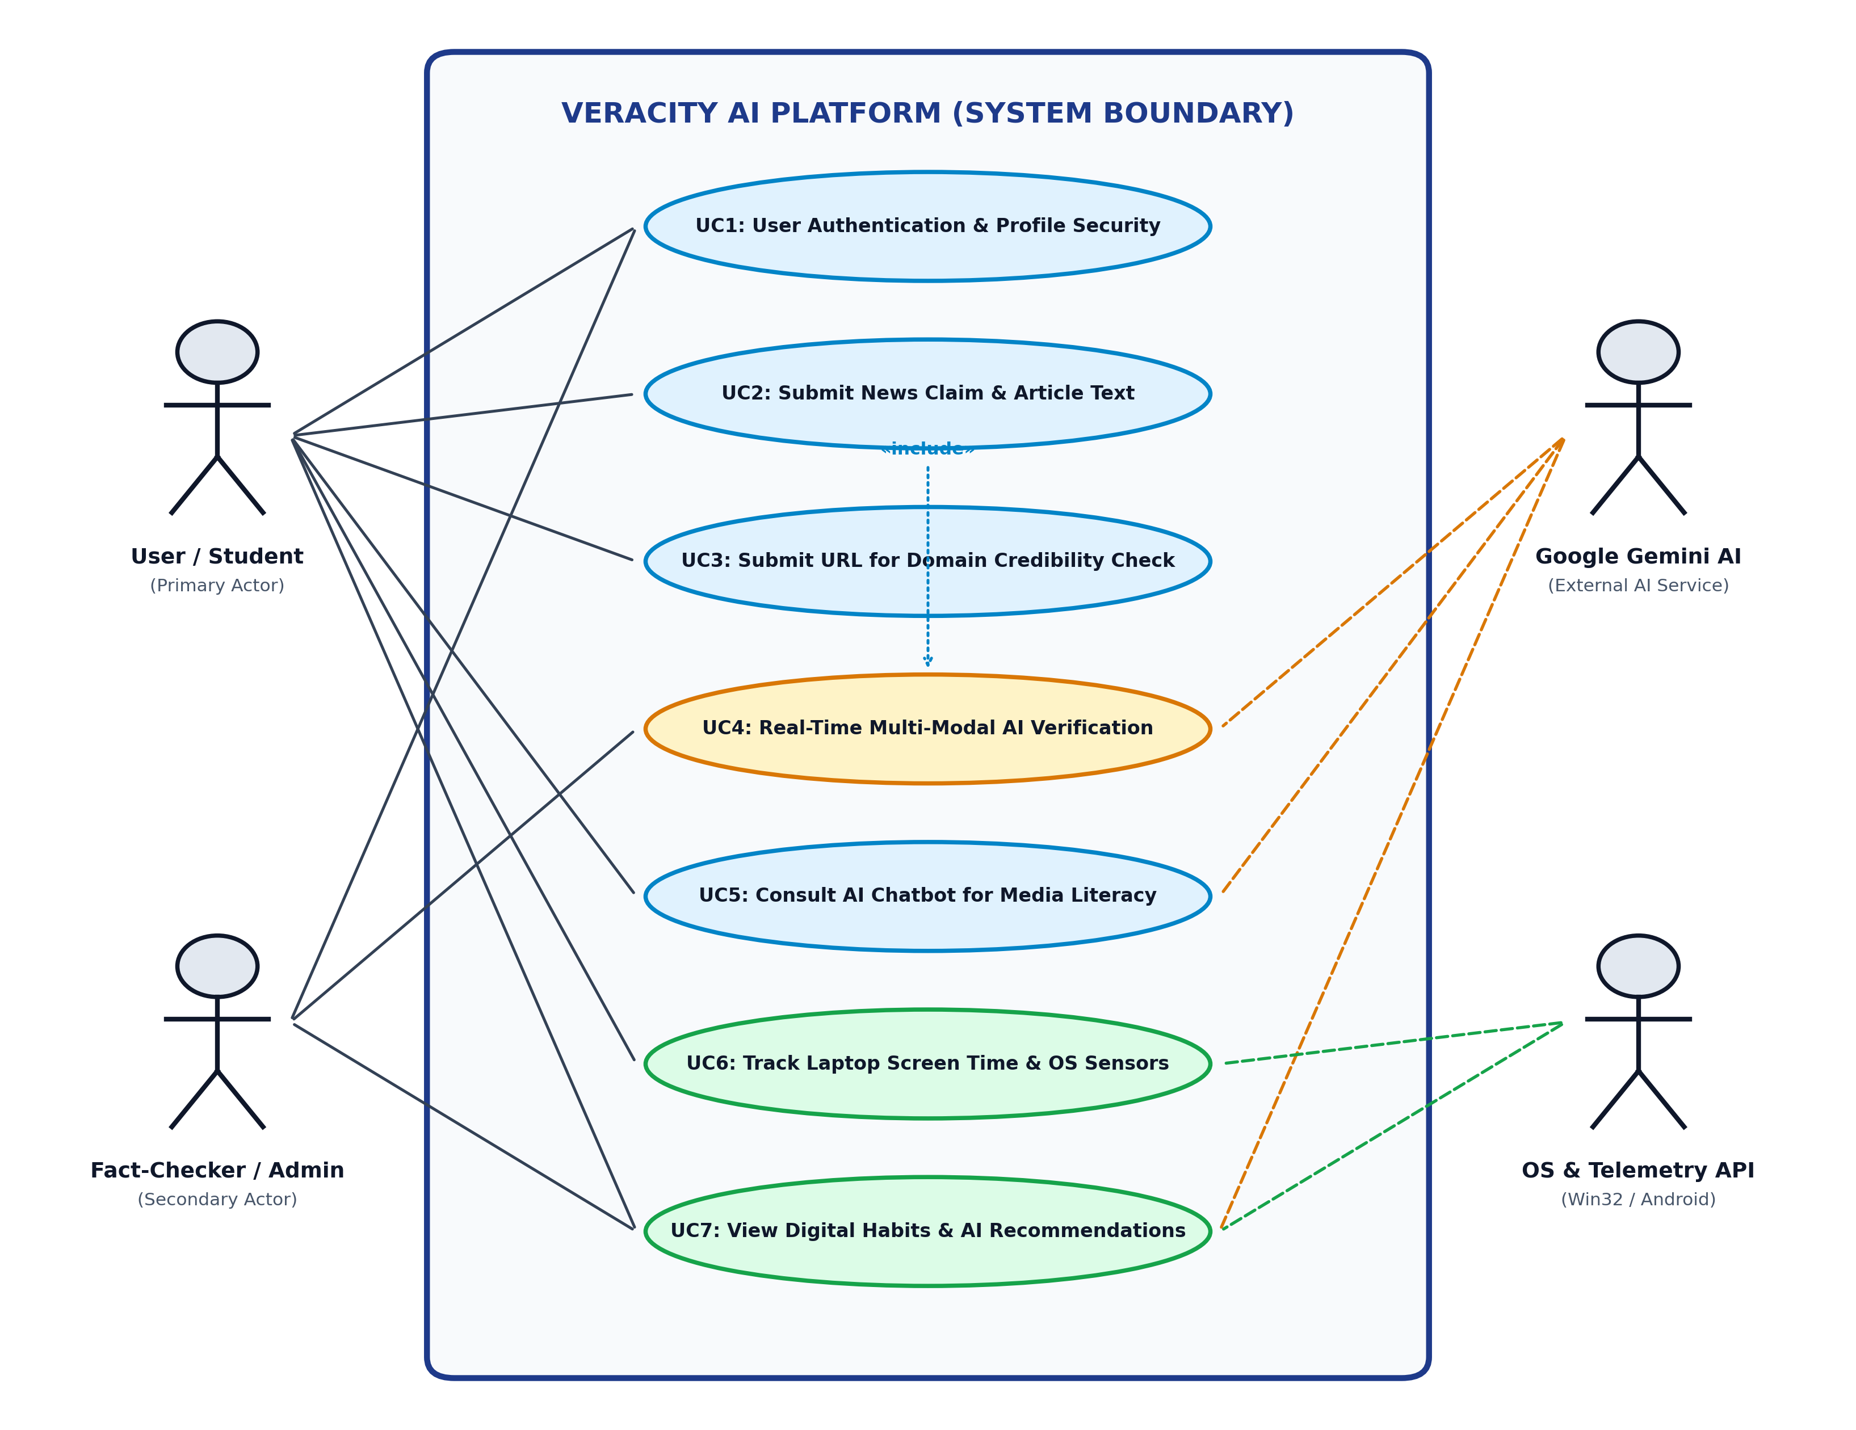
Figure 4.1: UML Use-Case Diagram for Veracity AI Platform

5.0 UML DIAGRAM 2: CLASS DIAGRAM
Subtitle: Static Domain Object Model, Class Compartments, and Structural Associations
The Class diagram visualizes the object-oriented structure of Veracity AI. Key classes include User and UserProfile (1-to-1 auth and student identity), VerificationCheck (encapsulating claim text, verdict enum, and confidence float), NLPEngine (handling TF-IDF vectorization and Gemini API calls), ScreenTimeRecord with AppUsageRecord composition, and LaptopMonitor (interfacing with Win32 kernel32/user32).
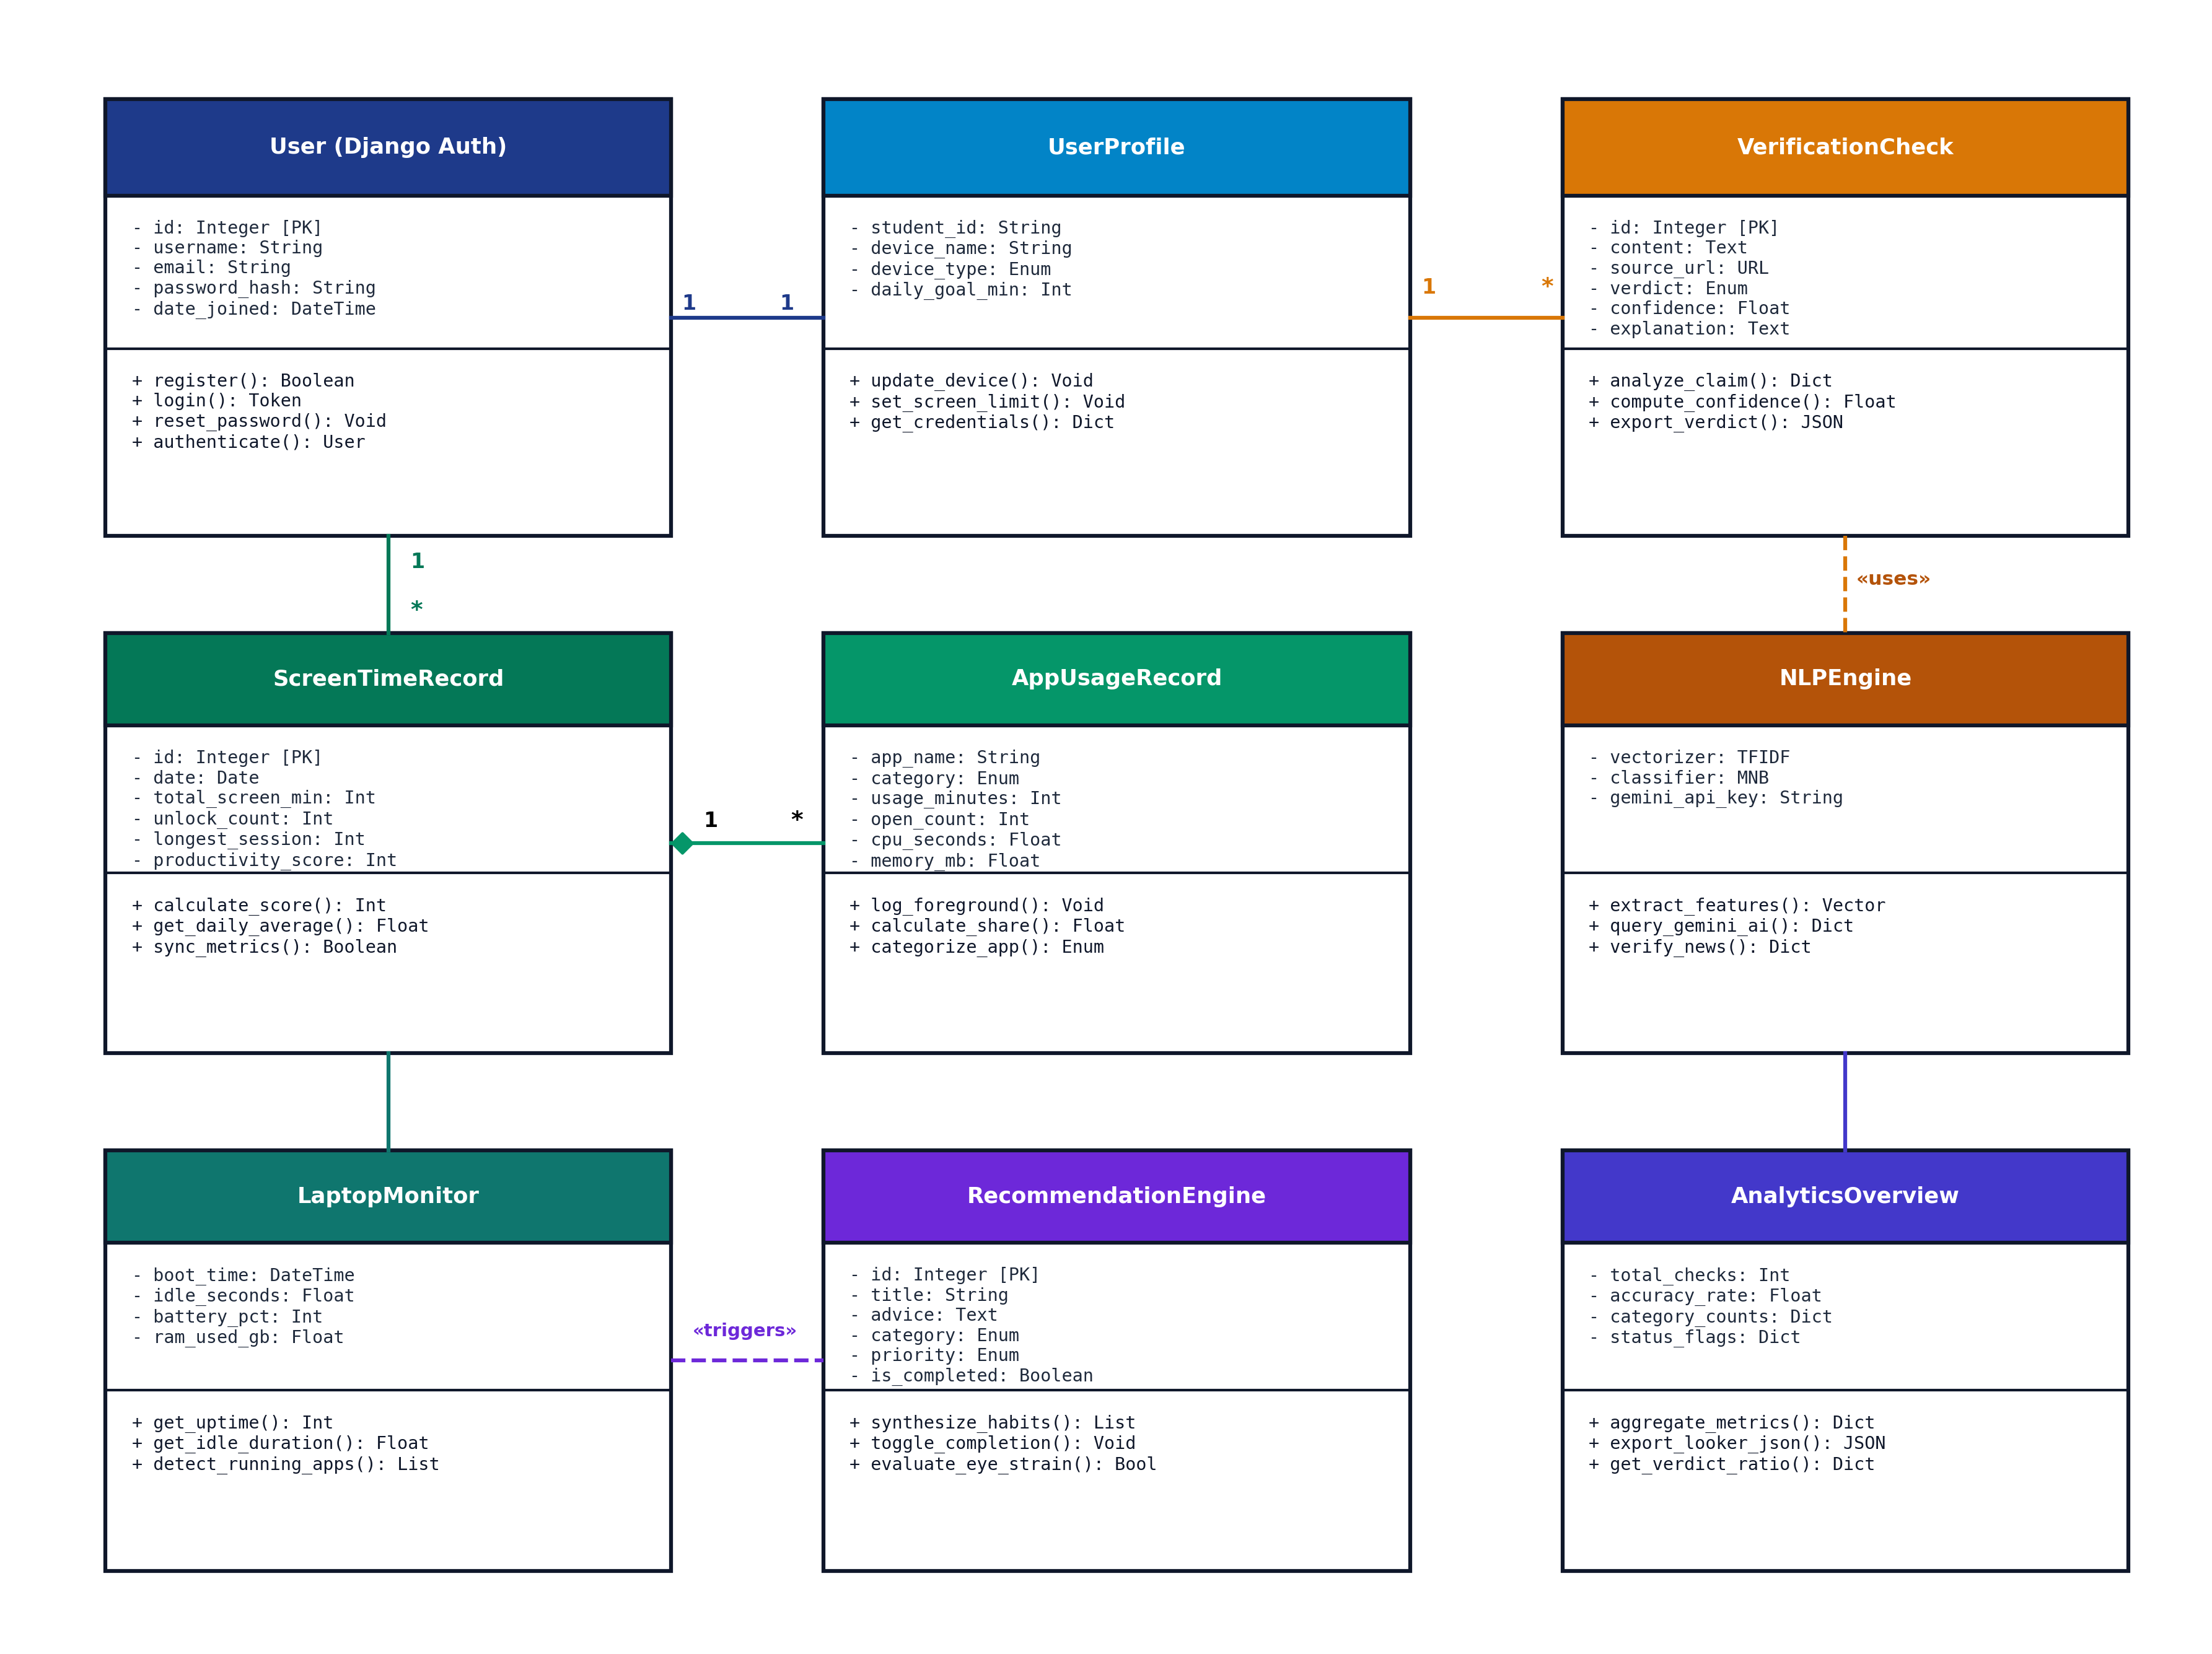
Figure 5.1: UML Class Diagram representing OOP Domain Architecture and ORM Entities

6.0 UML DIAGRAM 3: SEQUENCE DIAGRAM
Subtitle: Chronological Message Flow for Multi-Modal Claim Verification and Persistence
The Sequence diagram details the chronological message passing across lifelines: Client User -> React 19 Frontend -> Django REST API -> NLP / Scikit Engine -> Google Gemini 1.5 Cloud -> MySQL Database. It highlights asynchronous HTTP POST dispatching, structured JSON response synthesis, and live telemetry logging.
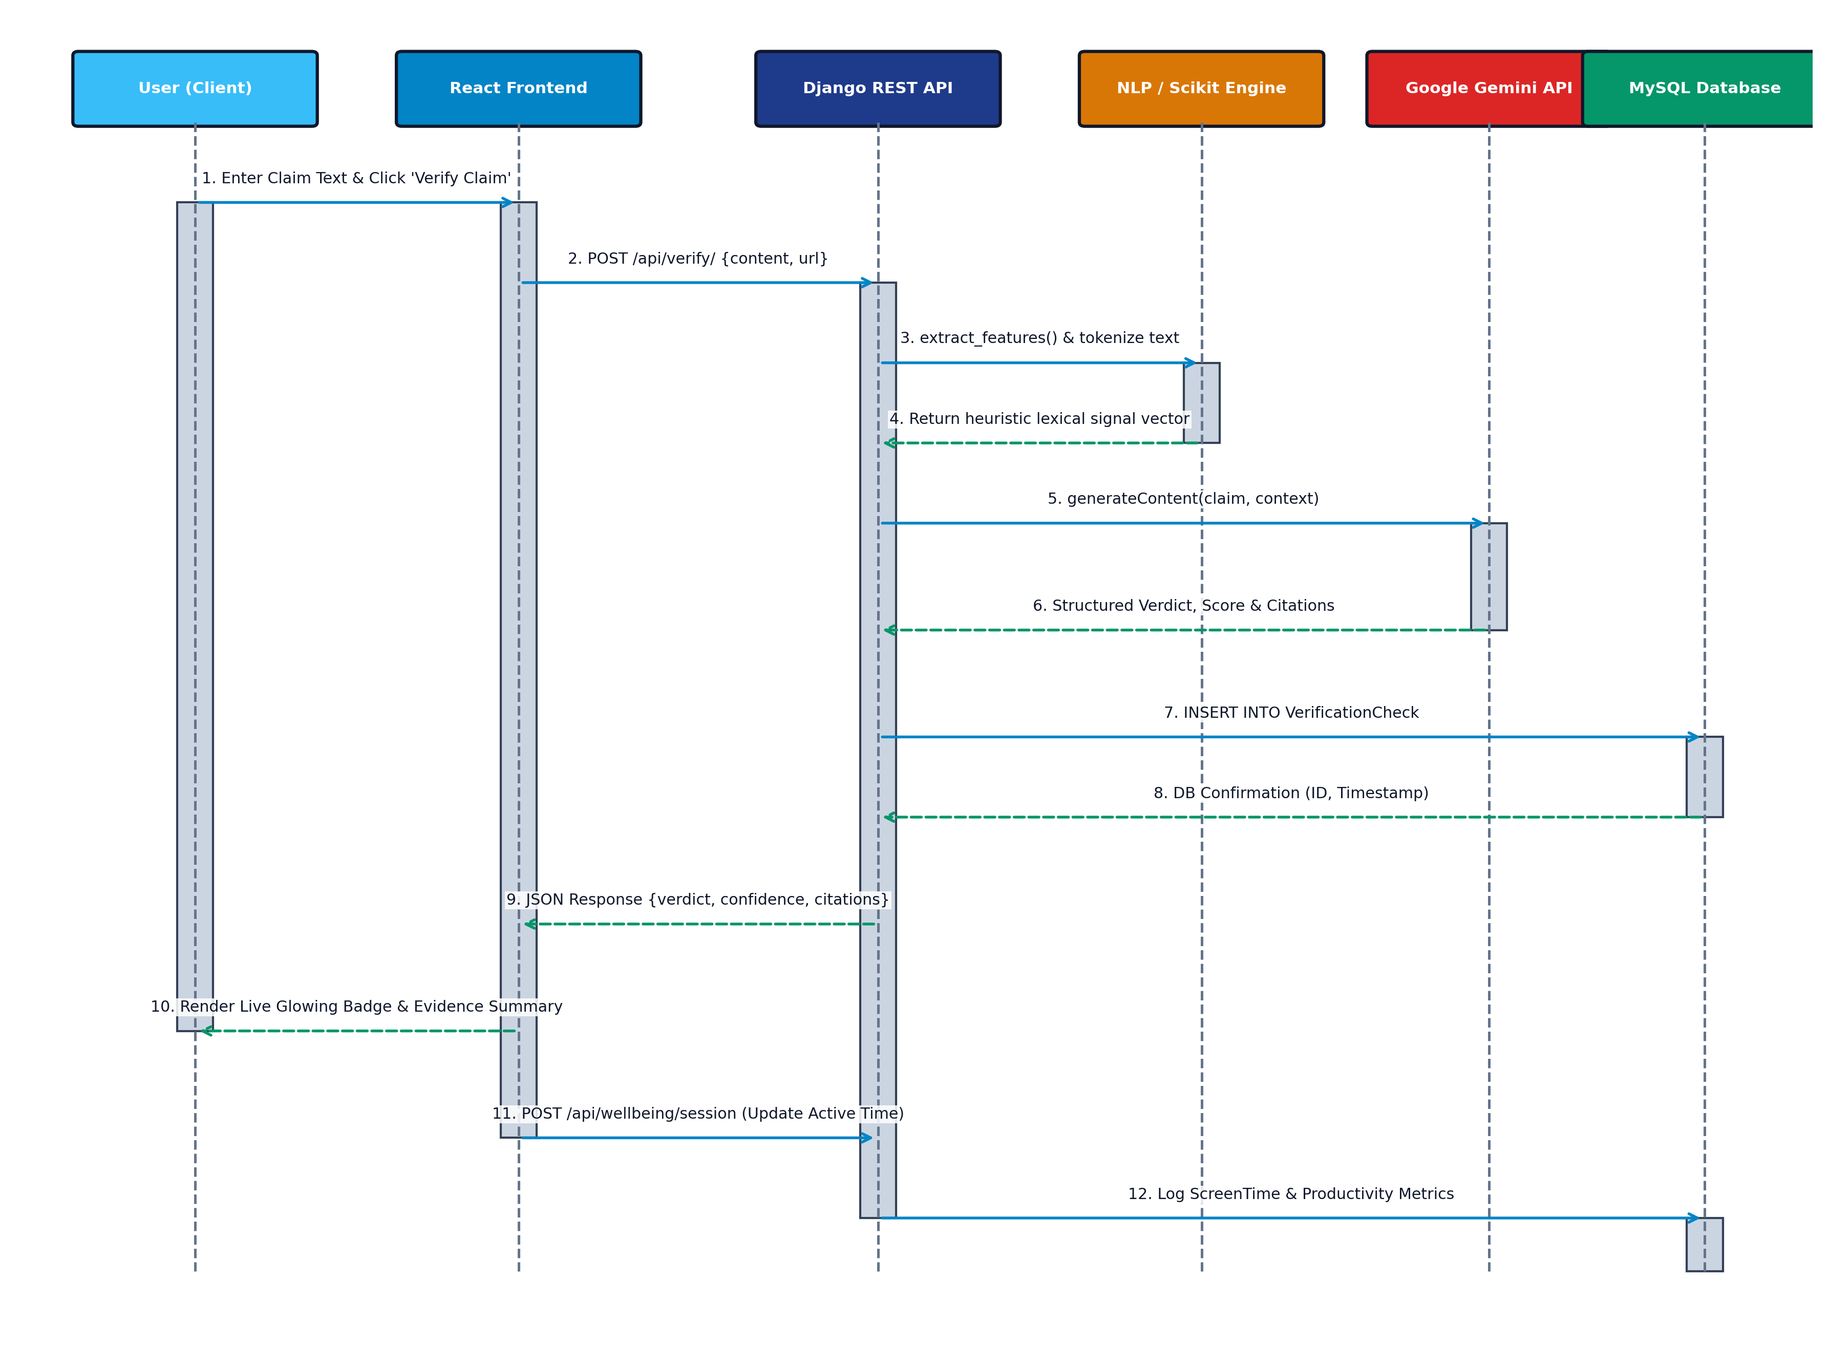
Figure 6.1: UML Sequence Diagram demonstrating Real-Time Claim Verification and Screen Logging

7.0 UML DIAGRAM 4: ACTIVITY DIAGRAM
Subtitle: Operational Logic, Decision Branches, and Concurrent Task Synchronization
The Activity diagram formalizes control flow through the system. It models input validation decision diamonds, parallel fork bars executing concurrent Scikit-learn TF-IDF analysis and Gemini AI grounded verification, join synchronization, database persistence, and automated conditional branching for screen breaks if active focus exceeds 45 minutes.
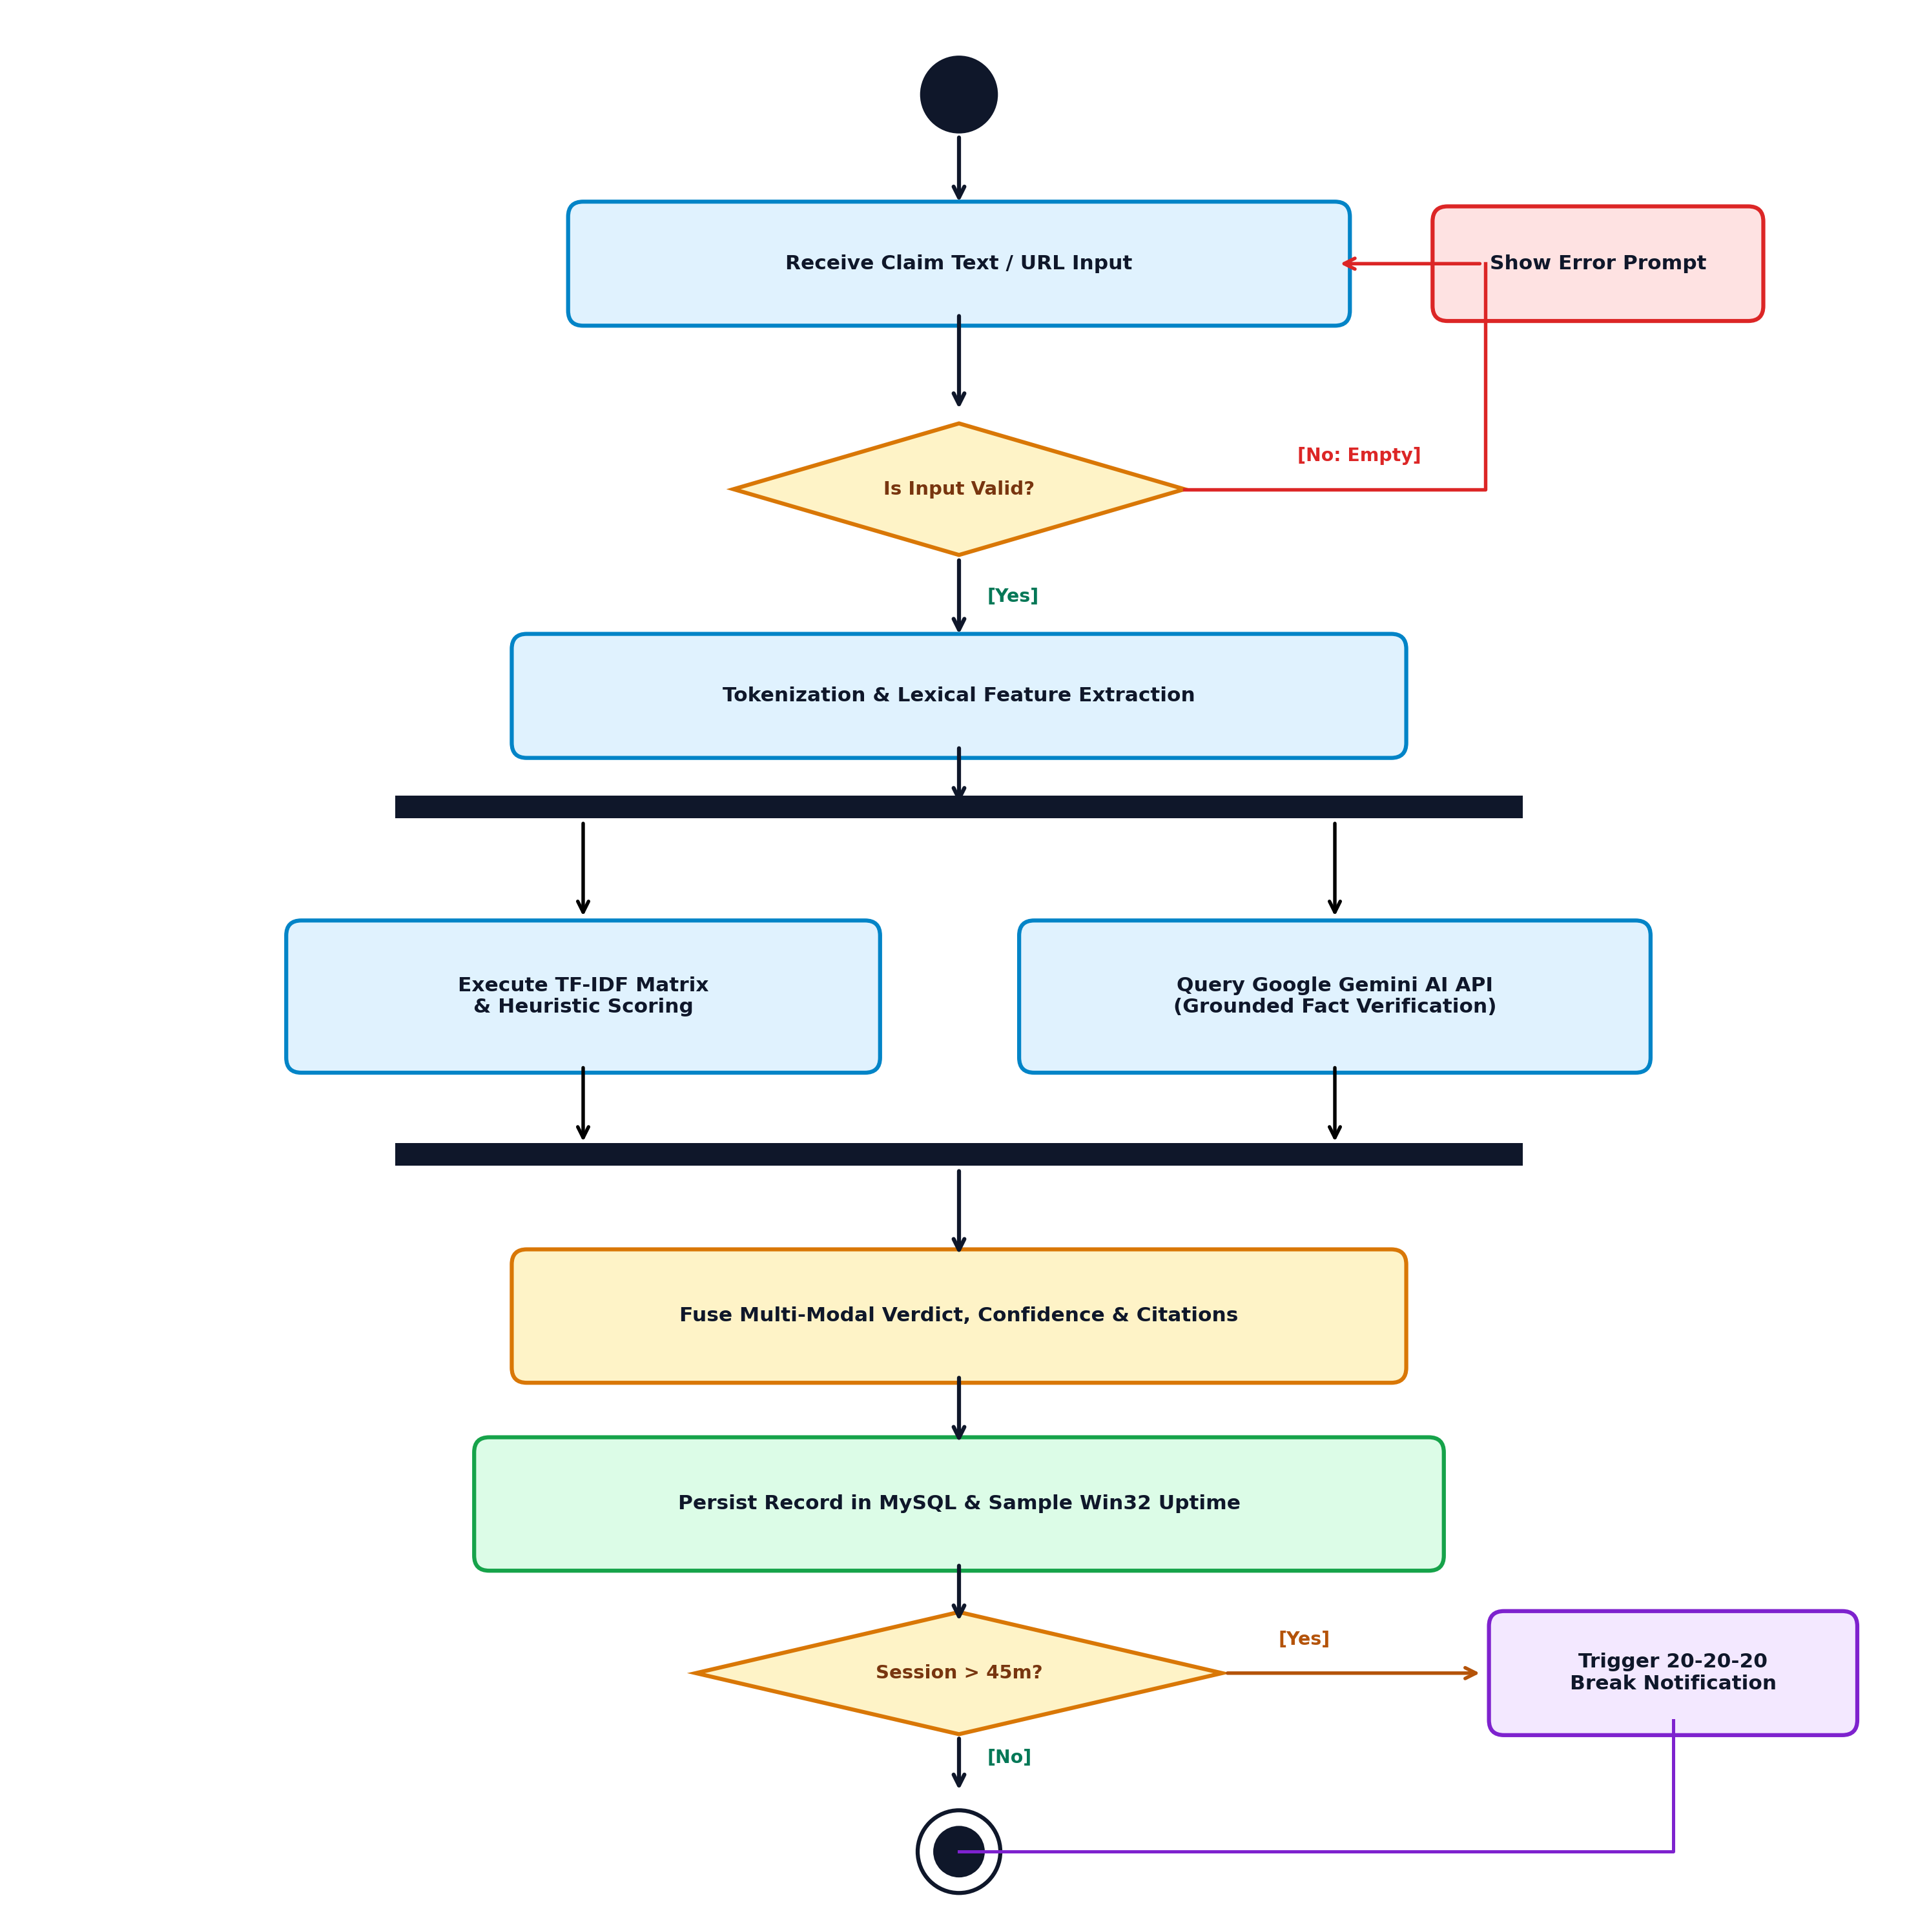
Figure 7.1: UML Activity Diagram illustrating Verification Fork/Join & Break Scheduling

8.0 UML DIAGRAM 5: STATE MACHINE DIAGRAM
Subtitle: Object State Transitions: Verification Lifecycle & Digital Wellbeing Modes
The State Machine diagram illustrates discrete state transitions for two core domains: (A) Claim Verification Lifecycle from Submitted to Processing, Evaluating, Verdicted (True/False/Misleading), and Archived; and (B) Digital Wellbeing States transitioning between System Booted, Active Focused, Idle / Paused, and Extended Screen Strain.
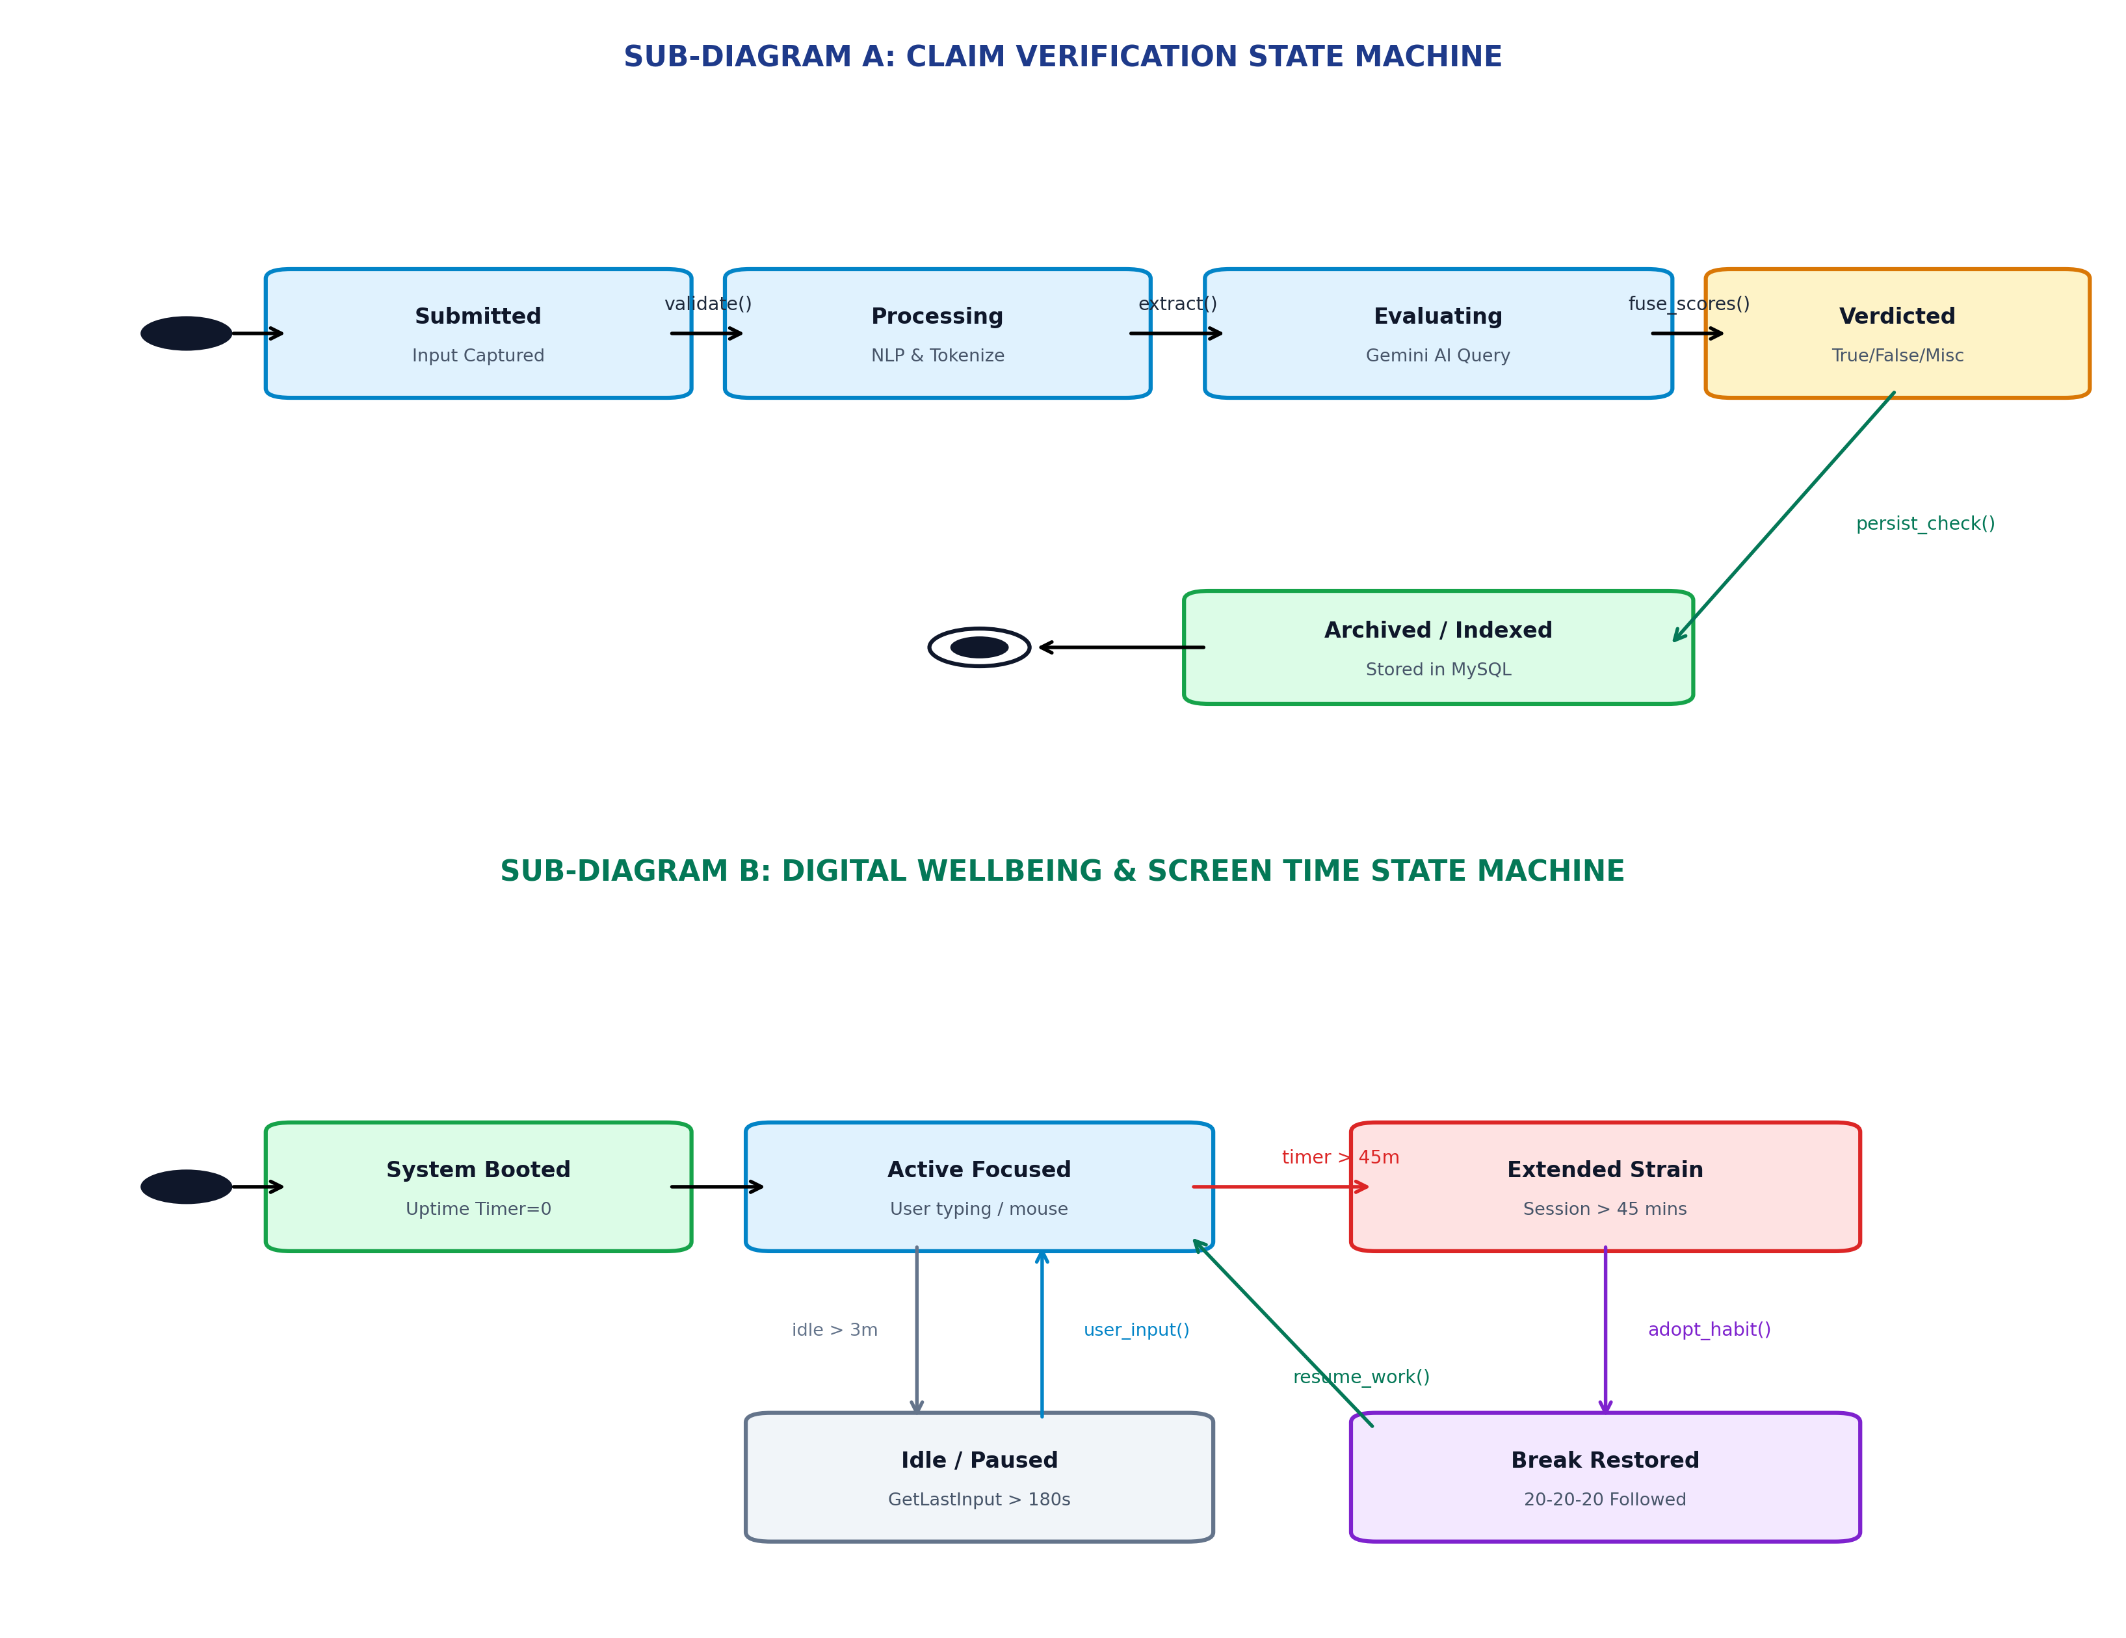
Figure 8.1: UML State Machine Diagram showing Claim Lifecycle & Screen Wellbeing Transitions

9.0 UML DIAGRAM 6: PACKAGE DIAGRAM
Subtitle: Multi-Tier Modular Subsystem Architecture and Inter-Package Dependencies
The Package diagram structures the application into layered, loosely-coupled packages: com.veracity.presentation (Next.js / React UI), com.veracity.api_controllers (Django REST Framework viewsets), com.veracity.ai_intelligence (Gemini and Scikit ML), com.veracity.telemetry (Win32 OS & Android bridge), and com.veracity.data_persistence (Django ORM & MySQL).
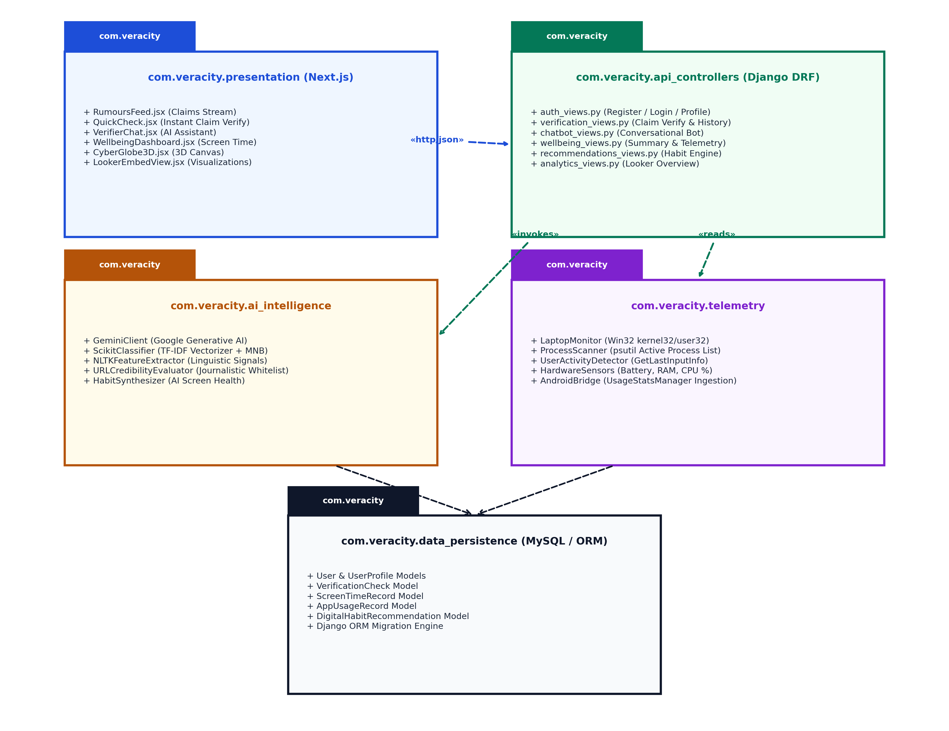
Figure 9.1: UML Package Diagram detailing Modular Layered Organization

10.0 UML DIAGRAM 7: COMPONENT & DEPLOYMENT DIAGRAM
Subtitle: Physical Hardware Nodes, Execution Environments, Artifacts, and Protocols
The Deployment diagram visualizes physical execution nodes and communication protocols: Client Workstation executing Chrome/Edge, Next.js Web Server (Port 3000), Django REST Backend (Port 8000), MySQL Relational Database Engine (TCP 3306), and Google Cloud Gemini API Server (HTTPS / TLS 1.3).
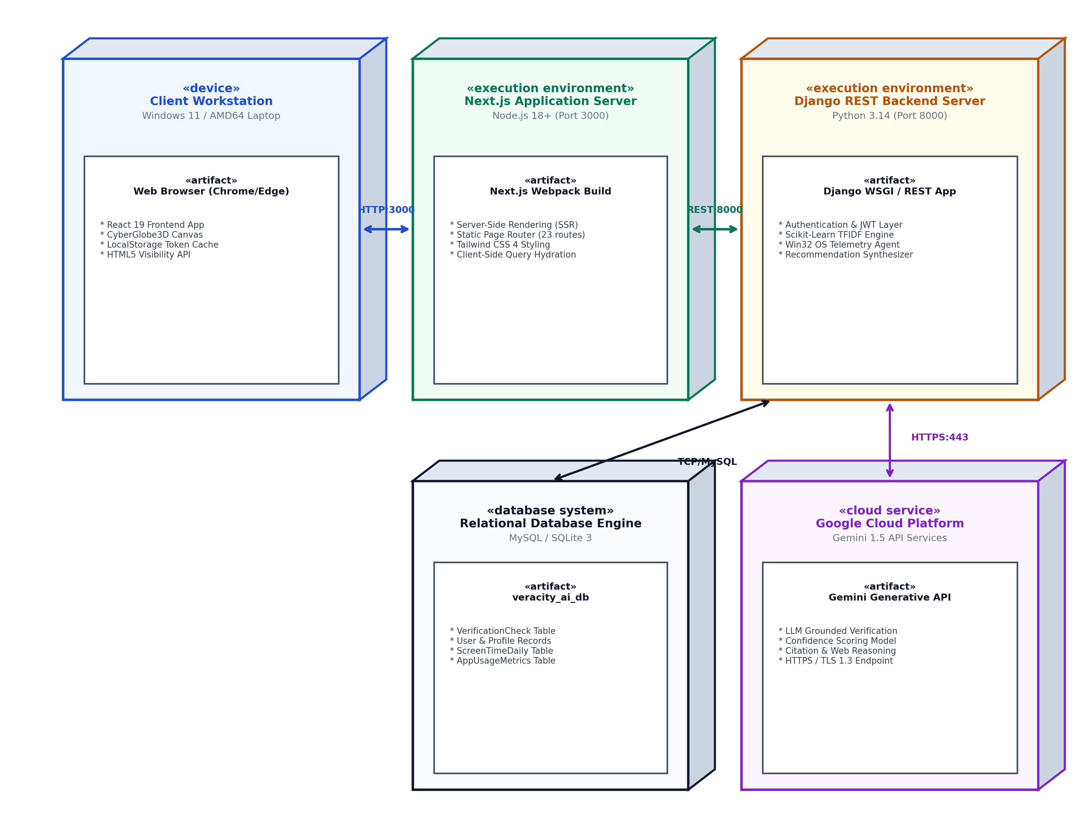
Figure 10.1: UML Deployment Diagram depicting Node Topology and Protocol Mapping

11.0 SOFTWARE ENGINEERING PRINCIPLES & CONCLUSION
The software architecture of VERACITY AI adheres to fundamental Software Engineering tenets, including Separation of Concerns (SoC), High Cohesion and Loose Coupling, Privacy by Design, and Modularity. By thoroughly capturing these architectural decisions in the complete suite of UML Design Diagrams, the system is fully specified for reliable deployment, rigorous maintenance, and academic assessment.
Submitted By:
DIVYANSHU YADAV
Roll Number: 25MCA00PY0036
Master of Computer Applications (MCA)
Mini Project Guide:
Dr. R. SUNITHA
Department of Computer Applications
Date: 30/10/2026

