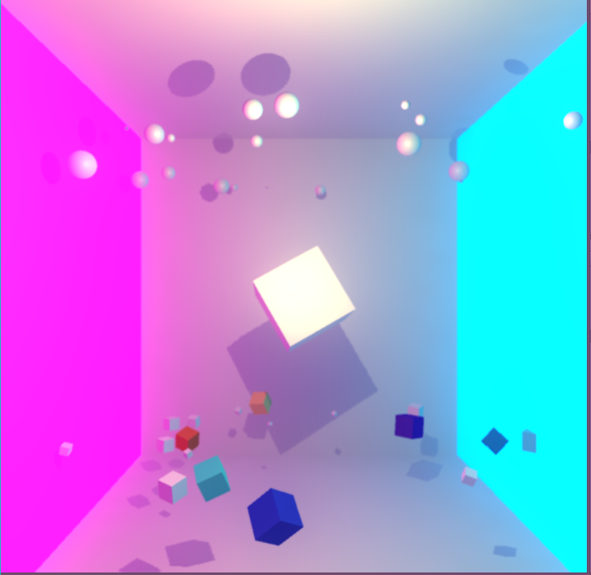Question 4 – Instead of all cubes create every second object as a sphere

Question 5 – change the colour of one cube every second

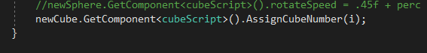The following code snippet from sketch.cs assigns a number value to each cube

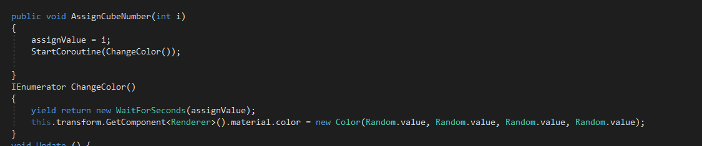Which is used in the cubeScript.cs code to generate the colour change every second using a co-routine

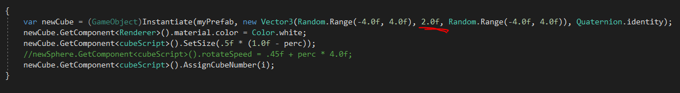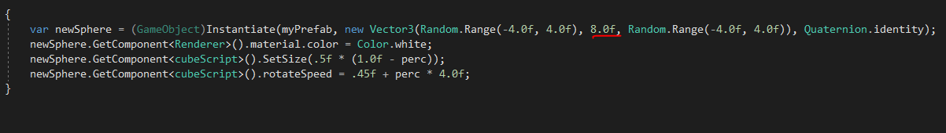Question 6 – Place the cubes at one Y position and the spheres at another

Question 7 – GitHub URL: <https://github.com/troy-anderson>