1. Write a Python program to print the calendar of a given month and year.
Note:
Take month and year input from the user
year in four digits format for example, 2003, 1997, 2018 etc.
month in digit format, for example 1 to 12.
If month and year are not in specified format display Invalid Input

AIM :

To write a Python program to print the calendar of a given month and
year.

PROGRAM :

import calendar as cal
year=int(input())
month=int(input())
if(year>999 and year<10000):
if(month>=1 and month<=12):
print(cal.month(year,month))
else:
print("Invalid Input")
else:
print("Invalid Input")

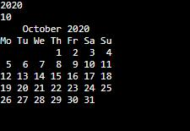
OUTPUT:

http://103.53.53.18/mod/vpl/forms/submissionview.php?id=229&userid=1668

RESULT :

Thus the python program of the calendar of a given month and year is
executed.

