3.Write a Python program to remove and print every second number from a list of
numbers until the list becomes empty.
Note:use function
Take input (total number of element in the list, list element) from the user and
call the function removeThirdNumber(int_list)).

AIM :

To remove and print every second number from a list of numbers until the
list becomes empty.
PROGRAM:
def removeThirdNumber(lst):
lst1=[]
pos=1
s=0
for i in range(0,len(lst)):
s=(pos+s)%len(lst)
el=lst.pop(s)
lst1.append(el)
return lst1
n=int(input())
int_list=[]
for i in range(0,n):
e=int(input())
int_list.append(e)
p=removeThirdNumber(int_list)
print(p)

OUTPUT :
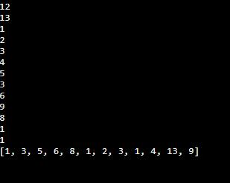

link : http://103.53.53.18/mod/vpl/forms/submissionview.php?id=231&userid=1668

RESULT :

Thus the python program to remove and print every second number
from a list of numbers until the list becomes empty.

