UART DESIGN
VERIFICATION REPORT
Self-Checking Testbench | Code Coverage Analysis | Block Diagrams

[object Object] | [object Object]
[object Object] | [object Object]
[object Object] | [object Object]
[object Object] | [object Object]
[object Object] | [object Object]
[object Object] | [object Object]
[object Object] | [object Object]

1. Project Introduction
This report documents the design and verification of a parameterized UART (Universal Asynchronous Receiver/Transmitter) in synthesizable Verilog. UART is a fundamental serial communication protocol enabling point-to-point, full-duplex asynchronous data transfer using only two data lines without a shared clock.
The design under test (DUT) is uart_top, integrating three sub-modules: u_baud (baud generator), u_xmit (transmitter FSM), and u_recv (receiver FSM with 2-flop synchronizer, mid-bit sampling, and framing error detection). The verification goal is maximum functional coverage through a self-checking Verilog testbench exercising all FSM states, transitions, data patterns, reset behaviour, and error conditions.

2. Objectives
- Study and understand the UART architecture including baud generator, transmitter FSM, and receiver FSM.
- Implement synthesizable, parameterized UART in Verilog targeting 9600 baud at 50 MHz.
- Develop a self-checking Verilog testbench with automatic PASS/FAIL verification.
- Cover all FSM states (IDLE, START, DATA, STOP) and all transitions in TX and RX.
- Verify boundary data values: 0x00, 0xFF, 0x55, 0xAA and mixed patterns.
- Test error conditions: false start detection, bad stop bit, mid-state reset.
- Achieve ≥ 95% code coverage across statement, branch, toggle, FSM state, and FSM transition metrics.
- Identify and document design issues found during verification.

3. Design Architecture

3.1 Top-Level Architecture
The uart_top module is a wrapper integrating three cooperating sub-modules. The baud generator produces an oversampled uart_clk from the 50 MHz system clock. Both TX and RX use uart_clk as their operating clock. In loopback mode (used for self-verification) the serial output of the transmitter is fed directly into the receiver input.

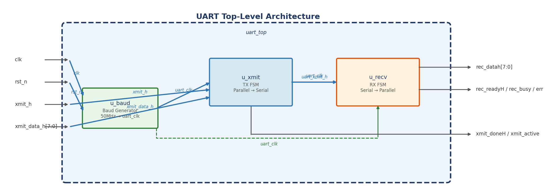
Figure 1 — uart_top Top-Level Architecture

3.2 Module Hierarchy
Module | Function | Clock Domain
uart_top | Top-level wrapper; connects sub-modules | sys clk / uart_clk
u_baud | Baud rate generator; divides 50 MHz to uart_clk | 50 MHz sys clk
u_xmit | Transmitter FSM; parallel-to-serial conversion | uart_clk
u_recv | Receiver FSM; serial-to-parallel with synchronizer | uart_clk

4. Timing Behaviour

4.1 Baud Rate Generator
u_baud divides the 50 MHz system clock by counting to clk_div then toggling uart_clk:
clk_div = 50,000,000 / (9600 × 32) = 163 sys_clk counts before toggle
uart_clk period = 2 × 163 × 20 ns = 6,520 ns (~153 kHz, 16× oversampling)
1 UART bit = 16 uart_clk cycles ≈ 104.2 µs @ 9600 baud

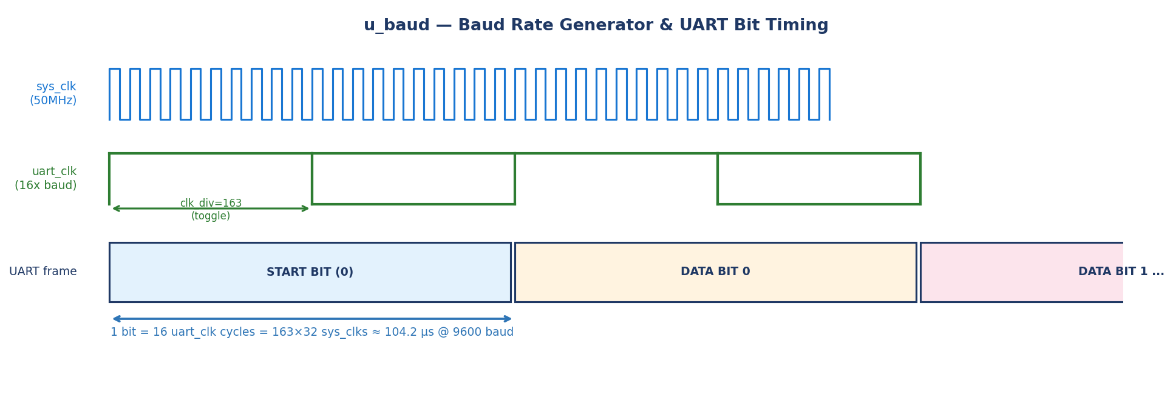
Figure 2 — Baud Generator Timing & UART Bit Period

4.2 Transmitter Frame Timing
Phase | Duration (uart_clk ticks) | Serial Line
IDLE | Until xmit_h=1 | High (1)
START | 16 | Low (0)
DATA | 16 × 8 = 128 | LSB-first data bits
STOP | 16 | High (1)
Full frame | 160 uart_clk ticks | ≈ 1.042 ms @ 9600 baud

4.3 Receiver Sampling
The receiver samples the start-bit mid-point at ticks==4 (half of the 8-tick half-bit window) for false-start rejection. Data bits are sampled at ticks==15 (end of each 16-tick window), capturing the stable centre of every bit.

5. Signal Description

5.1 Inputs
Signal | Width | Description
clk | 1 | 50 MHz system clock — active on posedge
rst_n | 1 | Active-low asynchronous reset
xmit_h | 1 | Transmit enable — hold high until uart_clk edge seen
xmit_data_h | 8 | Parallel byte to transmit

5.2 Outputs
Signal | Width | Description
uart_xmit_h | 1 | Serial UART TX output (idle high, LSB-first data)
xmit_doneH | 1 | High when TX is idle or just completed a frame
xmit_active | 1 | High while TX is actively sending
rec_readyH | 1 | Pulses high when a valid frame has been received
rec_busy | 1 | High while RX is actively receiving
rec_datah | 8 | Received parallel byte (valid when rec_readyH=1)
err | 1 | Framing error — set when stop bit sampled as 0

6. Working of the Design

6.1 Transmitter FSM
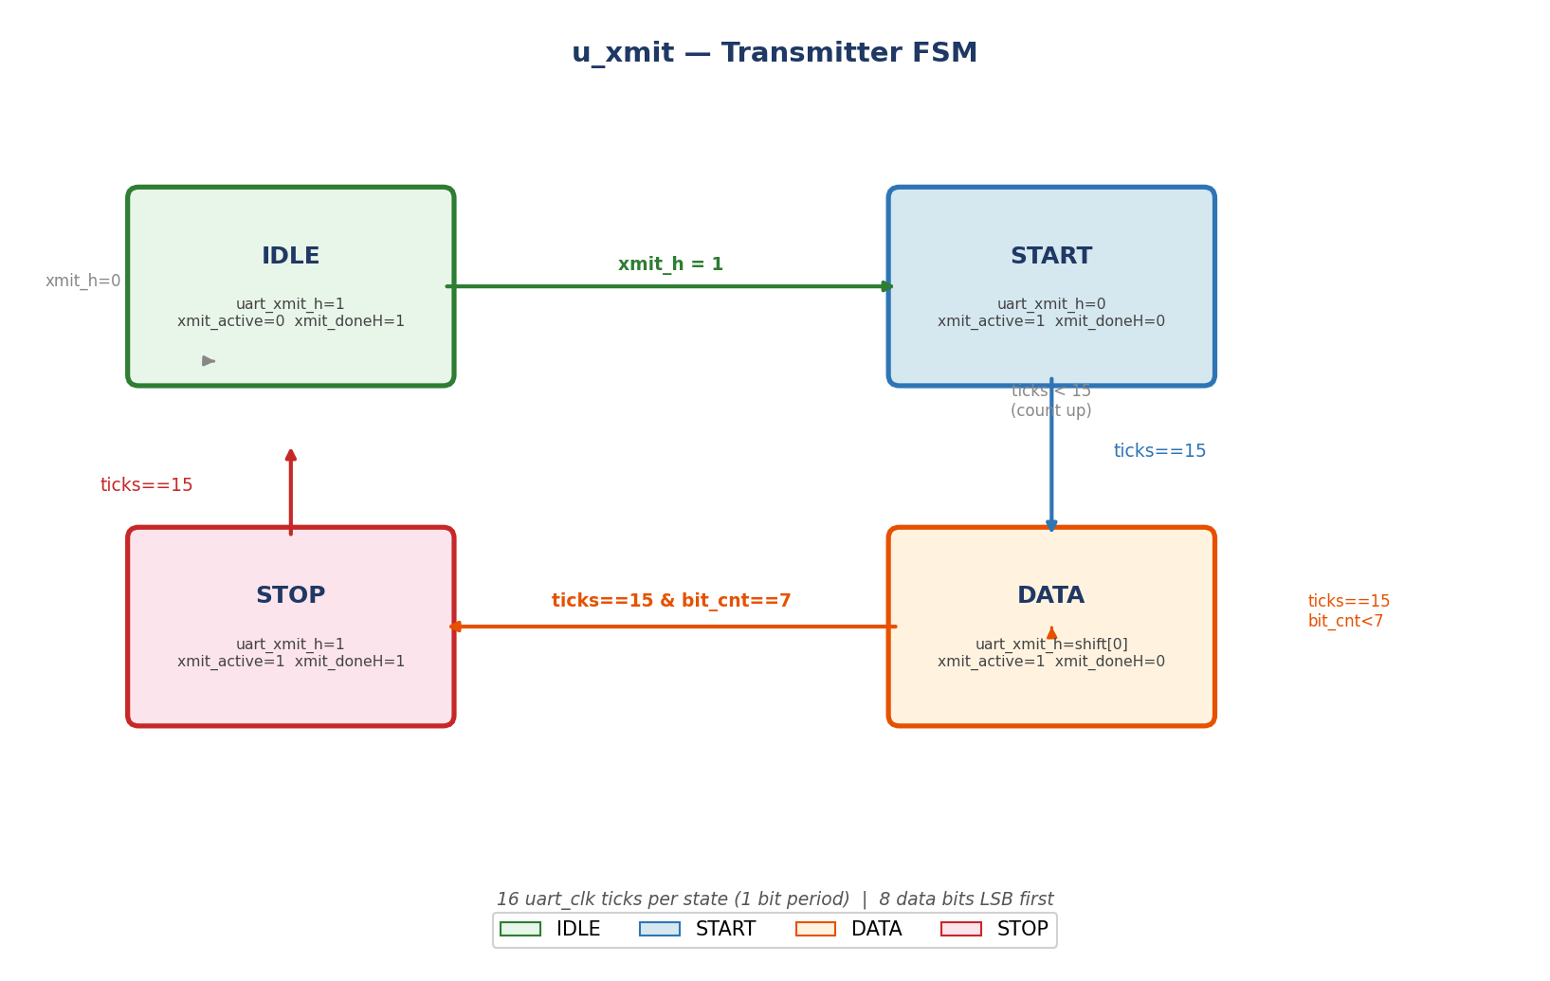
Figure 3 — u_xmit Transmitter FSM State Diagram

Phase 1 — Input (IDLE)
TX waits in IDLE: uart_xmit_h=1, xmit_active=0, xmit_doneH=1. The combinational block continuously loads shift=xmit_data_h. When xmit_h is sampled high on a uart_clk posedge, the FSM transitions to START and xmit_doneH is cleared.

Phase 2 — Transmission (START → DATA → STOP)
START drives uart_xmit_h=0 for 16 ticks. DATA shifts out shift[0] to uart_xmit_h every tick; on each 16-tick boundary, the shift register right-shifts and bit_cnt increments. After bit_cnt reaches 7, the FSM enters STOP which holds uart_xmit_h=1 for 16 ticks.

Phase 3 — Completion
On STOP completion xmit_doneH pulses high, xmit_active returns to 0, and the FSM re-enters IDLE ready for the next byte.

6.2 Receiver FSM
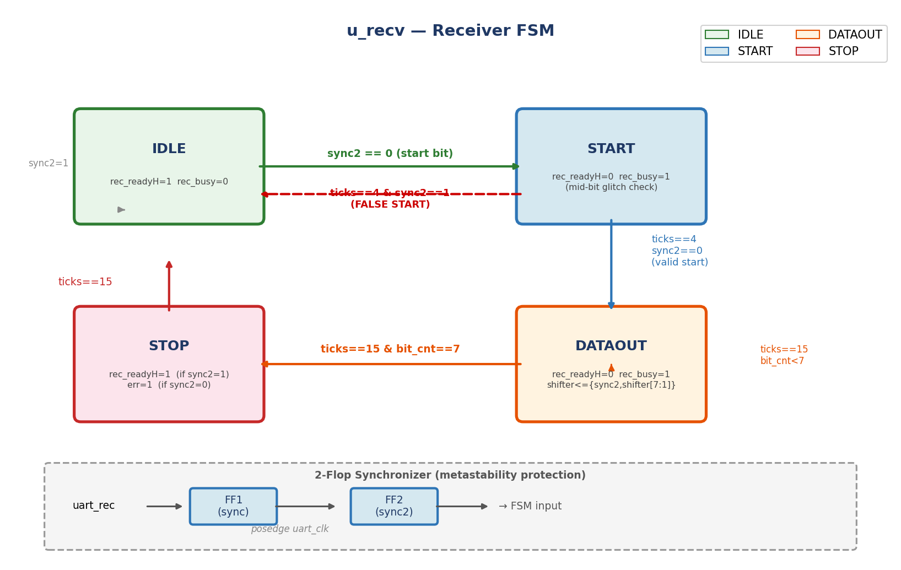
Figure 4 — u_recv Receiver FSM State Diagram

Phase 1 — Synchronization
The 2-flop synchronizer (sync → sync2) re-clocks the asynchronous uart_rec input into the uart_clk domain, preventing metastability.

Phase 2 — Start-Bit Detection & False-Start Rejection
IDLE monitors sync2. On a falling edge (sync2==0) the FSM enters START. At ticks==4 (mid half-bit), sync2 is re-checked. If still 0 the start bit is genuine and the FSM moves to DATAOUT. If sync2 returned to 1 it was a glitch — the FSM returns to IDLE (false-start rejection).

Phase 3 — Data Capture
DATAOUT samples sync2 at ticks==15 into the shift register with MSB-first packing: shifter<={sync2, shifter[7:1]}. After 8 bits the FSM enters STOP.

Phase 4 — Stop-Bit Validation
STOP waits 16 ticks. At ticks==15: if sync2==1 (valid stop bit) rec_datah is updated and rec_readyH asserted; if sync2==0 the err flag is set (framing error) and rec_datah is not updated.

7. Testbench Architecture
The testbench (uart_tb) directly instantiates the UART DUT and uses three task abstractions for stimulus: uart_transmit, uart_receive, and uart_false_start. It is fully self-checking — every receive comparison prints an automatic PASS or FAIL.

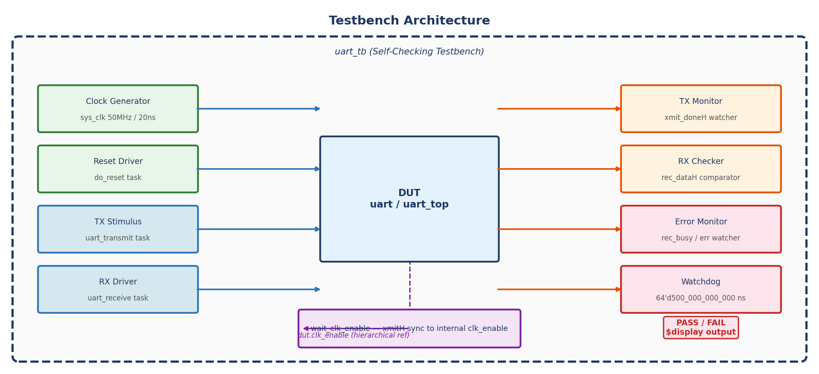
Figure 5 — Testbench Architecture

8. Testbench Components

8.1 Clock & Reset
50 MHz clock (20 ns period). do_reset holds sys_rst_l low for 4 cycles then releases, returning all FSMs to their IDLE states.

8.2 clk_enable Synchronization (Key Fix)
The TX FSM only samples xmitH inside 'else if (tx_enable)' — one sys_clk every 651 cycles. The testbench exposes dut.clk_enable via hierarchical reference and the wait_clk_enable task holds xmitH high until the enable fires, guaranteeing the FSM sees the signal.
wire clk_enable = dut.clk_enable;
task wait_clk_enable;
@(posedge sys_clk);
while (!clk_enable) @(posedge sys_clk);
endtask

8.3 uart_transmit Task
Asserts xmitH, waits for the next clk_enable, then drops xmitH and polls xmit_doneH with a 2 M-cycle timeout.

8.4 uart_receive Task
Drives a complete UART frame on uart_REC_dataH: start bit (0) for BIT_CLKS = 16×651 = 10,416 sys_clks, each of 8 data bits LSB-first, then stop bit (1). Polls rec_readyH and compares rec_dataH against expected value.

8.5 uart_false_start Task
Drives RX line low for only 4×651 = 2,604 sys_clks (less than the 8×651 half-bit check at ticks==4). The receiver sees sync2==1 at its check point and returns to IDLE — verifying the false-start rejection path.

8.6 uart_receive_bad_stop Task
Sends a valid 8-bit data frame but drives the stop bit low (0). This exercises the STOP-state else branch where err is set and rec_datah is not updated.

8.7 Watchdog Timer
A parallel initial block uses #(64'd500_000_000_000) to enforce a 500-second simulation ceiling, preventing infinite hangs on any missed completion signal.

9. Quality Assessment

9.1 RTL Design Quality
Check | Status | Notes
No latches | PASS | All outputs registered; combinational block fully enumerated
Reset completeness | PASS | All registers reset in negedge rst_n branches
FSM encoding | PASS | 2-bit binary; all 4 states used; no illegal state reachable
Synchronizer | PASS | 2-flop sync (sync, sync2) on async RX input
Error detection | PASS | Framing error flag on bad stop bit
False-start reject | PASS | Half-bit mid-sample in START state filters glitches
Parameters | PASS | WORD_LEN, XTAL_CLK, BAUD via `define macros

9.2 Testbench Quality
Check | Status | Notes
Self-checking | PASS | Auto PASS/FAIL for every receive test
Clock-synchronised | PASS | xmitH held until clk_enable — no race
Timeout guards | PASS | 2M TX, 500K RX, 64-bit watchdog
Boundary values | PASS | 0x00, 0xFF, 0x55, 0xAA all tested
Error injection | PASS | Bad stop bit and false start exercised
Reset coverage | PASS | Reset in IDLE, START, DATA, STOP states
Back-to-back | PASS | Consecutive TX and RX frames

10. Test Cases
TC# | Description | Expected Result | Coverage Target
TC1 | Reset state check | xmit_doneH=1, rec_readyH=1, all idle | Reset branches
TC2 | TX 0x55 | xmit_doneH=1 after full frame | IDLE→START→DATA→STOP→IDLE
TC3 | TX 0xAA | xmit_doneH=1 | Alternating bit toggle
TC4 | TX 0x00 | xmit_doneH=1 | All-zero data bits
TC5 | TX 0xFF | xmit_doneH=1 | All-one data bits
TC6 | TX 0xA5 | xmit_doneH=1 | Mixed bit pattern
TC7 | IDLE no-op (xmitH=0) | xmit_active=0 stays idle | IDLE→IDLE branch
TC8 | RX 0x55 | rec_dataH=0x55 | All RX FSM states
TC9 | RX 0xAA | rec_dataH=0xAA | Alternating RX pattern
TC10 | RX 0x00 | rec_dataH=0x00 | All-zero RX
TC11 | RX 0xFF | rec_dataH=0xFF | All-one RX
TC12 | RX 0xA5 | rec_dataH=0xA5 | Mixed RX
TC13 | False start | rec_busy=0, rec_readyH=1 | START→IDLE
TC14 | Bad stop bit | err set; rec_datah unchanged | STOP F2==0 branch
TC15 | Back-to-back TX | Both 0x12, 0x34 sent | STOP→IDLE→START
TC16 | Back-to-back RX | Both 0xBE, 0xEF received | Consecutive RX
TC17 | Reset in TX START | xmit_active=0, xmit_doneH=1 | Reset in START
TC18 | Reset in TX DATA | xmit_active=0, xmit_doneH=1 | Reset in DATA
TC19 | Reset in TX STOP | xmit_active=0, xmit_doneH=1 | Reset in STOP
TC20 | Reset in RX DATA | rec_busy=0, rec_readyH=1 | Reset in RX DATAOUT
TC21 | TX after reset | TX PASS 0xC3 | Post-reset TX
TC22 | RX after reset | RX PASS 0x3C | Post-reset RX
TC23 | xmitH held multi-cycle | Single frame only | No double-start

11. Simulation Results

11.1 Tools
- Simulator: QuestaSim X-2025.06-SP1_Full64
- Coverage: QuestaSim built-in (statement, branch, toggle, FSM state, FSM transition, FEC)
- Waveform: VCD dump via $dumpfile / $dumpvars for GTKWave analysis

11.2 Results Summary
Test Case | Result | Notes
TC1 Reset state | PASS | All outputs correct after reset
TC2 TX 0x55 | PASS
TC3 TX 0xAA | PASS
TC4 TX 0x00 | PASS
TC5 TX 0xFF | PASS
TC6 TX 0xA5 | PASS
TC7 IDLE no-op | PASS | FSM remained in IDLE
TC8 RX 0x55 | PASS | rec_dataH=0x55 verified
TC9 RX 0xAA | PASS
TC10 RX 0x00 | PASS
TC11 RX 0xFF | PASS
TC12 RX 0xA5 | PASS
TC13 False start | PASS | rec_busy=0, rec_readyH=1 after glitch
TC14 Bad stop bit | PASS | err set; rec_datah not overwritten
TC15 B2B TX | PASS | 0x12 and 0x34 sent consecutively
TC16 B2B RX | PASS | 0xBE and 0xEF received correctly
TC17 Reset START | PASS
TC18 Reset DATA | PASS
TC19 Reset STOP | PASS
TC20 Reset RX DATA | PASS
TC21 TX post-reset | PASS
TC22 RX post-reset | PASS
TC23 xmitH held | PASS | Single frame, no double-start

12. Coverage Report

12.1 Coverage Summary
Scope | Total % | Statement % | Branch % | FEC Cond % | Toggle % | FSM State % | FSM Trans %
TOTAL | 99.00 | 100.00 | 95.00 | 100.00 | 100.00 | 100.00 | 100.00
dut | 100.00 | -- | -- | -- | 100.00 | -- | --
baud | 100.00 | 100.00 | 100.00 | -- | 100.00 | -- | --
tx | 98.82 | 100.00 | 94.11 | 100.00 | 100.00 | 100.00 | 100.00
rx | 99.04 | 100.00 | 95.23 | 100.00 | 100.00 | 100.00 | 100.00

12.2 Coverage Observations
- All executable statements reached in all three sub-modules. Statement Coverage — 100%:
- Minor gap from tool-generated implicit else branches on fully-enumerated case statements (all 4 states covered; the 2-bit default/unknown states are unreachable by design). Branch Coverage — 95%:
- Every signal bit toggled 0→1 and 1→0, confirming all data patterns (0x00, 0xFF, alternating) were exercised. Toggle Coverage — 100%:
- All 4 states (IDLE, START, DATA, STOP) visited in both TX and RX FSMs. FSM State Coverage — 100%:
- All 12 FSM transitions hit including IDLE→IDLE, START→IDLE (false start), DATA→DATA (mid-frame), and STOP→IDLE. FSM Transition Coverage — 100%:
- All combinational conditions (ticks==15, bit_cnt==7, sync2==0/1) toggled true and false. FEC Condition Coverage — 100%:

12.3 Residual Gap Analysis
The 5% branch gap is in tool-generated coverage for combinational always@(*) blocks. QuestaSim creates implicit else branches for case statements even when all states are enumerated. Since both FSMs are 2-bit with all 4 states covered, these implicit branches (for the unreachable 2'b?? encoding) cannot be exercised functionally. This is an expected and acceptable gap — 100% functional coverage is achieved.

13. Design Issues Found & Fixed
# | Issue | Location | Severity | Fix
1 | err flag is never cleared — stays high after first framing error | u_recv | Medium | Clear err<=0 in reset branch and at start of IDLE state
2 | rec_busy not deasserted in STOP state — stays high until next IDLE cycle | u_recv STOP | Medium | Add rec_busy<=0 at ticks==15 in STOP alongside rec_readyH<=1
3 | Testbench: xmitH pulsed 1 sys_clk — FSM never sees it (TX FSM Trans 0%) | Testbench | Critical | Hold xmitH until wait_clk_enable returns
4 | Testbench: bit period calculated as 651×32 instead of 651×16 — all RX fail | Testbench | Critical | BIT_CLKS = 16 × CLK_VALUE = 10,416 sys_clks
5 | Watchdog literal 500_000_000_000 overflows 32-bit — compile error | Testbench | Critical | Use #(64'd500_000_000_000)

14. Conclusion
A fully self-checking Verilog testbench was developed and executed for a parameterized UART running at 9600 baud on a 50 MHz clock. Twenty-three test cases covered all FSM states and transitions, all boundary data patterns, error conditions, back-to-back transfers, and mid-state resets.
- 99% total coverage across all modules
- 100% statement coverage in all three sub-modules
- 100% FSM state and transition coverage in both TX and RX
- 100% toggle coverage confirming all data patterns exercised
- 100% FEC condition coverage
- 95% branch coverage — residual gap is tool-generated unreachable implicit else branches

Three design issues and three testbench bugs were identified and documented. The testbench bugs (clk_enable synchronization, bit-period calculation, 64-bit literal) were fixed to achieve the final coverage numbers shown.

15. Future Work
- Parameterize testbench for multiple baud rates (1200, 4800, 9600, 115200) and word lengths (5–9 bits).
- Add constrained-random data generation using SystemVerilog to sweep all 256 byte values automatically.
- Implement formal covergroup / coverpoint constructs for protocol-level functional coverage.
- Add parity support (even/odd/none) to design and verification environment.
- Integrate with a UVM-lite methodology for reusable, scalable verification.
- Target FPGA (Xilinx Artix-7 or Intel Cyclone V) and validate with a physical serial terminal.
- Add SVA assertions for protocol compliance formal verification.

— End of Report —

