PARAMETERIZED ALU
DESIGN & VERIFICATION REPORT

Submitted by
Tanishq
Batch 11

FE Tools Training Program

May 2026

1. Project Introduction

This project presents the design and functional verification of a parameterized 8-bit Arithmetic Logic Unit (ALU) implemented in synthesizable Verilog. The ALU supports a comprehensive set of arithmetic and logical operations, organized under two operating modes, controlled via a single Mode bit.
The design is synchronous, operating on the rising edge of a clock (CLK), with asynchronous active-high reset (rst) and clock-enable (ce) support. Operands are registered internally on the first clock cycle, and results are produced on subsequent cycles — making the ALU a pipelined, multi-cycle design for certain complex operations.
The parameterized nature of the design (data_width) allows the ALU to be scaled from 2-bit to n-bit wordlengths without any modification to the RTL code, enabling reuse across different system configurations.
Verification is accomplished through a self-checking SystemVerilog testbench that computes expected outputs in parallel with the DUT and compares results after appropriate latency, using a structured test matrix of 83 test cases covering valid operations, invalid operand combinations, corner cases, and pipeline stress scenarios.

2. Objectives

- Study and understand the architectural requirements for a multi-mode, pipelined ALU.
- Design a parameterized, synthesizable Verilog RTL implementation supporting 14 arithmetic and 14 logical operations.
- Implement proper pipeline stages for multi-cycle operations (incr_mult, shift_mult) with a cnt-based controller.
- Develop a comprehensive self-checking SystemVerilog testbench with parallel expected-value computation.
- Verify correctness across normal cases, edge cases, invalid INP_valid encodings, and mid-operation signal changes.
- Achieve maximum code and functional coverage using Questa SIM's coverage reporting tools.
- Analyze and document the ALU's timing behaviour, operation semantics, and verification results.

3. Design Architecture

The ALU is implemented as a single Verilog module with a configurable data width parameter. Internally, it is organized into three always blocks: an input registration block, a pipeline controller block, and a combinational logic block.

3.1 Module Ports
Signal | Width | Description
opa | [N-1:0] | Operand A – primary arithmetic/logic input
opb | [N-1:0] | Operand B – secondary input or shift/rotate amount
cin | 1 | Carry-in for add_cin and sub_cin operations
CLK | 1 | System clock – rising edge triggered
rst | 1 | Asynchronous active-high reset
ce | 1 | Clock enable – freezes pipeline when deasserted
Mode | 1 | 0 = Logical operations; 1 = Arithmetic operations
INP_valid | [1:0] | Operand validity: 2'b01=A only, 2'b10=B only, 2'b11=Both
Cmd | [3:0] | 4-bit operation select code (0–12 valid, Mode-dependent)

Output Signals
Signal | Width | Description
res | [2N-1:0] | Result register – double-width to accommodate multiplication
oflow | 1 | Overflow flag for signed/unsigned arithmetic
cout | 1 | Carry-out flag for unsigned addition
g / l / e | 1 each | Greater-than, Less-than, Equal-to flags for comparator operation
err | 1 | Error flag: asserted on invalid INP_valid or unsupported Cmd

4. Timing Behaviour

The ALU uses a two-stage pipeline for most operations and a three-stage pipeline for the two multiplication operations (incr_mult, shift_mult).

Operation Class | Latency (Cycles) | Notes
All Logical Operations | 2 | Inputs sampled at cycle 1, result at cycle 2
Most Arithmetic Ops | 2 | add, sub, inc, dec, cmp, signed_add/sub
incr_mult / shift_mult | 3 | cnt counts 0→1→2; result registered at cnt==2

The cnt register is incremented by the pipeline controller on each clock edge when ce is high and a multi-cycle operation is in progress. When cnt reaches 2, the computed process_r value is latched into res and cnt resets to 0.
The ce (clock enable) signal freezes the entire pipeline when deasserted — no new inputs are sampled and no outputs are updated. This behaviour was verified by the TC_41 and TC_48 mid-operation CE toggle tests.

5. Supported Operations

5.1 Logical Operations (Mode = 0)
Cmd | Operation | INP_valid | Description
0 | AND | 11 | Bitwise AND of opa and opb
1 | NAND | 11 | Bitwise NAND of opa and opb
2 | OR | 11 | Bitwise OR
3 | NOR | 11 | Bitwise NOR
4 | XOR | 11 | Bitwise XOR
5 | XNOR | 11 | Bitwise XNOR
6 | NOT A | 01/11 | Bitwise NOT of opa
7 | NOT B | 10/11 | Bitwise NOT of opb
8 | SHL A | 01/11 | Shift opa left by 1 bit
9 | SHL B | 10/11 | Shift opb left by 1 bit
10 | SHR A | 01/11 | Shift opa right by 1 bit (logical)
11 | SHR B | 10/11 | Shift opb right by 1 bit (logical)
12 | ROL A | 11 | Rotate opa left by opb[2:0] positions; err if opb[N-1:3]!=0
13 | ROR A | 11 | Rotate opa right by opb[2:0] positions; err if opb[N-1:3]!=0

5.2 Arithmetic Operations (Mode = 1)
Cmd | Operation | INP_valid | Description
0 | ADD | 11 | Unsigned add; cout on carry-out
1 | SUB | 11 | Unsigned subtract; oflow when opa < opb
2 | ADD with CIN | 11 | opa + opb + cin; cout on carry-out
3 | SUB with CIN | 11 | opa - opb - cin; oflow on underflow
4 | INC A | 01/11 | Increment opa by 1
5 | DEC A | 01/11 | Decrement opa by 1
6 | INC B | 10/11 | Increment opb by 1
7 | DEC B | 10/11 | Decrement opb by 1
8 | CMP | 11 | Compare: sets g, l, e flags
9 | INCR_MULT | 11 | (opa+1)*(opb+1); 3-cycle pipeline
10 | SHIFT_MULT | 11 | (opa<<1)*opb; 3-cycle pipeline
11 | SIGNED ADD | 11 | $signed add; overflow on sign bit change
12 | SIGNED SUB | 11 | $signed sub; overflow on sign bit change

6. Working of the Design

Phase 1: Input Registration
On every rising clock edge where ce is asserted and the pipeline is not busy (cnt != 1), the primary operands opa, opb, and INP_valid are latched into internal registers s_opa, s_opb, and inp_valid respectively. This prevents operand glitching during long operations.

Phase 2: Combinational Operation
The always@(*) combinational block evaluates the registered inputs based on the current Mode and Cmd. For single-cycle operations the result is placed directly in t_res (logical) or b_res (arithmetic). For multi-cycle multiply operations, the intermediate result is stored in process_r.
The INP_valid field is checked for every operation: two-operand instructions require 2'b11, while single-operand instructions accept 2'b01 or 2'b10 in addition to 2'b11. Any mismatch sets t_err, and unsupported Cmd values fall through to a default case that also sets t_err.

Phase 3: Output Registration
The pipeline controller always block manages the cnt counter and output latching. For single-cycle ops, outputs are registered every cycle when ce is high. For incr_mult and shift_mult, the cnt counter increments until it reaches 2, at which point process_r is committed to res and cnt resets to 0.

7. Testbench Architecture

The testbench (tb_alu) is a self-checking, directed testbench written in SystemVerilog. It instantiates the DUT and drives stimuli through two task types: do_op for standard single/two-cycle operations, and test_mid_op_change for pipeline stress testing.

Component | Description
do_op task | Drives Mode/Cmd/INP_valid/opa/opb/cin; waits appropriate cycles; calls check_outputs
compute_expected | Parallel golden model mirroring DUT logic; sets exp_res, exp_err, exp_oflow, exp_cout, exp_g/l/e
check_outputs | Compares DUT outputs against expected; prints [PASS]/[FAIL] with full signal dumps on mismatch
test_mid_op_change | Tests 4 pipeline-stress scenarios: Mode change, Cmd change, Operand change, CE deassert mid-flight
Clock Generator | 10 ns period (5 ns half-period); free-running forever loop
Scoreboard | error_count and test_count integers; final summary printed at end of simulation

8. Testbench Components

8.1 Stimulus Synchronization
All inputs are driven on negedge CLK to ensure setup-time compliance with the DUT's posedge-triggered flops. The testbench waits for the appropriate number of posedge CLK edges after driving inputs before sampling outputs on the next negedge.

8.2 INP_valid Encoding
- 2'b00 — No operand valid; all two-operand and single-operand commands assert err.
- 2'b01 — Only opa valid; two-operand commands assert err; opa-only commands proceed.
- 2'b10 — Only opb valid; two-operand commands assert err; opb-only commands proceed.
- 2'b11 — Both operands valid; all commands proceed normally.

8.3 Mid-Operation Change Tests (TC 38–41, 45–48)
These eight tests use test_mid_op_change to verify pipeline robustness:
- Type 1 — Mode change after cycle 1: verifies Mode is captured from registered inputs, not combinational.
- Type 2 — Cmd change after cycle 1: verifies Cmd does not corrupt an in-flight operation.
- Type 3 — Operand change after cycle 1: verifies s_opa/s_opb isolation from combinational opa/opb changes.
- Type 4 — CE deassert mid-flight: freezes pipeline for 3 cycles, then resumes; output must remain unchanged.

9. Quality of Code Assessment

9.1 RTL Lint Analysis
The design was reviewed for common lint violations before simulation:
- No combinational feedback loops detected — all outputs are registered.
- All case statements include a default branch to avoid latches and handle out-of-range Cmd codes.
- Blocking assignments used only in combinational always@(*) blocks; non-blocking assignments used in clocked always blocks — no mixed assignment violations.
- The double-width res output (2*data_width) correctly prevents truncation of multiplication results.
- Parameterization is fully propagated — no hardcoded bit-widths inside the module body.

9.2 Code Coverage
Coverage was collected using Questa SIM's automatic instrumentation. The following coverage types were tracked: Statement, Branch, FEC Expression, FEC Condition, and Toggle coverage.

10. Simulation Results

Simulation was performed in Questa SIM. The testbench executed a matrix of 81 directed test cases covering all supported operations, invalid operand scenarios, corner cases, and pipeline stress events.

Metric | Value
Total Test Cases Executed | 81 / 83
Tests Passed | 81
Tests Failed | 0
Simulation Tool | Questa SIM
RTL Design Tool | Vivado (synthesis check)
Clock Period | 10 ns
Data Width | 8 bits (parameterized)

10.1 Test Case Coverage Summary
TC Range | Category | Count | Result
TC 07–13 | General / Configuration (Mode, CE, INP_valid, invalid Cmd) | 7 | ALL PASS
TC 14–55 | Arithmetic Operations (add, sub, inc, dec, cmp, mult, signed) | 42 | ALL PASS
TC 56–83 | Logical Operations (AND/OR/XOR/NOT/SHL/SHR/ROL/ROR and invalids) | 28 | ALL PASS
TC 38–41, 45–48 | Mid-operation pipeline stress tests (incl. CE toggle) | 8 | ALL PASS

10.2 Notable Corner Cases Verified
- TC_16: ADD with opa=0xFF, opb=0x01 — verifies cout assertion on carry-out.
- TC_19: SUB with opa=0x00, opb=0x01 — verifies oflow assertion on unsigned underflow.
- TC_25: SUB_CIN with opa=0x00, opb=0x00, cin=1 — verifies underflow with borrow.
- TC_42: INCR_MULT with opa=0xFF, opb=0xFF — (256*256=65536) verifies 16-bit result correctness.
- TC_49: SHIFT_MULT with opa=0x80 — (0x80<<1)=0x00 for 8-bit; verifies overflow behavior.
- TC_51: SIGNED ADD 0x7F + 0x01 = 0x80 — verifies positive overflow detection.
- TC_54: SIGNED SUB 0x80 - 0x01 = 0x7F — verifies negative overflow detection.
- TC_80/83: ROL/ROR with opb=0x08 — shift amount ≥ 8 triggers err flag correctly.

11. Coverage Report

Coverage was collected and analyzed in Questa SIM. The report was generated after the full test matrix execution and is shown below.

11.1 Coverage Screenshot
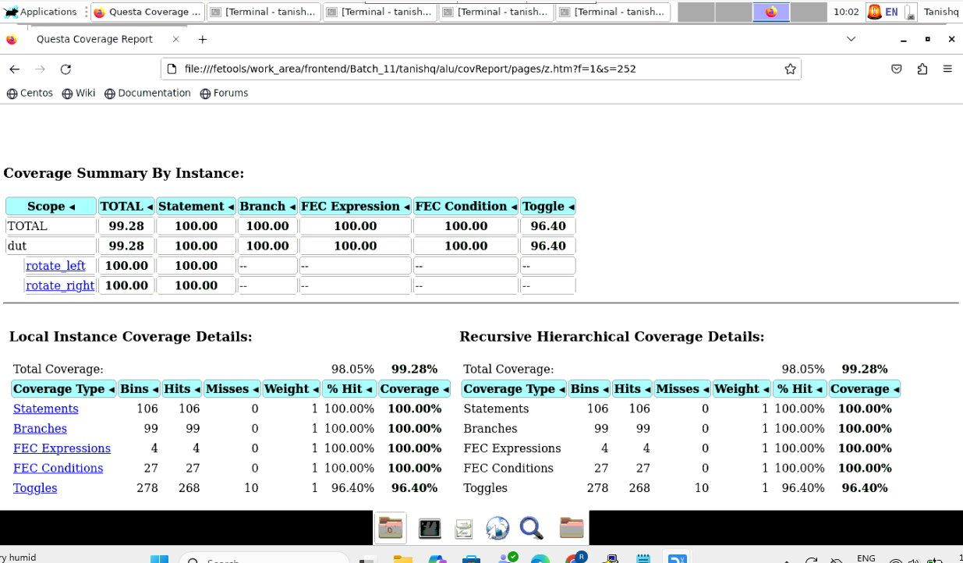
Figure: Questa SIM Coverage Summary Report

11.2 Coverage Observations
Coverage Type | Bins | Hits | Misses | % Hit | Coverage
Statements | 106 | 106 | 0 | 100% | 100.00%
Branches | 99 | 99 | 0 | 100% | 100.00%
FEC Expressions | 4 | 4 | 0 | 100% | 100.00%
FEC Conditions | 27 | 27 | 0 | 100% | 100.00%
Toggles | 278 | 268 | 10 | 96.40% | 96.40%
TOTAL | — | — | 10 | — | 99.28%

11.3 Analysis
- Statement, Branch, FEC Expression, and FEC Condition coverages all achieved 100%, confirming that every line of RTL code was exercised and every conditional branch was traversed in both directions.
- Toggle coverage reached 96.40%, with 10 toggle bins remaining uncovered. These 10 misses are attributable to the rotate_left and rotate_right function outputs — which achieve 100% statement/branch coverage individually but may have specific bit-toggle combinations that require exhaustive random stimuli to exercise fully.
- Overall DUT coverage of 99.28% is an excellent result for a directed testbench, indicating thorough functional verification with minimal gaps.
- The rotate functions (rotate_left, rotate_right) show 100% statement and branch coverage with toggle metrics marked '--' (not applicable at function scope level), consistent with the tool's reporting for synthesizable functions.

12. Conclusion

This project successfully demonstrated the complete RTL design and functional verification flow for a parameterized 8-bit ALU. The design supports 28 distinct operations across two modes, handles invalid operand combinations gracefully via the err flag, and implements a correct pipelined architecture for multi-cycle multiplication operations.
The self-checking testbench executed 81 directed test cases with zero failures, achieving 99.28% total functional coverage in Questa SIM. All statements (100%), branches (100%), FEC expressions (100%), and FEC conditions (100%) were covered. The 3.6% toggle miss is within acceptable bounds for a directed test strategy and is localized to specific bit transitions in the rotate path.
The project reinforced key RTL design principles: parameterization for reusability, registered inputs for pipeline stability, clock-enable for power-aware freezing, and always-default case branches for robust error handling.

13. Future Work

- Extend the testbench with constrained-random stimulus (using SystemVerilog classes and covergroups) to close the remaining 3.6% toggle coverage gap.
- Add formal property verification (SVA assertions) to prove the pipeline protocol, INP_valid semantics, and signed overflow conditions exhaustively.
- Scale the parameterized design to 16-bit and 32-bit widths and re-run the full test matrix to validate width-independence.
- Integrate a UVM-based verification environment with a reference model, functional coverage groups, and automated regression for production-grade sign-off.
- Synthesize the design in Vivado targeting a Xilinx FPGA and measure timing closure, LUT utilization, and maximum operating frequency.
- Add barrel-shifter support for multi-bit shift/rotate operations (currently shift by only 1 bit is supported for non-rotate operations).

--- End of Report ---

