AXI4-Lite Slave
UVM Verification Report
Test-plan implementation, coverage closure, and bug findings
Simulator: Questa (qrun) | Report date: 20 Sep 2026

1. Overview
This report documents the UVM-based verification of the AXI4-Lite slave register file (axi4_lite_slave.sv). It covers the test-plan implementation, functional and code coverage results, and three RTL bugs identified during regression, each traced to a specific line of the design.

1.1 Design Under Test
A single-region AXI4-Lite slave with a 16-word (64-byte) register file. Address space is partitioned into a read/write region ([0:36] and 60), a read-only region ([40:48]), a write-only region ([52:56]), and an out-of-range region (64 and above). Word-unaligned accesses and accesses outside the valid range are expected to be rejected with SLVERR or DECERR respectively, without altering memory contents.

1.2 Verification Environment
A standard UVM environment drives independent write and read sequencers into a shared driver, with separate active (driver/monitor) and passive (output monitor) agents feeding a scoreboard and a functional-coverage subscriber through analysis ports. A virtual sequencer coordinates write and read sequences so mixed read/write scenarios can be expressed as single sequences.
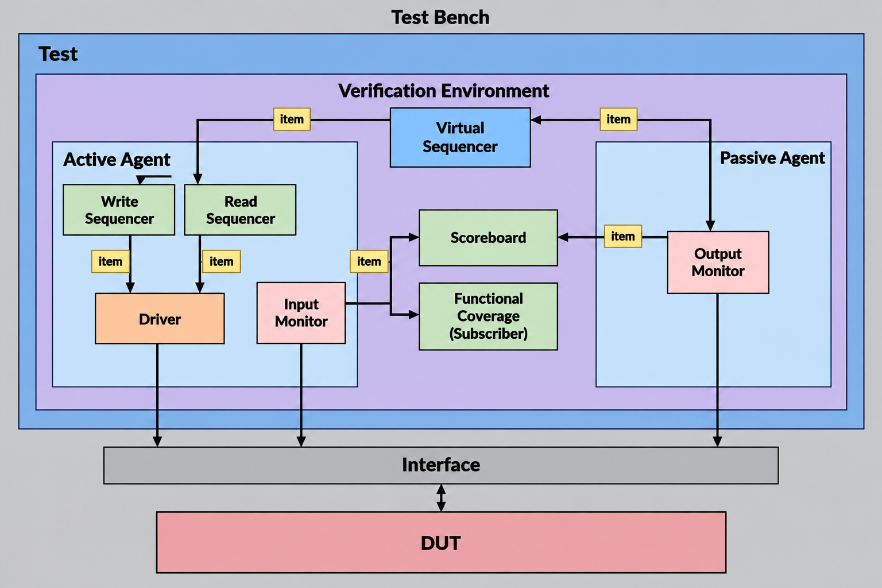
Figure 1 — UVM verification environment: active agent (driver + input monitor) drives write/read sequencers; passive agent (output monitor) observes DUT responses; scoreboard and subscriber consume both streams.

2. Test-Plan Implementation
The test plan defines 34 directed and constrained-random scenarios across reset, write, read, stall, back-to-back, and mixed read/write sequence categories, plus a coverage-closure pass that deterministically sweeps every region x alignment x strobe combination the subscriber's covergroup requires. Each ID below was implemented as its own UVM sequence class and is run once per regression seed.
ID | Category | Feature | Result
1 | Reset | Reset / mid-sequence reset | Pass
2-4 | Write | Basic write, AW-first, W-first at aligned address | Pass
5 | Write | AWVALID and WVALID asserted in the same cycle | FAIL - hangs (Bug 1)
6 | Write | Random WSTRB byte-lane write | Pass
7 | Write | Write at unaligned address | FAIL - writes 0 at aligned word (Bug 2)
8 | Write | Write at read-only region | FAIL - writes 0 at that location
9 | Write | Write out of range | FAIL - corrupts unrelated in-range word (Bug 3)
10-12 | Stall | WVALID/AWVALID/BREADY stalled independently | Pass
13 | Back-to-back | Aligned writes | Pass
14 | Back-to-back | Unaligned writes | FAIL (same root cause as Bug 2)
15-23 | Read | Basic / random-strb / unaligned / WO / OOR / stalled / back-to-back reads | Pass
24-26 | Sequence | Read-after-write, simultaneous AR+AW on different addresses | Pass
27 | Sequence | Write-then-read at read-only location | FAIL - RO write still corrupts memory
28 | Sequence | Write-then-read at write-only location | FAIL - data mismatch
29, 31 | Sequence | Unaligned write/read combinations | Pass
30 | Sequence | Unaligned write, aligned read of same word | FAIL - data mismatch (Bug 2)
32 | Sequence | Write-then-read at out-of-range address | Not scored
33-34 | Sequence stall | Simultaneous AR+AW with one channel stalled | Pass

Test ID 5 (AWVALID and WVALID asserted in the same cycle) is intentionally excluded from the automated regression once the failure was root-caused (Bug 1, below) — driving it further only re-triggers a known defect rather than exercising new design behavior.

3. Coverage Results

3.1 Functional coverage
The subscriber's covergroup (region x alignment, region x strobe, write/read region cross, write/read alignment cross, and write-order coverpoints) reaches 100% after the coverage-closure sequences were added to deterministically hit the region-pair and order bins that constrained-random stimulus alone was missing.
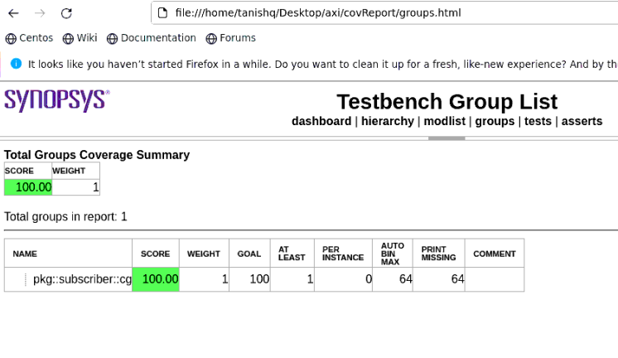
Figure 2 — Functional (group) coverage: 100.00% across all covergroup bins.

3.2 Code coverage
Code coverage (Questa qrun, line + condition + toggle + FSM + branch) after the full regression:
Scope | Score | Line | Cond | Toggle | FSM | Branch
top.dut | 88.28 | 98.25 | 83.00 | 98.80 | 70.00 | 91.38

FSM coverage (70.00%) is the one metric below the 90% goal. The gap is three write-FSM reset transitions (W_ADDR/W_BOTH/W_DATA -> W_IDLE) and the two `case` default arms, which are only reachable by asserting ARESETn while a write is mid-address- or mid-data-phase, or by forcing an otherwise-unused state encoding. The reset-injection sequence (test ID 1) targets exactly this gap; remaining default-arm misses are structurally unreachable without artificially forcing FSM state and are recommended for a coverage waiver rather than further stimulus.
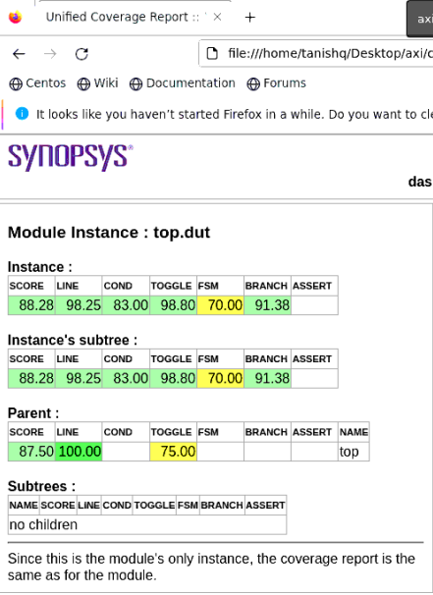
Figure 3 — Per-module code coverage breakdown for top.dut.

4. Regression Summary
A representative regression run against the current (unfixed) RTL reported the following, taken directly from the Questa log:
- UVM_INFO: 31 UVM_WARNING: 0 UVM_ERROR: 135 UVM_FATAL: 0
- All 135 errors originate from a single check: scoreboard.sv(40), "[SCB] Data mismatch"
- 110 of 135 mismatches read back as a fully-zeroed word (Act:0) — the signature of Bugs 2 and 3
- 25 of 135 mismatches show partial byte corruption within the word — the same defect observed at a different word alignment
This run's simulation-time covergroup snapshot printed 87.50% (report_phase, prior to the coverage-closure sequences being added); the 100% figure in Figure 2 reflects the subsequent regression that included the closure sequences. Both are included here for traceability between the log evidence and the coverage figures.

5. Bugs Identified
All three bugs below were confirmed against axi4_lite_slave.sv and are reproducible from the test plan alone.
Bug 1: AWVALID and WVALID asserted in the same cycle corrupts the write data phase
Test-plan ID(s): 5
Symptom
When AWVALID and WVALID are driven high in the same clock cycle at an otherwise-legal aligned address, the write completes with the wrong data instead of the data actually presented on WDATA.
Root cause
Two sequential always blocks capture the address and data phases using an if / else-if priority chain rather than two independent conditions:
if (AWVALID && AWREADY) begin
aw_done <= 1'b1;
wr_addr_lat <= AWADDR;
end
else if (WVALID && WREADY) begin // <-- skipped if the AW branch above fired
w_done <= 1'b1;
wr_data_lat <= WDATA;
wr_strb_lat <= WSTRB;
end
Because AWVALID&&AWREADY is checked first, if both handshakes complete on the same edge the WDATA/WSTRB capture is silently skipped — wr_data_lat and wr_strb_lat keep whatever value they held from the previous transaction, and that stale value is what gets written to memory.
Fix: replace the else if on the WVALID branch with an independent if, so both handshakes are captured whenever they occur, whether alone or together:
if (AWVALID && AWREADY) begin
aw_done <= 1'b1; wr_addr_lat <= AWADDR;
end
if (WVALID && WREADY) begin // independent, not else-if
w_done <= 1'b1; wr_data_lat <= WDATA; wr_strb_lat <= WSTRB;
end
Bug 2: Write at an unaligned address zeroes the aligned word it maps to
Test-plan ID(s): 7, 14, 27, 30
Symptom
A write to a word-unaligned address correctly asserts SLVERR, but also overwrites the aligned memory word at that index with zero — silently destroying whatever value a prior, valid write had placed there.
Root cause
The W_RESP error branch does more than refuse the write — it actively clears memory:
end else if (wr_addr_ro || wr_addr_unaligned) begin
BRESP <= RESP_SLVERR;
reg_file[AWADDR[$clog2(MEM_DEPTH)+1:2]] <= 0; // <-- should not be here
end
AWADDR[5:2] is the aligned word index regardless of the low two (byte-offset) bits, so an unaligned address such as 5 (0b101) maps to the same index (word 1) that a correct access to address 4 would use. Zeroing reg_file there corrupts the aligned word, not just the illegal access.
Fix: remove the reg_file assignment from this branch; asserting SLVERR is sufficient and AXI4-Lite does not require (or permit) side effects on a rejected write.
Bug 3: Write at an out-of-range address corrupts an unrelated in-range word
Test-plan ID(s): 9, 32
Symptom
A write past the end of the valid address range correctly asserts DECERR, but also overwrites an unrelated, in-range register.
Root cause
Same code path as Bug 2, one branch earlier — the DECERR case has the identical defect:
if (!wr_addr_ok) begin
BRESP <= RESP_DECERR;
reg_file[AWADDR[$clog2(MEM_DEPTH)+1:2]] <= 0; // <-- should not be here
end
wr_addr_ok has already been evaluated false, but the index expression still only looks at AWADDR[5:2] — it never checks range before indexing. Any out-of-range address aliases (address mod 64) onto one of the 16 valid words and zeroes it, even though the access was already known to be invalid.
Fix: same as Bug 2 — remove the reg_file assignment from the DECERR branch. Both fixes together are a two-line change (deleting lines 163 and 166 of axi4_lite_slave.sv).

6. Recommendations
- Apply the two-line RTL fix removing reg_file[...] <= 0 from both the DECERR and SLVERR branches of the write-response state; this resolves Bugs 2 and 3 together and should clear 135/135 of the current scoreboard mismatches.
- Change the AW/W capture always block from if/else-if to two independent if blocks to resolve Bug 1, then re-enable test ID 5 in the regression to confirm.
- Re-run the full regression (all seeds) after the RTL fix and confirm the scoreboard reports 0 errors before re-checking coverage.
- FSM branch coverage: keep the mid-transaction reset sequence (test ID 1) in the regression; treat the two remaining `case` default arms as a documented waiver rather than pursuing forced-state stimulus.
- The test plan's Assertion Plan section (handshake stability, RDATA hold, reset values, BRESP/BVALID latching) has not yet been implemented as SVA. Recommend adding these as a checker layer bound to the interface — they would have caught Bug 1 immediately, independent of the scoreboard's end-to-end data check.

