# Introduction

We are returning to reaction time measurements. This week we will use the buzzer to create an auditory sound at a random time between 0 and 5 seconds after starting the program. We will test two different audible frequencies for reaction time. We will compare the two frequencies' reaction time to one another to determine whether there is a statistical difference. Finally, we will compare our auditory reaction time to our visual reaction time to determine whether there is a statistical difference.

# Procedure

We have seen how the buzzer works based on audio output. We have also seen the code for turning an LED on at a random time between 0 and 5 seconds. We will put the two together so that we can turn a buzzer on at a random time between 0 and 5 seconds. Your circuit will be set up like the following diagram.

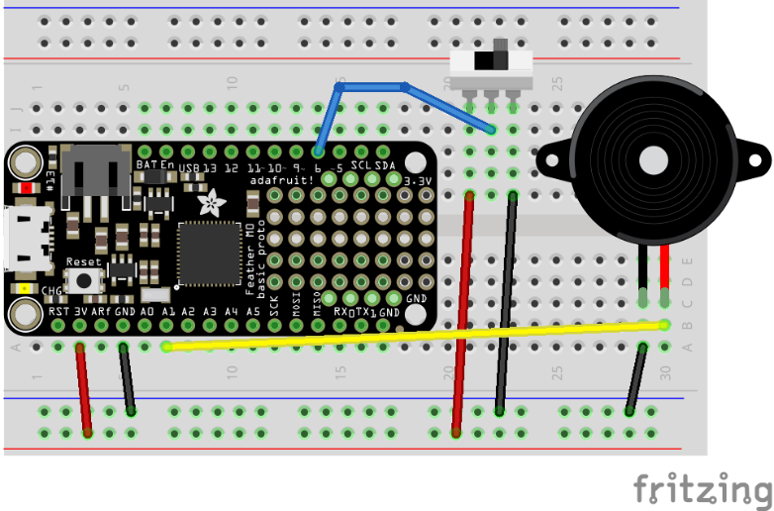

The code to do the audio reaction time experiment is below:

"""Lab 4 - Audio Reaction Time"""  
**import** time #keep track of time and make delays  
**import** random  
**import** array #store lists of values  
**import** math #do math like sine, cosine  
**import** audiocore  
**import** audioio #create sounds  
**import** board #identify the microcontroller  
**from** digitalio **import** DigitalInOut, Direction, Pull #do digital I/O  
  
# Button setup on digital pin 6.  
switch = DigitalInOut(board.D6)  
switch.direction = Direction.INPUT  
# Create a sine wave for audio output  
tone_volume = 1.0 # Increase this to increase the volume of the tone.  
frequency = 440 # Set this to the Hz of the tone you want to generate.  
length = 8000 // frequency  
sine_wave = array.array("h", [0] * length)  
**for** i **in** range(length):  
 sine_wave[i] = int(math.sin(math.pi * 2 * i / length) * (2 ** 15))  
  
audio = audioio.AudioOut(board.A1)  
sine_wave = audiocore.RawSample(sine_wave)  
  
# variables to store information  
ranDelay = 0.0 # random delay time in seconds  
startTime = 0.0  
rxnTime = 0.0 # start time and reaction time variables  
  
**while** True:  
   
 print("Push the button to start game")  
  
 **while** switch.value == True:  
 **continue**  
 # wait for the user to push the button for start  
  
 print("Get Ready!")  
 time.sleep(1.0)  
 print("Get Set!")  
 time.sleep(1.0)  
 ranDelay = random.random() * 5.0 # generate a random delay time 0 to 5 seconds  
 time.sleep(ranDelay) # wait the random amount of time  
 print("Go!")  
 startTime = time.monotonic() # get the time  
 audio.play(sine_wave, loop=True) #play the sound  
  
 **while** switch.value == True:  
 **continue**  
 # wait for the reaction button press  
  
 audio.stop() # turn off the audio  
 rxnTime = time.monotonic() - startTime # calculate the reaction time  
 print("Your time is ", rxnTime, " seconds.")  
 time.sleep(2.0)

* **Identify the two lines of code that were changed from the LED reaction timer to make the buzzer reaction timer.**
* **What does each of these lines do?**

Save your code as code.py and run 60 tests to measure your reaction timing. Change the frequency from 440 Hz to 880 Hz. This makes the buzzer have a higher pitch.  You should notice this frequency change. Repeat the experiment 60 times to see if the lower frequency affects your reaction time.

# Analysis

Repeat the statistical analysis you have done for the LED reaction times to find averages and standard errors for your reaction time related to different tones. Histograms are a nice visual, but you are not required to make histograms this week. Compare your auditory results to one another. **Does the tone frequency have an effect that makes your response time statistically different? Explain.**

**Compare your buzzer response times to the LED response times. Do you have a statistically different auditory response time from your visual response time? If so, do your results agree with the study of medical students**[**found here**](https://www.ncbi.nlm.nih.gov/pmc/articles/PMC4456887/)**?**You do not need to read the entire paper. Skip to the conclusion.

**Document your findings in your lab notebook and include conclusive statements for your results similar to the ones I make below.**

Here are my results if you would like to compare. For the different frequencies, my reaction times were:

$$t_{highf}=0.175 ± 0.006 s$$

$$t_{lowf}=0.186 ± 0.006 s$$

Thus, with 95% confidence there is no statistical difference observed based on audible frequency. On a graph, the distributions look like the following. It's obvious from the numbers above and the graph that the distributions overlap.

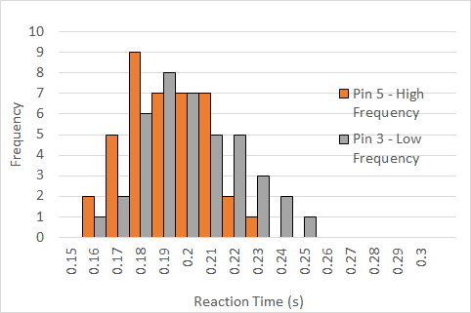

Comparing the auditory to the visual reaction times:

$$t_{highf}=0.175 ±0.006 s$$

$$t_{lowf}=0.186 ±0.006 s$$

$$t_{visual}=0.213 ±0.004 s$$

These are statistically different with 95% confidence intervals (even 99% confidence intervals at 3*SDM). I am quicker to react to audible cues. The distributions are shown below.

