# Purpose

* To become more familiar with DC resistor circuits.
* To learn to measure voltage and current.
* To evaluate Ohm’s Law.

You will do all of the experiments virtually and on the lab bench. The virtual experiments are done using this PhET simulator on the "Lab" tab. <https://phet.colorado.edu/en/simulation/circuit-construction-kit-dc>

# Background

Ohm’s Law says ***V = IR***, or voltage equals the current times the resistance.***V*** is in Volts (Volts are Joules/Coulomb). ***I*** is in amperes (or Coulomb per second), and ***R***is in Ohms (units you could work out from the others). These are SI units. Voltage, also called electric potential, is the source of energy pushing electrons through a typical circuit. Flowing charges, or current, is a result of the voltage pushing charges against electrical resistance. As voltage increases, the current should increase linearly for a particular resistance.

* **Explain how an increase in the current (number of charges flowing per second, not the speed of the charges) is a response to increasing voltage described by conservation of energy.**

## **Circuit Loop Rules**

The word circuit comes from the idea that electronics make loops. A circuit or electronic loop must conserve energy. This leads to two circuit rules.

1. The sum of voltages around a loop are zero, e.g., energy in from a battery equals energy out dissipated by a resistor.
2. The current through a circuit or electronic loop is constant.

Below on the left is a circuit shown as we might see in the lab with a battery and a resistor. On the right is the equivalent circuit diagram. We assume wires are ideal, with zero resistance.

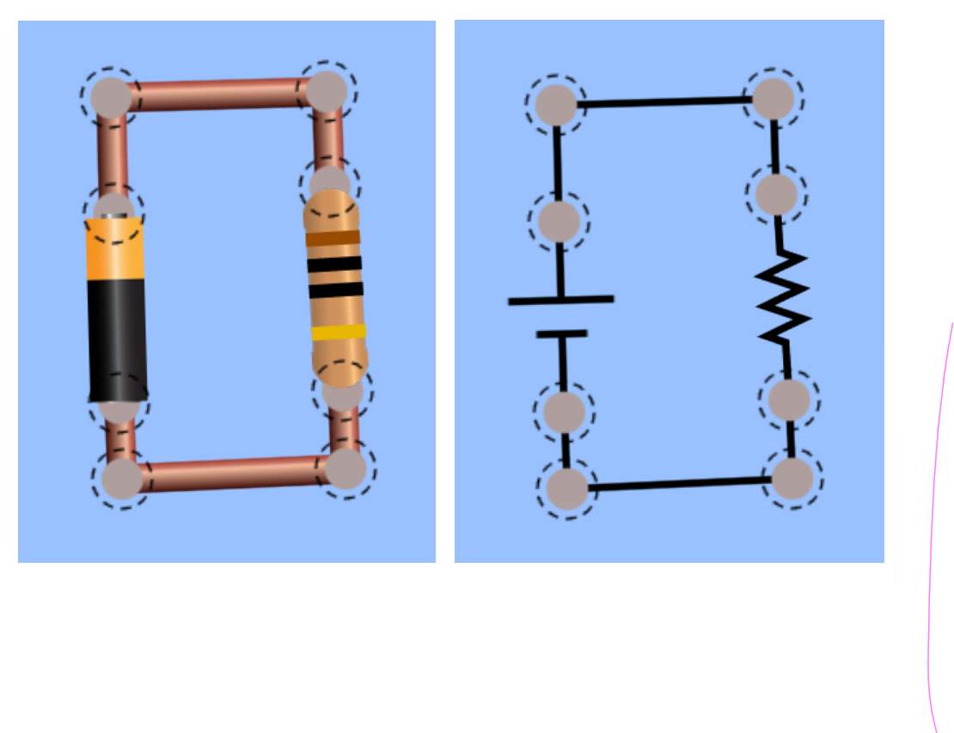

* **In your lab notebook, make a note of what battery and resistor circuit diagrams look like.**
  + **Which side of the battery is +, and which side is -?**
  + **How is this polarity indicated in the circuit diagram on the right?**

The resistors we will use have four colored bands on them. These bands quantify the resistance as shown in the table below:

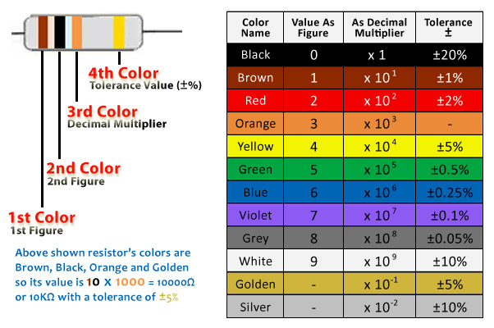

For example, a resistor with yellow, violet, red, and silver bands gives the numbers 4, 7, 2, $± 10 \%.$ This indicates the resistance is $47 ×{10}^{2}=4700 ±10 \%=4700 ±470 Ω$.

* **Calculate the resistance of the resistor shown below with green, blue, orange, and gold bands.**
* **Suppose this resistor is connected to a 3 Volt battery like the image of a circuit above. What current will flow through the circuit?**

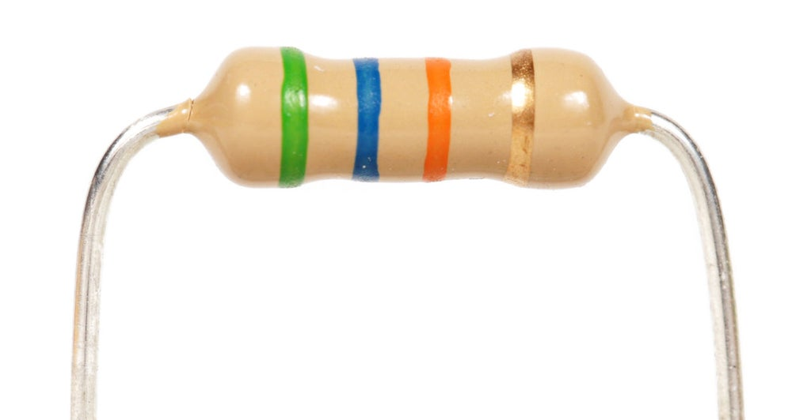

# Experiment

### Part 1 – Single Resistor

Set up the circuit shown above with a single resistor in the simulator and on the lab bench. From the colored bands, determine the resistance and set the same resistance in the simulator. On the lab bench, you will use a power supply instead of a battery so that you can adjust the voltage. Apply the voltages as shown in the table below and measure the current flows for each applied voltage.

**Single resistor Experiment**

|  |  |
| --- | --- |
| Voltage (V) | Current (A) |
| 0.5 |  |
| 1.0 |  |
| 1.5 |  |
| 2.0 |  |
| 2.5 |  |
| 3.0 |  |

* **Plot V vs I. What is the slope of your graph including uncertainty (We will go over graphing and fitting in Python.)?**
* **How does your slope compare to the theoretical value of the resistor from its bands including uncertainty? Does the simulation give the same results as your experiment? Explain.**

## Part 2 – Series Resistor

Set up a "series" circuit with two resistors in series as shown below. From the colored bands, determine the resistances and set those same resistances and voltages in the simulator.  Apply the voltages as shown in the table and measure the currents at the locations indicated (1-4) in the simulation. Measure the current anywhere on the real circuit. Measure the voltage across each resistor (two voltage measurements).

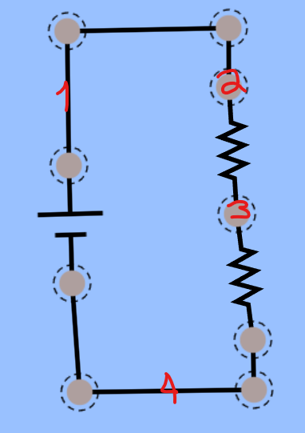

**Series resistor experiment**

|  |  |
| --- | --- |
| Voltage (V) | Current (A) |
| 0.5 |  |
| 1.0 |  |
| 1.5 |  |
| 2.0 |  |
| 2.5 |  |
| 3.0 |  |

Questions to consider:

* **Why do you think we call this a series circuit?**
* **How do the currents change throughout the circuit? Should current vary in this circuit based on the rules above?**
* **How do the voltages change for each resistor? Do the two resistor voltages add to the power supply voltage?**
* **Plot V (power supply setting) vs I (measured at 1 or 4). What is the slope of your graph including uncertainty?**
* **How does your slope compare to the theoretical value ( $R_{tot}=R_{1}+R_{2} )$?**
* **Calculate the uncertainty of the theoretical resistance based on the fourth resistor band, where gold is $∆R=0.05R$ and silver is $∆R=0.10R$.**
$∆ R_{tot}=\left( \frac{∆R_{1}}{R_{1}}+\frac{∆R_{2}}{R_{2}} \right) ∙R_{tot}$

* **Does the simulation give the same results as your experiment? Explain.**

## Part 3 - Parallel Resistor

Set up a "parallel" circuit with two resistors in series as shown below. From the colored bands, determine the resistances and set the same resistances and voltages in the simulator.  Apply the voltages as shown in the table and measure the currents at the locations indicated (1-6) in the simulation. Measure currents at 2 and 3 on the real circuit.

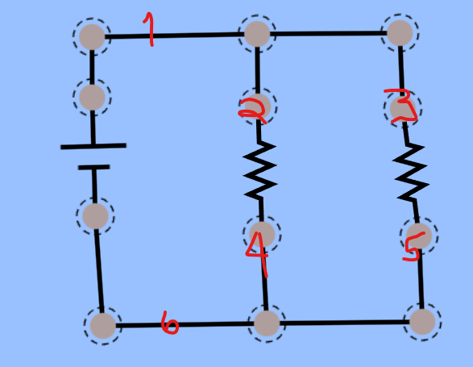

**Parallel resistor experiment**

|  |  |
| --- | --- |
| Voltage (V) | Current (A) |
| 0.5 |  |
| 1.0 |  |
| 1.5 |  |
| 2.0 |  |
| 2.5 |  |
| 3.0 |  |

Questions to consider:

* **Why do you think we call this a parallel circuit?**
* **How do the currents change throughout the circuit? Should current vary in this circuit based on the rules above?**
* **Are there different voltages on each resistor?**
* **Plot V (power supply setting) vs I (measured at 1 or 6). What is the slope of your graph including uncertainty?**
* **How does your slope compare to the theoretical value $R_{tot}={\left(\frac{1}{R_{1}}+\frac{1}{R_{2}} \right)}^{-1}$?**
* **Calculate the uncertainty of the theoretical resistance based on the fourth resistor band, where gold is $∆R=0.05R$ and silver is $∆R=0.10R$.**
$∆ R_{tot}=\left( \frac{∆R_{1}}{R_{1}^{2}}+\frac{∆R_{2}}{R_{2}^{2}} \right) ∙{R^2 }_{tot}$

* **Does the simulation give the same results as your experiment? Explain.**

# Conclusions

Write a concluding paragraph responding to the following:

* **Is Ohm's Law a good model for the dependence between voltage and current? Explain.**
* **If you were to put more resistors in series, how would you anticipate  mathematically modeling the total resistance?**
* **If you were to put more resistors in parallel, how would you anticipate mathematically modeling the total resistance?**