Lab 6: Measuring Currents with a Resistor

# Purpose

* To learn how to measure currents with a resistor.
* To make an application of a series circuit also known as a voltage divider.
* To model circuits with Ohm’s Law.
* To apply analog output techniques on a microcontroller.

# Introduction

When using digital acquisition systems such as a microcontroller, one does not have access to an ammeter (current measurement). It is possible to use a series circuit with a resistor of known value to calculate the current from Ohm’s Law. A series resistor circuit is shown below.

$$V_{in}$$

$$R_{1}$$

$$R_{2}$$

Figure . A series resistor circuit.

We found in a previous experiment that the resistances add together and that the input voltage is divided between the two resistors. These concepts can be written mathematically as

( )

( )

One way to think about this is that the amount of electric potential (voltage) varies depending on the resistance. In a series circuit, more of the electrical energy must be consumed pushing charges through the larger resistance. This unequal division ensures a constant current through the single pathway. Rewriting the second equation above for Ohm’s Law we have

( )

Suppose we insert a known value resistor for $R_{2}$. Since the current is the same for both resistors, we can measure the voltage across the known resistor and calculate the current

$$V_{2}=IR_{2}$$

Then, using equations (2) and (3), we can calculate the voltage, $V_{1}$, and resistance, $R_{1}$, respectively. This allows us to evaluate an unknown resistor. This week, we will do experiments to verify these measurements are possible with a microcontroller and determine how the value of $R_{2}$ affects our circuit. This will allow us to develop a resistive sensing apparatus in our next experiment.

# Experiment

You will set up a microcontroller circuit like the one shown below in Figure 2.

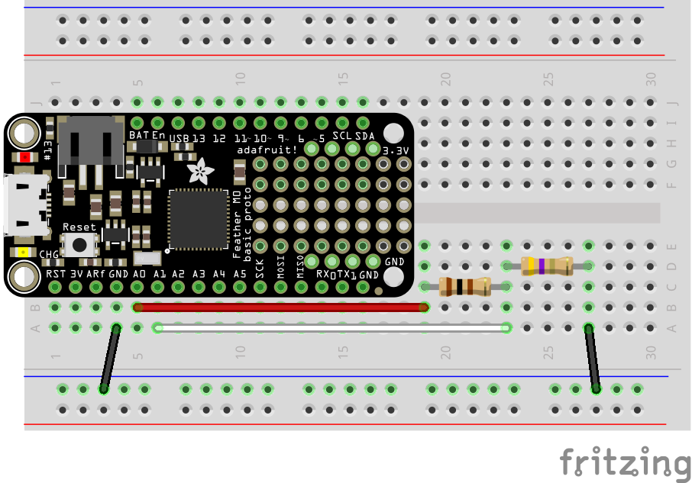

Figure . A cartoon diagram of a series resistor circuit connected to an Adafruit M4 Feather microcontroller.

In this experiment, you know the value of both resistors, but in the next experiment, you will only know the value of one of the resistors. Suppose your desired circuit is a single resistor circuit like Figure 3, where $R_{1}=100 Ω$. You wish to measure the current in this circuit without significantly affecting the circuit. To do this, you propose to make the series circuit of Figures 1 and 2.

* **Should the value of $R_{2}$ be large or small?**
  + **“Large” or “small” is relative in this case. How should $R_{2}$ compare to $R_{1}$? Explain and use Ohm’s Law in your rationale.**
* **Describe a method of using Ohm’s Law to determine the value of $R_{1}$ by using $R_{2}$ to measure the current.**
  + **HINT: You want to use the linear relationship in Ohm’s Law ($V=IR$) to determine $R_{1}$ while assuming $R_{2}$ as a means to measure current does not significantly affect value of the circuit resistance.**
  + **Choose three values of $R_{2}$ to test, and tell your instructor or TA your plan so they can provide these resistors (or ones close in value).**

$$V_{in}$$

$$R_{1}$$

Figure . A single resistor circuit.

## Programming the Microcontroller

We will use the analog input/output techniques we saw in a previous experiments programming a buzzer and potentiometer. To begin, we will set the voltage manually to verify that the experiment is functioning correctly. Recall that these analog values are 16-bit ranging from 0 to 65535, corresponding to 0 to 3.3 Volts. This means a voltage of 2 V in integer is

$$2 V=65535*2/3.3$$

The code to operate the analog output voltage on analog pin A0 and read the analog voltage on A1 is

**import** time *#keep track of time and make delays*  
**import** board *#identify the microcontroller*  
**import** analogio *#do analog I/O*  
  
Vin = analogio.AnalogOut(board.A0) *#apply analog output on A0*  
V2 = analogio.AnalogIn(board.A1) *#read analog input on A1*  
  
**while** True:  
 Vin.value = int(65535 * 0.5/3.3) *#adjust the input voltage*  
 print(V2.value)  
 print(V2.value*3.3/65535)  
 time.sleep(1.0)

Use this code to verify your experiment is working. Change the voltage $V_{in}$ to the values in Table 1 and record your measurements of $V_{2}$ (digital integer, conversion of integer to voltage, calculation of current). Compare your measurements to calculations of Ohm’s Law for the single resistor circuit.

|  |  |  |  |  |
| --- | --- | --- | --- | --- |
| $V_{in}$ (Volts) | $V_{2}$ (digital integer) | $V_{2}$ (Volts) | $I$ (A) | Ohm’s Law Current (A) |
| 0.5 |  |  |  |  |
| 1.0 |  |  |  |  |
| 1.5 |  |  |  |  |
| 2.0 |  |  |  |  |
| 2.5 |  |  |  |  |
| 3.0 |  |  |  |  |

Table . Manually run experimental results of a series resistor circuit using a resistor to measure current.

We can use CircuitPython to calculate the voltages $V_{1}, V_{2}$ and the current $I$.

* **Write the calculations symbolically using $V_{in}, V_{2},$ and $R_{2}$.**
  + **There are three calculations:** 
    - **Convert $V_{2}$ from digital integer to voltage.**
    - **Calculate the current from $V_{2}$ and $R_{2}$.**
    - **Calculate $V_{1}$ from $V_{in}$ and $V_{2}$.**
* **Write a method of conversion between $V_{in}$ in volts to digital integer.**

Next, we will program the microcontroller to scan the input voltage while measuring $V_{2}$ and incorporate the conversion calculations you determined. Here is the skeleton code. You will need to edit four lines in the for loop.

**import** time *#keep track of time and make delays*  
**import** board *#identify the microcontroller*  
**import** analogio *#do analog I/O*  
**import** array *#make lists of numbers*  
  
Vin = analogio.AnalogOut(board.A0) *#apply analog output on A0*  
V2 = analogio.AnalogIn(board.A1) *#read analog input on A1*  
V1_arr = array.array("d")*#create an array of V1*  
I_arr = array.array("d") *#create an array of current*  
Vin_list = [0.5, 1.0, 1.5, 2.0, 2.5, 3.0] *#list of Vin*  
  
**for** i **in** Vin_list: *#loop to scan input voltage*  
 *#Students edit the following four lines*  
 Vin.value = int()*#conversion to integer using i in place of Vin*  
 time.sleep(0.2)  
 V2Volts = *#conversion of V2 from integer to volts using V2.value*  
 V1_arr.append() *# calculation of V1 using i as Vin and V2Volts*  
 I_arr.append() *# conversion of V2 to current using R2 and V2Volts*  
 time.sleep(0.1)  
  
*#print the results*  
print("V1")  
print(V1_arr)  
print("I")  
print(I_arr)

The program should print a list of $V_{1}$ and $I$ values. The analysis will be performed using Python in Trinket. Open the Lab 6 Trinket. It has code like the following.

**import** numpy **as** np  
**import** matplotlib.pyplot **as** plt  
**from** scipy.optimize **import** curve_fit  
  
*#create a function that returns a line*  
**def** **line_fit**(x, m, b):  
 **return** m * x + b  
  
*#testing with a 2.2 ohm current resistor (paste your values in the square brackets)*  
*#You can copy and paste all of the code below for each resistor.*  
*#Change the arrays and the colors and labels on the graphs.*  
V1 = np.array([-0.0112795, 0.3931698, 0.7960077, 1.1988476, 1.6065135, 2.0093554, 2.4138086])  
Current = np.array([0.00512705, 0.00878918, 0.01318377, 0.01757836, 0.01977568, 0.02417027, 0.02783245])  
  
*#Do the linear fit and print the results*  
fitp, fitc = curve_fit(line_fit, Current, V1)  
slope = fitp[0]  
slope_unc = np.sqrt(fitc[0,0])  
intercept = fitp[1]  
intercept_unc = np.sqrt(fitc[1,1])  
print("R2 = 2.2 ohms")  
print("m = ", '{:.2f}'.format(slope), "+/-", '{:.2f}'.format(slope_unc))  
print("b = ", '{:.2f}'.format(intercept), "+/-", '{:.2f}'.format(intercept_unc))  
  
*#Graph the results*  
plt.plot(Current, V1, 'or', label='2.2 ohm') *#graph the data*  
plt.plot(Current, !!!!, '-r') *#graph the fit*  
plt.xlabel("I (Amps)") *#label y axis*  
plt.ylabel(r"$V_1$ (Volts)") *#label x axis*  
plt.legend() *#create a legend*  
plt.show()

This code will determine a best-fit line to your data and report the slope and intercept with uncertainty. You will need to

1. Paste your data into V1 and Current.
2. Change the resistance value in the print statement and the plot label.
3. Insert the formula for calculating a line from the fit values slope and intercept. Keep in mind that the x-values are Current. You will insert this formula in place of !!!!.
4. Copy the appropriate portion of the code to repeat the analysis for all of your resistor values.
5. Plotting all three datasets may work best if the last two lines of the plotting are only included for the last resistor.
   1. That is, delete plt.legend() and plt.show() for all but the last resistor.

# Conclusions

* Describe the resistance values you obtained for $R_{1}$ from the slopes of your graphs.
  + Do these values agree with the theoretical value given by the colored bands on the resistor? Explain in detail.
  + Use the uncertainty from the linear fit to explain this agreement.
  + Do you notice a trend in the value of slope as your $R_{2}$ value increases?
  + Can you draw conclusions about the ratio of $R_{2}/R_{1}$ that will provide the best result for $R_{1}$ in terms of accuracy and uncertainty? Explain in detail.
  + Can you prescribe an upper and lower limit to $R_{2}$ that will give the best results in terms of accuracy and uncertainty? Explain in detail.